2020 Meteorological Summary for
the Agua Salud, Celestino Tower

Prepared by: Steven Paton

Introduction

This is the 3rd yearly reports summarising the past year’s Smithsonian Tropical Research Institute’s Physical Monitoring Program at the Agua Salud, Celestino Tower. This report is not meant to be exhaustive in its coverage in that it summarizes only some of the most ‘important’ or interesting parameters available. Any comments on how future yearly summaries could be improved would be appreciated. Copies of this report, reports from previous years, and downloadable data from the Galeta and other research locations, can be obtained from:
biogeodb.stri.si.edu/physical_monitoring/research/aguasalud

Setting
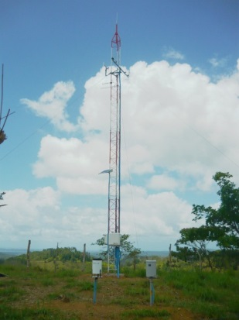
Installed in 2015, the Celestino Tower physical monitoring station (9.21142N, 79.72656W) is located approximately 13 km WNW of BCI and 25.5 km SSW of Galeta. The tower is 40ft (12.2m) tall. The tower is part of the Agua Salud research program but is operated by the Physical Monitoring Program. For more information about the Agua Salud Project, visit the following web site: https://stri.si.edu/facility/agua-salud

The station receives an average of 2665.2 mm of rain per year. The meteorological year is divided into two parts: a pronounced dry season (approximately from mid-December to the end of April), and a wet season (May to mid-December). On average, only 221mm of rain falls during the dry season. Relative humidity, air temperature, solar radiation, wind speed and direction, sea surface temperature (SST) all show marked seasonal differences.

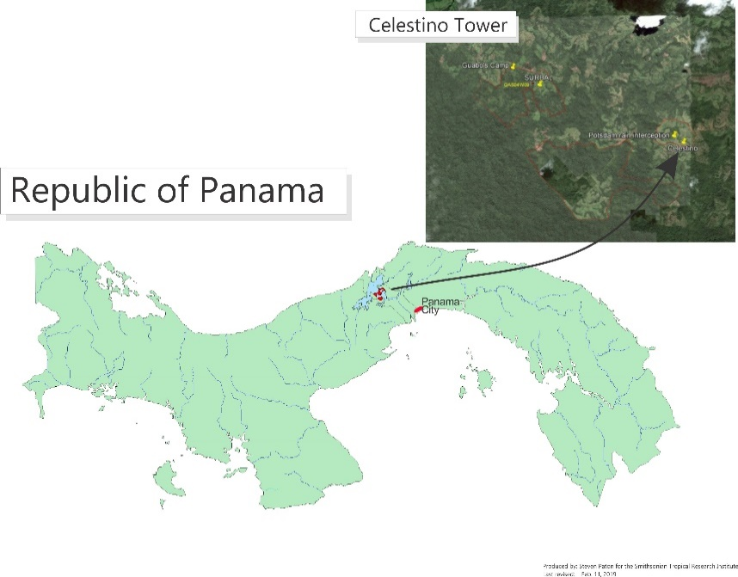

This report summarises the following data:
Air temperature
Net Radiation
Relative humidity
Rainfall
Solar radiation
Wind speed and direction

Rainfall
Rainfall is recorded as the average of two Hydrological Services CS700 Tipping Buckets

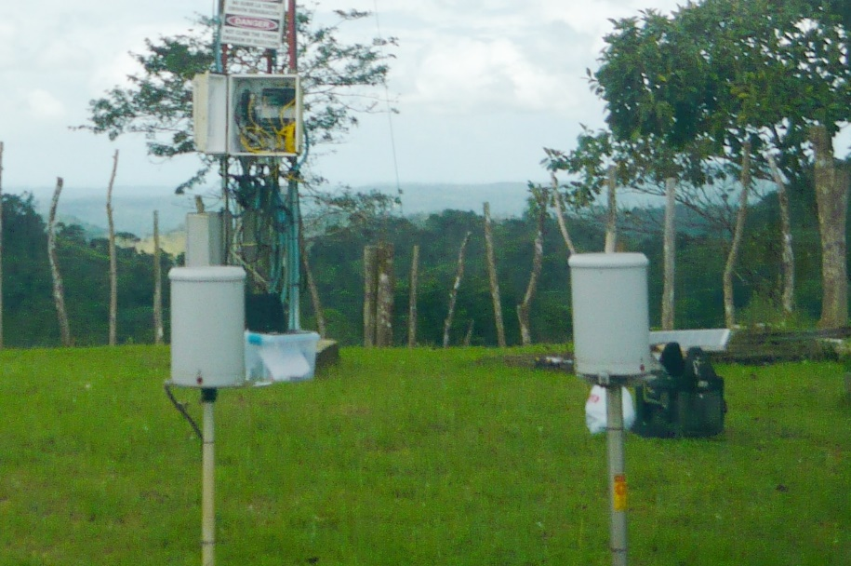

The daily rainfall data for 2020 are shown on page 6.

Page 7-8 show the monthly totals for 2020. The graph on the same page compares this year’s monthly totals with the average monthly totals (±SD) for the period 1974 to 2019.

Page 8 shows yearly rainfall totals for all years since 1974. Time series graph and frequency histograms are presented for these data.

Pages 9 and 10 show an analysis of rainfall ‘events’ (storms). For convenience, and again somewhat arbitrarily, I have defined a storm as any continuous period of rain separated by at least an hour from any other rainfall. Since this analysis required the timing of rainfall events, tipping bucket data were used. As a result, the absolute size of rainfall events should be considered only as an estimate since tipping buckets will tend to underestimate the size of storms - larger storms will be more underestimated than smaller ones. Keeping this in mind, the tables and graphs compare maximum and average storm size, and average storm duration per month for the period 2004 to 2019 versus 2020.

Relative Humidity

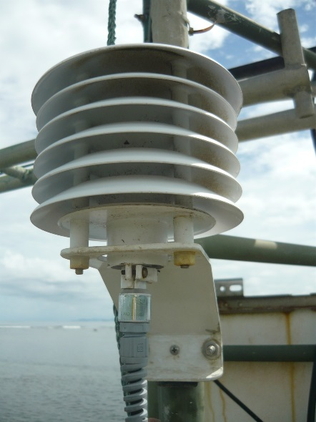
Relative humidity is recorded using a Viasala HMP60 electronic temperature/humidity sensor. The sensor is protected by a ventilated shield and is located on the side of the tower at 12m. Data are recorded at 15- minute intervals by dataloggers controlling the sensors. The average monthly relative humidity data are shown in tabular and graphical forms on page 11.

Air Temperature

Shaded air temperature data is currently recorded using a Viasala HMP60 electronic temperature/humidity sensor. The sensor is protected by a ventilated shield and is located on the side of the tower at 2m. Data are recorded at 15-minute intervals by dataloggers controlling the sensors.

The monthly average temperatures from the electronic sensors are shown in tabular and graphical form on pages 12-14.

Solar Radiation
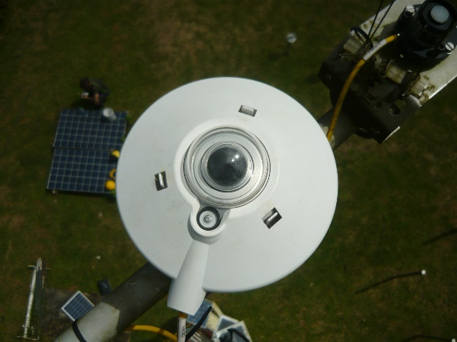
Currently, Celestino is the only station where both Photosynthetically Active Radiation (PAR) and solar flux (Pyranometer) is measured by STRI’s Physical Monitoring Program.

PAR is measured using two Kipp&Zonen PQS1 sensors. Solar flux is measured using Kipp&Zonen pyranometers (one CMP10 and one CMP3).

All sensors are located near the top of the tower
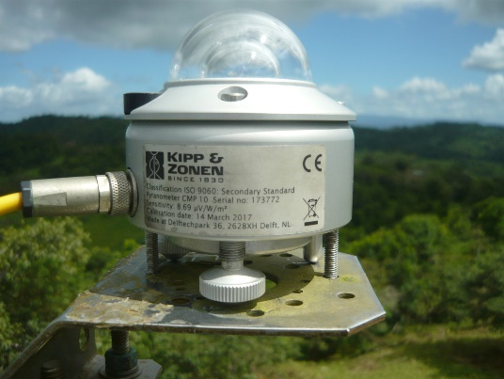
Daily total solar radiation (Pyranometer) is shown on page 15. Total PAR is shown on page 16. Monthly average daily total solar radiation and PAR are shown on pages 17 and 18, respectively.

Wind Speed and Direction

Wind speed and direction are recorded with a RM Model 05103 Young anemometer located at the top of the tower. 15-minute interval average, maximum and minimum wind speed plus average wind direction are recorded.

Page 19 shows average and maximum daily wind speeds from the Young Anemometer located at the top of the Pier tower. Page 20 shows daily average wind direction. The angles indicated in the table and graph on this page represent the direction from which the wind was predominately blowing on a given day. Page 21 shows the monthly average wind speed and monthly average directions for the year.

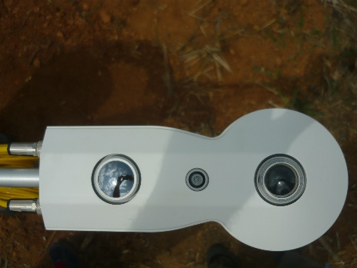
Net Radiation

Net radiation is measured using a Kipp & Zonen CNR4 Net-Radiometer. The sensor is mounted on the tower, 1.5m above the grass covered ground. The associated soil temperature probe is located nearby at a depth of 20cm

Pages 22-24 show the monthly average Net Radiation, Net Long and Shortwave Radiation, respectively.

Air Pressure

Air pressure is measured using a Vaisala PTB110 barometric sensor. The sensor is mounted on the tower, 1.5m above the grass covered ground. Air pressure is recorded hourly.
Page 25 shows the monthly average air pressure.

Times Series
Graphs showing the 2020 daily (Pages 26-7) and monthly averages for the entire period of record (Pages 28-30) for Relative Humidity, Air Temperature, Rainfall, Wind Speed, Solar Radiation and Water Temperature.

Daily Patterns
Pages 31 and 32 show the daily patterns for Relative Humidity, Air Temperature, Rainfall, Wind Speed, Solar Radiation, and Air Pressure.

2020 Daily Rainfall (mm)

 | Jan. | Feb. | Mar. | Apr. | May | June | July | Aug. | Sep. | Oct. | Nov. | Dec.
1 | 19.6 | 6.1 | 0.0 | 0.0 | 0.0 | 0.0 | 2.5 | 0.0 | 0.1 | 0.3 | 77.1 | 3.8
2 | 20.2 | 0.4 | 0.0 | 0.0 | 0.0 | 42.8 | 9.0 | 6.1 | 5.6 | 10.0 | 0.6 | 67.6
3 | 0.3 | 0.0 | 0.0 | 1.5 | 0.0 | 0.0 | 4.8 | 16.6 | 0.9 | 0.3 | 6.5 | 5.6
4 | 0.1 | 0.0 | 0.0 | 0.0 | 0.0 | 0.1 | 8.1 | 1.3 | 0.1 | 0.0 | 0.0 | 2.8
5 | 0.0 | 0.0 | 0.0 | 0.0 | 8.4 | 0.0 | 0.3 | 6.7 | 16.6 | 1.3 | 0.0 | 0.0
6 | 0.0 | 0.0 | 0.0 | 0.0 | 0.3 | 0.5 | 5.6 | 0.1 | 7.2 | 13.8 | 0.0 | 7.4
7 | 0.8 | 0.0 | 0.0 | 0.0 | 0.1 | 10.9 | 35.8 | 0.1 | 3.7 | 1.3 | 0.0 | 7.2
8 | 0.0 | 0.0 | 0.0 | 5.0 | 0.0 | 0.9 | 12.1 | 7.1 | 0.3 | 0.1 | 0.0 | 9.1
9 | 0.0 | 0.0 | 0.0 | 0.1 | 4.3 | 8.9 | 0.6 | 5.6 | 28.8 | 0.1 | 0.0 | 35.6
10 | 0.0 | 0.0 | 0.0 | 0.0 | 0.1 | 17.4 | 8.6 | 0.1 | 6.0 | 0.0 | 0.0 | 0.8
11 | 0.0 | 0.0 | 0.0 | 0.8 | 1.0 | 85.1 | 1.4 | 0.3 | 2.9 | 9.8 | 1.4 | 0.0
12 | 0.0 | 0.0 | 0.0 | 1.0 | 0.1 | 0.1 | 0.0 | 25.0 | 1.8 | 7.9 | 9.5 | 0.0
13 | 0.0 | 0.0 | 0.0 | 8.9 | 22.6 | 0.0 | 2.0 | 55.8 | 0.1 | 4.2 | 9.0 | 0.0
14 | 0.0 | 0.0 | 0.0 | 51.2 | 0.3 | 0.0 | 0.5 | 3.2 | 6.1 | 2.4 | 3.4 | 0.1
15 | 0.0 | 1.8 | 0.0 | 0.5 | 24.8 | 29.7 | 1.0 | 5.3 | 0.0 | 0.1 | 10.4 | 0.0
16 | 0.0 | 0.0 | 0.5 | 0.1 | 0.1 | 0.3 | 0.3 | 0.0 | 0.0 | 5.2 | 8.9 | 3.4
17 | 0.0 | 0.5 | 0.4 | 0.0 | 36.3 | 28.7 | 1.5 | 6.5 | 0.0 | 6.2 | 0.0 | 6.4
18 | 0.0 | 0.0 | 0.0 | 0.0 | 9.7 | 6.2 | 0.5 | 27.9 | 9.4 | 7.9 | 45.2 | 0.0
19 | 0.0 | 0.0 | 0.0 | 0.0 | 11.8 | 2.3 | 0.0 | 1.1 | 59.1 | 0.6 | 12.3 | 4.4
20 | 0.0 | 0.0 | 0.0 | 0.0 | 0.9 | 40.3 | 8.1 | 0.5 | 17.4 | 9.4 | 65.9 | 0.0
21 | 0.0 | 5.7 | 0.1 | 52.6 | 0.0 | 0.3 | 2.8 | 0.0 | 22.9 | 0.3 | 9.9 | 0.0
22 | 9.8 | 0.0 | 0.0 | 6.4 | 16.0 | 0.0 | 9.7 | 9.4 | 3.9 | 0.0 | 0.1 | 0.0
23 | 7.5 | 0.0 | 0.0 | 17.1 | 0.4 | 18.5 | 3.0 | 17.9 | 25.1 | 0.8 | 0.0 | 0.1
24 | 0.0 | 0.0 | 0.0 | 8.5 | 0.1 | 3.9 | 0.0 | 1.3 | 4.6 | 1.0 | 1.8 | 0.0
25 | 0.0 | 0.0 | 0.0 | 0.3 | 1.3 | 1.3 | 0.3 | 17.0 | 0.6 | 0.1 | 3.2 | 7.7
26 | 0.0 | 0.0 | 0.0 | 0.0 | 3.7 | 6.2 | 1.8 | 0.1 | 7.0 | 0.0 | 60.1 | 1.0
27 | 0.9 | 0.0 | 0.0 | 0.0 | 2.7 | 15.2 | 12.8 | 0.5 | 10.2 | 4.1 | 0.1 | 12.1
28 | 0.0 | 0.0 | 0.0 | 0.0 | 0.8 | 3.9 | 0.9 | 0.0 | 11.2 | 38.5 | 1.3 | 4.8
29 | 0.0 | 0.5 | 0.0 | 0.1 | 0.3 | 43.1 | 0.4 | 15.7 | 0.3 | 13.5 | 21.7 | 0.4
30 | 0.0 |  | 0.0 | 0.0 | 4.1 | 44.6 | 0.0 | 0.1 | 40.0 | 8.9 | 29.5 | 9.7
31 | 0.0 |  | 8.0 |  | 0.3 |  | 0.0 | 19.3 |  | 1.7 |  | 0.1
 | 59.1 | 15.0 | 9.0 | 154.1 | 150.2 | 411.2 | 134.5 | 250.8 | 291.9 | 149.6 | 378.0 | 190.1
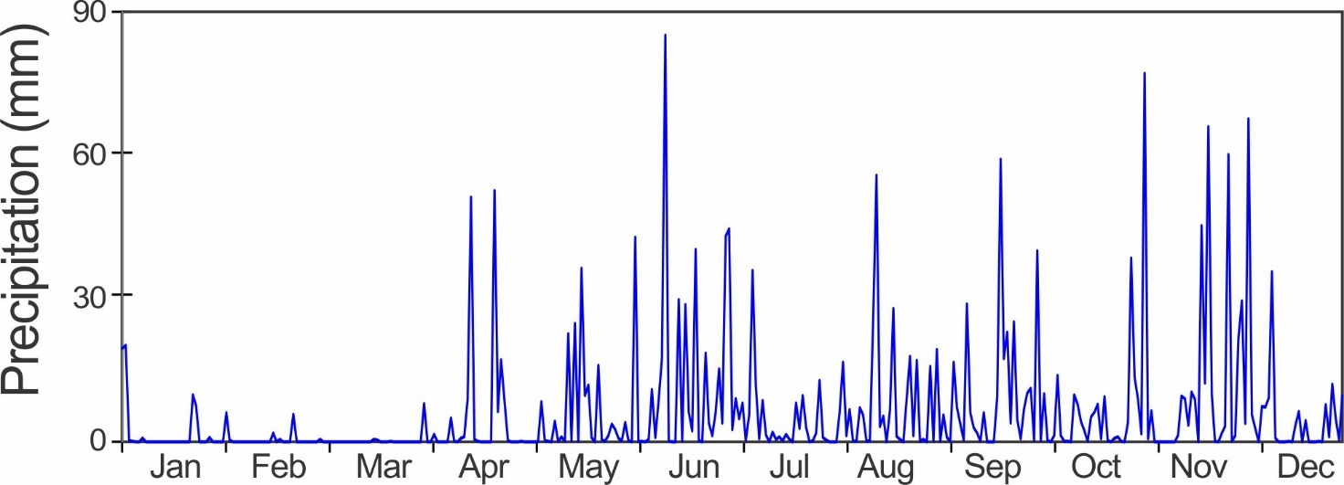
Monthly Rainfall (mm)

Year | Jan | Feb | Mar | Apr | May | June | July | Aug | Sep | Oct | Nov | Dec | Total
2009 | 42.1 | 38.6 | 37.6 | 48.4 | 138.8 | 377.9 | 285.9 | 349.0 | 100.0 | 305.0 | 449.0 | 117.0 | 2289.3
2010 | 0.0 | 42.0 | 8.0 | 122.0 | 121.0 | 298.0 | 400.0 | 351.0 | 146.0 | 372.0 | 586.0 | 1083.2 | 3529.2
2011 | 122.0 | 100.0 | 36.0 | 126.0 | 242.0 | 168.0 | 496.0 | 187.0 | 259.0 | 388.0 | 828.0 | 446.0 | 3398.0
2012 | 5.0 | 14.0 | 51.0 | 170.0 | 310.0 | 226.0 | 349.0 | 389.0 | 158.7 | 231.0 | 519.0 | 352.0 | 2774.7
2013 | 5.0 | 34.0 | 59.0 | 142.0 | 357.0 | 289.0 | 272.0 | 280.0 | 241.0 | 283.0 | 231.0 | 152.0 | 2345.0
2014 | 19.0 | 1.0 | 48.0 | 86.0 | 311.0 | 215.0 | 151.0 | 270.0 | 216.0 | 295.0 | 503.0 | 220.0 | 2335.0
2015 | 35.7 | 15.7 | 18.5 | 62.7 | 136.7 | 151.5 | 151.0 | 123.1 | 263.2 | 275.9 | 170.8 | 96.6 | 1501.1
2016 | 6.7 | 21.8 | 3.9 | 139.1 | 343.9 | 270.7 | 231.2 | 241.2 | 289.2 | 463.8 | 919.7 | 159.7 | 3090.7
2017 | 21.2 | 4.3 | 22.7 | 111.5 | 335.9 | 257.5 | 351.0 | 233.3 | 192.9 | 355.4 | 500.9 | 312.3 | 2698.8
2018 | 136.7 | 1.0 | 80.8 | 172.5 | 217.4 | 399.0 | 261.7 | 176.2 | 410.6 | 513.2 | 219.1 | 20.1 | 2608.2
2019 | 9.4 | 1.5 | 19.6 | 74.7 | 341.6 | 205.5 | 367.0 | 202.7 | 206.8 | 310.9 | 252.2 | 160.5 | 2152.4
2020 | 59.1 | 15.0 | 9.0 | 154.1 | 150.2 | 411.2 | 134.5 | 250.8 | 291.8 | 149.6 | 378.0 | 190.1 | 2193.4
Mean | 38.5 | 24.1 | 32.8 | 117.5 | 250.5 | 272.8 | 288.0 | 254.6 | 231.3 | 335.9 | 462.7 | 275.8 | 2584.5
sd | 46.0 | 28.0 | 23.5 | 41.4 | 93.6 | 86.6 | 111.2 | 78.8 | 81.5 | 100.4 | 236.6 | 280.1 | 564.5
Min | 119.7 | 116.3 | 71.6 | 35.2 | 37.4 | 31.7 | 38.6 | 30.9 | 35.3 | 29.9 | 51.1 | 101.6 | 21.8
Max | 0.0 | 1.0 | 3.9 | 48.4 | 121.0 | 151.5 | 134.5 | 123.1 | 100.0 | 149.6 | 170.8 | 20.1 | 1501.1
Rank* | 3 | 7 | 10 | 3 | 9 | 1 | 12 | 6 | 2 | 12 | 8 | 6 | 11
Data in Green are from the ACP Agua Salud station
Data in Purple estimated entirely or in part from STRI's BCI Clearing station
*Rank 1 = Wettest

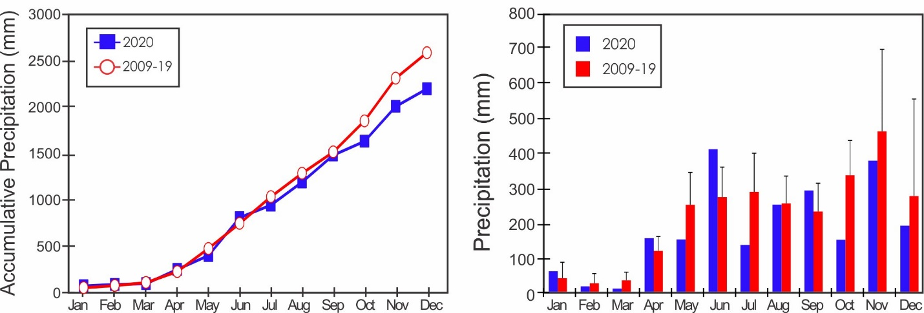

Yearly Rainfall (mm)

Year | Rain | Year | Rain
2009 | 2289.3 | 2015 | 1501.1
2010 | 3529.2 | 2016 | 3090.7
2011 | 3398.0 | 2017 | 2698.8
2012 | 2774.7 | 2018 | 2608.2
2013 | 2345.0 | 2019 | 2251.0
2014 | 2335.0 | 2020 | 2193.4

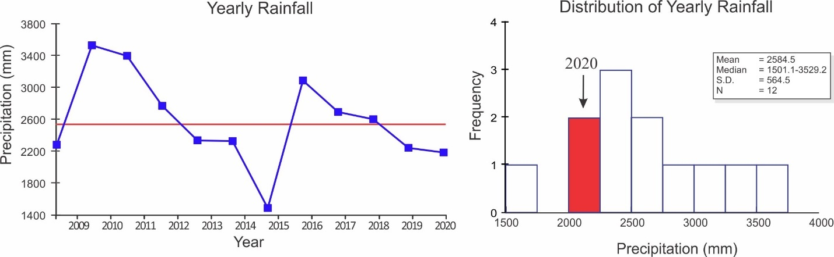

Storm Analysis

 |  | Max. Rainfall per Storm (mm) |  |  |  | Storm Duration (min.)
 | 2015-2019 |  |  | 2020 |  | 2015-2019 |  | 2020
 | Mean |  | S.D. |  |  | Mean | S.D.
January | 12.4 |  | 20.1 | 19.8 |  | 30.4 | 23.1 | 32.7
February | 6.2 |  | 4.9 | 5.1 |  | 59.3 | 16.8 | 36.1
March | 13.3 |  | 13.7 | 5.3 |  | 43.8 | 20.3 | 13.6
April | 42.0 |  | 12.7 | 51.8 |  | 48.9 | 13.1 | 43.6
May | 53.9 |  | 16.4 | 35.6 |  | 64.5 | 11.8 | 42.1
June | 49.9 |  | 12.7 | 84.1 |  | 64.8 | 10.2 | 64.3
July | 45.4 |  | 15.8 | 31.2 |  | 57.7 | 8.1 | 46.2
August | 31.0 |  | 14.8 | 54.4 |  | 56.2 | 8.4 | 43.5
September | 50.4 |  | 15.7 | 58.2 |  | 62.7 | 12.4 | 61.5
October | 68.1 |  | 16.2 | 25.1 |  | 66.1 | 11.5 | 35.7
November | 105.5 |  | 109.4 | 77.0 |  | 77.2 | 22.4 | 79.5
December | 40.3 |  | 26.1 | 66.3 |  | 54.5 | 11.7 | 32.6

 | Av. Rainfall per Storm (mm)
 | 2015-2019 |  | 2020
 | Mean | S.D.
January | 1.5 | 1.3 | 3.2
February | 1.5 | 0.7 | 1.7
March | 2.3 | 1.4 | 1.8
April | 6.0 | 1.4 | 6.4
May | 5.8 | 1.5 | 4.1
June | 7.9 | 2.8 | 7.7
July | 4.5 | 1.0 | 2.3
August | 3.9 | 0.8 | 4.1
September | 5.4 | 1.3 | 6.2
October | 8.2 | 2.1 | 3.2
November | 7.1 | 3.2 | 8.0
December | 4.7 | 2.1 | 3.1

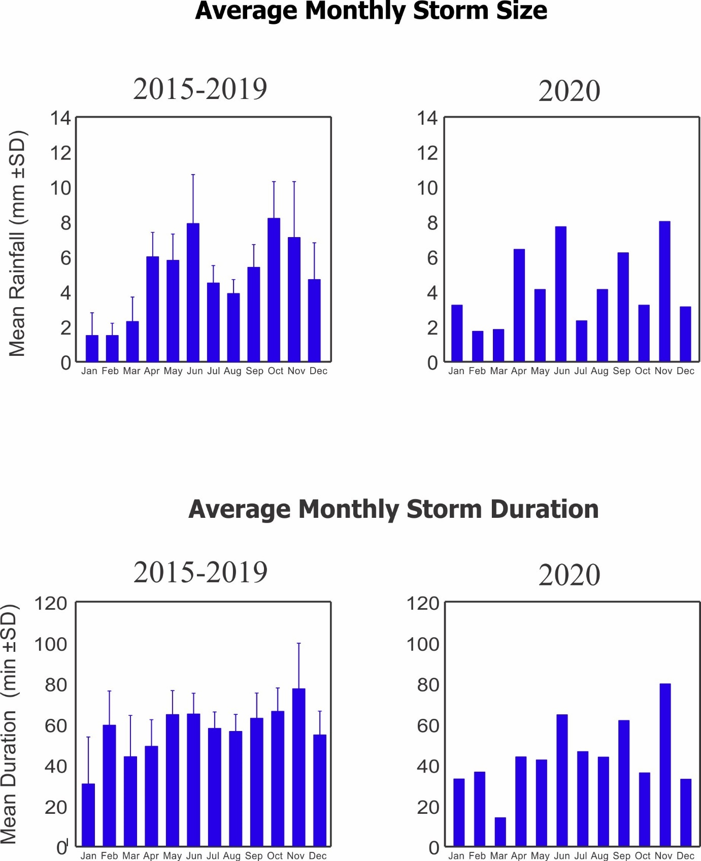
Relative Humidity (%)

Year | Jan | Feb | Mar | Apr | May | June | July | Aug | Sep | Oct | Nov | Dec
2015 |  | 82.9 | 81.1 | 84.1 | 89.2 | 88.1 | 92.5 | 93.0 | 94.0 | 92.4 | 92.4 | 89.7
2016 | 82.9 | 82.4 | 84.3 | 86.0 | 91.9 | 90.6 | 94.7 | 93.8 | 93.2 | 93.3 | 95.3 | 89.9
2017 | 82.8 | 82.2 | 82.9 | 86.9 | 93.8 | 93.7 | 96.6 | 94.8 | 93.6 | 94.1 | 96.6 | 93.0
2018 | 94.0 | 84.0 | 87.2 | 89.2 | 94.4 | 90.8 | 87.9 | 95.9 | 96.4 | 94.1 | 96.2 | 89.8
2019 | 88.7 | 88.4 | 86.1 | 86.5 | 92.6 | 93.9 | 95.6 | 95.3 | 96.3 | 95.3 | 95.7 | 95.1
2020 | 90.1 | 89.0 | 83.6 | 89.8 | 92.8 | 95.4 | 95.4 | 95.4 | 94.4 | 94.1 | 95.0 | 91.7
mean | 87.7 | 85.2 | 84.2 | 87.1 | 92.4 | 92.1 | 93.8 | 94.7 | 94.7 | 93.9 | 95.2 | 91.5
sd | 4.8 | 3.2 | 2.2 | 2.1 | 1.8 | 2.7 | 3.2 | 1.1 | 1.4 | 0.9 | 1.5 | 2.2
min | 5.5 | 3.8 | 2.6 | 2.4 | 2.0 | 2.9 | 3.4 | 1.2 | 1.5 | 1.0 | 1.5 | 2.4
max | 82.8 | 82.2 | 81.1 | 84.1 | 89.2 | 88.1 | 87.9 | 93.0 | 93.2 | 92.4 | 92.4 | 89.7

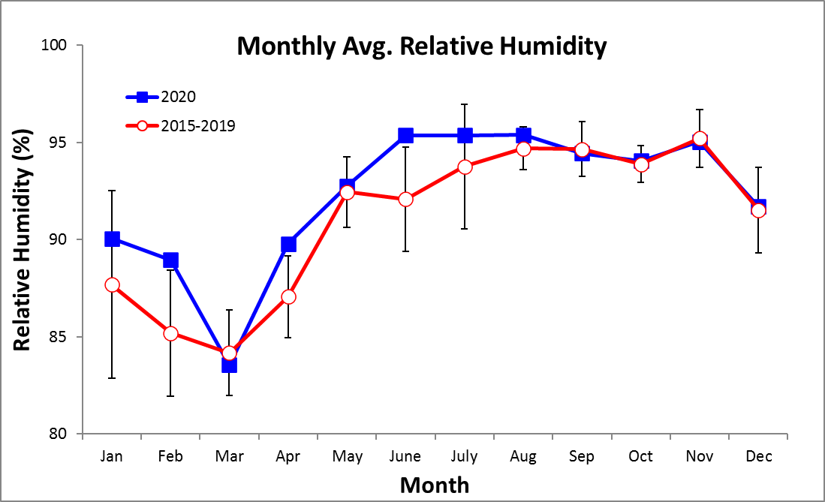
Monthly Average of Daily Maximum & Minimum Temperatures (°C)
Monthly Average Temperature
Year | Jan | Feb | Mar | Apr | May | June | July | Aug | Sep | Oct | Nov | Dec
2015 |  | 24.3 | 24.2 | 25.1 | 24.9 | 25.4 | 24.5 | 24.6 | 24.7 | 24.6 | 24.3 | 24.9
2016 | 24.2 | 24.1 | 24.3 | 24.9 | 24.9 | 24.4 | 23.9 | 24.3 | 23.8 | 23.6 | 22.9 | 23.6
2017 | 24.2 | 24.5 | 24.8 | 25.5 | 25.0 | 24.8 | 24.5 | 24.8 | 24.9 | 24.8 | 23.8 | 24.0
2018 | 23.7 | 24.2 | 24.2 | 24.7 | 24.6 | 24.3 | 25.0 | 24.9 | 24.5 | 24.5 | 24.5 | 24.8
2019 | 24.1 | 24.3 | 24.6 | 25.9 | 25.8 | 25.9 | 25.1 | 25.3 | 25.0 | 24.7 | 24.9 | 25.1
2020 | 24.9 | 25.0 | 25.3 | 25.8 | 26.1 | 25.4 | 25.2 | 25.2 | 25.2 | 24.5 | 23.7 | 24.1
mean | 24.2 | 24.4 | 24.6 | 25.3 | 25.2 | 25.1 | 24.7 | 24.8 | 24.7 | 24.5 | 24.0 | 24.4
sd | 0.4 | 0.3 | 0.4 | 0.5 | 0.6 | 0.6 | 0.5 | 0.4 | 0.5 | 0.4 | 0.7 | 0.6
min | 23.7 | 24.1 | 24.2 | 24.7 | 24.6 | 24.3 | 23.9 | 24.3 | 23.8 | 23.6 | 22.9 | 23.6
max | 24.9 | 25.0 | 25.3 | 25.9 | 26.1 | 25.9 | 25.2 | 25.3 | 25.2 | 24.8 | 24.9 | 25.1

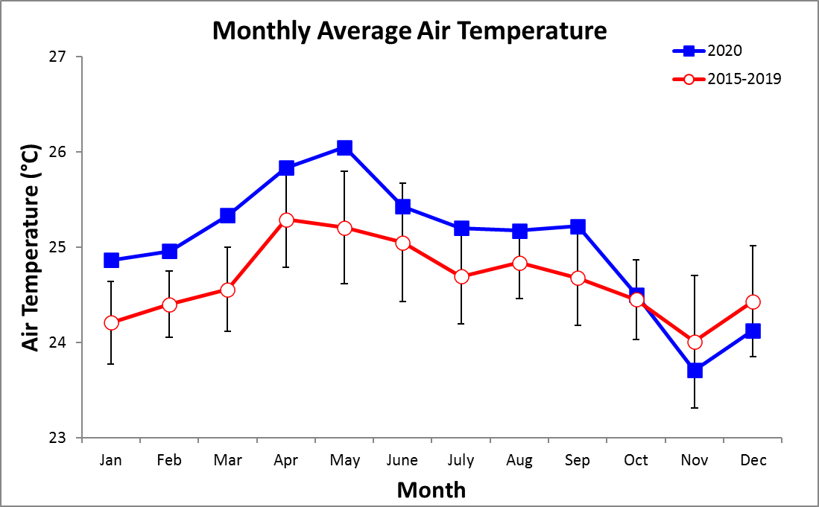
Monthly Average of Daily Maximum Temperature

Year | Jan | Feb | Mar | Apr | May | June | July | Aug | Sep | Oct | Nov | Dec
2015 |  | 28.2 | 28.8 | 30.3 | 28.8 | 30.0 | 28.0 | 28.3 | 29.0 | 29.0 | 28.2 | 28.6
2016 | 28.5 | 28.4 | 29.1 | 29.9 | 29.5 | 28.9 | 27.6 | 27.9 | 27.7 | 27.9 | 26.1 | 27.0
2017 | 28.7 | 29.2 | 29.6 | 30.7 | 30.0 | 29.4 | 28.8 | 29.2 | 29.6 | 29.3 | 28.0 | 28.0
2018 | 27.2 | 29.3 | 28.6 | 29.4 | 29.2 | 28.4 | 29.3 | 29.3 | 29.0 | 29.2 | 28.3 | 29.0
2019 | 28.1 | 28.8 | 29.5 | 31.1 | 31.0 | 30.7 | 29.6 | 29.7 | 29.5 | 29.6 | 29.1 | 29.0
2020 | 28.9 | 29.3 | 30.6 | 31.0 | 30.7 | 30.3 | 29.6 | 29.6 | 30.1 | 29.0 | 27.8 | 27.8
mean | 28.3 | 29.0 | 29.4 | 30.4 | 29.9 | 29.6 | 28.8 | 29.0 | 29.1 | 29.0 | 27.9 | 28.2
sd | 0.6 | 0.4 | 0.7 | 0.7 | 0.9 | 0.9 | 0.9 | 0.7 | 0.8 | 0.6 | 1.0 | 0.8
min | 27.2 | 28.4 | 28.6 | 29.4 | 28.8 | 28.4 | 27.6 | 27.9 | 27.7 | 27.9 | 26.1 | 27.0
max | 28.9 | 29.3 | 30.6 | 31.1 | 31.0 | 30.7 | 29.6 | 29.7 | 30.1 | 29.6 | 29.1 | 29.0

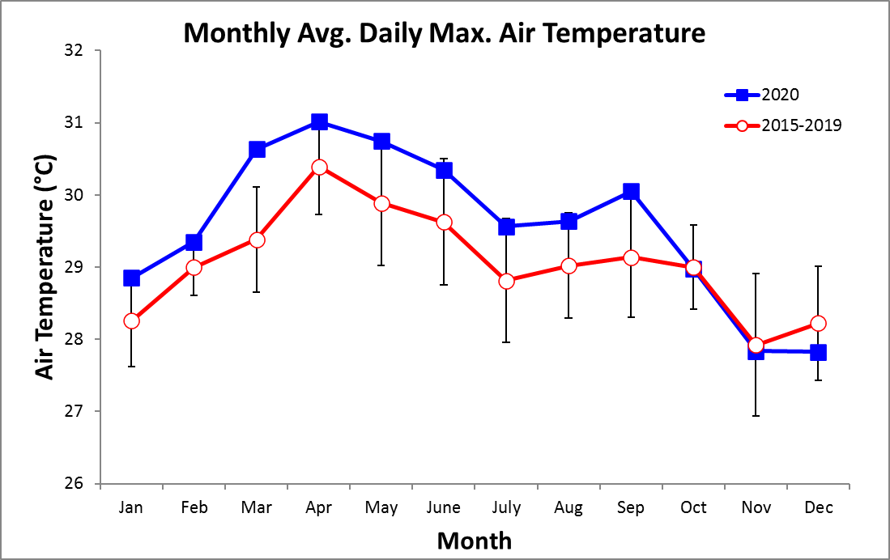
Monthly Average of Daily Minimum Temperature

Year | Jan | Feb | Mar | Apr | May | June | July | Aug | Sep | Oct | Nov | Dec
2015 |  | 22.2 | 21.8 | 22.7 | 22.9 | 23.1 | 22.7 | 22.7 | 22.4 | 22.4 | 22.4 | 23.1
2016 | 22.2 | 21.9 | 21.9 | 22.5 | 22.7 | 22.1 | 22.0 | 22.3 | 21.7 | 21.7 | 21.2 | 21.8
2017 | 21.8 | 22.0 | 22.3 | 22.8 | 22.7 | 22.8 | 22.6 | 22.6 | 22.7 | 22.6 | 22.1 | 22.2
2018 | 21.8 | 21.7 | 22.0 | 22.4 | 22.6 | 22.4 | 23.1 | 22.8 | 22.6 | 22.4 | 22.8 | 22.8
2019 | 22.3 | 22.3 | 22.3 | 23.3 | 23.7 | 23.8 | 23.0 | 23.1 | 22.9 | 22.5 | 22.9 | 23.1
2020 | 22.9 | 22.9 | 22.7 | 23.6 | 23.6 | 23.2 | 23.2 | 23.1 | 23.1 | 22.4 | 22.0 | 22.3
mean | 22.2 | 22.2 | 22.2 | 22.9 | 23.0 | 22.9 | 22.8 | 22.8 | 22.6 | 22.3 | 22.2 | 22.6
sd | 0.4 | 0.5 | 0.3 | 0.5 | 0.5 | 0.6 | 0.4 | 0.3 | 0.5 | 0.3 | 0.6 | 0.5
min | 21.8 | 21.7 | 21.8 | 22.4 | 22.6 | 22.1 | 22.0 | 22.3 | 21.7 | 21.7 | 21.2 | 21.8
max | 22.9 | 22.9 | 22.7 | 23.6 | 23.7 | 23.8 | 23.2 | 23.1 | 23.1 | 22.6 | 22.9 | 23.1

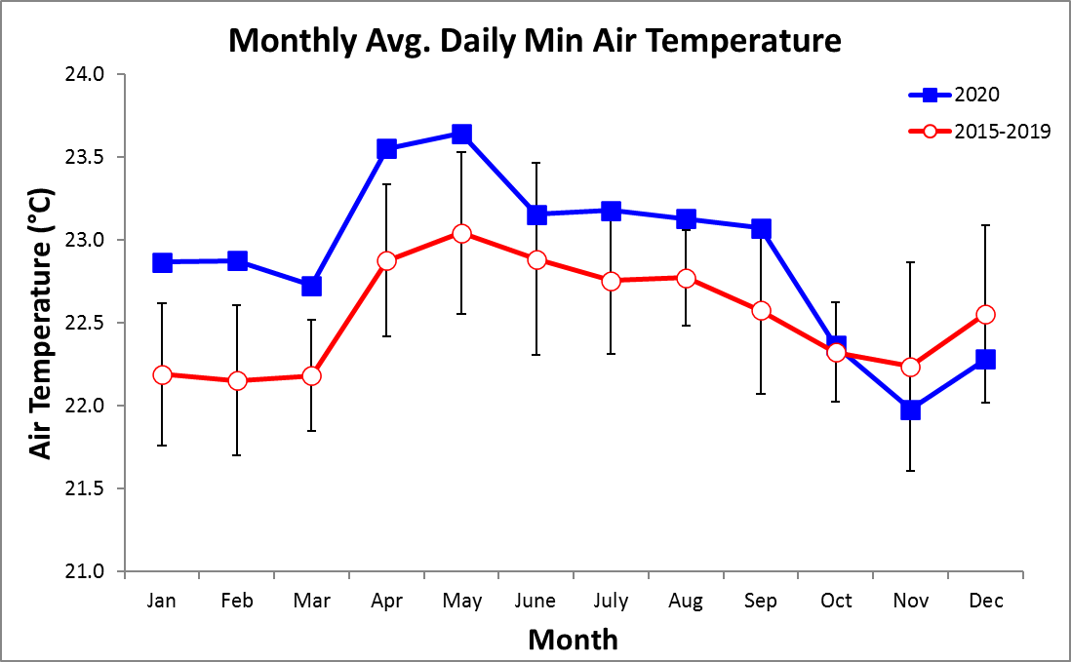
2020 Daily Total Radiation (MJ m⁻² day⁻¹)

 | Jan. | Feb. | Mar. | Apr. | May | June | July | Aug. | Sep. | Oct. | Nov. | Dec.
1 | 7.1 | 14.9 | 22.4 | 17.6 | 16.3 | 12.4 | 12.3 | 17.9 | 14.1 | 19.9 | 12.5 | 4.4
2 | 12.9 | 18.9 | 18.8 | 24.1 | 16.1 | 6.7 | 9.4 | 15.0 | 15.0 | 12.1 | 13.8 | 9.8
3 | 20.3 | 14.6 | 14.1 | 13.3 | 16.9 | 20.8 | 10.9 | 10.9 | 21.9 | 13.6 | 9.8 | 11.8
4 | 21.2 | 20.5 | 19.0 | 19.5 | 14.9 | 20.7 | 3.1 | 15.1 | 21.6 | 14.0 | 10.2 | 21.4
5 | 17.1 | 12.5 | 15.6 | 17.2 | 11.4 | 10.2 | 16.6 | 10.0 | 19.1 | 16.1 | 19.2 | 12.2
6 | 18.7 | 24.0 | 23.3 | 17.4 | 16.4 | 11.4 | 12.8 | 6.9 | 9.4 | 11.0 | 20.3 | 14.6
7 | 17.1 | 24.4 | 21.6 | 12.3 | 11.2 | 14.9 | 9.8 | 16.9 | 5.8 | 22.0 | 23.8 | 17.4
8 | 20.8 | 23.1 | 19.2 | 10.4 | 12.8 | 12.3 | 8.4 | 14.0 | 16.9 | 6.0 | 19.8 | 15.2
9 | 22.9 | 19.0 | 25.2 | 16.6 | 11.1 | 11.1 | 16.7 | 4.3 | 15.6 | 19.7 | 22.2 | 12.9
10 | 21.5 | 20.4 | 24.3 | 14.0 | 15.0 | 5.2 | 12.3 | 9.1 | 16.8 | 17.6 | 19.7 | 14.7
11 | 17.9 | 18.5 | 23.2 | 13.7 | 16.2 | 13.1 | 9.0 | 12.5 | 12.7 | 13.5 | 9.1 | 21.5
12 | 19.4 | 22.4 | 24.8 | 11.7 | 24.7 | 19.1 | 14.7 | 6.6 | 13.2 | 11.7 | 7.7 | 20.2
13 | 18.9 | 20.0 | 25.8 | 8.5 | 13.9 | 17.7 | 5.7 | 12.1 | 15.4 | 10.0 | 9.5 | 18.1
14 | 18.9 | 21.6 | 21.4 | 12.9 | 18.2 | 16.6 | 9.9 | 14.8 | 15.1 | 9.9 | 9.5 | 21.1
15 | 18.2 | 19.5 | 20.7 | 19.1 | 7.9 | 6.6 | 17.1 | 4.8 | 9.5 | 21.3 | 1.8 | 15.6
16 | 20.9 | 16.2 | 22.3 | 18.5 | 21.4 | 16.0 | 13.9 | 11.8 | 15.1 | 17.3 | 12.2 | 12.5
17 | 12.3 | 13.6 | 18.9 | 23.2 | 5.6 | 10.4 | 19.2 | 14.9 | 17.5 | 9.3 | 8.5 | 12.6
18 | 9.4 | 12.0 | 22.7 | 18.5 | 10.8 | 7.7 | 14.9 | 7.2 | 15.9 | 3.7 | 14.5 | 21.3
19 | 14.9 | 18.6 | 17.0 | 19.4 | 5.2 | 6.6 | 12.7 | 4.9 | 15.1 | 15.3 | 10.8 | 11.2
20 | 16.6 | 18.3 | 16.8 | 25.3 | 16.8 | 11.4 | 12.6 | 8.7 | 16.1 | 13.7 | 10.9 | 18.7
21 | 18.4 | 17.0 | 19.1 | 18.8 | 20.2 | 9.1 | 9.3 | 21.5 | 13.6 | 19.4 | 10.5 | 13.8
22 | 8.0 | 23.4 | 25.7 | 18.9 | 9.7 | 15.7 | 7.6 | 9.7 | 8.7 | 12.7 | 14.3 | 18.8
23 | 7.3 | 24.1 | 21.8 | 13.3 | 18.4 | 7.5 | 13.5 | 13.2 | 17.1 | 11.5 | 18.2 | 15.6
24 | 16.9 | 17.4 | 19.6 | 12.2 | 18.9 | 13.4 | 7.0 | 14.6 | 7.6 | 13.7 | 11.6 | 19.5
25 | 21.8 | 23.7 | 19.8 | 25.6 | 18.3 | 21.0 | 13.4 | 10.0 | 8.1 | 20.1 | 9.1 | 7.6
26 | 24.5 | 23.0 | 23.9 | 18.3 | 15.6 | 5.1 | 12.6 | 25.3 | 16.0 | 21.3 | 5.4 | 20.7
27 | 14.8 | 17.3 | 23.9 | 11.3 | 5.4 | 6.1 | 15.8 | 17.2 | 9.7 | 13.4 | 16.5 | 14.4
28 | 19.9 | 22.2 | 25.3 | 15.0 | 8.0 | 8.2 | 20.9 | 10.7 | 11.0 | 13.0 | 10.6 | 11.5
29 | 17.2 | 20.7 | 22.2 | 19.0 | 14.7 | 12.3 | 13.8 | 14.1 | 7.1 | 14.9 | 11.7 | 15.8
30 | 21.8 |  | 21.3 | 22.7 | 16.0 | 8.1 | 20.9 | 14.0 | 2.8 | 20.9 | 12.4 | 15.9
31 | 19.3 |  | 13.7 |  | 19.9 |  | 20.2 | 15.4 |  | 14.6 |  | 14.6
 | 7.1 | 14.9 | 22.4 | 17.6 | 16.3 | 12.4 | 12.3 | 17.9 | 14.1 | 19.9 | 12.5 | 4.4
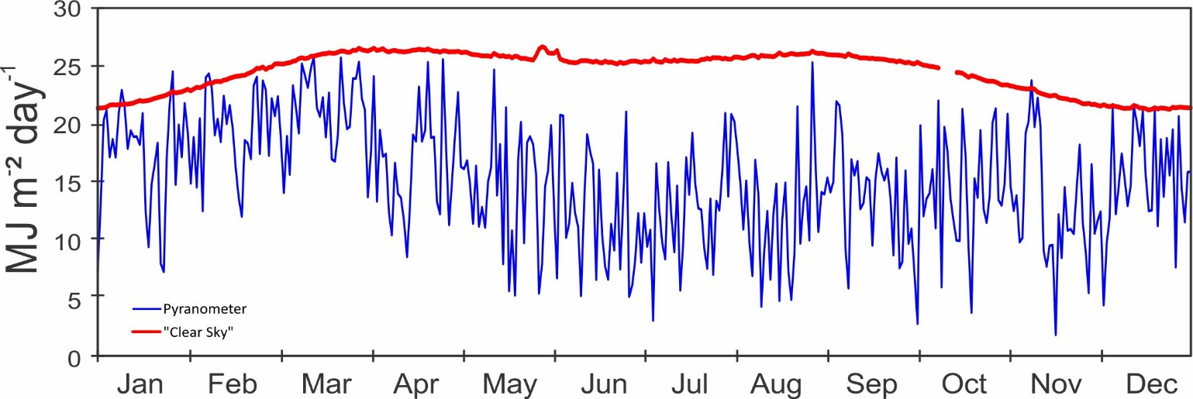
2020 Daily PAR (Mol m⁻² day⁻¹)

 | Jan. | Feb. | Mar. | Apr. | May | June | July | Aug. | Sep. | Oct. | Nov. | Dec.
1 | 14.9 | 30.3 | 44.7 | 36.7 | 34.8 | 28.1 | 27.1 | 37.4 | 29.1 | 43.6 | 27.9 | 10.4
2 | 25.5 | 38.7 | 37.7 | 50.0 | 34.4 | 15.5 | 21.1 | 32.1 | 30.8 | 27.1 | 31.0 | 21.7
3 | 39.3 | 29.7 | 28.0 | 28.5 | 35.9 | 45.7 | 23.9 | 23.7 | 44.0 | 30.9 | 21.9 | 26.5
4 | 40.6 | 41.2 | 37.6 | 40.6 | 32.5 | 45.4 | 7.4 | 32.2 | 43.5 | 31.4 | 22.4 | 47.0
5 | 32.8 | 25.2 | 31.1 | 35.6 | 25.4 | 23.2 | 36.4 | 21.7 | 38.1 | 35.8 | 41.9 | 26.9
6 | 36.3 | 48.2 | 46.3 | 36.6 | 35.7 | 25.5 | 27.2 | 15.5 | 19.3 | 25.1 | 44.2 | 32.3
7 | 33.3 | 49.3 | 43.0 | 26.1 | 25.0 | 33.0 | 21.6 | 35.2 | 12.5 | 48.6 | 52.1 | 38.2
8 | 40.8 | 46.6 | 38.3 | 22.2 | 27.9 | 27.5 | 18.7 | 29.5 | 34.5 | 13.8 | 43.4 | 33.6
9 | 45.1 | 38.0 | 50.5 | 35.2 | 24.1 | 25.2 | 35.7 | 9.5 | 31.9 | 43.8 | 49.2 | 28.6
10 | 42.1 | 40.9 | 48.7 | 29.5 | 32.8 | 12.3 | 26.4 | 19.5 | 33.9 | 38.7 | 43.5 | 32.4
11 | 35.4 | 36.9 | 46.4 | 28.9 | 34.5 | 29.0 | 20.2 | 27.1 | 26.0 | 30.8 | 20.6 | 46.9
12 | 38.2 | 44.9 | 50.3 | 25.3 | 51.4 | 41.8 | 31.7 | 14.9 | 26.9 | 26.3 | 17.8 | 44.3
13 | 37.2 | 39.9 | 52.7 | 19.3 | 29.7 | 38.9 | 12.7 | 25.7 | 31.4 | 22.5 | 21.5 | 39.5
14 | 37.5 | 43.4 | 43.7 | 28.5 | 39.8 | 36.4 | 21.8 | 31.1 | 30.6 | 22.5 | 21.6 | 45.8
15 | 36.2 | 39.4 | 42.2 | 40.4 | 17.7 | 15.3 | 35.2 | 10.6 | 19.6 | 47.2 | 4.6 | 33.8
16 | 42.0 | 32.6 | 45.7 | 39.0 | 45.4 | 36.5 | 29.0 | 24.9 | 30.1 | 38.3 | 27.3 | 27.3
17 | 24.6 | 27.3 | 38.6 | 48.1 | 12.9 | 23.6 | 40.7 | 30.8 | 34.8 | 20.9 | 19.1 | 27.9
18 | 19.0 | 24.1 | 46.3 | 38.4 | 24.2 | 17.3 | 32.0 | 15.4 | 32.4 | 8.8 | 32.5 | 46.7
19 | 29.9 | 37.2 | 34.6 | 40.1 | 12.1 | 15.0 | 27.2 | 10.7 | 30.7 | 34.3 | 24.2 | 24.7
20 | 33.8 | 36.8 | 34.3 | 52.4 | 36.8 | 25.7 | 27.5 | 18.9 | 33.2 | 30.4 | 24.4 | 40.9
21 | 37.5 | 34.1 | 39.7 | 39.6 | 42.6 | 20.5 | 20.6 | 43.9 | 27.7 | 43.4 | 23.8 | 30.4
22 | 16.9 | 47.0 | 52.9 | 40.3 | 21.5 | 34.4 | 16.4 | 20.2 | 17.5 | 28.1 | 31.8 | 41.5
23 | 15.5 | 48.3 | 44.9 | 28.9 | 40.0 | 17.4 | 29.0 | 27.7 | 33.7 | 25.7 | 40.5 | 34.6
24 | 34.4 | 34.7 | 40.0 | 27.0 | 41.1 | 29.5 | 15.7 | 30.2 | 15.6 | 30.2 | 25.7 | 42.3
25 | 43.9 | 48.0 | 40.5 | 53.5 | 40.0 | 45.3 | 29.1 | 21.3 | 16.8 | 44.4 | 20.5 | 16.9
26 | 49.6 | 46.6 | 49.0 | 39.3 | 34.3 | 12.2 | 26.9 | 51.2 | 32.0 | 47.6 | 12.5 | 44.7
27 | 30.0 | 34.8 | 49.3 | 25.0 | 12.9 | 14.4 | 33.6 | 34.9 | 19.8 | 30.1 | 36.7 | 31.9
28 | 40.8 | 44.7 | 52.3 | 31.9 | 18.6 | 18.9 | 43.5 | 22.3 | 22.3 | 29.1 | 23.6 | 25.7
29 | 35.1 | 41.4 | 45.7 | 40.6 | 32.8 | 27.3 | 28.7 | 29.4 | 14.9 | 32.9 | 25.9 | 34.4
30 | 43.7 |  | 43.5 | 47.8 | 35.6 | 17.8 | 42.9 | 29.1 | 6.9 | 46.3 | 27.6 | 34.7
31 | 39.3 |  | 28.7 |  | 43.0 |  | 41.8 | 32.1 |  | 32.5 |  | 32.0
 | 14.9 | 30.3 | 44.7 | 36.7 | 34.8 | 28.1 | 27.1 | 37.4 | 29.1 | 43.6 | 27.9 | 10.4
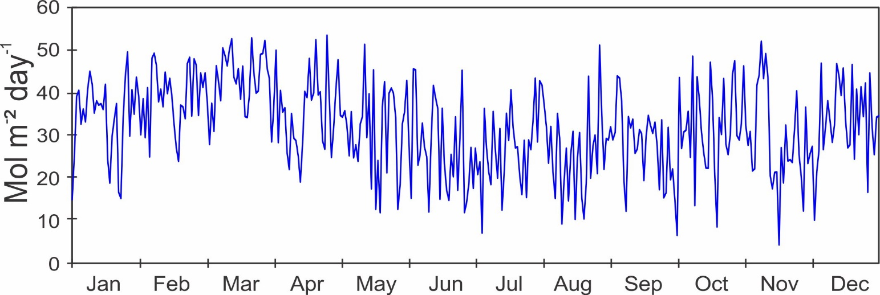

Monthly Average Total Daily Solar Radiation (MJ m⁻² day⁻¹)

Year | Jan | Feb | Mar | Apr | May | June | July | Aug | Sep | Oct | Nov | Dec
2015 |  | 18.6 | 18.9 | 16.7 | 13.2 | 15.4 | 13.1 | 13.0 | 12.2 | 12.5 | 12.4 | 14.6
2016 | 17.3 | 16.6 | 17.2 | 17.0 | 13.2 | 12.1 | 10.0 | 11.7 | 11.1 | 11.2 | 9.5 | 13.1
2017 | 17.6 | 18.5 | 18.2 | 16.6 | 12.5 | 11.7 | 11.5 | 14.3 | 15.2 | 14.4 | 12.8 | 15.2
2018 | 15.6 | 21.3 | 19.6 | 18.2 | 14.5 | 10.7 | 12.7 | 13.3 | 12.9 | 14.6 | 12.0 | 17.5
2019 | 18.4 | 18.8 | 19.7 | 19.2 | 14.2 | 13.1 | 12.8 | 12.5 | 12.5 | 12.9 | 12.9 | 13.0
2020 | 17.3 | 19.4 | 21.1 | 16.9 | 14.4 | 11.9 | 12.8 | 12.4 | 13.4 | 14.6 | 12.9 | 15.3
mean | 17.2 | 18.9 | 19.1 | 17.3 | 13.5 | 12.8 | 12.1 | 12.9 | 12.9 | 13.4 | 12.1 | 14.8
sd | 1.0 | 1.5 | 1.4 | 1.1 | 0.8 | 1.5 | 1.2 | 0.9 | 1.4 | 1.4 | 1.3 | 1.7
min | 15.6 | 16.6 | 17.2 | 16.6 | 12.5 | 11.7 | 10.0 | 11.7 | 11.1 | 11.2 | 9.5 | 13.0
max | 18.4 | 21.3 | 21.1 | 19.2 | 14.4 | 15.4 | 13.1 | 14.3 | 15.2 | 14.6 | 12.9 | 17.5

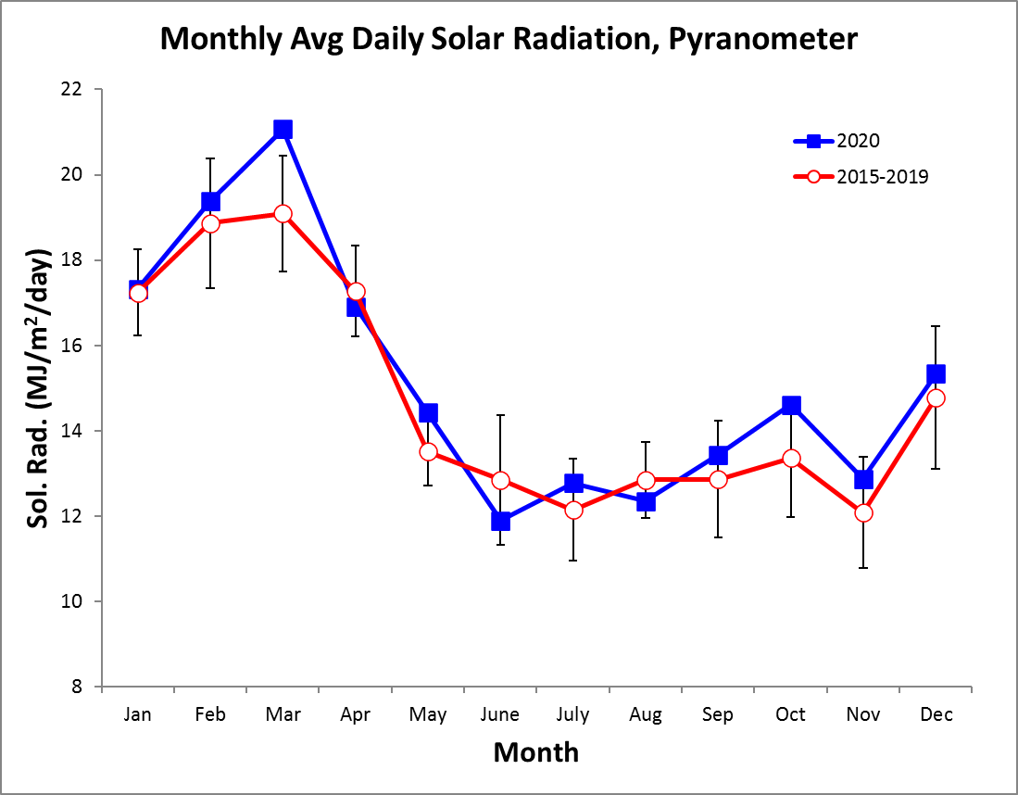
Monthly Average Daily PAR (Mols m⁻² day⁻¹)

Year | Jan | Feb | Mar | Apr | May | June | July | Aug | Sep | Oct | Nov | Dec
2015 |  | 31.4 | 41.9 | 37.5 | 30.0 | 34.6 | 29.1 | 29.3 | 27.7 | 28.6 | 27.6 | 33.6
2016 | 40.1 | 38.5 | 37.9 | 36.5 | 29.1 | 27.1 | 22.4 | 25.6 | 23.8 | 24.4 | 21.0 | 29.0
2017 | 39.4 | 48.3 | 49.6 | 44.4 | 34.5 | 32.5 | 27.6 | 34.5 | 36.8 | 33.5 | 29.0 | 34.0
2018 | 35.3 | 46.8 | 45.6 | 44.3 | 37.3 | 27.5 | 26.6 | 27.5 | 26.5 | 29.8 | 25.0 | 36.2
2019 | 37.6 | 38.3 | 39.8 | 38.6 | 29.2 | 26.7 | 25.7 | 24.9 | 24.0 | 24.5 | 23.8 | 23.7
2020 | 34.6 | 39.0 | 42.8 | 35.7 | 31.5 | 26.6 | 27.5 | 26.1 | 27.4 | 32.6 | 28.7 | 33.7
mean | 38.2 | 43.0 | 43.6 | 40.2 | 32.5 | 29.4 | 27.3 | 28.8 | 28.6 | 29.9 | 26.7 | 32.8
sd | 3.1 | 4.5 | 3.9 | 4.1 | 3.0 | 3.5 | 2.5 | 3.3 | 4.4 | 3.7 | 2.9 | 4.8
min | 34.6 | 38.5 | 37.9 | 35.7 | 29.1 | 26.1 | 22.4 | 25.6 | 23.8 | 24.4 | 21.0 | 26.3
max | 41.7 | 48.3 | 49.6 | 44.4 | 37.3 | 34.6 | 29.1 | 34.5 | 36.8 | 33.5 | 29.0 | 40.1

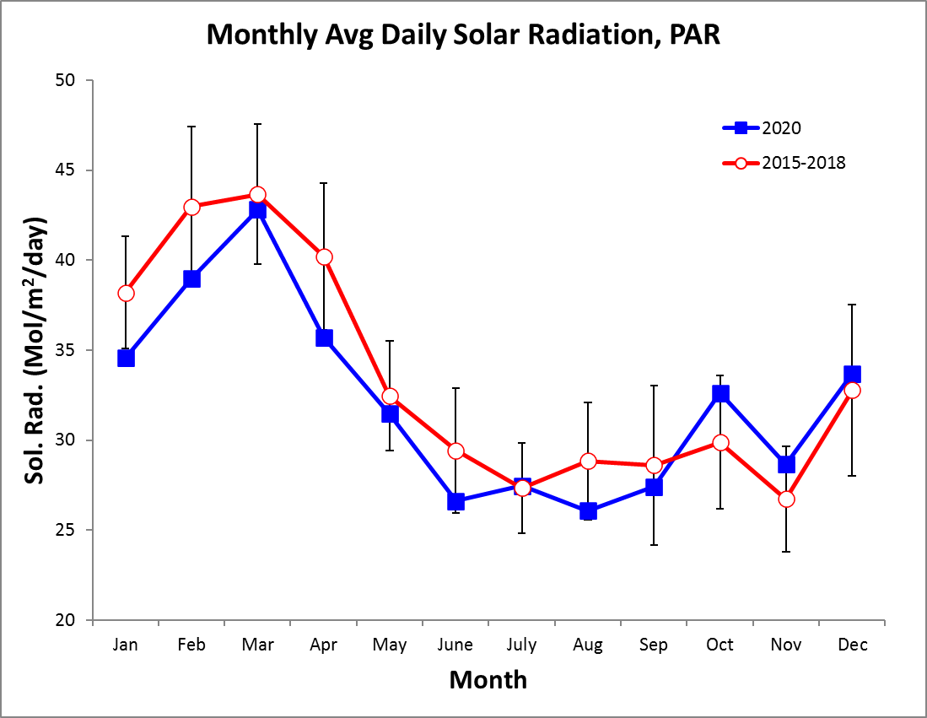

2020 Daily Average Wind Speed (m/s)
 | Jan. |  | Feb. |  |  | Mar. |  |  | Apr. |  |  | May |  |  | June |  | July |  | Aug. |  | Sep. |  | Oct. |  | Nov. |  |  | Dec.
 | Avg | Max | Avg | Max | Avg |  | Max | Avg |  | Max | Avg |  | Max | Avg |  | Max | Avg | Max | Avg | Max | Avg | Max | Avg | Max | Avg | Max | Avg |  |  | Max
1 | 2.9 | 8.3 | 4.3 | 10.7 | 5.2 |  | 11.5 | 2.8 |  | 8.3 | 2.7 |  | 6.9 | 1.9 |  | 5.6 | 2.3 | 6.3 |  |  |  |  | 1.7 | 4.7 | 2.8 | 8.4 | 2.5 |  | 7.8
2 | 2.7 | 10.2 | 4.4 | 9.9 | 4.1 |  | 9.8 | 3.2 |  | 8.7 | 3.5 |  | 9.1 | 2.6 |  | 9.0 | 2.7 | 8.7 |  |  | 0.7 | 6.2 | 1.8 | 8.0 | 4.8 | 11.0 | 1.7 |  | 8.6
3 | 3.0 | 8.6 | 4.0 | 10.7 | 4.3 |  | 11.1 | 3.5 |  | 7.8 | 4.2 |  | 9.5 | 2.4 |  | 8.2 | 2.4 | 7.1 |  |  | 1.7 | 9.3 | 2.2 | 6.4 | 6.0 | 14.9 | 1.8 |  | 6.4
4 | 4.2 | 9.8 | 4.7 | 12.5 | 4.1 |  | 10.1 | 3.5 |  | 9.0 | 3.7 |  | 10.4 | 2.2 |  | 6.8 | 2.2 | 9.2 |  |  | 2.0 | 7.9 | 2.1 | 6.1 | 5.9 | 14.3 | 2.7 |  | 7.8
5 | 4.2 | 10.8 | 3.8 | 8.6 | 5.3 |  | 11.9 | 3.9 |  | 10.4 | 2.8 |  | 9.6 | 1.6 |  | 5.3 | 2.0 | 6.0 |  |  | 1.9 | 7.8 | 2.5 | 11.1 | 4.7 | 10.7 | 2.9 |  | 7.0
6 | 3.6 | 9.3 | 4.4 | 9.5 | 5.3 |  | 12.0 | 4.4 |  | 11.0 | 2.5 |  | 10.3 | 1.5 |  | 7.1 | 2.5 | 8.7 |  |  | 1.6 | 8.4 | 2.6 | 9.4 | 4.2 | 10.8 | 2.9 |  | 8.3
7 | 3.7 | 9.3 | 3.9 | 9.8 | 4.7 |  | 13.4 | 4.5 |  | 11.1 | 2.7 |  | 8.5 | 1.9 |  | 7.4 | 2.6 | 8.0 |  |  | 2.1 | 8.7 | 2.8 | 6.9 | 3.8 | 11.1 | 3.5 |  | 10.3
8 | 4.5 | 13.2 | 5.3 | 11.0 | 4.4 |  | 12.1 | 4.4 |  | 11.2 | 2.8 |  | 9.1 | 1.7 |  | 7.8 | 2.8 | 8.3 |  |  | 2.4 | 7.7 | 2.2 | 7.2 | 2.8 | 10.8 | 3.8 |  | 10.4
9 | 4.7 | 15.1 | 4.5 | 11.8 | 5.1 |  | 12.7 | 3.5 |  | 8.5 | 2.4 |  | 8.3 | 2.2 |  | 7.4 | 2.2 | 7.1 |  |  | 1.8 | 6.2 | 2.1 | 6.4 | 2.4 | 6.8 | 4.5 |  | 11.8
10 | 3.9 | 12.0 | 3.5 | 10.0 | 5.3 |  | 12.9 | 3.7 |  | 9.9 | 3.2 |  | 9.0 | 2.0 |  | 9.2 | 2.7 | 8.1 |  |  | 2.2 | 8.9 | 2.9 | 8.4 | 2.1 | 9.4 | 3.8 |  | 11.2
11 | 3.1 | 9.2 | 4.1 | 9.8 | 4.5 |  | 11.9 | 4.0 |  | 9.0 | 2.6 |  | 9.9 | 2.2 |  | 7.0 | 1.5 | 7.1 |  |  | 2.5 | 7.8 | 2.2 | 8.2 | 2.1 | 5.4 | 3.7 |  | 9.5
12 | 3.6 | 9.4 | 4.3 | 9.5 | 4.7 |  | 12.1 | 2.9 |  | 8.5 | 3.5 |  | 9.0 | 1.5 |  | 5.5 | 1.9 | 6.6 |  |  | 1.5 | 6.9 | 1.6 | 5.1 | 1.3 | 6.3 | 3.8 |  | 8.5
13 | 4.3 | 10.1 | 4.1 | 9.2 | 4.3 |  | 10.2 | 1.2 |  | 6.2 | 2.1 |  | 7.4 | 1.9 |  | 5.3 | 2.8 | 8.5 |  |  | 1.8 | 7.7 | 1.7 | 8.0 | 1.8 | 8.2 | 3.2 |  | 10.1
14 | 4.2 | 12.1 | 4.6 | 12.4 | 4.0 |  | 11.1 | 2.2 |  | 7.0 | 2.8 |  | 7.9 | 2.4 |  | 7.9 | 2.0 | 7.1 |  |  | 2.1 | 8.2 | 1.8 | 9.4 | 2.8 | 10.9 | 3.9 |  | 11.3
15 | 3.8 | 9.9 | 4.7 | 11.6 | 4.0 |  | 10.9 | 2.8 |  | 9.6 | 2.5 |  | 11.4 | 1.9 |  | 10.8 | 2.7 | 9.6 |  |  | 2.1 | 10.3 | 1.9 | 6.6 | 2.9 | 6.7 | 3.0 |  | 7.9
16 | 4.0 | 9.9 | 4.4 | 12.1 | 4.5 |  | 11.3 | 3.5 |  | 10.4 | 2.6 |  | 8.4 | 1.6 |  | 4.4 | 3.6 | 9.7 |  |  | 1.7 | 5.9 | 2.8 | 9.2 | 3.8 | 8.6 | 2.8 |  | 7.9
17 | 3.5 | 9.5 | 4.4 | 11.3 | 4.9 |  | 11.4 | 4.0 |  | 9.7 | 2.5 |  | 9.9 | 1.6 |  | 6.5 | 2.1 | 8.0 |  |  | 2.0 | 6.4 | 2.2 | 9.5 | 5.4 | 11.2 | 3.7 |  | 11.1
18 | 3.2 | 7.8 | 5.0 | 10.9 | 4.2 |  | 10.2 | 5.0 |  | 10.8 | 1.6 |  | 6.5 | 2.4 |  | 7.0 | 1.3 | 8.9 |  |  | 1.6 | 7.0 | 2.2 | 7.9 | 3.2 | 9.0 | 3.9 |  | 12.5
19 | 3.5 | 8.6 | 5.8 | 12.3 | 3.1 |  | 9.6 | 3.6 |  | 10.0 | 1.9 |  | 7.9 | 2.4 |  | 5.9 |  |  |  |  | 2.2 | 10.3 | 2.3 | 9.5 | 1.7 | 6.2 | 4.4 |  | 11.8
20 | 4.5 | 9.8 | 4.7 | 11.5 | 4.1 |  | 9.9 | 3.7 |  | 10.5 | 1.9 |  | 6.7 | 1.9 |  | 6.4 |  |  |  |  | 2.3 | 8.7 | 2.7 | 10.0 | 1.9 | 6.9 | 3.8 |  | 11.2
21 | 4.6 | 11.0 | 4.5 | 12.1 | 4.3 |  | 12.4 | 2.8 |  | 8.2 | 2.6 |  | 8.5 | 1.9 |  | 6.4 |  |  |  |  | 2.2 | 9.2 | 2.4 | 7.7 | 2.3 | 7.0 | 3.9 |  | 9.2
22 | 3.7 | 8.9 | 5.6 | 13.7 | 3.6 |  | 10.9 | 3.3 |  | 9.4 | 3.2 |  | 12.3 | 2.4 |  | 7.1 |  |  |  |  | 2.2 | 6.4 | 1.9 | 6.3 | 2.5 | 8.5 | 3.5 |  | 11.9
23 | 2.5 | 7.0 | 5.1 | 12.0 | 4.1 |  | 11.2 | 3.1 |  | 8.3 | 2.0 |  | 7.5 | 2.2 |  | 14.1 |  |  |  |  | 2.4 | 8.5 | 1.6 | 7.4 | 2.9 | 8.2 | 4.7 |  | 11.6
24 | 3.4 | 8.4 | 4.1 | 9.5 | 4.3 |  | 11.1 | 3.0 |  | 9.1 | 2.4 |  | 8.9 | 2.2 |  | 7.1 |  |  |  |  | 1.9 | 7.3 | 2.5 | 7.4 | 2.7 | 7.6 | 3.5 |  | 9.7
25 | 4.9 | 11.6 | 3.4 | 9.3 | 4.5 |  | 10.5 | 3.7 |  | 9.5 | 1.7 |  | 6.0 | 2.7 |  | 7.3 |  |  |  |  | 1.7 | 8.2 | 3.2 | 11.0 | 1.9 | 8.9 | 3.8 |  | 10.7
26 | 4.3 | 9.1 | 2.7 | 9.2 | 4.6 |  | 10.8 | 3.3 |  | 8.4 | 2.2 |  | 7.3 | 2.6 |  | 10.5 |  |  |  |  | 2.5 | 8.4 | 2.3 | 7.7 | 1.8 | 7.1 | 3.9 |  | 8.8
27 | 2.7 | 6.9 | 2.8 | 7.0 | 4.2 |  | 11.0 | 2.3 |  | 8.0 | 2.3 |  | 7.6 | 2.6 |  | 6.6 |  |  |  |  | 2.3 | 14.1 | 2.1 | 4.8 | 3.0 | 10.8 | 2.8 |  | 9.8
28 | 2.6 | 7.6 | 5.1 | 12.0 | 4.0 |  | 12.3 | 2.6 |  | 7.5 | 1.9 |  | 4.9 | 1.5 |  | 5.0 |  |  |  |  | 2.4 | 14.6 | 2.0 | 8.1 | 2.1 | 6.9 | 2.2 |  | 6.8
29 | 3.7 | 9.9 | 4.8 | 12.6 | 4.4 |  | 12.4 | 2.7 |  | 7.5 | 2.2 |  | 8.7 | 2.2 |  | 12.7 |  |  |  |  | 2.7 | 7.5 | 2.4 | 8.6 | 2.5 | 8.0 | 2.6 |  | 7.9
30 | 3.3 | 9.2 |  |  | 4.5 |  | 12.8 | 3.1 |  | 8.9 | 2.7 |  | 8.0 | 2.4 |  | 9.8 |  |  |  |  | 2.1 | 6.4 | 2.4 | 6.6 | 2.3 | 11.4 | 2.4 |  | 8.5
31 | 4.2 | 9.6 |  |  | 3.1 |  | 8.9 |  |  |  | 2.5 |  | 9.2 |  |  |  |  |  |  |  |  |  | 2.0 | 8.9 |  |  | 2.6 |  | 7.5
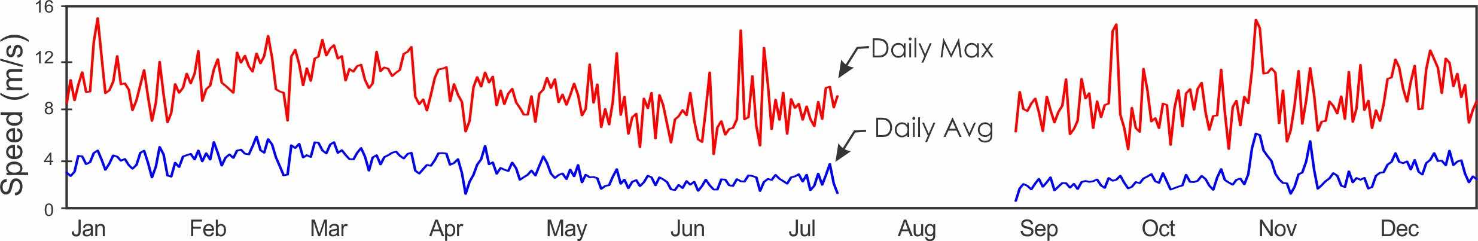
2020 Average Daily Wind Direction (°)

 |  | Jan. | Feb. | Mar. | Apr. | May | June | July | Aug. | Sep. | Oct. | Nov. | Dec.
 | 1 | 345.0 | 341.6 | 353.5 | 10.0 | 12.0 | 78.5 | 303.7 |  |  | 162.2 | 202.0 | 336.8
 | 2 | 343.1 | 21.6 | 7.3 | 19.0 | 6.1 | 316.3 | 303.2 |  | 3.0 | 121.1 | 183.8 | 255.0
 | 3 | 343.1 | 354.6 | 352.6 | 350.4 | 358.8 | 164.6 | 305.6 |  | 143.9 | 131.7 | 179.3 | 285.3
 | 4 | 349.1 | 356.1 | 355.2 | 25.6 | 354.2 | 155.1 | 216.7 |  | 136.6 | 148.8 | 171.9 | 1.8
 | 5 | 7.4 | 353.7 | 350.4 | 0.7 | 348.8 | 104.7 | 113.0 |  | 107.7 | 165.2 | 171.1 | 4.9
 | 6 | 7.0 | 349.2 | 358.5 | 358.2 | 326.1 | 329.8 | 353.1 |  | 315.7 | 144.1 | 170.9 | 338.8
 | 7 | 6.9 | 352.4 | 1.5 | 358.5 | 351.9 | 90.2 | 336.2 |  | 123.1 | 144.5 | 167.8 | 342.4
 | 8 | 31.2 | 354.5 | 15.7 | 354.2 | 353.6 | 24.4 | 293.2 |  | 145.2 | 130.1 | 146.1 | 356.5
 | 9 | 33.7 | 357.6 | 15.2 | 356.5 | 316.3 | 342.8 | 256.7 |  | 129.1 | 136.8 | 140.8 | 349.2
 | 10 | 22.1 | 355.0 | 356.3 | 351.3 | 343.0 | 177.8 | 340.4 |  | 3.6 | 12.9 | 136.6 | 18.2
 | 11 | 12.4 | 348.2 | 355.4 | 347.4 | 323.9 | 139.6 | 287.3 |  | 357.1 | 331.8 | 126.4 | 19.5
 | 12 | 357.5 | 355.1 | 357.6 | 20.0 | 352.9 | 207.2 | 346.6 |  | 126.2 | 244.8 | 233.9 | 11.9
 | 13 | 3.7 | 353.6 | 356.0 | 141.3 | 1.0 | 136.4 | 330.9 |  | 135.6 | 338.3 | 291.5 | 1.8
 | 14 | 25.1 | 356.5 | 10.7 | 133.7 | 349.0 | 37.9 | 356.4 |  | 98.9 | 253.1 | 255.3 | 341.7
 | 15 | 9.6 | 0.3 | 8.8 | 53.3 | 348.9 | 304.9 | 345.5 |  | 309.4 | 339.4 | 205.5 | 329.5
 | 16 | 357.7 | 8.1 | 6.5 | 0.3 | 355.1 | 24.7 | 354.3 |  | 143.0 | 335.5 | 168.9 | 318.4
 | 17 | 12.0 | 4.4 | 2.6 | 5.3 | 346.3 | 355.1 | 349.2 |  | 162.6 | 310.5 | 174.5 | 38.3
 | 18 | 5.7 | 355.1 | 16.6 | 347.3 | 294.8 | 335.8 | 332.1 |  | 184.6 | 281.2 | 165.8 | 27.6
 | 19 | 357.2 | 352.6 | 0.8 | 350.3 | 198.2 | 309.3 |  |  | 98.2 | 226.7 | 259.4 | 44.0
 | 20 | 355.6 | 359.5 | 353.8 | 348.6 | 113.0 | 306.9 |  |  | 49.5 | 152.0 | 246.4 | 27.7
 | 21 | 348.6 | 3.2 | 7.2 | 19.6 | 36.9 | 313.7 |  |  | 327.0 | 166.8 | 192.8 | 13.5
 | 22 | 331.9 | 355.3 | 23.3 | 356.2 | 53.7 | 342.7 |  |  | 321.6 | 97.3 | 142.4 | 25.4
 | 23 | 8.8 | 357.0 | 10.9 | 359.9 | 342.4 | 23.8 |  |  | 352.8 | 322.7 | 31.7 | 47.7
 | 24 | 8.1 | 356.0 | 355.5 | 337.2 | 345.2 | 312.6 |  |  | 134.5 | 126.4 | 339.5 | 5.6
 | 25 | 0.7 | 0.3 | 354.9 | 14.2 | 79.2 | 5.3 |  |  | 20.4 | 158.8 | 345.4 | 324.0
 | 26 | 348.8 | 0.5 | 357.7 | 19.0 | 20.8 | 356.5 |  |  | 342.3 | 154.6 | 275.5 | 337.6
 | 27 | 1.4 | 12.3 | 357.8 | 13.8 | 74.1 | 317.9 |  |  | 330.6 | 57.0 | 8.8 | 333.0
 | 28 | 22.7 | 352.3 | 14.5 | 6.8 | 150.9 | 240.4 |  |  | 350.0 | 309.3 | 318.5 | 320.0
 | 29 | 46.7 | 9.8 | 354.7 | 5.7 | 149.3 | 309.2 |  |  | 301.3 | 148.3 | 302.6 | 316.1
 | 30 | 14.8 |  | 350.2 | 352.3 | 148.4 | 308.8 |  |  | 173.3 | 158.0 | 307.5 | 327.7
 | 31 | 6.7 |  | 0.3 |  | 144.9 |  |  |  |  | 249.9 |  | 1.0
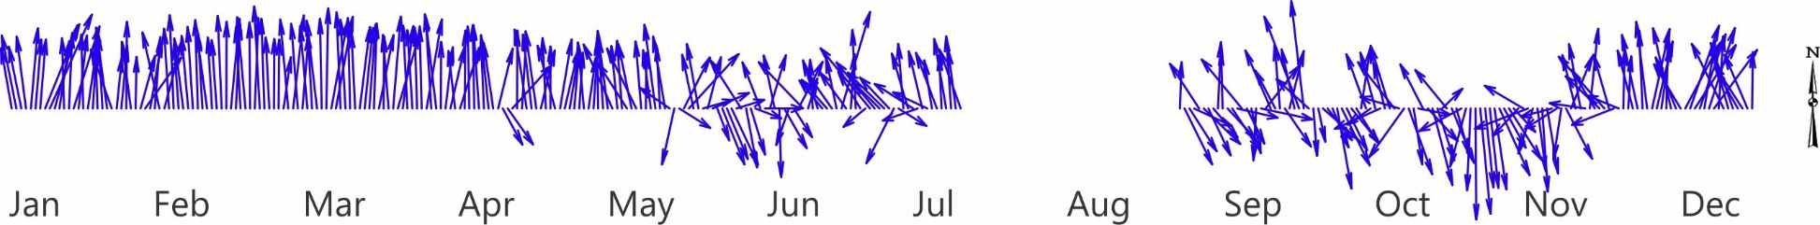

Average Monthly Wind Speed (km/h) and Direction (°)

 | Long-term Av. |  |  | 2020
 | Speed | Wsmx | Dir. | Speed | Wsmx | Dir.
January | 4.2 | 10.5 | 4.1 | 3.7 | 9.7 | 4.8
February | 4.5 | 11.1 | 4.8 | 4.4 | 10.8 | 357.7
March | 4.6 | 11.3 | 2.4 | 4.4 | 11.3 | 1.8
April | 3.6 | 9.9 | 359.9 | 3.3 | 9.1 | 3.2
May | 2.7 | 8.5 | 1.6 | 2.6 | 8.5 | 1.3
June | 2.5 | 8.1 | 348.9 | 2.1 | 7.6 | 332.6
July | 3.0 | 8.6 | 339.3
August | 2.8 | 8.7 | 338.4
September | 2.4 | 8.6 | 332.1 | 2.0 | 8.3 | 53.9
October | 2.4 | 8.2 | 165.9 | 2.2 | 7.8 | 153.7
November | 2.8 | 8.5 | 315.7 | 3.0 | 9.1 | 189.9
December | 3.4 | 9.3 | 357.8 | 3.3 | 9.5 | 353.0
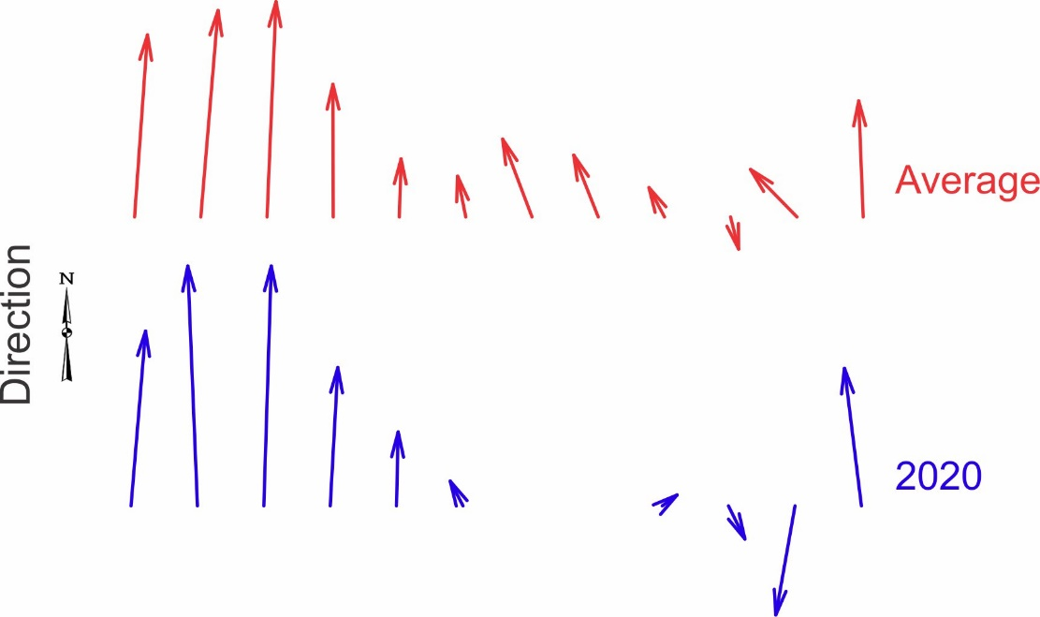

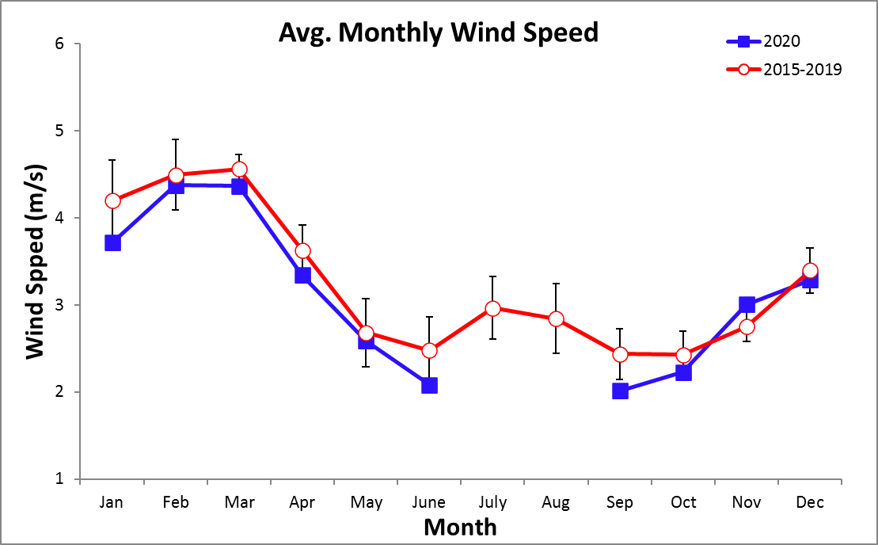
Monthly Average Net Radiation (W m-²)

Year | Jan | Feb | Mar | Apr | May | June | July | Aug | Sep | Oct | Nov | Dec
2015 |  |  |  |  | 107.3 | 103.6 | 97.0 | 99.1 | 95.3 | 92.9 | 90.2 | 96.0
2016 | 94.3 | 98.3 | 96.9 | 105.2 | 102.6 | 91.4 | 78.1 | 90.2 | 84.0 | 87.6 | 82.4 | 94.0
2017 | 101.5 | 100.7 | 106.1 | 101.5 | 98.0 | 88.0 | 75.9 | 93.6 | 93.7 | 87.0 | 81.5 | 83.5
2018 | 89.9 | 103.6 | 109.3 | 112.3 | 97.9 | 73.1 | 83.7 | 86.2 | 80.4 | 83.7 | 70.5 | 91.6
2019 | 98.8 | 101.9 | 110.2 | 114.4 | 96.9 | 86.6 | 85.7 | 79.6 | 90.1 | 88.1 | 85.7 | 86.8
2020 | 105.4 | 120.3 | 122.9 | 115.5 | 103.9 | 83.7 | 89.0 | 86.3 | 90.3 | 96.3 | 86.6 | 98.8
mean | 98.0 | 105.0 | 109.1 | 109.8 | 101.1 | 87.7 | 84.9 | 89.2 | 89.0 | 89.3 | 82.8 | 91.8
sd | 6.1 | 8.8 | 9.3 | 6.1 | 4.1 | 10.0 | 7.6 | 6.8 | 5.7 | 4.5 | 6.8 | 5.8
min | 89.9 | 98.3 | 96.9 | 101.5 | 96.9 | 73.1 | 75.9 | 79.6 | 80.4 | 83.7 | 70.5 | 83.5
max | 105.4 | 120.3 | 122.9 | 115.5 | 107.3 | 103.6 | 97.0 | 99.1 | 95.3 | 96.3 | 90.2 | 98.8

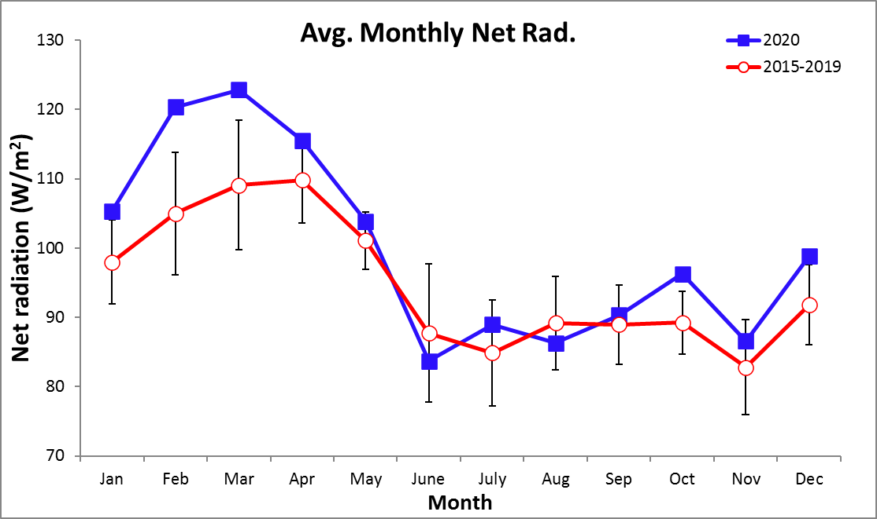

Monthly Average Net Longwave Radiation (W m-²)

Year | Jan | Feb | Mar | Apr | May | June | July | Aug | Sep | Oct | Nov | Dec
2015 |  |  |  |  | -38.6 | -45.0 | -32.1 | -30.6 | -28.8 | -34.3 | -36.3 | -48.0
2016 | -71.0 | -65.5 | -73.4 | -61.8 | -33.5 | -36.0 | -26.6 | -28.4 | -29.9 | -31.0 | -20.5 | -40.3
2017 | -72.6 | -68.6 | -82.9 | -61.0 | -32.8 | -33.8 | -25.5 | -32.5 | -34.1 | -33.6 | -24.1 | -39.0
2018 | -39.6 | -71.4 | -59.2 | -51.8 | -35.6 | -25.9 | -28.8 | -30.0 | -30.2 | -34.7 | -31.8 | -56.8
2019 | -62.0 | -67.4 | -69.7 | -61.9 | -36.9 | -33.2 | -28.8 | -30.3 | -24.4 | -32.3 | -30.8 | -31.6
2020 | -48.9 | -59.0 | -73.7 | -49.1 | -34.9 | -28.6 | -31.5 | -30.1 | -35.6 | -33.1 | -29.3 | -38.5
mean | -58.8 | -66.3 | -71.8 | -57.1 | -35.4 | -33.7 | -28.9 | -30.3 | -30.5 | -33.2 | -28.8 | -42.4
sd | 14.3 | 4.7 | 8.6 | 6.2 | 2.1 | 6.6 | 2.6 | 1.3 | 4.0 | 1.4 | 5.7 | 8.8
min | -72.6 | -71.4 | -82.9 | -61.9 | -38.6 | -45.0 | -32.1 | -32.5 | -35.6 | -34.7 | -36.3 | -56.8
max | -39.6 | -59.0 | -59.2 | -49.1 | -32.8 | -25.9 | -25.5 | -28.4 | -24.4 | -31.0 | -20.5 | -31.6

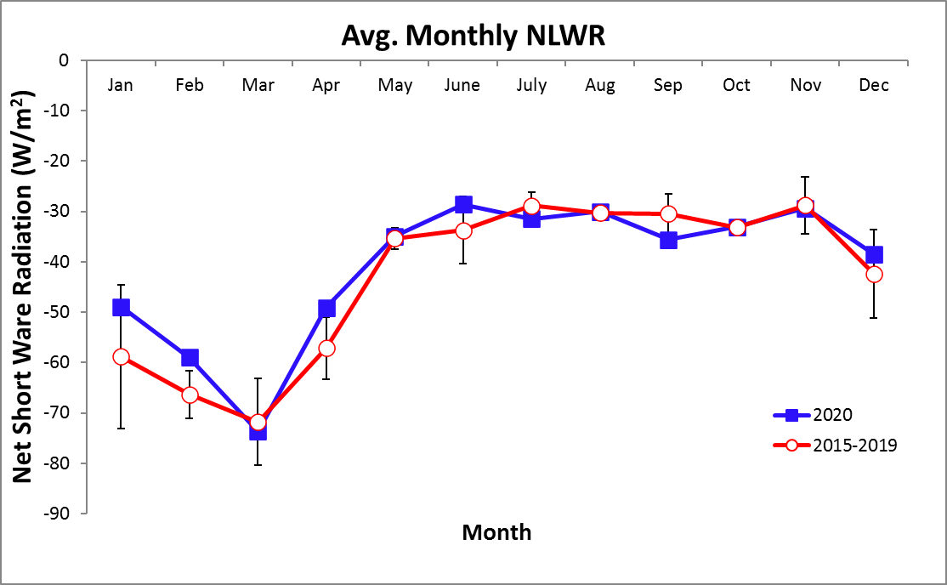
Monthly Average Net Shortwave Radiation (W m-²)

Year | Jan | Feb | Mar | Apr | May | June | July | Aug | Sep | Oct | Nov | Dec
2015 |  |  |  |  | 145.8 | 148.5 | 129.1 | 129.7 | 124.1 | 127.2 | 126.5 | 144.0
2016 | 165.3 | 163.8 | 170.2 | 167.0 | 136.1 | 127.4 | 104.7 | 118.6 | 113.8 | 118.6 | 102.9 | 134.3
2017 | 174.2 | 169.3 | 189.0 | 162.5 | 130.8 | 121.8 | 101.3 | 126.1 | 127.7 | 120.6 | 105.6 | 122.5
2018 | 129.5 | 175.0 | 168.5 | 164.2 | 133.5 | 98.9 | 112.6 | 116.2 | 110.6 | 118.3 | 102.3 | 148.4
2019 | 160.8 | 169.3 | 179.9 | 176.3 | 133.7 | 119.8 | 114.5 | 109.9 | 114.5 | 120.3 | 116.6 | 118.4
2020 | 193.1 | 217.6 | 236.4 | 195.7 | 167.2 | 137.6 | 146.6 | 142.0 | 155.6 | 161.1 | 144.4 | 172.3
mean | 195.6 | 211.2 | 222.2 | 202.1 | 162.0 | 145.5 | 136.9 | 144.6 | 145.7 | 150.0 | 137.3 | 167.0
sd | 21.8 | 6.3 | 15.2 | 5.7 | 7.0 | 19.4 | 12.9 | 6.8 | 9.2 | 6.3 | 12.2 | 14.6
min | 160.4 | 203.4 | 205.6 | 195.7 | 153.3 | 120.3 | 121.0 | 135.7 | 135.4 | 142.5 | 122.5 | 149.3
max | 218.1 | 217.6 | 239.9 | 210.5 | 172.8 | 179.5 | 153.5 | 154.9 | 156.6 | 161.1 | 152.7 | 186.7

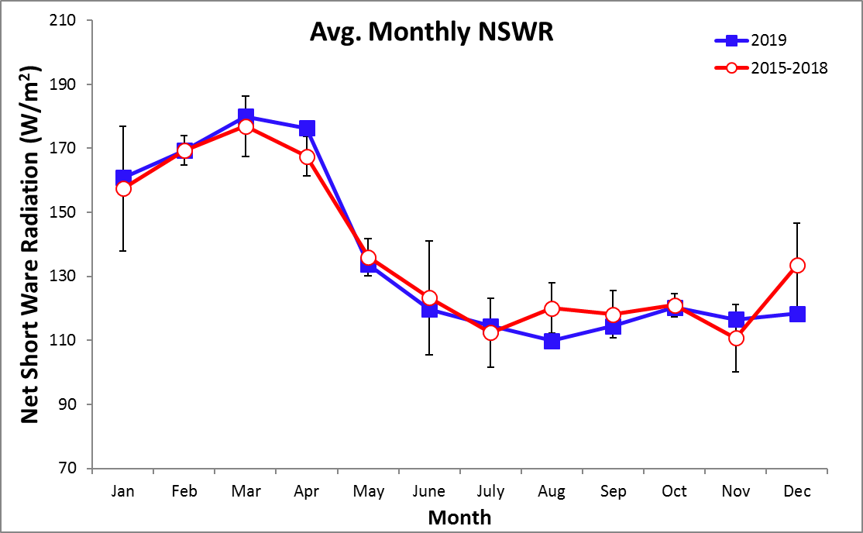

Monthly Average Daily Air Pressure (mmHg)

Year | Jan | Feb | Mar | Apr | May | June | July | Aug | Sep | Oct | Nov | Dec
2015 |  | 731.1 | 731.2 | 730.1 | 730.2 | 729.5 | 730.0 | 729.5 | 729.4 | 729.8 | 729.0 | 728.9
2016 | 730.7 | 730.3 | 731.0 | 730.1 | 730.2 | 730.6 | 730.5 | 729.9 | 730.5 | 729.6 | 729.5 | 730.1
2017 | 730.9 | 730.9 | 730.8 | 729.9 | 730.1 | 730.1 | 730.4 | 730.3 | 729.9 | 729.3 | 729.5 | 730.1
2018 | 730.0 | 731.1 | 730.2 | 730.7 | 730.1 | 730.0 | 730.3 | 730.4 | 729.5 | 730.0 | 729.7 | 730.6
2019 | 731.1 | 730.8 | 730.7 | 730.6 | 729.8 | 730.1 | 730.3 | 730.4 | 730.3 | 729.9 | 729.7 | 729.7
2020 | 730.9 | 730.9 | 731.4 | 730.9 | 730.3 | 730.3 | 730.2 | 730.2 | 729.1 | 729.6 | 729.9 | 730.4
mean | 730.7 | 730.8 | 730.9 | 730.4 | 730.1 | 730.1 | 730.3 | 730.1 | 729.8 | 729.7 | 729.5 | 730.0
sd | 0.4 | 0.3 | 0.4 | 0.4 | 0.2 | 0.4 | 0.2 | 0.3 | 0.6 | 0.3 | 0.3 | 0.6
min | 730.0 | 730.3 | 730.2 | 729.9 | 729.8 | 729.5 | 730.0 | 729.5 | 729.1 | 729.3 | 729.0 | 728.9
max | 731.1 | 731.1 | 731.4 | 730.9 | 730.3 | 730.6 | 730.5 | 730.4 | 730.5 | 730.0 | 729.9 | 730.6

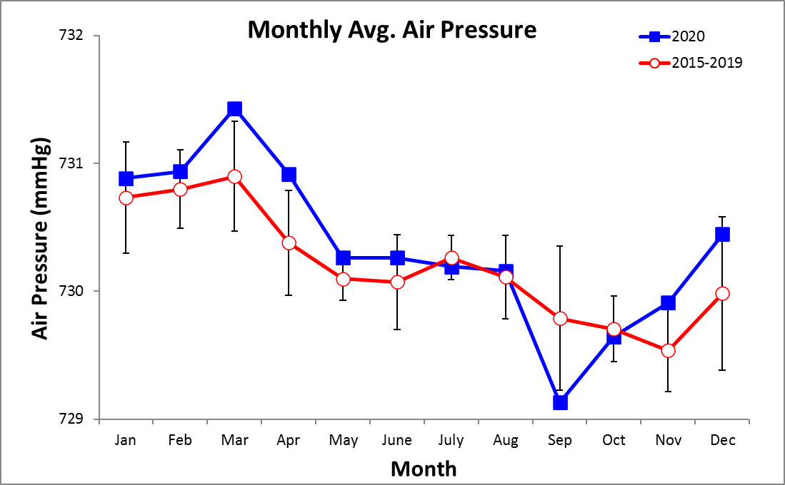

Time Series – Daily 2020

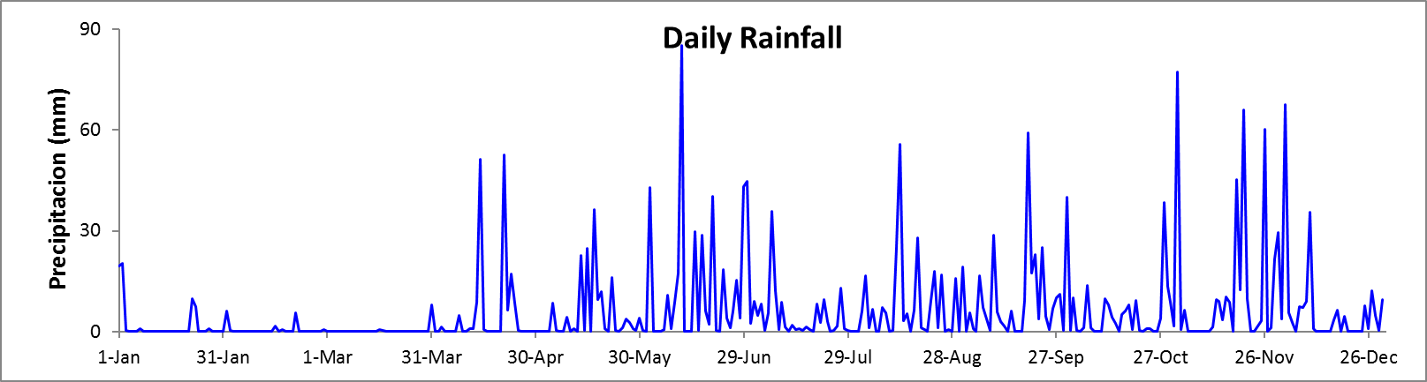

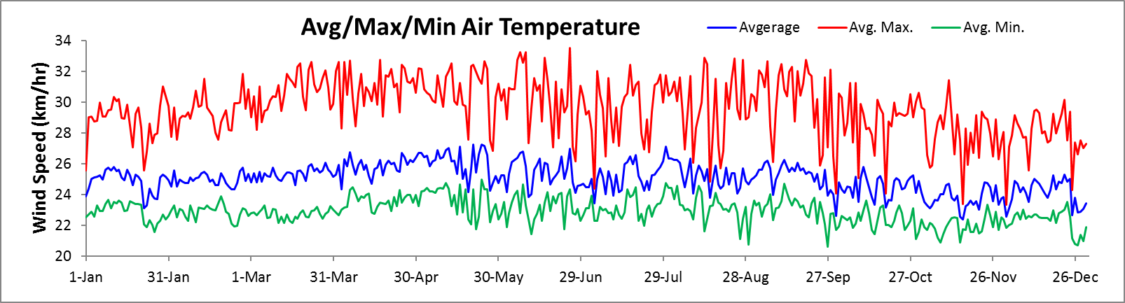

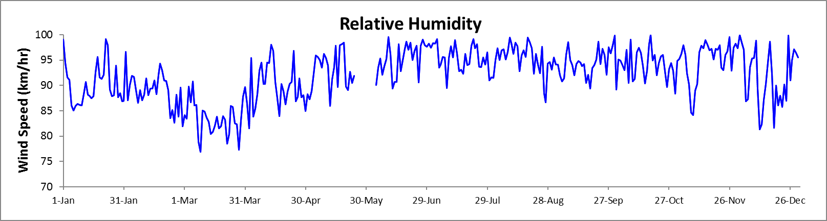

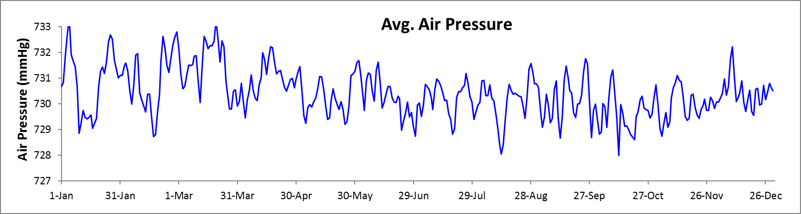
Time Series – Daily 2020

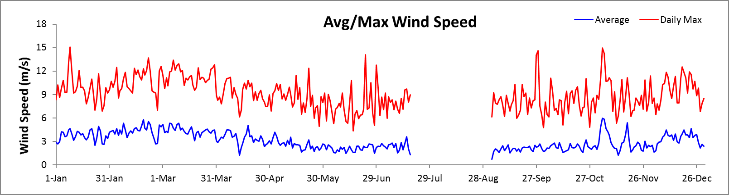

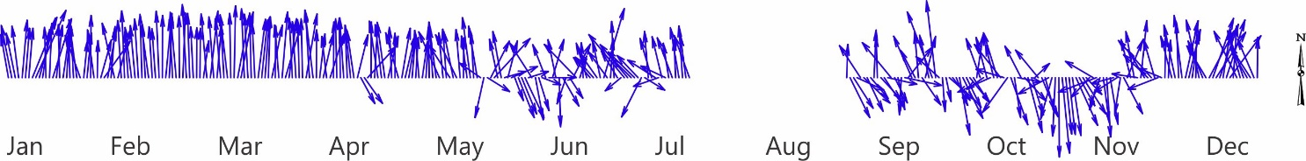

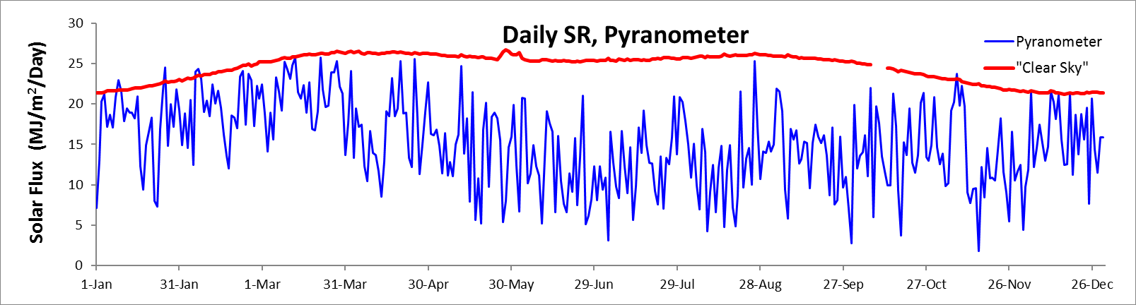

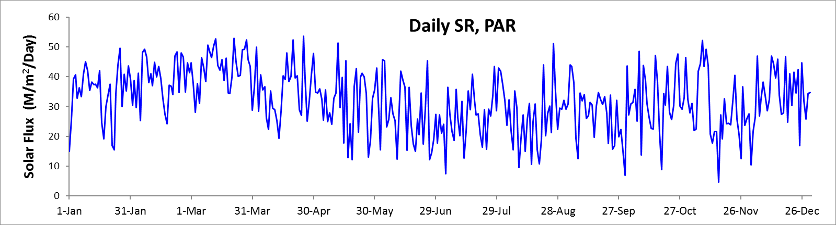
Time Series - Monthly

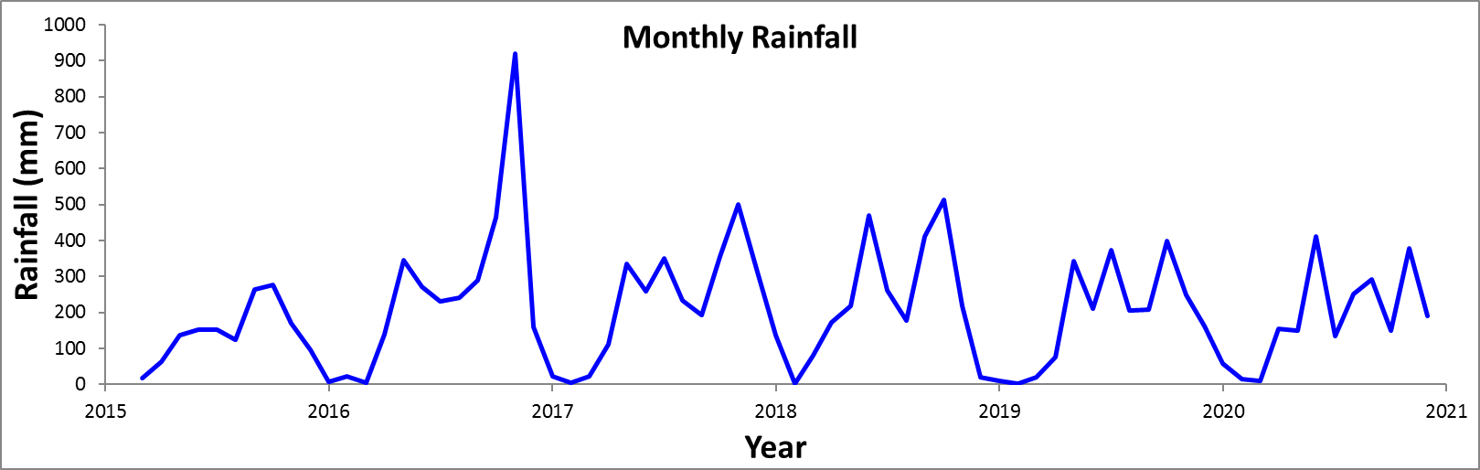

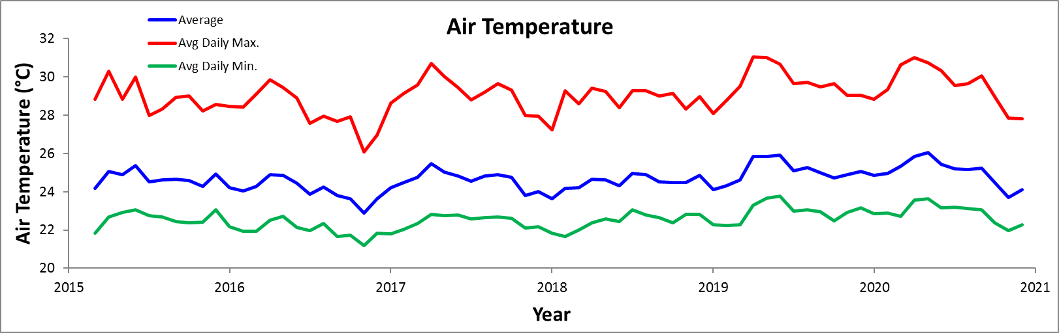

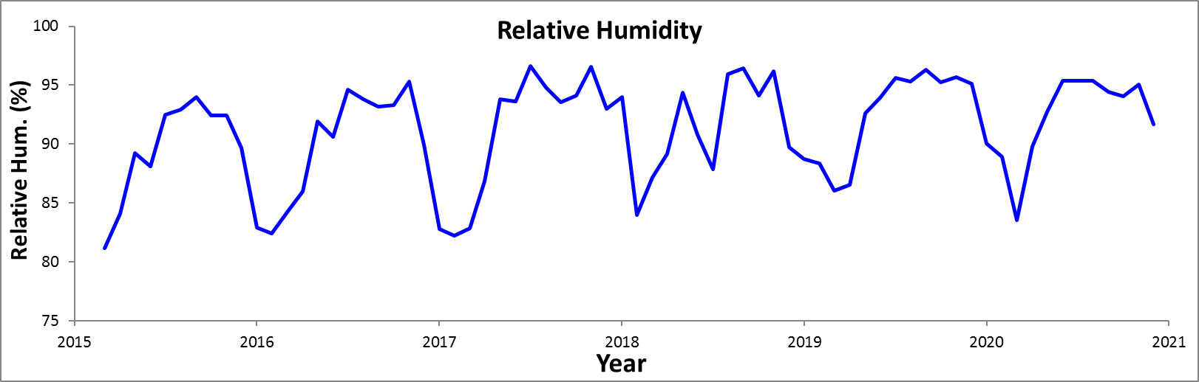

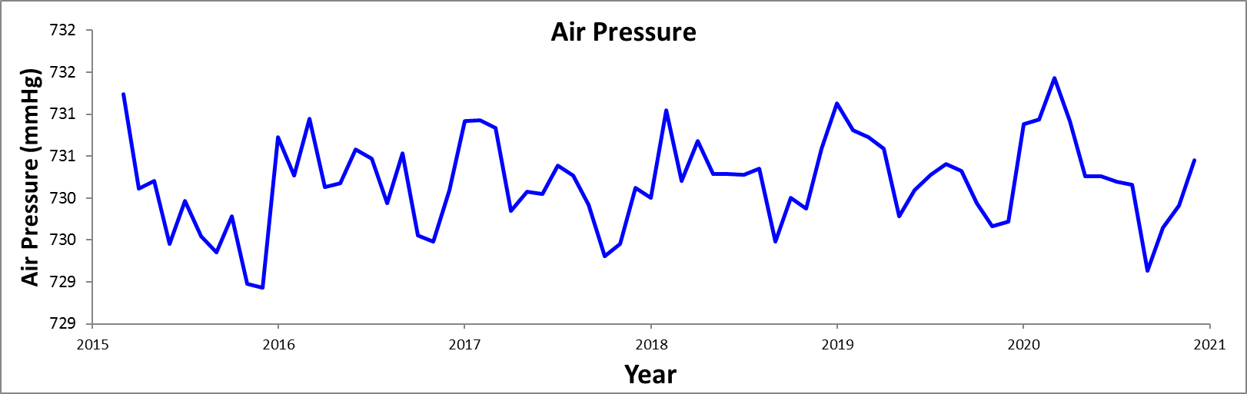

Time Series - Monthly

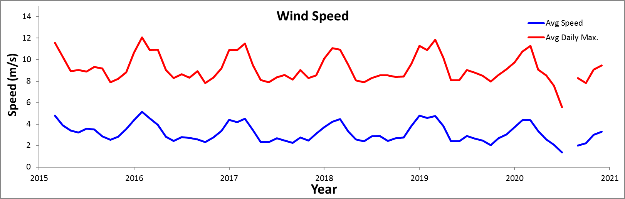

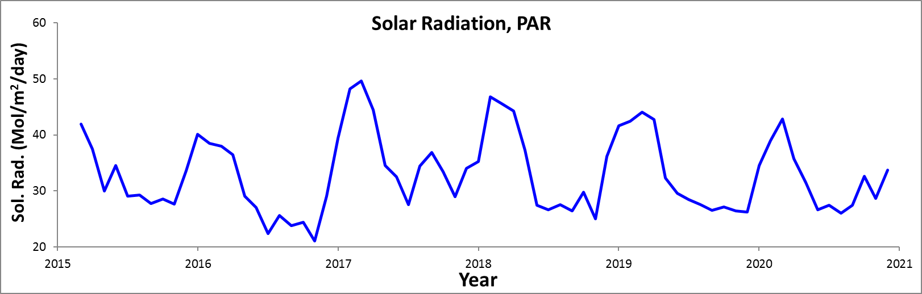

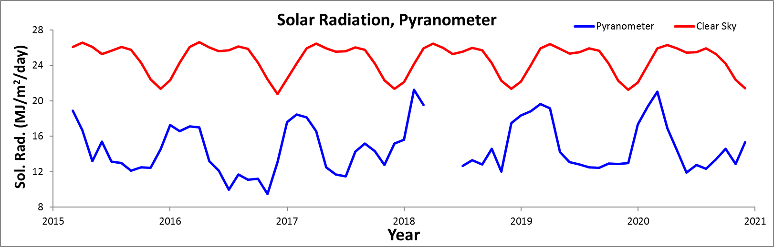

Time Series – Monthly

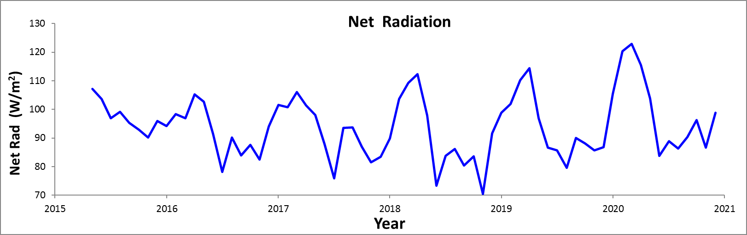

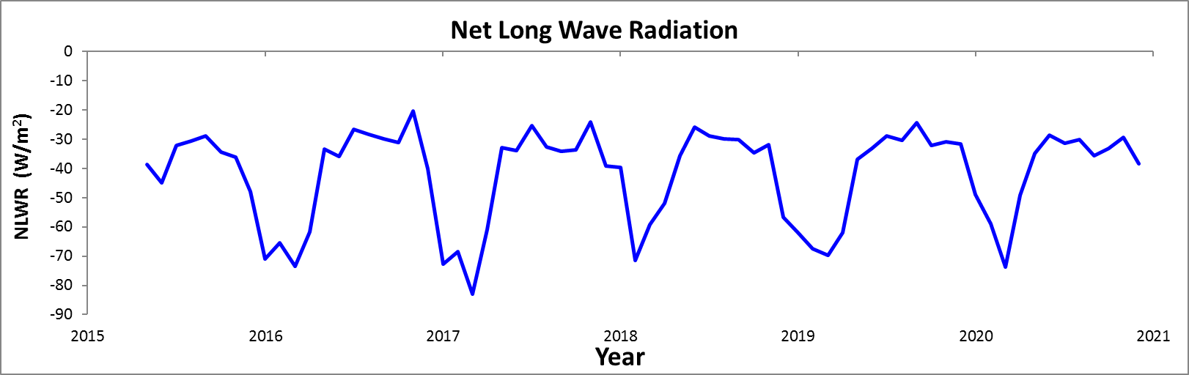

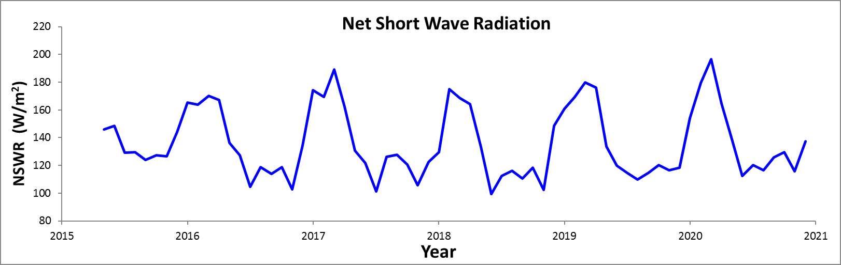

Average Daily Cycles

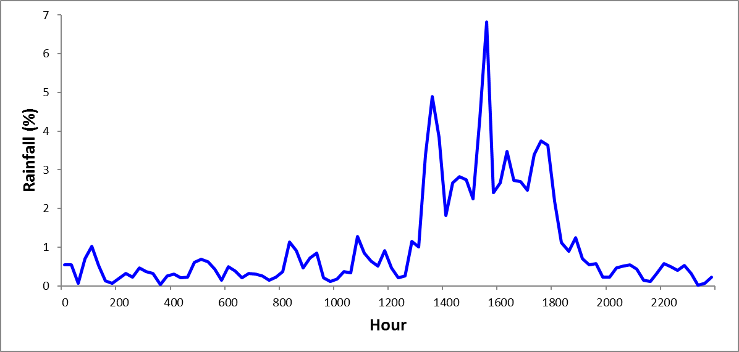

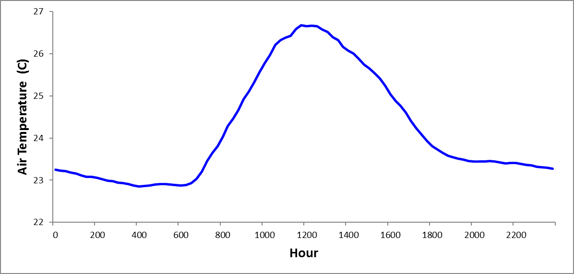

Average Daily Cycles

