2020 Meteorological Summary for
the Punta Culebra Nature Center

Prepared by: Steven Paton

Introduction

This is the 7th of a series of yearly reports summarising the past year’s Smithsonian Tropical Research Institute’s Physical Monitoring Program at the Punta Culebra Nature Center (PCNC). This report is not meant to be exhaustive in its coverage in that it summarizes only some of the most ‘important’ or interesting parameters available. Any comments on how future yearly summaries could be improved would be appreciated. Additional copies of this report, reports from previous years, and downloadable data from the PCNC and other research locations, can be obtained from:

biogeodb.stri.si.edu/physical_monitoring/research/culebra
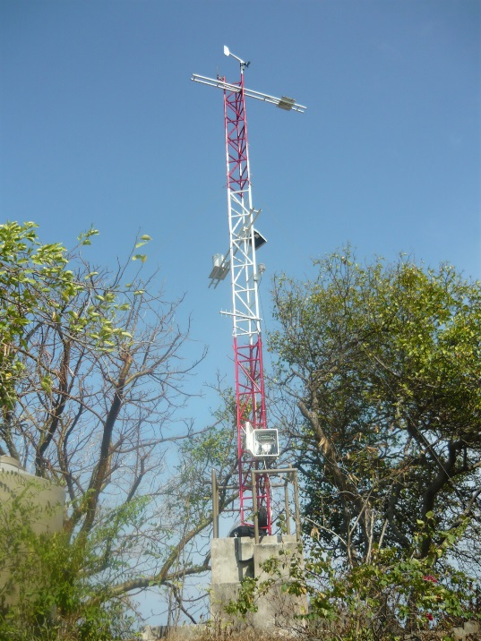
Setting

Established in 2010, the PCNC meteorological station (8.910718°, -79.528919°) is located at the South Western edge of Panama City, at the end of the Amador Causeway, at the southern end of Punta Culebra. The station consists of a standard 6m triangular tower that was erected in March of 2010. In addition, a manual rain gauge located at the entrance to the PCNC has been in operation since July of 2004.

The PCNC occupies a territory of approximately 1 1/2 hectares and offers visitors an open-air museum focusing mainly on marine science and education, conservation and interpretation of marine coastal environments. In addition to the surrounding marine environment, the PCNC also has one of the few remaining patches of tropical dry forest in the area.

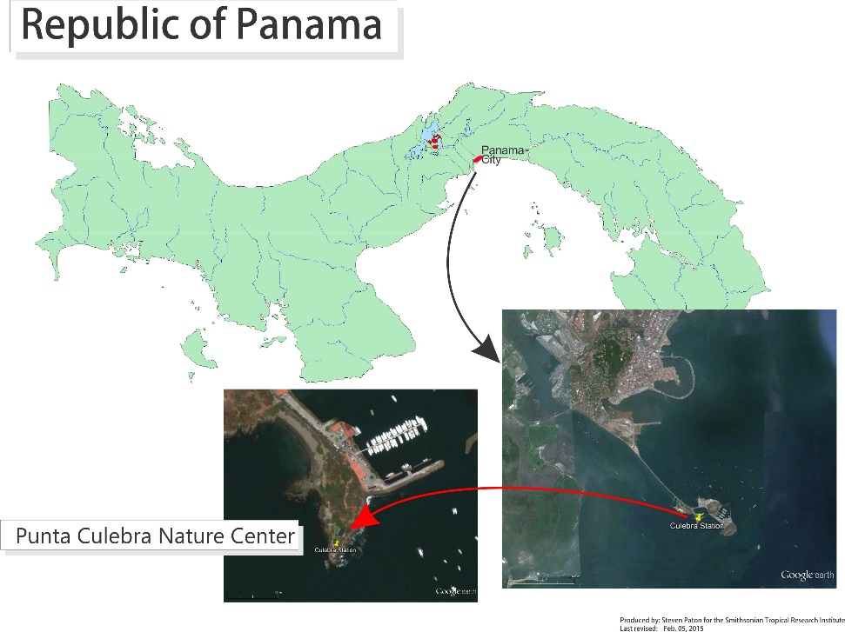
The station receives an average of 1558.4 mm of rain per year. The meteorological year is divided into two parts: a pronounced dry season (approximately from mid-December to the end of April), and a wet season (May to mid-December). On average, only 139mm of rain falls during the dry season. Relative humidity, soil moisture, air pressure, solar radiation, evapotranspiration, wind speed and direction all show marked wet/dry season differences. On the other hand, temperature varies relatively little throughout the year. All data are collected using electronic sensors and recorded every 15 minutes.

This report summarises the following data:
Relative humidity
Air temperature
Rainfall
Wind speed and direction
Solar radiation

The Autoridad del Canal de Panamá (ACP) (Panama Canal Authority in English) maintains two nearby stations: Albrook Airbase (FAA) and Balboa Heights (HTS) – located 6.9 and 6.1km NNW of the PCNC tower, respectively. Both stations record precipitation, while the HTS station also records wind, air temperature, relative humidity and solar radiation. This report summarizes the data from these stations.
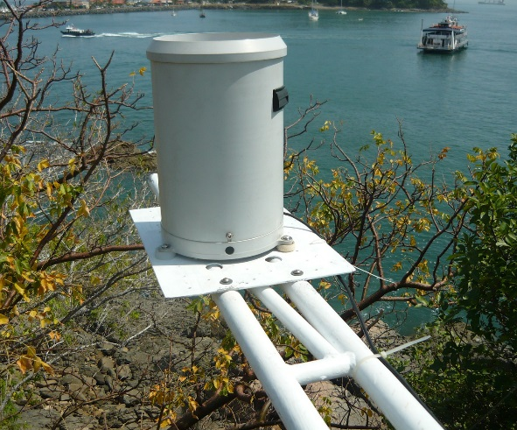
Rainfall
Rainfall was collected by a tipping bucket rain gauge located at approximately 3m on the tower. Tipping buckets generate ‘events’ for every 0.254 mm of rainfall recorded. Rainfall was also collected using a manual rain gauge. The gauge was read an average of 8.5 times per month.

The daily rainfall data for 2020 are shown on page 6.

Page 7 shows the monthly totals for the period 2004 to 2020 using data from that manual rain guage that have been prorated using tipping bucket data so that totals collected after several days (such as weekends) are distributed according to the data registered by the tipping bucket. The graph on the same page compares this year’s monthly totals with the average monthly totals (±SD) for the period 2010 to 2019.

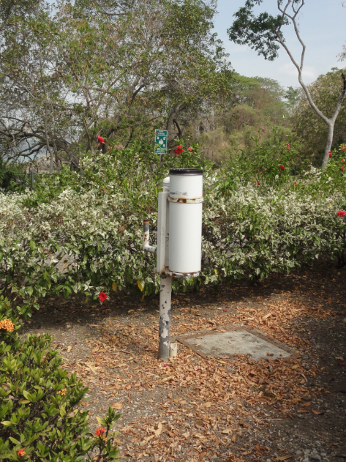
Page 8 shows yearly rainfall totals for all years since 2005. Time series graph and frequency histograms are presented for these data.

Pages 9 and 10 show an analysis of rainfall ‘events’ (storms). For convenience, and again somewhat arbitrarily, I have defined a storm as any continuous period of rain separated by at least an hour from any other rainfall. Since this analysis required the timing of rainfall events, tipping bucket data were used. As a result, the absolute size of rainfall events should be considered as only an estimate since they will tend to disproportionately underestimate the size of storms - larger storms will be more underestimated than smaller ones. Keeping this in mind, the tables and graphs on this page compare the maximum storm size and the average storm size and duration per month for the period 1995 to 2019 and for the year 2020.

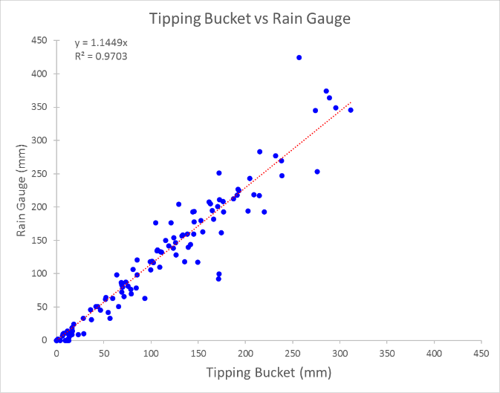
Because manual rain gauge measurements were suspended in Feb., tipping bucket data have been used to estimate rainfall. A simple correlation analysis between monthly Tipping Buckent and Rain Gauge data shows that on average the Tipping Bucket underestimates rainfall by 11.45%. This value was used to adjust rainfall values from mid-Feb until the end of the year.

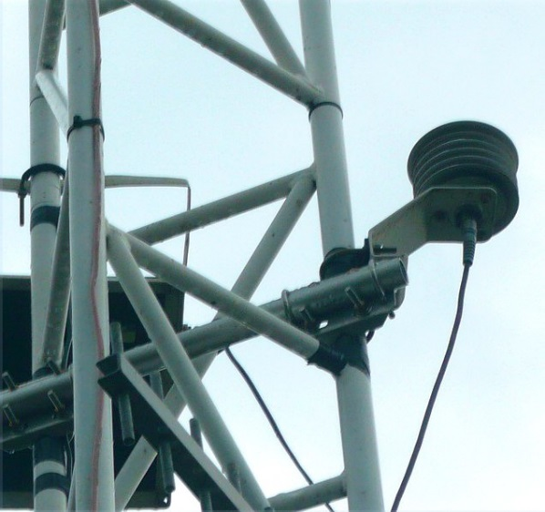
Relative Humidity

Relative Humidity was measured by a Campbell Sci. CS215 temperature/humidity sensors located at approximately 3m (Viasala HMP 35/45 sensors prior to 2010).

The average monthly relative humidity data are shown in tabular and graphical form on pages 11.

Air Temperature

Air temperature was measured by a Campbell Sci. CS215 temperature/humidity sensors (Viasala HMP 35/45 sensors prior to 2010) located at approximately 3m. The monthly average, maximum and minimum temperatures are shown in tabular and graphical form on page 12 to 14, respectively.
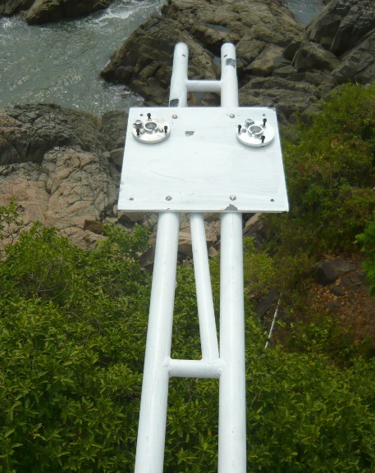

Solar Radiation

Until Mar 2016, Global solar radiation was measured by two Li-Cor LI200SB pyranometers located near the top of the tower (~6m). After that date, one of the sensors has been a Kipp&Zonen SPLite2 pyranometer. 15-minute interval average intensity, maximum and minimum (W/m²) were recorded.

Page 15 shows the Daily Global Radiation values. Page 16 shows monthly daily average total Global Radiation.

Wind Speed and Direction

Wind speed and direction was measured by a Model 05103 Young Anemometer located at the very top of the tower (6m).

Page 17 shows average and maximum daily wind speeds. Page 18 shows daily average wind direction. The angles indicated in the table and graph on this page represent the direction into which the wind was predominately blowing on a given day. Pages 19 to 21 show the monthly average wind speed, monthly average daily maximum wind speed and monthly average directions, respectively.

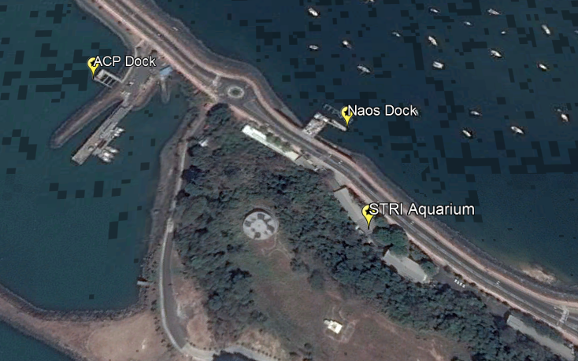
Marine Monitoring
Temperature, salinity and pH readings are made 3-5 times per week in the morning at three locations on Naos Island: the Naos Station marine tanks, the STRI Naos Dock, and the ACP Noas Dock.

Measurements are made with a YSI Professional Pro handheld sensor with the following sensors:
- YSI model Pro1001A pH sensor
- YSI model 5560 Conductivity/Temperature sensor

Monthly averages are found on pages 23 to 28.

Times Series
Graphs showing the daily averages for 2020 and the monthly averages for the entire period of record for Humidity, Air Temperature, Rainfall, Wind Speed and Solar Radiation can be found on pages 29 to 32.

Daily Patterns
Pages 33 and 34 show the daily patterns for Humidity, Air Temperature, Rainfall, Wind Speed and Solar Radiation.

ACP Stations
The Autoridad del Canal de Panamá (ACP) (Panama Canal Authority in English) maintains two nearby stations: Albrook Airbase (FAA) and Balboa Heights (HTS). The stations are located at Lat/Long 8.968889°, -79.549444° and 8.959444°, -79.554167° respectively. Data were collected hourly. No information is available regarding instrumentation. A summary of rainfall, wind speed and direction and air temp for these stations is shown on pages 27-33. Relative humidity, air pressure and solar radiation data were also collected at the FAA station, but not reported here due to obvious problems with the data (the data are, however, available in the associated Excel spreadsheet).

2020 Daily Rainfall (mm) - Electronic

 | Jan. | Feb. | Mar. | Apr. | May | June | July | Aug. | Sep. | Oct. | Nov. | Dec.
1 | 8.6 | 0.0 | 0.0 | 0.0 | 0.0 | 39.4 | 0.0 | 0.0 | 0.0 | 0.3 | 5.1 | 0.0
2 | 1.3 | 0.0 | 0.0 | 0.0 | 1.8 | 72.6 | 7.1 | 0.0 | 0.0 | 13.5 | 2.8 | 3.0
3 | 0.0 | 0.0 | 0.0 | 0.0 | 0.0 | 0.0 | 8.6 | 8.9 | 51.1 | 0.0 | 1.5 | 0.0
4 | 0.0 | 0.0 | 0.0 | 0.0 | 2.0 | 0.0 | 24.6 | 18.0 | 0.0 | 0.0 | 0.8 | 0.0
5 | 0.0 | 0.0 | 0.0 | 0.0 | 4.8 | 0.0 | 0.8 | 39.1 | 5.6 | 0.0 | 0.0 | 4.3
6 | 0.0 | 0.0 | 0.0 | 0.0 | 0.0 | 2.5 | 0.0 | 0.0 | 1.0 | 13.0 | 0.0 | 2.5
7 | 0.0 | 0.0 | 0.0 | 0.0 | 32.8 | 5.6 | 5.3 | 0.0 | 8.6 | 53.6 | 0.0 | 0.0
8 | 0.0 | 0.0 | 0.0 | 0.0 | 0.0 | 0.0 | 1.3 | 1.3 | 0.0 | 1.5 | 0.0 | 9.1
9 | 0.0 | 0.0 | 0.0 | 0.0 | 0.0 | 1.0 | 3.0 | 1.3 | 13.0 | 9.7 | 0.0 | 6.6
10 | 0.0 | 0.0 | 0.0 | 0.0 | 0.0 | 35.6 | 1.3 | 0.0 | 1.0 | 0.0 | 0.0 | 0.8
11 | 0.0 | 0.0 | 0.0 | 0.0 | 8.4 | 0.3 | 6.4 | 6.1 | 0.0 | 0.0 | 7.4 | 0.0
12 | 0.0 | 0.0 | 0.0 | 1.5 | 0.0 | 0.0 | 0.0 | 17.0 | 0.5 | 21.3 | 2.8 | 0.0
13 | 0.0 | 0.0 | 0.0 | 19.3 | 14.0 | 17.8 | 3.0 | 4.8 | 0.3 | 1.5 | 28.2 | 0.0
14 | 0.0 | 0.0 | 0.0 | 18.5 | 0.0 | 0.0 | 0.0 | 2.8 | 0.0 | 2.8 | 5.1 | 0.0
15 | 0.0 | 0.0 | 0.0 | 0.0 | 0.0 | 22.9 | 0.0 | 16.0 | 4.1 | 0.0 | 6.1 | 0.0
16 | 0.0 | 0.0 | 0.0 | 0.0 | 0.0 | 0.0 | 0.0 | 0.5 | 1.0 | 0.0 | 7.1 | 0.8
17 | 0.0 | 0.0 | 0.0 | 0.0 | 3.6 | 0.0 | 0.0 | 2.0 | 11.2 | 1.5 | 5.8 | 1.8
18 | 0.0 | 0.0 | 0.0 | 0.0 | 0.0 | 0.3 | 0.0 | 34.0 | 0.0 | 0.0 | 0.8 | 0.0
19 | 0.0 | 0.0 | 1.0 | 0.0 | 1.3 | 0.0 | 2.8 | 0.0 | 32.3 | 22.1 | 9.4 | 0.0
20 | 0.0 | 0.0 | 22.6 | 0.0 | 2.5 | 0.5 | 0.3 | 27.4 | 35.6 | 19.1 | 21.3 | 0.0
21 | 0.0 | 0.0 | 0.0 | 0.0 | 0.0 | 0.5 | 0.3 | 2.0 | 44.2 | 1.0 | 0.3 | 2.3
22 | 0.0 | 0.0 | 0.0 | 0.0 | 48.5 | 1.3 | 0.3 | 72.4 | 8.1 | 1.5 | 8.4 | 0.0
23 | 0.3 | 0.0 | 0.0 | 15.2 | 0.0 | 10.2 | 0.0 | 0.0 | 0.3 | 0.5 | 39.9 | 0.0
24 | 0.0 | 0.0 | 0.0 | 0.0 | 0.3 | 0.0 | 44.5 | 0.0 | 29.2 | 1.3 | 24.6 | 0.0
25 | 0.3 | 0.0 | 0.0 | 0.0 | 5.3 | 1.0 | 31.2 | 0.5 | 1.0 | 0.0 | 13.2 | 2.0
26 | 0.0 | 0.0 | 0.0 | 0.0 | 0.5 | 35.3 | 40.4 | 0.0 | 0.0 | 0.0 | 32.0 | 0.0
27 | 0.0 | 0.0 | 0.0 | 0.0 | 17.0 | 6.9 | 4.1 | 0.0 | 15.2 | 0.0 | 2.8 | 6.6
28 | 0.0 | 0.0 | 0.0 | 0.0 | 2.3 | 0.3 | 3.3 | 0.0 | 0.3 | 0.0 | 0.0 | 0.5
29 | 0.0 | 0.0 | 0.0 | 0.3 | 10.7 | 0.0 | 0.0 | 2.5 | 0.0 | 0.0 | 5.6 | 0.0
30 | 0.0 |  | 0.0 | 0.0 | 11.9 | 8.6 | 0.0 | 0.0 | 33.3 | 0.0 | 2.8 | 0.0
31 | 0.0 |  | 0.0 |  | 0.8 |  | 0.0 | 0.0 |  | 3.0 |  | 7.1
 | 10.4 | 0.0 | 23.6 | 54.9 | 168.4 | 262.4 | 188.5 | 256.8 | 296.7 | 167.1 | 233.7 | 47.5

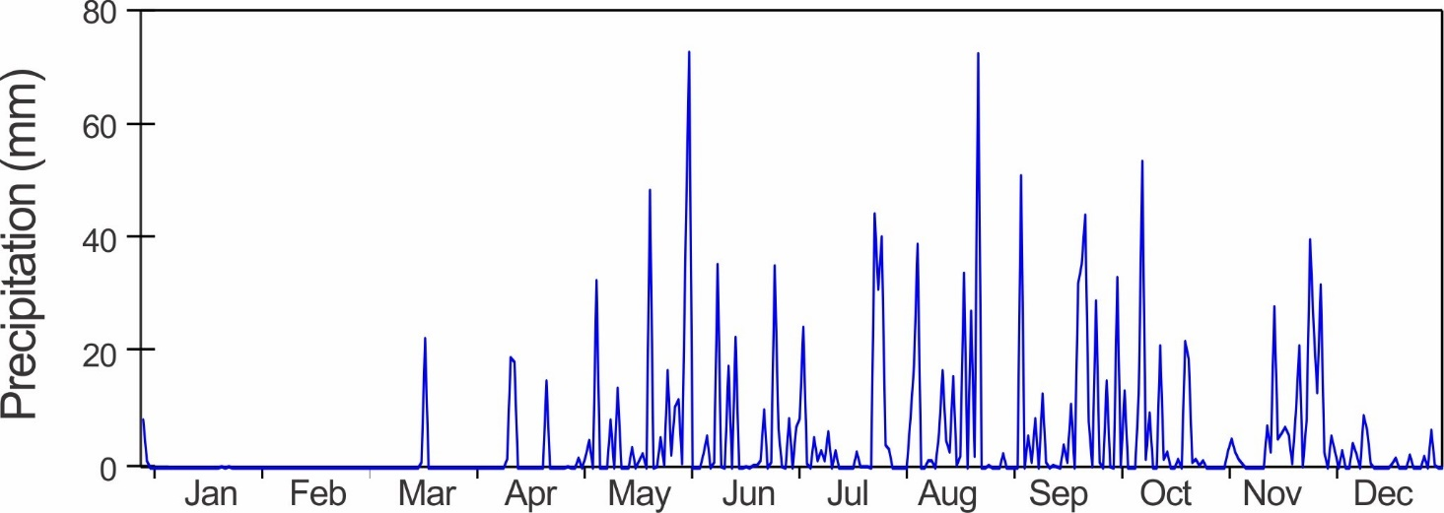

Monthly Rainfall (mm)

Year | Jan | Feb | Mar | Apr | May | June | July | Aug | Sep | Oct | Nov | Dec | Total
2004 |  |  |  |  |  |  | 207.5 | 134.6 | 245.5 | 234.0 | 302.3 | 32.8
2005 | 18.3 | 3.2 | 22.6 | 77.2 | 178.0 | 330.8 | 227.6 | 162.0 | 308.4 | 180.8 | 115.3 | 105.6 | 1729.8
2006 | 14.0 | 3.1 | 42.8 | 79.1 | 157.8 | 325.2 | 174.6 | 181.6 | 142.9 | 179.8 | 261.2 | 56.4 | 1618.5
2007 | 2.0 | 0.8 | 0.0 | 46.7 | 256.8 | 135.8 | 188.0 | 179.8 | 187.5 | 117.8 | 163.8 | 131.7 | 1410.7
2008 | 8.4 | 45.6 | 4.5 | 32.2 | 137.4 | 195.2 | 74.2 | 323.9 | 163.8 | 231.4 | 320.0 | 163.8 | 1700.4
2009 | 12.6 | 6.5 | 0.0 | 7.2 | 135.0 | 244.6 | 115.4 | 84.4 | 73.8 | 170.5 | 276.5 | 8.7 | 1135.2
2010 | 2.5 | 2.0 | 16.5 | 138.4 | 141.7 | 277.3 | 246.9 | 364.1 | 132.5 | 98.3 | 156.7 | 177.5 | 1754.4
2011 | 63.0 | 10.5 | 33.2 | 120.8 | 211.0 | 63.0 | 345.7 | 204.3 | 192.5 | 92.5 | 424.4 | 99.5 | 1860.4
2012 | 81.2 | 8.5 | 0.0 | 66.0 | 105.5 | 188.8 | 132.7 | 51.0 | 72.8 | 253.5 | 193.0 | 117.5 | 1270.5
2013 | 0.0 | 0.0 | 0.4 | 5.1 | 143.5 | 193.4 | 76.6 | 208.2 | 344.8 | 283.3 | 193.1 | 86.8 | 1535.1
2014 | 11.1 | 13.0 | 1.0 | 14.3 | 226.9 | 117.7 | 64.0 | 45.4 | 217.6 | 242.9 | 150.1 | 158.2 | 1262.3
2015 | 79.6 | 1.0 | 33.3 | 23.9 | 128.2 | 176.5 | 61.3 | 87.6 | 207.5 | 162.6 | 179.5 | 31.0 | 1172.0
2016 | 8.6 | 0.0 | 0.0 | 14.3 | 251.5 | 216.9 | 116.5 | 119.0 | 134.7 | 205.3 | 374.2 | 45.8 | 1486.7
2017 | 18.5 | 0.3 | 50.6 | 10.5 | 159.2 | 176.3 | 159.5 | 349.2 | 224.6 | 200.9 | 269.7 | 110.1 | 1729.4
2018 | 136.0 | 1.5 | 9.4 | 69.5 | 146.4 | 218.9 | 154.0 | 106.31 | 212.4 | 139.7 | 194.9 | 9.65 | 1398.6
2019 | 0.0 | 6.9 | 1.8 | 51.0 | 78.6 | 83.6 | 42.0 | 118.1 | 194.0 | 161.8 | 182.1 | 98.3 | 1018.2
2020 | 11.7 | 0.0 | 27.0 | 62.8 | 192.8 | 300.4 | 215.8 | 294.0 | 339.7 | 191.3 | 267.5 | 54.4 | 1957.5
Mean | 37.5 | 4.0 | 15.8 | 52.4 | 162.3 | 183.0 | 146.8 | 177.0 | 206.6 | 184.7 | 235.0 | 89.9 | 1495.0
sd | 45.4 | 4.8 | 17.7 | 45.1 | 52.8 | 73.4 | 92.6 | 115.4 | 81.4 | 61.3 | 90.5 | 51.8 | 302.8
Min | 121.2 | 121.7 | 112.5 | 86.1 | 32.5 | 40.1 | 63.1 | 65.2 | 39.4 | 33.2 | 38.5 | 57.6 | 20.3
Max | 136.0 | 13.0 | 50.6 | 138.4 | 251.5 | 300.4 | 345.7 | 364.1 | 344.8 | 283.3 | 424.4 | 177.5 | 1957.5
Rank | 9 | 14 | 5 | 7 | 5 | 3 | 4 | 4 | 2 | 7 | 6 | 12 | 1

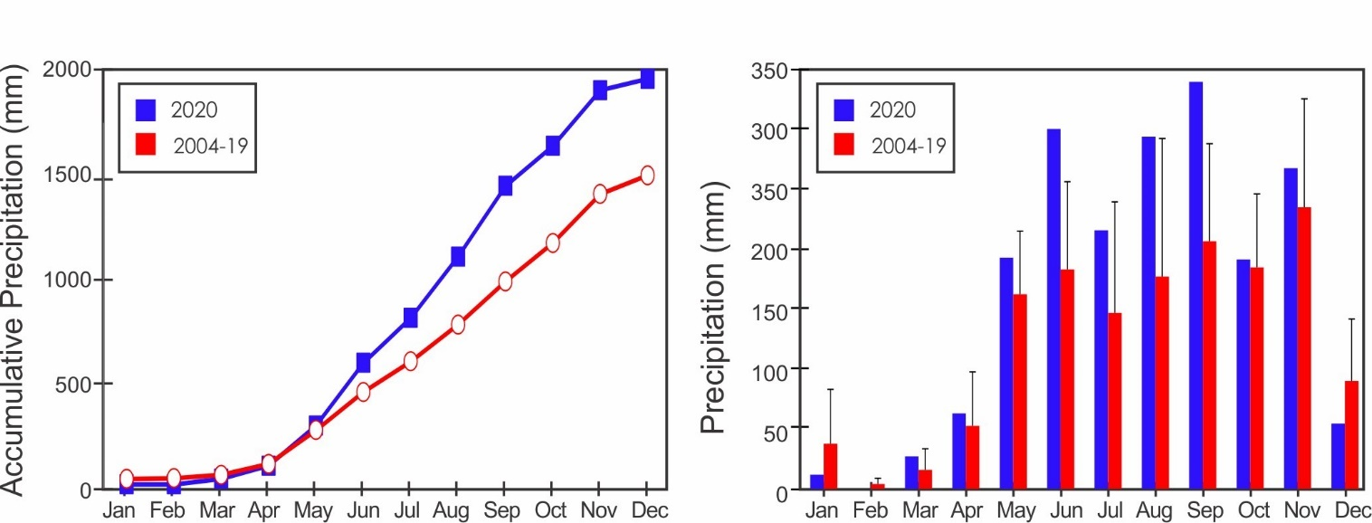
Yearly Rainfall (mm) - Manual

Year | Rain | Year | Rain | Year | Rain
2005 | 1729.8 | 2011 | 1860.4 | 2017 | 1729.4
2006 | 1618.5 | 2012 | 1270.5 | 2018 | 1398.6
2007 | 1410.7 | 2013 | 1535.1 | 2019 | 1018.2
2008 | 1700.4 | 2014 | 1262.3 | 2020 | 1957.5
2009 | 1135.2 | 2015 | 1172.0
2010 | 1754.4 | 2016 | 1486.7

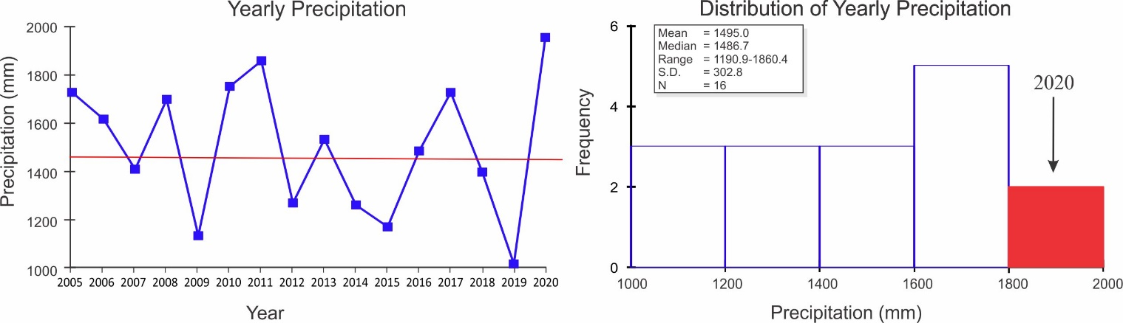

Storm Analysis

 |  | Max. Rainfall per Storm (mm) |  |  |  | Storm Duration (min.)
 | 2006-2019 |  |  | 2020 |  | 2006-2019 |  | 2020
 | Mean |  | S.D. |  |  | Mean | S.D.
January | 17.6 |  | 20.5 | 8.6 |  | 24.6 | 17.8 | 37.3
February | 4.5 |  | 3.6 |  |  | 27.2 | 18.7
March | 8.1 |  | 10.0 | 22.4 |  | 31.0 | 12.9 | 55.0
April | 15.4 |  | 10.2 | 17.8 |  | 52.3 | 22.6 | 73.3
May | 44.1 |  | 22.2 | 48.3 |  | 56.5 | 14.1 | 69.2
June | 39.8 |  | 19.6 | 72.6 |  | 64.6 | 12.7 | 82.0
July | 29.5 |  | 16.3 | 44.2 |  | 60.1 | 14.4 | 74.8
August | 26.9 |  | 14.3 | 72.4 |  | 55.8 | 18.7 | 83.0
September | 55.2 |  | 32.5 | 42.7 |  | 66.0 | 11.3 | 77.4
October | 46.1 |  | 13.5 | 53.3 |  | 65.7 | 14.4 | 64.8
November | 39.5 |  | 9.9 | 39.1 |  | 60.4 | 15.9 | 57.7
December | 27.1 |  | 8.5 | 9.1 |  | 45.4 | 12.4 | 43.3

 | Av. Rainfall per Storm (mm)
 | 2006-2019 |  | 2020
 | Mean | S.D.
January | 3.1 | 2.7 | 2.6
February | 1.7 | 1.9
March | 2.9 | 3.2 | 7.9
April | 5.0 | 5.3 | 6.1
May | 4.9 | 1.9 | 5.6
June | 5.5 | 2.7 | 9.0
July | 3.9 | 1.8 | 5.4
August | 4.1 | 2.5 | 9.5
September | 5.5 | 1.8 | 7.8
October | 5.0 | 1.0 | 5.8
November | 5.0 | 1.6 | 6.1
December | 3.4 | 1.3 | 2.2

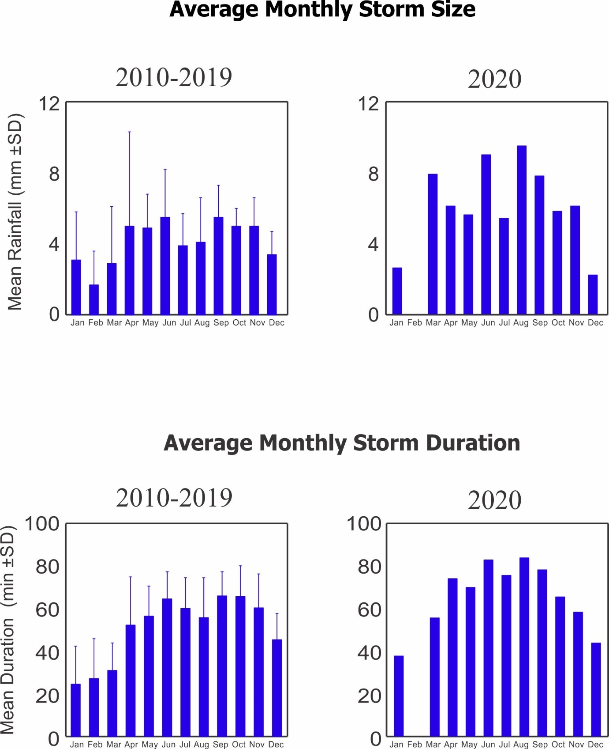
Relative Humidity (%)

Year | Jan | Feb | Mar | Apr | May | June | July | Aug | Sep | Oct | Nov | Dec
2010 |  |  | 76.5 | 81.3 | 83.3 | 87.2 | 88.5 | 88.0 | 87.4 | 89.3 | 88.8 | 87.8
2011 | 84.1 | 80.4 | 79.1 | 83.3 | 85.9 | 87.9 | 89.1 | 88.6 | 88.8 | 87.9 | 91.2 | 87.6
2012 | 78.7 | 77.5 | 78.6 | 85.1 | 87.4 | 85.3 | 87.1 | 87.4 | 87.7 | 88.0 | 89.0 | 87.5
2013 | 77.2 | 78.3 | 79.6 | 82.1 | 86.4 | 88.9 | 89.0 | 89.3 | 89.4 | 90.7 | 89.2 | 85.9
2014 | 80.5 | 78.5 | 78.3 | 81.8 | 87.6 | 88.5 | 86.2 | 87.8 | 88.8 | 88.8 | 88.8 | 87.4
2015 | 78.6 | 78.4 | 77.3 | 82.4 | 85.7 | 86.3 | 86.9 | 88.1 | 90.1 | 89.7 | 90.3 | 85.3
2016 | 79.3 | 76.0 | 78.9 | 79.1 | 87.1 | 88.2 | 89.2 | 88.8 | 89.2 | 90.0 | 91.6 | 87.1
2017 | 79.4 | 79.6 | 78.6 | 84.1 | 89.3 | 89.4 | 90.6 | 90.4 | 90.0 | 90.2 | 91.3 | 87.6
2018 | 86.6 | 78.6 | 77.9 | 85.4 | 87.0 | 88.7 | 87.9 | 88.4 | 89.2 | 87.5 | 89.0 | 80.5
2019 | 76.6 | 76.0 | 74.8 | 81.3 | 86.9 | 88.1 | 88.1 | 87.6 | 88.2 | 87.9 | 88.9 | 87.0
2020 | 79.3 | 76.1 | 73.4 | 82.5 | 86.6 | 89.2 | 89.0 | 88.9 | 89.5 | 88.7 | 89.2 | 85.7
mean | 80.0 | 77.9 | 77.6 | 82.6 | 86.7 | 88.0 | 88.3 | 88.5 | 88.9 | 89.0 | 89.8 | 86.3
sd | 3.1 | 1.5 | 1.9 | 1.8 | 1.5 | 1.3 | 1.3 | 0.9 | 0.9 | 1.1 | 1.1 | 2.1
min | 76.6 | 76.0 | 73.4 | 79.1 | 83.3 | 85.3 | 86.2 | 87.4 | 87.4 | 87.5 | 88.8 | 80.5
max | 86.6 | 80.4 | 79.6 | 85.4 | 89.3 | 89.4 | 90.6 | 90.4 | 90.1 | 90.7 | 91.6 | 87.8

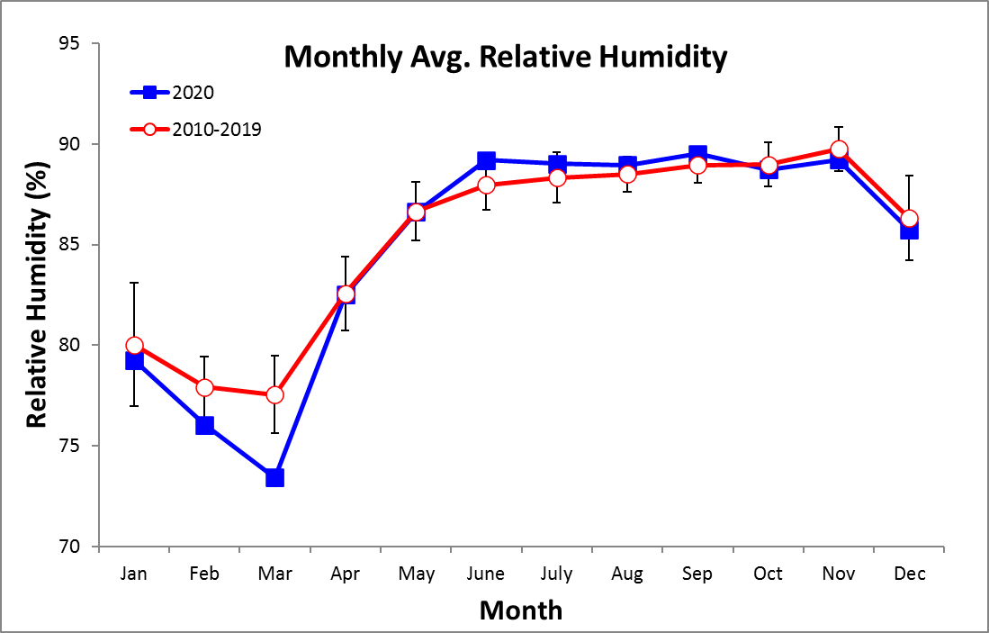
Monthly Average, Maximum & Minimum Temperatures (°C)

Monthly Average Temperature

Year | Jan | Feb | Mar | Apr | May | June | July | Aug | Sep | Oct | Nov | Dec
2010 |  |  | 28.1 | 28.1 | 28.3 | 27.2 | 26.7 | 27.0 | 26.9 | 26.4 | 25.8 | 25.0
2011 | 26.3 | 26.6 | 26.4 | 26.7 | 27.4 | 27.2 | 26.8 | 27.0 | 26.9 | 26.4 | 25.8 | 26.2
2012 | 26.8 | 26.5 | 26.7 | 26.7 | 27.3 | 27.9 | 27.6 | 27.4 | 27.5 | 27.1 | 26.5 | 27.1
2013 | 27.6 | 27.0 | 27.4 | 27.9 | 27.6 | 27.5 | 27.4 | 27.1 | 27.4 | 27.0 | 27.2 | 27.5
2014 | 27.5 | 27.3 | 27.6 | 28.0 | 27.7 | 27.7 | 28.2 | 27.3 | 27.1 | 27.2 | 27.0 | 27.1
2015 | 27.8 | 27.5 | 27.2 | 27.9 | 28.1 | 28.4 | 28.1 | 28.0 | 27.9 | 27.8 | 27.6 | 28.7
2016 | 28.0 | 28.0 | 27.8 | 27.5 | 27.5 | 27.2 | 26.8 | 27.3 | 26.9 | 26.7 | 26.1 | 26.9
2017 | 27.0 | 26.4 | 27.1 | 27.4 | 27.6 | 27.4 | 27.2 | 27.1 | 27.4 | 27.2 | 26.4 | 26.8
2018 | 26.6 | 26.6 | 27.1 | 26.8 | 27.3 | 27.1 | 27.3 | 27.1 | 26.8 | 26.9 | 26.9 | 27.4
2019 | 26.8 | 26.8 | 27.1 | 27.4 | 27.6 | 27.7 | 27.2 | 27.3 | 27.3 | 26.9 | 27.0 | 27.4
2020 | 27.5 | 27.5 | 27.2 | 27.6 | 27.9 | 27.3 | 27.0 | 27.1 | 27.0 | 27.2 | 26.6 | 26.9
mean | 27.2 | 27.0 | 27.2 | 27.5 | 27.7 | 27.5 | 27.3 | 27.2 | 27.2 | 27.0 | 26.6 | 27.0
sd | 0.6 | 0.5 | 0.5 | 0.5 | 0.3 | 0.4 | 0.5 | 0.3 | 0.3 | 0.4 | 0.6 | 0.9
min | 26.3 | 26.4 | 26.4 | 26.7 | 27.3 | 27.1 | 26.7 | 27.0 | 26.8 | 26.4 | 25.8 | 25.0
max | 28.0 | 28.0 | 28.1 | 28.1 | 28.3 | 28.4 | 28.2 | 28.0 | 27.9 | 27.8 | 27.6 | 28.7

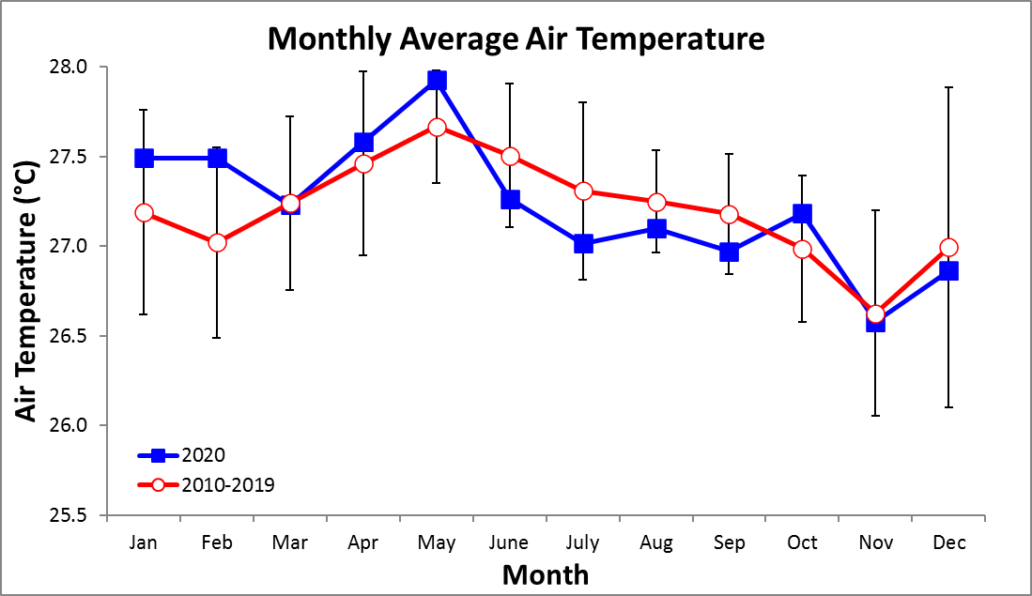
Monthly Average of Daily Maximum Temperature

Year | Jan | Feb | Mar | Apr | May | June | July | Aug | Sep | Oct | Nov | Dec
2010 |  |  | 32.1 | 31.7 | 31.4 | 29.9 | 29.4 | 30.0 | 29.2 | 29.6 | 29.5 | 28.4
2011 | 30.9 | 31.4 | 30.9 | 30.9 | 30.7 | 30.0 | 29.9 | 30.3 | 30.0 | 29.1 | 29.4 | 30.5
2012 | 31.6 | 31.3 | 30.9 | 30.8 | 30.7 | 31.4 | 31.6 | 30.6 | 32.1 | 30.6 | 31.3 | 31.8
2013 | 32.5 | 31.5 | 31.3 | 31.8 | 30.6 | 30.6 | 31.1 | 30.5 | 30.9 | 31.1 | 31.5 | 32.9
2014 | 32.3 | 32.2 | 32.4 | 32.0 | 31.4 | 31.4 | 32.4 | 31.4 | 31.1 | 30.4 | 31.2 | 31.6
2015 | 32.7 | 32.1 | 31.7 | 31.8 | 31.5 | 32.0 | 31.7 | 31.7 | 32.0 | 31.5 | 31.1 | 33.1
2016 | 32.3 | 32.5 | 32.4 | 31.4 | 30.5 | 30.6 | 30.5 | 30.4 | 30.5 | 29.8 | 29.4 | 31.3
2017 | 31.4 | 30.8 | 32.0 | 31.6 | 30.2 | 30.0 | 30.7 | 30.5 | 30.2 | 30.5 | 30.1 | 31.1
2018 | 31.1 | 31.6 | 31.8 | 31.0 | 30.1 | 30.9 | 31.6 | 30.9 | 30.9 | 29.9 | 30.9 | 31.9
2019 | 31.2 | 31.3 | 31.7 | 31.6 | 30.1 | 31.0 | 31.0 | 30.6 | 30.3 | 29.9 | 31.2 | 31.9
2020 | 31.7 | 31.9 | 32.4 | 31.8 | 31.6 | 30.3 | 30.4 | 30.5 | 30.2 | 30.1 | 29.5 | 31.8
mean | 31.8 | 31.7 | 31.8 | 31.5 | 30.8 | 30.7 | 30.9 | 30.7 | 30.7 | 30.2 | 30.4 | 31.5
sd | 0.6 | 0.5 | 0.6 | 0.4 | 0.6 | 0.7 | 0.9 | 0.5 | 0.9 | 0.7 | 0.9 | 1.3
min | 30.9 | 30.8 | 30.9 | 30.8 | 30.1 | 29.9 | 29.4 | 30.0 | 29.2 | 29.1 | 29.4 | 28.4
max | 32.7 | 32.5 | 32.4 | 32.0 | 31.6 | 32.0 | 32.4 | 31.7 | 32.1 | 31.5 | 31.5 | 33.1

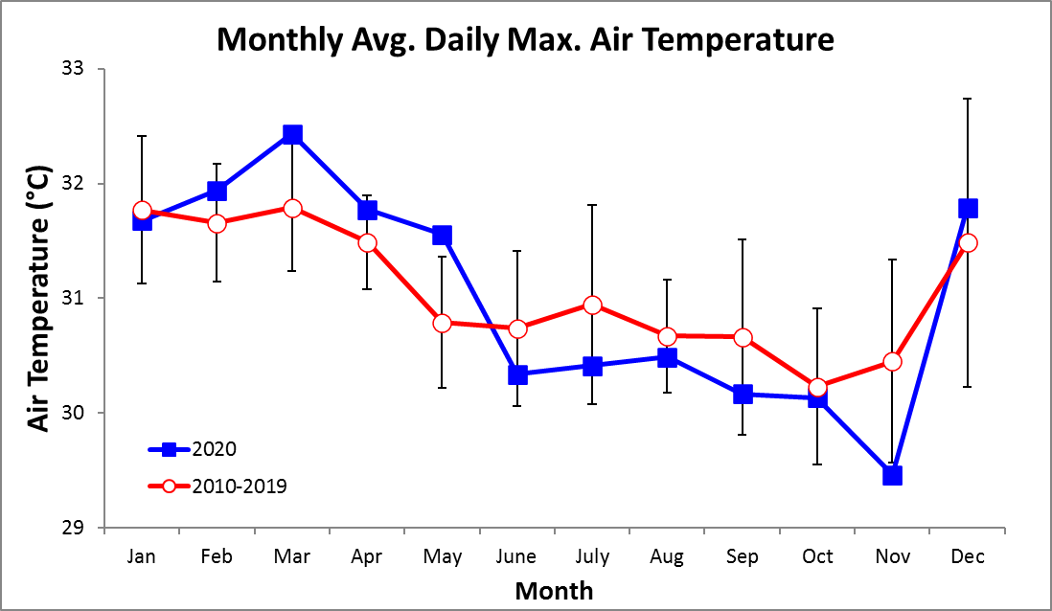
Monthly Average of Daily Minimum Temperature

Year | Jan | Feb | Mar | Apr | May | June | July | Aug | Sep | Oct | Nov | Dec
2010 |  |  | 25.8 | 25.7 | 26.2 | 25.1 | 24.7 | 24.8 | 25.0 | 24.6 | 24.0 | 23.1
2011 | 23.9 | 24.0 | 23.7 | 24.3 | 25.2 | 25.3 | 24.6 | 24.9 | 24.7 | 24.5 | 24.0 | 24.1
2012 | 24.2 | 23.8 | 24.2 | 24.4 | 25.3 | 26.0 | 25.4 | 25.3 | 25.4 | 24.9 | 24.9 | 25.0
2013 | 24.9 | 24.0 | 24.9 | 25.7 | 25.7 | 25.4 | 25.4 | 24.9 | 25.2 | 25.1 | 25.1 | 25.2
2014 | 24.9 | 24.5 | 24.7 | 25.6 | 25.6 | 25.8 | 26.0 | 25.3 | 24.9 | 25.0 | 24.9 | 25.0
2015 | 25.3 | 24.9 | 24.4 | 25.6 | 26.1 | 26.2 | 26.0 | 26.0 | 25.9 | 25.7 | 25.5 | 26.5
2016 | 25.4 | 25.3 | 25.1 | 25.1 | 25.6 | 24.9 | 24.8 | 25.3 | 24.8 | 24.7 | 24.2 | 24.7
2017 | 24.3 | 23.6 | 24.3 | 25.1 | 25.6 | 25.5 | 25.2 | 25.0 | 25.4 | 25.4 | 24.4 | 24.6
2018 | 24.4 | 23.6 | 24.3 | 24.4 | 25.5 | 25.1 | 25.4 | 25.0 | 24.7 | 24.9 | 24.9 | 24.9
2019 | 24.1 | 23.9 | 24.2 | 25.0 | 25.8 | 25.7 | 25.2 | 25.3 | 25.4 | 25.0 | 25.0 | 25.4
2020 | 25.1 | 24.9 | 24.0 | 25.2 | 25.8 | 25.1 | 25.0 | 25.1 | 24.7 | 25.2 | 24.6 | 24.7
mean | 24.6 | 24.2 | 24.5 | 25.1 | 25.7 | 25.5 | 25.2 | 25.2 | 25.1 | 25.0 | 24.7 | 24.8
sd | 0.5 | 0.6 | 0.6 | 0.5 | 0.3 | 0.4 | 0.5 | 0.3 | 0.4 | 0.4 | 0.5 | 0.8
min | 23.9 | 23.6 | 23.7 | 24.3 | 25.2 | 24.9 | 24.6 | 24.8 | 24.7 | 24.5 | 24.0 | 23.1
max | 25.4 | 25.3 | 25.8 | 25.7 | 26.2 | 26.2 | 26.0 | 26.0 | 25.9 | 25.7 | 25.5 | 26.5

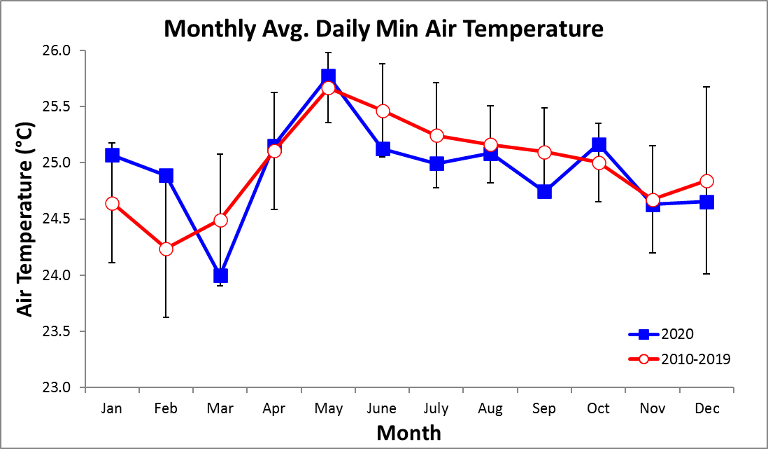
2020 Daily Total Radiation (MJ m⁻² day⁻¹)

 | Jan. | Feb. | Mar. | Apr. | May | June | July | Aug. | Sep. | Oct. | Nov. | Dec.
1 | 12.2 | 20.1 | 22.0 | 20.6 | 22.4 | 22.5 | 18.7 | 17.6 | 16.1 | 24.9 | 17.9 | 11.9
2 | 12.8 | 19.9 | 22.2 | 26.3 | 16.6 | 11.0 | 14.7 | 19.6 | 17.7 | 21.1 | 13.7 | 16.8
3 | 21.0 | 20.4 | 14.9 | 21.4 | 18.0 | 15.7 | 18.1 | 11.4 | 14.5 | 6.4 | 8.9 | 16.9
4 | 22.4 | 21.4 | 22.5 | 18.0 | 15.8 | 21.0 | 4.0 | 19.4 | 21.5 | 15.2 | 11.4 | 18.1
5 | 21.6 | 16.8 | 19.3 | 18.9 | 18.4 | 12.0 | 18.8 | 12.4 | 25.9 | 24.3 | 23.1 | 12.0
6 | 19.2 | 23.6 | 22.8 | 18.6 | 16.5 | 18.4 | 16.4 | 9.5 | 17.0 | 15.6 | 22.0 | 13.3
7 | 17.4 | 24.2 | 23.0 | 13.3 | 12.6 | 21.6 | 13.5 | 19.7 | 6.0 | 22.8 | 23.9 | 19.4
8 | 21.4 | 22.8 | 20.6 | 16.8 | 20.3 | 19.3 | 14.1 | 20.5 | 23.0 | 7.2 | 18.6 | 16.8
9 | 21.6 | 23.5 | 26.0 | 13.2 | 13.9 | 12.6 | 22.9 | 7.5 | 12.9 | 20.3 | 23.7 | 14.0
10 | 22.1 | 22.9 | 24.6 | 22.0 | 16.0 | 4.2 | 15.0 | 13.5 | 24.0 | 23.6 | 18.9 | 14.2
11 | 18.8 | 15.8 | 22.2 | 15.6 | 11.6 | 17.3 | 9.8 | 14.4 | 20.9 | 22.2 | 16.8 | 20.8
12 | 19.7 | 22.6 | 25.8 | 17.0 | 22.7 | 23.8 | 14.8 | 7.6 | 12.8 | 14.5 | 13.4 | 18.8
13 | 16.8 | 23.6 | 26.2 | 14.5 | 18.7 | 20.2 | 11.6 | 15.8 | 21.3 | 16.2 | 18.9 | 18.0
14 | 19.9 | 22.9 | 23.1 | 20.3 | 21.2 | 17.7 | 16.1 | 12.2 | 20.0 | 10.1 | 12.4 | 21.9
15 | 22.1 | 23.7 | 20.8 | 26.3 | 17.5 | 5.7 | 26.1 | 6.5 | 15.6 | 25.4 | 6.5 | 20.6
16 | 22.8 | 18.7 | 21.3 | 24.2 | 23.3 | 23.0 | 16.4 | 14.2 | 23.8 | 23.4 | 11.9 | 16.5
17 | 15.7 | 19.0 | 19.9 | 21.4 | 6.5 | 18.3 | 21.4 | 21.1 | 20.3 | 11.9 | 9.0 | 16.4
18 | 16.8 | 23.2 | 23.5 | 20.8 | 19.3 | 9.6 | 10.1 | 15.6 | 24.1 | 5.1 | 11.0 | 17.8
19 | 22.2 | 24.2 | 23.3 | 24.0 | 9.9 | 9.9 | 17.8 | 9.3 | 23.6 | 17.2 | 13.2 | 15.9
20 | 16.4 | 18.5 | 18.1 | 26.0 | 16.0 | 16.0 | 12.3 | 5.2 | 24.9 | 15.7 | 21.3 | 19.1
21 | 20.2 | 21.9 | 14.8 | 26.5 | 26.0 | 12.5 | 11.2 | 23.3 | 19.3 | 21.8 | 11.3 | 10.3
22 | 13.7 | 23.7 | 24.3 | 21.9 | 18.8 | 21.2 | 7.8 | 16.7 | 11.4 | 23.2 | 17.5 | 18.7
23 | 12.0 | 24.1 | 25.7 | 20.8 | 26.1 | 8.3 | 17.6 | 22.3 | 22.8 | 19.0 | 21.6 | 20.1
24 | 15.4 | 18.1 | 22.0 | 19.8 | 24.3 | 18.8 | 6.6 | 22.5 | 5.7 | 10.8 | 18.2 | 19.2
25 | 22.1 | 25.0 | 22.3 | 26.7 | 21.0 | 20.4 | 15.7 | 10.7 | 11.9 | 21.2 | 11.9 | 9.2
26 | 24.0 | 23.9 | 25.0 | 16.7 | 19.6 | 8.8 | 20.2 | 25.7 | 22.0 | 24.8 | 4.8 | 17.7
27 | 18.8 | 23.2 | 25.5 | 20.6 | 3.4 | 2.4 | 25.3 | 22.7 | 11.9 | 17.9 | 12.8 | 16.1
28 | 22.7 | 22.6 | 22.2 | 17.1 | 7.8 | 12.0 | 22.8 | 15.4 | 18.6 | 17.8 | 18.6 | 11.7
29 | 20.9 | 25.1 | 23.5 | 23.3 | 13.4 | 14.0 | 19.2 | 16.7 | 17.2 | 15.0 | 15.4 | 19.3
30 | 23.5 |  | 22.5 | 21.4 | 13.3 | 14.7 | 23.4 | 19.5 | 5.3 | 24.9 | 15.7 | 21.1
31 | 16.3 |  | 21.3 |  | 15.0 |  | 18.4 | 26.3 |  | 18.7 |  | 21.2

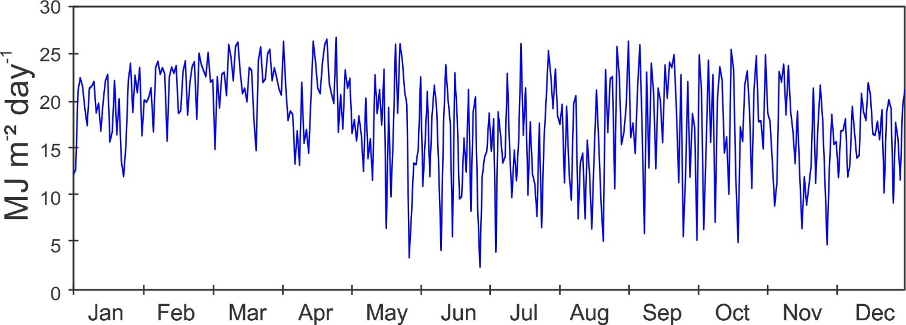
Monthly Average Total Daily Solar Radiation (MJ m⁻² day⁻¹)

Year | Jan | Feb | Mar | Apr | May | June | July | Aug | Sep | Oct | Nov | Dec
2010 |  |  | 18.3 | 17.6 | 18.0 | 14.9 | 14.6 | 16.7 | 15.4 | 13.7 | 14.2 | 13.1
2011 | 16.1 | 18.3 | 18.3 | 17.8 | 16.3 | 14.3 | 14.1 | 16.3 | 15.1 | 14.5 | 13.2 | 13.5
2012 | 17.2 | 17.9 | 17.4 | 17.9 | 15.8 | 16.0 | 14.6 | 15.6 | 14.8 | 14.9 | 13.9 | 14.5
2013 | 17.6 | 18.2 | 16.2 | 17.1 | 14.5 | 14.2 | 14.6 | 15.0 | 14.0 | 14.4 | 15.4 | 14.8
2014 | 17.0 | 16.8 | 17.7 | 16.0 | 15.6 | 13.7 | 15.7 | 14.5 | 16.1 | 15.1 | 15.6 | 14.5
2015 | 16.7 | 17.4 | 19.3 | 18.5 | 14.7 | 16.2 | 15.5 | 14.9 | 15.4 | 15.4 | 13.6 | 16.4
2016 | 17.7 | 17.8 | 17.7 | 19.5 | 16.1 | 15.3 | 13.9 | 14.6 | 16.0 | 15.6 | 12.7 | 15.7
2017 | 18.5 | 20.5 | 17.3 | 19.9 | 16.7 | 14.5 | 13.4 | 15.6 | 15.4 | 15.3 | 14.4 | 15.0
2018 | 16.2 | 20.4 | 19.6 | 18.3 | 16.3 | 14.5 | 16.2 | 16.3 | 17.3 | 18.2 | 15.6 | 19.5
2019 | 20.0 | 20.4 | 22.4 | 20.7 | 16.3 | 15.9 | 16.1 | 16.1 | 16.1 | 16.5 | 16.3 | 16.0
2020 | 19.1 | 21.9 | 22.3 | 20.5 | 16.9 | 15.0 | 16.1 | 16.0 | 17.6 | 18.0 | 15.5 | 16.8
mean | 17.6 | 19.0 | 18.8 | 18.5 | 16.1 | 15.0 | 15.0 | 15.6 | 15.7 | 15.6 | 14.6 | 15.4
sd | 1.3 | 1.7 | 2.0 | 1.5 | 1.0 | 0.8 | 1.0 | 0.8 | 1.0 | 1.4 | 1.2 | 1.8
min | 16.1 | 16.8 | 16.2 | 16.0 | 14.5 | 13.7 | 13.4 | 14.5 | 14.0 | 13.7 | 12.7 | 13.1
max | 20.0 | 21.9 | 22.4 | 20.7 | 18.0 | 16.2 | 16.2 | 16.7 | 17.6 | 18.2 | 16.3 | 19.5

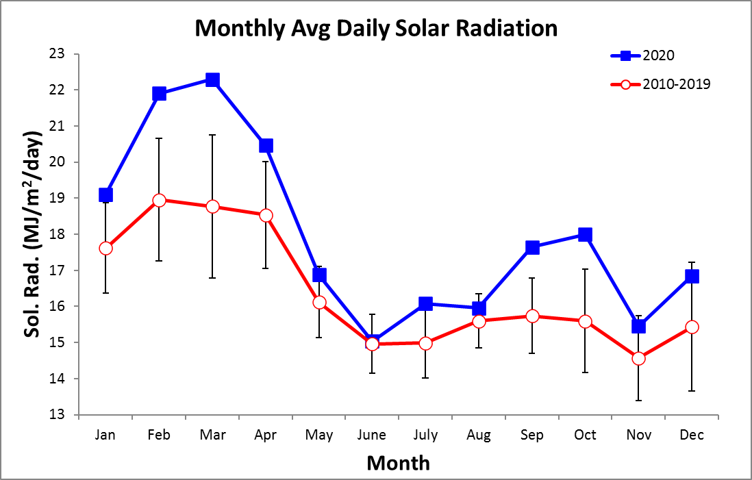

2020 Daily Average Wind Speed (km/h)
 | Jan. |  | Feb. |  |  | Mar. |  |  | Apr. |  |  | May |  |  | June |  | July |  | Aug. |  | Sep. |  | Oct. |  | Nov. |  |  | Dec.
 | Avg | Max | Avg | Max | Avg |  | Max | Avg |  | Max | Avg |  | Max | Avg |  | Max | Avg | Max | Avg | Max | Avg | Max | Avg | Max | Avg | Max | Avg |  |  | Max
1 | 11.6 | 27.7 | 18.7 | 37.0 | 14.0 |  | 31.9 | 6.8 |  | 23.1 | 11.0 |  | 26.4 | 8.5 |  | 18.9 | 14.3 | 27.9 | 10.9 | 27.3 | 8.8 | 20.9 | 7.0 | 19.1 | 17.9 | 43.7 | 11.0 |  | 32.5
2 | 10.9 | 22.7 | 10.2 | 25.3 | 12.3 |  | 32.2 | 7.5 |  | 32.4 | 10.4 |  | 25.5 | 9.5 |  | 34.3 | 13.0 | 28.7 | 11.1 | 29.4 | 9.7 | 20.8 | 11.5 | 24.9 | 28.7 | 47.2 | 9.8 |  | 24.7
3 | 11.9 | 31.5 | 14.8 | 34.4 | 11.8 |  | 36.6 | 13.9 |  | 35.4 | 12.5 |  | 30.1 | 12.8 |  | 29.1 | 9.7 | 28.2 | 10.2 | 26.2 | 7.5 | 27.8 | 16.9 | 30.6 | 32.9 | 54.2 | 7.6 |  | 22.5
4 | 13.9 | 35.9 | 14.3 | 32.9 | 12.4 |  | 33.3 | 8.5 |  | 25.9 | 12.6 |  | 27.4 | 10.0 |  | 24.3 | 8.0 | 41.1 | 7.3 | 23.0 | 9.4 | 22.1 | 13.7 | 29.9 | 30.5 | 48.7 | 9.9 |  | 23.1
5 | 8.5 | 28.1 | 13.1 | 30.7 | 16.2 |  | 40.9 | 10.3 |  | 28.2 | 15.0 |  | 41.3 | 7.5 |  | 17.6 | 7.5 | 20.0 | 8.1 | 32.6 | 3.0 | 44.8 | 16.6 | 35.8 | 24.8 | 33.6 | 8.1 |  | 25.4
6 | 11.2 | 28.6 | 15.1 | 36.7 | 13.8 |  | 38.4 | 12.7 |  | 35.0 | 15.2 |  | 30.1 | 6.5 |  | 17.0 | 10.3 | 30.2 | 7.2 | 28.6 | 8.7 | 35.8 | 12.3 | 29.5 | 22.6 | 35.9 | 11.9 |  | 29.5
7 | 10.8 | 29.0 | 15.7 | 40.6 | 11.5 |  | 32.3 | 12.3 |  | 39.8 | 13.3 |  | 38.9 | 7.8 |  | 17.8 | 10.9 | 25.9 | 12.0 | 30.2 | 11.8 | 40.4 | 12.8 | 25.8 | 24.3 | 38.1 | 16.2 |  | 35.7
8 | 10.9 | 35.3 | 13.4 | 31.2 | 9.6 |  | 30.8 | 13.8 |  | 32.8 | 12.6 |  | 32.9 | 7.7 |  | 20.9 | 15.2 | 30.0 | 13.5 | 36.3 | 16.8 | 41.0 | 12.2 | 38.3 | 14.8 | 30.5 | 12.0 |  | 36.9
9 | 12.2 | 36.4 | 13.7 | 34.6 | 11.5 |  | 35.1 | 11.2 |  | 27.6 | 15.2 |  | 32.3 | 11.0 |  | 41.5 | 7.8 | 24.1 | 12.7 | 31.8 | 9.9 | 30.2 | 9.2 | 24.6 | 10.4 | 21.1 | 12.7 |  | 35.3
10 | 13.3 | 31.7 | 12.8 | 31.9 | 16.1 |  | 37.9 | 12.3 |  | 33.8 | 12.6 |  | 36.7 | 8.4 |  | 41.2 | 11.7 | 34.6 | 8.2 | 20.0 | 8.4 | 20.9 | 8.1 | 28.8 | 10.0 | 20.8 | 10.2 |  | 25.4
11 | 11.9 | 29.7 | 13.8 | 33.0 | 11.7 |  | 41.3 | 11.1 |  | 26.6 | 11.9 |  | 31.3 | 12.2 |  | 32.0 | 9.2 | 24.0 | 9.4 | 23.5 | 7.8 | 30.2 | 10.8 | 33.0 | 7.9 | 21.4 | 8.6 |  | 25.4
12 | 12.7 | 30.2 | 14.8 | 30.7 | 10.7 |  | 32.2 | 9.4 |  | 36.8 | 12.5 |  | 27.9 | 7.8 |  | 18.7 | 7.2 | 26.4 | 7.7 | 27.8 | 7.4 | 24.6 | 6.9 | 22.1 | 4.8 | 21.8 | 11.9 |  | 26.5
13 | 13.8 | 30.0 | 15.0 | 30.9 | 11.1 |  | 29.1 | 7.2 |  | 23.9 | 8.0 |  | 25.1 | 6.6 |  | 24.9 | 11.4 | 34.9 | 12.2 | 27.6 | 9.2 | 25.5 | 6.8 | 24.0 | 6.2 | 24.3 | 10.7 |  | 24.4
14 | 12.1 | 32.3 | 14.9 | 36.0 | 11.0 |  | 32.0 | 11.6 |  | 26.0 | 8.2 |  | 27.8 | 6.6 |  | 17.3 | 8.3 | 33.7 | 9.8 | 37.7 | 6.6 | 18.7 | 6.3 | 21.9 | 13.1 | 41.2 | 16.0 |  | 37.5
15 | 11.9 | 34.6 | 14.6 | 38.4 | 10.3 |  | 39.0 | 7.9 |  | 22.8 | 11.1 |  | 25.5 | 9.4 |  | 38.5 | 10.6 | 33.2 | 8.6 | 36.0 | 12.2 | 40.6 | 6.1 | 16.8 | 22.2 | 42.8 | 12.7 |  | 29.6
16 | 14.1 | 35.5 | 12.5 | 37.6 | 11.9 |  | 37.1 | 12.5 |  | 45.0 | 12.1 |  | 30.8 | 6.4 |  | 19.7 | 12.0 | 30.8 | 9.4 | 24.2 | 9.9 | 28.3 | 11.4 | 30.4 | 27.3 | 43.6 | 13.2 |  | 29.5
17 | 11.8 | 29.4 | 14.9 | 41.5 | 12.3 |  | 34.6 | 9.9 |  | 25.3 | 11.5 |  | 56.1 | 8.4 |  | 21.9 | 15.3 | 33.0 | 8.0 | 18.4 | 8.4 | 21.2 | 15.2 | 31.7 | 27.0 | 40.3 | 9.7 |  | 27.2
18 | 14.7 | 31.7 | 18.0 | 42.1 | 11.4 |  | 33.9 | 17.5 |  | 41.1 | 8.1 |  | 31.3 | 13.3 |  | 33.5 | 15.1 | 30.4 | 12.8 | 37.8 | 8.3 | 27.1 | 14.7 | 32.5 | 19.4 | 38.4 | 11.1 |  | 29.5
19 | 14.4 | 33.2 | 17.0 | 40.8 | 11.7 |  | 36.4 | 13.2 |  | 36.5 | 9.2 |  | 40.6 | 10.9 |  | 24.7 | 11.9 | 36.5 | 10.0 | 25.4 | 8.9 | 36.3 | 10.6 | 46.3 | 6.8 | 22.4 | 7.6 |  | 23.8
20 | 13.3 | 31.9 | 13.3 | 35.0 | 13.2 |  | 32.3 | 13.3 |  | 34.1 | 6.5 |  | 18.6 | 7.8 |  | 19.0 | 13.2 | 43.3 | 8.2 | 25.8 | 8.5 | 23.4 | 20.0 | 44.6 | 6.8 | 27.4 | 10.5 |  | 30.1
21 | 15.5 | 37.5 | 11.6 | 33.0 | 10.9 |  | 32.2 | 8.4 |  | 21.5 | 7.5 |  | 17.5 | 8.3 |  | 23.7 | 8.9 | 27.3 | 12.8 | 22.9 | 10.6 | 35.2 | 18.0 | 29.6 | 16.4 | 38.4 | 9.6 |  | 24.5
22 | 14.7 | 33.6 | 13.4 | 39.1 | 9.2 |  | 27.8 | 12.1 |  | 44.7 | 9.5 |  | 34.9 | 13.6 |  | 31.6 | 10.2 | 28.4 | 8.3 | 27.4 | 11.0 | 35.1 | 11.4 | 27.2 | 17.3 | 35.6 | 10.4 |  | 25.1
23 | 10.1 | 24.3 | 11.1 | 33.0 | 11.8 |  | 35.5 | 10.5 |  | 31.2 | 7.8 |  | 20.0 | 9.3 |  | 26.6 | 9.2 | 32.0 | 7.0 | 21.3 | 10.2 | 25.8 | 3.5 | 24.5 | 8.1 | 24.5 | 7.8 |  | 26.1
24 | 10.2 | 29.9 | 9.8 | 24.5 | 11.9 |  | 31.7 | 10.1 |  | 33.5 | 7.8 |  | 19.2 | 10.2 |  | 27.1 | 8.2 | 31.1 | 8.0 | 20.4 | 4.7 | 20.7 | 12.3 | 32.6 | 11.2 | 45.0 | 10.2 |  | 27.8
25 | 12.6 | 38.0 | 10.3 | 35.2 | 12.3 |  | 28.2 | 9.5 |  | 30.1 | 9.3 |  | 25.5 | 11.6 |  | 24.6 | 4.8 | 18.9 | 13.9 | 51.9 | 6.7 | 20.4 | 20.2 | 41.0 | 9.2 | 25.2 | 17.5 |  | 37.0
26 | 15.3 | 36.2 | 8.2 | 24.1 | 10.7 |  | 30.4 | 10.7 |  | 34.2 | 7.6 |  | 28.8 | 10.5 |  | 42.7 | 6.9 | 36.3 | 26.6 | 50.8 | 8.2 | 20.7 | 13.3 | 30.7 | 8.6 | 32.7 | 12.8 |  | 31.8
27 | 10.9 | 28.6 | 8.6 | 28.8 | 11.3 |  | 32.6 | 12.1 |  | 35.3 | 10.4 |  | 33.2 | 10.4 |  | 40.4 | 7.3 | 29.4 | 8.2 | 29.9 | 8.8 | 29.4 | 6.1 | 19.6 | 10.8 | 34.5 | 12.7 |  | 30.0
28 | 8.5 | 17.7 | 13.0 | 34.5 | 12.6 |  | 31.7 | 9.7 |  | 30.9 | 6.3 |  | 16.6 | 10.3 |  | 23.4 | 8.0 | 26.5 | 7.5 | 27.0 | 9.5 | 28.6 | 9.6 | 24.6 | 9.0 | 22.7 | 12.0 |  | 25.2
29 | 8.4 | 19.4 | 10.8 | 28.5 | 14.2 |  | 35.2 | 9.9 |  | 27.1 | 12.5 |  | 32.6 | 9.4 |  | 37.0 | 9.9 | 27.3 | 9.8 | 29.8 | 13.7 | 32.4 | 10.2 | 34.6 | 11.6 | 30.5 | 12.5 |  | 30.0
30 | 9.9 | 28.2 |  |  | 13.9 |  | 37.9 | 9.9 |  | 27.9 | 16.7 |  | 34.8 | 11.7 |  | 28.5 | 10.4 | 31.2 | 9.2 | 24.2 | 8.5 | 36.6 | 10.2 | 26.1 | 11.7 | 32.3 | 12.7 |  | 29.9
31 | 11.6 | 26.6 |  |  | 11.5 |  | 28.9 |  |  |  | 14.1 |  | 23.6 |  |  |  | 11.4 | 32.0 | 11.2 | 26.9 |  |  | 8.5 | 31.9 |  |  | 8.8 |  | 29.1
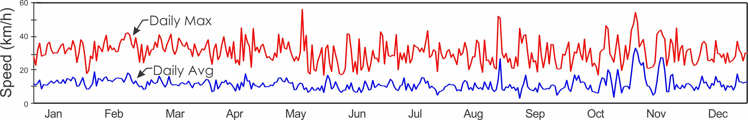
2020 Average Daily Wind Direction (°)
 |  | Jan. | Feb. | Mar. | Apr. | May | June | July | Aug. | Sep. | Oct. | Nov. | Dec.
 | 1 | 315.0 | 310.4 | 319.7 | 283.3 | 294.9 | 166.2 | 304.4 | 312.3 | 325.1 | 198.3 | 233.4 | 312.9
 | 2 | 315.4 | 336.6 | 322.7 | 227.9 | 319.5 | 301.7 | 311.3 | 316.5 | 88.8 | 121.4 | 206.2 | 301.4
 | 3 | 312.8 | 318.9 | 313.9 | 313.0 | 319.0 | 126.3 | 306.4 | 313.3 | 95.1 | 221.5 | 186.4 | 308.1
 | 4 | 316.4 | 319.6 | 303.1 | 337.5 | 309.9 | 174.8 | 315.5 | 310.9 | 122.3 | 205.1 | 177.7 | 304.2
 | 5 | 336.4 | 318.0 | 316.6 | 326.9 | 308.0 | 136.3 | 92.0 | 326.4 | 358.2 | 193.0 | 186.2 | 345.5
 | 6 | 322.6 | 313.6 | 324.7 | 319.7 | 306.4 | 271.4 | 317.0 | 17.9 | 308.2 | 152.1 | 189.1 | 313.6
 | 7 | 324.1 | 312.1 | 325.2 | 324.1 | 312.2 | 84.1 | 315.2 | 317.0 | 194.3 | 140.4 | 196.8 | 311.6
 | 8 | 345.9 | 321.9 | 337.9 | 322.2 | 293.8 | 318.4 | 308.8 | 310.8 | 113.5 | 140.9 | 183.0 | 312.7
 | 9 | 348.0 | 322.6 | 330.6 | 320.9 | 307.2 | 304.8 | 280.4 | 308.4 | 190.2 | 91.5 | 182.4 | 312.3
 | 10 | 334.8 | 326.2 | 319.7 | 313.7 | 310.2 | 250.0 | 318.5 | 303.0 | 309.1 | 301.4 | 163.4 | 336.9
 | 11 | 339.3 | 320.0 | 322.1 | 315.7 | 301.5 | 176.4 | 293.5 | 324.1 | 307.1 | 321.0 | 127.6 | 327.5
 | 12 | 322.8 | 317.9 | 320.4 | 299.1 | 297.8 | 141.5 | 358.7 | 300.7 | 15.2 | 338.8 | 315.1 | 317.2
 | 13 | 319.9 | 318.3 | 311.3 | 243.9 | 308.5 | 272.6 | 315.1 | 307.8 | 98.4 | 325.2 | 18.3 | 321.8
 | 14 | 323.9 | 322.3 | 323.0 | 144.0 | 305.0 | 289.8 | 322.8 | 229.5 | 186.3 | 27.6 | 268.9 | 311.9
 | 15 | 325.3 | 325.9 | 349.0 | 156.7 | 313.8 | 316.8 | 308.9 | 118.2 | 308.1 | 299.2 | 229.9 | 302.7
 | 16 | 316.2 | 329.8 | 352.8 | 309.2 | 310.4 | 284.2 | 310.1 | 313.0 | 144.6 | 307.4 | 200.8 | 308.8
 | 17 | 328.3 | 327.8 | 325.6 | 330.5 | 309.0 | 318.2 | 305.3 | 323.8 | 220.6 | 318.8 | 190.8 | 327.9
 | 18 | 314.7 | 322.7 | 325.6 | 313.9 | 309.3 | 312.7 | 307.2 | 311.5 | 339.0 | 312.6 | 212.8 | 331.5
 | 19 | 316.1 | 318.9 | 306.6 | 301.1 | 335.6 | 315.4 | 312.8 | 303.4 | 301.0 | 275.5 | 291.3 | 328.6
 | 20 | 318.2 | 329.3 | 313.4 | 307.1 | 350.8 | 323.4 | 293.2 | 174.6 | 288.1 | 203.3 | 318.6 | 339.4
 | 21 | 314.8 | 328.7 | 322.6 | 298.4 | 300.9 | 306.9 | 277.8 | 177.7 | 316.2 | 184.7 | 206.6 | 322.0
 | 22 | 311.1 | 322.1 | 332.7 | 302.6 | 328.9 | 309.4 | 311.6 | 37.8 | 308.1 | 191.0 | 172.5 | 318.2
 | 23 | 307.7 | 326.4 | 311.5 | 300.6 | 290.5 | 314.9 | 313.3 | 94.5 | 286.9 | 1.2 | 26.7 | 320.7
 | 24 | 322.5 | 298.9 | 298.3 | 307.0 | 314.8 | 312.5 | 293.4 | 76.8 | 354.4 | 163.6 | 307.5 | 304.4
 | 25 | 319.1 | 313.7 | 316.4 | 297.7 | 252.0 | 303.7 | 12.8 | 262.9 | 323.8 | 193.7 | 314.3 | 311.8
 | 26 | 313.0 | 269.1 | 316.7 | 310.5 | 321.8 | 313.2 | 301.5 | 185.0 | 325.8 | 163.8 | 331.7 | 316.5
 | 27 | 321.0 | 319.2 | 309.2 | 311.0 | 313.7 | 306.9 | 314.8 | 184.4 | 317.1 | 10.8 | 321.1 | 312.8
 | 28 | 305.1 | 324.7 | 330.8 | 318.9 | 144.6 | 285.5 | 79.9 | 297.0 | 330.2 | 272.1 | 327.2 | 308.0
 | 29 | 328.4 | 336.1 | 320.1 | 301.4 | 196.1 | 315.9 | 315.7 | 314.3 | 310.1 | 86.3 | 312.7 | 309.8
 | 30 | 306.3 |  | 319.4 | 312.4 | 186.4 | 311.6 | 305.6 | 349.8 | 288.5 | 177.8 | 300.6 | 306.4
 | 31 | 313.9 |  | 320.8 |  | 183.4 |  | 315.3 | 316.1 |  | 283.8 |  | 305.4
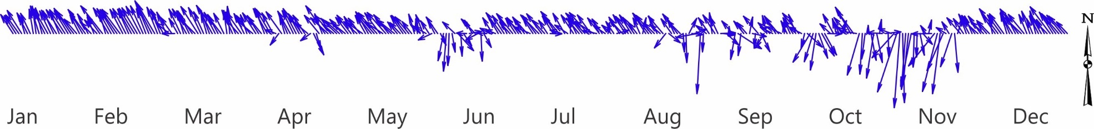

Average Monthly Wind Speed (km/h)

Year | Jan | Feb | Mar | Apr | May | June | July | Aug | Sep | Oct | Nov | Dec
2010 |  |  | 14.3 | 11.8 | 13.6 | 11.5 | 10.7 | 10.4 | 14.9 | 11.1 | 13.1 | 13.9
2011 | 13.0 | 11.7 | 11.6 | 11.1 | 10.5 | 12.7 | 10.9 | 9.4 | 9.3 | 14.0 | 10.9 | 11.8
2012 | 11.7 | 12.3 | 12.8 | 11.1 | 10.2 | 10.9 | 12.4 | 10.4 | 10.6 | 12.8 | 13.2 | 11.8
2013 | 12.7 | 12.3 | 12.6 | 12.5 | 11.8 | 10.6 | 10.9 | 10.5 | 9.5 | 9.5 | 9.9 | 10.4
2014 | 12.8 | 13.4 | 12.6 | 12.8 | 10.8 | 11.3 | 12.7 | 11.2 | 9.9 | 11.9 | 10.7 | 12.0
2015 | 12.1 | 13.0 | 13.0 | 12.1 | 12.7 | 11.9 | 13.9 | 13.0 | 11.5 | 10.1 | 10.5 | 12.5
2016 | 13.1 | 13.7 | 13.3 | 11.9 | 11.3 | 9.9 | 11.8 | 11.0 | 10.6 | 11.5 | 12.4 | 11.0
2017 | 12.1 | 11.6 | 11.3 | 11.0 | 10.9 | 10.3 | 11.1 | 8.5 | 10.2 | 12.7 | 12.3 | 12.4
2018 | 13.1 | 11.3 | 12.5 | 7.9 | 9.2 | 10.1 | 11.3 | 11.5 | 9.7 | 13.6 | 10.6 | 12.5
2019 | 13.6 | 13.8 | 13.2 | 12.2 | 10.8 | 10.9 | 12.4 | 11.0 | 11.9 | 10.2 | 10.9 | 11.4
2020 | 12.1 | 13.4 | 12.1 | 10.9 | 10.9 | 9.5 | 10.3 | 10.3 | 9.1 | 11.4 | 15.7 | 11.2
mean | 12.6 | 12.7 | 12.7 | 11.4 | 11.2 | 10.9 | 11.7 | 10.6 | 10.7 | 11.7 | 11.8 | 11.9
sd | 0.6 | 0.9 | 0.8 | 1.3 | 1.2 | 0.9 | 1.1 | 1.2 | 1.7 | 1.5 | 1.7 | 0.9
min | 11.7 | 11.3 | 11.3 | 7.9 | 9.2 | 9.5 | 10.3 | 8.5 | 9.1 | 9.5 | 9.9 | 10.4
max | 13.6 | 13.8 | 14.3 | 12.8 | 13.6 | 12.7 | 13.9 | 13.0 | 14.9 | 14.0 | 15.7 | 13.9

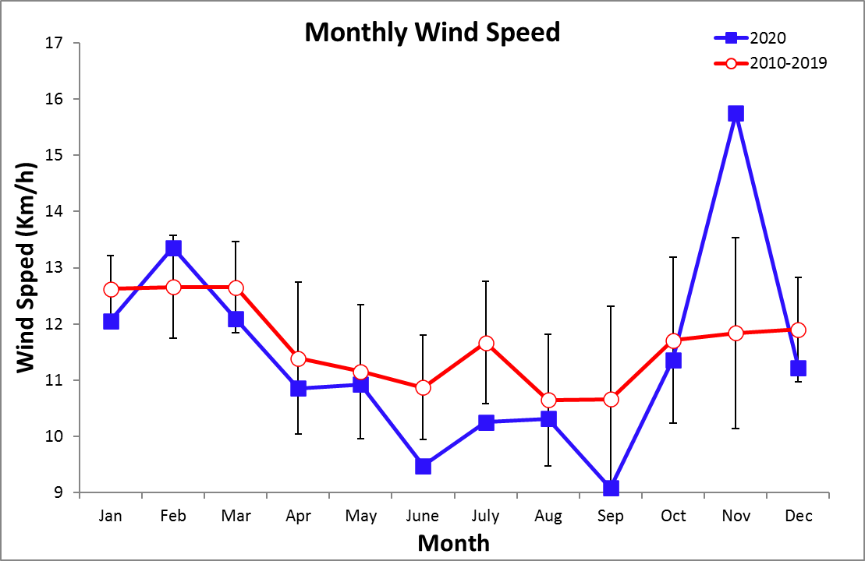

Average Monthly Max. Wind Speed (km/h)

Year | Jan | Feb | Mar | Apr | May | June | July | Aug | Sep | Oct | Nov | Dec
2010 |  |  | 35.9 | 30.7 | 32.1 | 30.0 | 29.6 | 28.6 | 34.3 | 30.7 | 31.2 | 33.7
2011 | 32.1 | 31.1 | 32.8 | 31.9 | 27.5 | 32.0 | 31.3 | 29.3 | 27.0 | 34.3 | 28.5 | 29.9
2012 | 30.2 | 32.2 | 34.5 | 30.9 | 29.1 | 30.4 | 32.7 | 29.1 | 31.6 | 33.3 | 33.8 | 31.1
2013 | 31.7 | 32.2 | 32.4 | 32.7 | 30.6 | 31.5 | 29.1 | 29.9 | 27.6 | 27.4 | 26.3 | 28.1
2014 | 32.2 | 33.2 | 32.6 | 32.5 | 30.8 | 30.3 | 33.1 | 29.3 | 29.5 | 32.2 | 28.3 | 30.6
2015 | 32.1 | 33.2 | 34.6 | 33.4 | 34.5 | 31.5 | 33.8 | 33.5 | 31.3 | 28.1 | 28.9 | 30.2
2016 | 33.9 | 35.3 | 34.7 | 30.3 | 29.3 | 30.8 | 32.0 | 28.9 | 30.8 | 29.3 | 32.0 | 28.1
2017 | 31.7 | 30.7 | 32.9 | 31.0 | 29.2 | 27.5 | 30.2 | 29.8 | 26.4 | 30.5 | 32.2 | 32.5
2018 | 32.7 | 30.1 | 33.3 | 26.2 | 25.8 | 27.7 | 31.7 | 31.4 | 27.9 | 31.7 | 28.2 | 31.0
2019 | 34.0 | 34.3 | 36.1 | 34.3 | 29.6 | 30.5 | 31.3 | 31.3 | 31.2 | 28.5 | 30.5 | 30.0
2020 | 30.5 | 33.9 | 33.8 | 31.6 | 29.8 | 27.3 | 30.2 | 29.1 | 28.8 | 29.4 | 34.0 | 28.7
mean | 32.1 | 32.6 | 34.0 | 31.4 | 29.8 | 29.9 | 31.4 | 30.0 | 29.7 | 30.5 | 30.3 | 30.3
sd | 1.2 | 1.7 | 1.3 | 2.1 | 2.3 | 1.7 | 1.5 | 1.5 | 2.4 | 2.2 | 2.5 | 1.7
min | 30.2 | 30.1 | 32.4 | 26.2 | 25.8 | 27.3 | 29.1 | 28.6 | 26.4 | 27.4 | 26.3 | 28.1
max | 34.0 | 35.3 | 36.1 | 34.3 | 34.5 | 32.0 | 33.8 | 33.5 | 34.3 | 34.3 | 34.0 | 33.7

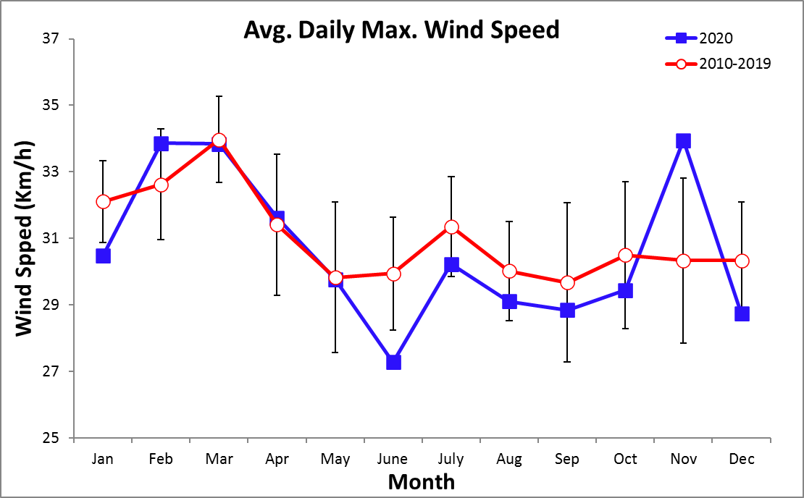

Average Monthly Wind Direction

Year | Jan | Feb | Mar | Apr | May | June | July | Aug | Sep | Oct | Nov | Dec
2010 |  |  | 325.7 | 308.5 | 254.3 | 291.5 | 289.3 | 241.2 | 185.4 | 303.9 | 298.5 | 316.8
2011 | 314.9 | 316.4 | 322.9 | 312.0 | 309.2 | 274.4 | 307.8 | 308.9 | 314.5 | 237.6 | 311.9 | 317.2
2012 | 323.9 | 322.9 | 323.6 | 312.5 | 310.1 | 302.3 | 313.3 | 307.5 | 313.3 | 288.0 | 313.0 | 313.9
2013 | 321.8 | 318.5 | 321.7 | 314.9 | 310.3 | 308.1 | 313.1 | 312.2 | 264.9 | 307.8 | 316.3 | 311.5
2014 | 315.9 | 315.7 | 318.7 | 317.0 | 314.3 | 314.7 | 314.7 | 313.8 | 321.2 | 277.9 | 318.6 | 317.4
2015 | 326.9 | 322.5 | 323.8 | 315.7 | 318.7 | 317.5 | 315.5 | 318.3 | 313.6 | 315.4 | 314.5 | 317.9
2016 | 324.1 | 330.2 | 322.8 | 308.6 | 308.2 | 307.9 | 309.8 | 310.2 | 309.3 | 271.1 | 286.7 | 309.7
2017 | 322.2 | 318.2 | 322.2 | 304.4 | 276.0 | 306.5 | 305.9 | 312.9 | 246.5 | 271.3 | 297.1 | 318.4
2018 | 312.7 | 319.5 | 320.1 | 310.7 | 314.8 | 319.2 | 318.8 | 320.0 | 325.7 | 290.0 | 322.6 | 321.3
2019 | 323.7 | 324.2 | 328.0 | 321.1 | 302.7 | 323.1 | 322.2 | 319.9 | 294.3 | 271.6 | 312.9 | 313.0
2020 | 321.0 | 321.6 | 322.0 | 310.1 | 301.9 | 302.4 | 311.1 | 303.8 | 312.0 | 222.9 | 226.5 | 315.8
mean | 320.5 | 321.0 | 322.2 | 312.0 | 308.9 | 308.7 | 312.4 | 312.7 | 306.7 | 289.0 | 309.2 | 316.1

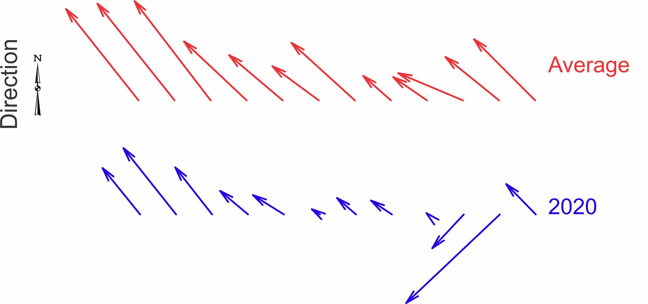

Average Monthly SST
STRI Pier
Year | Jan | Feb | Mar | Apr | May | June | July | Aug | Sep | Oct | Nov | Dec
2012 |  |  |  |  |  |  |  |  |  |  |  | 27.9
2013 | 26.4 | 23.8 | 24.3 | 26.8 | 28.4 | 29.0 | 28.8 | 28.5 | 29.1 | 28.4 | 28.7 | 28.4
2014 | 26.4 | 24.7 | 25.5 | 25.6 | 28.8 | 29.0 | 29.2 | 29.0 | 29.2 | 29.1 | 29.0 | 28.3
2015 | 27.5 | 25.6 | 23.6 | 26.4 | 28.7 | 29.2 | 29.2 | 29.4
2016
2017 |  |  |  |  |  | 29.2 | 28.7 | 28.8 | 29.3 | 28.7 | 28.0 | 27.4
2018 | 27.2 | 23.8 | 23.5 | 26.6 | 29.2 | 28.6 | 28.5 | 28.2 | 28.9 | 28.5 | 28.5 | 27.7
2019 | 23.7 | 22.4 | 22.7 | 25.0 | 28.8 | 29.3 | 28.6 | 28.7 | 28.6 | 28.7 | 28.2 | 28.2
mean | 26.3 | 24.1 | 23.9 | 26.1 | 28.8 | 29.0 | 28.8 | 28.8 | 29.0 | 28.7 | 28.5 | 28.0
sd | 1.5 | 1.2 | 1.0 | 0.8 | 0.3 | 0.2 | 0.3 | 0.4 | 0.3 | 0.3 | 0.4 | 0.4
min | 23.7 | 22.4 | 22.7 | 25.0 | 28.4 | 28.6 | 28.5 | 28.2 | 28.6 | 28.4 | 28.0 | 27.4
max | 27.5 | 25.6 | 25.5 | 26.8 | 29.2 | 29.3 | 29.2 | 29.4 | 29.3 | 29.1 | 29.0 | 28.4

ACP Pier
Year | Jan | Feb | Mar | Apr | May | June | July | Aug | Sep | Oct | Nov | Dec
2012 |  |  |  |  |  |  |  |  |  |  |  | 27.9
2013 | 26.4 | 23.8 | 24.3 | 26.8 | 28.4 | 29.0 | 28.8 | 28.5 | 29.1 | 28.4 | 28.7 | 28.4
2014 | 26.4 | 24.7 | 25.5 | 25.6 | 28.8 | 29.0 | 29.2 | 29.0 | 29.2 | 29.1 | 29.0 | 28.3
2015 | 27.5 | 25.6 | 23.6 | 26.4 | 28.7 | 29.2 | 29.2 | 29.4
2016
2017 |  |  |  |  |  |  | 28.6 | 28.6 | 28.9 | 28.4 | 27.8 | 27.0
2018 | 26.7 | 21.6 | 21.9 | 23.9 | 28.7 | 28.5 | 28.2 | 28.0 | 28.6 | 28.4 | 28.2 | 27.4
2019 | 22.5 | 21.0 | 20.6 | 23.8 | 28.2 | 29.1 | 28.4 | 28.4 | 28.2 | 28.4 | 27.8 | 27.9
mean | 25.9 | 23.4 | 23.2 | 25.3 | 28.5 | 28.9 | 28.7 | 28.6 | 28.8 | 28.6 | 28.3 | 27.8
sd | 2.0 | 2.0 | 1.9 | 1.4 | 0.3 | 0.3 | 0.4 | 0.5 | 0.4 | 0.3 | 0.5 | 0.5
min | 22.5 | 21.0 | 20.6 | 23.8 | 28.2 | 28.5 | 28.2 | 28.0 | 28.2 | 28.4 | 27.8 | 27.0
max | 27.5 | 25.6 | 25.5 | 26.8 | 28.8 | 29.2 | 29.2 | 29.4 | 29.2 | 29.1 | 29.0 | 28.4

Seawater Tanks
Year | Jan | Feb | Mar | Apr | May | June | July | Aug | Sep | Oct | Nov | Dec
2012 |  |  |  |  |  |  |  |  |  |  |  | 27.8
2013 | 26.1 | 23.6 | 24.1 | 26.6 | 27.9 | 28.6 | 28.3 | 27.8 | 28.2 | 26.9 | 27.9 | 27.8
2014 | 26.3 | 25.0 | 25.5 | 25.6 | 27.8 | 28.6 | 28.0 | 28.7 | 28.8 | 28.6 | 28.5 | 27.9
2015 | 27.0 | 25.6 | 22.9 | 25.6 | 28.0 | 28.6 | 28.1 | 28.4 | 29.0 | 29.3 | 28.7 | 28.8
2016 | 27.0 | 24.4 | 23.9 | 25.6 | 28.1 | 29.0 | 28.5 | 28.6 | 28.7 | 28.5 | 27.8 | 27.7
2017 | 26.8 | 23.1 | 24.8 | 26.1 | 28.9 | 28.8 | 28.3 | 28.3 | 28.6 | 28.2 | 27.5 | 27.0
2018 | 26.7 | 23.5 | 23.5 | 26.1 | 28.0 | 27.5 | 27.5 | 27.2 | 27.1 | 27.3 | 27.3 | 26.6
2019 | 24.6 | 23.0 | 22.6 | 25.0 | 28.5 | 28.9 | 28.2 | 28.4 | 28.3 | 28.1 | 27.8 | 27.7
mean | 26.4 | 24.0 | 23.9 | 25.8 | 28.2 | 28.6 | 28.1 | 28.2 | 28.4 | 28.1 | 27.9 | 27.7
sd | 0.8 | 1.0 | 1.0 | 0.5 | 0.4 | 0.5 | 0.3 | 0.5 | 0.6 | 0.8 | 0.5 | 0.7
min | 24.6 | 23.0 | 22.6 | 25.0 | 27.8 | 27.5 | 27.5 | 27.2 | 27.1 | 26.9 | 27.3 | 26.6
max | 27.0 | 25.6 | 25.5 | 26.6 | 28.9 | 29.0 | 28.5 | 28.7 | 29.0 | 29.3 | 28.7 | 28.8

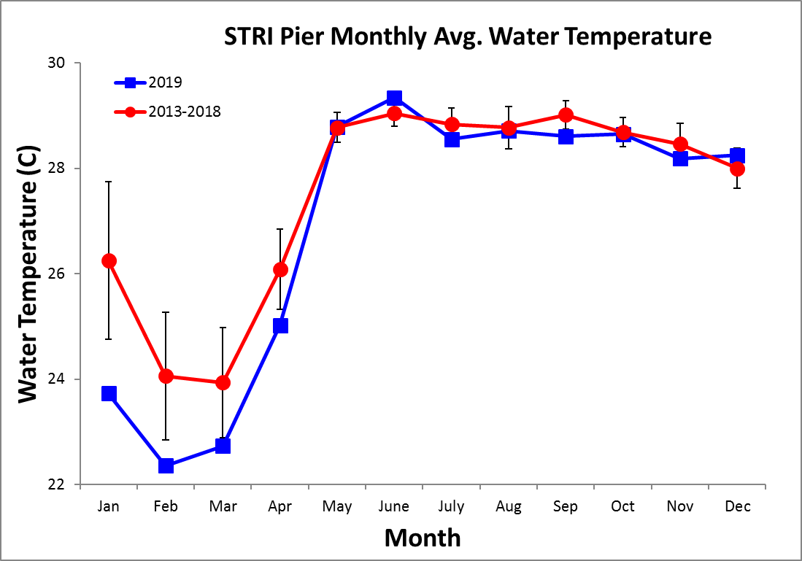
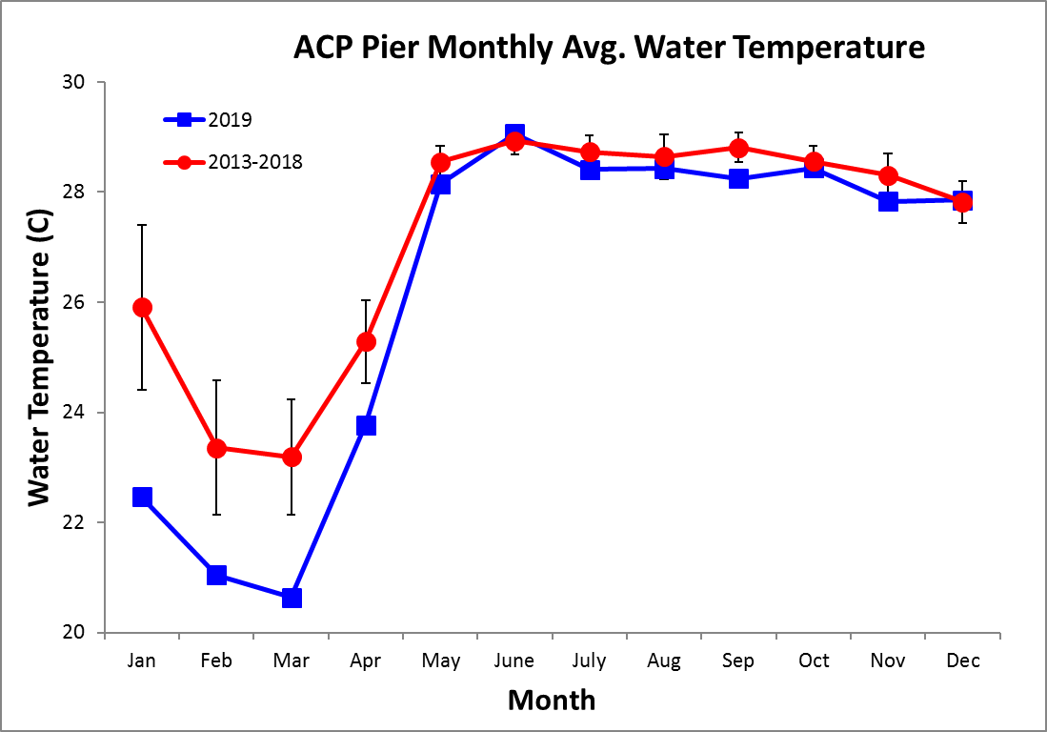
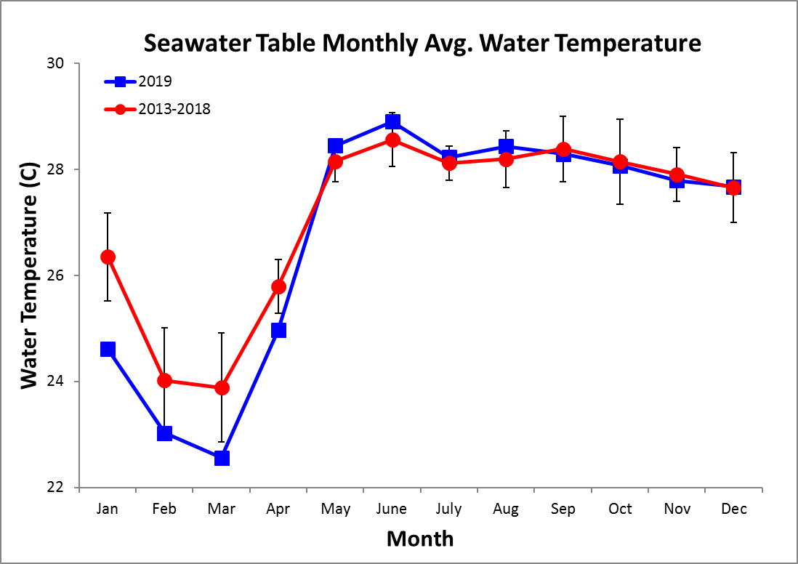
Average Monthly pH
STRI Pier
Year | Jan | Feb | Mar | Apr | May | June | July | Aug | Sep | Oct | Nov | Dec
2017 |  |  |  |  |  | 8.15 | 8.09 | 8.10 | 8.10 | 8.10 | 8.11 | 8.11
2018 | 8.00 | 8.03 | 8.03 | 7.94 | 8.02 | 8.02 | 8.04 | 8.06 | 8.07 | 8.04 | 8.10 | 8.13
2019 | 7.98 | 7.93 | 8.01 | 7.97 | 7.99 | 8.01 | 8.09 | 8.11 | 8.06 | 8.01 | 8.09 | 8.02
mean | 7.99 | 7.98 | 8.02 | 7.96 | 8.00 | 8.05 | 8.07 | 8.09 | 8.07 | 8.05 | 8.10 | 8.08
min | 7.98 | 7.93 | 8.01 | 7.94 | 7.99 | 8.01 | 8.04 | 8.06 | 8.06 | 8.01 | 8.09 | 8.02
max | 8.00 | 8.03 | 8.03 | 7.97 | 8.02 | 8.15 | 8.09 | 8.11 | 8.10 | 8.10 | 8.11 | 8.13

ACP Pier
Year | Jan | Feb | Mar | Apr | May | June | July | Aug | Sep | Oct | Nov | Dec
2017 |  |  |  |  |  | 8.12 | 8.01 | 8.00 | 8.06 | 8.07 | 8.05 | 8.03
2018 | 7.96 | 7.87 | 7.90 | 7.82 | 7.99 | 7.94 | 8.00 | 8.00 | 8.02 | 8.01 | 8.07 | 8.09
2019 | 7.85 | 7.80 | 7.80 | 7.85 | 7.91 | 8.00 | 8.05 | 8.06 | 8.09 | 8.01 | 8.03 | 7.97
mean | 7.90 | 7.83 | 7.85 | 7.83 | 7.95 | 8.01 | 8.02 | 8.02 | 8.06 | 8.03 | 8.05 | 8.03
min | 7.85 | 7.80 | 7.80 | 7.82 | 7.91 | 7.94 | 8.00 | 8.00 | 8.02 | 8.01 | 8.03 | 7.97
max | 7.96 | 7.87 | 7.90 | 7.85 | 7.99 | 8.12 | 8.05 | 8.06 | 8.09 | 8.07 | 8.07 | 8.09

Seawater Tanks
Year | Jan | Feb | Mar | Apr | May | June | July | Aug | Sep | Oct | Nov | Dec
2017 |  |  |  |  |  | 8.05 | 8.01 | 8.00 | 8.01 | 8.01 | 8.01 | 8.00
2018 | 7.91 | 7.86 | 7.92 | 7.84 | 7.96 | 7.90 | 7.93 | 8.03 | 8.03 | 7.99 | 8.05 | 8.06
2019 | 7.96 | 7.84 | 7.82 | 7.79 | 7.85 | 7.89 | 7.99 | 8.01 | 7.99 | 7.90 | 7.97 | 7.92
mean | 7.94 | 7.85 | 7.86 | 7.81 | 7.90 | 7.94 | 7.97 | 8.01 | 8.01 | 7.96 | 8.01 | 7.99
min | 7.91 | 7.84 | 7.82 | 7.79 | 7.85 | 7.89 | 7.93 | 8.00 | 7.99 | 7.90 | 7.97 | 7.92
max | 7.96 | 7.86 | 7.92 | 7.84 | 7.96 | 8.05 | 8.01 | 8.03 | 8.03 | 8.01 | 8.05 | 8.06

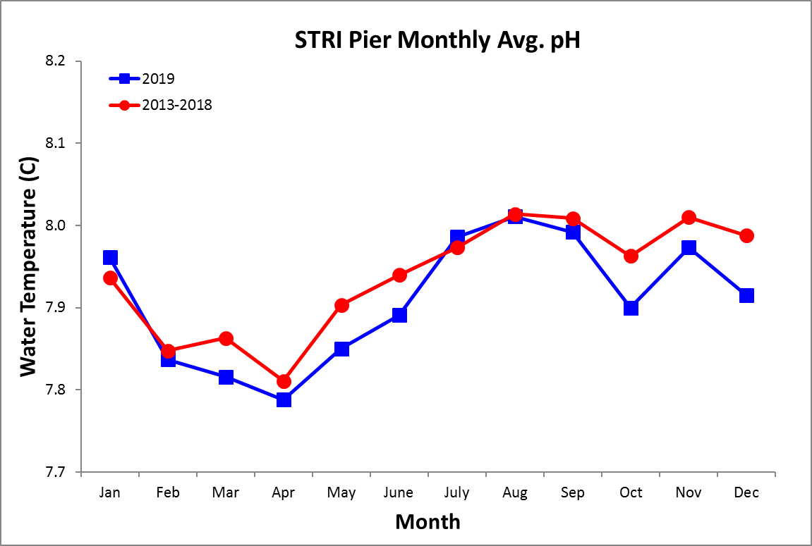
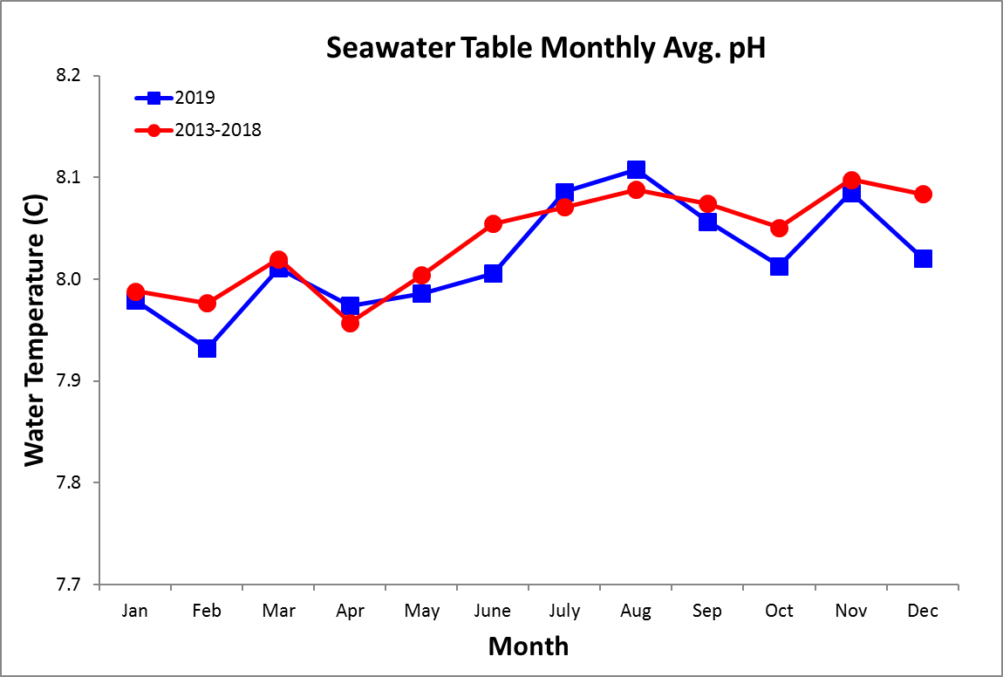
Average Monthly Salinity
STRI Pier
Year | Jan | Feb | Mar | Apr | May | June | July | Aug | Sep | Oct | Nov | Dec
2017 |  |  |  |  |  | 30.0 | 29.5 | 27.8 | 26.6 | 26.1 | 27.2 | 28.3
2018 | 29.5 | 32.6 | 33.0 | 32.5 | 30.0 | 29.4 | 29.2 | 29.6 | 28.1 | 27.3 | 27.2 | 29.5
2019 | 33.3 | 34.0 | 34.2 | 33.7 | 32.0 | 30.3 | 30.6 | 30.2 | 29.6 | 28.4 | 27.8 | 29.2
mean | 31.4 | 33.3 | 33.6 | 33.1 | 31.0 | 29.9 | 29.7 | 29.2 | 28.1 | 27.2 | 27.4 | 29.0
sd | 2.7 | 1.0 | 0.9 | 0.9 | 1.4 | 0.5 | 0.7 | 1.2 | 1.5 | 1.1 | 0.3 | 0.6
min | 29.5 | 32.6 | 33.0 | 32.5 | 30.0 | 29.4 | 29.2 | 27.8 | 26.6 | 26.1 | 27.2 | 28.3
max | 33.3 | 34.0 | 34.2 | 33.7 | 32.0 | 30.3 | 30.6 | 30.2 | 29.6 | 28.4 | 27.8 | 29.5

ACP Pier
Year | Jan | Feb | Mar | Apr | May | June | July | Aug | Sep | Oct | Nov | Dec
2017 |  |  |  |  |  |  | 28.5 | 26.9 | 25.8 | 25.5 | 25.6 | 26.9
2018 | 27.9 | 31.3 | 31.7 | 31.2 | 28.4 | 28.3 | 27.4 | 27.9 | 26.7 | 25.5 | 25.7 | 28.3
2019 | 31.9 | 32.7 | 32.7 | 32.2 | 30.9 | 29.2 | 29.3 | 28.7 | 27.8 | 27.0 | 26.5 | 28.1
mean | 29.9 | 32.0 | 32.2 | 31.7 | 29.7 | 28.7 | 28.4 | 27.8 | 26.8 | 26.0 | 25.9 | 27.8
sd | 2.8 | 1.0 | 0.7 | 0.7 | 1.7 | 0.6 | 1.0 | 0.9 | 1.0 | 0.9 | 0.5 | 0.8
min | 27.9 | 31.3 | 31.7 | 31.2 | 28.4 | 28.3 | 27.4 | 26.9 | 25.8 | 25.5 | 25.6 | 26.9
max | 31.9 | 32.7 | 32.7 | 32.2 | 30.9 | 29.2 | 29.3 | 28.7 | 27.8 | 27.0 | 26.5 | 28.3

Seawater Tanks
Year | Jan | Feb | Mar | Apr | May | June | July | Aug | Sep | Oct | Nov | Dec
2017 |  |  |  |  |  | 30.1 | 29.7 | 28.1 | 26.7 | 26.9 | 27.2 | 28.4
2018 | 29.4 | 32.7 | 33.1 | 32.3 | 30.2 | 29.7 | 29.5 | 30.0 | 28.6 | 27.5 | 27.4 | 29.7
2019 | 32.5 | 34.1 | 34.2 | 33.7 | 32.1 | 30.4 | 30.7 | 30.3 | 29.7 | 28.5 | 27.9 | 29.2
mean | 31.0 | 33.4 | 33.7 | 33.0 | 31.2 | 30.1 | 30.0 | 29.5 | 28.4 | 27.6 | 27.5 | 29.1
sd | 2.2 | 1.0 | 0.8 | 1.0 | 1.3 | 0.3 | 0.7 | 1.2 | 1.5 | 0.8 | 0.3 | 0.7
min | 29.4 | 32.7 | 33.1 | 32.3 | 30.2 | 29.7 | 29.5 | 28.1 | 26.7 | 26.9 | 27.2 | 28.4
max | 32.5 | 34.1 | 34.2 | 33.7 | 32.1 | 30.4 | 30.7 | 30.3 | 29.7 | 28.5 | 27.9 | 29.7

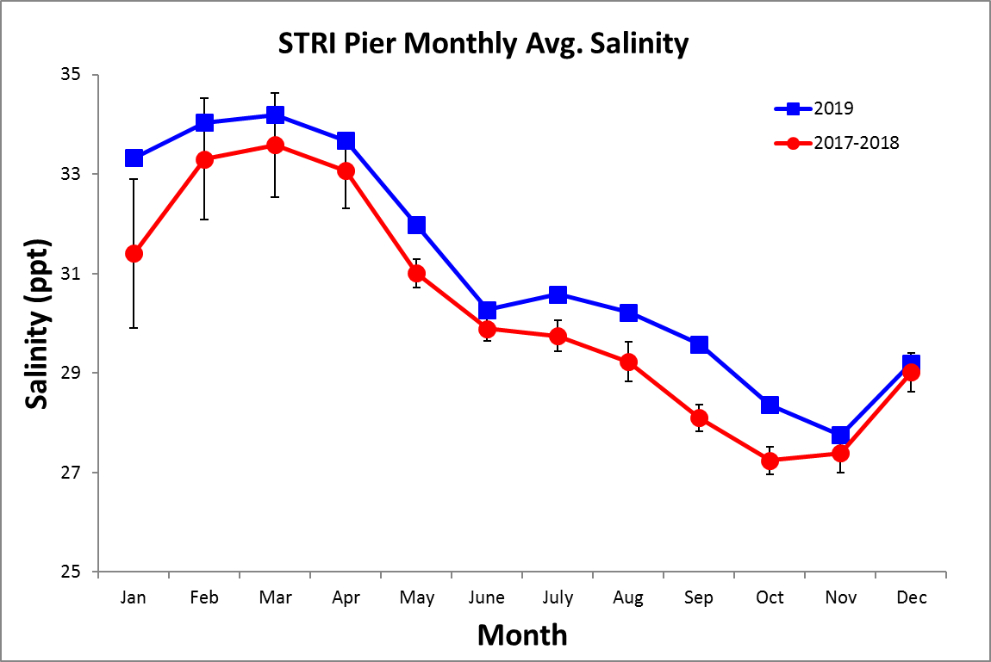
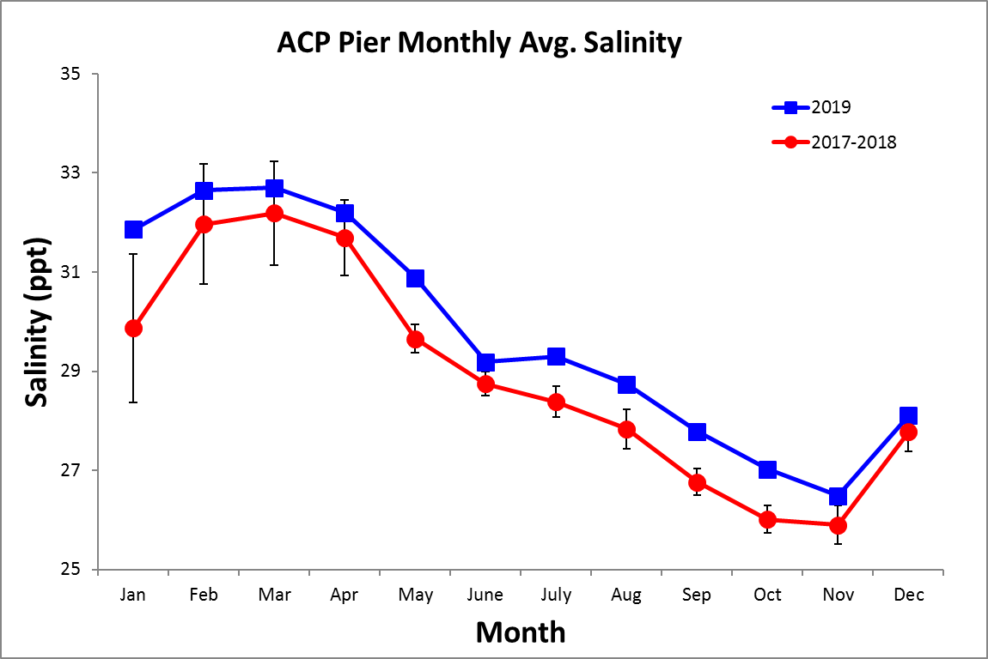
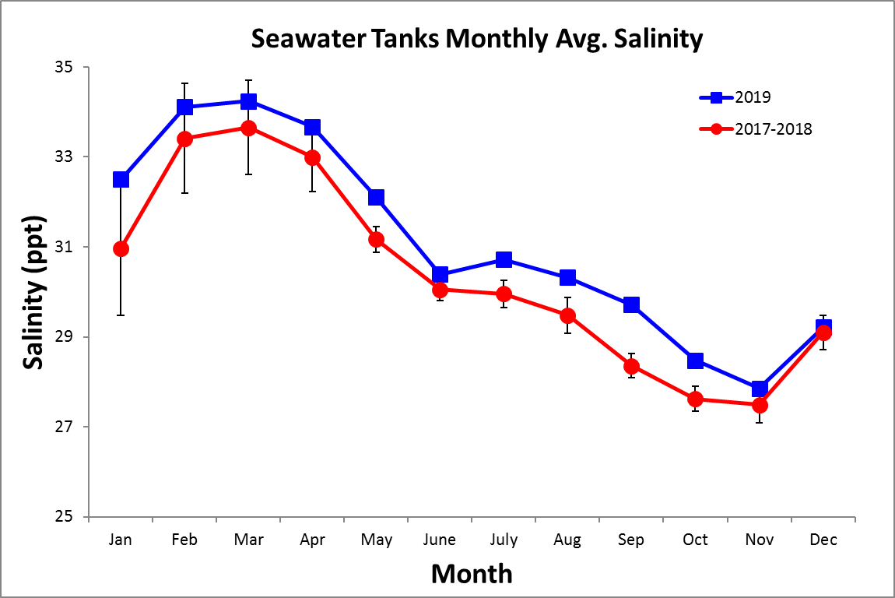

Time Series – Daily, 2020

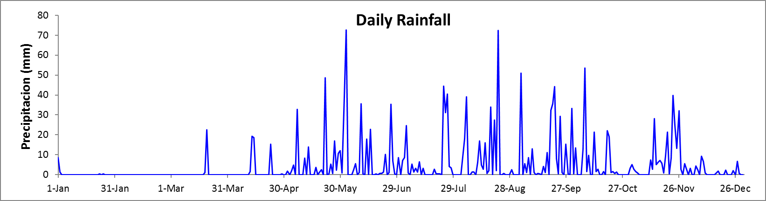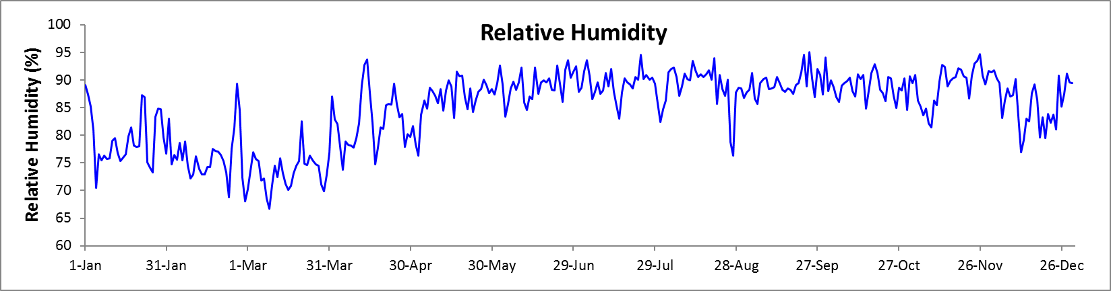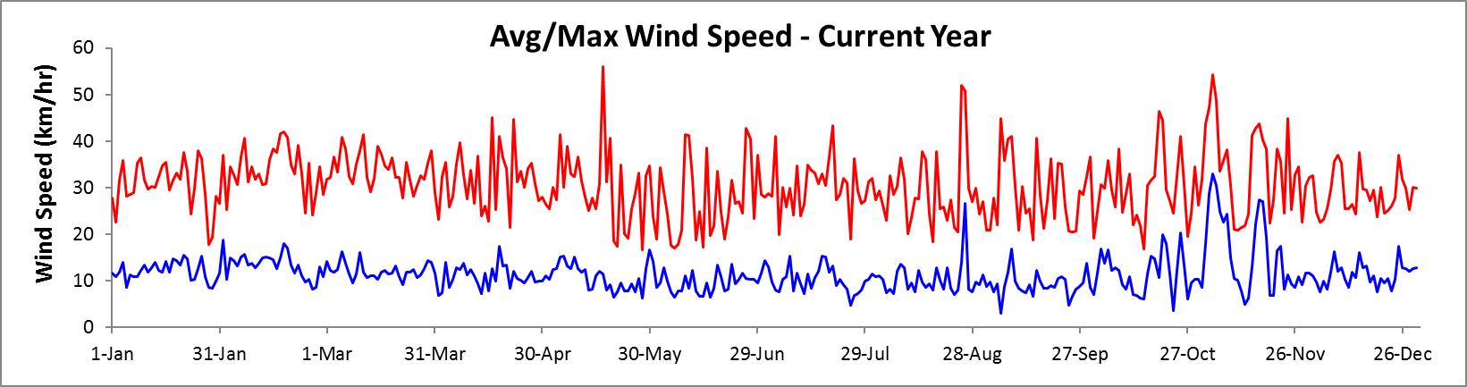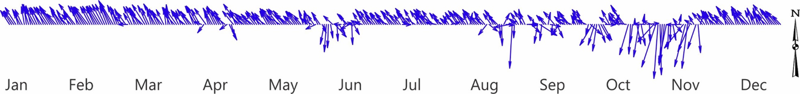
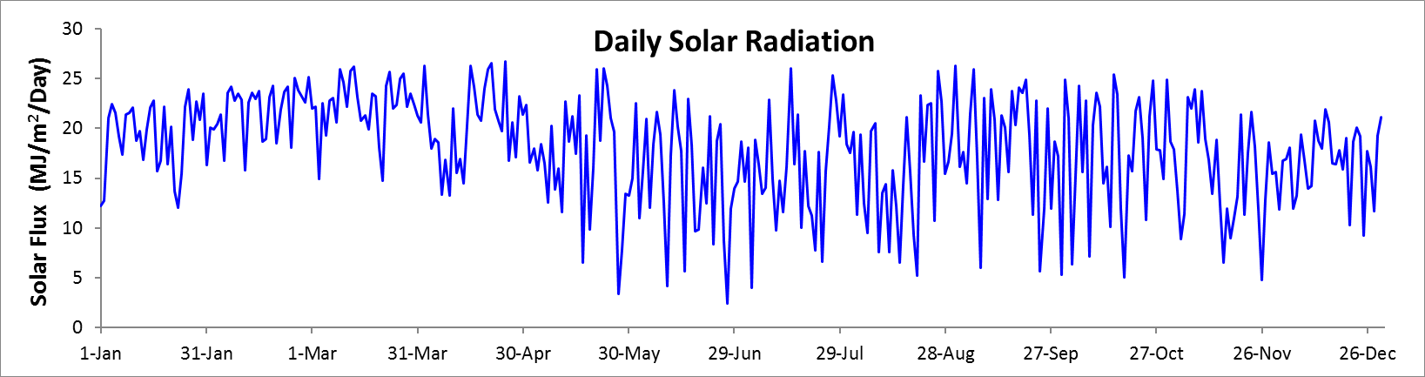

Time Series – Monthly

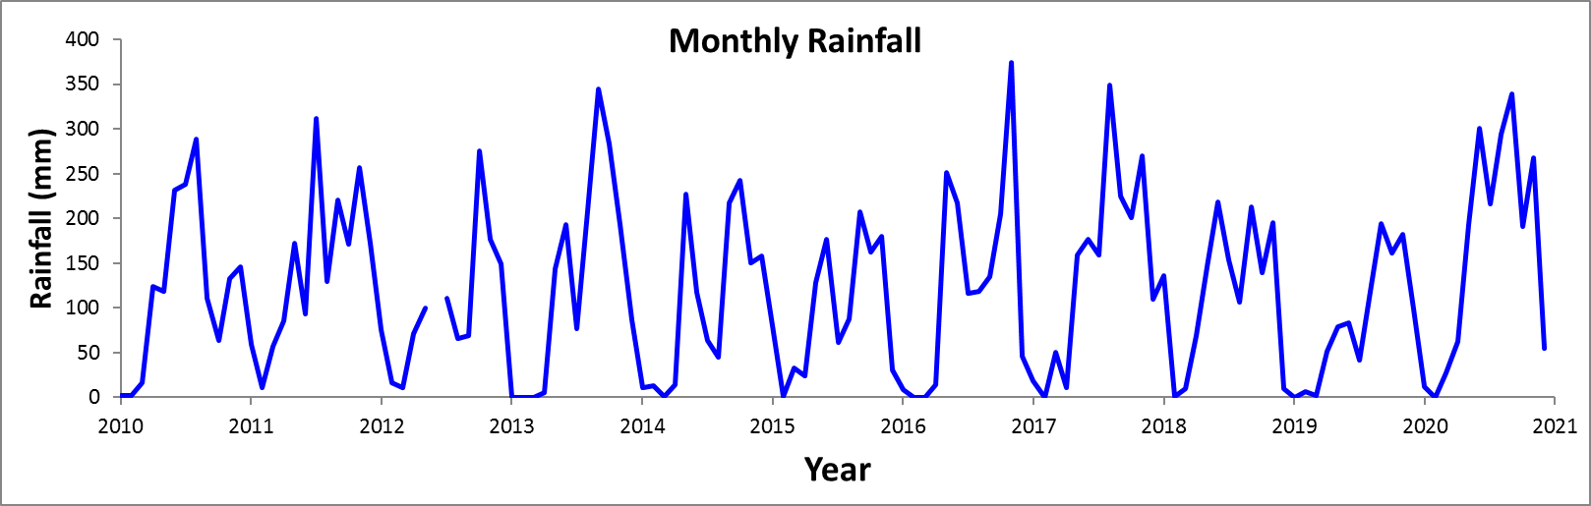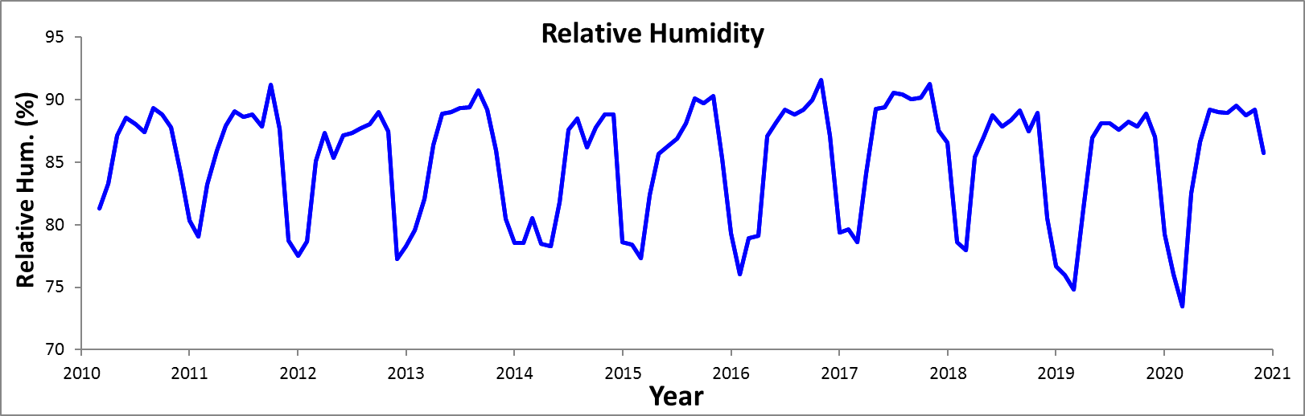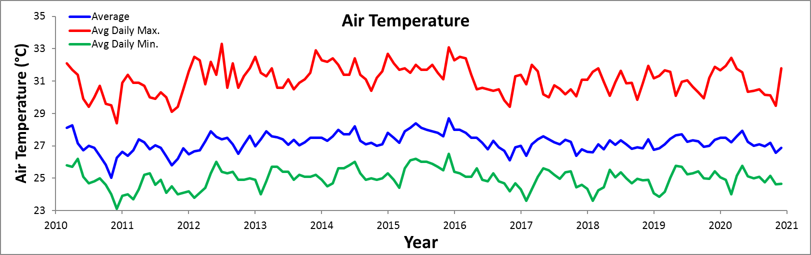

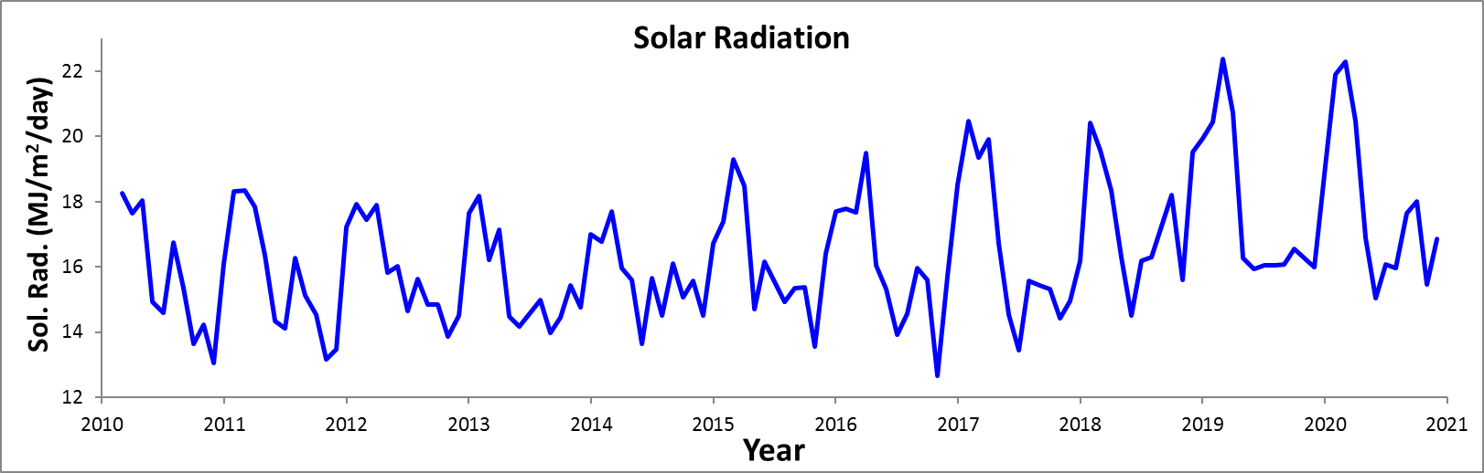

Time Series – Monthly

