2020 Meteorological Summary for
the Galeta Marine Island Laboratory

Prepared by: Steven Paton

Introduction

This is the 8th in a series of yearly reports summarising the past year’s Smithsonian Tropical Research Institute’s Physical Monitoring Program at the Galeta Island Marine Laboratory. This report is not meant to be exhaustive in its coverage in that it summarizes only some of the most ‘important’ or interesting parameters available. Any comments on how future yearly summaries could be improved would be appreciated. Additional copies of this report, reports from previous years, and downloadable data from the Galeta and other research locations, can be obtained from:
http://biogeodb.stri.si.edu/physical_monitoring/research/galeta

Setting

Installed in 1974, the Galeta Island Marine Laboratory physical monitoring station (9.402742°, -79.860837°) is located approximately 6 km North East of the city of Colon. Established in the 1960’s, The Galeta Island Marine Laboratory was the first marine laboratory established by STRI on the Caribbean coast of Panama. It was the site of an extensive study of the biological effects of a major oil spill.

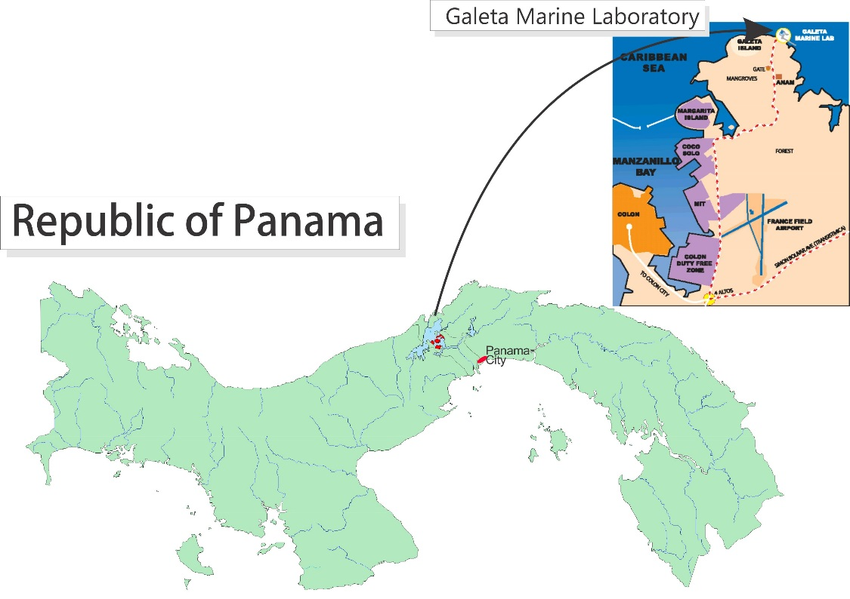

The station receives an average of 2923.1 mm of rain per year. The meteorological year is divided into two parts: a pronounced dry season (approximately from mid-December to the end of April), and a wet season (May to mid-December). On average, only 206mm of rain falls during the dry season. Relative humidity, air temperature, solar radiation, wind speed and direction, sea surface temperature (SST) all show marked seasonal differences.

All data are collected using electronic sensors. Sensors exist (or have existed) at five locations: Upstream, DownStream, and MidReef sensor platforms, on top of the laboratory building and a small (~9m above sea level) tower on the Pier. This report summarises the following data:
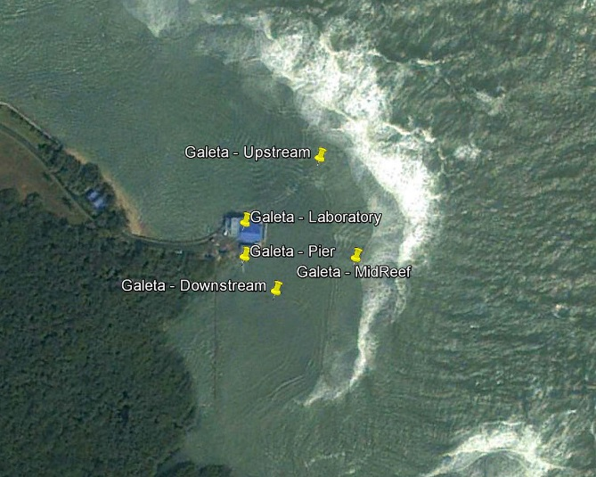
Pier Relative humidity
Air temperature
Rainfall
Wind speed and direction
Solar radiation
SST
Laboratory Solar radiation (1974 – 1981)
Rainfall (1974 - 2007)
MidReef Wind speed and direction
Upstream Air temperature
SST
Downstream Solar Radiation (1982 – 2007)
SST

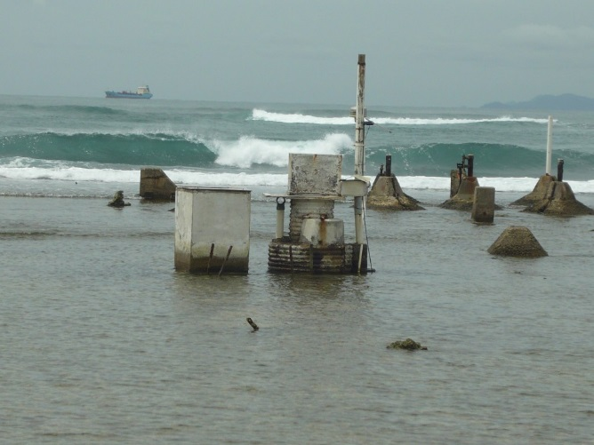
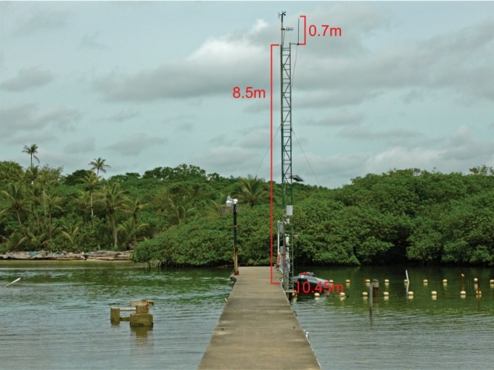
Pier Tower Mid-Reef site
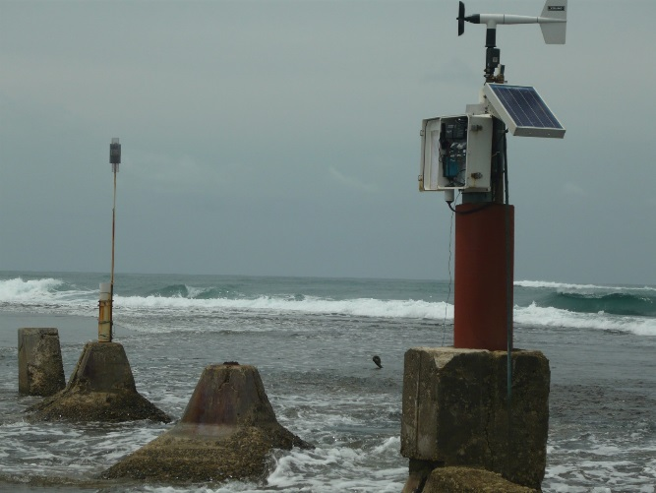
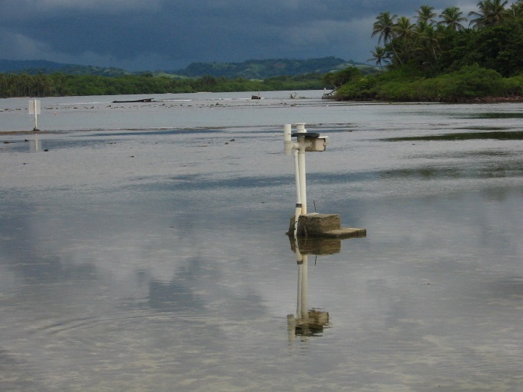
UpStream Site DownStream Site
Rainfall
Rainfall was originally collected by a Stevens Type ‘A’ water level recorder with intake located on top of the laboratory building. Rainfall were recorded to paper charts and digitized at 1-hour intervals. In 1991 a digital encoder was added which recorded 1mm rainfall increments. In 2002, an electronic tipping bucket was installed on the pier. This device records rainfall in 0.254mm increments. Data were also manually recorded weekly using a plastic rain gauge.

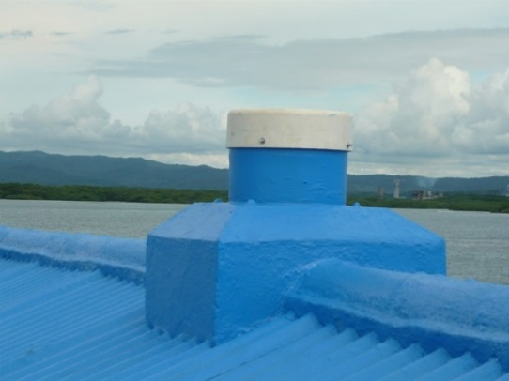
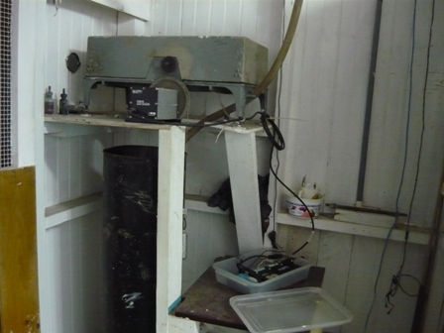
Stevens Type ‘A’ water level recorder with intake located on top of the laboratory building

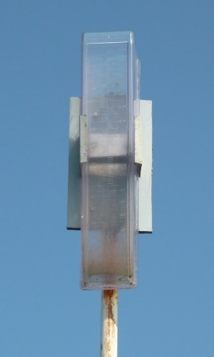
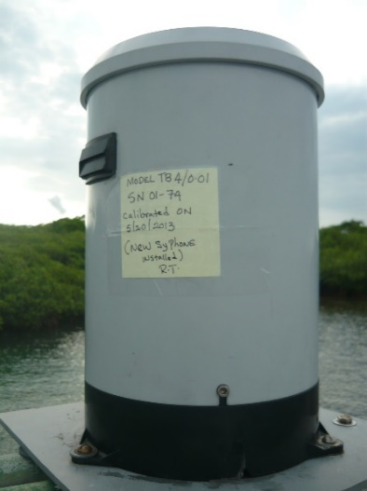
Tipping Bucket (left) and manual Rain gauge (right)

The daily rainfall data for 2020 are shown on page 6.

Page 7-8 show the monthly totals for 2020. The graph on the same page compares this year’s monthly totals with the average monthly totals (±SD) for the period 1974 to 2019.

Page 8 shows yearly rainfall totals for all years since 1974. Time series graph and frequency histograms are presented for these data.

Pages 9 and 10 show an analysis of rainfall ‘events’ (storms). For convenience, and again somewhat arbitrarily, I have defined a storm as any continuous period of rain separated by at least an hour from any other rainfall. Since this analysis required the timing of rainfall events, tipping bucket data were used. As a result, the absolute size of rainfall events should be considered only as an estimate since tipping buckets will tend to underestimate the size of storms - larger storms will be more underestimated than smaller ones. Keeping this in mind, the tables and graphs compare maximum and average storm size, and average storm duration per month for the period 2004 to 2019 versus 2020.

Relative Humidity
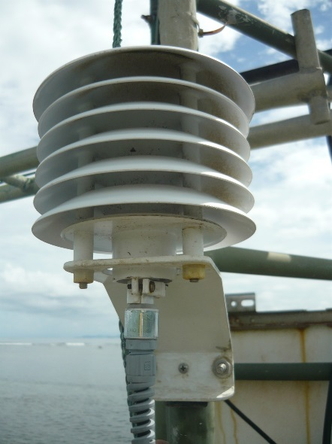
Relative humidity data have been collected with a number of electronic Temperature/Humidity sensors: Viasala HMP 35, Viasala HMP45, and most recently Campbell Sci. CS215. Sensors have been located on the small tower on the Pier. Data are recorded at 15- minute intervals by dataloggers controlling the sensors. The average monthly relative humidity data are shown in tabular and graphical forms on page 11.

Air Temperature

Shaded air temperature data is currently recorded using a Campbell Sci. CS215 electronic temperature/humidity sensor located on the small tower on the Pier. Data are recorded at 15- minute intervals by dataloggers controlling the sensors. Data have also been collected at the Up Stream station using a Hydrolab RT-125 Marine Thermometer connected to a datalogger and recorded at 1-hour intervals. Daily Max/min temperatures were also collected using Taylor Instruments Max/Min thermometers.

The monthly average temperatures from the electronic sensors are shown in tabular and graphical form on pages 12-14.

Solar Radiation
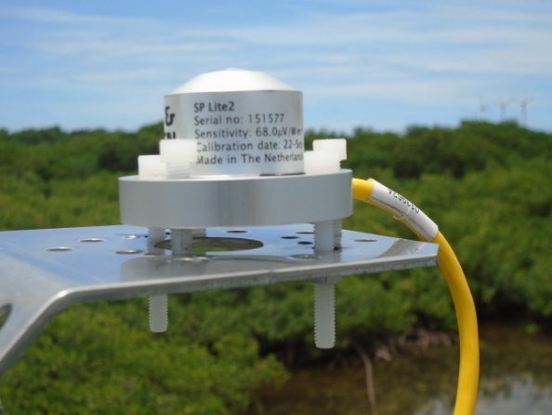
From 1974 until 1981, Global solar radiation was measured on the roof of the laboratory building using a Moll-Gorczynski-type pyranometer. The sensor was destroyed by lightning in 1981 and in 1984 a Li-Cor LI200SZ pyranometer sensor was deployed at the reef flat Down Stream location. Sensors were connected to dataloggers and the data were recorded hourly.

From 2004 to 2016, Global solar radiation was measured on the Pier tower using Li-Cor LI200SB pyranometers attached to a datalogger recording total (MJm⁻²), maximum and minimum (J m⁻² s⁻¹) radiation at 15-minute intervals. On Sept. 13, 2016 the Li-Cor pyranometers were replaced with Kipp&Zonen SPLite2 pyranometers.

Page 15 shows the Daily Global Radiation values. Pages 16 and 17 show total monthly Global Radiation.

Wind Speed and Direction
Wind speed and direction were originally recorded at the MidReef site using an MRI Mechanical Weather Station model 1072 connected to a datalogger and recording at 1-hour intervals. Anemometers were located on two cement pylons, located 10m from each other, and 3m above the surface of the reef flat.

From 1983 to 1992 and Omnidata sensors were used. These were replaced in 1992 with RM Young anemometers. Beginning in April of 2002, 15-minute interval average, maximum and minimum wind speed plus average wind direction have also been recorded by a Model 05103 Young Anemometer located on top of the Pier tower.

Page 18 shows average and maximum daily wind speeds from the Young Anemometer located at the top of the Pier tower. Page 19 shows daily average wind direction. The angles indicated in the table and graph on this page represent the direction from which the wind was predominately blowing on a given day. Page 20 shows the monthly average wind speed and monthly average directions for the year.
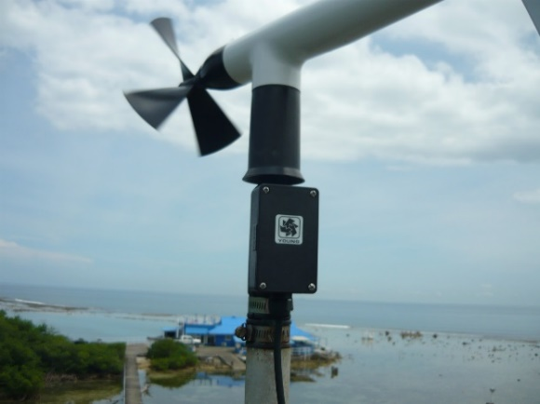
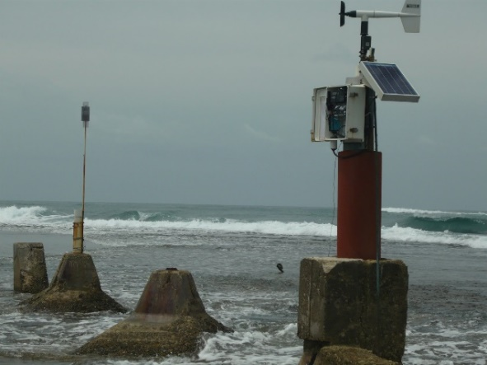
Upstream Anemometer Pier Tower Anemometer

Water Temperature
Water temperature was collected at the UpStream, DownStream and Tower Base sites. Reef site temperatures were inicially measured using Hydrolab RT-125 thermometers connected to dataloggers. In 2007 these sensors were replaced with self-contained Hobo U22 Water Temperature Pro v2 probes. Temperatures were recorded hourly; changed to every 15 minutes in 2020. SST at the base of the Tower has always been measured using Campbell Sci. Model 107 temperature sensors at 15-minute intervals. Monthly average SST data are shown on pages 21-22.

Times Series
Graphs showing the 2020 daily (Pages 25-6) and monthly averages for the entire period of record (Pages 27-9) for Relative Humidity, Air Temperature, Rainfall, Wind Speed, Solar Radiation and Water Temperature.

More details about how data were collected between 1974 and 1988 can be found in: Cubit et al, 1989. Meteorology and hydrography of a shoaling reef flat on the Caribbean coast of Panama. Coral Reefs 8:59-66.
Daily Patterns
Pages 30 and 31 show the daily patterns for Relative Humidity, Air Temperature, Rainfall, Wind Speed and Solar Radiation.

2020 Daily Rainfall (mm)

 | Jan. | Feb. | Mar. | Apr. | May | June | July | Aug. | Sep. | Oct. | Nov. | Dec.
1 | 12.4 | 2.3 | 0.0 | 0.0 | 6.4 | 28.4 | 38.9 | 0.0 | 0.0 | 30.0 | 2.0 | 150.4
2 | 0.0 | 0.0 | 4.3 | 0.0 | 0.0 | 39.9 | 5.6 | 26.7 | 39.6 | 5.1 | 0.0 | 43.9
3 | 0.0 | 0.0 | 0.0 | 2.3 | 0.0 | 0.0 | 15.5 | 10.7 | 7.9 | 0.0 | 4.6 | 13.5
4 | 0.3 | 0.0 | 0.0 | 0.0 | 14.0 | 0.0 | 29.2 | 17.0 | 0.0 | 0.0 | 0.0 | 10.7
5 | 0.5 | 0.0 | 0.0 | 0.0 | 0.3 | 2.5 | 2.0 | 11.7 | 1.3 | 0.0 | 0.0 | 0.0
6 | 1.3 | 0.0 | 0.0 | 0.0 | 0.8 | 2.8 | 3.3 | 9.7 | 1.5 | 2.0 | 0.0 | 0.5
7 | 0.0 | 0.0 | 0.0 | 1.8 | 0.0 | 1.0 | 26.9 | 0.0 | 2.5 | 0.0 | 0.0 | 0.0
8 | 0.0 | 0.0 | 4.3 | 0.0 | 5.3 | 0.0 | 7.4 | 146.8 | 2.0 | 0.0 | 0.0 | 13.7
9 | 0.0 | 0.5 | 0.0 | 0.0 | 9.9 | 9.4 | 0.0 | 1.8 | 9.1 | 5.6 | 0.3 | 17.5
10 | 0.0 | 0.0 | 0.0 | 14.0 | 0.0 | 0.0 | 5.3 | 0.0 | 0.5 | 3.8 | 0.0 | 4.1
11 | 0.0 | 0.0 | 0.0 | 0.0 | 0.0 | 49.0 | 11.7 | 22.1 | 0.0 | 15.0 | 0.0 | 0.0
12 | 0.0 | 0.0 | 0.0 | 11.7 | 0.0 | 0.3 | 0.5 | 35.3 | 8.1 | 0.0 | 12.4 | 0.0
13 | 0.0 | 0.3 | 0.0 | 12.4 | 0.0 | 0.0 | 49.8 | 43.4 | 20.6 | 14.7 | 4.1 | 0.0
14 | 0.3 | 0.0 | 0.0 | 5.8 | 0.0 | 0.0 | 23.4 | 5.1 | 6.6 | 14.0 | 76.7 | 0.0
15 | 2.0 | 2.5 | 0.8 | 0.0 | 2.3 | 81.3 | 0.0 | 1.5 | 1.0 | 16.5 | 35.1 | 4.6
16 | 0.0 | 0.3 | 1.0 | 0.0 | 0.0 | 3.6 | 0.0 | 40.6 | 6.4 | 13.0 | 0.0 | 17.0
17 | 0.0 | 3.0 | 0.5 | 0.0 | 1.0 | 1.3 | 24.4 | 13.7 | 0.0 | 15.2 | 0.0 | 12.7
18 | 2.3 | 0.5 | 0.3 | 0.0 | 7.9 | 25.9 | 28.4 | 17.3 | 16.8 | 11.4 | 47.5 | 0.0
19 | 0.0 | 0.3 | 0.0 | 0.0 | 7.9 | 19.8 | 2.3 | 8.1 | 14.2 | 0.3 | 9.1 | 0.0
20 | 0.0 | 3.8 | 0.0 | 0.0 | 0.8 | 16.8 | 28.2 | 0.8 | 18.0 | 22.1 | 8.6 | 0.0
21 | 0.0 | 6.1 | 1.0 | 0.0 | 0.0 | 0.0 | 40.6 | 0.0 | 23.1 | 2.0 | 1.0 | 0.0
22 | 3.8 | 0.0 | 0.0 | 1.0 | 2.0 | 0.0 | 8.1 | 2.0 | 1.3 | 0.5 | 0.0 | 0.0
23 | 13.2 | 0.0 | 0.0 | 0.0 | 0.0 | 20.3 | 0.0 | 0.0 | 19.3 | 0.0 | 0.0 | 11.7
24 | 0.0 | 0.0 | 0.0 | 0.0 | 0.0 | 1.3 | 1.3 | 5.3 | 9.1 | 93.2 | 7.6 | 4.6
25 | 0.0 | 0.0 | 0.0 | 0.0 | 0.0 | 11.4 | 4.3 | 48.8 | 3.8 | 0.5 | 9.4 | 51.1
26 | 0.0 | 0.0 | 0.0 | 1.0 | 3.6 | 33.5 | 9.4 | 0.3 | 1.0 | 0.0 | 51.6 | 5.6
27 | 1.0 | 0.0 | 0.0 | 0.3 | 41.1 | 8.6 | 16.5 | 0.0 | 2.5 | 0.0 | 8.9 | 1.0
28 | 0.0 | 5.8 | 0.0 | 0.3 | 0.3 | 8.9 | 4.3 | 0.0 | 6.1 | 0.3 | 5.6 | 9.4
29 | 0.0 | 0.0 | 0.0 | 4.3 | 0.0 | 13.7 | 1.8 | 44.2 | 3.6 | 2.0 | 13.0 | 12.2
30 | 0.0 |  | 0.0 | 1.5 | 39.1 | 8.1 | 0.0 | 0.8 | 128.8 | 18.3 | 5.3 | 0.0
31 | 0.0 |  | 3.8 |  | 25.2 |  | 0.0 | 8.9 |  | 0.8 |  | 0.8
 | 37.1 | 25.4 | 16.0 | 56.4 | 167.6 | 387.9 | 389.1 | 522.5 | 354.8 | 286.3 | 302.8 | 384.8
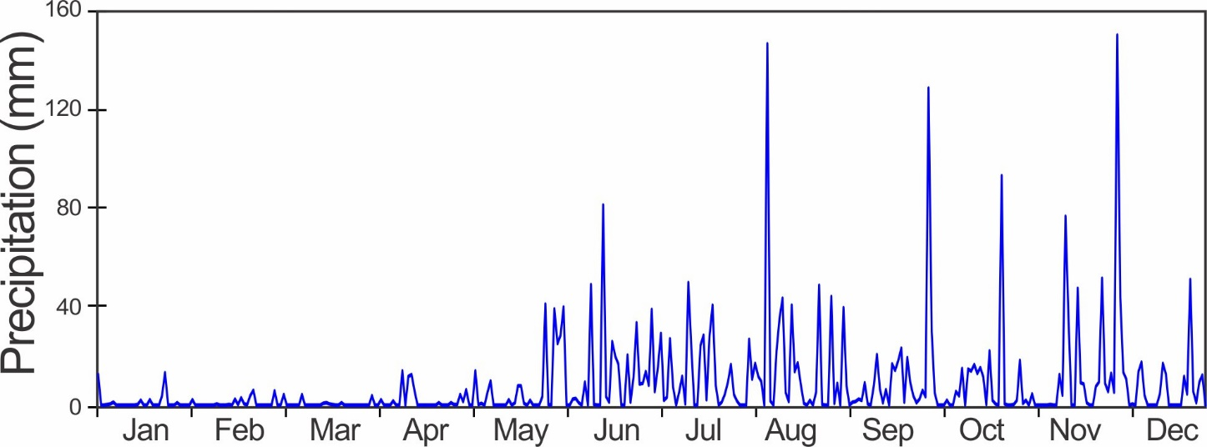
Monthly Rainfall (mm)

Year | Jan | Feb | Mar | Apr | May | June | July | Aug | Sep | Oct | Nov | Dec | Total
1974 | 18.3 | 16.6 | 17.9 | 41.5 | 171.0 | 378.0 | 462.2 | 287.4 | 152.5 | 453.1 | 708.4 | 149.4 | 2856.3
1975 | 20.8 | 20.6 | 21.2 | 13.5 | 137.9 | 392.7 | 311.0 | 376.0 | 451.0 | 336.5 | 298.0 | 340.8 | 2720.0
1976 | 16.2 | 25.3 | 13.8 | 85.6 | 191.4 | 347.0 | 184.1 | 302.5 | 346.4 | 421.0 | 297.5 | 37.3 | 2268.1
1977 | 12.5 | 7.8 | 2.8 | 84.9 | 316.0 | 214.8 | 260.2 | 651.8 | 157.4 | 585.3 | 585.6 | 173.5 | 3052.6
1978 | 45.8 | 20.8 | 64.1 | 191.8 | 253.2 | 451.5 | 329.0 | 389.4 | 211.0 | 463.8 | 276.6 | 33.8 | 2730.8
1979 | 7.2 | 39.1 | 2.2 | 300.8 | 431.9 | 416.9 | 284.3 | 323.4 | 269.9 | 296.1 | 414.8 | 241.5 | 3028.1
1980 | 152.3 | 47.0 | 5.0 | 16.0 | 345.0 | 264.0 | 251.0 | 335.0 | 195.0 | 362.0 | 467.0 | 314.0 | 2753.3
1981 | 56.0 | 2.0 | 60.0 | 343.0 | 518.0 | 231.0 | 290.0 | 497.0 | 132.0 | 475.0 | 867.0 | 412.0 | 3883.0
1982 | 280.0 | 40.0 | 4.0 | 148.0 | 148.0 | 203.0 | 351.0 | 131.0 | 299.0 | 313.0 | 135.0 | 9.0 | 2061.0
1983 | 26.0 | 12.0 | 6.0 | 150.0 | 148.0 | 365.0 | 151.0 | 421.0 | 427.0 | 363.0 | 256.0 | 365.0 | 2690.0
1984 | 49.0 | 27.0 | 12.0 | 29.0 | 204.0 | 519.0 | 261.0 | 284.0 | 149.0 | 298.0 | 388.0 | 78.0 | 2298.0
1985 | 41.1 | 10.4 | 7.2 | 16.6 | 457.6 | 447.7 | 184.3 | 350.7 | 153.4 | 487.6 | 318.5 | 456.2 | 2931.3
1986 | 8.9 | 21.0 | 19.3 | 91.6 | 168.2 | 340.6 | 189.4 | 231.9 | 179.6 | 256.3 | 216.4 | 61.4 | 1784.6
1987 | 8.1 | 6.6 | 5.6 | 248.6 | 473.7 | 329.2 | 377.7 | 576.4 | 401.7 | 605.7 | 577.5 | 412.7 | 4023.5
1988 | 2.7 | 43.1 | 4.4 | 10.4 | 262.7 | 354.3 | 503.3 | 255.1 | 255.3 | 347.9 | 541.4 | 174.2 | 2754.8
1989 | 4.8 | 18.5 | 3.7 | 10.1 | 155.5 | 172.4 | 413.6 | 420.7 | 179.7 | 790.2 | 454.9 | 65.6 | 2689.7
1990 | 14.5 | 2.4 | 25.3 | 32.6 | 235.5 | 256.3 | 338.0 | 429.5 | 386.3 | 535.3 | 286.4 | 191.4 | 2733.5
1991 | 10.0 | 11.5 | 14.3 | 102.0 | 271.0 | 185.0 | 207.0 | 263.0 | 410.0 | 237.0 | 598.0 | 59.0 | 2367.8
1992 | 1.0 | 11.0 | 0.0 | 185.0 | 319.0 | 223.0 | 300.0 | 418.0 | 357.0 | 287.0 | 207.0 | 211.0 | 2519.0
1993 | 90.0 | 16.0 | 35.0 | 258.0 | 131.0 | 486.0 | 243.0 | 368.0 | 343.0 | 293.0 | 375.0 | 326.0 | 2964.0
1994 | 40.0 | 3.0 | 16.0 | 14.0 | 307.0 | 415.0 | 224.0 | 382.0 | 235.0 | 186.0 | 359.0 | 106.0 | 2287.0
1995 | 105.0 | 7.0 | 5.0 | 117.0 | 307.0 | 351.0 | 302.0 | 201.0 | 305.0 | 189.0 | 673.0 | 342.0 | 2904.0
1996 | 287.0 | 71.0 | 33.0 | 87.0 | 99.0 | 476.0 | 303.0 | 469.0 | 363.0 | 336.0 | 613.0 | 233.0 | 3370.0
1997 | 34.0 | 7.0 | 0.0 | 97.0 | 229.0 | 175.0 | 145.0 | 330.0 | 411.0 | 244.0 | 350.0 | 17.0 | 2039.0
1998 | 8.0 | 2.0 | 6.0 | 283.0 | 180.0 | 312.0 | 380.0 | 493.0 | 296.0 | 322.0 | 236.0 | 453.0 | 2971.0
1999 | 127.0 | 21.0 | 70.0 | 58.0 | 249.0 | 412.0 | 527.0 | 661.0 | 125.0 | 398.0 | 326.0 | 650.0 | 3624.0
2000 | 30.0 | 12.0 | 0.0 | 72.0 | 351.0 | 515.0 | 157.0 | 355.0 | 129.0 | 523.0 | 224.0 | 662.0 | 3030.0
2001 | 98.0 | 4.0 | 30.0 | 12.0 | 236.0 | 102.0 | 208.0 | 211.0 | 264.0 | 283.0 | 441.0 | 518.0 | 2407.0
2002 | 157.0 | 8.0 | 33.0 | 45.0 | 113.0 | 248.0 | 384.0 | 305.0 | 246.0 | 349.0 | 328.0 | 32.0 | 2248.0
2003 | 16.0 | 6.0 | 3.0 | 153.0 | 512.0 | 379.0 | 272.0 | 345.0 | 249.0 | 200.0 | 615.0 | 294.0 | 3044.0
2004 | 34.0 | 1.0 | 11.0 | 147.0 | 307.0 | 370.0 | 323.0 | 648.0 | 434.0 | 357.0 | 419.0 | 119.0 | 3170.0
2005 | 64.7 | 32.8 | 33.1 | 305.1 | 190.0 | 203.0 | 127.0 | 511.0 | 365.0 | 208.0 | 581.0 | 128.0 | 2748.7
2006 | 86.0 | 12.0 | 45.0 | 155.0 | 469.0 | 106.0 | 433.0 | 218.0 | 424.0 | 347.0 | 790.0 | 365.0 | 3450.0
2007 | 11.4 | 13.7 | 41.9 | 138.0 | 113.9 | 324.9 | 336.3 | 283.5 | 309.1 | 574.6 | 780.6 | 365.3 | 3292.9
2008 | 5.3 | 33.7 | 1.8 | 145.5 | 283.6 | 266.8 | 352.1 | 332.0 | 158.3 | 258.7 | 780.8 | 179.2 | 2797.6
2009 | 16.9 | 46.1 | 29.1 | 166.8 | 211.2 | 334.5 | 359.9 | 411.9 | 245.0 | 271.3 | 546.6 | 98.2 | 2737.7
2010 | 22.1 | 13.2 | 35.0 | 66.8 | 135.7 | 371.3 | 294.4 | 337.1 | 60.6 | 605.1 | 727.1 | 1193.3 | 3861.6
2011 | 390.5 | 19.8 | 29.9 | 111.9 | 222.4 | 296.7 | 385.9 | 253.8 | 371.9 | 330.8 | 964.1 | 441.8 | 3819.2
2012 | 19.8 | 3.5 | 71.1 | 114.7 | 236.0 | 282.2 | 370.0 | 250.0 | 445.8 | 397.8 | 899.4 | 427.4 | 3517.7
2013 | 7.9 | 32.2 | 56.1 | 14.7 | 311.4 | 317.2 | 362.5 | 550.6 | 206.1 | 333.2 | 214.5 | 213.7 | 2620.0
2014 | 32.5 | 14.2 | 48.2 | 103.1 | 396.6 | 610.3 | 100.8 | 395.7 | 277.7 | 488.8 | 439.1 | 358.2 | 3265.0
2015 | 37.1 | 10.7 | 6.1 | 47.5 | 160.0 | 93.7 | 220.0 | 479.3 | 650.5 | 493.5 | 408.7 | 98.8 | 2705.9
2016 | 31.0 | 18.0 | 10.2 | 57.9 | 280.4 | 397.3 | 543.0 | 319.0 | 466.1 | 464.6 | 864.6 | 279.4 | 3731.5
2017 | 23.4 | 10.4 | 35.6 | 23.9 | 285.7 | 280.2 | 556.9 | 380.0 | 355.1 | 314.7 | 355.6 | 740.0 | 3361.3
2018 | 96.8 | 10.9 | 43.4 | 51.3 | 438.9 | 435.6 | 619.5 | 357.1 | 530.6 | 300.2 | 592.1 | 43.7 | 3520.2
2019 | 17.8 | 4.6 | 32.8 | 90.7 | 240.8 | 224.0 | 350.8 | 304.3 | 419.9 | 194.6 | 383.3 | 560.1 | 2823.5
2020 | 37.1 | 25.4 | 16.0 | 56.4 | 167.6 | 387.9 | 389.1 | 522.5 | 354.9 | 286.3 | 302.8 | 384.8 | 2930.7
Mean | 57.5 | 17.9 | 22.7 | 108.4 | 263.2 | 324.8 | 317.4 | 374.8 | 301.1 | 371.5 | 478.4 | 285.4 | 2923.1
sd | 80.2 | 14.7 | 20.2 | 87.3 | 112.7 | 115.1 | 117.6 | 121.4 | 123.9 | 131.0 | 213.1 | 230.1 | 520.6
Min | 1.0 | 1.0 | 0.0 | 10.1 | 99.0 | 93.7 | 100.8 | 131.0 | 60.6 | 186.0 | 135.0 | 9.0 | 1784.6
Max | 390.5 | 71.0 | 71.1 | 343.0 | 518.0 | 610.3 | 619.5 | 661.0 | 650.5 | 790.2 | 964.1 | 1193.3 | 4023.5
Rank* | 19 | 11 | 24 | 32 | 37 | 14 | 9 | 6 | 19 | 36 | 36 | 13 | 22
*Rank of current year: 1 = wettest
Note: Data in Purple estimated from ACP station Limon

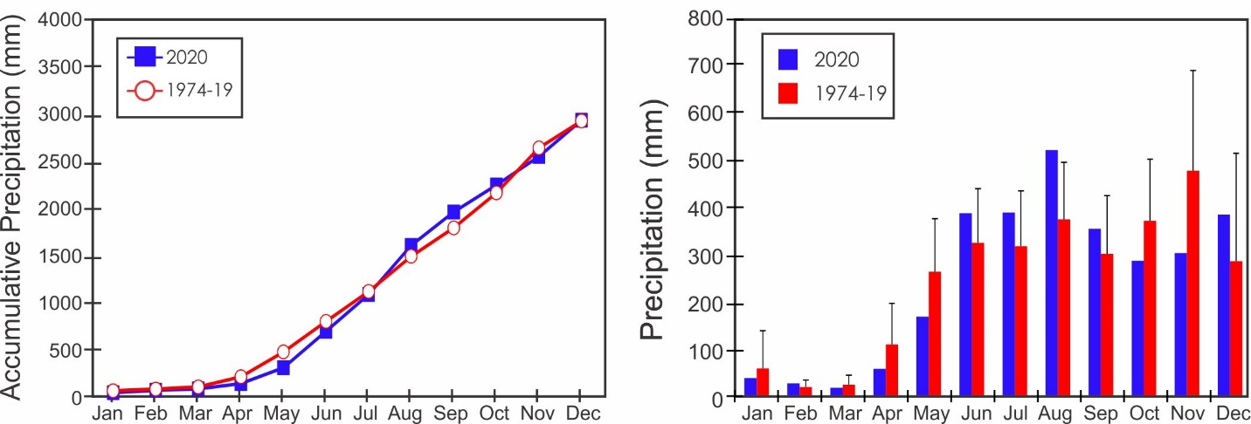

Yearly Rainfall (mm)

Year | Rain | Year | Rain | Year | Rain
1974 | 2856.3 | 1991 | 2367.8 | 2008 | 2797.6
1975 | 2720.0 | 1992 | 2519.0 | 2009 | 2737.7
1976 | 2268.1 | 1993 | 2964.0 | 2010 | 3861.6
1977 | 3052.6 | 1994 | 2287.0 | 2011 | 3819.2
1978 | 2730.8 | 1995 | 2904.0 | 2012 | 3517.7
1979 | 3028.1 | 1996 | 3370.0 | 2013 | 2620.0
1980 | 2753.3 | 1997 | 2039.0 | 2014 | 3265.0
1981 | 3883.0 | 1998 | 2971.0 | 2015 | 2705.9
1982 | 2061.0 | 1999 | 3624.0 | 2016 | 3731.5
1983 | 2690.0 | 2000 | 3030.0 | 2017 | 3361.3
1984 | 2298.0 | 2001 | 2407.0 | 2018 | 3520.2
1985 | 2931.3 | 2002 | 2248.0 | 2019 | 2823.5
1986 | 1784.6 | 2003 | 3044.0 | 2020 | 2930.7
1987 | 4023.5 | 2004 | 3170.0
1988 | 2754.8 | 2005 | 2748.7
1989 | 2689.7 | 2006 | 3450.0
1990 | 2733.5 | 2007 | 3292.9

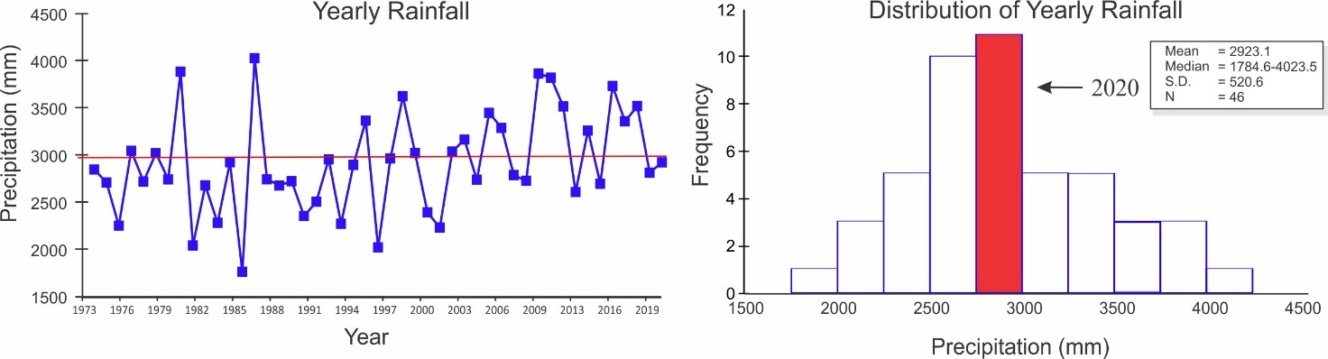

Storm Analysis

 |  | Max. Rainfall per Storm (mm) |  |  |  | Storm Duration (min.)
 | 2006-2019 |  |  | 2020 |  | 2006-2019 |  | 2020
 | Mean |  | S.D. |  |  | Mean | S.D.
January | 17.7 |  | 23.6 | 8.9 |  | 35.3 | 14.5 | 46.6
February | 5.1 |  | 3.2 | 5.1 |  | 33.9 | 12.0 | 47.1
March | 14.8 |  | 9.9 | 4.3 |  | 34.1 | 11.3 | 27.0
April | 42.1 |  | 31.2 | 14.0 |  | 50.5 | 11.5 | 44.0
May | 61.2 |  | 18.8 | 38.9 |  | 66.8 | 11.0 | 64.9
June | 73.8 |  | 37.7 | 76.2 |  | 65.6 | 8.3 | 77.8
July | 59.0 |  | 24.4 | 45.2 |  | 71.5 | 14.7 | 71.1
August | 80.0 |  | 40.8 | 133.1 |  | 68.7 | 10.1 | 70.3
September | 72.5 |  | 37.2 | 128.8 |  | 63.5 | 10.4 | 68.6
October | 73.6 |  | 31.2 | 93.2 |  | 76.9 | 15.1 | 55.3
November | 105.6 |  | 51.4 | 67.8 |  | 86.7 | 24.2 | 62.2
December | 79.1 |  | 65.2 | 148.3 |  | 62.6 | 22.4 | 74.1

 | Av. Rainfall per Storm (mm)
 | 2006-2019 |  | 2020
 | Mean | S.D.
January | 2.3 | 2.6 | 2.2
February | 1.3 | 0.6 | 1.3
March | 2.2 | 1.4 | 1.6
April | 4.8 | 2.7 | 2.3
May | 7.0 | 1.7 | 5.8
June | 6.9 | 2.0 | 7.9
July | 7.0 | 2.0 | 6.8
August | 7.4 | 2.3 | 9.0
September | 7.2 | 2.3 | 8.1
October | 8.4 | 3.1 | 7.2
November | 9.0 | 2.9 | 5.5
December | 6.8 | 3.6 | 7.7

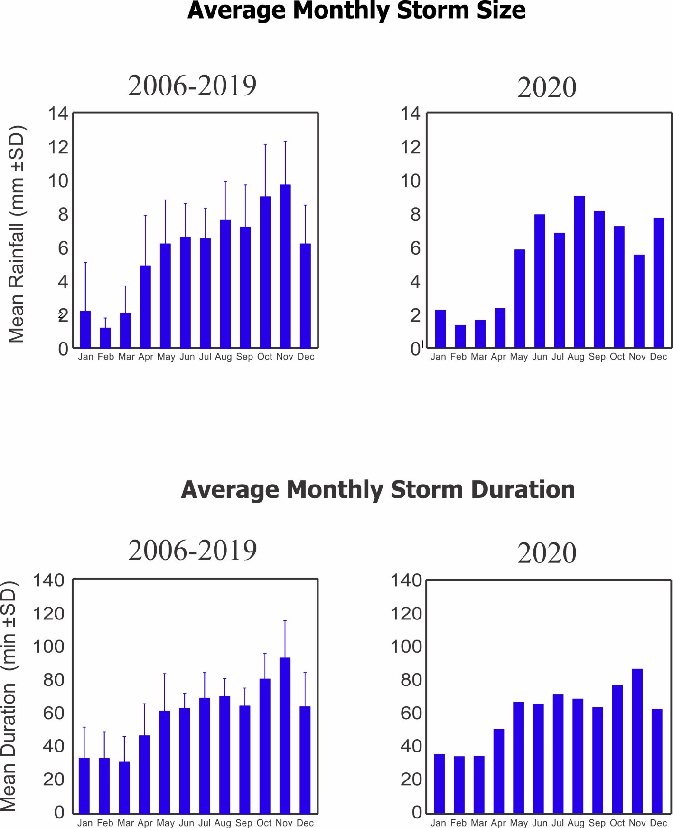
Relative Humidity (%)

Year | Jan | Feb | Mar | Apr | May | June | July | Aug | Sep | Oct | Nov | Dec
2002 |  |  |  | 83.8 | 84.0 | 85.4 | 87.2 | 88.2 | 89.0 | 89.4 | 89.2 | 81.5
2003 | 79.4 | 80.2 | 79.3 | 81.7 | 88.8 | 87.3 | 88.4 | 88.5
2004 |  |  |  |  |  |  |  |  |  |  | 88.6 | 83.9
2005 | 85.0 | 82.5 | 86.9 | 87.8 | 91.1 | 89.2 | 88.3 | 90.9 | 91.5 | 87.6 | 90.8 | 87.1
2006 | 87.2 | 84.6 | 86.1 | 87.3 | 90.9 | 89.6 | 91.9 | 90.9 | 91.7 | 90.4 | 91.8 | 89.6
2007 | 84.4 | 83.3 | 84.0 |  | 90.9 | 90.6 | 91.5 | 90.9 | 90.4 | 89.8 | 92.1 | 89.0
2008 | 82.9 | 82.6 | 79.1 | 78.6 | 81.0 | 88.0 | 90.6 | 89.1 | 86.5 | 85.7 | 91.5 | 83.9
2009 | 82.1 | 80.6 | 79.8 | 81.5 | 86.6 | 87.8 | 89.4 | 90.1 | 88.7 | 89.8 | 91.8 | 86.4
2010 | 83.1 | 84.6 | 85.4 | 86.7 | 87.0 | 89.3 | 89.6 | 91.5 | 87.9 | 91.6 | 91.2 | 89.6
2011 | 87.0 | 81.3 | 79.4 | 82.9 | 86.5 | 88.2 | 88.5 | 89.3 | 88.7 | 88.1 | 91.9 | 88.9
2012 | 82.8 | 82.4 | 84.5 | 85.8 | 88.3 | 87.2 | 89.5 | 89.9 | 89.5 | 89.2 | 92.8 | 91.4
2013 | 84.1 | 83.6 | 86.9 | 86.9 | 89.1 | 92.6 | 93.1 | 93.0 | 93.1 | 93.9 | 93.0 | 86.3
2014 | 82.5 | 82.4 | 82.3 | 86.8 | 89.5 | 92.6 | 90.8 | 92.5 | 92.8 | 92.6 | 93.4 | 92.1
2015 | 86.0 | 85.7 | 84.5 | 88.2 | 90.7 | 91.6 | 91.7 | 92.4 | 93.7 | 93.1 | 93.3 | 90.8
2016 | 84.2 | 81.2 | 83.1 | 84.5 | 87.5 | 89.4 | 91.1 | 90.4 | 91.3 | 90.3 | 93.5 | 89.3
2017 | 84.5 | 84.1 | 84.6 | 86.8 | 90.6 | 90.3 | 91.6 | 90.0 | 89.8 | 88.1 | 91.5 | 90.4
2018 | 90.5 | 83.8 | 84.4 | 86.6 | 86.8 | 87.5 | 86.4 | 89.6 | 92.4 | 88.9 | 91.7 | 84.0
2019 | 81.8 | 83.6 | 83.9 | 85.9 | 90.3 | 89.6 | 91.4 | 91.7 | 90.8 | 91.2 | 91.1 | 91.0
2020 | 86.1 | 85.3 | 82.3 | 87.1 | 89.9 | 92.4 | 92.0 | 92.6 | 92.0 | 88.6 | 86.8 | 85.5
mean | 84.6 | 83.2 | 83.4 | 85.8 | 88.6 | 89.9 | 90.4 | 91.1 | 90.9 | 90.4 | 91.8 | 88.8
sd | 2.5 | 1.7 | 2.2 | 1.9 | 1.7 | 2.0 | 1.8 | 1.3 | 1.9 | 2.0 | 1.8 | 2.6
min | 81.8 | 80.6 | 79.4 | 81.5 | 86.5 | 87.2 | 86.4 | 89.3 | 87.9 | 88.1 | 86.8 | 84.0
max | 90.5 | 85.7 | 86.9 | 88.2 | 90.7 | 92.6 | 93.1 | 93.0 | 93.7 | 93.9 | 93.5 | 92.1

* A sensor change at the end of 2008 resulted in significantly higher readings. Summary statistics only include data from 2009 onwards.
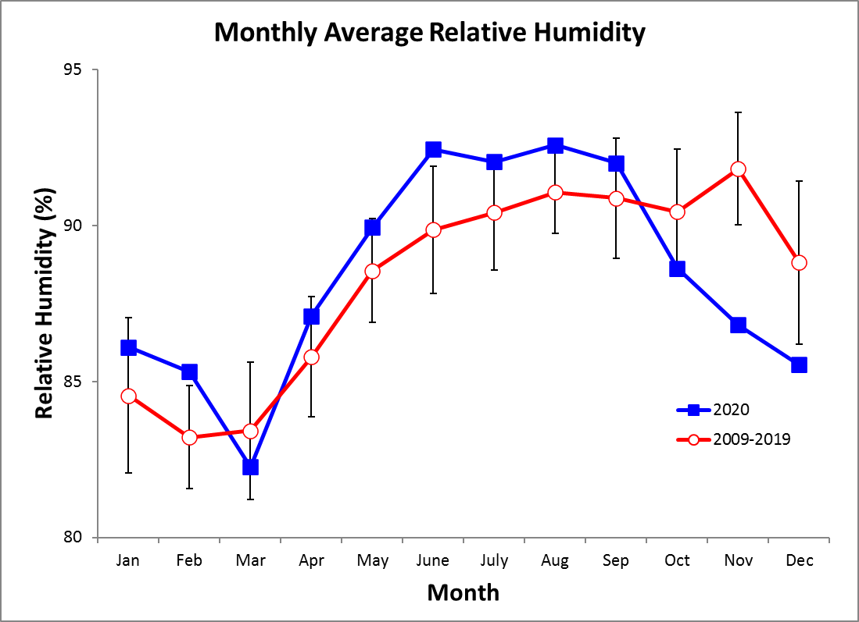
Monthly Average of Daily Maximum & Minimum Temperatures (°C)
Monthly Average Temperature
Year | Jan | Feb | Mar | Apr | May | June | July | Aug | Sep | Oct | Nov | Dec
2002 |  |  |  | 27.9 | 28.1 | 28.0 | 27.7 | 27.6 | 27.4 | 27.0 | 26.9 | 27.9
2003 | 27.6 | 27.6 | 27.8 | 28.2 | 27.6 | 27.5 | 27.5 | 27.0
2004 |  |  |  |  |  |  |  |  |  |  | 26.8 | 27.6
2005 | 27.2 | 26.9 | 27.6 | 27.9 | 27.2 | 27.6 | 27.9 | 27.1 | 26.7 | 26.8 | 26.3 | 27.1
2006 | 27.2 | 26.9 | 27.1 | 27.1 | 27.0 | 27.3 | 27.1 | 27.2 | 26.8 | 26.6 | 26.2 | 27.1
2007 | 27.3 | 26.9 | 27.1 |  | 26.4 | 26.9 | 26.6 | 26.2 | 26.4 | 26.0 | 25.7 | 26.7
2008 | 27.1 | 27.3 | 27.8 | 27.8 | 26.2 | 27.1 | 26.5 | 26.5 | 27.1 | 26.7 | 24.4 | 25.5
2009 | 25.2 |  | 26.7 | 27.6 | 27.9 | 27.4 | 27.8 | 27.5 | 28.0 | 27.2 | 27.0 | 28.1
2010 | 28.0 | 28.2 | 28.3 | 28.7 | 28.6 | 27.7 | 27.3 | 27.1 | 27.2 | 26.7 | 26.2 | 26.1
2011 | 26.9 | 27.2 | 27.3 | 27.4 | 27.6 | 27.4 | 27.2 | 27.1 | 27.0 | 26.4 | 26.1 | 26.7
2012 | 27.4 | 27.1 | 27.3 | 27.5 | 27.6 | 27.8 | 27.5 | 26.9 | 27.2 | 26.5 | 26.4 | 26.6
2013 | 27.2 | 27.1 | 27.2 | 27.8 | 27.4 | 26.9 | 27.0 | 26.6 | 26.8 | 26.7 | 26.9 | 27.8
2014 | 27.8 | 27.6 | 27.8 | 28.3 | 28.2 | 28.2 | 28.9 | 27.8 | 27.5 | 27.2 | 27.2 | 27.5
2015 | 28.2 | 27.9 | 27.8 | 28.4 | 28.5 | 28.7 | 28.3 | 28.3 | 28.1 | 28.0 | 27.8 | 29.0
2016 | 28.6 | 27.8 | 27.8 | 28.1 | 28.3 | 27.7 | 27.4 | 27.6 | 27.0 | 27.0 | 26.1 | 27.2
2017 | 27.2 | 27.2 | 27.5 | 28.0 | 27.4 | 27.4 | 27.2 | 26.8 | 26.8 | 27.1 | 26.0 | 26.4
2018 | 26.1 | 26.5 | 26.9 | 27.1 | 26.7 | 26.2 | 26.6 | 27.2 | 26.4 | 26.4 | 26.6 | 27.5
2019 | 26.9 | 26.9 | 26.9 | 27.6 | 27.3 | 27.9 | 27.0 | 27.1 | 26.9 | 26.3 | 27.0 | 27.2
2020 | 27.2 | 27.2 | 27.4 | 27.7 | 27.9 | 27.0 | 26.9 | 26.6 | 26.5 | 26.9 | 26.5 | 27.2
mean | 27.2 | 27.3 | 27.4 | 27.8 | 27.5 | 27.5 | 27.4 | 27.2 | 27.1 | 26.8 | 26.4 | 27.2
sd | 0.8 | 0.5 | 0.5 | 0.5 | 0.7 | 0.6 | 0.6 | 0.5 | 0.5 | 0.5 | 0.7 | 0.8
min | 25.2 | 26.5 | 26.7 | 27.1 | 26.2 | 26.2 | 26.5 | 26.2 | 26.4 | 26.0 | 24.4 | 25.5
max | 28.6 | 28.2 | 28.3 | 28.7 | 28.6 | 28.7 | 28.9 | 28.3 | 28.1 | 28.0 | 27.8 | 29.0
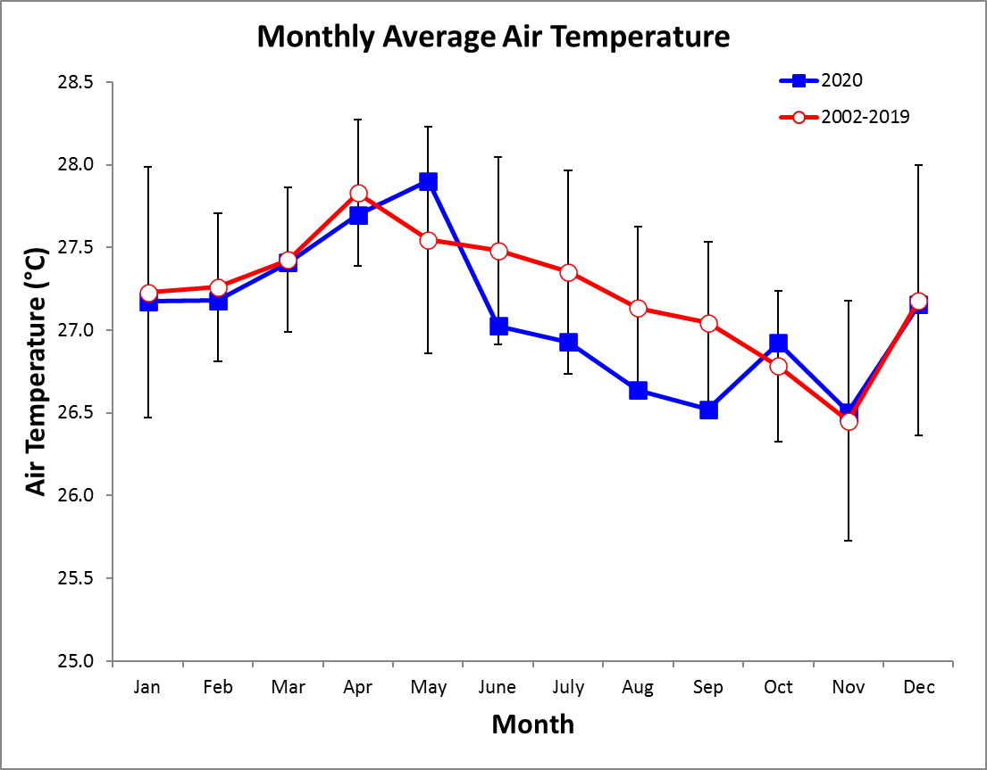
Monthly Average of Daily Maximum Temperature

Year | Jan | Feb | Mar | Apr | May | June | July | Aug | Sep | Oct | Nov | Dec
2002 |  |  |  | 28.8 | 30.5 | 30.7 | 29.9 | 30.0 | 30.9 | 30.1 | 30.0 | 29.3
2003 | 28.5 | 28.6 | 29.7 | 30.3 | 30.4 | 30.9 | 29.9 | 29.7
2004 |  |  |  |  |  |  |  |  |  |  | 28.7 | 28.9
2005 | 28.2 | 27.7 | 29.0 | 29.3 | 30.0 | 31.5 | 30.8 | 29.9 | 30.0 | 31.1 | 29.0 | 28.8
2006 | 28.3 | 27.8 | 27.8 | 28.3 | 29.5 | 30.1 | 29.4 | 29.5 | 29.4 | 29.8 | 28.9 | 28.8
2007 | 28.0 | 27.8 | 27.8 |  | 30.1 | 29.6 | 29.0 | 29.3 | 29.7 | 29.8 | 28.1 | 28.5
2008 | 27.9 | 28.3 | 28.9 | 28.8 | 29.5 | 29.6 | 29.4 | 29.8 | 30.7 | 30.2 | 27.3 | 27.3
2009 | 26.3 |  | 28.2 | 28.5 | 29.5 | 30.4 | 29.6 | 29.4 | 30.1 | 30.2 | 29.2 | 29.4
2010 | 28.9 | 29.2 | 29.4 | 30.0 | 31.0 | 30.5 | 30.2 | 30.3 | 30.8 | 29.4 | 28.7 | 27.5
2011 | 27.9 | 27.9 | 27.9 | 28.5 | 29.6 | 30.2 | 29.7 | 29.8 | 30.1 | 29.7 | 28.7 | 28.1
2012 | 28.0 | 27.7 | 27.9 | 29.2 | 29.9 | 30.3 | 29.1 | 29.5 | 29.6 | 29.4 | 28.1 | 28.0
2013 | 27.6 | 27.6 | 28.0 | 28.7 | 29.6 | 29.4 | 29.1 | 29.1 | 29.8 | 29.5 | 29.5 | 28.8
2014 | 28.5 | 28.3 | 28.6 | 29.1 | 29.7 | 29.7 | 29.9 | 29.7 | 30.0 | 30.0 | 29.4 | 28.8
2015 | 28.6 | 28.8 | 28.4 | 29.2 | 29.6 | 30.3 | 29.5 | 29.8 | 30.3 | 30.8 | 30.2 | 30.0
2016 | 29.3 | 28.4 | 28.5 | 29.5 | 30.7 | 30.5 | 29.3 | 29.8 | 29.8 | 30.3 | 29.0 | 28.8
2017 | 28.1 | 28.2 | 28.4 | 29.4 | 30.6 | 30.3 | 29.1 | 29.5 | 30.0 | 29.9 | 28.6 | 28.0
2018 | 27.2 | 27.0 | 28.1 | 28.4 | 29.5 | 28.3 | 28.4 | 29.3 | 29.4 | 29.7 | 28.9 | 28.7
2019 | 27.8 | 27.7 | 27.8 | 28.8 | 30.1 | 29.8 | 29.3 | 29.5 | 30.1 | 29.9 | 29.1 | 29.0
2020 | 28.2 | 28.1 | 28.2 | 29.0 | 30.1 | 30.0 | 29.3 | 29.5 | 29.9 | 30.6 | 29.8 | 28.8
mean | 28.1 | 28.1 | 28.4 | 29.1 | 30.0 | 30.1 | 29.5 | 29.6 | 30.0 | 30.0 | 28.9 | 28.6
sd | 0.7 | 0.5 | 0.6 | 0.6 | 0.5 | 0.7 | 0.5 | 0.3 | 0.5 | 0.5 | 0.7 | 0.7
min | 26.3 | 27.0 | 27.8 | 28.3 | 29.5 | 28.3 | 28.4 | 29.1 | 29.4 | 29.4 | 27.3 | 27.3
max | 29.3 | 29.2 | 29.7 | 30.3 | 31.0 | 31.5 | 30.8 | 30.3 | 30.9 | 31.1 | 30.2 | 30.0
Values in green were calculated by using the monthly average of daily maximum, interval-average temperature values. In Mar. 2018 this was changed to averages of interval-maximum values.
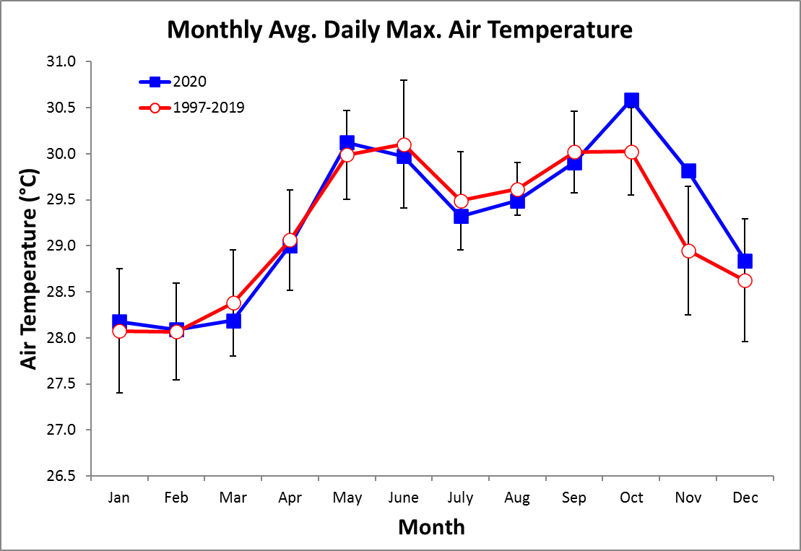
Monthly Average of Daily Minimum Temperature

Year | Jan | Feb | Mar | Apr | May | June | July | Aug | Sep | Oct | Nov | Dec
2002 |  |  |  | 26.3 | 26.2 | 25.8 | 25.7 | 25.6 | 24.7 | 24.6 | 24.4 | 26.3
2003 | 26.6 | 26.5 | 26.2 | 26.2 | 25.5 | 24.3 | 25.3 | 24.3
2004 |  |  |  |  |  |  |  |  |  |  | 24.9 | 26.1
2005 | 26.0 | 25.8 | 26.1 | 26.2 | 25.1 | 25.1 | 25.3 | 24.8 | 24.4 | 24.3 | 24.2 | 24.9
2006 | 25.9 | 25.9 | 26.3 | 25.4 | 25.1 | 25.2 | 24.8 | 25.0 | 24.5 | 24.3 | 23.9 | 25.3
2007 | 26.5 | 26.0 | 26.2 |  | 24.2 | 24.5 | 24.6 | 24.0 | 23.9 | 23.7 | 23.8 | 24.5
2008 | 26.1 | 26.0 | 26.6 | 26.5 | 23.8 | 24.9 | 24.3 | 24.1 | 24.4 | 24.0 | 22.1 | 23.4
2009 | 24.0 |  | 26.0 | 26.3 | 26.2 | 24.8 | 25.7 | 25.4 | 25.8 | 24.9 | 25.2 | 26.7
2010 | 26.8 | 27.1 | 27.3 | 27.3 | 26.5 | 25.4 | 25.0 | 25.0 | 25.0 | 24.5 | 23.9 | 24.1
2011 | 25.4 | 26.2 | 26.2 | 25.7 | 25.4 | 24.9 | 24.9 | 24.7 | 24.6 | 24.3 | 24.1 | 25.4
2012 | 26.5 | 26.4 | 26.5 | 25.7 | 25.5 | 25.3 | 25.5 | 24.7 | 24.9 | 24.2 | 24.5 | 24.8
2013 | 26.5 | 25.9 | 26.0 | 26.9 | 25.5 | 24.7 | 24.9 | 24.3 | 24.6 | 24.4 | 24.6 | 26.1
2014 | 26.9 | 26.9 | 26.7 | 27.3 | 26.3 | 26.1 | 27.7 | 25.7 | 25.3 | 25.0 | 25.1 | 26.0
2015 | 27.4 | 26.9 | 27.0 | 27.4 | 27.2 | 27.3 | 27.0 | 26.7 | 25.9 | 25.6 | 25.8 | 27.8
2016 | 27.6 | 26.8 | 27.0 | 26.5 | 26.0 | 25.1 | 25.2 | 25.5 | 24.6 | 24.7 | 24.0 | 25.4
2017 | 25.8 | 25.4 | 26.4 | 26.6 | 25.0 | 25.0 | 25.1 | 24.5 | 24.4 | 24.6 | 23.9 | 24.8
2018 | 24.8 | 26.0 | 25.9 | 25.5 | 24.4 | 23.9 | 24.6 | 25.0 | 24.2 | 24.1 | 24.4 | 25.9
2019 | 25.9 | 26.0 | 25.8 | 26.0 | 25.4 | 25.8 | 25.0 | 24.7 | 24.4 | 23.9 | 24.5 | 25.1
2020 | 25.6 | 25.7 | 26.3 | 26.1 | 25.8 | 24.6 | 24.8 | 24.1 | 24.1 | 24.4 | 24.4 | 25.4
mean | 26.1 | 26.2 | 26.4 | 26.3 | 25.5 | 25.2 | 25.3 | 24.9 | 24.7 | 24.4 | 24.3 | 25.4
sd | 0.9 | 0.5 | 0.4 | 0.6 | 0.8 | 0.8 | 0.8 | 0.7 | 0.5 | 0.4 | 0.8 | 1.0
min | 24.0 | 25.4 | 25.8 | 25.4 | 23.8 | 23.9 | 24.3 | 24.0 | 23.9 | 23.7 | 22.1 | 23.4
max | 27.6 | 27.1 | 27.3 | 27.4 | 27.2 | 27.3 | 27.7 | 26.7 | 25.9 | 25.6 | 25.8 | 27.8
Values in green were calculated by using the monthly average of daily maximum, interval-average temperature values. In Mar. 2018 this was changed to averages of interval-maximum values.
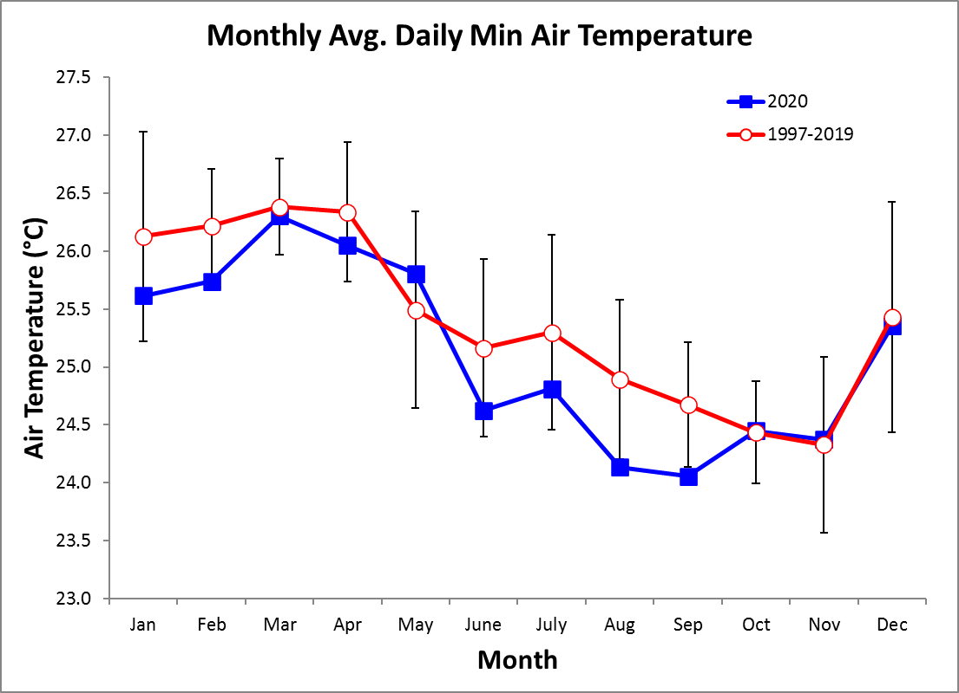
2020 Daily Total Radiation (MJ m⁻² day⁻¹)

 | Jan. | Feb. | Mar. | Apr. | May | June | July | Aug. | Sep. | Oct. | Nov. | Dec.
1 | 7.6 | 10.1 | 26.2 | 21.6 | 24.9 | 16.1 | 10.4 | 20.6 | 23.2 | 22.6 | 11.7 | 1.9
2 | 19.4 | 18.8 | 24.8 | 26.1 | 25.1 | 7.7 | 13.4 | 12.3 | 17.7 | 19.2 | 15.8 | 9.3
3 | 22.0 | 18.2 | 22.8 | 10.4 | 17.1 | 24.6 | 12.7 | 17.2 | 19.0 | 17.3 | 16.1 | 13.9
4 | 19.4 | 18.3 | 25.5 | 22.7 | 19.2 | 18.0 | 4.2 | 17.6 | 19.1 | 16.0 | 12.8 | 22.0
5 | 21.6 | 17.6 | 20.7 | 22.7 | 13.7 | 9.0 | 18.0 | 10.0 | 20.4 | 19.0 | 22.3 | 16.3
6 | 20.7 | 22.9 | 24.4 | 21.6 | 21.3 | 18.2 | 14.7 | 6.2 | 13.7 | 11.6 | 23.2 | 17.8
7 | 20.5 | 23.5 | 23.4 | 16.4 | 14.5 | 21.2 | 16.7 | 18.2 | 5.9 | 7.8 | 23.0 | 17.0
8 | 21.5 | 22.4 | 22.5 | 11.8 | 18.7 | 19.9 | 8.4 | 15.3 | 15.7 | 9.2 | 21.5 | 10.4
9 | 21.9 | 21.3 | 25.7 | 22.3 | 20.8 | 9.5 | 20.8 | 5.8 | 16.1 | 19.0 | 15.8 | 4.6
10 | 21.5 | 19.6 | 25.2 | 21.2 | 13.9 | 7.2 | 17.5 | 10.5 | 22.4 | 23.2 | 15.8 | 17.0
11 | 20.3 | 20.4 | 25.2 | 17.9 | 20.6 | 15.1 | 9.2 | 10.5 | 21.2 | 7.7 | 8.8 | 22.4
12 | 21.1 | 21.9 | 25.2 | 14.6 | 26.4 | 22.9 | 16.3 | 7.1 | 12.8 | 13.3 | 9.9 | 22.4
13 | 21.3 | 22.6 | 26.8 | 11.4 | 26.4 | 18.3 | 4.0 | 12.2 | 14.5 | 11.4 | 16.2 | 20.5
14 | 17.5 | 22.2 | 25.8 | 14.1 | 20.0 | 20.9 | 9.8 | 18.1 | 14.2 | 8.5 | 6.1 | 20.4
15 | 19.3 | 21.0 | 24.6 | 25.4 | 14.7 | 6.6 | 23.2 | 7.0 | 7.7 | 17.7 | 1.3 | 19.4
16 | 21.1 | 20.9 | 25.6 | 25.4 | 24.0 | 16.3 | 18.8 | 14.3 | 17.1 | 23.4 | 15.2 | 11.4
17 | 9.9 | 13.2 | 20.2 | 24.7 | 9.9 | 15.8 | 19.6 | 22.9 | 14.8 | 10.9 | 14.8 | 10.1
18 | 8.5 | 10.3 | 25.9 | 21.1 | 14.8 | 9.1 | 19.5 | 12.0 | 15.9 | 5.1 | 14.8 | 21.1
19 | 20.3 | 13.6 | 26.3 | 26.1 | 5.5 | 6.7 | 14.6 | 3.4 | 16.3 | 15.5 | 12.8 | 15.9
20 | 18.0 | 19.4 | 25.5 | 25.9 | 19.0 | 9.4 | 13.5 | 12.9 | 17.2 | 15.1 | 14.6 | 17.2
21 | 18.1 | 21.1 | 22.9 | 26.6 | 26.4 | 9.5 | 7.8 | 16.5 | 16.9 | 20.6 | 14.8 | 18.7
22 | 7.7 | 23.2 | 26.7 | 24.1 | 19.7 | 17.4 | 8.8 | 11.8 | 10.6 | 14.1 | 19.8 | 22.1
23 | 6.5 | 24.6 | 26.5 | 23.4 | 24.1 | 6.1 | 18.7 | 14.5 | 23.7 | 16.9 | 19.5 | 10.7
24 | 21.6 | 25.7 | 25.4 | 14.8 | 24.8 | 15.0 | 11.9 | 18.4 | 10.0 | 12.0 | 19.8 | 21.6
25 | 20.0 | 25.7 | 25.6 | 26.9 | 23.3 | 22.4 | 15.2 | 9.0 | 10.0 | 19.3 | 13.0 | 9.3
26 | 23.2 | 25.7 | 26.2 | 21.7 | 21.3 | 5.0 | 22.4 | 24.9 | 25.5 | 22.4 | 7.7 | 20.9
27 | 20.7 | 25.8 | 26.1 | 12.8 | 4.3 | 6.0 | 19.8 | 21.1 | 9.5 | 13.2 | 16.0 | 19.2
28 | 22.5 | 21.6 | 26.0 | 20.2 | 9.2 | 6.8 | 20.1 | 11.2 | 13.9 | 21.3 | 13.1 | 12.5
29 | 22.7 | 24.7 | 25.2 | 13.8 | 21.5 | 12.6 | 20.7 | 12.0 | 17.8 | 18.7 | 14.3 | 19.1
30 | 24.6 |  | 23.1 | 23.4 | 14.0 | 14.0 | 25.2 | 12.6 | 2.7 | 22.2 | 11.6 | 20.5
31 | 17.1 |  | 18.6 |  | 17.2 |  | 20.8 | 21.4 |  | 20.3 |  | 13.2
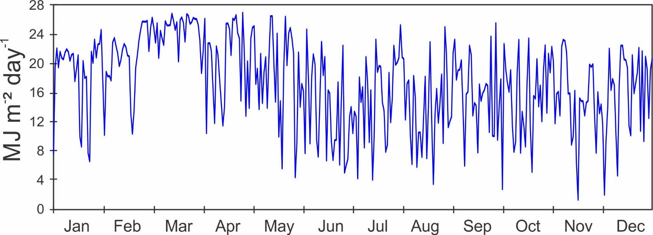

Monthly Average Total Daily Solar Radiation (MJ m⁻² day⁻¹)

Year | Jan | Feb | Mar | Apr | May | June | July | Aug | Sep | Oct | Nov | Dec
1974 | 20.9 | 22.6 | 24.7 | 23.0 | 19.9 | 17.0 | 12.8 | 16.0 | 16.4 | 15.5 | 13.5 | 19.1
1975 | 19.6 | 22.4 | 22.5 | 23.3 | 18.6 | 12.8 | 14.5 | 13.5 | 15.4 | 14.8 | 14.3
1976 | 17.8 | 19.9 | 19.7 |  |  |  |  |  | 15.3 | 15.1 | 13.9 | 15.9
1977 | 18.0 | 18.1 | 18.9 | 17.8 | 15.2 | 12.7 | 14.0 | 14.5 | 15.4 | 15.8 | 15.4 | 18.8
1978 | 21.2 | 20.2 | 21.9 | 18.6 | 17.3 | 14.8 | 15.7 | 16.7 | 18.2 | 14.3 | 13.7 | 15.4
1979 | 17.8 | 21.2 | 23.1 | 16.6 | 17.3 | 15.6 | 15.2 | 16.0 | 15.8 | 14.9 | 14.0 | 14.9
1980 | 18.0 | 20.2 | 21.5 | 18.0 | 15.8
1981
1982
1983 |  |  |  |  | 15.8 | 12.7 | 13.1 | 13.6 | 15.6 | 14.8 | 14.8 | 17.2
1984 | 18.6 | 19.2 | 21.0 | 21.7 | 15.9 | 12.5 | 13.0 | 13.2 | 16.5 | 13.2 | 15.3 | 14.8
1985 | 17.8 | 20.9 | 21.6 | 18.0 | 18.8 | 14.0 | 15.3 | 15.2 | 14.1 | 12.7 | 14.7 | 16.9
1986 | 16.7 | 17.7 | 21.2 | 15.7 | 15.4 | 12.5 | 12.3 | 13.1 | 13.6 | 12.5 | 13.0 | 15.8
1987 | 19.6 | 18.8 | 21.4 | 22.1 | 15.2 | 14.3 | 10.6 | 13.8 | 14.9 | 13.0 | 12.3 | 16.1
1988 | 19.8 | 20.3 | 22.9 | 21.3 | 18.0 | 13.3 | 14.0 | 12.9 | 15.5 | 12.8 | 13.7 | 16.9
1989 | 18.1 | 21.5 | 20.2 | 21.3 | 14.7 | 13.2 | 14.6 | 13.4 | 13.8 | 13.7 | 14.5 | 16.4
1990 | 19.6 | 19.1 | 22.4 | 22.1 | 13.9 | 14.0 | 16.3 | 15.1 | 14.8 | 15.3 | 12.6 | 15.9
1991 | 18.4 | 21.0 | 20.7 | 18.8 | 15.7 | 15.6 | 13.2 | 12.7 | 14.1 | 12.5 | 14.2 | 15.4
1992 | 15.8 | 19.9 | 19.6 | 18.6 | 16.9 | 12.2 | 14.8 | 14.0 | 12.4 | 13.6 | 12.0 | 14.4
1993 | 18.6 | 20.5 | 19.5 | 21.5 | 14.2 | 12.5 | 14.8 | 14.6 | 15.0 | 16.5 | 12.7 | 16.9
1994 | 18.1 | 20.9 | 22.2 | 21.5 | 15.1 | 15.2 | 15.1 | 18.3 | 15.7 | 15.9 | 12.3 | 14.5
1995 | 16.6 | 20.3 | 22.6 | 20.2 | 17.5 | 13.7 | 13.3 | 14.8 | 15.2 | 16.1 | 12.3 | 14.2
1996 | 20.2 | 20.1 | 23.6 | 21.9 | 17.4 | 16.9 | 18.3 | 18.6 | 15.4 | 16.7 | 13.6 | 18.5
1997 | 19.1 | 19.4 | 22.0 | 20.6 | 16.1 | 14.3 | 14.1 | 13.8 | 16.3 | 15.2 | 15.5 | 12.3
1998 | 18.8 | 18.5 | 21.3 | 19.9 | 17.1 | 13.9 | 14.0 | 14.3 | 14.7 | 14.4 | 13.1 | 11.0
1999 | 19.6 | 21.2 | 22.1 | 21.3 | 15.9 | 14.1 | 15.7 | 15.3 | 16.6 | 13.5 | 17.7 | 13.9
2000 | 19.4 | 20.7 | 20.9 | 21.6 | 18.4 | 17.7 | 15.1 | 15.3 | 15.3 | 15.8 | 13.6 | 12.3
2001 | 18.5 | 21.2 | 21.8 | 20.9 | 20.4 | 15.4 | 14.8 | 16.1 | 15.8 | 13.4 | 13.9 | 19.2
2002 | 19.0 | 20.3 | 22.5 | 20.8 | 13.4 | 13.8 | 13.1 | 14.1 | 16.4 | 16.2 | 14.0 | 12.9
2003 | 20.5 | 22.2 | 21.2 | 20.1 | 14.4 | 14.4 | 13.2 | 12.3 | 16.5 | 16.8 | 13.8 | 18.6
2004 | 17.9 | 20.7 | 21.1 | 18.9 | 14.4 | 16.6 | 16.4 | 14.3 | 13.8 | 16.2 | 14.0 | 18.0
2005 | 16.8 | 19.0 | 19.7 | 17.3 | 13.0 | 15.1 | 15.0 | 13.3 | 13.0 | 15.4 | 12.6 | 16.9
2006 | 17.8 | 19.0 | 19.8 | 18.0 | 14.3 | 14.9 | 13.9 | 14.7 | 12.9 | 14.2 | 11.6 | 15.8
2007 | 18.5 | 20.1 | 20.1 | 0.0 | 16.7 | 12.7 | 12.8 | 10.3 | 11.8 | 13.8 | 11.1 | 13.9
2008 | 18.5 | 19.0 | 22.0 | 21.2 | 15.9 | 12.5 | 12.3 | 15.1 | 16.9 | 16.1 | 12.3 | 18.4
2009 | 18.7 | 20.1 | 22.0 | 21.2 | 17.3 | 15.9 | 14.0 | 13.8 | 15.0 | 13.9 | 10.2 | 17.2
2010 | 17.6 | 17.2 | 17.6 | 19.1 | 15.9 | 14.0 | 14.5 | 13.6 | 14.6 | 12.4 | 11.3 | 8.1
2011 | 17.4 | 21.4 | 22.2 | 19.7 | 18.6 | 14.5 | 14.3 | 14.7 | 15.3 | 13.6 | 12.2 | 13.4
2012 | 20.0 | 20.9 | 19.7 | 18.8 | 16.9 | 16.5 | 14.2 | 14.2 | 14.5 | 13.9 | 10.8 | 14.9
2013 | 19.8 | 20.4 | 18.0 | 20.7 | 15.0 | 12.8 | 13.8 | 14.0 | 14.4 | 14.7 | 15.0 | 17.1
2014 | 17.8 | 20.5 | 20.9 | 18.7 | 17.0 | 9.2 | 17.4 | 14.7 | 14.4 | 12.8 | 14.2 | 14.5
2015 | 17.8 | 18.7 | 21.2 | 20.6 | 14.0 | 17.4 | 14.1 | 15.1 | 14.7 | 15.6 | 13.8 | 15.8
2016 | 18.3 | 19.4 | 20.3 | 20.6 | 16.4 | 15.5 | 12.0 | 13.9 | 13.7 | 15.8 | 12.3 | 15.7
2017 | 20.2 | 22.5 | 22.5 | 21.4 | 15.2 | 15.2 | 13.3 | 15.9 | 15.4 | 16.1 | 13.4 | 15.0
2018 | 15.4 | 23.2 | 21.4 | 19.7 | 16.3 | 12.8 | 15.5 | 16.3 | 15.5 | 15.7 | 13.7 | 19.6
Data in Purple are from sensors on Laboratory Roof, Data in Green are from sensors on Reef Station. Other data are from the Pier Tower
Year | Jan | Feb | Mar | Apr | May | June | July | Aug | Sep | Oct | Nov | Dec
2019 | 18.2 | 20.8 | 22.0 | 21.9 | 16.6 | 16.9 | 15.7 | 15.4 | 15.2 | 14.7 | 14.7 | 14.5
2020 | 18.5 | 20.3 | 24.6 | 20.1 | 18.5 | 13.5 | 15.3 | 13.7 | 15.5 | 16.0 | 14.7 | 16.1
mean | 18.5 | 20.3 | 21.2 | 20.1 | 16.2 | 14.3 | 14.3 | 14.5 | 15.0 | 14.6 | 13.4 | 15.6
sd | 1.3 | 1.3 | 1.4 | 1.8 | 1.7 | 1.7 | 1.5 | 1.5 | 1.2 | 1.3 | 1.4 | 2.3
min | 15.4 | 17.2 | 17.6 | 15.7 | 13.0 | 9.2 | 10.6 | 10.3 | 11.8 | 12.4 | 10.2 | 8.1
max | 21.2 | 23.2 | 24.7 | 23.3 | 20.4 | 17.7 | 18.3 | 18.6 | 18.2 | 16.8 | 17.7 | 19.6

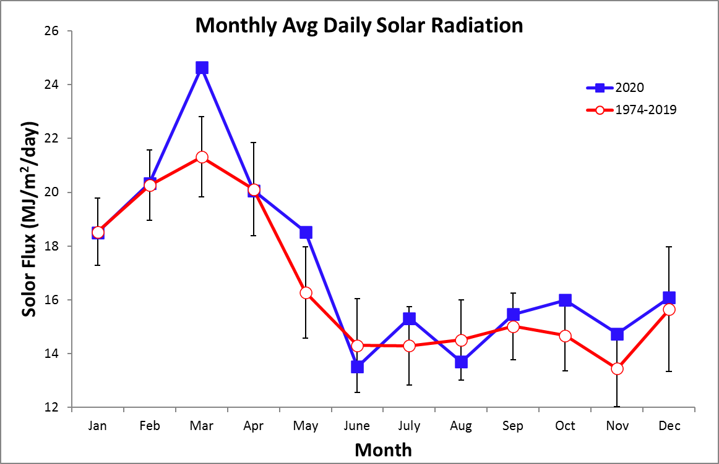

2020 Daily Average Wind Speed (km/h) – Pier Tower
 | Jan. |  | Feb. |  |  | Mar. |  |  | Apr. |  |  | May |  |  | June |  | July |  | Aug. |  | Sep. |  | Oct. |  | Nov. |  |  | Dec.
 | Avg | Max | Avg | Max | Avg |  | Max | Avg |  | Max | Avg |  | Max | Avg |  | Max | Avg | Max | Avg | Max | Avg | Max | Avg | Max | Avg | Max | Avg |  |  | Max
1 | 16.6 | 34.6 | 18.0 | 32.1 | 25.0 |  | 38.7 | 15.1 |  | 29.6 | 18.9 |  | 32.7 | 4.7 |  | 17.3 | 7.7 | 30.3 | 6.1 | 16.5 | 5.3 | 23.3 | 6.8 | 21.9 | 7.8 | 23.5 | 11.6 |  | 43.6
2 | 14.7 | 29.3 | 31.3 | 45.0 | 26.4 |  | 38.7 | 15.5 |  | 28.7 | 27.3 |  | 36.8 | 5.6 |  | 25.7 | 6.1 | 23.3 | 6.4 | 21.1 | 5.4 | 23.4 | 5.3 | 29.0 | 11.7 | 36.2 | 5.6 |  | 28.5
3 | 5.1 | 19.2 | 29.6 | 46.2 | 24.0 |  | 37.3 | 13.7 |  | 28.2 | 26.4 |  | 39.1 | 10.2 |  | 27.1 | 5.7 | 21.5 | 5.8 | 22.5 | 6.8 | 29.6 | 6.6 | 21.8 | 18.4 | 44.3 | 5.3 |  | 19.9
4 | 11.6 | 29.9 | 25.5 | 38.8 | 22.2 |  | 33.7 | 24.7 |  | 36.2 | 23.7 |  | 49.7 | 9.4 |  | 25.4 | 6.3 | 31.1 | 6.6 | 31.0 | 7.6 | 22.2 | 6.4 | 18.1 | 19.7 | 44.2 | 13.4 |  | 32.3
5 | 23.3 | 38.3 | 24.2 | 35.2 | 21.8 |  | 32.6 | 20.2 |  | 34.6 | 17.2 |  | 35.4 | 4.3 |  | 13.8 | 6.0 | 24.7 | 5.1 | 47.7 | 6.9 | 18.7 | 7.1 | 23.8 | 17.5 | 36.9 | 17.6 |  | 30.6
6 | 26.4 | 43.8 | 16.8 | 27.6 | 26.3 |  | 38.0 | 25.9 |  | 36.1 | 15.3 |  | 28.9 | 5.9 |  | 20.7 | 11.3 | 31.0 | 3.9 | 27.9 | 4.7 | 18.4 | 9.0 | 33.6 | 14.3 | 36.0 | 8.9 |  | 32.4
7 | 25.0 | 41.4 | 9.7 | 26.9 | 26.8 |  | 41.9 | 28.1 |  | 45.6 | 15.6 |  | 29.2 | 7.3 |  | 22.5 | 16.2 | 37.3 | 6.6 | 21.2 | 6.4 | 23.3 | 5.8 | 19.3 | 12.4 | 37.4 | 11.1 |  | 25.5
8 | 30.7 | 47.0 | 22.9 | 37.5 | 30.2 |  | 50.0 | 23.3 |  | 38.7 | 17.7 |  | 33.1 | 11.0 |  | 31.2 | 6.2 | 24.5 | 9.3 | 32.9 | 7.6 | 38.8 | 8.3 | 30.5 | 12.0 | 34.7 | 17.3 |  | 44.2
9 | 32.1 | 49.4 | 29.1 | 41.4 | 31.5 |  | 49.7 | 21.7 |  | 36.7 | 11.0 |  | 23.0 | 9.5 |  | 30.6 | 7.1 | 18.6 | 5.7 | 26.9 | 7.5 | 22.6 | 8.7 | 26.9 | 8.7 | 24.7 | 21.9 |  | 49.2
10 | 31.9 | 46.2 | 27.0 | 38.9 | 25.0 |  | 39.5 | 19.1 |  | 32.5 | 7.2 |  | 19.7 | 6.7 |  | 25.9 | 7.5 | 27.8 | 4.5 | 15.2 | 6.9 | 25.0 | 10.0 | 29.6 | 7.4 | 22.8 | 26.2 |  | 43.7
11 | 21.2 | 36.5 | 24.3 | 35.0 | 25.0 |  | 33.8 | 19.8 |  | 29.6 | 12.2 |  | 26.0 | 7.6 |  | 45.1 | 6.3 | 27.5 | 10.1 | 41.7 | 6.6 | 22.3 | 5.7 | 35.8 | 5.7 | 22.5 | 21.0 |  | 41.5
12 | 26.3 | 37.4 | 25.2 | 37.8 | 23.8 |  | 39.4 | 18.8 |  | 36.3 | 16.3 |  | 26.9 | 5.2 |  | 18.1 | 5.6 | 13.8 | 10.8 | 33.7 | 5.1 | 21.8 | 6.4 | 24.2 | 4.5 | 12.9 | 20.8 |  | 34.9
13 | 28.1 | 41.5 | 25.5 | 41.5 | 21.2 |  | 32.6 | 3.8 |  | 19.4 | 12.8 |  | 30.9 | 6.1 |  | 20.4 | 6.1 | 35.7 | 9.9 | 44.1 | 6.1 | 23.8 | 6.0 | 32.6 | 6.2 | 24.3 | 20.6 |  | 38.8
14 | 33.1 | 46.3 | 27.3 | 40.4 | 23.9 |  | 40.2 | 6.8 |  | 16.9 | 6.2 |  | 22.3 | 7.2 |  | 18.8 | 5.5 | 40.4 | 5.6 | 17.8 | 6.3 | 29.1 | 5.6 | 33.8 | 6.6 | 33.9 | 14.5 |  | 29.0
15 | 31.7 | 51.9 | 30.0 | 46.3 | 26.8 |  | 39.6 | 14.2 |  | 34.6 | 7.7 |  | 21.7 | 5.3 |  | 32.1 | 8.6 | 26.2 | 5.5 | 20.4 | 5.9 | 31.5 | 5.5 | 14.7 | 7.1 | 19.2 | 9.3 |  | 25.1
16 | 27.1 | 39.6 | 33.4 | 49.4 | 26.2 |  | 45.9 | 15.4 |  | 32.4 | 7.8 |  | 21.1 | 4.5 |  | 18.9 | 22.8 | 34.4 | 6.7 | 26.6 | 5.1 | 20.0 | 7.4 | 36.5 | 11.6 | 30.7 | 9.4 |  | 31.2
17 | 31.5 | 44.5 | 30.6 | 50.7 | 24.2 |  | 43.7 | 25.1 |  | 40.9 | 10.0 |  | 28.5 | 4.7 |  | 16.2 | 19.8 | 44.5 | 7.2 | 26.6 | 5.2 | 16.3 | 11.4 | 35.7 | 17.4 | 40.3 | 20.8 |  | 40.8
18 | 31.8 | 45.6 | 29.1 | 43.5 | 29.4 |  | 43.3 | 18.3 |  | 32.4 | 4.7 |  | 17.0 | 5.9 |  | 28.8 | 13.0 | 29.1 | 6.0 | 21.3 | 6.2 | 23.7 | 6.2 | 40.9 | 10.7 | 30.8 | 29.3 |  | 44.8
19 | 25.3 | 38.2 | 27.1 | 42.5 | 28.0 |  | 41.0 | 18.9 |  | 31.0 | 4.0 |  | 20.6 | 4.3 |  | 17.3 | 17.3 | 32.9 | 3.8 | 17.0 | 6.5 | 31.5 | 7.2 | 24.1 | 6.0 | 19.8 | 31.5 |  | 44.5
20 | 23.4 | 35.6 | 30.4 | 50.6 | 24.3 |  | 34.4 | 11.6 |  | 25.5 | 8.9 |  | 24.7 | 5.5 |  | 21.1 | 11.6 | 39.2 | 6.4 | 18.4 | 8.2 | 44.7 | 9.4 | 29.5 | 6.8 | 25.9 | 25.5 |  | 40.3
21 | 18.4 | 34.7 | 30.4 | 46.8 | 26.6 |  | 42.1 | 8.7 |  | 20.2 | 10.5 |  | 31.4 | 5.2 |  | 19.0 | 5.1 | 17.8 | 7.8 | 22.3 | 5.3 | 21.7 | 7.8 | 22.2 | 5.9 | 22.1 | 25.4 |  | 38.1
22 | 8.8 | 26.5 | 26.6 | 36.8 | 31.9 |  | 41.0 | 15.1 |  | 31.9 | 12.7 |  | 32.6 | 10.1 |  | 29.6 | 4.7 | 16.5 | 5.4 | 22.2 | 6.8 | 38.2 | 5.1 | 18.3 | 7.1 | 25.7 | 24.3 |  | 35.3
23 | 17.8 | 39.8 | 24.9 | 36.8 | 28.7 |  | 39.8 | 14.4 |  | 26.9 | 6.5 |  | 17.9 | 8.8 |  | 32.6 | 5.1 | 16.8 | 4.5 | 17.6 | 5.9 | 26.5 | 5.0 | 21.0 | 6.6 | 17.5 | 25.2 |  | 39.4
24 | 22.4 | 31.5 | 19.3 | 30.8 | 24.9 |  | 35.1 | 10.2 |  | 22.2 | 6.2 |  | 17.1 | 7.0 |  | 23.3 | 4.9 | 20.5 | 6.6 | 37.5 | 6.1 | 35.5 | 6.8 | 28.9 | 9.4 | 32.1 | 19.9 |  | 36.1
25 | 22.6 | 33.5 | 11.7 | 28.8 | 24.0 |  | 36.5 | 19.1 |  | 34.1 | 8.4 |  | 22.4 | 23.0 |  | 50.5 | 4.7 | 18.2 | 5.3 | 21.9 | 8.1 | 42.0 | 11.2 | 30.6 | 8.7 | 45.8 | 10.7 |  | 38.2
26 | 14.3 | 29.1 | 11.7 | 28.9 | 23.4 |  | 36.0 | 22.8 |  | 33.5 | 7.4 |  | 27.2 | 11.8 |  | 50.4 | 6.6 | 25.5 | 13.8 | 35.6 | 6.5 | 21.9 | 10.5 | 28.7 | 5.9 | 23.3 | 9.6 |  | 32.9
27 | 10.7 | 25.9 | 16.4 | 34.4 | 24.7 |  | 39.3 | 21.3 |  | 37.0 | 7.9 |  | 44.4 | 4.4 |  | 20.8 | 6.2 | 22.9 | 7.8 | 24.9 | 5.9 | 35.8 | 5.3 | 13.9 | 12.4 | 39.4 | 7.9 |  | 28.6
28 | 10.1 | 27.0 | 25.3 | 42.4 | 28.9 |  | 41.5 | 25.0 |  | 38.1 | 6.0 |  | 20.8 | 6.3 |  | 24.1 | 7.2 | 24.8 | 6.1 | 28.9 | 6.7 | 47.4 | 5.2 | 17.2 | 6.5 | 26.9 | 6.0 |  | 34.7
29 | 18.1 | 35.6 | 31.5 | 45.7 | 26.0 |  | 38.0 | 23.2 |  | 34.9 | 8.8 |  | 27.9 | 5.2 |  | 24.8 | 13.1 | 34.4 | 4.7 | 20.0 | 6.4 | 25.5 | 7.7 | 26.5 | 6.2 | 23.2 | 7.0 |  | 39.0
30 | 17.1 | 36.8 |  |  | 23.4 |  | 38.2 | 11.6 |  | 26.9 | 9.4 |  | 50.5 | 7.7 |  | 30.8 | 15.6 | 28.9 | 7.7 | 30.8 | 7.4 | 26.4 | 8.2 | 34.5 | 9.6 | 31.7 | 6.9 |  | 22.5
31 | 23.2 | 37.6 |  |  | 23.9 |  | 35.2 |  |  |  | 7.2 |  | 22.4 |  |  |  | 9.8 | 21.4 | 6.4 | 24.2 |  |  | 7.2 | 30.6 |  |  | 9.0 |  | 31.2
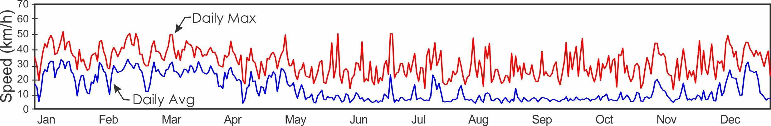
2020 Average Daily Wind Direction (°) – Pier Tower

 |  | Jan. | Feb. | Mar. | Apr. | May | June | July | Aug. | Sep. | Oct. | Nov. | Dec.
 | 1 | 13.0 | 351.5 | 17.4 | 41.0 | 43.0 | 167.0 | 300.5 | 24.8 | 210.0 | 182.3 | 195.3 | 353.3
 | 2 | 44.6 | 37.6 | 24.9 | 49.9 | 35.3 | 235.7 | 235.0 | 349.9 | 196.9 | 180.3 | 176.2 | 218.9
 | 3 | 337.0 | 27.7 | 20.5 | 358.2 | 24.3 | 168.5 | 248.1 | 267.2 | 162.8 | 185.3 | 167.8 | 212.0
 | 4 | 33.9 | 22.7 | 21.8 | 43.2 | 22.0 | 134.2 | 207.0 | 283.3 | 136.5 | 178.1 | 162.7 | 25.7
 | 5 | 27.5 | 28.9 | 6.8 | 22.1 | 30.6 | 206.7 | 146.4 | 179.4 | 127.9 | 188.4 | 159.0 | 25.6
 | 6 | 31.8 | 15.0 | 21.2 | 20.9 | 26.2 | 260.5 | 54.9 | 192.6 | 220.1 | 154.6 | 158.9 | 320.0
 | 7 | 31.2 | 22.2 | 18.8 | 16.4 | 24.8 | 254.2 | 26.6 | 301.5 | 176.5 | 174.1 | 164.5 | 345.0
 | 8 | 40.1 | 22.4 | 37.4 | 7.5 | 20.1 | 33.9 | 259.8 | 318.4 | 161.5 | 160.4 | 164.6 | 27.5
 | 9 | 46.0 | 26.2 | 34.7 | 25.9 | 350.6 | 91.2 | 260.2 | 218.3 | 131.8 | 125.3 | 155.9 | 358.6
 | 10 | 44.9 | 32.9 | 24.4 | 15.4 | 345.9 | 179.8 | 47.0 | 265.7 | 169.4 | 339.1 | 154.3 | 25.5
 | 11 | 41.4 | 29.0 | 23.5 | 15.0 | 6.8 | 176.6 | 229.2 | 354.2 | 14.1 | 187.7 | 175.4 | 22.2
 | 12 | 36.5 | 31.4 | 22.0 | 35.7 | 19.6 | 192.1 | 249.9 | 52.8 | 186.5 | 212.9 | 196.4 | 16.3
 | 13 | 35.9 | 28.2 | 26.0 | 227.6 | 24.9 | 161.9 | 279.6 | 316.9 | 178.8 | 195.7 | 214.5 | 22.4
 | 14 | 45.1 | 26.5 | 32.9 | 148.0 | 280.8 | 357.3 | 179.0 | 182.4 | 187.0 | 176.0 | 208.8 | 359.1
 | 15 | 36.8 | 26.1 | 30.8 | 66.9 | 4.9 | 222.1 | 290.7 | 189.2 | 167.4 | 202.2 | 189.8 | 298.3
 | 16 | 35.0 | 30.4 | 25.0 | 53.7 | 31.2 | 199.6 | 20.6 | 235.0 | 177.5 | 283.4 | 170.4 | 302.4
 | 17 | 44.8 | 28.2 | 32.7 | 23.8 | 13.2 | 203.2 | 15.6 | 272.0 | 170.9 | 299.3 | 161.1 | 57.5
 | 18 | 41.5 | 17.6 | 35.4 | 358.8 | 263.2 | 257.1 | 23.9 | 288.8 | 188.8 | 214.4 | 170.7 | 32.4
 | 19 | 33.0 | 18.2 | 35.0 | 14.8 | 197.2 | 262.3 | 33.7 | 215.8 | 184.9 | 192.3 | 195.8 | 40.7
 | 20 | 21.7 | 19.3 | 26.4 | 13.2 | 56.7 | 234.6 | 25.4 | 187.1 | 54.2 | 157.6 | 219.6 | 36.6
 | 21 | 4.2 | 20.7 | 32.0 | 6.6 | 43.2 | 239.5 | 241.3 | 139.2 | 218.0 | 183.1 | 182.2 | 22.3
 | 22 | 314.1 | 9.9 | 40.7 | 50.0 | 77.4 | 42.3 | 255.9 | 187.8 | 283.1 | 205.3 | 174.6 | 28.5
 | 23 | 28.7 | 17.0 | 35.2 | 28.1 | 243.7 | 127.2 | 258.4 | 178.9 | 227.1 | 230.7 | 321.7 | 46.5
 | 24 | 36.8 | 24.4 | 24.4 | 15.5 | 28.9 | 261.1 | 212.1 | 155.4 | 187.9 | 171.5 | 351.9 | 8.1
 | 25 | 16.9 | 66.6 | 25.2 | 34.2 | 68.2 | 35.4 | 187.9 | 190.9 | 146.3 | 162.2 | 0.7 | 312.4
 | 26 | 0.4 | 41.6 | 26.1 | 41.6 | 342.9 | 11.6 | 246.0 | 158.5 | 266.9 | 146.9 | 219.2 | 347.2
 | 27 | 46.7 | 59.6 | 27.8 | 52.3 | 184.5 | 242.5 | 242.1 | 161.3 | 170.3 | 171.5 | 89.4 | 266.3
 | 28 | 45.4 | 8.6 | 34.1 | 38.5 | 175.4 | 225.2 | 316.8 | 254.8 | 200.4 | 224.2 | 237.7 | 288.6
 | 29 | 58.6 | 26.7 | 25.8 | 38.7 | 165.2 | 215.9 | 353.9 | 219.3 | 295.7 | 178.2 | 251.8 | 238.2
 | 30 | 55.9 |  | 19.8 | 39.1 | 168.0 | 183.7 | 27.2 | 190.4 | 204.3 | 184.3 | 264.5 | 228.2
 | 31 | 28.1 |  | 37.2 |  | 170.8 |  | 356.3 | 236.1 |  | 226.0 |  | 90.1
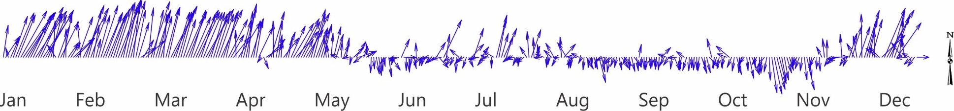

Average Monthly Wind Speed (km/h) and Direction (°)
 | Long-term Av. |  |  |  |  | 2020
 | Reef |  | Tower |  |  | Reef | Tower
 | Avg. | Max. | Avg. | Max. | Dir. | Avg. | Avg. | Máx. | Dir.
January | 21.5 | 35.1 | 22.2 | 38.7 | 20.0 | 21.7 | 22.0 | 37.2 | 31.5
February | 24.1 | 34.1 | 23.5 | 37.6 | 19.7 | 24.4 | 24.7 | 39.3 | 24.6
March | 23.4 | 32.5 | 23.5 | 37.2 | 18.4 | 25.3 | 25.8 | 39.2 | 27.3
April | 19.1 | 30.9 | 18.5 | 32.8 | 18.0 | 16.7 | 17.7 | 31.7 | 28.7
May | 12.3 | 27.3 | 11.3 | 28.9 | 19.3 |  | 11.7 | 28.4 | 303.6
June | 10.3 | 26.5 | 9.2 | 28.2 | 252.7 |  | 7.3 | 26.1 | 303.6
July | 11.7 | 27.4 | 10.5 | 30.0 | 334.6 |  | 9.0 | 27.1 | 212.8
August | 10.4 | 26.6 | 9.0 | 28.4 | 275.3 |  | 6.7 | 26.3 | 185.1
September | 8.9 | 25.4 | 7.6 | 28.3 | 204.9 |  | 6.4 | 27.7 | 185.1
October | 9.3 | 25.4 | 7.8 | 27.9 | 192.6 | 8.6 | 7.3 | 26.9 | 183.8
November | 10.5 | 28.2 | 9.3 | 30.8 | 232.5 | 12.3 | 9.7 | 29.6 | 181.8
December | 17.2 | 33.6 | 16.3 | 35.3 | 10.9 | 16.8 | 15.9 | 35.4 | 6.7

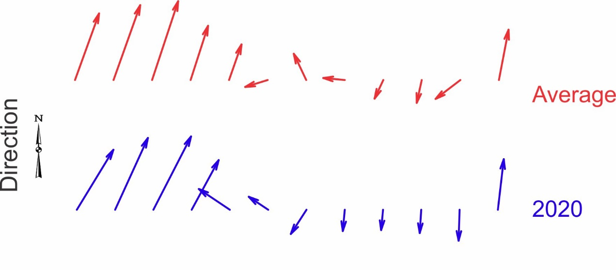

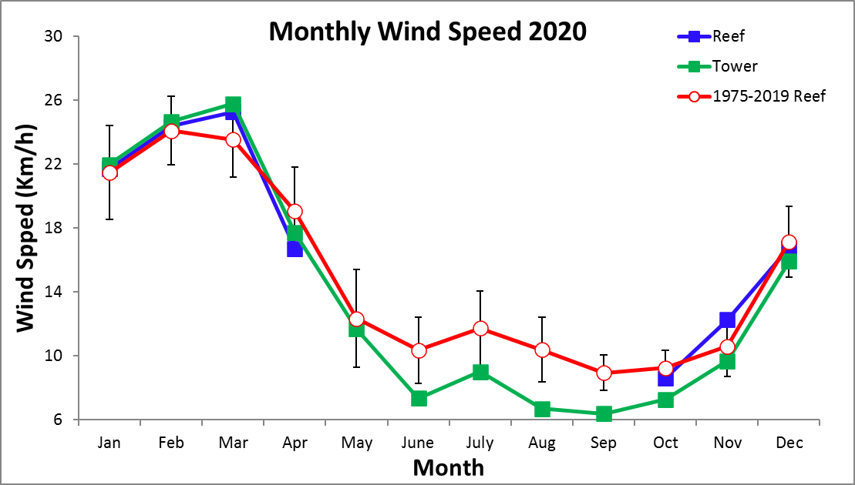
Average Monthly SST (C)
Reef, Upstream
Year | Jan | Feb | Mar | Apr | May | June | July | Aug | Sep | Oct | Nov | Dec
1975 | 26.8 | 26.7 | 27.5 | 27.8 | 28.6 | 28.6 | 28.2 | 27.7 | 28.4 | 28.1 | 27.8 | 26.2
1976 | 26.1 | 26.3 | 26.9 | 27.9 | 28.3 | 28.5 | 28.3 | 28.0 | 27.9 | 28.6 | 28.2 | 27.7
1977 | 26.9 | 26.9 | 27.0 | 27.6 | 29.2 | 28.6 | 27.7 | 27.9 | 28.1 | 28.1 | 27.6 | 28.1
1978 | 27.0 | 26.9 | 27.7 | 28.2 | 28.5 | 28.5 | 27.9 | 28.4 | 28.2 | 28.3 | 28.0 | 27.4
1979 | 26.7 | 26.8 | 27.3 | 27.7 | 28.8 | 28.7 | 28.5 | 28.3 | 28.4 | 28.4 | 27.9 | 27.3
1980 | 27.1 | 27.8 | 27.7 | 28.7 | 29.9 | 29.4 | 28.9 | 29.3 | 28.8
1981
1982
1983
1984 |  |  |  | 28.9 | 29.3 | 29.1 | 28.5 | 28.2 | 27.9 | 28.2 | 27.3 | 26.5
1985 | 25.8 | 26.3 | 27.1 | 28.5 | 29.2 | 29.1 | 28.9 | 28.7 | 29.3 | 28.9 | 28.5 | 28.0
1986 | 26.8 | 27.2 | 27.9 | 28.4 | 29.3 | 28.9 | 28.1 | 28.2 | 28.2 | 27.9 | 28.0 | 27.4
1987 | 27.1 | 27.2 | 28.1 | 28.0 | 28.6 | 29.0 | 28.4 | 28.3 | 28.4 | 28.2 | 27.9 | 27.8
1988 | 27.4 | 27.3 | 27.3 | 28.8 | 29.0 | 29.1 | 28.4 | 28.2 | 28.3 | 27.9 | 27.6 | 27.0
1989 | 26.4 | 26.0 | 27.0 | 27.6 | 28.3 | 28.1 | 27.8 | 27.7 | 28.1 | 27.9 | 27.7 | 27.3
1990 | 26.5 | 26.5 | 26.9 | 28.1 | 28.0 | 28.2 | 27.9 | 28.2 | 28.3 | 28.1 | 28.3 | 27.5
1991 | 27.3 | 26.9 | 28.0 | 28.7 | 28.4 | 29.0 | 28.7 | 28.2 | 28.4 | 28.4 |  | 26.8
1992 | 26.8 | 27.3 | 28.0 | 28.5 | 28.3 | 29.7 | 28.7 | 28.0 | 28.0 | 28.3 | 28.2 | 27.9
1993 | 27.3 | 27.2 | 27.9 | 29.1 | 29.4 | 29.2 | 28.5 | 28.4 | 28.0 | 28.4 | 27.6 | 27.4
1994 | 26.9 | 27.0 | 27.5 | 28.3 | 28.6 | 28.4 | 28.0 | 28.0 | 28.1 | 28.5 | 27.8 | 27.5
1995 | 27.2 | 27.3 | 28.3 | 28.9 | 28.9 | 29.3 | 28.7 | 29.1 | 29.1 | 28.4 | 28.0 | 27.4
1996 | 27.0 | 27.0 | 27.5 | 28.2 | 28.6 | 28.5 | 28.1 | 28.0 | 28.6 | 28.0 | 27.6 | 26.7
1997 | 26.9 | 26.9 | 27.2 | 28.0 | 28.1 | 28.8 | 28.5 | 28.5 | 28.4 | 28.4 | 27.7 | 27.8
1998 | 27.4 | 27.6 | 28.2 | 28.7 | 28.8 | 28.8 | 28.2 | 28.3 | 29.0 | 29.1 | 28.5 | 27.5
1999 | 27.2 | 27.0 | 27.4 | 28.1 | 29.1 | 29.0 | 28.4 | 28.5 | 28.4 | 27.9 | 27.2 | 26.4
2000 | 26.2 | 26.5 | 27.1 | 27.6 |  |  | 28.0 | 29.8 | 29.3 | 28.7 | 28.6 | 27.8
2001 | 26.9 | 26.7 | 27.4 | 27.7 | 28.9 | 28.9 | 28.1 | 28.6 | 28.7 | 28.9 | 27.4 | 27.6
2002 | 27.8 | 27.5 | 28.5 | 29.0 | 29.3 | 30.0 | 29.1 | 28.8 | 30.0 | 29.5 | 28.9 | 28.2
2003 | 28.2 | 28.3 | 28.8 | 29.8 | 29.1 | 29.3 | 28.9 | 29.0 | 29.9 | 29.8 | 29.3 | 28.1
2004 | 28.0 | 28.5 | 28.1 | 29.2 | 29.0 | 29.1 | 29.0 | 29.1 | 29.2 | 29.6 | 28.7 | 27.9
2005 | 27.5 | 27.4 | 29.3 | 29.6 | 29.6 | 30.4 | 30.4 | 29.7 | 29.5 | 29.3 | 27.9 | 27.3
2006 | 27.4 | 27.8 | 28.0 | 28.5 | 28.8 | 29.3 | 29.2 | 28.9 | 29.1
2007 | 27.5 | 27.8 | 28.4 | 29.4 | 29.8 | 29.6 | 29.0 | 29.3 | 29.5 | 29.1 | 28.4
2008 |  | 27.8 | 28.3 | 29.2 | 29.2 | 29.7 |  |  |  | 29.2 | 28.2 | 27.5
2009 | 27.2 | 27.0 | 27.6 | 28.8 | 29.2 | 29.8 | 29.0 | 29.0 | 29.5 | 29.2 | 28.3 | 28.4
2010 | 28.0 | 28.4 | 28.6 | 29.7 | 29.9 | 30.0 | 29.8 | 29.7 | 29.2 | 28.8 | 27.9 | 26.2
2011 | 27.1 | 27.8 | 28.1 | 28.9 | 29.9 | 29.9 | 29.5 | 29.5 | 29.8 | 29.1 | 28.4 | 27.5
2012 | 27.3 | 27.3 | 27.4 | 28.8 | 29.4 | 29.7 | 28.8 | 28.9 | 29.1 | 29.0 | 27.9 | 27.8
2013 | 27.8 | 27.8 | 28.0 | 29.0 | 29.1 | 29.0 | 28.9 | 28.9 | 29.3 | 29.4 | 29.2 | 28.6
2014 | 27.9 | 27.9 | 28.4 | 28.8 | 29.4 | 29.2 | 29.1 | 28.9 | 29.2 | 29.1 | 28.8 | 28.0
2015 | 27.7 | 27.9 | 28.0 | 28.9 | 28.9 | 29.7 | 28.8 | 28.9 | 29.3 | 29.9 | 29.7 | 28.8
2016 | 28.5 | 27.5 | 28.0 | 29.3 | 30.0 | 30.3 | 29.0 | 29.3 | 29.5 | 29.3 | 28.7 | 28.1
2017 | 27.7 | 28.1 | 28.2 | 29.2 | 29.9 | 29.8 | 29.1 | 29.5 | 29.8 | 29.6 | 29.2 | 27.8
2018 | 27.3 | 27.3 | 27.8 | 28.8 | 29.4 | 29.4 | 28.6 | 28.7 | 29.2 | 28.8 | 28.6 | 28.6
2019 | 27.6 | 27.7 | 27.9 | 29.0 | 29.6 | 30.0 | 28.9 | 29.3 | 29.3 | 29.5
mean | 27.2 | 27.3 | 27.8 | 28.6 | 29.0 | 29.2 | 28.6 | 28.7 | 28.8 | 28.7 | 28.2 | 27.6
sd | 0.6 | 0.6 | 0.5 | 0.6 | 0.5 | 0.6 | 0.6 | 0.6 | 0.6 | 0.6 | 0.6 | 0.6
min | 25.8 | 26.0 | 26.9 | 27.6 | 28.0 | 28.1 | 27.7 | 27.7 | 27.9 | 27.9 | 27.2 | 26.2
max | 28.5 | 28.5 | 29.3 | 29.8 | 30.0 | 30.4 | 30.4 | 29.8 | 30.0 | 29.9 | 29.7 | 29.0

Average Monthly SST (C)
Reef, Downstream
Year | Jan | Feb | Mar | Apr | May | June | July | Aug | Sep | Oct | Nov | Dec
1984 |  |  |  |  | 29.0 | 28.6 | 28.3 | 28.1 | 28.1 | 28.1 | 27.1 | 26.4
1985 | 26.5 | 26.7 | 27.0 | 28.2 | 28.8 | 28.5 | 27.9 | 28.0 | 28.7 | 28.3 | 27.7 | 27.4
1986 | 26.8 | 27.0 | 27.8 | 28.4 | 29.4 | 29.1 | 28.2 | 28.3 | 28.4 | 28.0 | 28.1 | 27.5
1987 | 27.2 | 27.3 | 27.9 | 28.1 | 28.9 | 29.5 | 28.5 | 28.4 | 28.5 | 28.3 | 27.8 | 27.7
1988 | 27.3 | 27.2 | 27.1 | 28.7 | 29.0 | 29.2 | 28.5 | 28.4 | 28.4 | 27.8 | 27.6 | 26.9
1989 | 26.4 | 26.0 | 27.0 | 27.6 | 28.3 | 28.1 | 27.9 | 27.8 | 28.2 | 27.8 | 27.6 | 27.1
1990 | 26.5 | 26.6 | 27.0 | 28.1 | 28.0 | 28.2 | 27.9 | 27.9 | 28.0 | 27.8 | 27.8 | 27.0
1991 | 26.9 | 26.5 | 27.6 | 28.2 | 28.2 | 29.3 | 28.9 | 28.4 | 28.6 | 29.0 | 28.1 | 27.1
1992 | 27.0 | 27.3 | 27.9 | 28.8 | 28.5 | 29.9 | 28.7 | 27.9 | 28.0 | 28.2 | 28.1 | 27.7
1993 | 27.2 | 27.3 | 27.9 | 29.1 | 29.8 | 29.6 | 28.7 | 28.8 | 28.2 | 28.7 | 27.8 | 27.5
1994 | 27.2 | 27.4 | 27.8 | 28.6 | 29.0 | 28.8 | 28.3 | 28.4 | 28.4 | 28.8 | 28.1 | 27.7
1995 | 27.4 | 27.5 | 28.5 | 29.3 | 29.4 | 29.7 | 29.2 | 29.5 | 29.7 | 28.9 | 28.3 | 27.7
1996 | 27.3 | 27.3 | 27.9 | 28.7 | 28.9 | 28.9 | 28.5 | 28.4 | 28.8 | 28.7 | 27.9 | 27.1
1997 | 27.3 | 27.3 | 27.6 | 28.5 | 28.7 | 29.4 | 29.1 | 29.2 | 29.0 | 28.9 | 28.3 | 28.2
1998 | 27.7 | 27.8 | 28.5 | 28.8 | 29.3 | 29.3 | 28.9 | 28.9 | 29.0 | 29.2 | 28.7 | 27.6
1999 | 27.3 | 27.1 | 27.5 | 28.2 | 29.0 | 28.9 | 28.5 | 28.6 | 28.8 | 28.4 | 27.9
2000 | 26.2 | 26.4 | 26.9 | 27.9 | 28.5 | 28.6 | 28.2 | 28.3 | 28.5 | 27.9 | 27.5 | 26.7
2001 | 25.9 | 25.8 | 26.5 | 26.7 |  |  | 28.7 | 29.2 | 29.2 | 29.4 | 28.2 | 27.5
2002 | 27.8 | 27.7 | 28.0 | 28.8 | 29.4 | 30.1 | 29.1 | 28.8 | 29.5 | 29.3 | 28.8 | 28.1
2003 | 27.7 | 27.9 | 28.4 | 29.6 | 29.4 | 29.7 | 29.0 | 29.1 | 30.2 | 30.1 | 29.4 | 28.1
2004 | 27.7 | 28.2 | 28.3 | 29.4 | 29.3 | 29.7 | 29.2 | 29.1 | 29.5 | 29.3 | 28.2 | 27.9
2005 | 27.3 | 27.1 | 29.8 | 30.2 | 30.3 | 31.0 | 30.8 | 29.5 | 29.2 | 29.5 | 28.4 | 28.0
2006 | 28.1 | 27.6 | 28.0 | 28.9 | 28.8 | 29.1 | 29.0 | 28.7 | 28.7 | 28.2 | 27.8 | 27.3
2007 | 26.9 | 27.2 | 27.8 | 28.5 |  |  | 27.5 | 27.2 | 27.3 | 26.9 | 26.6 | 27.0
2008 | 26.7 | 26.9 |  |  |  | 28.8 | 28.4 | 28.3 | 28.9 | 28.7 | 28.1 | 27.3
2009 | 27.0 | 26.9 | 27.5 | 28.6 | 29.3 | 29.9 | 29.1 | 29.1 | 29.6 | 29.2 | 28.3 | 28.4
2010 | 28.0 | 28.4 | 28.7 | 29.8 | 29.8 | 30.1 | 29.8 | 29.9 | 29.4 | 29.0 | 28.1 | 26.4
2011 | 27.1 | 27.8 | 28.1 | 29.0 | 30.0 | 29.9 | 29.5 | 29.5 | 29.6 | 28.9 | 28.2 | 27.4
2012 | 27.4 | 27.4 | 27.6 | 29.0 | 29.7 | 30.1 | 28.9 | 28.9 | 29.1 | 29.0 | 27.9 | 27.7
2013 | 27.7 | 27.8 | 28.0 | 29.1 | 29.2 | 29.1 | 29.1 | 29.0 | 29.5 | 29.4 | 29.2 | 28.7
2014 | 28.0 | 27.9 | 28.3 | 28.8 | 29.4 | 29.2 | 29.1 | 28.9 | 29.2 | 29.0 | 28.8 | 28.0
2015 | 27.7 | 27.9 | 28.0 | 29.0 | 28.9 | 29.8 | 28.9 | 29.0 | 29.4 | 29.9 | 29.6 | 28.7
2016 | 28.4 | 27.8 | 28.3 | 29.8 | 30.2 | 30.5 | 29.0 | 29.4 | 29.5 | 29.3 | 28.7 | 28.1
2017 | 27.5 | 28.0 | 28.1 | 29.5 | 30.3 | 30.0 | 29.2 | 29.6 | 29.8 | 29.6 | 29.1 | 27.7
2018 | 27.2 | 27.1 | 27.8 | 28.8 | 29.8 | 29.6 | 28.8 | 28.9 | 29.3 | 28.9 | 28.7 | 28.4
2019 | 27.4 | 27.5 | 28.0 | 29.1 | 29.8 | 30.2 | 29.0 | 29.3 | 29.4 | 29.4
mean | 27.2 | 27.3 | 27.8 | 28.7 | 29.2 | 29.4 | 28.8 | 28.7 | 28.9 | 28.8 | 28.2 | 27.6
sd | 0.6 | 0.6 | 0.6 | 0.7 | 0.6 | 0.6 | 0.6 | 0.6 | 0.6 | 0.7 | 0.6 | 0.6
min | 25.9 | 25.8 | 26.5 | 26.7 | 28.0 | 28.1 | 27.5 | 27.2 | 27.3 | 26.9 | 26.6 | 26.4
max | 28.4 | 28.4 | 29.8 | 30.2 | 30.3 | 31.0 | 30.8 | 29.9 | 30.2 | 30.1 | 29.6 | 29.0

Average Monthly SST (C)
Tower
Year | Jan | Feb | Mar | Apr | May | June | July | Aug | Sep | Oct | Nov | Dec
2002 | 27.8 | 27.7 | 28.0 | 28.8 | 29.4 | 30.1 | 29.1 | 28.8 | 29.5 | 29.3 | 28.8 | 28.1
2003 | 27.7 | 27.9 | 28.4 | 29.6 | 29.4 | 29.7 | 29.0 | 29.1 | 30.2 | 30.1 | 29.4 | 28.1
2004 | 27.7 | 28.2 | 28.3 | 29.4 | 29.3 | 29.7 | 29.2 | 29.1 | 29.5 | 29.3 | 28.2 | 27.9
2005 | 27.3 | 27.1 | 29.8 | 30.2 | 30.3 | 31.0 | 30.8 | 29.5 | 29.2 | 29.5 | 28.4 | 28.0
2006 | 28.1 | 27.6 | 28.0 | 28.9 | 28.8 | 29.1 | 29.0 | 28.7 | 28.7 | 28.2 | 27.8 | 27.3
2007 | 26.9 | 27.2 | 27.8 | 28.5 |  |  | 27.5 | 27.2 | 27.3 | 26.9 | 26.6 | 27.0
2008 | 26.7 | 26.9 |  |  |  | 28.8 | 28.4 | 28.3 | 28.9 | 28.7 | 28.1 | 27.3
2009 | 27.0 | 26.9 | 27.5 | 28.6 | 29.3 | 29.9 | 29.1 | 29.1 | 29.6 | 29.2 | 28.3 | 28.4
2010 | 28.0 | 28.4 | 28.7 | 29.8 | 29.8 | 30.1 | 29.8 | 29.9 | 29.4 | 29.0 | 28.1 | 26.4
2011 | 27.1 | 27.8 | 28.1 | 29.0 | 30.0 | 29.9 | 29.5 | 29.5 | 29.6 | 28.9 | 28.2 | 27.4
2012 | 27.4 | 27.4 | 27.6 | 29.0 | 29.7 | 30.1 | 28.9 | 28.9 | 29.1 | 29.0 | 27.9 | 27.7
2013 | 27.7 | 27.8 | 28.0 | 29.1 | 29.2 | 29.1 | 29.1 | 29.0 | 29.5 | 29.4 | 29.2 | 28.7
2014 | 28.1 | 28.0 | 28.2 | 28.8 | 29.3 | 29.2 | 29.1 | 28.8 | 29.1 | 29.0 | 28.7 | 27.8
2015 | 27.3 | 27.5 | 27.5 | 28.4 | 28.4 | 29.1 | 28.3 | 28.4 | 29.0 | 29.5 | 29.8 | 29.1
2016 | 28.5 | 27.9 | 28.5 | 29.6 | 30.2 | 30.3 | 29.1 | 29.4 | 29.6 | 29.5 | 28.9 | 28.4
2017 | 27.9 | 28.2 | 28.3 | 29.4 | 30.0 | 29.9 | 29.3 | 29.6 | 29.9 | 29.8 | 29.2 | 27.8
2018 | 27.3 | 27.3 | 27.9 | 28.9 | 29.5 | 29.4 | 28.8 | 29.0 | 29.5 | 29.1 | 28.8 | 28.5
2019 | 27.6 | 27.8 | 28.1 | 29.1 | 29.7 | 30.1 | 29.1 | 29.4 | 29.5 | 29.6 | 29.3 | 28.7
2020 | 28.3 | 28.3 | 28.5 | 29.5 | 30.1 | 30.0 | 29.5 | 29.6 | 30.4 | 30.1 | 29.4 | 28.5
mean | 27.7 | 27.8 | 28.2 | 29.0 | 29.4 | 29.6 | 29.2 | 29.1 | 29.4 | 29.3 | 28.7 | 28.1
sd | 0.4 | 0.4 | 0.4 | 0.4 | 0.5 | 0.3 | 0.4 | 0.3 | 0.3 | 0.3 | 0.5 | 0.7
min | 27.0 | 27.1 | 27.5 | 28.4 | 28.4 | 29.1 | 28.3 | 28.4 | 29.0 | 28.9 | 28.0 | 26.4
max | 28.5 | 28.4 | 28.9 | 29.6 | 30.2 | 30.3 | 29.9 | 29.7 | 29.9 | 29.8 | 29.8 | 29.1

Note: Data in green are suspect. Unexpectedly low compared to long-term relationships with other stations

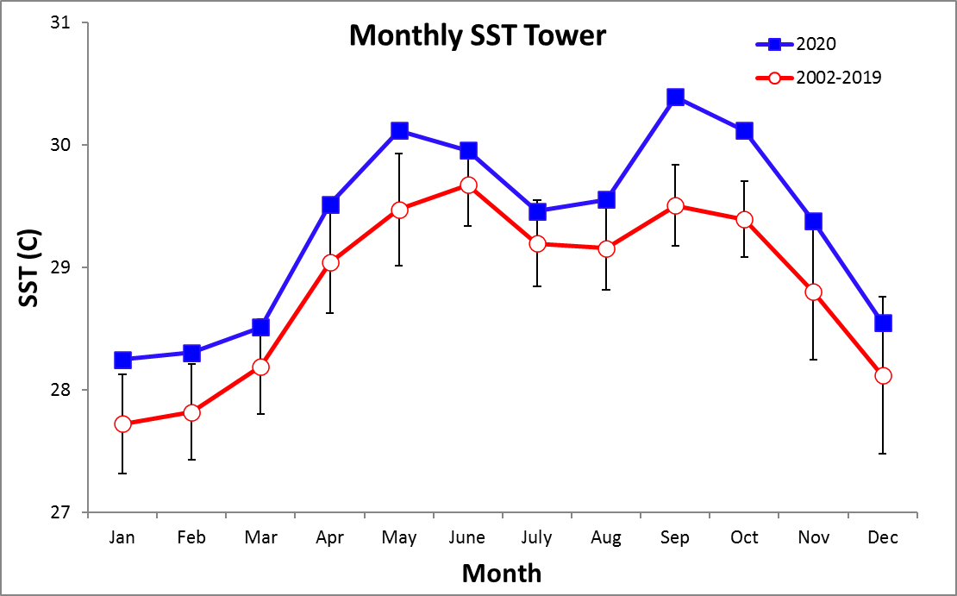

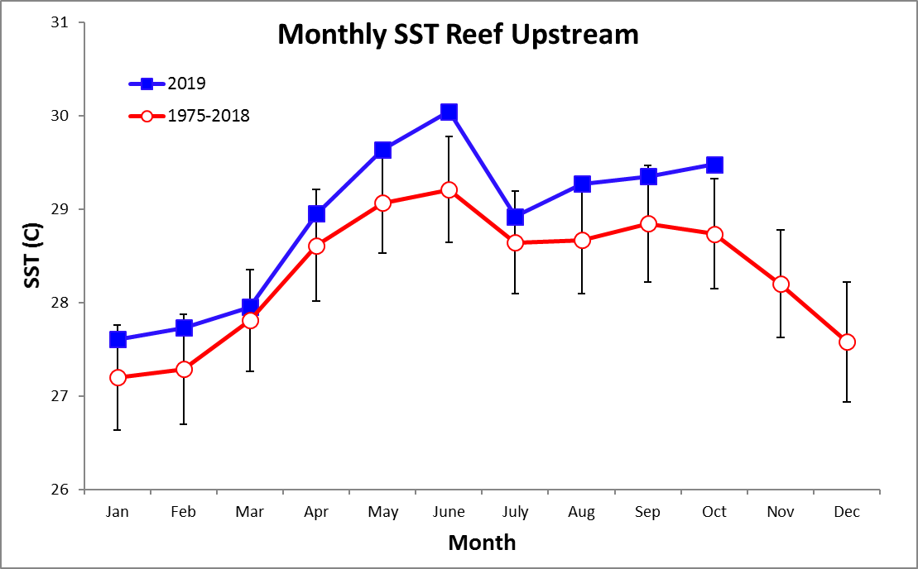

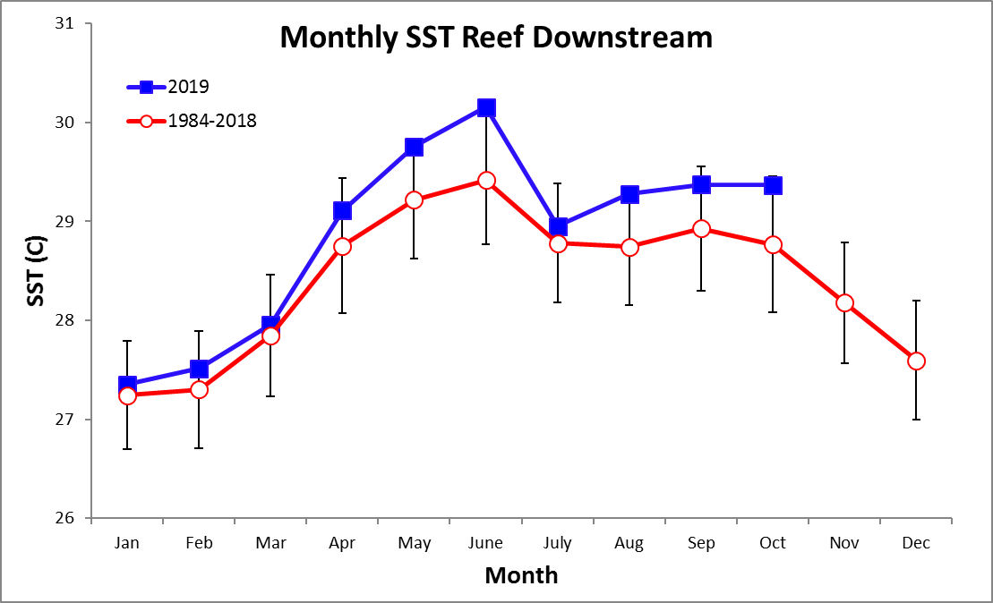

Time Series – Daily 2020

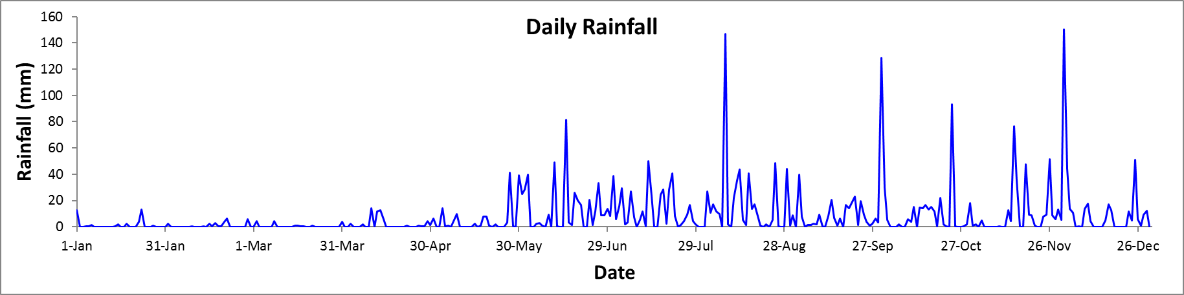\

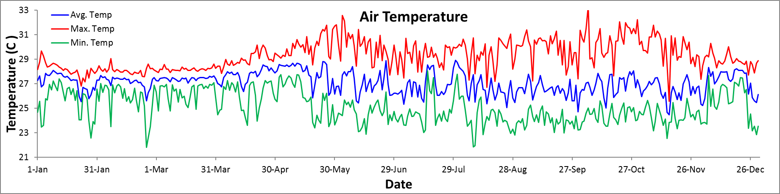

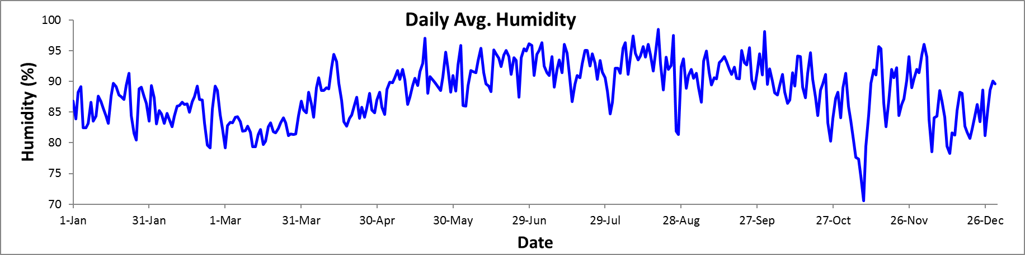

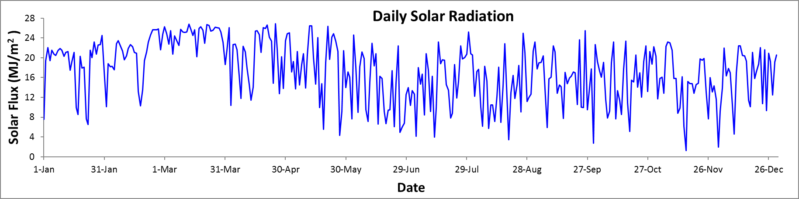

Time Series – Daily 2020

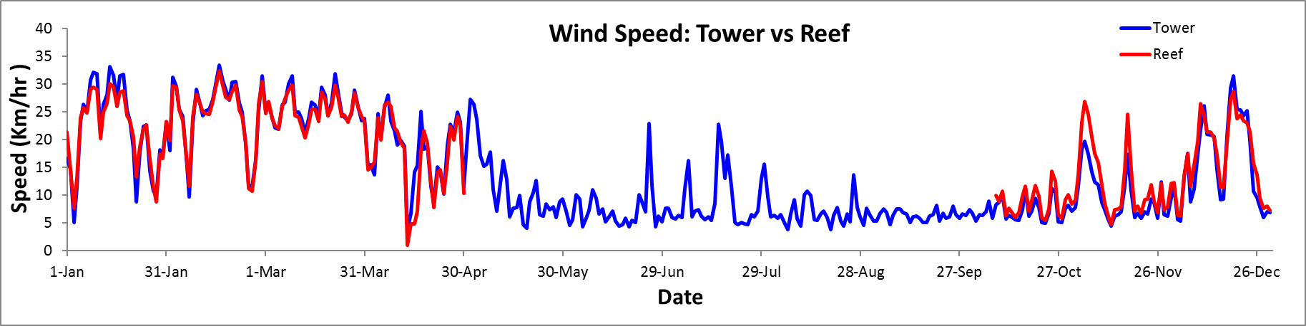

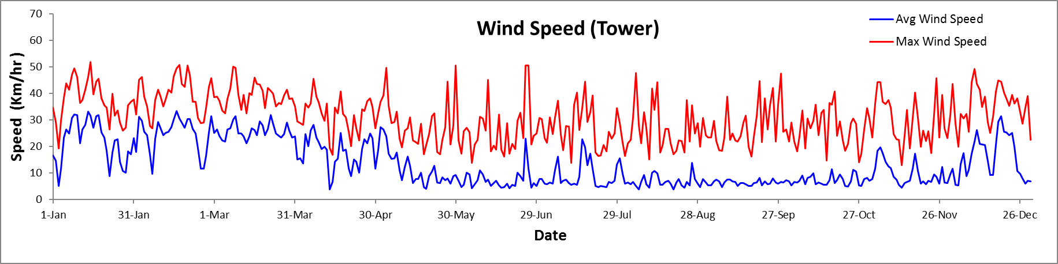

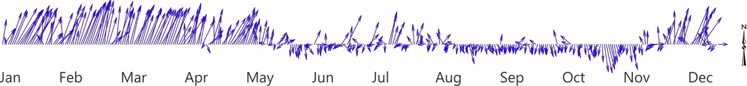

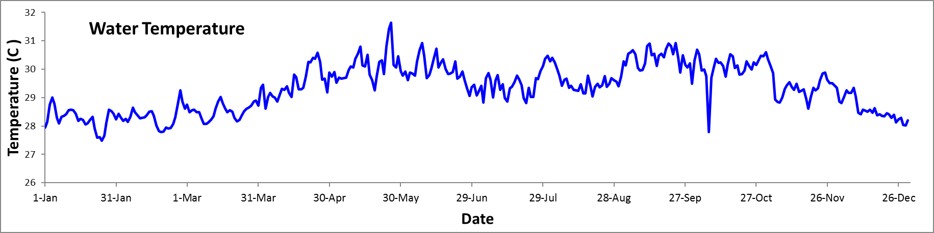
Time Series - Monthly

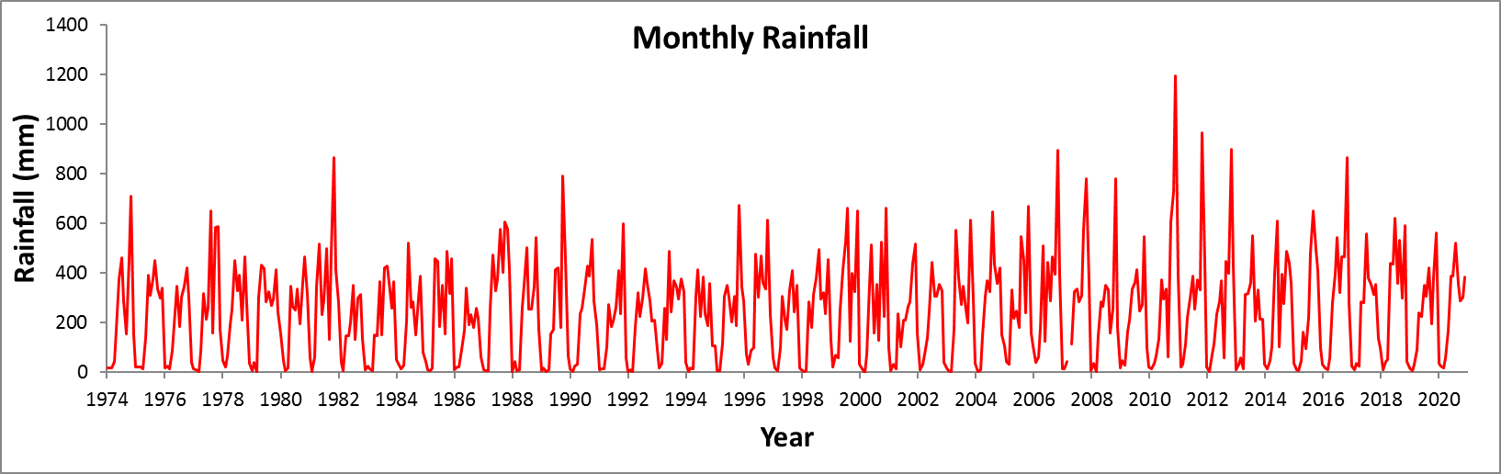

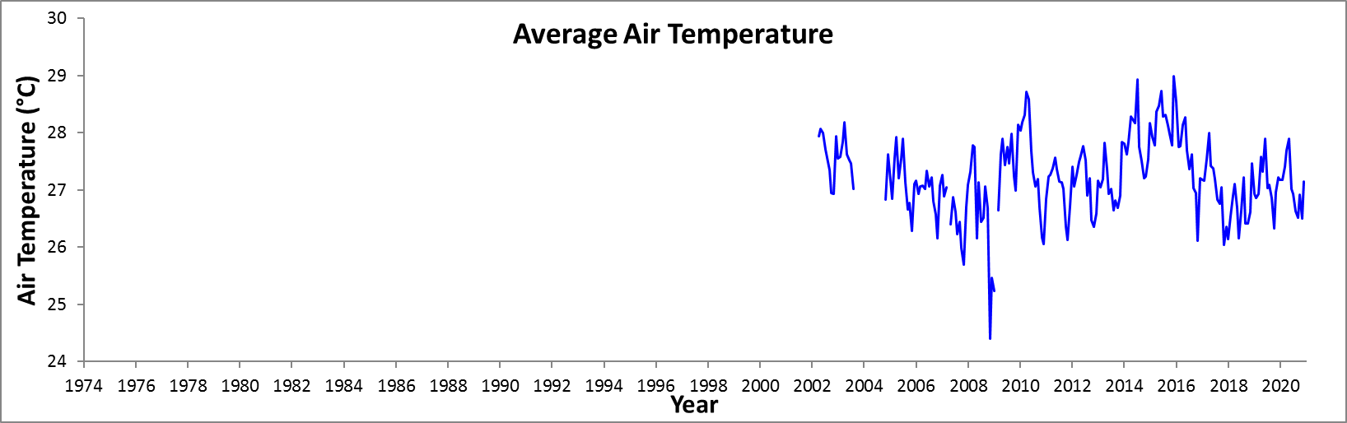

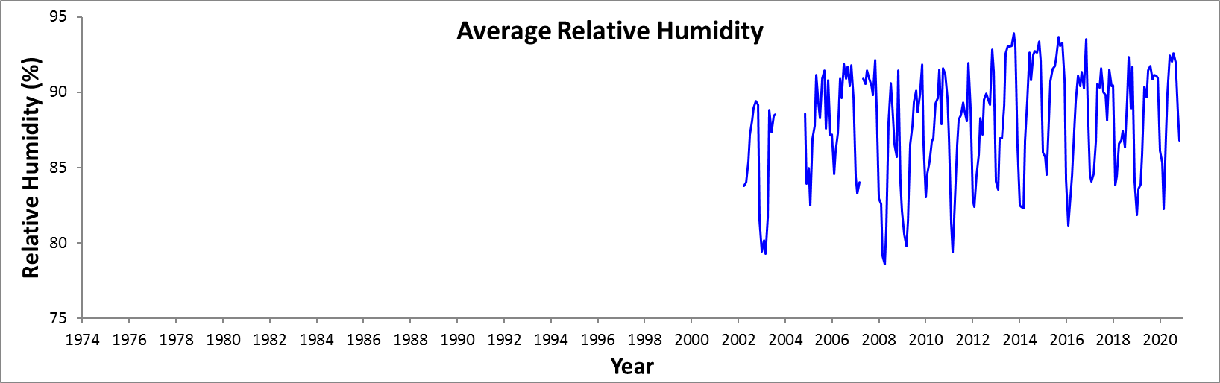

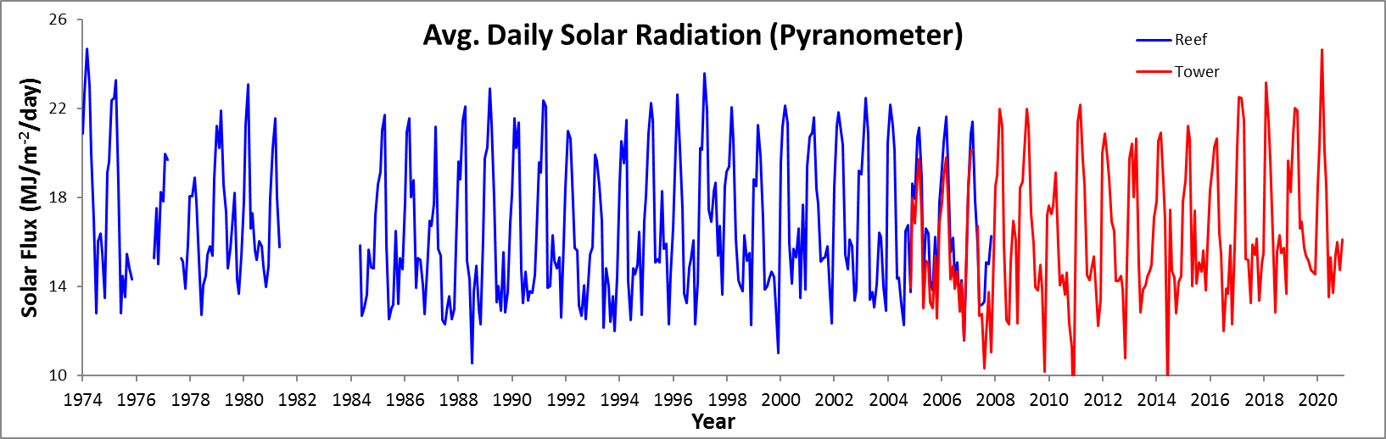

Time Series - Monthly

