Resumen Meteorológico 2020 para el Laboratorio Marino de Isla Galeta

Por: Steven Paton
Panamá, Febrero 2020
Introducción

Este reporte resume los datos del 2020 para el Laboratorio Marino de Isla Galeta recogidos por el Programa de Monitoreo Físico del Instituto Smithsonian de Investigaciones Tropicales (STRI por sus siglas en inglés). Este documento no cubre toda la información disponible, solo resume aquellos datos del clima de interés para la mayoría de las personas. Cualquier comentario sobre sobre cómo mejorar informes en el futuro, serán bienvenidos. Copias de este informe, de los de años previos y reportes de otras estaciones (disponibles en inglés), están disponibles en nuestro sitio web: biogeodb.stri.si.edu/physical_monitoring/

El Sitio
Establecido en la década de 1960, el Laboratorio Marino de Isla Galeta fue el primero establecido por el STRI en el Caribe de Panamá, ubicado a unos 6km al noreste de la ciudad portuaria de Colon y la entrada Caribe del canal de Panama (9.402742°, -79.860837°). En 1974, se inicia el Programa de Monitoreo Físico. A partir de 1986 fue sede del estudio muy extenso sobre los impactos biológicos de un gran derrame de petróleo ocurrido en la cercana refinería de Bahía de Las Minas.
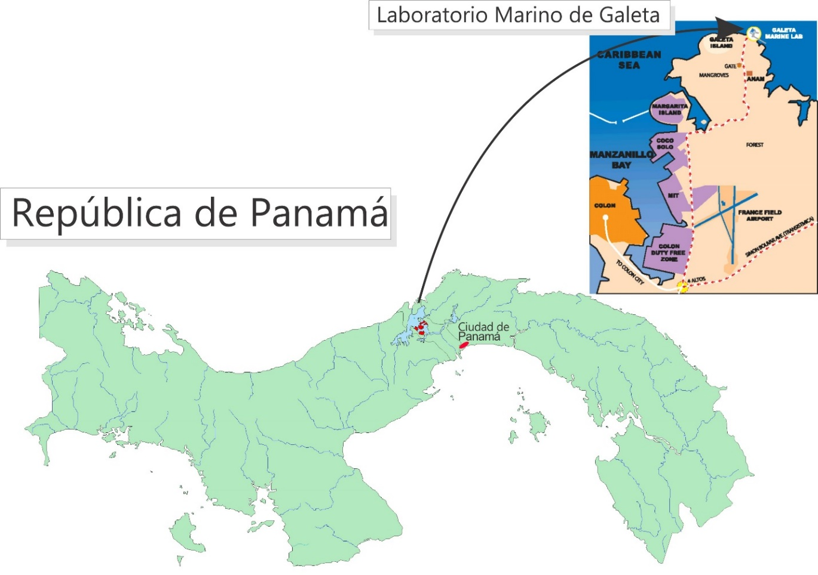

La estación recibe un promedio de 2923.1 mm de lluvia al año. El año meteorológico se divide en dos partes: una estación seca fuerte, el verano, (de mediados de diciembre a inicios de mayo), y una temporada lluviosa, llamada invierno, (de mayo a mediados de diciembre). Durante la temporada seca el promedio de precipitación es de solo 206mm.

La Humedad Relativa, la Temperatura del aire, la Radiación solar, la Velocidad y dirección del viento, la Temperatura superficial del mar (SST) todos estos parámetros muestran patrones relacionadas con las temporadas de lluvias.
Todos los datos se físicos se recolectados con equipos electrónicos. Los sensores existen (o han existido) en cinco sitios llamados: Upstream, DownStream, y MidReef (corriente arriba, corriente abajo y a mitad del recife), sobre el techo del Laboratorio, y en una pequeña torre al final del muelle. Este reporte resume los siguientes datos:
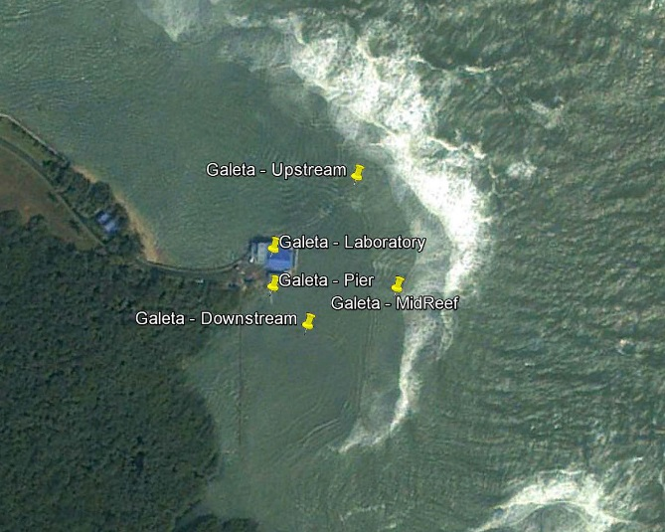
Muelle Humedad Relativa
Temperatura del aire
Lluvia
Velocidad y dirección del viento
Radiación solar
SST
Laboratorio Radiación solar (1974 – 1981)
Lluvia (1974 - 2007)
MidReef Velocidad y dirección del viento
Upstream Temperatura del aire
SST
Downstream Radiación solar (1982 – 2007)
SST

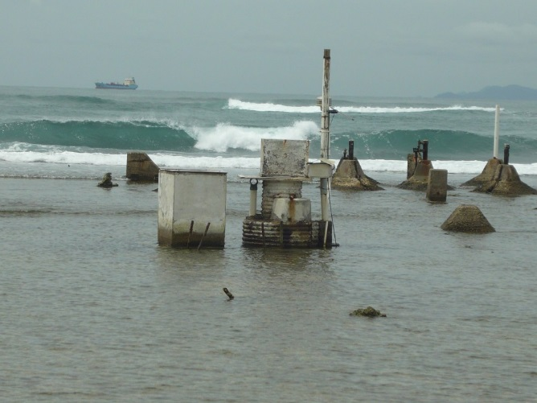
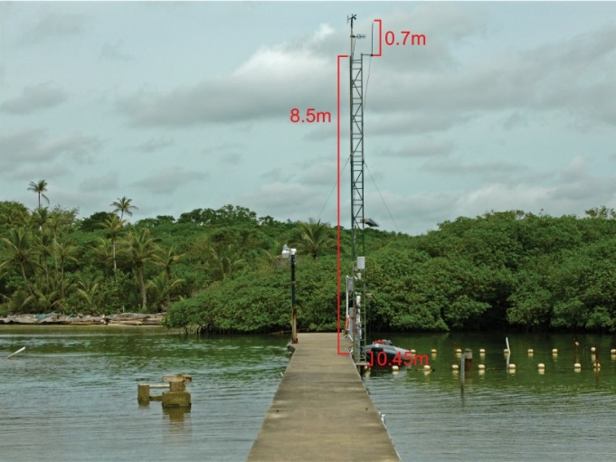
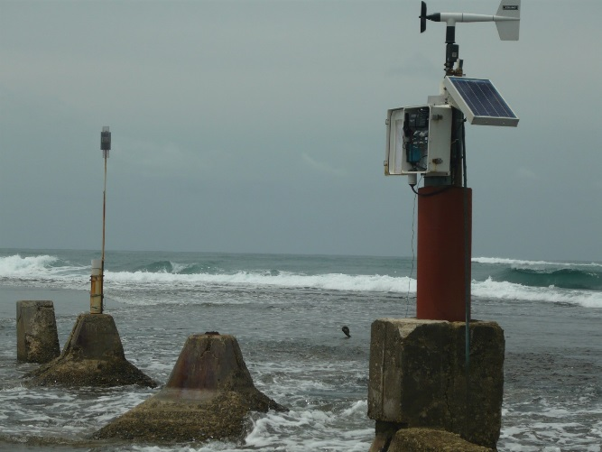
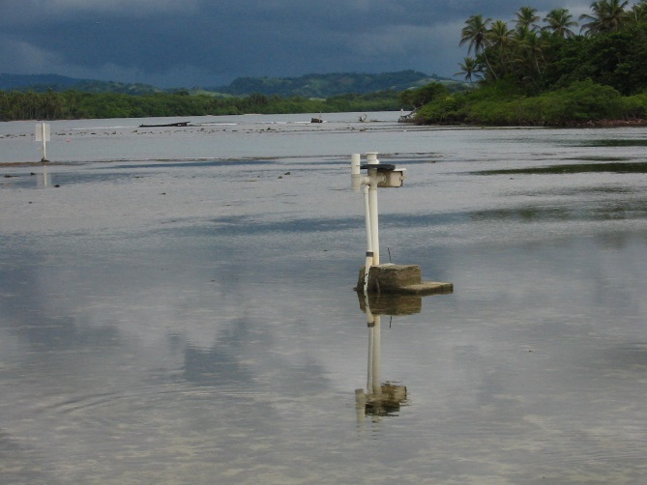
Torre de Instrumentos del Muelle Sitio de Mid-Reef
Sitio de UpStream Sitio de DownStream
Lluvia
Originalmente la lluvia se colectado por un registrador de nivel de agua Stevens Tipo ‘A’ con una entrada ubicada en el techo del Laboratorio. La lluvia se marcado en hojas de papel y luego se digitalizaba a intérvalos de una hora. En 1991 se instaló un aparato digital que registraba la lluvia en intervalos de 1mm. En 2002, se instaló en el muelle otro aparato electrónico, de la clase llamado ‘tipping bucket’ en ingles. Este registra la lluvia en intervalos de 0.254mm. La lluvia también se registraba semanalmente usando un pluviómetro plástico.

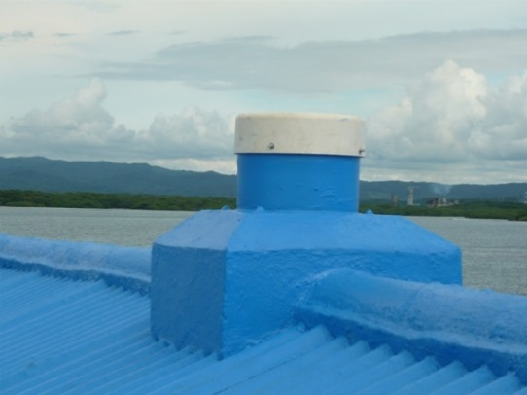
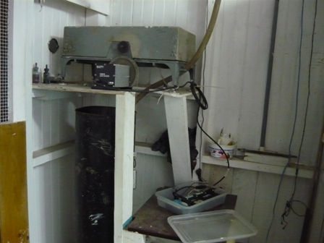
Registrador Stevens Tipo ‘A’ con entrada en el techo del edificio del laboratorio

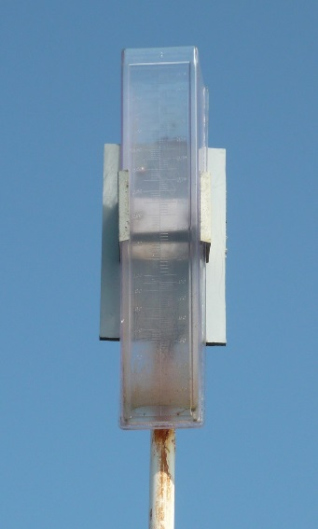
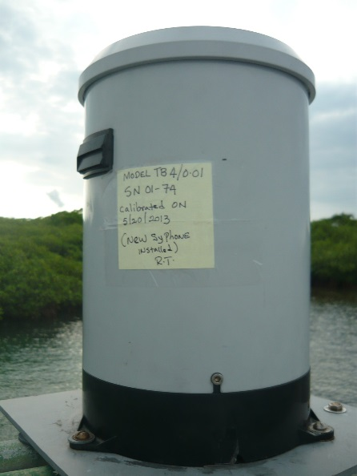
Tipping Bucket (izquierda) y Pluvímetro (derecho)

Los datos de precipitación diaria para 2020 están en la página 6.

Las páginas 7-8 muestran los totales mensuales para 2020. El gráfico en esta página compara los totales mensuales de este año con los totales mensuales promedios con (±DE) para el periodo 1974-2019.

La página 8 muestra la lluvia total anual para todos los años desde 1974. El gráfico de la serie de tiempo y el histograma de frecuencia muestran los datos visualmente.

Las páginas 9 y 10 muestran un análisis de los ‘eventos’ de lluvia (tormentas). Por conveniencia, y un poco arbitrariamente, se ha definido una tormenta como cualquier periodo de lluvia separado por lo menos por una hora de cualquier otra lluvia. Dado que este análisis requiere saber la hora exacta de la lluvia, se utilizaron los datos de lluvia del Tipping Bucket. Como resultado, debe considerse que el tamaño absoluto de los eventos de lluvia es solo un estimado dado a que los tipping buckets suelen subestimar el tamaño de las tormentas– las tormentas mayores son subestimadas más que las pequeñas. Tomando en cuenta esto, las tablas y gráficas comparan el tamaño máximo y promedio de las tormentas, y la duración promedio de las tormentas para cada mes durante el periodo 2004 -2019 versus 2020.

Humedad Relativa

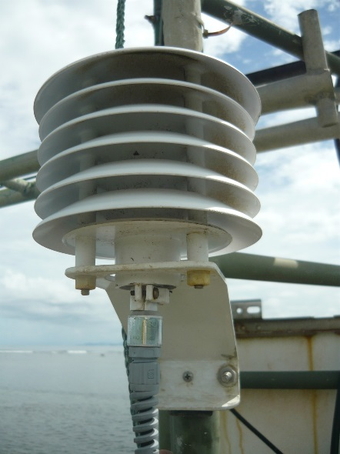
Los datos de Humedad Relativa han sido recolectados usando diversos sensores electrónicos de Temperatura/Humedad: Viasala HMP 35, Viasala HMP45, y recientemente Campbell Sci. CS215. Estos sensores están ubicados en la torre al final del muelle. Los datos fueron registrados cada 15 mínutos, controlados por un registrador electrónico (Datalogger). En la página 11 se presenta los datos de Humedad Relativa mensual en forma tabular y gráfica.

Temperatura del aire

Actualmente los datos de la temperatura del aire, a la sombra, se colectan por medio de un sensor electrónico de Temperatura/Humedad Campbell Sci. CS215 ubicado en la torre del muelle. Los datos son registrados cada 15 mínutos controlado por un registrador electrónico (Datalogger). Los datos también se colectan en la estación UpStream usando un termómetro marino Hydrolab RT-125. Las temperaturas Máx/Mín fueron colectadas con termómetros Máx/Mín de Taylor Instruments.

Los datos de la Temperatura promedia mensual de los sensores electrónicos se presentan en forma tabular y gráfica en las páginas 12-14.

Radiación solar

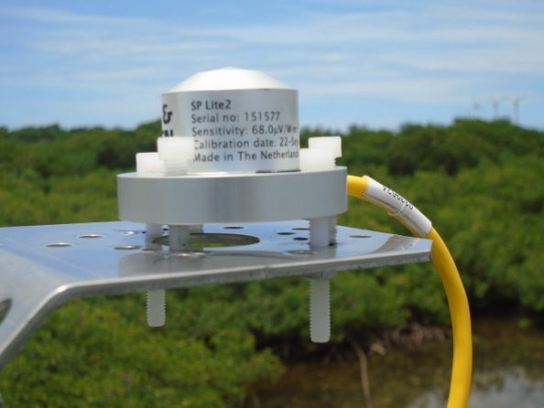
De 1974 a 1981, se medía la Radiación solar global sobre el techo del Laboratorio via un pirómetro tipo Moll-Gorczynski. El sensor fue destruido por un relámpago en 1981. En 1984 un pirómetro Li-Cor LI200SZ se instaló en el arrecife en la estación DownStream. Los datos fueron registrados cada 60 mínutos, controlados por un registrador electrónico (Datalogger).

De 2004 a 2016, la radiación solar global fue medida en la torre del muelle con pirómetros Li-Cor LI200SB, conectados a dataloggers, registrando radiación total (MJm⁻²), máximos y mínimos (J m⁻² s⁻¹) a intérvalos de 15 mínutos. A partir de Sep. 13, 2016 los sensores de Li-Cor fueron reemplazados con pirómetros Kipp&Zonen SPLite2.

En la página 15 se presenta los datos de la Radiación solar global diaria. Las páginas 16 y 17 muestran la Radiación solar global mensual.

Velocidad y Dirección del viento

Originalmente la Velocidad y dirección del viento se registraban en el sitio MidReef del arrecife usando una ‘MRI Mechanical Weather Station model 1072’ conectado a un datalogger registrando a intervalos de una hora. Los Anemómetros estaban ubicados a 3 metros arriba de la superficie del arrecife con una separación de 10m sobre dos pilastras de concreto que en el pasado fueron las bases de unas torres de comuniccion de la marina americana.

De 1983 a 1992 se emplearon sensores tipo Omnidata. Reemplazados en 1992 por anemómetros RM Young. Empezando en abril de 2002, el viento promedio, máximum y mínimum, a intérvalos de 15 mínutos, se han colectado con anemómetros RM Young Modelo 05103 ubicados en la punta de la torre del muelle.

En la página 18 se presenta los datos de la Velocidad promedia y máxima del viento de los anemómetros RM Young. Anemómetro ubicado en la torre del muelle. La página 19 muestra los datos de la dirección promedio del viento diario. Los ángulos presentados en la tabla y la gráfico en esta página representan la dirección promedio de donde provenía el viento para cada día. La página 20 muestra la velocidad y dirección promedia mensual durante el año.

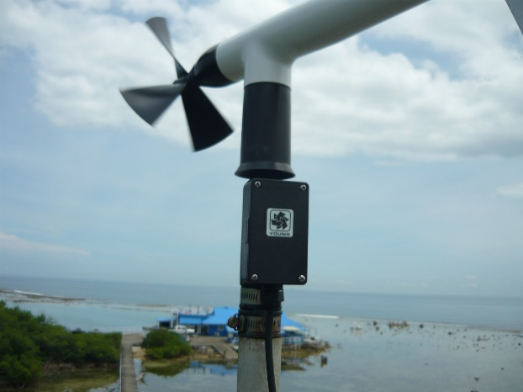
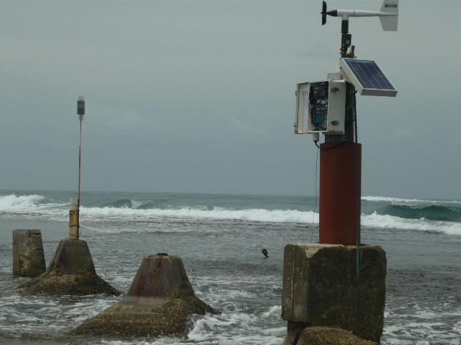
Anemómetro ‘Upstream’ Anemómetro de la Torre del Muelle

Temperatura del Mar
Se colectaba la Temperatura superficial del mar (SST) en los sitios UpStream, DownStream y en la base de la Torre del muelle. Al principio los datos de SST en el arrecife se tomaron usando termómetros tipo Hydrolab RT-125 conectados a dataloggers. En 2007 estos sensores se reemplazaron por sensores autónomos tipo ‘Hobo U22 Water Temperatura Pro V2’. Inicialmente se registraron las temperaturas cada hora. En 2020 eso cambió a cada 15 mínutos. SST en la base de la torre, siempre se ha tomado con sensores de temperatura modelo 107 de Campbell Sci a intérvalos de 15 mínutos. Las páginas 21-22 presentan los datos de los promedios mensuales de SST en forma tabular y gráfica.

Series de Tiempo
En las páginas 25 y 26 se presenta gráficas con los datos diarios para 2020. Los promedios mensuales de todos los datos disponibles sobre Humedad Relativa, Temperatura del aire, Lluvia, Velocidad del Viento, Radiación Solar y SST aparecen en las páginas 27-29.

Más detalles sobre cómo se colectaron los datos entre 1974 y 1988 están disponibles en la publicación: Cubit et al, 1989. Meteorology and hydrográficoy of a shoaling reef flat on the Caribbean coast of Panama. Coral Reefs 8:59-66.

Patrones Diarios
Las páginas 30 y 31 muestran los patrones diarios de Humedad Relativa, Temperatura del aire, Lluvia, Velocidad de Viento y Radiación Solar.

2020 Precipitación Diaria (mm)

 | Ene. | Feb. | Mar. | Abr. | May | Jun. | Jul. | Ago. | Sep. | Oct. | Nov. | Dic.
1 | 12.4 | 2.3 | 0.0 | 0.0 | 6.4 | 28.4 | 38.9 | 0.0 | 0.0 | 30.0 | 2.0 | 150.4
2 | 0.0 | 0.0 | 4.3 | 0.0 | 0.0 | 39.9 | 5.6 | 26.7 | 39.6 | 5.1 | 0.0 | 43.9
3 | 0.0 | 0.0 | 0.0 | 2.3 | 0.0 | 0.0 | 15.5 | 10.7 | 7.9 | 0.0 | 4.6 | 13.5
4 | 0.3 | 0.0 | 0.0 | 0.0 | 14.0 | 0.0 | 29.2 | 17.0 | 0.0 | 0.0 | 0.0 | 10.7
5 | 0.5 | 0.0 | 0.0 | 0.0 | 0.3 | 2.5 | 2.0 | 11.7 | 1.3 | 0.0 | 0.0 | 0.0
6 | 1.3 | 0.0 | 0.0 | 0.0 | 0.8 | 2.8 | 3.3 | 9.7 | 1.5 | 2.0 | 0.0 | 0.5
7 | 0.0 | 0.0 | 0.0 | 1.8 | 0.0 | 1.0 | 26.9 | 0.0 | 2.5 | 0.0 | 0.0 | 0.0
8 | 0.0 | 0.0 | 4.3 | 0.0 | 5.3 | 0.0 | 7.4 | 146.8 | 2.0 | 0.0 | 0.0 | 13.7
9 | 0.0 | 0.5 | 0.0 | 0.0 | 9.9 | 9.4 | 0.0 | 1.8 | 9.1 | 5.6 | 0.3 | 17.5
10 | 0.0 | 0.0 | 0.0 | 14.0 | 0.0 | 0.0 | 5.3 | 0.0 | 0.5 | 3.8 | 0.0 | 4.1
11 | 0.0 | 0.0 | 0.0 | 0.0 | 0.0 | 49.0 | 11.7 | 22.1 | 0.0 | 15.0 | 0.0 | 0.0
12 | 0.0 | 0.0 | 0.0 | 11.7 | 0.0 | 0.3 | 0.5 | 35.3 | 8.1 | 0.0 | 12.4 | 0.0
13 | 0.0 | 0.3 | 0.0 | 12.4 | 0.0 | 0.0 | 49.8 | 43.4 | 20.6 | 14.7 | 4.1 | 0.0
14 | 0.3 | 0.0 | 0.0 | 5.8 | 0.0 | 0.0 | 23.4 | 5.1 | 6.6 | 14.0 | 76.7 | 0.0
15 | 2.0 | 2.5 | 0.8 | 0.0 | 2.3 | 81.3 | 0.0 | 1.5 | 1.0 | 16.5 | 35.1 | 4.6
16 | 0.0 | 0.3 | 1.0 | 0.0 | 0.0 | 3.6 | 0.0 | 40.6 | 6.4 | 13.0 | 0.0 | 17.0
17 | 0.0 | 3.0 | 0.5 | 0.0 | 1.0 | 1.3 | 24.4 | 13.7 | 0.0 | 15.2 | 0.0 | 12.7
18 | 2.3 | 0.5 | 0.3 | 0.0 | 7.9 | 25.9 | 28.4 | 17.3 | 16.8 | 11.4 | 47.5 | 0.0
19 | 0.0 | 0.3 | 0.0 | 0.0 | 7.9 | 19.8 | 2.3 | 8.1 | 14.2 | 0.3 | 9.1 | 0.0
20 | 0.0 | 3.8 | 0.0 | 0.0 | 0.8 | 16.8 | 28.2 | 0.8 | 18.0 | 22.1 | 8.6 | 0.0
21 | 0.0 | 6.1 | 1.0 | 0.0 | 0.0 | 0.0 | 40.6 | 0.0 | 23.1 | 2.0 | 1.0 | 0.0
22 | 3.8 | 0.0 | 0.0 | 1.0 | 2.0 | 0.0 | 8.1 | 2.0 | 1.3 | 0.5 | 0.0 | 0.0
23 | 13.2 | 0.0 | 0.0 | 0.0 | 0.0 | 20.3 | 0.0 | 0.0 | 19.3 | 0.0 | 0.0 | 11.7
24 | 0.0 | 0.0 | 0.0 | 0.0 | 0.0 | 1.3 | 1.3 | 5.3 | 9.1 | 93.2 | 7.6 | 4.6
25 | 0.0 | 0.0 | 0.0 | 0.0 | 0.0 | 11.4 | 4.3 | 48.8 | 3.8 | 0.5 | 9.4 | 51.1
26 | 0.0 | 0.0 | 0.0 | 1.0 | 3.6 | 33.5 | 9.4 | 0.3 | 1.0 | 0.0 | 51.6 | 5.6
27 | 1.0 | 0.0 | 0.0 | 0.3 | 41.1 | 8.6 | 16.5 | 0.0 | 2.5 | 0.0 | 8.9 | 1.0
28 | 0.0 | 5.8 | 0.0 | 0.3 | 0.3 | 8.9 | 4.3 | 0.0 | 6.1 | 0.3 | 5.6 | 9.4
29 | 0.0 | 0.0 | 0.0 | 4.3 | 0.0 | 13.7 | 1.8 | 44.2 | 3.6 | 2.0 | 13.0 | 12.2
30 | 0.0 |  | 0.0 | 1.5 | 39.1 | 8.1 | 0.0 | 0.8 | 128.8 | 18.3 | 5.3 | 0.0
31 | 0.0 |  | 3.8 |  | 25.2 |  | 0.0 | 8.9 |  | 0.8 |  | 0.8
 | 37.1 | 25.4 | 16.0 | 56.4 | 167.6 | 387.9 | 389.1 | 522.5 | 354.8 | 286.3 | 302.8 | 384.8

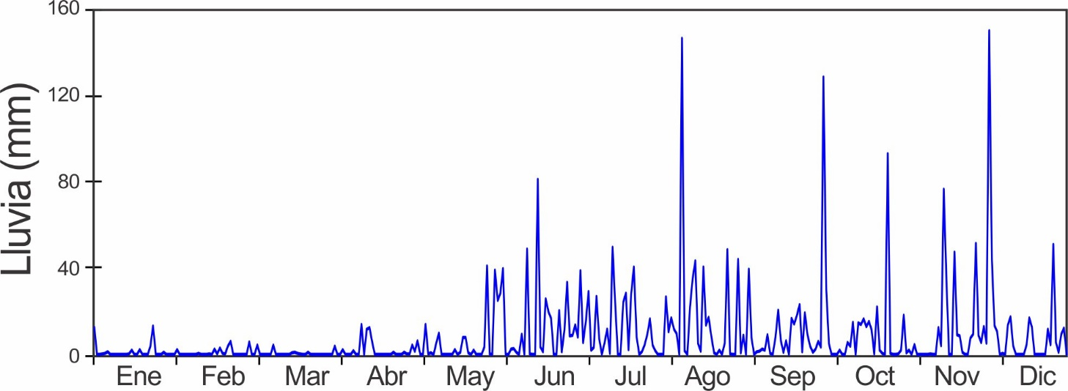
Precipitación Mensual (mm)

Año | Ene. | Feb. | Mar. | Abr. | May | Jun. | Jul. | Ago. | Sep. | Oct. | Nov. | Dic. | Total
1974 | 18.3 | 16.6 | 17.9 | 41.5 | 171.0 | 378.0 | 462.2 | 287.4 | 152.5 | 453.1 | 708.4 | 149.4 | 2856.3
1975 | 20.8 | 20.6 | 21.2 | 13.5 | 137.9 | 392.7 | 311.0 | 376.0 | 451.0 | 336.5 | 298.0 | 340.8 | 2720.0
1976 | 16.2 | 25.3 | 13.8 | 85.6 | 191.4 | 347.0 | 184.1 | 302.5 | 346.4 | 421.0 | 297.5 | 37.3 | 2268.1
1977 | 12.5 | 7.8 | 2.8 | 84.9 | 316.0 | 214.8 | 260.2 | 651.8 | 157.4 | 585.3 | 585.6 | 173.5 | 3052.6
1978 | 45.8 | 20.8 | 64.1 | 191.8 | 253.2 | 451.5 | 329.0 | 389.4 | 211.0 | 463.8 | 276.6 | 33.8 | 2730.8
1979 | 7.2 | 39.1 | 2.2 | 300.8 | 431.9 | 416.9 | 284.3 | 323.4 | 269.9 | 296.1 | 414.8 | 241.5 | 3028.1
1980 | 152.3 | 47.0 | 5.0 | 16.0 | 345.0 | 264.0 | 251.0 | 335.0 | 195.0 | 362.0 | 467.0 | 314.0 | 2753.3
1981 | 56.0 | 2.0 | 60.0 | 343.0 | 518.0 | 231.0 | 290.0 | 497.0 | 132.0 | 475.0 | 867.0 | 412.0 | 3883.0
1982 | 280.0 | 40.0 | 4.0 | 148.0 | 148.0 | 203.0 | 351.0 | 131.0 | 299.0 | 313.0 | 135.0 | 9.0 | 2061.0
1983 | 26.0 | 12.0 | 6.0 | 150.0 | 148.0 | 365.0 | 151.0 | 421.0 | 427.0 | 363.0 | 256.0 | 365.0 | 2690.0
1984 | 49.0 | 27.0 | 12.0 | 29.0 | 204.0 | 519.0 | 261.0 | 284.0 | 149.0 | 298.0 | 388.0 | 78.0 | 2298.0
1985 | 41.1 | 10.4 | 7.2 | 16.6 | 457.6 | 447.7 | 184.3 | 350.7 | 153.4 | 487.6 | 318.5 | 456.2 | 2931.3
1986 | 8.9 | 21.0 | 19.3 | 91.6 | 168.2 | 340.6 | 189.4 | 231.9 | 179.6 | 256.3 | 216.4 | 61.4 | 1784.6
1987 | 8.1 | 6.6 | 5.6 | 248.6 | 473.7 | 329.2 | 377.7 | 576.4 | 401.7 | 605.7 | 577.5 | 412.7 | 4023.5
1988 | 2.7 | 43.1 | 4.4 | 10.4 | 262.7 | 354.3 | 503.3 | 255.1 | 255.3 | 347.9 | 541.4 | 174.2 | 2754.8
1989 | 4.8 | 18.5 | 3.7 | 10.1 | 155.5 | 172.4 | 413.6 | 420.7 | 179.7 | 790.2 | 454.9 | 65.6 | 2689.7
1990 | 14.5 | 2.4 | 25.3 | 32.6 | 235.5 | 256.3 | 338.0 | 429.5 | 386.3 | 535.3 | 286.4 | 191.4 | 2733.5
1991 | 10.0 | 11.5 | 14.3 | 102.0 | 271.0 | 185.0 | 207.0 | 263.0 | 410.0 | 237.0 | 598.0 | 59.0 | 2367.8
1992 | 1.0 | 11.0 | 0.0 | 185.0 | 319.0 | 223.0 | 300.0 | 418.0 | 357.0 | 287.0 | 207.0 | 211.0 | 2519.0
1993 | 90.0 | 16.0 | 35.0 | 258.0 | 131.0 | 486.0 | 243.0 | 368.0 | 343.0 | 293.0 | 375.0 | 326.0 | 2964.0
1994 | 40.0 | 3.0 | 16.0 | 14.0 | 307.0 | 415.0 | 224.0 | 382.0 | 235.0 | 186.0 | 359.0 | 106.0 | 2287.0
1995 | 105.0 | 7.0 | 5.0 | 117.0 | 307.0 | 351.0 | 302.0 | 201.0 | 305.0 | 189.0 | 673.0 | 342.0 | 2904.0
1996 | 287.0 | 71.0 | 33.0 | 87.0 | 99.0 | 476.0 | 303.0 | 469.0 | 363.0 | 336.0 | 613.0 | 233.0 | 3370.0
1997 | 34.0 | 7.0 | 0.0 | 97.0 | 229.0 | 175.0 | 145.0 | 330.0 | 411.0 | 244.0 | 350.0 | 17.0 | 2039.0
1998 | 8.0 | 2.0 | 6.0 | 283.0 | 180.0 | 312.0 | 380.0 | 493.0 | 296.0 | 322.0 | 236.0 | 453.0 | 2971.0
1999 | 127.0 | 21.0 | 70.0 | 58.0 | 249.0 | 412.0 | 527.0 | 661.0 | 125.0 | 398.0 | 326.0 | 650.0 | 3624.0
2000 | 30.0 | 12.0 | 0.0 | 72.0 | 351.0 | 515.0 | 157.0 | 355.0 | 129.0 | 523.0 | 224.0 | 662.0 | 3030.0
2001 | 98.0 | 4.0 | 30.0 | 12.0 | 236.0 | 102.0 | 208.0 | 211.0 | 264.0 | 283.0 | 441.0 | 518.0 | 2407.0
2002 | 157.0 | 8.0 | 33.0 | 45.0 | 113.0 | 248.0 | 384.0 | 305.0 | 246.0 | 349.0 | 328.0 | 32.0 | 2248.0
2003 | 16.0 | 6.0 | 3.0 | 153.0 | 512.0 | 379.0 | 272.0 | 345.0 | 249.0 | 200.0 | 615.0 | 294.0 | 3044.0
2004 | 34.0 | 1.0 | 11.0 | 147.0 | 307.0 | 370.0 | 323.0 | 648.0 | 434.0 | 357.0 | 419.0 | 119.0 | 3170.0
2005 | 64.7 | 32.8 | 33.1 | 305.1 | 190.0 | 203.0 | 127.0 | 511.0 | 365.0 | 208.0 | 581.0 | 128.0 | 2748.7
2006 | 86.0 | 12.0 | 45.0 | 155.0 | 469.0 | 106.0 | 433.0 | 218.0 | 424.0 | 347.0 | 790.0 | 365.0 | 3450.0
2007 | 11.4 | 13.7 | 41.9 | 138.0 | 113.9 | 324.9 | 336.3 | 283.5 | 309.1 | 574.6 | 780.6 | 365.3 | 3292.9
2008 | 5.3 | 33.7 | 1.8 | 145.5 | 283.6 | 266.8 | 352.1 | 332.0 | 158.3 | 258.7 | 780.8 | 179.2 | 2797.6
2009 | 16.9 | 46.1 | 29.1 | 166.8 | 211.2 | 334.5 | 359.9 | 411.9 | 245.0 | 271.3 | 546.6 | 98.2 | 2737.7
2010 | 22.1 | 13.2 | 35.0 | 66.8 | 135.7 | 371.3 | 294.4 | 337.1 | 60.6 | 605.1 | 727.1 | 1193.3 | 3861.6
2011 | 390.5 | 19.8 | 29.9 | 111.9 | 222.4 | 296.7 | 385.9 | 253.8 | 371.9 | 330.8 | 964.1 | 441.8 | 3819.2
2012 | 19.8 | 3.5 | 71.1 | 114.7 | 236.0 | 282.2 | 370.0 | 250.0 | 445.8 | 397.8 | 899.4 | 427.4 | 3517.7
2013 | 7.9 | 32.2 | 56.1 | 14.7 | 311.4 | 317.2 | 362.5 | 550.6 | 206.1 | 333.2 | 214.5 | 213.7 | 2620.0
2014 | 32.5 | 14.2 | 48.2 | 103.1 | 396.6 | 610.3 | 100.8 | 395.7 | 277.7 | 488.8 | 439.1 | 358.2 | 3265.0
2015 | 37.1 | 10.7 | 6.1 | 47.5 | 160.0 | 93.7 | 220.0 | 479.3 | 650.5 | 493.5 | 408.7 | 98.8 | 2705.9
2016 | 31.0 | 18.0 | 10.2 | 57.9 | 280.4 | 397.3 | 543.0 | 319.0 | 466.1 | 464.6 | 864.6 | 279.4 | 3731.5
2017 | 23.4 | 10.4 | 35.6 | 23.9 | 285.7 | 280.2 | 556.9 | 380.0 | 355.1 | 314.7 | 355.6 | 740.0 | 3361.3
2018 | 96.8 | 10.9 | 43.4 | 51.3 | 438.9 | 435.6 | 619.5 | 357.1 | 530.6 | 300.2 | 592.1 | 43.7 | 3520.2
2019 | 17.8 | 4.6 | 32.8 | 90.7 | 240.8 | 224.0 | 350.8 | 304.3 | 419.9 | 194.6 | 383.3 | 560.1 | 2823.5
2020 | 37.1 | 25.4 | 16.0 | 56.4 | 167.6 | 387.9 | 389.1 | 522.5 | 354.9 | 286.3 | 302.8 | 384.8 | 2930.7
$$\overline{x}$$ | 57.5 | 17.9 | 22.7 | 108.4 | 263.2 | 324.8 | 317.4 | 374.8 | 301.1 | 371.5 | 478.4 | 285.4 | 2923.1
D.E. | 80.2 | 14.7 | 20.2 | 87.3 | 112.7 | 115.1 | 117.6 | 121.4 | 123.9 | 131.0 | 213.1 | 230.1 | 520.6
mín | 1.0 | 1.0 | 0.0 | 10.1 | 99.0 | 93.7 | 100.8 | 131.0 | 60.6 | 186.0 | 135.0 | 9.0 | 1784.6
máx | 390.5 | 71.0 | 71.1 | 343.0 | 518.0 | 610.3 | 619.5 | 661.0 | 650.5 | 790.2 | 964.1 | 1193.3 | 4023.5
Rango* | 19 | 11 | 24 | 32 | 37 | 14 | 9 | 6 | 19 | 36 | 36 | 13 | 22
*Rango del Año Actual: 1 = más lluviosa
Nota: Datos en morado son etimaciones de la estación Limón del la ACP

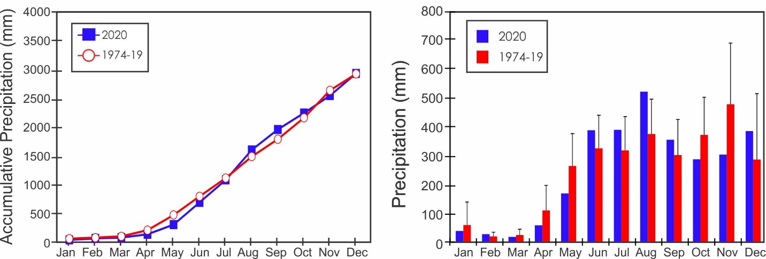

Lluvia Anual (mm)

Año | Lluvia | Año | Lluvia | Año | Lluvia
1974 | 2856.3 | 1991 | 2367.8 | 2008 | 2797.6
1975 | 2720.0 | 1992 | 2519.0 | 2009 | 2737.7
1976 | 2268.1 | 1993 | 2964.0 | 2010 | 3861.6
1977 | 3052.6 | 1994 | 2287.0 | 2011 | 3819.2
1978 | 2730.8 | 1995 | 2904.0 | 2012 | 3517.7
1979 | 3028.1 | 1996 | 3370.0 | 2013 | 2620.0
1980 | 2753.3 | 1997 | 2039.0 | 2014 | 3265.0
1981 | 3883.0 | 1998 | 2971.0 | 2015 | 2705.9
1982 | 2061.0 | 1999 | 3624.0 | 2016 | 3731.5
1983 | 2690.0 | 2000 | 3030.0 | 2017 | 3361.3
1984 | 2298.0 | 2001 | 2407.0 | 2018 | 3520.2
1985 | 2931.3 | 2002 | 2248.0 | 2019 | 2823.5
1986 | 1784.6 | 2003 | 3044.0 | 2020 | 2930.7
1987 | 4023.5 | 2004 | 3170.0
1988 | 2754.8 | 2005 | 2748.7
1989 | 2689.7 | 2006 | 3450.0
1990 | 2733.5 | 2007 | 3292.9

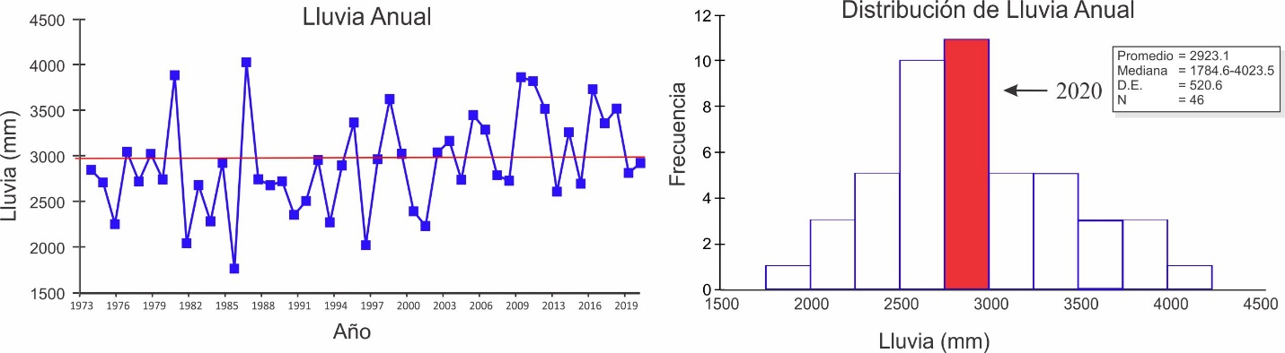
Analisis de Tormentas

 |  | Lluvia Máx. por Tormenta (mm) |  |  |  | Duración (mín.)
 | 2006-2019 |  |  | 2020 |  | 2006-2019 |  | 2020
 | Prom. |  | D.E. |  |  | Prom. | D.E.
Enero | 17.7 |  | 23.6 | 8.9 |  | 35.3 | 14.5 | 46.6
Febrero | 5.1 |  | 3.2 | 5.1 |  | 33.9 | 12.0 | 47.1
Marzo | 14.8 |  | 9.9 | 4.3 |  | 34.1 | 11.3 | 27.0
Abril | 42.1 |  | 31.2 | 14.0 |  | 50.5 | 11.5 | 44.0
Mayo | 61.2 |  | 18.8 | 38.9 |  | 66.8 | 11.0 | 64.9
Junio | 73.8 |  | 37.7 | 76.2 |  | 65.6 | 8.3 | 77.8
Julio | 59.0 |  | 24.4 | 45.2 |  | 71.5 | 14.7 | 71.1
Agosto | 80.0 |  | 40.8 | 133.1 |  | 68.7 | 10.1 | 70.3
Septiembre | 72.5 |  | 37.2 | 128.8 |  | 63.5 | 10.4 | 68.6
Octubre | 73.6 |  | 31.2 | 93.2 |  | 76.9 | 15.1 | 55.3
Noviembre | 105.6 |  | 51.4 | 67.8 |  | 86.7 | 24.2 | 62.2
Diciembre | 79.1 |  | 65.2 | 148.3 |  | 62.6 | 22.4 | 74.1

 | Lluvia Prom. por Tormenta (mm)
 | 2006-2019 |  | 2020
 | Prom. | D.E.
Enero | 2.3 | 2.6 | 2.2
Febrero | 1.3 | 0.6 | 1.3
Marzo | 2.2 | 1.4 | 1.6
Abril | 4.8 | 2.7 | 2.3
Mayo | 7.0 | 1.7 | 5.8
Junio | 6.9 | 2.0 | 7.9
Julio | 7.0 | 2.0 | 6.8
Agosto | 7.4 | 2.3 | 9.0
Septiembre | 7.2 | 2.3 | 8.1
Octubre | 8.4 | 3.1 | 7.2
Noviembre | 9.0 | 2.9 | 5.5
Diciembre | 6.8 | 3.6 | 7.7

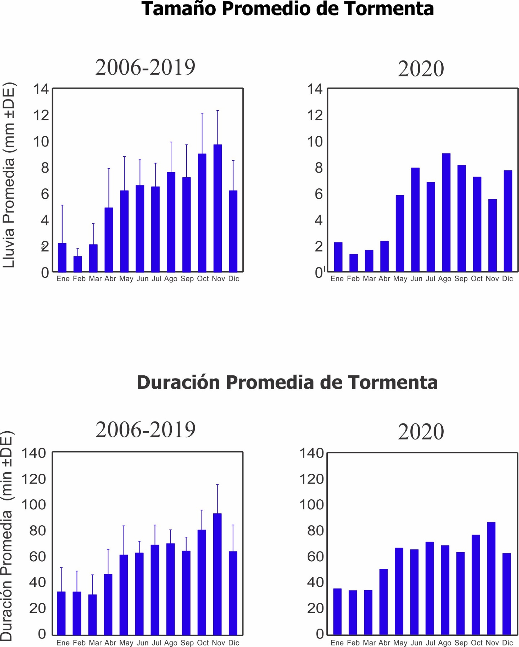
Humedad Relativa (%)

Año | Ene. | Feb. | Mar. | Abr. | May | Jun. | Jul. | Ago. | Sep. | Oct. | Nov. | Dic.
2002 |  |  |  | 83.8 | 84.0 | 85.4 | 87.2 | 88.2 | 89.0 | 89.4 | 89.2 | 81.5
2003 | 79.4 | 80.2 | 79.3 | 81.7 | 88.8 | 87.3 | 88.4 | 88.5
2004 |  |  |  |  |  |  |  |  |  |  | 88.6 | 83.9
2005 | 85.0 | 82.5 | 86.9 | 87.8 | 91.1 | 89.2 | 88.3 | 90.9 | 91.5 | 87.6 | 90.8 | 87.1
2006 | 87.2 | 84.6 | 86.1 | 87.3 | 90.9 | 89.6 | 91.9 | 90.9 | 91.7 | 90.4 | 91.8 | 89.6
2007 | 84.4 | 83.3 | 84.0 |  | 90.9 | 90.6 | 91.5 | 90.9 | 90.4 | 89.8 | 92.1 | 89.0
2008 | 82.9 | 82.6 | 79.1 | 78.6 | 81.0 | 88.0 | 90.6 | 89.1 | 86.5 | 85.7 | 91.5 | 83.9
2009 | 82.1 | 80.6 | 79.8 | 81.5 | 86.6 | 87.8 | 89.4 | 90.1 | 88.7 | 89.8 | 91.8 | 86.4
2010 | 83.1 | 84.6 | 85.4 | 86.7 | 87.0 | 89.3 | 89.6 | 91.5 | 87.9 | 91.6 | 91.2 | 89.6
2011 | 87.0 | 81.3 | 79.4 | 82.9 | 86.5 | 88.2 | 88.5 | 89.3 | 88.7 | 88.1 | 91.9 | 88.9
2012 | 82.8 | 82.4 | 84.5 | 85.8 | 88.3 | 87.2 | 89.5 | 89.9 | 89.5 | 89.2 | 92.8 | 91.4
2013 | 84.1 | 83.6 | 86.9 | 86.9 | 89.1 | 92.6 | 93.1 | 93.0 | 93.1 | 93.9 | 93.0 | 86.3
2014 | 82.5 | 82.4 | 82.3 | 86.8 | 89.5 | 92.6 | 90.8 | 92.5 | 92.8 | 92.6 | 93.4 | 92.1
2015 | 86.0 | 85.7 | 84.5 | 88.2 | 90.7 | 91.6 | 91.7 | 92.4 | 93.7 | 93.1 | 93.3 | 90.8
2016 | 84.2 | 81.2 | 83.1 | 84.5 | 87.5 | 89.4 | 91.1 | 90.4 | 91.3 | 90.3 | 93.5 | 89.3
2017 | 84.5 | 84.1 | 84.6 | 86.8 | 90.6 | 90.3 | 91.6 | 90.0 | 89.8 | 88.1 | 91.5 | 90.4
2018 | 90.5 | 83.8 | 84.4 | 86.6 | 86.8 | 87.5 | 86.4 | 89.6 | 92.4 | 88.9 | 91.7 | 84.0
2019 | 81.8 | 83.6 | 83.9 | 85.9 | 90.3 | 89.6 | 91.4 | 91.7 | 90.8 | 91.2 | 91.1 | 91.0
2020 | 86.1 | 85.3 | 82.3 | 87.1 | 89.9 | 92.4 | 92.0 | 92.6 | 92.0 | 88.6 | 86.8 | 85.5
$$\overline{x}$$ | 84.6 | 83.2 | 83.4 | 85.8 | 88.6 | 89.9 | 90.4 | 91.1 | 90.9 | 90.4 | 91.8 | 88.8
D.E. | 2.5 | 1.7 | 2.2 | 1.9 | 1.7 | 2.0 | 1.8 | 1.3 | 1.9 | 2.0 | 1.8 | 2.6
mín | 81.8 | 80.6 | 79.4 | 81.5 | 86.5 | 87.2 | 86.4 | 89.3 | 87.9 | 88.1 | 86.8 | 84.0
máx | 90.5 | 85.7 | 86.9 | 88.2 | 90.7 | 92.6 | 93.1 | 93.0 | 93.7 | 93.9 | 93.5 | 92.1

* Un cambio de sensor al final de 2008 resultó en valores significativamente mayor. Las estatistics solamente incluyen los datos apartir de 2009.
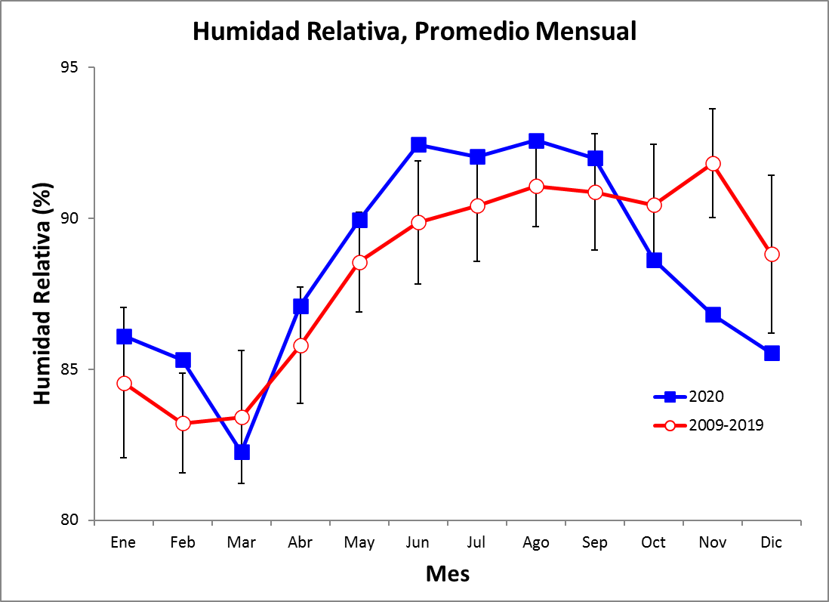
Temperaturas Promedios Mensuales del Máximo & Mínimo Diario (°C)
Temperatura Promedio Mensual
Año | Ene. | Feb. | Mar. | Abr. | May | Jun. | Jul. | Ago. | Sep. | Oct. | Nov. | Dic.
2002 |  |  |  | 27.9 | 28.1 | 28.0 | 27.7 | 27.6 | 27.4 | 27.0 | 26.9 | 27.9
2003 | 27.6 | 27.6 | 27.8 | 28.2 | 27.6 | 27.5 | 27.5 | 27.0
2004 |  |  |  |  |  |  |  |  |  |  | 26.8 | 27.6
2005 | 27.2 | 26.9 | 27.6 | 27.9 | 27.2 | 27.6 | 27.9 | 27.1 | 26.7 | 26.8 | 26.3 | 27.1
2006 | 27.2 | 26.9 | 27.1 | 27.1 | 27.0 | 27.3 | 27.1 | 27.2 | 26.8 | 26.6 | 26.2 | 27.1
2007 | 27.3 | 26.9 | 27.1 |  | 26.4 | 26.9 | 26.6 | 26.2 | 26.4 | 26.0 | 25.7 | 26.7
2008 | 27.1 | 27.3 | 27.8 | 27.8 | 26.2 | 27.1 | 26.5 | 26.5 | 27.1 | 26.7 | 24.4 | 25.5
2009 | 25.2 |  | 26.7 | 27.6 | 27.9 | 27.4 | 27.8 | 27.5 | 28.0 | 27.2 | 27.0 | 28.1
2010 | 28.0 | 28.2 | 28.3 | 28.7 | 28.6 | 27.7 | 27.3 | 27.1 | 27.2 | 26.7 | 26.2 | 26.1
2011 | 26.9 | 27.2 | 27.3 | 27.4 | 27.6 | 27.4 | 27.2 | 27.1 | 27.0 | 26.4 | 26.1 | 26.7
2012 | 27.4 | 27.1 | 27.3 | 27.5 | 27.6 | 27.8 | 27.5 | 26.9 | 27.2 | 26.5 | 26.4 | 26.6
2013 | 27.2 | 27.1 | 27.2 | 27.8 | 27.4 | 26.9 | 27.0 | 26.6 | 26.8 | 26.7 | 26.9 | 27.8
2014 | 27.8 | 27.6 | 27.8 | 28.3 | 28.2 | 28.2 | 28.9 | 27.8 | 27.5 | 27.2 | 27.2 | 27.5
2015 | 28.2 | 27.9 | 27.8 | 28.4 | 28.5 | 28.7 | 28.3 | 28.3 | 28.1 | 28.0 | 27.8 | 29.0
2016 | 28.6 | 27.8 | 27.8 | 28.1 | 28.3 | 27.7 | 27.4 | 27.6 | 27.0 | 27.0 | 26.1 | 27.2
2017 | 27.2 | 27.2 | 27.5 | 28.0 | 27.4 | 27.4 | 27.2 | 26.8 | 26.8 | 27.1 | 26.0 | 26.4
2018 | 26.1 | 26.5 | 26.9 | 27.1 | 26.7 | 26.2 | 26.6 | 27.2 | 26.4 | 26.4 | 26.6 | 27.5
2019 | 26.9 | 26.9 | 26.9 | 27.6 | 27.3 | 27.9 | 27.0 | 27.1 | 26.9 | 26.3 | 27.0 | 27.2
2020 | 27.2 | 27.2 | 27.4 | 27.7 | 27.9 | 27.0 | 26.9 | 26.6 | 26.5 | 26.9 | 26.5 | 27.2
$$\overline{x}$$ | 27.2 | 27.3 | 27.4 | 27.8 | 27.5 | 27.5 | 27.4 | 27.2 | 27.1 | 26.8 | 26.4 | 27.2
D.E. | 0.8 | 0.5 | 0.5 | 0.5 | 0.7 | 0.6 | 0.6 | 0.5 | 0.5 | 0.5 | 0.7 | 0.8
mín | 25.2 | 26.5 | 26.7 | 27.1 | 26.2 | 26.2 | 26.5 | 26.2 | 26.4 | 26.0 | 24.4 | 25.5
máx | 28.6 | 28.2 | 28.3 | 28.7 | 28.6 | 28.7 | 28.9 | 28.3 | 28.1 | 28.0 | 27.8 | 29.0
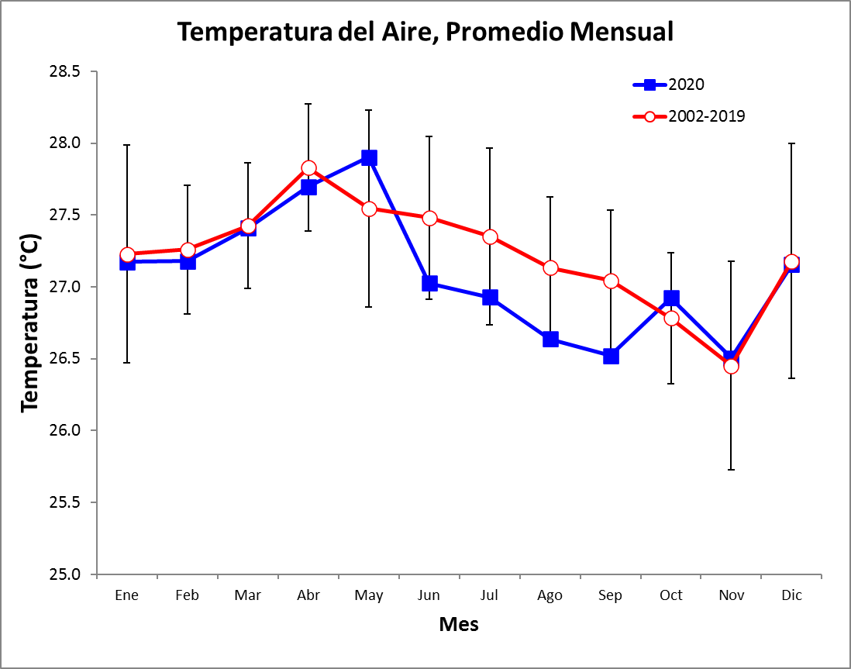
Temperatura Promedio Mensual del Máximo Diario
Año | Ene. | Feb. | Mar. | Abr. | May | Jun. | Jul. | Ago. | Sep. | Oct. | Nov. | Dic.
2002 |  |  |  | 28.8 | 30.5 | 30.7 | 29.9 | 30.0 | 30.9 | 30.1 | 30.0 | 29.3
2003 | 28.5 | 28.6 | 29.7 | 30.3 | 30.4 | 30.9 | 29.9 | 29.7
2004 |  |  |  |  |  |  |  |  |  |  | 28.7 | 28.9
2005 | 28.2 | 27.7 | 29.0 | 29.3 | 30.0 | 31.5 | 30.8 | 29.9 | 30.0 | 31.1 | 29.0 | 28.8
2006 | 28.3 | 27.8 | 27.8 | 28.3 | 29.5 | 30.1 | 29.4 | 29.5 | 29.4 | 29.8 | 28.9 | 28.8
2007 | 28.0 | 27.8 | 27.8 |  | 30.1 | 29.6 | 29.0 | 29.3 | 29.7 | 29.8 | 28.1 | 28.5
2008 | 27.9 | 28.3 | 28.9 | 28.8 | 29.5 | 29.6 | 29.4 | 29.8 | 30.7 | 30.2 | 27.3 | 27.3
2009 | 26.3 |  | 28.2 | 28.5 | 29.5 | 30.4 | 29.6 | 29.4 | 30.1 | 30.2 | 29.2 | 29.4
2010 | 28.9 | 29.2 | 29.4 | 30.0 | 31.0 | 30.5 | 30.2 | 30.3 | 30.8 | 29.4 | 28.7 | 27.5
2011 | 27.9 | 27.9 | 27.9 | 28.5 | 29.6 | 30.2 | 29.7 | 29.8 | 30.1 | 29.7 | 28.7 | 28.1
2012 | 28.0 | 27.7 | 27.9 | 29.2 | 29.9 | 30.3 | 29.1 | 29.5 | 29.6 | 29.4 | 28.1 | 28.0
2013 | 27.6 | 27.6 | 28.0 | 28.7 | 29.6 | 29.4 | 29.1 | 29.1 | 29.8 | 29.5 | 29.5 | 28.8
2014 | 28.5 | 28.3 | 28.6 | 29.1 | 29.7 | 29.7 | 29.9 | 29.7 | 30.0 | 30.0 | 29.4 | 28.8
2015 | 28.6 | 28.8 | 28.4 | 29.2 | 29.6 | 30.3 | 29.5 | 29.8 | 30.3 | 30.8 | 30.2 | 30.0
2016 | 29.3 | 28.4 | 28.5 | 29.5 | 30.7 | 30.5 | 29.3 | 29.8 | 29.8 | 30.3 | 29.0 | 28.8
2017 | 28.1 | 28.2 | 28.4 | 29.4 | 30.6 | 30.3 | 29.1 | 29.5 | 30.0 | 29.9 | 28.6 | 28.0
2018 | 27.2 | 27.0 | 28.1 | 28.4 | 29.5 | 28.3 | 28.4 | 29.3 | 29.4 | 29.7 | 28.9 | 28.7
2019 | 27.8 | 27.7 | 27.8 | 28.8 | 30.1 | 29.8 | 29.3 | 29.5 | 30.1 | 29.9 | 29.1 | 29.0
2020 | 28.2 | 28.1 | 28.2 | 29.0 | 30.1 | 30.0 | 29.3 | 29.5 | 29.9 | 30.6 | 29.8 | 28.8
$$\overline{x}$$ | 28.1 | 28.1 | 28.4 | 29.1 | 30.0 | 30.1 | 29.5 | 29.6 | 30.0 | 30.0 | 28.9 | 28.6
D.E. | 0.7 | 0.5 | 0.6 | 0.6 | 0.5 | 0.7 | 0.5 | 0.3 | 0.5 | 0.5 | 0.7 | 0.7
mín | 26.3 | 27.0 | 27.8 | 28.3 | 29.5 | 28.3 | 28.4 | 29.1 | 29.4 | 29.4 | 27.3 | 27.3
máx | 29.3 | 29.2 | 29.7 | 30.3 | 31.0 | 31.5 | 30.8 | 30.3 | 30.9 | 31.1 | 30.2 | 30.0
Los valores en verde fueron calculados usando los promedios mensuales de las máximas diarias de las temperaturas promedios por intervalo. En Mar. 2018 esto fue cambiado a los promedios de las temperaturas máximas por intervalo.
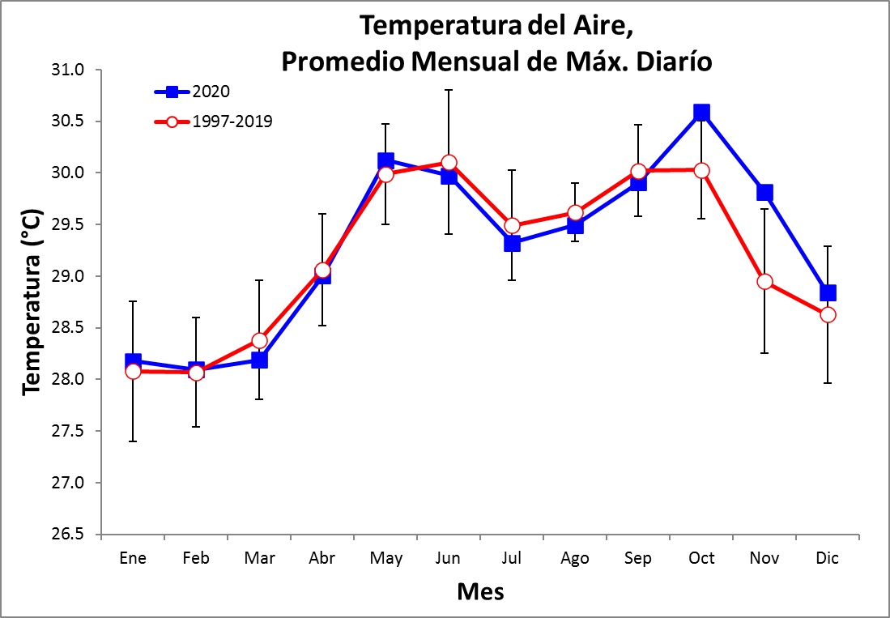
Temperatura Promedio Mensual del Mínimo Diario
Año | Ene. | Feb. | Mar. | Abr. | May | Jun. | Jul. | Ago. | Sep. | Oct. | Nov. | Dic.
2002 |  |  |  | 26.3 | 26.2 | 25.8 | 25.7 | 25.6 | 24.7 | 24.6 | 24.4 | 26.3
2003 | 26.6 | 26.5 | 26.2 | 26.2 | 25.5 | 24.3 | 25.3 | 24.3
2004 |  |  |  |  |  |  |  |  |  |  | 24.9 | 26.1
2005 | 26.0 | 25.8 | 26.1 | 26.2 | 25.1 | 25.1 | 25.3 | 24.8 | 24.4 | 24.3 | 24.2 | 24.9
2006 | 25.9 | 25.9 | 26.3 | 25.4 | 25.1 | 25.2 | 24.8 | 25.0 | 24.5 | 24.3 | 23.9 | 25.3
2007 | 26.5 | 26.0 | 26.2 |  | 24.2 | 24.5 | 24.6 | 24.0 | 23.9 | 23.7 | 23.8 | 24.5
2008 | 26.1 | 26.0 | 26.6 | 26.5 | 23.8 | 24.9 | 24.3 | 24.1 | 24.4 | 24.0 | 22.1 | 23.4
2009 | 24.0 |  | 26.0 | 26.3 | 26.2 | 24.8 | 25.7 | 25.4 | 25.8 | 24.9 | 25.2 | 26.7
2010 | 26.8 | 27.1 | 27.3 | 27.3 | 26.5 | 25.4 | 25.0 | 25.0 | 25.0 | 24.5 | 23.9 | 24.1
2011 | 25.4 | 26.2 | 26.2 | 25.7 | 25.4 | 24.9 | 24.9 | 24.7 | 24.6 | 24.3 | 24.1 | 25.4
2012 | 26.5 | 26.4 | 26.5 | 25.7 | 25.5 | 25.3 | 25.5 | 24.7 | 24.9 | 24.2 | 24.5 | 24.8
2013 | 26.5 | 25.9 | 26.0 | 26.9 | 25.5 | 24.7 | 24.9 | 24.3 | 24.6 | 24.4 | 24.6 | 26.1
2014 | 26.9 | 26.9 | 26.7 | 27.3 | 26.3 | 26.1 | 27.7 | 25.7 | 25.3 | 25.0 | 25.1 | 26.0
2015 | 27.4 | 26.9 | 27.0 | 27.4 | 27.2 | 27.3 | 27.0 | 26.7 | 25.9 | 25.6 | 25.8 | 27.8
2016 | 27.6 | 26.8 | 27.0 | 26.5 | 26.0 | 25.1 | 25.2 | 25.5 | 24.6 | 24.7 | 24.0 | 25.4
2017 | 25.8 | 25.4 | 26.4 | 26.6 | 25.0 | 25.0 | 25.1 | 24.5 | 24.4 | 24.6 | 23.9 | 24.8
2018 | 24.8 | 26.0 | 25.9 | 25.5 | 24.4 | 23.9 | 24.6 | 25.0 | 24.2 | 24.1 | 24.4 | 25.9
2019 | 25.9 | 26.0 | 25.8 | 26.0 | 25.4 | 25.8 | 25.0 | 24.7 | 24.4 | 23.9 | 24.5 | 25.1
2020 | 25.6 | 25.7 | 26.3 | 26.1 | 25.8 | 24.6 | 24.8 | 24.1 | 24.1 | 24.4 | 24.4 | 25.4
$$\overline{x}$$ | 26.1 | 26.2 | 26.4 | 26.3 | 25.5 | 25.2 | 25.3 | 24.9 | 24.7 | 24.4 | 24.3 | 25.4
de | 0.9 | 0.5 | 0.4 | 0.6 | 0.8 | 0.8 | 0.8 | 0.7 | 0.5 | 0.4 | 0.8 | 1.0
mín | 24.0 | 25.4 | 25.8 | 25.4 | 23.8 | 23.9 | 24.3 | 24.0 | 23.9 | 23.7 | 22.1 | 23.4
máx | 27.6 | 27.1 | 27.3 | 27.4 | 27.2 | 27.3 | 27.7 | 26.7 | 25.9 | 25.6 | 25.8 | 27.8
Los valores en verde fueron calculados usando los promedios mensuales de las mínimas diarias de las temperaturas promedios por intervalo. En Mar. 2018 esto fue cambiado a los promedios de las temperaturas mínimas por intervalo.
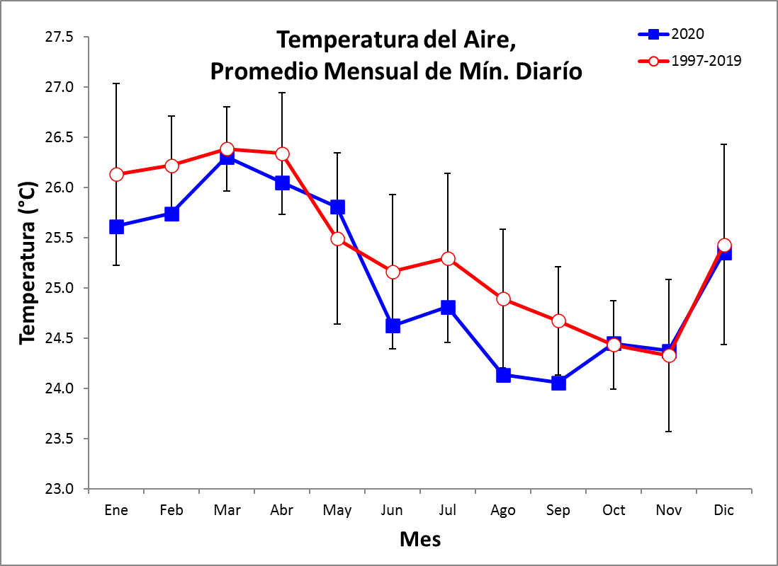
2020 Radiación Total Diaria (MJ m⁻² day⁻¹)

 | Ene. | Feb. | Mar. | Abr. | May | Jun. | Jul. | Ago. | Sep. | Oct. | Nov. | Dic.
1 | 7.6 | 10.1 | 26.2 | 21.6 | 24.9 | 16.1 | 10.4 | 20.6 | 23.2 | 22.6 | 11.7 | 1.9
2 | 19.4 | 18.8 | 24.8 | 26.1 | 25.1 | 7.7 | 13.4 | 12.3 | 17.7 | 19.2 | 15.8 | 9.3
3 | 22.0 | 18.2 | 22.8 | 10.4 | 17.1 | 24.6 | 12.7 | 17.2 | 19.0 | 17.3 | 16.1 | 13.9
4 | 19.4 | 18.3 | 25.5 | 22.7 | 19.2 | 18.0 | 4.2 | 17.6 | 19.1 | 16.0 | 12.8 | 22.0
5 | 21.6 | 17.6 | 20.7 | 22.7 | 13.7 | 9.0 | 18.0 | 10.0 | 20.4 | 19.0 | 22.3 | 16.3
6 | 20.7 | 22.9 | 24.4 | 21.6 | 21.3 | 18.2 | 14.7 | 6.2 | 13.7 | 11.6 | 23.2 | 17.8
7 | 20.5 | 23.5 | 23.4 | 16.4 | 14.5 | 21.2 | 16.7 | 18.2 | 5.9 | 7.8 | 23.0 | 17.0
8 | 21.5 | 22.4 | 22.5 | 11.8 | 18.7 | 19.9 | 8.4 | 15.3 | 15.7 | 9.2 | 21.5 | 10.4
9 | 21.9 | 21.3 | 25.7 | 22.3 | 20.8 | 9.5 | 20.8 | 5.8 | 16.1 | 19.0 | 15.8 | 4.6
10 | 21.5 | 19.6 | 25.2 | 21.2 | 13.9 | 7.2 | 17.5 | 10.5 | 22.4 | 23.2 | 15.8 | 17.0
11 | 20.3 | 20.4 | 25.2 | 17.9 | 20.6 | 15.1 | 9.2 | 10.5 | 21.2 | 7.7 | 8.8 | 22.4
12 | 21.1 | 21.9 | 25.2 | 14.6 | 26.4 | 22.9 | 16.3 | 7.1 | 12.8 | 13.3 | 9.9 | 22.4
13 | 21.3 | 22.6 | 26.8 | 11.4 | 26.4 | 18.3 | 4.0 | 12.2 | 14.5 | 11.4 | 16.2 | 20.5
14 | 17.5 | 22.2 | 25.8 | 14.1 | 20.0 | 20.9 | 9.8 | 18.1 | 14.2 | 8.5 | 6.1 | 20.4
15 | 19.3 | 21.0 | 24.6 | 25.4 | 14.7 | 6.6 | 23.2 | 7.0 | 7.7 | 17.7 | 1.3 | 19.4
16 | 21.1 | 20.9 | 25.6 | 25.4 | 24.0 | 16.3 | 18.8 | 14.3 | 17.1 | 23.4 | 15.2 | 11.4
17 | 9.9 | 13.2 | 20.2 | 24.7 | 9.9 | 15.8 | 19.6 | 22.9 | 14.8 | 10.9 | 14.8 | 10.1
18 | 8.5 | 10.3 | 25.9 | 21.1 | 14.8 | 9.1 | 19.5 | 12.0 | 15.9 | 5.1 | 14.8 | 21.1
19 | 20.3 | 13.6 | 26.3 | 26.1 | 5.5 | 6.7 | 14.6 | 3.4 | 16.3 | 15.5 | 12.8 | 15.9
20 | 18.0 | 19.4 | 25.5 | 25.9 | 19.0 | 9.4 | 13.5 | 12.9 | 17.2 | 15.1 | 14.6 | 17.2
21 | 18.1 | 21.1 | 22.9 | 26.6 | 26.4 | 9.5 | 7.8 | 16.5 | 16.9 | 20.6 | 14.8 | 18.7
22 | 7.7 | 23.2 | 26.7 | 24.1 | 19.7 | 17.4 | 8.8 | 11.8 | 10.6 | 14.1 | 19.8 | 22.1
23 | 6.5 | 24.6 | 26.5 | 23.4 | 24.1 | 6.1 | 18.7 | 14.5 | 23.7 | 16.9 | 19.5 | 10.7
24 | 21.6 | 25.7 | 25.4 | 14.8 | 24.8 | 15.0 | 11.9 | 18.4 | 10.0 | 12.0 | 19.8 | 21.6
25 | 20.0 | 25.7 | 25.6 | 26.9 | 23.3 | 22.4 | 15.2 | 9.0 | 10.0 | 19.3 | 13.0 | 9.3
26 | 23.2 | 25.7 | 26.2 | 21.7 | 21.3 | 5.0 | 22.4 | 24.9 | 25.5 | 22.4 | 7.7 | 20.9
27 | 20.7 | 25.8 | 26.1 | 12.8 | 4.3 | 6.0 | 19.8 | 21.1 | 9.5 | 13.2 | 16.0 | 19.2
28 | 22.5 | 21.6 | 26.0 | 20.2 | 9.2 | 6.8 | 20.1 | 11.2 | 13.9 | 21.3 | 13.1 | 12.5
29 | 22.7 | 24.7 | 25.2 | 13.8 | 21.5 | 12.6 | 20.7 | 12.0 | 17.8 | 18.7 | 14.3 | 19.1
30 | 24.6 |  | 23.1 | 23.4 | 14.0 | 14.0 | 25.2 | 12.6 | 2.7 | 22.2 | 11.6 | 20.5
31 | 17.1 |  | 18.6 |  | 17.2 |  | 20.8 | 21.4 |  | 20.3 |  | 13.2
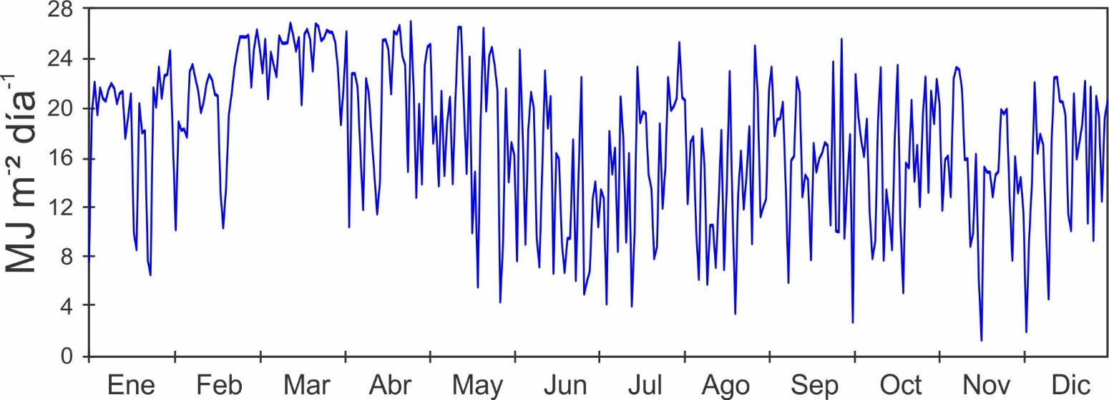

Promedio Mensual de Radiación Solar Total Diaria (MJ m⁻² day⁻¹)

Año | Ene. | Feb. | Mar. | Abr. | May | Jun. | Jul. | Ago. | Sep. | Oct. | Nov. | Dic.
1974 | 20.9 | 22.6 | 24.7 | 23.0 | 19.9 | 17.0 | 12.8 | 16.0 | 16.4 | 15.5 | 13.5 | 19.1
1975 | 19.6 | 22.4 | 22.5 | 23.3 | 18.6 | 12.8 | 14.5 | 13.5 | 15.4 | 14.8 | 14.3
1976 | 17.8 | 19.9 | 19.7 |  |  |  |  |  | 15.3 | 15.1 | 13.9 | 15.9
1977 | 18.0 | 18.1 | 18.9 | 17.8 | 15.2 | 12.7 | 14.0 | 14.5 | 15.4 | 15.8 | 15.4 | 18.8
1978 | 21.2 | 20.2 | 21.9 | 18.6 | 17.3 | 14.8 | 15.7 | 16.7 | 18.2 | 14.3 | 13.7 | 15.4
1979 | 17.8 | 21.2 | 23.1 | 16.6 | 17.3 | 15.6 | 15.2 | 16.0 | 15.8 | 14.9 | 14.0 | 14.9
1980 | 18.0 | 20.2 | 21.5 | 18.0 | 15.8
1981
1982
1983 |  |  |  |  | 15.8 | 12.7 | 13.1 | 13.6 | 15.6 | 14.8 | 14.8 | 17.2
1984 | 18.6 | 19.2 | 21.0 | 21.7 | 15.9 | 12.5 | 13.0 | 13.2 | 16.5 | 13.2 | 15.3 | 14.8
1985 | 17.8 | 20.9 | 21.6 | 18.0 | 18.8 | 14.0 | 15.3 | 15.2 | 14.1 | 12.7 | 14.7 | 16.9
1986 | 16.7 | 17.7 | 21.2 | 15.7 | 15.4 | 12.5 | 12.3 | 13.1 | 13.6 | 12.5 | 13.0 | 15.8
1987 | 19.6 | 18.8 | 21.4 | 22.1 | 15.2 | 14.3 | 10.6 | 13.8 | 14.9 | 13.0 | 12.3 | 16.1
1988 | 19.8 | 20.3 | 22.9 | 21.3 | 18.0 | 13.3 | 14.0 | 12.9 | 15.5 | 12.8 | 13.7 | 16.9
1989 | 18.1 | 21.5 | 20.2 | 21.3 | 14.7 | 13.2 | 14.6 | 13.4 | 13.8 | 13.7 | 14.5 | 16.4
1990 | 19.6 | 19.1 | 22.4 | 22.1 | 13.9 | 14.0 | 16.3 | 15.1 | 14.8 | 15.3 | 12.6 | 15.9
1991 | 18.4 | 21.0 | 20.7 | 18.8 | 15.7 | 15.6 | 13.2 | 12.7 | 14.1 | 12.5 | 14.2 | 15.4
1992 | 15.8 | 19.9 | 19.6 | 18.6 | 16.9 | 12.2 | 14.8 | 14.0 | 12.4 | 13.6 | 12.0 | 14.4
1993 | 18.6 | 20.5 | 19.5 | 21.5 | 14.2 | 12.5 | 14.8 | 14.6 | 15.0 | 16.5 | 12.7 | 16.9
1994 | 18.1 | 20.9 | 22.2 | 21.5 | 15.1 | 15.2 | 15.1 | 18.3 | 15.7 | 15.9 | 12.3 | 14.5
1995 | 16.6 | 20.3 | 22.6 | 20.2 | 17.5 | 13.7 | 13.3 | 14.8 | 15.2 | 16.1 | 12.3 | 14.2
1996 | 20.2 | 20.1 | 23.6 | 21.9 | 17.4 | 16.9 | 18.3 | 18.6 | 15.4 | 16.7 | 13.6 | 18.5
1997 | 19.1 | 19.4 | 22.0 | 20.6 | 16.1 | 14.3 | 14.1 | 13.8 | 16.3 | 15.2 | 15.5 | 12.3
1998 | 18.8 | 18.5 | 21.3 | 19.9 | 17.1 | 13.9 | 14.0 | 14.3 | 14.7 | 14.4 | 13.1 | 11.0
1999 | 19.6 | 21.2 | 22.1 | 21.3 | 15.9 | 14.1 | 15.7 | 15.3 | 16.6 | 13.5 | 17.7 | 13.9
2000 | 19.4 | 20.7 | 20.9 | 21.6 | 18.4 | 17.7 | 15.1 | 15.3 | 15.3 | 15.8 | 13.6 | 12.3
2001 | 18.5 | 21.2 | 21.8 | 20.9 | 20.4 | 15.4 | 14.8 | 16.1 | 15.8 | 13.4 | 13.9 | 19.2
2002 | 19.0 | 20.3 | 22.5 | 20.8 | 13.4 | 13.8 | 13.1 | 14.1 | 16.4 | 16.2 | 14.0 | 12.9
2003 | 20.5 | 22.2 | 21.2 | 20.1 | 14.4 | 14.4 | 13.2 | 12.3 | 16.5 | 16.8 | 13.8 | 18.6
2004 | 17.9 | 20.7 | 21.1 | 18.9 | 14.4 | 16.6 | 16.4 | 14.3 | 13.8 | 16.2 | 14.0 | 18.0
2005 | 16.8 | 19.0 | 19.7 | 17.3 | 13.0 | 15.1 | 15.0 | 13.3 | 13.0 | 15.4 | 12.6 | 16.9
2006 | 17.8 | 19.0 | 19.8 | 18.0 | 14.3 | 14.9 | 13.9 | 14.7 | 12.9 | 14.2 | 11.6 | 15.8
2007 | 18.5 | 20.1 | 20.1 | 0.0 | 16.7 | 12.7 | 12.8 | 10.3 | 11.8 | 13.8 | 11.1 | 13.9
2008 | 18.5 | 19.0 | 22.0 | 21.2 | 15.9 | 12.5 | 12.3 | 15.1 | 16.9 | 16.1 | 12.3 | 18.4
2009 | 18.7 | 20.1 | 22.0 | 21.2 | 17.3 | 15.9 | 14.0 | 13.8 | 15.0 | 13.9 | 10.2 | 17.2
2010 | 17.6 | 17.2 | 17.6 | 19.1 | 15.9 | 14.0 | 14.5 | 13.6 | 14.6 | 12.4 | 11.3 | 8.1
2011 | 17.4 | 21.4 | 22.2 | 19.7 | 18.6 | 14.5 | 14.3 | 14.7 | 15.3 | 13.6 | 12.2 | 13.4
2012 | 20.0 | 20.9 | 19.7 | 18.8 | 16.9 | 16.5 | 14.2 | 14.2 | 14.5 | 13.9 | 10.8 | 14.9
2013 | 19.8 | 20.4 | 18.0 | 20.7 | 15.0 | 12.8 | 13.8 | 14.0 | 14.4 | 14.7 | 15.0 | 17.1
2014 | 17.8 | 20.5 | 20.9 | 18.7 | 17.0 | 9.2 | 17.4 | 14.7 | 14.4 | 12.8 | 14.2 | 14.5
2015 | 17.8 | 18.7 | 21.2 | 20.6 | 14.0 | 17.4 | 14.1 | 15.1 | 14.7 | 15.6 | 13.8 | 15.8
2016 | 18.3 | 19.4 | 20.3 | 20.6 | 16.4 | 15.5 | 12.0 | 13.9 | 13.7 | 15.8 | 12.3 | 15.7
2017 | 20.2 | 22.5 | 22.5 | 21.4 | 15.2 | 15.2 | 13.3 | 15.9 | 15.4 | 16.1 | 13.4 | 15.0
2018 | 15.4 | 23.2 | 21.4 | 19.7 | 16.3 | 12.8 | 15.5 | 16.3 | 15.5 | 15.7 | 13.7 | 19.6
Datos en Morado son de sensors en el techo del Laboratorio. Datos en Verde son de sensors de la Estación del Reciefe. Otros datos son de la Estación de la Torre del Muelle.

Año | Ene. | Feb. | Mar. | Abr. | May | Jun. | Jul. | Ago. | Sep. | Oct. | Nov. | Dic.
2019 | 18.2 | 20.8 | 22.0 | 21.9 | 16.6 | 16.9 | 15.7 | 15.4 | 15.2 | 14.7 | 14.7 | 14.5
2020 | 18.5 | 20.3 | 24.6 | 20.1 | 18.5 | 13.5 | 15.3 | 13.7 | 15.5 | 16.0 | 14.7 | 16.1
$$\overline{x}$$ | 18.5 | 20.3 | 21.2 | 20.1 | 16.2 | 14.3 | 14.3 | 14.5 | 15.0 | 14.6 | 13.4 | 15.6
D.E. | 1.3 | 1.3 | 1.4 | 1.8 | 1.7 | 1.7 | 1.5 | 1.5 | 1.2 | 1.3 | 1.4 | 2.3
mín | 15.4 | 17.2 | 17.6 | 15.7 | 13.0 | 9.2 | 10.6 | 10.3 | 11.8 | 12.4 | 10.2 | 8.1
máx | 21.2 | 23.2 | 24.7 | 23.3 | 20.4 | 17.7 | 18.3 | 18.6 | 18.2 | 16.8 | 17.7 | 19.6

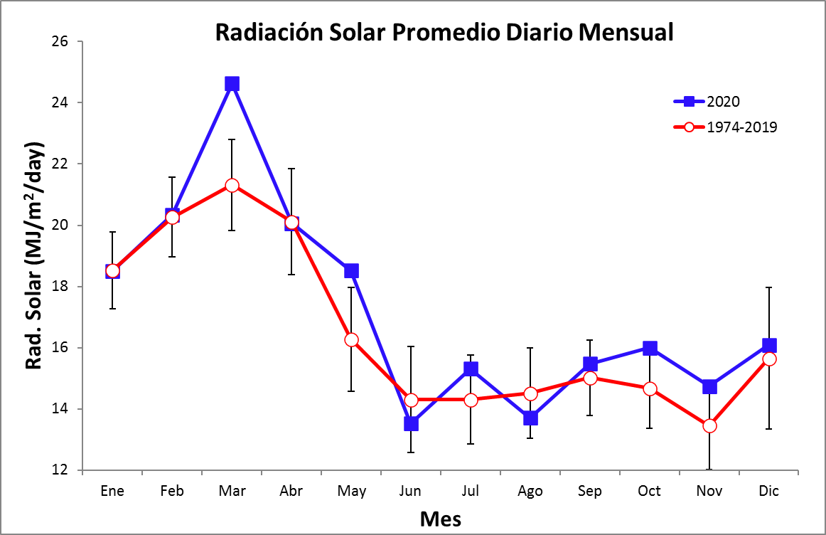

2020 Velocidad del Viento Promedio Diario (km/h) – Torre
 | Ene. |  | Feb. |  |  | Mar. |  |  | Abr. |  |  | May |  |  | Jun. |  | Jul. |  | Ago. |  | Sep. |  | Oct. |  | Nov. |  |  | Dic.
 | $$\overline{x}$$ | Máx | $$\overline{x}$$ | Máx | $$\overline{x}$$ |  | Máx | $$\overline{x}$$ |  | Máx | $$\overline{x}$$ |  | Máx | $$\overline{x}$$ |  | Máx | $$\overline{x}$$ | Máx | $$\overline{x}$$ | Máx | $$\overline{x}$$ | Máx | $$\overline{x}$$ | Máx | $$\overline{x}$$ | Máx | $$\overline{x}$$ |  |  | Máx
1 | 16.6 | 34.6 | 18.0 | 32.1 | 25.0 |  | 38.7 | 15.1 |  | 29.6 | 18.9 |  | 32.7 | 4.7 |  | 17.3 | 7.7 | 30.3 | 6.1 | 16.5 | 5.3 | 23.3 | 6.8 | 21.9 | 7.8 | 23.5 | 11.6 |  | 43.6
2 | 14.7 | 29.3 | 31.3 | 45.0 | 26.4 |  | 38.7 | 15.5 |  | 28.7 | 27.3 |  | 36.8 | 5.6 |  | 25.7 | 6.1 | 23.3 | 6.4 | 21.1 | 5.4 | 23.4 | 5.3 | 29.0 | 11.7 | 36.2 | 5.6 |  | 28.5
3 | 5.1 | 19.2 | 29.6 | 46.2 | 24.0 |  | 37.3 | 13.7 |  | 28.2 | 26.4 |  | 39.1 | 10.2 |  | 27.1 | 5.7 | 21.5 | 5.8 | 22.5 | 6.8 | 29.6 | 6.6 | 21.8 | 18.4 | 44.3 | 5.3 |  | 19.9
4 | 11.6 | 29.9 | 25.5 | 38.8 | 22.2 |  | 33.7 | 24.7 |  | 36.2 | 23.7 |  | 49.7 | 9.4 |  | 25.4 | 6.3 | 31.1 | 6.6 | 31.0 | 7.6 | 22.2 | 6.4 | 18.1 | 19.7 | 44.2 | 13.4 |  | 32.3
5 | 23.3 | 38.3 | 24.2 | 35.2 | 21.8 |  | 32.6 | 20.2 |  | 34.6 | 17.2 |  | 35.4 | 4.3 |  | 13.8 | 6.0 | 24.7 | 5.1 | 47.7 | 6.9 | 18.7 | 7.1 | 23.8 | 17.5 | 36.9 | 17.6 |  | 30.6
6 | 26.4 | 43.8 | 16.8 | 27.6 | 26.3 |  | 38.0 | 25.9 |  | 36.1 | 15.3 |  | 28.9 | 5.9 |  | 20.7 | 11.3 | 31.0 | 3.9 | 27.9 | 4.7 | 18.4 | 9.0 | 33.6 | 14.3 | 36.0 | 8.9 |  | 32.4
7 | 25.0 | 41.4 | 9.7 | 26.9 | 26.8 |  | 41.9 | 28.1 |  | 45.6 | 15.6 |  | 29.2 | 7.3 |  | 22.5 | 16.2 | 37.3 | 6.6 | 21.2 | 6.4 | 23.3 | 5.8 | 19.3 | 12.4 | 37.4 | 11.1 |  | 25.5
8 | 30.7 | 47.0 | 22.9 | 37.5 | 30.2 |  | 50.0 | 23.3 |  | 38.7 | 17.7 |  | 33.1 | 11.0 |  | 31.2 | 6.2 | 24.5 | 9.3 | 32.9 | 7.6 | 38.8 | 8.3 | 30.5 | 12.0 | 34.7 | 17.3 |  | 44.2
9 | 32.1 | 49.4 | 29.1 | 41.4 | 31.5 |  | 49.7 | 21.7 |  | 36.7 | 11.0 |  | 23.0 | 9.5 |  | 30.6 | 7.1 | 18.6 | 5.7 | 26.9 | 7.5 | 22.6 | 8.7 | 26.9 | 8.7 | 24.7 | 21.9 |  | 49.2
10 | 31.9 | 46.2 | 27.0 | 38.9 | 25.0 |  | 39.5 | 19.1 |  | 32.5 | 7.2 |  | 19.7 | 6.7 |  | 25.9 | 7.5 | 27.8 | 4.5 | 15.2 | 6.9 | 25.0 | 10.0 | 29.6 | 7.4 | 22.8 | 26.2 |  | 43.7
11 | 21.2 | 36.5 | 24.3 | 35.0 | 25.0 |  | 33.8 | 19.8 |  | 29.6 | 12.2 |  | 26.0 | 7.6 |  | 45.1 | 6.3 | 27.5 | 10.1 | 41.7 | 6.6 | 22.3 | 5.7 | 35.8 | 5.7 | 22.5 | 21.0 |  | 41.5
12 | 26.3 | 37.4 | 25.2 | 37.8 | 23.8 |  | 39.4 | 18.8 |  | 36.3 | 16.3 |  | 26.9 | 5.2 |  | 18.1 | 5.6 | 13.8 | 10.8 | 33.7 | 5.1 | 21.8 | 6.4 | 24.2 | 4.5 | 12.9 | 20.8 |  | 34.9
13 | 28.1 | 41.5 | 25.5 | 41.5 | 21.2 |  | 32.6 | 3.8 |  | 19.4 | 12.8 |  | 30.9 | 6.1 |  | 20.4 | 6.1 | 35.7 | 9.9 | 44.1 | 6.1 | 23.8 | 6.0 | 32.6 | 6.2 | 24.3 | 20.6 |  | 38.8
14 | 33.1 | 46.3 | 27.3 | 40.4 | 23.9 |  | 40.2 | 6.8 |  | 16.9 | 6.2 |  | 22.3 | 7.2 |  | 18.8 | 5.5 | 40.4 | 5.6 | 17.8 | 6.3 | 29.1 | 5.6 | 33.8 | 6.6 | 33.9 | 14.5 |  | 29.0
15 | 31.7 | 51.9 | 30.0 | 46.3 | 26.8 |  | 39.6 | 14.2 |  | 34.6 | 7.7 |  | 21.7 | 5.3 |  | 32.1 | 8.6 | 26.2 | 5.5 | 20.4 | 5.9 | 31.5 | 5.5 | 14.7 | 7.1 | 19.2 | 9.3 |  | 25.1
16 | 27.1 | 39.6 | 33.4 | 49.4 | 26.2 |  | 45.9 | 15.4 |  | 32.4 | 7.8 |  | 21.1 | 4.5 |  | 18.9 | 22.8 | 34.4 | 6.7 | 26.6 | 5.1 | 20.0 | 7.4 | 36.5 | 11.6 | 30.7 | 9.4 |  | 31.2
17 | 31.5 | 44.5 | 30.6 | 50.7 | 24.2 |  | 43.7 | 25.1 |  | 40.9 | 10.0 |  | 28.5 | 4.7 |  | 16.2 | 19.8 | 44.5 | 7.2 | 26.6 | 5.2 | 16.3 | 11.4 | 35.7 | 17.4 | 40.3 | 20.8 |  | 40.8
18 | 31.8 | 45.6 | 29.1 | 43.5 | 29.4 |  | 43.3 | 18.3 |  | 32.4 | 4.7 |  | 17.0 | 5.9 |  | 28.8 | 13.0 | 29.1 | 6.0 | 21.3 | 6.2 | 23.7 | 6.2 | 40.9 | 10.7 | 30.8 | 29.3 |  | 44.8
19 | 25.3 | 38.2 | 27.1 | 42.5 | 28.0 |  | 41.0 | 18.9 |  | 31.0 | 4.0 |  | 20.6 | 4.3 |  | 17.3 | 17.3 | 32.9 | 3.8 | 17.0 | 6.5 | 31.5 | 7.2 | 24.1 | 6.0 | 19.8 | 31.5 |  | 44.5
20 | 23.4 | 35.6 | 30.4 | 50.6 | 24.3 |  | 34.4 | 11.6 |  | 25.5 | 8.9 |  | 24.7 | 5.5 |  | 21.1 | 11.6 | 39.2 | 6.4 | 18.4 | 8.2 | 44.7 | 9.4 | 29.5 | 6.8 | 25.9 | 25.5 |  | 40.3
21 | 18.4 | 34.7 | 30.4 | 46.8 | 26.6 |  | 42.1 | 8.7 |  | 20.2 | 10.5 |  | 31.4 | 5.2 |  | 19.0 | 5.1 | 17.8 | 7.8 | 22.3 | 5.3 | 21.7 | 7.8 | 22.2 | 5.9 | 22.1 | 25.4 |  | 38.1
22 | 8.8 | 26.5 | 26.6 | 36.8 | 31.9 |  | 41.0 | 15.1 |  | 31.9 | 12.7 |  | 32.6 | 10.1 |  | 29.6 | 4.7 | 16.5 | 5.4 | 22.2 | 6.8 | 38.2 | 5.1 | 18.3 | 7.1 | 25.7 | 24.3 |  | 35.3
23 | 17.8 | 39.8 | 24.9 | 36.8 | 28.7 |  | 39.8 | 14.4 |  | 26.9 | 6.5 |  | 17.9 | 8.8 |  | 32.6 | 5.1 | 16.8 | 4.5 | 17.6 | 5.9 | 26.5 | 5.0 | 21.0 | 6.6 | 17.5 | 25.2 |  | 39.4
24 | 22.4 | 31.5 | 19.3 | 30.8 | 24.9 |  | 35.1 | 10.2 |  | 22.2 | 6.2 |  | 17.1 | 7.0 |  | 23.3 | 4.9 | 20.5 | 6.6 | 37.5 | 6.1 | 35.5 | 6.8 | 28.9 | 9.4 | 32.1 | 19.9 |  | 36.1
25 | 22.6 | 33.5 | 11.7 | 28.8 | 24.0 |  | 36.5 | 19.1 |  | 34.1 | 8.4 |  | 22.4 | 23.0 |  | 50.5 | 4.7 | 18.2 | 5.3 | 21.9 | 8.1 | 42.0 | 11.2 | 30.6 | 8.7 | 45.8 | 10.7 |  | 38.2
26 | 14.3 | 29.1 | 11.7 | 28.9 | 23.4 |  | 36.0 | 22.8 |  | 33.5 | 7.4 |  | 27.2 | 11.8 |  | 50.4 | 6.6 | 25.5 | 13.8 | 35.6 | 6.5 | 21.9 | 10.5 | 28.7 | 5.9 | 23.3 | 9.6 |  | 32.9
27 | 10.7 | 25.9 | 16.4 | 34.4 | 24.7 |  | 39.3 | 21.3 |  | 37.0 | 7.9 |  | 44.4 | 4.4 |  | 20.8 | 6.2 | 22.9 | 7.8 | 24.9 | 5.9 | 35.8 | 5.3 | 13.9 | 12.4 | 39.4 | 7.9 |  | 28.6
28 | 10.1 | 27.0 | 25.3 | 42.4 | 28.9 |  | 41.5 | 25.0 |  | 38.1 | 6.0 |  | 20.8 | 6.3 |  | 24.1 | 7.2 | 24.8 | 6.1 | 28.9 | 6.7 | 47.4 | 5.2 | 17.2 | 6.5 | 26.9 | 6.0 |  | 34.7
29 | 18.1 | 35.6 | 31.5 | 45.7 | 26.0 |  | 38.0 | 23.2 |  | 34.9 | 8.8 |  | 27.9 | 5.2 |  | 24.8 | 13.1 | 34.4 | 4.7 | 20.0 | 6.4 | 25.5 | 7.7 | 26.5 | 6.2 | 23.2 | 7.0 |  | 39.0
30 | 17.1 | 36.8 |  |  | 23.4 |  | 38.2 | 11.6 |  | 26.9 | 9.4 |  | 50.5 | 7.7 |  | 30.8 | 15.6 | 28.9 | 7.7 | 30.8 | 7.4 | 26.4 | 8.2 | 34.5 | 9.6 | 31.7 | 6.9 |  | 22.5
31 | 23.2 | 37.6 |  |  | 23.9 |  | 35.2 |  |  |  | 7.2 |  | 22.4 |  |  |  | 9.8 | 21.4 | 6.4 | 24.2 |  |  | 7.2 | 30.6 |  |  | 9.0 |  | 31.2
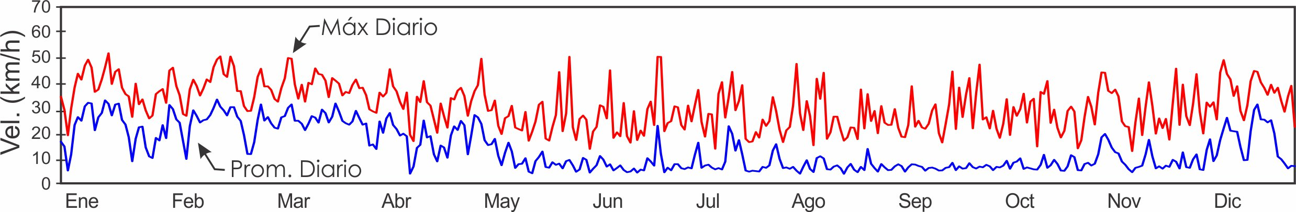
2020 Dirección del Viento Promedio Diario (°) –Torre
 |  | Ene. | Feb. | Mar. | Abr. | May | Jun. | Jul. | Ago. | Sep. | Oct. | Nov. | Dic.
 | 1 | 13.0 | 351.5 | 17.4 | 41.0 | 43.0 | 167.0 | 300.5 | 24.8 | 210.0 | 182.3 | 195.3 | 353.3
 | 2 | 44.6 | 37.6 | 24.9 | 49.9 | 35.3 | 235.7 | 235.0 | 349.9 | 196.9 | 180.3 | 176.2 | 218.9
 | 3 | 337.0 | 27.7 | 20.5 | 358.2 | 24.3 | 168.5 | 248.1 | 267.2 | 162.8 | 185.3 | 167.8 | 212.0
 | 4 | 33.9 | 22.7 | 21.8 | 43.2 | 22.0 | 134.2 | 207.0 | 283.3 | 136.5 | 178.1 | 162.7 | 25.7
 | 5 | 27.5 | 28.9 | 6.8 | 22.1 | 30.6 | 206.7 | 146.4 | 179.4 | 127.9 | 188.4 | 159.0 | 25.6
 | 6 | 31.8 | 15.0 | 21.2 | 20.9 | 26.2 | 260.5 | 54.9 | 192.6 | 220.1 | 154.6 | 158.9 | 320.0
 | 7 | 31.2 | 22.2 | 18.8 | 16.4 | 24.8 | 254.2 | 26.6 | 301.5 | 176.5 | 174.1 | 164.5 | 345.0
 | 8 | 40.1 | 22.4 | 37.4 | 7.5 | 20.1 | 33.9 | 259.8 | 318.4 | 161.5 | 160.4 | 164.6 | 27.5
 | 9 | 46.0 | 26.2 | 34.7 | 25.9 | 350.6 | 91.2 | 260.2 | 218.3 | 131.8 | 125.3 | 155.9 | 358.6
 | 10 | 44.9 | 32.9 | 24.4 | 15.4 | 345.9 | 179.8 | 47.0 | 265.7 | 169.4 | 339.1 | 154.3 | 25.5
 | 11 | 41.4 | 29.0 | 23.5 | 15.0 | 6.8 | 176.6 | 229.2 | 354.2 | 14.1 | 187.7 | 175.4 | 22.2
 | 12 | 36.5 | 31.4 | 22.0 | 35.7 | 19.6 | 192.1 | 249.9 | 52.8 | 186.5 | 212.9 | 196.4 | 16.3
 | 13 | 35.9 | 28.2 | 26.0 | 227.6 | 24.9 | 161.9 | 279.6 | 316.9 | 178.8 | 195.7 | 214.5 | 22.4
 | 14 | 45.1 | 26.5 | 32.9 | 148.0 | 280.8 | 357.3 | 179.0 | 182.4 | 187.0 | 176.0 | 208.8 | 359.1
 | 15 | 36.8 | 26.1 | 30.8 | 66.9 | 4.9 | 222.1 | 290.7 | 189.2 | 167.4 | 202.2 | 189.8 | 298.3
 | 16 | 35.0 | 30.4 | 25.0 | 53.7 | 31.2 | 199.6 | 20.6 | 235.0 | 177.5 | 283.4 | 170.4 | 302.4
 | 17 | 44.8 | 28.2 | 32.7 | 23.8 | 13.2 | 203.2 | 15.6 | 272.0 | 170.9 | 299.3 | 161.1 | 57.5
 | 18 | 41.5 | 17.6 | 35.4 | 358.8 | 263.2 | 257.1 | 23.9 | 288.8 | 188.8 | 214.4 | 170.7 | 32.4
 | 19 | 33.0 | 18.2 | 35.0 | 14.8 | 197.2 | 262.3 | 33.7 | 215.8 | 184.9 | 192.3 | 195.8 | 40.7
 | 20 | 21.7 | 19.3 | 26.4 | 13.2 | 56.7 | 234.6 | 25.4 | 187.1 | 54.2 | 157.6 | 219.6 | 36.6
 | 21 | 4.2 | 20.7 | 32.0 | 6.6 | 43.2 | 239.5 | 241.3 | 139.2 | 218.0 | 183.1 | 182.2 | 22.3
 | 22 | 314.1 | 9.9 | 40.7 | 50.0 | 77.4 | 42.3 | 255.9 | 187.8 | 283.1 | 205.3 | 174.6 | 28.5
 | 23 | 28.7 | 17.0 | 35.2 | 28.1 | 243.7 | 127.2 | 258.4 | 178.9 | 227.1 | 230.7 | 321.7 | 46.5
 | 24 | 36.8 | 24.4 | 24.4 | 15.5 | 28.9 | 261.1 | 212.1 | 155.4 | 187.9 | 171.5 | 351.9 | 8.1
 | 25 | 16.9 | 66.6 | 25.2 | 34.2 | 68.2 | 35.4 | 187.9 | 190.9 | 146.3 | 162.2 | 0.7 | 312.4
 | 26 | 0.4 | 41.6 | 26.1 | 41.6 | 342.9 | 11.6 | 246.0 | 158.5 | 266.9 | 146.9 | 219.2 | 347.2
 | 27 | 46.7 | 59.6 | 27.8 | 52.3 | 184.5 | 242.5 | 242.1 | 161.3 | 170.3 | 171.5 | 89.4 | 266.3
 | 28 | 45.4 | 8.6 | 34.1 | 38.5 | 175.4 | 225.2 | 316.8 | 254.8 | 200.4 | 224.2 | 237.7 | 288.6
 | 29 | 58.6 | 26.7 | 25.8 | 38.7 | 165.2 | 215.9 | 353.9 | 219.3 | 295.7 | 178.2 | 251.8 | 238.2
 | 30 | 55.9 |  | 19.8 | 39.1 | 168.0 | 183.7 | 27.2 | 190.4 | 204.3 | 184.3 | 264.5 | 228.2
 | 31 | 28.1 |  | 37.2 |  | 170.8 |  | 356.3 | 236.1 |  | 226.0 |  | 90.1
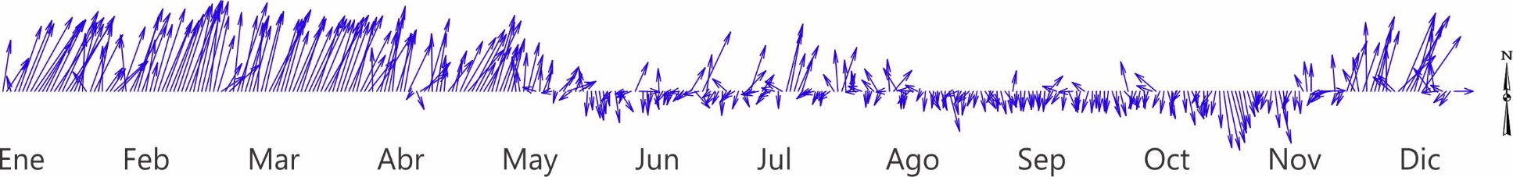

Velocidad del Viento (km/h) y Dirección (°) Promedio Mensual
 | Prom. a largo plazo |  |  |  |  | 2020
 | Arrecife |  | Torre |  |  | Arrecife | Torre
 | $$\overline{x}$$ | Máx. | $$\overline{x}$$ | Máx. | Dir. | $$\overline{x}$$ | $$\overline{x}$$ | Máx. | Dir.
Enero | 21.5 | 35.1 | 22.2 | 38.7 | 20.0 | 21.7 | 22.0 | 37.2 | 31.5
Febrero | 24.1 | 34.1 | 23.5 | 37.6 | 19.7 | 24.4 | 24.7 | 39.3 | 24.6
Marzo | 23.4 | 32.5 | 23.5 | 37.2 | 18.4 | 25.3 | 25.8 | 39.2 | 27.3
Abril | 19.1 | 30.9 | 18.5 | 32.8 | 18.0 | 16.7 | 17.7 | 31.7 | 28.7
Mayo | 12.3 | 27.3 | 11.3 | 28.9 | 19.3 |  | 11.7 | 28.4 | 303.6
Junio | 10.3 | 26.5 | 9.2 | 28.2 | 252.7 |  | 7.3 | 26.1 | 303.6
Julio | 11.7 | 27.4 | 10.5 | 30.0 | 334.6 |  | 9.0 | 27.1 | 212.8
Agosto | 10.4 | 26.6 | 9.0 | 28.4 | 275.3 |  | 6.7 | 26.3 | 185.1
Septiembre | 8.9 | 25.4 | 7.6 | 28.3 | 204.9 |  | 6.4 | 27.7 | 185.1
Octubre | 9.3 | 25.4 | 7.8 | 27.9 | 192.6 | 8.6 | 7.3 | 26.9 | 183.8
Noviembre | 10.5 | 28.2 | 9.3 | 30.8 | 232.5 | 12.3 | 9.7 | 29.6 | 181.8
Diciembre | 17.2 | 33.6 | 16.3 | 35.3 | 10.9 | 16.8 | 15.9 | 35.4 | 6.7

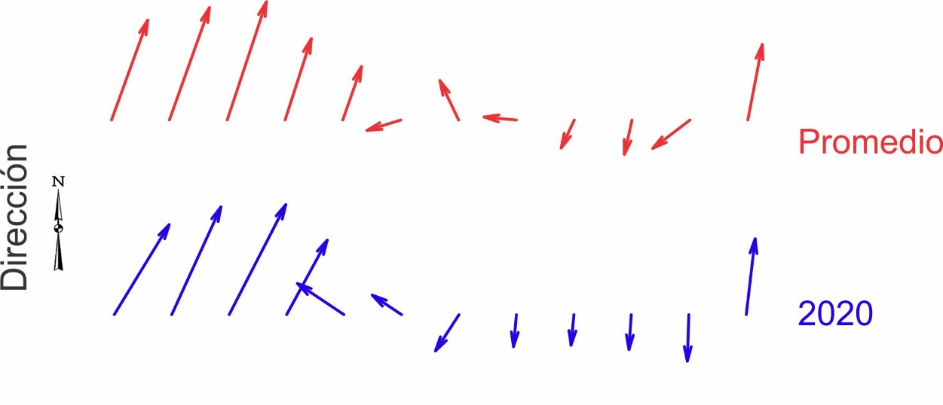

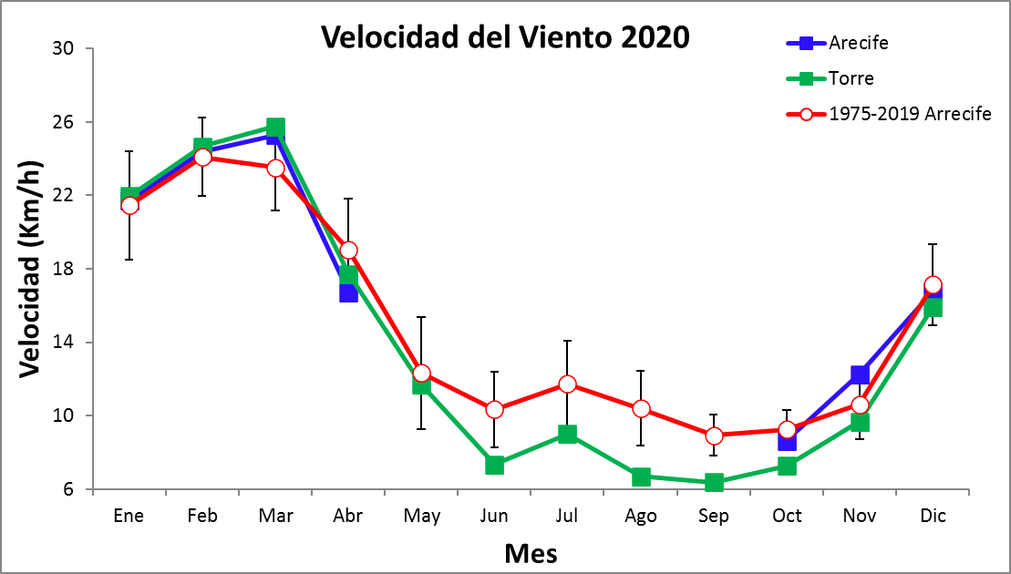
SST (C) Promedio Mensual
Arrecife Arriba
Año | Ene. | Feb. | Mar. | Abr. | May | Jun. | Jul. | Ago. | Sep. | Oct. | Nov. | Dic.
1975 | 26.8 | 26.7 | 27.5 | 27.8 | 28.6 | 28.6 | 28.2 | 27.7 | 28.4 | 28.1 | 27.8 | 26.2
1976 | 26.1 | 26.3 | 26.9 | 27.9 | 28.3 | 28.5 | 28.3 | 28.0 | 27.9 | 28.6 | 28.2 | 27.7
1977 | 26.9 | 26.9 | 27.0 | 27.6 | 29.2 | 28.6 | 27.7 | 27.9 | 28.1 | 28.1 | 27.6 | 28.1
1978 | 27.0 | 26.9 | 27.7 | 28.2 | 28.5 | 28.5 | 27.9 | 28.4 | 28.2 | 28.3 | 28.0 | 27.4
1979 | 26.7 | 26.8 | 27.3 | 27.7 | 28.8 | 28.7 | 28.5 | 28.3 | 28.4 | 28.4 | 27.9 | 27.3
1980 | 27.1 | 27.8 | 27.7 | 28.7 | 29.9 | 29.4 | 28.9 | 29.3 | 28.8
1981
1982
1983
1984 |  |  |  | 28.9 | 29.3 | 29.1 | 28.5 | 28.2 | 27.9 | 28.2 | 27.3 | 26.5
1985 | 25.8 | 26.3 | 27.1 | 28.5 | 29.2 | 29.1 | 28.9 | 28.7 | 29.3 | 28.9 | 28.5 | 28.0
1986 | 26.8 | 27.2 | 27.9 | 28.4 | 29.3 | 28.9 | 28.1 | 28.2 | 28.2 | 27.9 | 28.0 | 27.4
1987 | 27.1 | 27.2 | 28.1 | 28.0 | 28.6 | 29.0 | 28.4 | 28.3 | 28.4 | 28.2 | 27.9 | 27.8
1988 | 27.4 | 27.3 | 27.3 | 28.8 | 29.0 | 29.1 | 28.4 | 28.2 | 28.3 | 27.9 | 27.6 | 27.0
1989 | 26.4 | 26.0 | 27.0 | 27.6 | 28.3 | 28.1 | 27.8 | 27.7 | 28.1 | 27.9 | 27.7 | 27.3
1990 | 26.5 | 26.5 | 26.9 | 28.1 | 28.0 | 28.2 | 27.9 | 28.2 | 28.3 | 28.1 | 28.3 | 27.5
1991 | 27.3 | 26.9 | 28.0 | 28.7 | 28.4 | 29.0 | 28.7 | 28.2 | 28.4 | 28.4 |  | 26.8
1992 | 26.8 | 27.3 | 28.0 | 28.5 | 28.3 | 29.7 | 28.7 | 28.0 | 28.0 | 28.3 | 28.2 | 27.9
1993 | 27.3 | 27.2 | 27.9 | 29.1 | 29.4 | 29.2 | 28.5 | 28.4 | 28.0 | 28.4 | 27.6 | 27.4
1994 | 26.9 | 27.0 | 27.5 | 28.3 | 28.6 | 28.4 | 28.0 | 28.0 | 28.1 | 28.5 | 27.8 | 27.5
1995 | 27.2 | 27.3 | 28.3 | 28.9 | 28.9 | 29.3 | 28.7 | 29.1 | 29.1 | 28.4 | 28.0 | 27.4
1996 | 27.0 | 27.0 | 27.5 | 28.2 | 28.6 | 28.5 | 28.1 | 28.0 | 28.6 | 28.0 | 27.6 | 26.7
1997 | 26.9 | 26.9 | 27.2 | 28.0 | 28.1 | 28.8 | 28.5 | 28.5 | 28.4 | 28.4 | 27.7 | 27.8
1998 | 27.4 | 27.6 | 28.2 | 28.7 | 28.8 | 28.8 | 28.2 | 28.3 | 29.0 | 29.1 | 28.5 | 27.5
1999 | 27.2 | 27.0 | 27.4 | 28.1 | 29.1 | 29.0 | 28.4 | 28.5 | 28.4 | 27.9 | 27.2 | 26.4
2000 | 26.2 | 26.5 | 27.1 | 27.6 |  |  | 28.0 | 29.8 | 29.3 | 28.7 | 28.6 | 27.8
2001 | 26.9 | 26.7 | 27.4 | 27.7 | 28.9 | 28.9 | 28.1 | 28.6 | 28.7 | 28.9 | 27.4 | 27.6
2002 | 27.8 | 27.5 | 28.5 | 29.0 | 29.3 | 30.0 | 29.1 | 28.8 | 30.0 | 29.5 | 28.9 | 28.2
2003 | 28.2 | 28.3 | 28.8 | 29.8 | 29.1 | 29.3 | 28.9 | 29.0 | 29.9 | 29.8 | 29.3 | 28.1
2004 | 28.0 | 28.5 | 28.1 | 29.2 | 29.0 | 29.1 | 29.0 | 29.1 | 29.2 | 29.6 | 28.7 | 27.9
2005 | 27.5 | 27.4 | 29.3 | 29.6 | 29.6 | 30.4 | 30.4 | 29.7 | 29.5 | 29.3 | 27.9 | 27.3
2006 | 27.4 | 27.8 | 28.0 | 28.5 | 28.8 | 29.3 | 29.2 | 28.9 | 29.1
2007 | 27.5 | 27.8 | 28.4 | 29.4 | 29.8 | 29.6 | 29.0 | 29.3 | 29.5 | 29.1 | 28.4
2008 |  | 27.8 | 28.3 | 29.2 | 29.2 | 29.7 |  |  |  | 29.2 | 28.2 | 27.5
2009 | 27.2 | 27.0 | 27.6 | 28.8 | 29.2 | 29.8 | 29.0 | 29.0 | 29.5 | 29.2 | 28.3 | 28.4
2010 | 28.0 | 28.4 | 28.6 | 29.7 | 29.9 | 30.0 | 29.8 | 29.7 | 29.2 | 28.8 | 27.9 | 26.2
2011 | 27.1 | 27.8 | 28.1 | 28.9 | 29.9 | 29.9 | 29.5 | 29.5 | 29.8 | 29.1 | 28.4 | 27.5
2012 | 27.3 | 27.3 | 27.4 | 28.8 | 29.4 | 29.7 | 28.8 | 28.9 | 29.1 | 29.0 | 27.9 | 27.8
2013 | 27.8 | 27.8 | 28.0 | 29.0 | 29.1 | 29.0 | 28.9 | 28.9 | 29.3 | 29.4 | 29.2 | 28.6
2014 | 27.9 | 27.9 | 28.4 | 28.8 | 29.4 | 29.2 | 29.1 | 28.9 | 29.2 | 29.1 | 28.8 | 28.0
2015 | 27.7 | 27.9 | 28.0 | 28.9 | 28.9 | 29.7 | 28.8 | 28.9 | 29.3 | 29.9 | 29.7 | 28.8
2016 | 28.5 | 27.5 | 28.0 | 29.3 | 30.0 | 30.3 | 29.0 | 29.3 | 29.5 | 29.3 | 28.7 | 28.1
2017 | 27.7 | 28.1 | 28.2 | 29.2 | 29.9 | 29.8 | 29.1 | 29.5 | 29.8 | 29.6 | 29.2 | 27.8
2018 | 27.3 | 27.3 | 27.8 | 28.8 | 29.4 | 29.4 | 28.6 | 28.7 | 29.2 | 28.8 | 28.6 | 28.6
2019 | 27.6 | 27.7 | 27.9 | 29.0 | 29.6 | 30.0 | 28.9 | 29.3 | 29.3 | 29.5
$$\overline{x}$$ | 27.2 | 27.3 | 27.8 | 28.6 | 29.0 | 29.2 | 28.6 | 28.7 | 28.8 | 28.7 | 28.2 | 27.6
D.E. | 0.6 | 0.6 | 0.5 | 0.6 | 0.5 | 0.6 | 0.6 | 0.6 | 0.6 | 0.6 | 0.6 | 0.6
mín | 25.8 | 26.0 | 26.9 | 27.6 | 28.0 | 28.1 | 27.7 | 27.7 | 27.9 | 27.9 | 27.2 | 26.2
máx | 28.5 | 28.5 | 29.3 | 29.8 | 30.0 | 30.4 | 30.4 | 29.8 | 30.0 | 29.9 | 29.7 | 29.0

SST (C) Promedio Mensual
Arrecife Abajo
Año | Ene. | Feb. | Mar. | Abr. | May | Jun. | Jul. | Ago. | Sep. | Oct. | Nov. | Dic.
1984 |  |  |  |  | 29.0 | 28.6 | 28.3 | 28.1 | 28.1 | 28.1 | 27.1 | 26.4
1985 | 26.5 | 26.7 | 27.0 | 28.2 | 28.8 | 28.5 | 27.9 | 28.0 | 28.7 | 28.3 | 27.7 | 27.4
1986 | 26.8 | 27.0 | 27.8 | 28.4 | 29.4 | 29.1 | 28.2 | 28.3 | 28.4 | 28.0 | 28.1 | 27.5
1987 | 27.2 | 27.3 | 27.9 | 28.1 | 28.9 | 29.5 | 28.5 | 28.4 | 28.5 | 28.3 | 27.8 | 27.7
1988 | 27.3 | 27.2 | 27.1 | 28.7 | 29.0 | 29.2 | 28.5 | 28.4 | 28.4 | 27.8 | 27.6 | 26.9
1989 | 26.4 | 26.0 | 27.0 | 27.6 | 28.3 | 28.1 | 27.9 | 27.8 | 28.2 | 27.8 | 27.6 | 27.1
1990 | 26.5 | 26.6 | 27.0 | 28.1 | 28.0 | 28.2 | 27.9 | 27.9 | 28.0 | 27.8 | 27.8 | 27.0
1991 | 26.9 | 26.5 | 27.6 | 28.2 | 28.2 | 29.3 | 28.9 | 28.4 | 28.6 | 29.0 | 28.1 | 27.1
1992 | 27.0 | 27.3 | 27.9 | 28.8 | 28.5 | 29.9 | 28.7 | 27.9 | 28.0 | 28.2 | 28.1 | 27.7
1993 | 27.2 | 27.3 | 27.9 | 29.1 | 29.8 | 29.6 | 28.7 | 28.8 | 28.2 | 28.7 | 27.8 | 27.5
1994 | 27.2 | 27.4 | 27.8 | 28.6 | 29.0 | 28.8 | 28.3 | 28.4 | 28.4 | 28.8 | 28.1 | 27.7
1995 | 27.4 | 27.5 | 28.5 | 29.3 | 29.4 | 29.7 | 29.2 | 29.5 | 29.7 | 28.9 | 28.3 | 27.7
1996 | 27.3 | 27.3 | 27.9 | 28.7 | 28.9 | 28.9 | 28.5 | 28.4 | 28.8 | 28.7 | 27.9 | 27.1
1997 | 27.3 | 27.3 | 27.6 | 28.5 | 28.7 | 29.4 | 29.1 | 29.2 | 29.0 | 28.9 | 28.3 | 28.2
1998 | 27.7 | 27.8 | 28.5 | 28.8 | 29.3 | 29.3 | 28.9 | 28.9 | 29.0 | 29.2 | 28.7 | 27.6
1999 | 27.3 | 27.1 | 27.5 | 28.2 | 29.0 | 28.9 | 28.5 | 28.6 | 28.8 | 28.4 | 27.9
2000 | 26.2 | 26.4 | 26.9 | 27.9 | 28.5 | 28.6 | 28.2 | 28.3 | 28.5 | 27.9 | 27.5 | 26.7
2001 | 25.9 | 25.8 | 26.5 | 26.7 |  |  | 28.7 | 29.2 | 29.2 | 29.4 | 28.2 | 27.5
2002 | 27.8 | 27.7 | 28.0 | 28.8 | 29.4 | 30.1 | 29.1 | 28.8 | 29.5 | 29.3 | 28.8 | 28.1
2003 | 27.7 | 27.9 | 28.4 | 29.6 | 29.4 | 29.7 | 29.0 | 29.1 | 30.2 | 30.1 | 29.4 | 28.1
2004 | 27.7 | 28.2 | 28.3 | 29.4 | 29.3 | 29.7 | 29.2 | 29.1 | 29.5 | 29.3 | 28.2 | 27.9
2005 | 27.3 | 27.1 | 29.8 | 30.2 | 30.3 | 31.0 | 30.8 | 29.5 | 29.2 | 29.5 | 28.4 | 28.0
2006 | 28.1 | 27.6 | 28.0 | 28.9 | 28.8 | 29.1 | 29.0 | 28.7 | 28.7 | 28.2 | 27.8 | 27.3
2007 | 26.9 | 27.2 | 27.8 | 28.5 |  |  | 27.5 | 27.2 | 27.3 | 26.9 | 26.6 | 27.0
2008 | 26.7 | 26.9 |  |  |  | 28.8 | 28.4 | 28.3 | 28.9 | 28.7 | 28.1 | 27.3
2009 | 27.0 | 26.9 | 27.5 | 28.6 | 29.3 | 29.9 | 29.1 | 29.1 | 29.6 | 29.2 | 28.3 | 28.4
2010 | 28.0 | 28.4 | 28.7 | 29.8 | 29.8 | 30.1 | 29.8 | 29.9 | 29.4 | 29.0 | 28.1 | 26.4
2011 | 27.1 | 27.8 | 28.1 | 29.0 | 30.0 | 29.9 | 29.5 | 29.5 | 29.6 | 28.9 | 28.2 | 27.4
2012 | 27.4 | 27.4 | 27.6 | 29.0 | 29.7 | 30.1 | 28.9 | 28.9 | 29.1 | 29.0 | 27.9 | 27.7
2013 | 27.7 | 27.8 | 28.0 | 29.1 | 29.2 | 29.1 | 29.1 | 29.0 | 29.5 | 29.4 | 29.2 | 28.7
2014 | 28.0 | 27.9 | 28.3 | 28.8 | 29.4 | 29.2 | 29.1 | 28.9 | 29.2 | 29.0 | 28.8 | 28.0
2015 | 27.7 | 27.9 | 28.0 | 29.0 | 28.9 | 29.8 | 28.9 | 29.0 | 29.4 | 29.9 | 29.6 | 28.7
2016 | 28.4 | 27.8 | 28.3 | 29.8 | 30.2 | 30.5 | 29.0 | 29.4 | 29.5 | 29.3 | 28.7 | 28.1
2017 | 27.5 | 28.0 | 28.1 | 29.5 | 30.3 | 30.0 | 29.2 | 29.6 | 29.8 | 29.6 | 29.1 | 27.7
2018 | 27.2 | 27.1 | 27.8 | 28.8 | 29.8 | 29.6 | 28.8 | 28.9 | 29.3 | 28.9 | 28.7 | 28.4
2019 | 27.4 | 27.5 | 28.0 | 29.1 | 29.8 | 30.2 | 29.0 | 29.3 | 29.4 | 29.4
$$\overline{x}$$ | 27.2 | 27.3 | 27.8 | 28.7 | 29.2 | 29.4 | 28.8 | 28.7 | 28.9 | 28.8 | 28.2 | 27.6
D.E. | 0.6 | 0.6 | 0.6 | 0.7 | 0.6 | 0.6 | 0.6 | 0.6 | 0.6 | 0.7 | 0.6 | 0.6
mín | 25.9 | 25.8 | 26.5 | 26.7 | 28.0 | 28.1 | 27.5 | 27.2 | 27.3 | 26.9 | 26.6 | 26.4
máx | 28.4 | 28.4 | 29.8 | 30.2 | 30.3 | 31.0 | 30.8 | 29.9 | 30.2 | 30.1 | 29.6 | 29.0

SST (C) Promedio Mensual
Torre
Año | Ene. | Feb. | Mar. | Abr. | May | Jun. | Jul. | Ago. | Sep. | Oct. | Nov. | Dic.
2002 | 27.8 | 27.7 | 28.0 | 28.8 | 29.4 | 30.1 | 29.1 | 28.8 | 29.5 | 29.3 | 28.8 | 28.1
2003 | 27.7 | 27.9 | 28.4 | 29.6 | 29.4 | 29.7 | 29.0 | 29.1 | 30.2 | 30.1 | 29.4 | 28.1
2004 | 27.7 | 28.2 | 28.3 | 29.4 | 29.3 | 29.7 | 29.2 | 29.1 | 29.5 | 29.3 | 28.2 | 27.9
2005 | 27.3 | 27.1 | 29.8 | 30.2 | 30.3 | 31.0 | 30.8 | 29.5 | 29.2 | 29.5 | 28.4 | 28.0
2006 | 28.1 | 27.6 | 28.0 | 28.9 | 28.8 | 29.1 | 29.0 | 28.7 | 28.7 | 28.2 | 27.8 | 27.3
2007 | 26.9 | 27.2 | 27.8 | 28.5 |  |  | 27.5 | 27.2 | 27.3 | 26.9 | 26.6 | 27.0
2008 | 26.7 | 26.9 |  |  |  | 28.8 | 28.4 | 28.3 | 28.9 | 28.7 | 28.1 | 27.3
2009 | 27.0 | 26.9 | 27.5 | 28.6 | 29.3 | 29.9 | 29.1 | 29.1 | 29.6 | 29.2 | 28.3 | 28.4
2010 | 28.0 | 28.4 | 28.7 | 29.8 | 29.8 | 30.1 | 29.8 | 29.9 | 29.4 | 29.0 | 28.1 | 26.4
2011 | 27.1 | 27.8 | 28.1 | 29.0 | 30.0 | 29.9 | 29.5 | 29.5 | 29.6 | 28.9 | 28.2 | 27.4
2012 | 27.4 | 27.4 | 27.6 | 29.0 | 29.7 | 30.1 | 28.9 | 28.9 | 29.1 | 29.0 | 27.9 | 27.7
2013 | 27.7 | 27.8 | 28.0 | 29.1 | 29.2 | 29.1 | 29.1 | 29.0 | 29.5 | 29.4 | 29.2 | 28.7
2014 | 28.1 | 28.0 | 28.2 | 28.8 | 29.3 | 29.2 | 29.1 | 28.8 | 29.1 | 29.0 | 28.7 | 27.8
2015 | 27.3 | 27.5 | 27.5 | 28.4 | 28.4 | 29.1 | 28.3 | 28.4 | 29.0 | 29.5 | 29.8 | 29.1
2016 | 28.5 | 27.9 | 28.5 | 29.6 | 30.2 | 30.3 | 29.1 | 29.4 | 29.6 | 29.5 | 28.9 | 28.4
2017 | 27.9 | 28.2 | 28.3 | 29.4 | 30.0 | 29.9 | 29.3 | 29.6 | 29.9 | 29.8 | 29.2 | 27.8
2018 | 27.3 | 27.3 | 27.9 | 28.9 | 29.5 | 29.4 | 28.8 | 29.0 | 29.5 | 29.1 | 28.8 | 28.5
2019 | 27.6 | 27.8 | 28.1 | 29.1 | 29.7 | 30.1 | 29.1 | 29.4 | 29.5 | 29.6 | 29.3 | 28.7
2020 | 28.3 | 28.3 | 28.5 | 29.5 | 30.1 | 30.0 | 29.5 | 29.6 | 30.4 | 30.1 | 29.4 | 28.5
$$\overline{x}$$ | 27.7 | 27.8 | 28.2 | 29.0 | 29.4 | 29.6 | 29.2 | 29.1 | 29.4 | 29.3 | 28.7 | 28.1
D.E. | 0.4 | 0.4 | 0.4 | 0.4 | 0.5 | 0.3 | 0.4 | 0.3 | 0.3 | 0.3 | 0.5 | 0.7
mín | 27.0 | 27.1 | 27.5 | 28.4 | 28.4 | 29.1 | 28.3 | 28.4 | 29.0 | 28.9 | 28.0 | 26.4
máx | 28.5 | 28.4 | 28.9 | 29.6 | 30.2 | 30.3 | 29.9 | 29.7 | 29.9 | 29.8 | 29.8 | 29.1

Nota: Los datos en verde son dudosos. Los valores son por debajo de lo esperado basado en relaciones a largo plazo con otras estaciones.

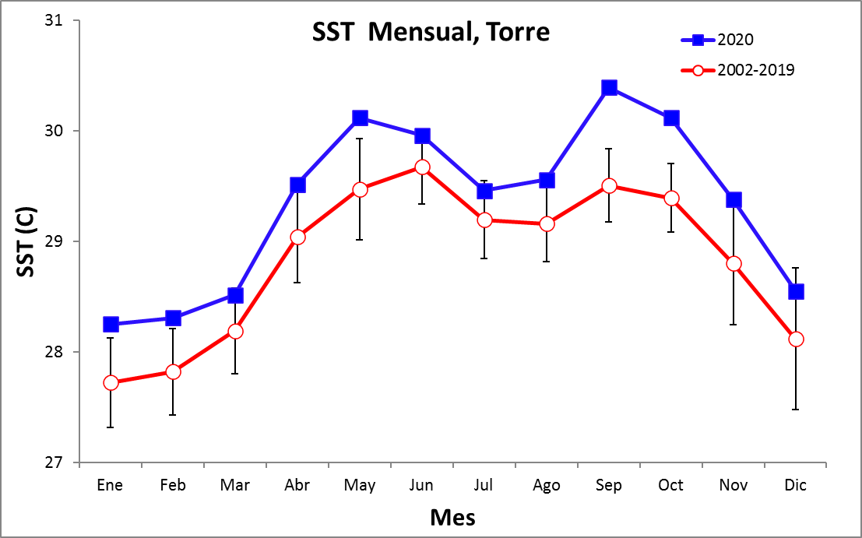

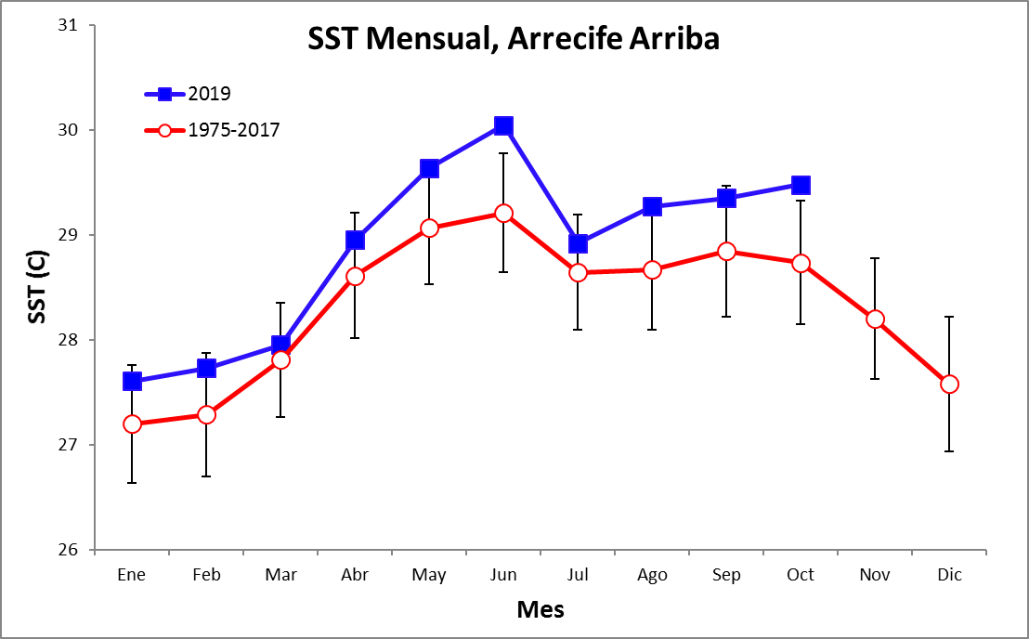

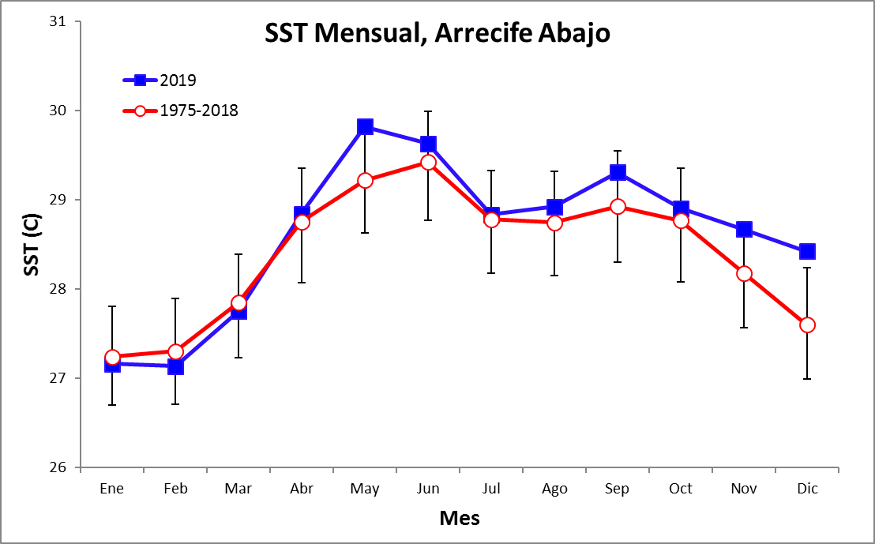

Series del Tiempo – Diario 2020

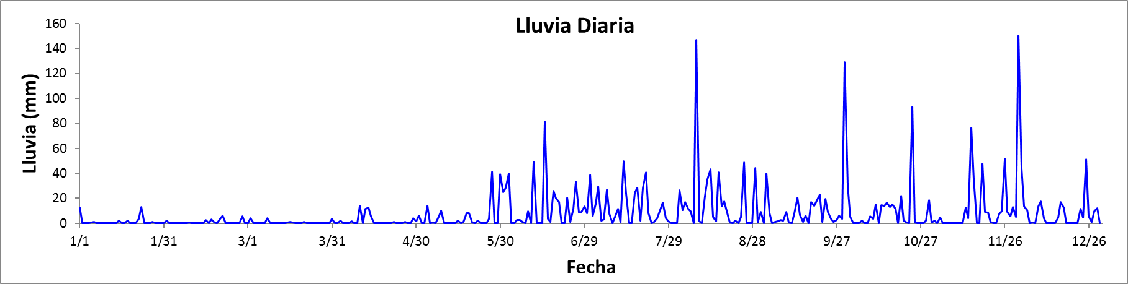

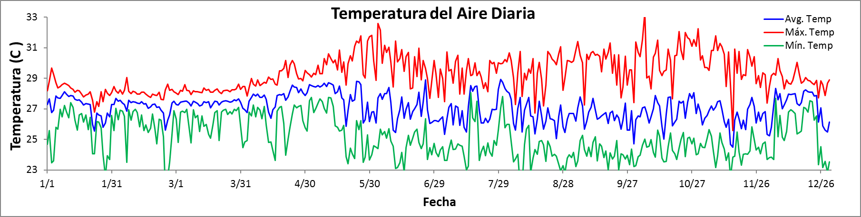

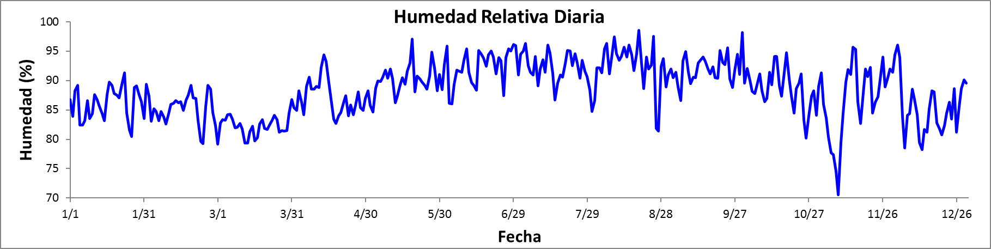

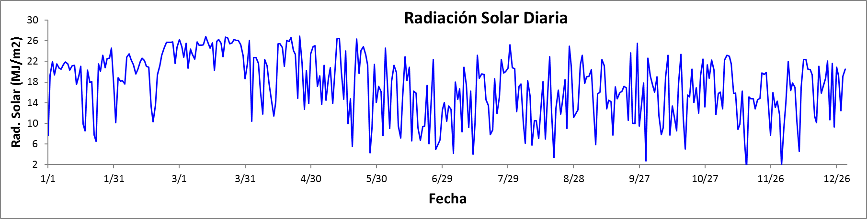

Series del Tiempo – Diario 2020

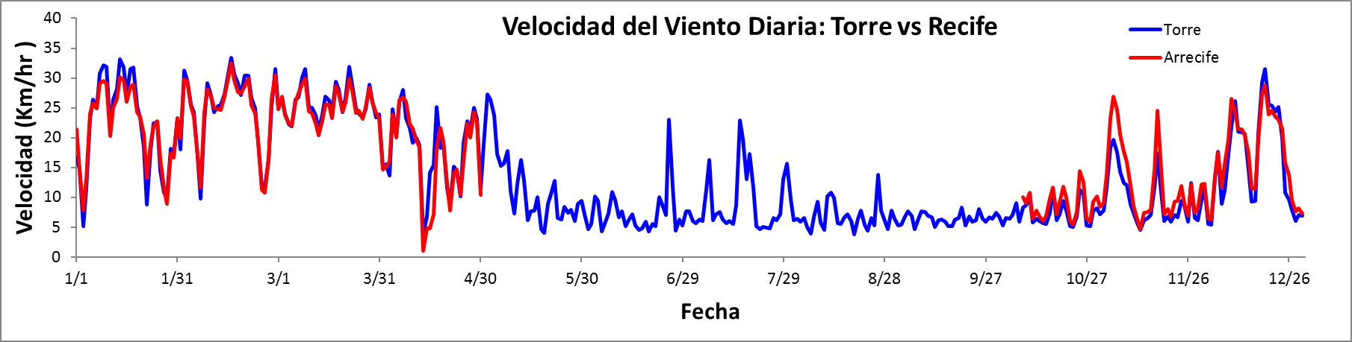

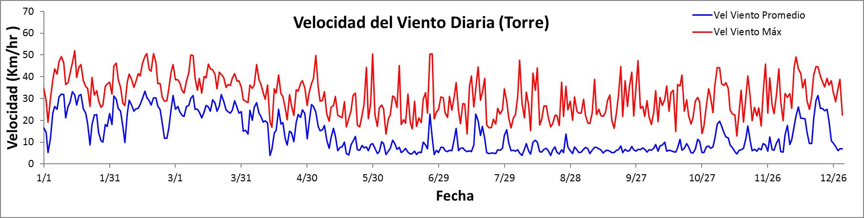

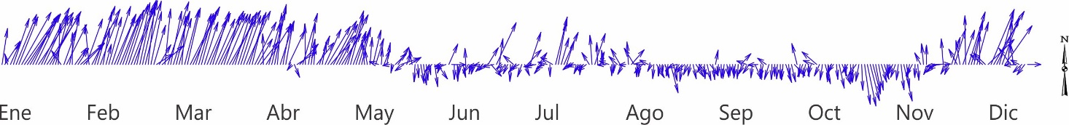

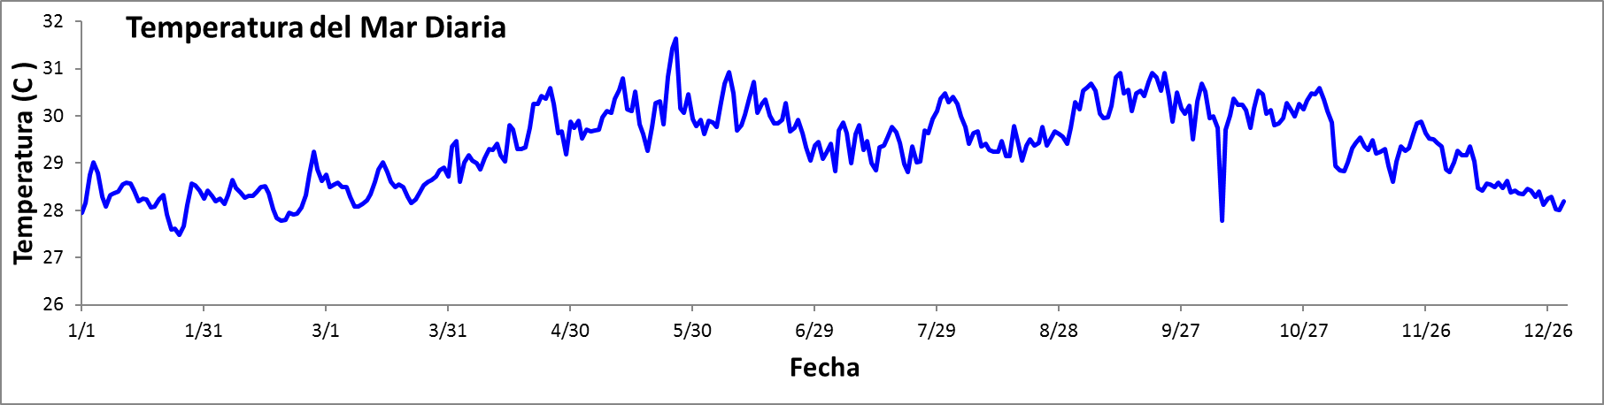

Series de Tiempo – Mensual

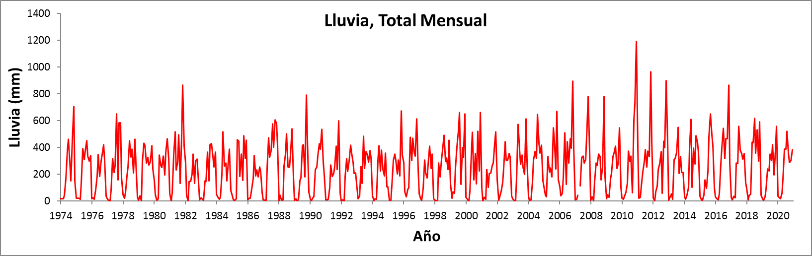

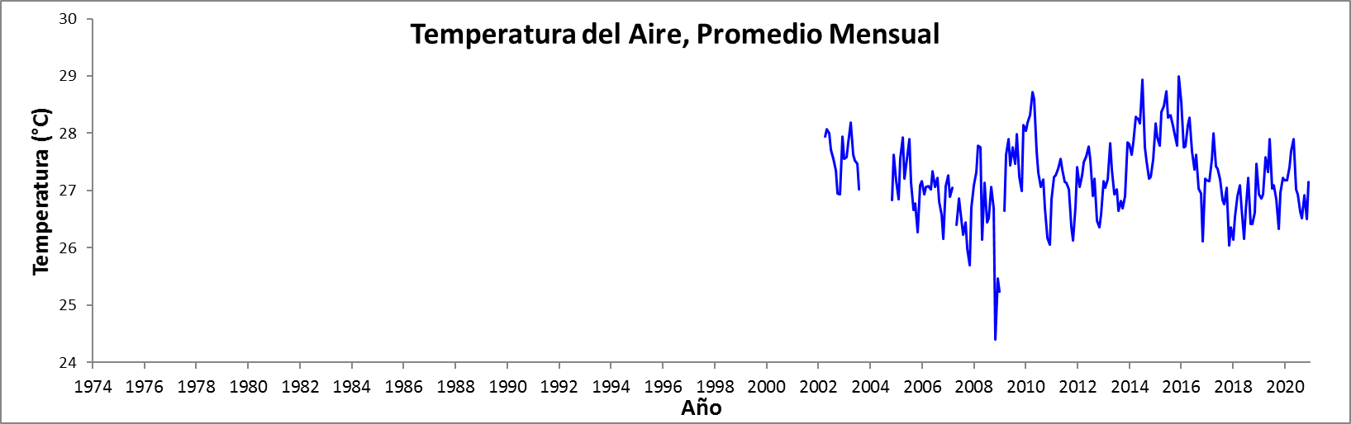

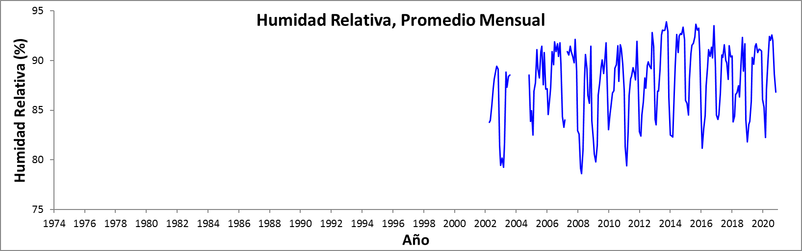

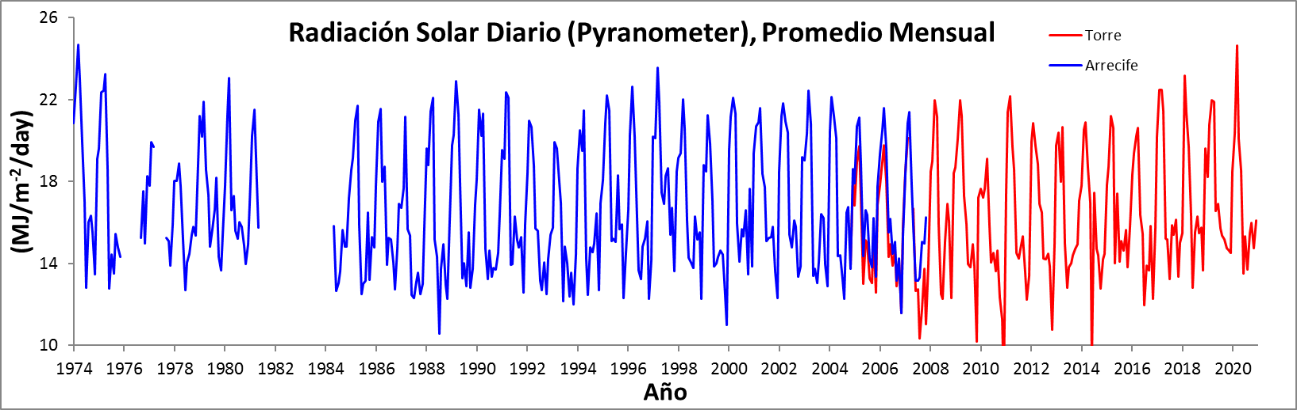
Series de Tiempo – Mensual

