2020 Meteorological Summary for
the Parque Natural Metropolitano
Canopy Crane

Prepared by: Steven Paton

Introduction

This is the 7th in a series of yearly reports summarising the data from the past year’s Smithsonian Tropical Research Institute’s Physical Monitoring Program on the Parque Natural Metropolitano (PNM) Canopy Access Crane. This report is not meant to be exhaustive in its coverage in that it summarizes only some of the most ‘important’ or interesting parameters available. Any comments on how future yearly summaries could be improved would be appreciated. Additional copies of this report and downloadable data from the PNM and other research locations, can be obtained from:
biogeodb.stri.si.edu/physical_monitoring/research/metpark

Setting
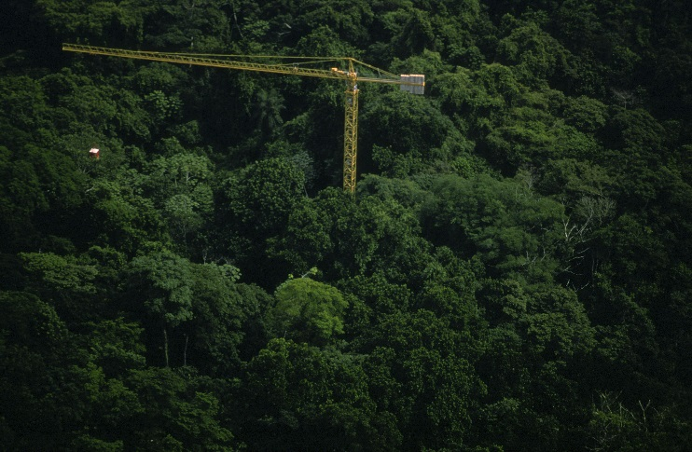
Established in 1992, the PNM canopy crane (8.994410°, -79.543000°) is located at the North Western edge of Panama City, at the eastern edge of the Parque Natural Metropolitano (Metropolitan Nature Park) and is surrounded by 80-year old, lowland semi-deciduous forest. The crane is 50 meters tall with a radius of 51 meters, and can reach approximately 80 species of trees and lianas.

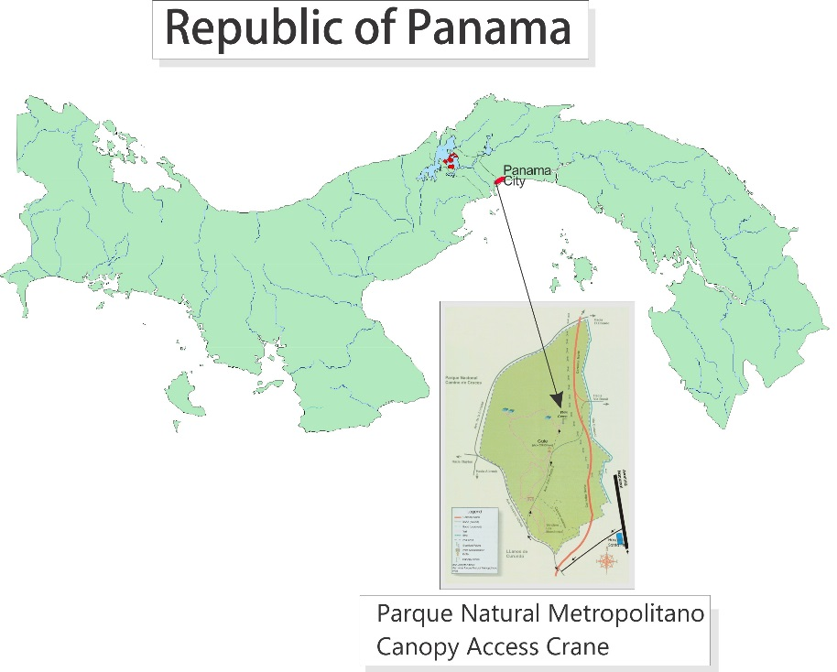
The station receives an average of 1851.4 mm of rain per year. The meteorological year is divided into two parts: a pronounced dry season (approximately from mid-December to the end of April), and a wet season (May to mid-December). On average, only 210mm of rain falls during the dry season. Relative humidity, soil moisture, air pressure, solar radiation, evapotranspiration, wind speed and direction all show marked wet/dry season differences. On the other hand, temperature varies relatively little throughout the year.

All data are collected using electronic sensors. Originally, all sensors were located at an instrument pack located approcimately 25m above the ground (see photo below).

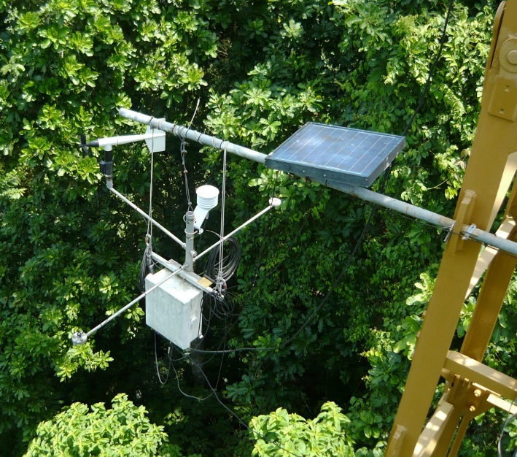

The Anemometer was eliminated in June 2008. The tipping bucket was moved to the top of the crane on March, 2009. In 2010, two pyranometer sensors were installed on the top of the crane to supplement the 25m measurements.

Data were originally collected hourly, but changed to every 15 minutes in June of 2005.

This report summarises the following data:

Relative humidity
Air temperature
Rainfall
Wind speed and direction
Solar radiation
The Autoridad del Canal de Panamá (ACP) (Panama Canal Authority in English) maintains two nearby stations: Albrook Airbase (FAA) and Balboa Heights (HTS) – located 2.8 and 3.1km SSW of the PNM crane, respectively. Both stations record precipitation, while the HTS station also records wind, air temperature, relative humidity and solar radiation. This report summarizes the data from these stations.
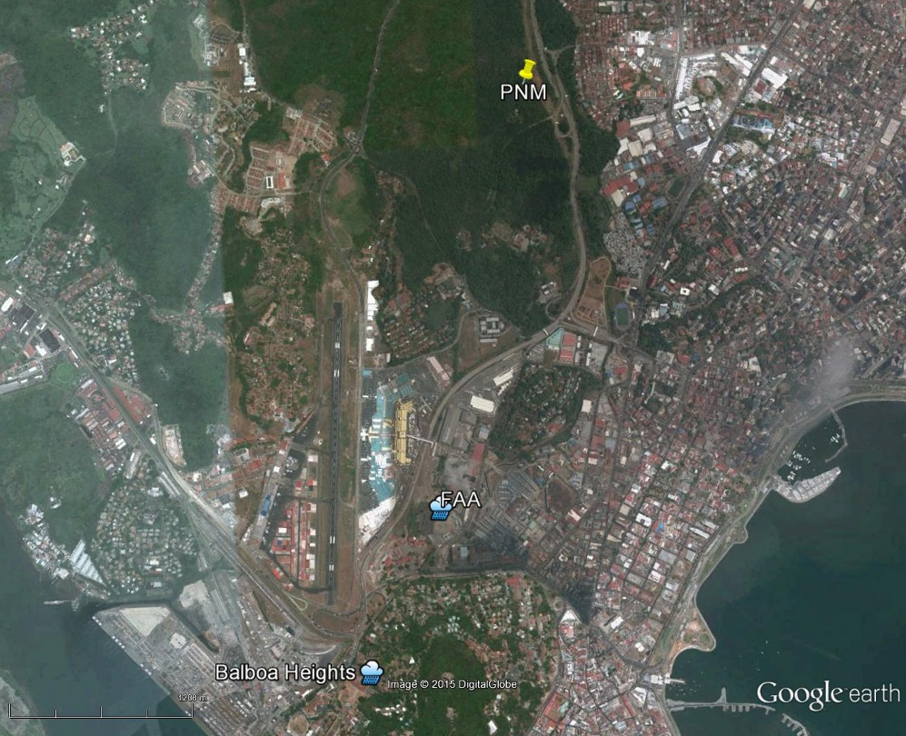
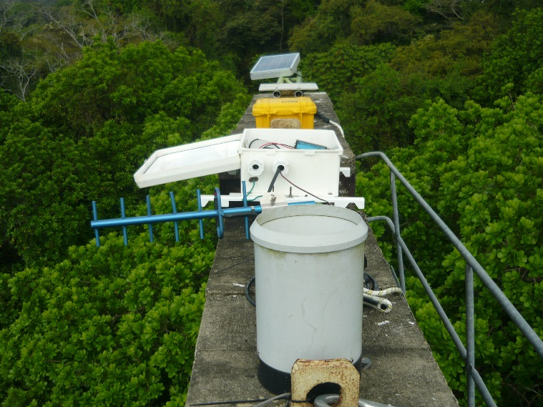
Rainfall
Rainfall was collected by a tipping bucket rain gauge originally located at the 25m station, and then moved to the top of the crane in 2009. Tipping buckets generate ‘events’ for every 0.254 mm of rainfall recorded. There are several large gaps in the data. Missing data have been estimated using an average of the data from the two ACP stations. The r² between the monthly PNM rainfall and an average of the two ACP station’s rainfall is 0.909.

The daily rainfall data for 2020 are shown on page 6.

Page 7 shows the monthly totals for 2020. The graph on the same page compares this year’s monthly totals with the average monthly totals (±SD) for the period 1995 to 2017.

Page 8 shows yearly rainfall totals for all year since 1995. Time series graph and frequency histograms are presented for these data.

Pages 9 and 10 show an analysis of rainfall ‘events’ (storms). For convenience, and again somewhat arbitrarily, I have defined a storm as any continuous period of rain separated by at least an hour from any other rainfall. The tables and graphs on this page compare the maximum storm size and the average storm size and duration per month for the period 1995 to 2017 and for the year 2020.

Relative Humidity

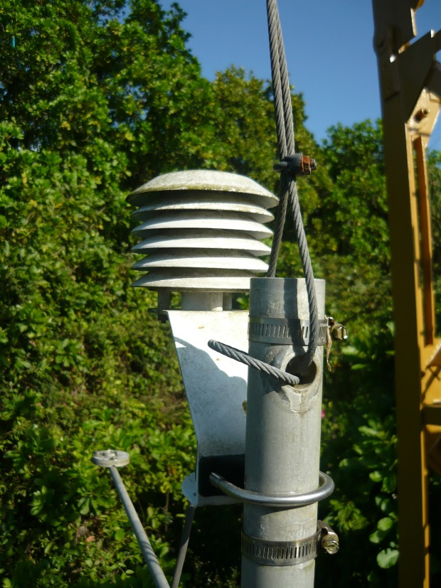
Data were originally collected hourly at the 25m station (later every 15-minutes) by dataloggers attached to Viasala HMP temperature/humidity sensors. Since 2010, Campbell Scientific CS215 temperature/humidity sensors have been used.

The average monthly relative humidity data are shown in tabular and graphical form on pages 11.

Air Temperature

Data were originally collected hourly at the 25m station (later every 15-minutes) by dataloggers attached to Viasala HMP temperature/humidity sensors. Since 2010, Campbell Scientific CS215 temperature/humidity sensors have been used. The monthly average, maximum and minimum temperatures are shown in tabular and graphical form on page 12 to 14, respectively.

Solar Radiation
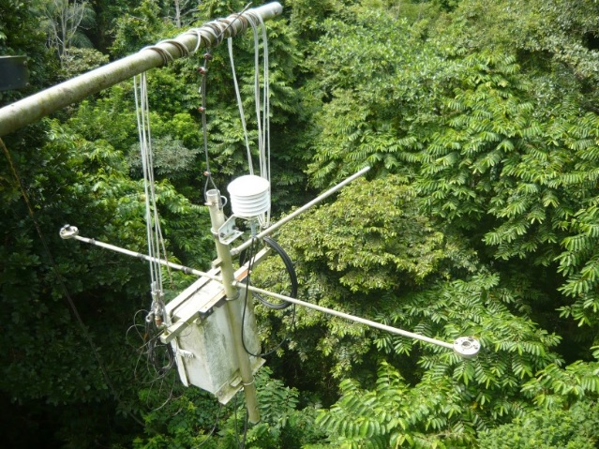
Global solar radiation has been measured at the 25m station (see photo at right) since Aug, 2007, and on the top of the crane boom (see photo at the top of the next page) since Mar. 2012 using two Li-Cor LI200SB pyranometers attached to dataloggers. 15-minute interval average intensity, maximum and minimum (W/m²) were collected. On Apr. 12, 2019 the 25m sensor was discontinued. On June 14, 2016 one of the top sensors was replaced with a Kipp&Zonen SPLite2 pyranometer.

Page 15 shows the daily Global Radiation values from the top of the crane. Graphs of these data, plus the data from the 25m station are shown on Page 16. Pages 17-8 show the monthly average daily Global Radiation for both the 25m and crane top sensors.

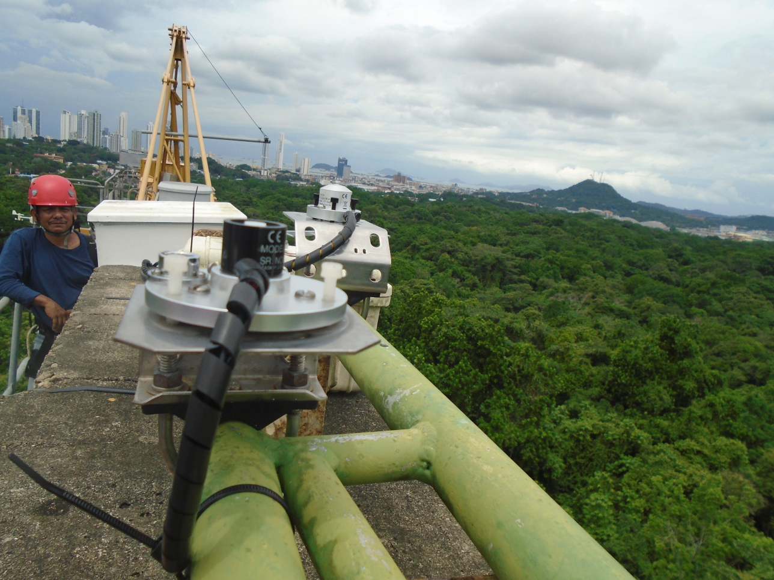

Wind Speed and Direction

Data were collected hourly at the 25m station (later every 15-minutes) using Model 05103 Young Anemometers. No data have been collected since June 2008. The data are available on the associated Excel spreadsheet.

Times Series
In this section, graphs show the 2020 daily averages (pages 19-20) and monthly averages for the entire period of record (pages 21-22) for Humidity, Air Temperature, Rainfall, Wind Speed and Solar Radiation.

Daily Patterns
Pages 23-4 show the daily patterns for Humidity, Air Temperature, Rainfall, Wind Speed and Solar Radiation.

ACP Stations
The Autoridad del Canal de Panamá (ACP) (Panama Canal Authority in English) maintains two nearby stations: Albrook Airbase (FAA) and Balboa Heights (HTS). The stations are located at Lat/Long 8.968889°, -79.549444° and 8.959444°, -79.554167° respectively. Data were collected hourly. No information is available regarding instrumentation. A summary rainfall, wind speed and direction and air temp for these stations is shown on pages 26-32. Relative humidity, air pressure and solar radiation data were also collected at the FAA station, but not reported here due to obvious problems with the data (the data are, however, available in the associated Excel spreadsheet).

2020 Daily Rainfall (mm)

 | Jan. | Feb. | Mar. | Apr. | May | June | July | Aug. | Sep. | Oct. | Nov. | Dec.
1 | 4.1 | 0.0 | 0.0 | 0.0 | 0.0 | 0.0 | 0.0 | 0.0 | 1.8 |  | 4.3 | 0.0
2 | 9.1 | 0.0 | 0.0 | 0.0 | 0.0 | 36.8 | 6.1 | 0.0 | 0.5 |  | 3.6 | 3.8
3 | 0.0 | 0.0 | 0.0 | 0.0 | 0.0 | 1.0 | 42.4 | 7.4 | 7.4 |  | 2.8 | 0.0
4 | 0.0 | 0.0 | 0.0 | 0.0 | 2.8 | 0.0 | 16.5 | 4.6 | 0.0 |  | 1.5 | 0.0
5 | 0.0 | 0.0 | 0.0 | 0.0 | 11.4 | 0.0 | 1.5 | 11.7 | 3.8 |  | 0.0 | 0.0
6 | 0.0 | 0.0 | 0.0 | 0.0 | 0.0 | 0.0 | 0.0 | 0.0 | 29.5 |  | 0.0 | 61.5
7 | 0.0 | 0.0 | 0.0 | 0.0 | 5.3 | 1.0 | 7.9 | 0.0 | 1.3 |  | 0.0 | 0.0
8 | 0.0 | 0.0 | 0.0 | 0.0 | 0.3 | 0.3 | 1.5 | 3.6 | 0.0 |  | 0.0 | 1.5
9 | 0.0 | 0.0 | 0.0 | 0.0 | 0.0 | 0.8 | 0.3 | 2.8 | 23.4 |  | 0.0 | 3.6
10 | 0.0 | 0.0 | 0.0 | 0.0 | 0.0 | 20.3 | 13.2 | 10.7 | 0.3 |  | 0.0 | 0.3
11 | 0.0 | 0.0 | 0.0 | 0.0 | 10.9 | 18.0 | 4.1 | 5.3 | 0.0 |  | 0.0 | 0.0
12 | 0.0 | 0.0 | 0.0 | 17.8 | 0.0 | 0.0 | 6.6 | 7.1 | 9.1 |  | 21.8 | 0.0
13 | 0.0 | 0.0 | 0.0 | 55.4 | 15.5 | 0.3 | 5.1 | 9.7 | 1.0 |  | 12.4 | 0.0
14 | 0.0 | 0.0 | 0.0 | 30.5 | 33.5 | 0.0 | 0.3 | 14.0 | 3.0 |  | 8.1 | 0.0
15 | 0.0 | 0.0 | 0.0 | 0.3 | 0.0 | 8.1 | 0.0 | 29.0 | 11.7 |  | 1.3 | 27.4
16 | 0.0 | 0.0 | 0.0 | 9.9 | 0.0 | 0.0 | 18.0 | 0.0 | 0.8 | 2.3 | 8.9 | 6.6
17 | 0.0 | 0.0 | 0.0 | 0.0 | 14.7 | 0.0 | 1.5 | 15.2 | 7.6 | 9.4 | 20.8 | 14.0
18 | 0.0 | 0.0 | 0.0 | 0.0 | 5.6 | 0.5 | 0.0 | 0.8 | 16.0 | 1.0 | 3.6 | 0.0
19 | 0.0 | 0.0 | 0.0 | 17.5 | 0.5 | 0.0 | 16.5 | 0.0 | 2.3 | 4.6 | 2.0 | 0.0
20 | 0.0 | 0.0 | 0.0 | 0.0 | 3.0 | 1.0 | 1.3 | 14.5 | 10.7 | 25.7 | 82.6 | 0.0
21 | 0.0 | 0.0 | 3.3 | 0.0 | 0.0 | 0.0 | 0.8 | 0.0 | 56.9 | 1.3 | 0.0 | 0.0
22 | 0.0 | 0.0 | 0.0 | 61.5 | 56.4 | 0.5 | 0.3 | 56.9 | 33.9 | 1.0 | 0.0 | 5.1
23 | 0.3 | 0.0 | 0.0 | 8.4 | 0.3 | 16.0 | 48.3 | 0.0 | 0.0 | 11.9 | 32.0 | 19.8
24 | 0.0 | 0.0 | 0.0 | 54.6 | 12.7 | 0.5 | 9.9 | 0.0 | 7.6 | 4.3 | 21.6 | 0.0
25 | 0.0 | 0.0 | 0.0 | 0.0 | 15.7 | 0.0 | 61.2 | 2.0 |  | 0.3 | 19.6 | 1.5
26 | 0.0 | 5.1 | 0.0 | 25.4 | 1.0 | 24.6 | 34.3 | 0.0 |  | 0.0 | 12.7 | 2.5
27 | 0.0 | 0.0 | 0.0 | 0.0 | 25.1 | 2.5 | 8.9 | 0.0 |  | 0.0 | 6.9 | 42.4
28 | 0.0 | 0.0 | 0.0 | 0.0 | 1.3 | 0.0 | 2.5 | 0.3 |  | 0.0 | 2.8 | 21.6
29 | 0.0 | 0.0 | 0.0 | 11.4 | 4.6 | 2.3 | 2.3 | 6.4 |  | 3.0 | 23.1 | 15.0
30 | 0.0 |  | 0.0 | 0.0 | 74.4 | 17.5 | 0.0 | 0.0 |  | 0.0 | 37.8 | 11.9
31 | 0.0 |  | 0.0 |  | 0.3 |  | 0.3 | 0.0 |  | 3.3 |  | 6.6
 | 13.5 | 5.1 | 3.3 | 292.6 | 295.4 | 152.1 | 311.4 | 201.7 |  |  | 330.2 | 245.1

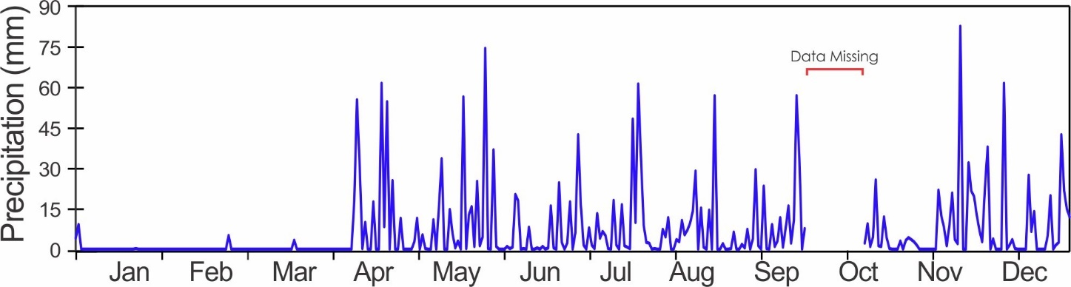
Monthly Rainfall (mm)
Year | Jan | Feb | Mar | Apr | May | June | July | Aug | Sep | Oct | Nov | Dec | Total
1995 | 0.0 | 2.5 | 61.7 | 73.0 | 319.1 | 377.5 | 237.8 | 175.7 | 490.2 | 266.2 | 179.6 | 141.5 | 2324.8
1996 | 155.2 | 51.2 | 64.1 | 123.3 | 384.4 | 178.5 | 133.2 | 188.3 | 99.5 | 218.3 | 335.8 | 101.2 | 2033.0
1997 | 129.0 | 17.1 | 2.4 | 7.3 | 102.0 | 189.5 | 135.0 | 140.9 | 344.5 | 230.8 | 272.3 | 0.0 | 1570.8
1998 | 0.5 | 3.8 | 0.0 | 73.7 | 373.4 | 279.4 | 198.1 | 172.7 | 230.8 | 158.4 | 211.1 | 222.9 | 1924.8
1999 | 57.6 | 33.7 | 87.2 | 69.8 | 187.3 | 189.3 | 115.4 | 0.0 | 182.3 | 258.6 | 297.7 | 222.9 | 1701.8
2000 | 19.5 | 44.0 | 7.5 | 90.6 | 122.3 | 251.2 | 231.3 | 118.2 | 214.7 | 276.9 | 191.3 | 146.3 | 1713.8
2001 | 23.5 | 0.4 | 1.1 | 50.8 | 233.5 | 254.0 | 149.9 | 88.9 | 236.2 | 264.2 | 236.2 | 218.4 | 1757.1
2002 | 100.9 | 0.6 | 22.8 | 117.4 | 96.2 | 136.6 | 197.6 | 197.4 | 137.7 | 281.3 | 210.7 | 34.8 | 1534.0
2003 | 0.0 | 21.7 | 8.9 | 186.0 | 223.6 | 147.2 | 135.9 | 125.3 | 103.6 | 219.6 | 222.9 | 152.0 | 1546.8
2004 | 4.4 | 0.0 | 11.6 | 79.9 | 177.0 | 140.7 | 221.0 | 170.2 | 355.6 | 408.9 | 221.0 | 52.8 | 1843.1
2005 | 35.5 | 0.0 | 11.0 | 68.7 | 225.5 | 172.1 | 202.7 | 192.3 | 403.2 | 66.0 | 76.2 | 61.0 | 1514.1
2006 | 17.8 | 2.5 | 67.2 | 81.5 | 133.2 | 137.2 | 294.6 | 266.7 | 106.7 | 223.5 | 241.3 | 233.7 | 1805.9
2007 | 20.8 | 0.0 | 7.6 | 143.8 | 264.4 | 148.7 | 112.9 | 208.5 | 144.0 | 259.0 | 223.0 | 196.0 | 1728.7
2008 | 35.0 | 44.0 | 8.0 | 8.1 | 76.1 | 237.9 | 240.8 | 365.0 | 141.0 | 291.9 | 534.3 | 43.1 | 2025.1
2009 | 7.6 | 10.7 | 36.8 | 41.9 | 193.1 | 222.4 | 323.2 | 204.6 | 220.8 | 326.0 | 251.4 | 57.6 | 1895.9
2010 | 25.7 | 6.8 | 67.6 | 67.8 | 220.1 | 389.2 | 324.6 | 275.9 | 185.2 | 303.1 | 209.5 | 312.1 | 2387.4
2011 | 101.5 | 102.1 | 53.8 | 177.2 | 300.3 | 117.9 | 375.2 | 272.2 | 171.0 | 433.3 | 377.8 | 184.1 | 2666.3
2012 | 0.3 | 2.5 | 17.3 | 54.2 | 222.6 | 172.7 | 110.2 | 111.4 | 258.6 | 323.8 | 376.5 | 285.0 | 1935.0
2013 | 0.0 | 0.8 | 1.0 | 12.7 | 252.0 | 171.2 | 133.7 | 358.4 | 273.3 | 268.5 | 170.8 | 158.4 | 1800.7
2014 | 63.5 | 6.1 | 7.6 | 19.5 | 402.0 | 143.8 | 179.2 | 164.2 | 203.8 | 213.4 | 230.2 | 189.3 | 1822.4
2015 | 20.0 | 0.0 | 0.0 | 44.2 | 164.7 | 141.4 | 193.1 | 277.5 | 208.9 | 242.4 | 226.2 | 62.7 | 1581.0
2016 | 18.0 | 0.5 | 0.0 | 143.7 | 350.5 | 208.7 | 161.1 | 163.6 | 134.1 | 263.9 | 408.0 | 131.7 | 1983.8
2017 | 1.3 | 0.0 | 9.4 | 52.0 | 201.5 | 160.8 | 130.5 | 291.6 | 253.5 | 172.2 | 306.8 | 203.7 | 1783.3
2018 | 107.7 | 1.3 | 0.5 | 235.2 | 249.9 | 562.1 | 295.7 | 182.6 | 214.6 | 208.0 | 404.1 | 96.5 | 2558.3
2019 | 0.25 | 0.0 | 0.25 | 153.2 | 171.2 | 205.0 | 262.9 | 242.3 | 208.8 | 206.7 | 370.8 | 173.5 | 1994.9
2020 | 13.5 | 5.1 | 3.3 | 292.6 | 295.4 | 152.2 | 311.4 | 201.7 |  |  | 330.2 | 245.1
ean | 37.8 | 14.1 | 22.2 | 87.0 | 225.8 | 213.4 | 203.8 | 198.2 | 220.9 | 255.4 | 271.4 | 147.2 | 1897.3
sd | 45.7 | 24.2 | 27.4 | 59.4 | 90.5 | 100.5 | 75.5 | 83.0 | 95.5 | 74.5 | 98.2 | 82.0 | 307.7
min | 0.0 | 0.0 | 0.0 | 7.3 | 76.1 | 117.9 | 110.2 | 0.0 | 99.5 | 66.0 | 76.2 | 0.0 | 1514.1
max | 155.2 | 102.1 | 87.2 | 235.2 | 402.0 | 562.1 | 375.2 | 365.0 | 490.2 | 433.3 | 534.3 | 312.1 | 2666.3
Rank* | 17 | 11 | 18 | 1 | 7 | 18 | 4 | 11 |  |  | 8 | 3
*Rank of current year. 1 = wettest year
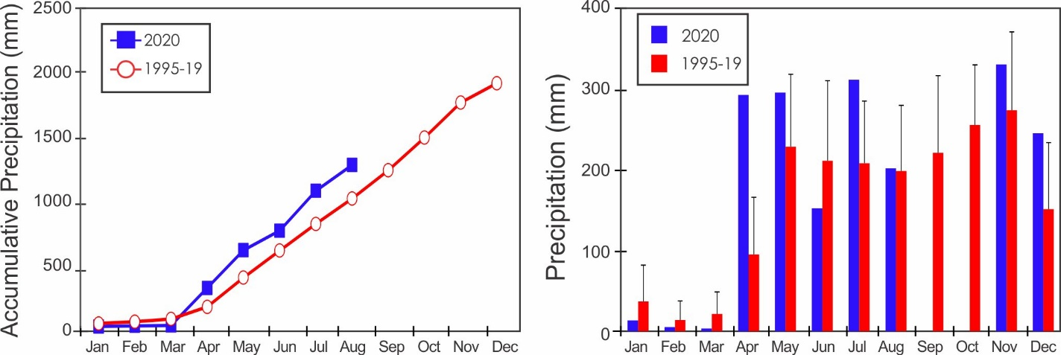
Yearly Rainfall (mm)

Year | Rain | Year | Rain | Year | Rain
1995 | 2324.8 | 2006 | 1805.9 | 2017 | 1783.3
1996 | 2033.0 | 2007 | 1728.7 | 2018 | 2558.3
1997 | 1570.8 | 2008 | 2025.1 | 2019 | 1954.9
1998 | 1924.8 | 2009 | 1895.9 | 2020 | n/a
1999 | 1701.8 | 2010 | 2387.4
2000 | 1713.8 | 2011 | 2666.3
2001 | 1757.1 | 2012 | 1935.0
2002 | 1534.0 | 2013 | 1800.7
2003 | 1546.8 | 2014 | 1822.4
2004 | 1843.1 | 2015 | 1581.0
2005 | 1514.1 | 2016 | 1983.8

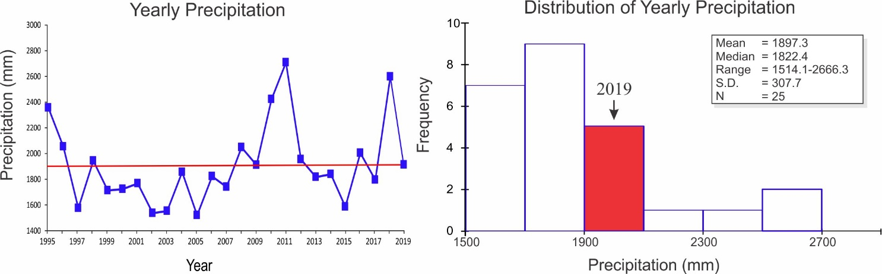

Storm Analysis

 |  | Max. Rainfall per Storm (mm) |  |  |  | Storm Duration (min.)
 | 1995-2019 |  |  | 2020 |  | 1995-2019 |  | 2020
 | Mean |  | S.D. |  |  | Mean | S.D.
January | 12.3 |  | 10.9 | 9.1 |  | 25.1 | 26.0 | 31.0
February | 6.7 |  | 9.4 | 5.1 |  | 21.8 | 26.6 | 95.0
March | 10.8 |  | 12.0 | 3.3 |  | 29.8 | 20.5 | 109.0
April | 36.7 |  | 25.1 | 61.5 |  | 37.2 | 14.9 | 62.3
May | 48.2 |  | 22.0 | 65.5 |  | 52.6 | 18.4 | 63.1
June | 49.0 |  | 25.0 | 30.0 |  | 54.1 | 27.4 | 75.9
July | 48.1 |  | 23.9 | 61.2 |  | 50.3 | 38.7 | 58.2
August | 40.8 |  | 21.4 | 56.7 |  | 41.6 | 19.5 | 64.6
September | 47.3 |  | 23.0 | 55.9 |  | 48.5 | 17.9 | 46.6
October | 47.3 |  | 16.4 | 18.8 |  | 47.6 | 18.3 | 46.7
November | 46.7 |  | 17.6 | 81.8 |  | 47.9 | 23.7 | 59.1
December | 35.7 |  | 24.5 | 61.5 |  | 39.9 | 22.7 | 50.9

 | Av. Rainfall per Storm (mm)
 | 1995-2019 |  | 2020
 | Mean | S.D.
January | 3.8 | 4.1 | 3.4
February | 2.6 | 4.6 | 5.1
March | 3.7 | 3.4 | 3.3
April | 6.8 | 6.6 | 16.3
May | 6.5 | 2.7 | 10.2
June | 6.1 | 3.3 | 5.6
July | 6.2 | 2.7 | 6.8
August | 5.8 | 2.7 | 6.3
September | 6.3 | 2.7 | 6.8
October | 6.4 | 2.8 | 3.7
November | 6.4 | 2.4 | 6.9
December | 5.3 | 2.9 | 10.0

Values for 2020 may be skewed slightly due to data missing between Sept 25 and Oct. 15.

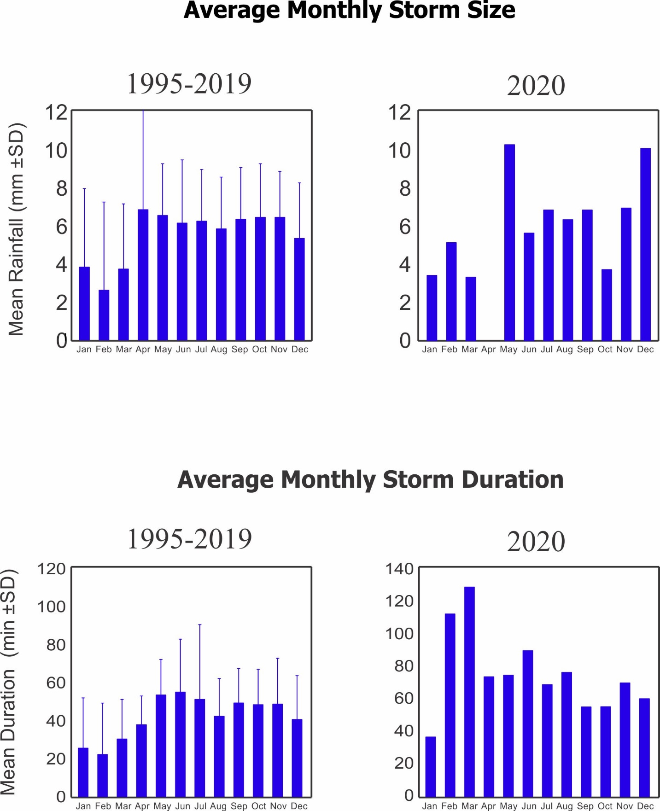
Relative Humidity (%)
Year | Jan | Feb | Mar | Apr | May | June | July | Aug | Sep | Oct | Nov | Dec
1995 | 91.0 | 90.0 |  |  | 91.3 | 91.3 | 92.2 | 90.8 |  | 92.6 | 92.8 | 89.7
1996 | 85.9 | 81.5 | 79.6 | 81.6 | 90.4 | 93.1 | 92.0 | 92.0 | 92.4 | 91.5 | 91.6 | 91.6
1997 | 83.4 | 81.0 | 75.7 | 78.9 | 85.2 | 90.4 | 89.9 | 90.4 | 93.1 | 92.1 | 91.8 | 80.6
1998 | 78.8 | 77.9 | 73.6 |  |  |  |  |  | 88.1 | 89.1 | 91.0 | 91.3
1999 | 81.5 | 78.5 | 77.3 | 82.8 | 91.9
2000 |  |  |  |  |  |  | 92.3 | 91.4 | 91.1 | 92.5 | 89.9 | 88.1
2001 | 80.0 | 75.9 | 76.8 |  | 88.2 | 89.6 | 91.3 | 91.3 | 91.5 | 92.1 | 92.3 | 91.8
2002 | 84.3 | 77.7 | 77.5 | 80.4 | 84.9 | 90.1 | 91.4 | 92.1 | 91.6 | 92.6 | 91.8 | 84.0
2003 | 77.9 | 75.4 | 77.4 | 73.6 | 90.5 | 92.3 | 92.4 | 92.2 | 90.8 | 92.5 | 94.2 | 90.0
2004 | 80.5 | 76.9 | 75.3 | 81.2 | 90.4 | 91.4 |  |  |  |  |  | 82.1
2005 | 81.2 | 74.9 | 80.0 | 81.9 | 89.4 | 90.8 | 90.6 | 91.8 | 91.9 |  |  | 79.2
2006 |  | 75.5 | 77.0 | 83.4 | 89.5 | 90.0 | 88.7 | 90.8 | 91.1 | 89.0 | 92.0 | 88.7
2007 |  |  |  | 84.9 | 91.6 | 91.1 | 91.5 | 91.7 | 90.6 | 90.6 | 92.7 | 89.7
2008 | 79.5 | 80.4 | 76.7 | 78.0 | 87.3 | 92.6 | 93.1 | 91.7 | 89.0 | 90.3 | 94.1 | 83.9
2009 | 81.5 | 78.2 | 75.2 | 76.1 | 88.7 | 89.4 | 91.5 | 92.1 | 90.7 | 90.3 | 93.1 | 85.9
2010 | 80.7 | 81.6 | 81.7 | 85.4 | 87.9 | 92.7 | 93.8 | 91.3 | 90.5 | 93.1 | 92.7 | 91.2
2011 | 86.2 | 80.6 | 79.3 | 84.0 | 87.5 | 91.3 | 92.2 | 91.4 | 91.7 | 91.3 | 94.6 | 90.4
2012 | 79.6 | 77.4 | 75.8 | 84.0 | 90.3 | 90.8 | 93.3 | 92.4 | 93.8 | 93.2 | 95.0 | 92.4
2013 | 80.8 | 79.6 | 80.5 | 82.3 | 88.9 | 93.2 | 93.9 | 94.0 | 94.1 | 95.1 | 93.6 | 90.5
2014 | 84.9 | 80.6 | 79.2 | 82.3 | 90.0 | 93.0 | 90.7 | 92.0 | 92.5 | 92.2 | 92.2 | 90.5
2015 | 80.3 | 79.3 | 76.2 | 80.7 | 87.0 | 88.1 | 90.1 | 91.7 | 93.2 | 92.8 | 92.9 | 88.3
2016 | 80.5 | 76.5 | 76.3 | 80.0 | 91.1 | 90.3 | 90.9 | 89.5 | 89.9 | 90.1 | 91.9 | 86.9
2017 | 75.7 | 73.2 | 71.3 | 77.6 | 86.7 | 88.5 | 91.8 | 92.1 | 92.3 | 92.6 | 94.5 | 88.8
2018 | 88.0 | 74.8 | 73.5 | 82.5 | 92.3 | 95.7 | 88.2 | 88.2 | 88.5 | 85.6 | 88.2 | 79.3
2019 | 74.8 | 72.5 | 70.0 | 75.258 | 83.8 | 87.6 | 88.0 | 88.3 | 88.5 | 87.4 | 88.7 | 86.6
2020 | 78.3 |  |  |  | 86.8 | 88.7 | 89.6 | 88.7
mean | 81.7 | 78.3 | 76.6 | 80.8 | 88.9 | 91.1 | 91.3 | 91.3 | 91.2 | 91.3 | 92.3 | 87.6
sd | 3.8 | 3.7 | 2.9 | 3.2 | 2.3 | 1.9 | 1.6 | 1.3 | 1.7 | 2.1 | 1.8 | 4.0
min | 74.8 | 72.5 | 70.0 | 73.6 | 83.8 | 87.6 | 88.0 | 88.2 | 88.1 | 85.6 | 88.2 | 79.2
max | 91.0 | 90.0 | 81.7 | 85.4 | 92.3 | 95.7 | 93.9 | 94.0 | 94.1 | 95.1 | 95.0 | 92.4
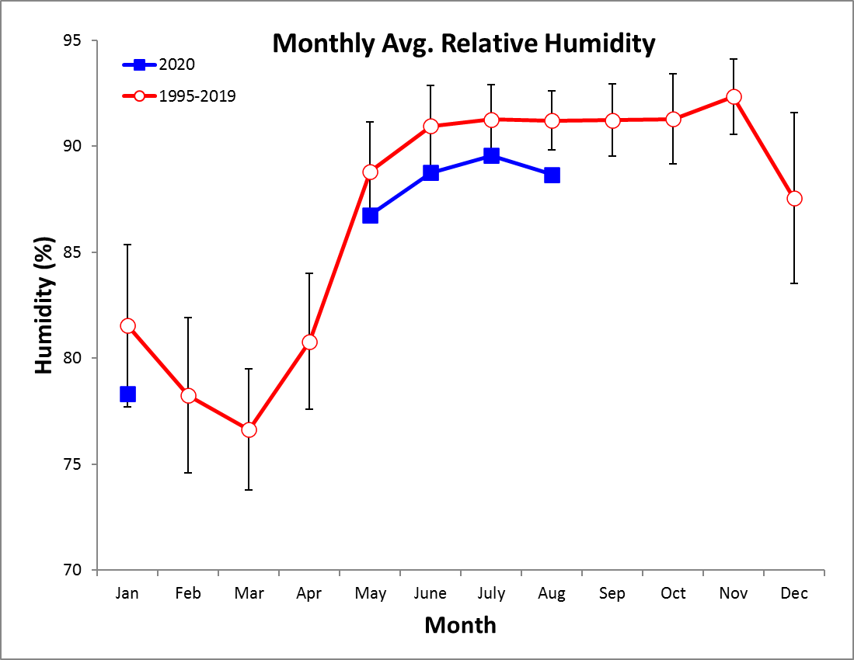
Avg. Monthly Temperatures (°C)
Monthly Average Temperature
Year | Jan | Feb | Mar | Apr | May | June | July | Aug | Sep | Oct | Nov | Dec
1995 | 27.2 | 27.2 |  |  | 27.0 | 27.2 | 26.7 | 27.0 |  | 26.4 | 26.6 | 26.6
1996 | 26.6 | 26.8 | 27.0 | 27.5 | 27.1 | 27.0 | 26.8 | 26.7 | 26.8 | 26.6 | 26.3 | 26.3
1997 | 26.4 | 27.2 | 26.9 | 27.5 | 27.9 | 27.4 | 28.0 | 28.0 | 27.2 | 27.3 | 25.9 | 26.9
1998 | 27.1 | 27.2 | 27.8 |  |  |  |  |  | 26.2 | 26.1 | 25.6 | 25.4
1999 | 26.0 | 25.7 | 26.2 | 26.5 | 26.0 | 25.6 | 25.6 |  | 25.4 | 25.3 | 25.3 | 25.4
2000 | 25.2 | 25.6 | 25.9 | 26.3 | 25.9 | 25.8 | 25.6 | 25.6 | 25.2 | 25.2 | 25.4 | 25.2
2001 | 25.5 | 25.8 | 26.0 |  | 26.0 | 26.1 | 25.5 | 26.3 | 25.3 | 25.5 | 24.4 | 24.8
2002 | 25.8 | 26.1 | 26.4 | 26.0 | 26.1 | 25.4 | 25.3 | 25.3 | 25.4 | 25.0 | 25.2 | 26.2
2003 | 26.4 | 27.0 | 26.7 | 27.9 |  |  |  |  |  | 25.2 | 25.2 | 25.6
2004 | 25.9 | 26.5 | 27.1 |  |  |  |  |  |  |  |  | 25.6
2005 | 25.7 | 26.2 | 26.5 | 26.7 | 25.1 | 24.7 | 24.7 | 24.0 |  |  |  | 25.6
2006 |  | 26.3 | 26.1 | 25.3 | 23.9 | 24.4 | 24.6 | 24.4 | 24.2 | 24.3 | 23.6 | 24.8
2007 |  |  |  | 26.0 | 24.6 | 25.2 | 24.9 | 24.6 | 25.0 | 24.8 | 23.9 | 24.6
2008 | 26.0 | 26.0 | 26.5 | 27.1 | 26.0 | 24.5 | 23.8 | 24.2 | 25.9 | 25.3 | 23.8 | 25.8
2009 | 26.1 | 26.4 | 26.7 | 27.3 | 26.2 | 25.9 | 25.7 | 25.3 | 26.0 | 25.6 | 25.0 | 26.6
2010 | 26.4 | 26.7 | 27.0 | 27.0 | 27.1 | 25.8 | 25.5 | 25.6 | 25.4 | 24.9 | 24.4 | 23.9
2011 | 25.2 | 25.8 | 25.6 | 25.7 | 26.1 | 25.7 | 25.3 | 25.6 | 25.3 | 24.7 | 24.4 | 24.8
2012 | 25.7 | 25.7 | 27.0 | 26.6 | 26.5 | 26.5 | 26.1 | 26.0 | 25.9 | 25.6 | 25.3 | 25.9
2013 | 26.8 | 26.7 | 27.2 | 27.6 | 26.7 | 26.4 | 26.2 | 26.0 | 26.1 | 25.8 | 25.9 | 26.3
2014 | 26.5 | 26.8 | 27.1 | 27.7 | 26.8 | 27.1 | 27.6 | 26.8 | 26.6 | 26.7 | 26.4 | 26.6
2015 | 27.3 | 27.3 | 27.5 | 28.1 | 27.6 | 27.8 | 27.2 | 27.0 | 27.0 | 26.9 | 26.6 | 27.9
2016 | 27.6 | 27.8 | 28.2 | 28.4 | 27.6 | 26.6 | 25.8 | 26.3 | 25.7 | 25.6 | 24.9 | 25.7
2017 | 25.9 | 26.2 | 26.8 | 26.9 | 26.3 | 26.0 | 25.8 | 25.7 | 25.9 | 25.8 | 25.0 | 25.4
2018 | 25.2 | 25.8 | 26.3 | 26.1 | 25.8 | 25.3 | 26.0 | 25.9 | 25.6 | 25.8 | 25.8 | 26.4
2019 | 26.3 | 26.6 | 27.0 | 27.4 | 26.9 | 26.6 | 26.1 | 26.1 | 26.1 | 25.7 | 25.9 | 26.3
2020
mean | 26.2 | 26.5 | 26.9 | 27.1 | 26.7 | 26.3 | 26.1 | 26.0 | 26.0 | 25.7 | 25.4 | 25.9
sd | 0.7 | 0.6 | 0.6 | 0.8 | 1.0 | 1.0 | 1.0 | 1.0 | 0.7 | 0.8 | 0.9 | 0.9
min | 25.2 | 25.6 | 25.6 | 25.3 | 23.9 | 24.4 | 23.8 | 24.0 | 24.2 | 24.3 | 23.6 | 23.9
max | 27.6 | 27.8 | 28.2 | 28.4 | 27.9 | 27.8 | 28.0 | 28.0 | 27.2 | 27.3 | 26.6 | 27.9
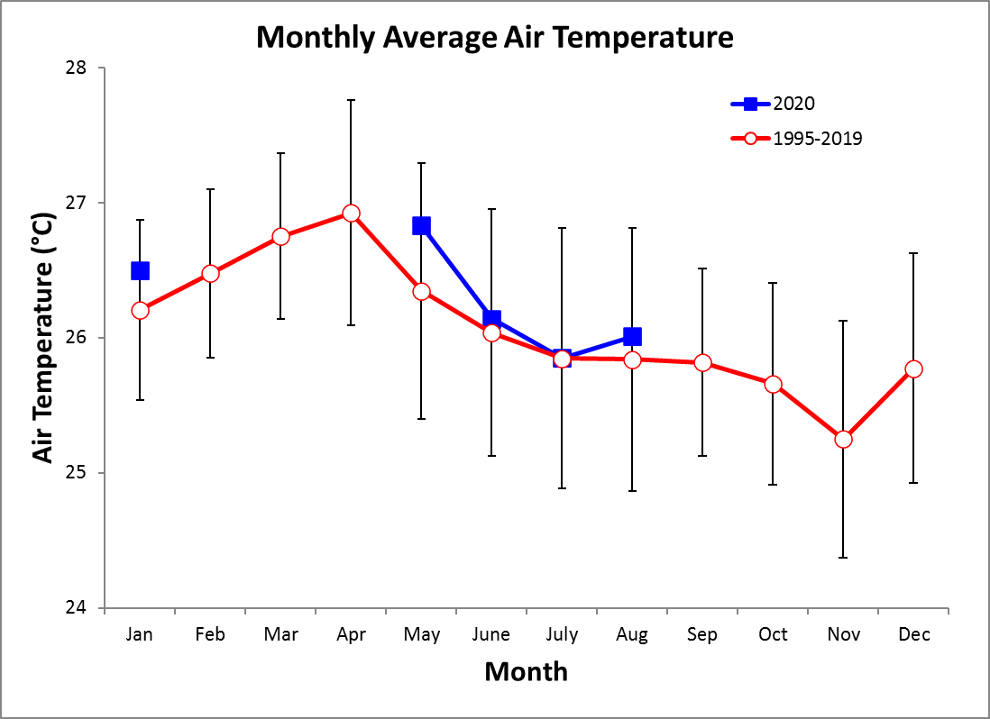
Monthly Average of Daily Maximum Temperature
Year | Jan | Feb | Mar | Apr | May | June | July | Aug | Sep | Oct | Nov | Dec
1995 | 31.2 | 30.2 |  |  | 31.6 | 30.7 | 30.9 | 30.9 |  | 31.1 | 31.2 | 31.8
1996 | 31.6 | 32.2 | 32.7 | 33.0 | 31.4 | 31.1 | 30.9 | 31.0 | 31.1 | 30.7 | 30.1 | 30.5
1997 | 32.3 | 32.5 | 32.5 | 32.7 | 33.0 | 31.7 | 32.9 | 33.2 | 31.9 | 32.0 | 30.1 | 32.1
1998 | 32.7 | 32.6 | 33.4 |  |  |  |  |  | 30.4 | 29.5 | 30.2 | 29.8
1999 | 31.1 | 30.6 | 31.5 | 31.2 | 29.9 | 29.6 | 30.1 |  | 28.9 | 28.7 | 29.8 | 29.8
2000 | 30.2 | 30.9 | 31.3 | 31.3 | 30.1 | 29.9 | 29.7 | 30.0 | 28.6 | 29.7 | 30.1 | 29.6
2001 | 30.6 | 30.8 | 31.3 |  | 30.0 | 30.4 | 29.9 | 30.5 | 28.9 | 29.3 | 28.7 | 29.3
2002 | 30.9 | 31.2 | 31.7 | 31.3 | 30.8 | 29.7 | 30.0 | 30.3 | 29.7 | 29.5 | 30.1 | 31.3
2003 | 31.7 | 32.2 | 31.7 | 33.7 |  |  |  |  |  | 29.7 | 30.4 | 30.4
2004 | 31.4 | 32.3 | 32.1 |  |  |  |  |  |  |  |  | 31.5
2005 | 31.2 | 31.8 | 32.5 | 32.2 | 29.7 | 28.4 | 29.4 | 29.2 |  |  |  | 31.6
2006 |  | 32.0 | 31.8 | 31.1 | 28.3 | 27.6 | 28.4 | 29.8 | 29.3 | 28.4 | 28.3 | 30.5
2007 |  |  |  | 31.4 | 29.7 | 29.7 | 29.8 | 28.7 | 29.6 | 28.7 | 28.7 | 29.8
2008 | 31.5 | 31.7 | 32.6 | 33.0 | 30.4 | 29.3 | 28.6 | 28.5 | 29.8 | 29.5 | 28.3 | 31.4
2009 | 31.6 | 31.7 | 32.3 | 32.9 | 31.3 | 30.3 | 30.4 | 30.2 | 31.1 | 30.3 | 29.4 | 32.0
2010 | 31.9 | 32.0 | 32.2 | 32.1 | 31.3 | 29.7 | 29.2 | 29.8 | 28.8 | 29.1 | 29.0 | 28.4
2011 | 30.9 | 32.1 | 31.5 | 31.3 | 30.7 | 29.9 | 29.6 | 30.1 | 29.9 | 28.8 | 29.1 | 30.0
2012 | 31.6 | 31.9 | 32.8 | 32.2 | 31.4 | 31.2 | 31.1 | 30.9 | 31.2 | 30.5 | 30.3 | 31.2
2013 | 32.4 | 32.6 | 32.5 | 33.6 | 31.5 | 30.7 | 30.9 | 30.6 | 30.2 | 30.4 | 31.0 | 32.0
2014 | 32.4 | 33.1 | 33.3 | 33.3 | 31.9 | 31.5 | 32.9 | 31.6 | 31.5 | 31.1 | 31.6 | 31.9
2015 | 33.1 | 33.1 | 33.1 | 33.8 | 32.8 | 33.0 | 32.2 | 32.2 | 32.7 | 32.0 | 31.3 | 33.5
2016 | 33.6 | 33.4 | 34.3 | 33.8 | 32.5 | 31.4 | 30.3 | 30.7 | 30.5 | 29.9 | 29.0 | 30.8
2017 | 31.4 | 31.9 | 32.5 | 32.2 | 30.4 | 29.7 | 30.2 | 30.2 | 29.7 | 30.1 | 29.7 | 30.3
2018 | 30.3 | 31.4 | 31.7 | 31.7 | 29.8 | 30.0 | 30.6 | 30.5 | 30.4 | 29.8 | 30.7 | 32.0
2019 | 31.7 | 32.3 | 32.7 | 33.0 | 31.0 | 31.1 | 31.0 | 30.8 | 30.3 | 29.9 | 30.9 | 31.6
2020 | 31.8 |  |  |  | 31.7 | 30.1 | 30.4 | 30.3
mean | 31.6 | 31.9 | 32.3 | 32.4 | 30.9 | 30.3 | 30.4 | 30.5 | 30.2 | 29.9 | 29.9 | 30.9
sd | 0.8 | 0.8 | 0.7 | 0.9 | 1.1 | 1.2 | 1.2 | 1.1 | 1.1 | 1.0 | 1.0 | 1.2
min | 30.2 | 30.2 | 31.3 | 31.1 | 28.3 | 27.6 | 28.4 | 28.5 | 28.6 | 28.4 | 28.3 | 28.4
max | 33.6 | 33.4 | 34.3 | 33.8 | 33.0 | 33.0 | 32.9 | 33.2 | 32.7 | 32.0 | 31.6 | 33.5
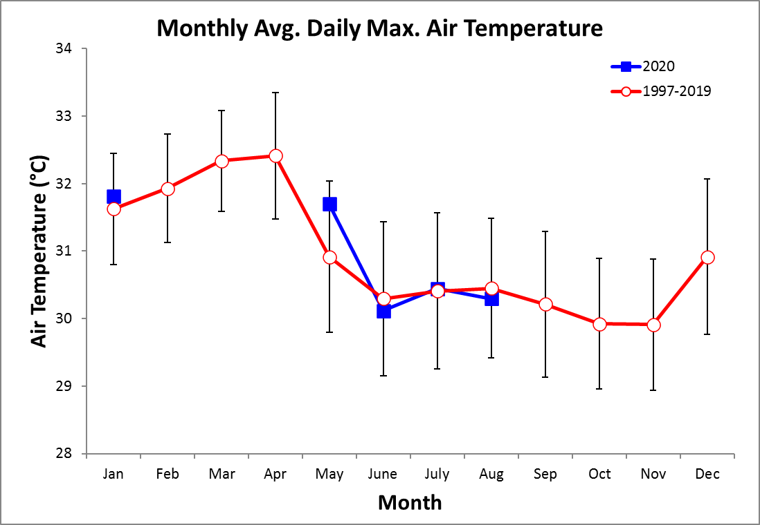
Monthly Average of Daily Minimum Temperature
Year | Jan | Feb | Mar | Apr | May | June | July | Aug | Sep | Oct | Nov | Dec
1995 | 25.0 | 25.2 |  |  | 24.4 | 24.9 | 24.4 | 24.4 |  | 24.2 | 24.4 | 24.2
1996 | 23.9 | 23.7 | 23.5 | 24.1 | 24.9 | 24.9 | 24.4 | 24.4 | 24.7 | 24.5 | 24.4 | 24.2
1997 | 23.2 | 24.1 | 23.1 | 24.1 | 25.2 | 24.8 | 25.2 | 25.2 | 24.8 | 24.8 | 23.7 | 23.5
1998 | 23.7 | 23.9 | 24.1 |  |  |  |  |  | 23.6 | 24.1 | 23.4 | 23.4
1999 | 23.0 | 22.8 | 22.9 | 23.7 | 23.7 | 23.5 | 23.2 |  | 23.2 | 23.3 | 23.3 | 23.4
2000 | 22.2 | 22.3 | 22.2 | 23.2 | 23.7 | 23.7 | 23.4 | 23.1 | 22.9 | 22.9 | 22.9 | 22.7
2001 | 22.2 | 22.4 | 22.4 |  | 23.6 | 23.4 | 23.1 | 23.9 | 22.9 | 23.3 | 22.2 | 22.3
2002 | 22.6 | 22.5 | 22.8 | 22.5 | 22.9 | 22.6 | 22.6 | 22.7 | 22.8 | 22.5 | 22.7 | 23.2
2003 | 22.8 | 23.4 | 23.1 | 24.2 |  |  |  |  |  | 22.5 | 22.8 | 23.0
2004 | 22.3 | 22.5 | 23.6 |  |  |  |  |  |  |  |  | 21.7
2005 | 22.1 | 22.4 | 22.5 | 23.0 | 22.0 | 21.8 | 21.5 | 21.2 |  |  |  | 21.7
2006 |  | 22.4 | 22.0 | 21.5 | 20.7 | 21.5 | 20.5 | 21.5 | 21.4 | 21.5 | 21.3 | 22.2
2007 |  |  |  | 22.7 | 21.7 | 22.3 | 22.3 | 21.9 | 22.2 | 22.6 | 21.7 | 21.9
2008 | 22.4 | 22.3 | 22.5 | 23.2 | 23.1 | 21.9 | 21.2 | 21.5 | 23.3 | 23.0 | 21.6 | 22.3
2009 | 22.8 | 22.9 | 22.8 | 23.4 | 23.4 | 23.0 | 23.3 | 22.9 | 23.4 | 23.1 | 22.9 | 23.5
2010 | 22.8 | 23.6 | 23.8 | 23.8 | 24.5 | 23.5 | 23.2 | 23.2 | 23.3 | 22.8 | 22.1 | 21.5
2011 | 22.1 | 22.1 | 22.0 | 22.4 | 23.2 | 23.4 | 22.9 | 23.0 | 22.8 | 22.5 | 22.4 | 22.3
2012 | 22.0 | 21.9 | 23.4 | 23.4 | 24.0 | 23.9 | 23.5 | 23.4 | 23.4 | 23.3 | 23.3 | 23.4
2013 | 23.1 | 22.9 | 23.8 | 24.1 | 24.0 | 23.9 | 23.7 | 23.4 | 23.6 | 23.5 | 23.3 | 23.3
2014 | 22.9 | 22.9 | 23.0 | 24.3 | 24.3 | 24.9 | 24.9 | 24.3 | 24.0 | 24.3 | 23.9 | 23.8
2015 | 23.8 | 23.7 | 23.6 | 24.7 | 24.7 | 24.9 | 24.6 | 24.5 | 24.5 | 24.4 | 24.2 | 24.9
2016 | 23.8 | 24.3 | 24.2 | 24.9 | 25.1 | 23.8 | 23.4 | 24.0 | 23.1 | 23.3 | 22.8 | 23.0
2017 | 22.2 | 22.4 | 22.9 | 23.6 | 23.8 | 23.5 | 23.4 | 23.2 | 23.5 | 23.7 | 22.8 | 22.7
2018 | 22.5 | 22.1 | 22.7 | 22.8 | 23.5 | 22.9 | 23.7 | 23.5 | 23.2 | 23.5 | 23.3 | 23.1
2019 | 22.8 | 22.9 | 23.1 | 23.8 | 24.4 | 24.2 | 23.6 | 23.6 | 24.0 | 23.2 | 23.3 | 23.7
2020 | 23.2 |  |  |  | 24.2 | 23.7 | 23.4 | 23.6
mean | 22.9 | 23.0 | 23.0 | 23.5 | 23.7 | 23.5 | 23.3 | 23.3 | 23.4 | 23.3 | 23.0 | 23.0
sd | 0.7 | 0.8 | 0.6 | 0.8 | 1.1 | 1.0 | 1.1 | 1.1 | 0.8 | 0.8 | 0.9 | 0.9
min | 22.0 | 21.9 | 22.0 | 21.5 | 20.7 | 21.5 | 20.5 | 21.2 | 21.4 | 21.5 | 21.3 | 21.5
max | 25.0 | 25.2 | 24.2 | 24.9 | 25.2 | 24.9 | 25.2 | 25.2 | 24.8 | 24.8 | 24.4 | 24.9
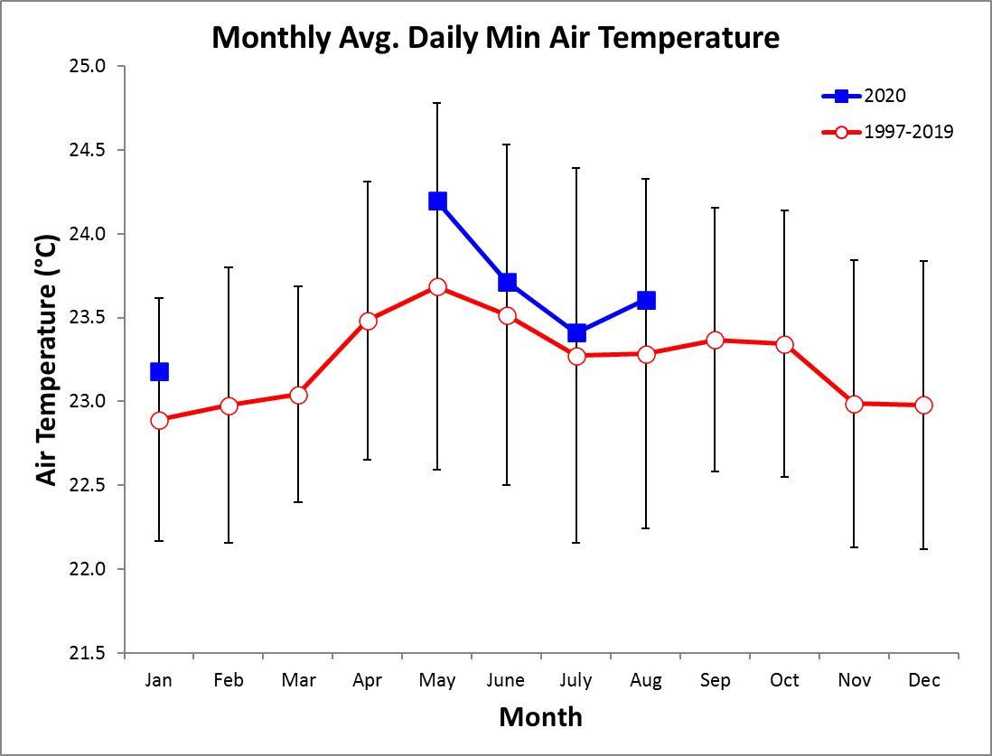
2020 Daily Total Radiation (MJ m⁻² day⁻¹) - Top

 | Jan. | Feb. | Mar. | Apr. | May | June | July | Aug. | Sep. | Oct. | Nov. | Dec.
1 | 10.6 | 18.9 | 23.0 | 17.6 | 16.1 | 19.2 | 15.8 | 17.7 | 13.5 | 23.3 | 15.8 | 12.9
2 | 11.3 | 21.0 | 26.1 | 22.2 | 17.6 | 7.6 | 14.4 | 17.8 | 13.9 | 19.4 | 11.8 | 11.5
3 | 18.9 | 19.9 | 17.4 | 17.9 | 19.4 | 16.2 | 14.7 | 11.9 | 20.5 | 10.4 | 6.4 | 15.1
4 | 22.4 | 21.9 | 19.8 | 17.0 | 16.1 | 19.1 | 4.5 | 12.5 | 19.9 | 13.3 | 7.3 | 13.9
5 | 22.1 | 19.5 | 18.8 | 21.3 | 15.3 | 12.0 | 17.6 | 11.5 | 24.9 | 20.9 | 17.1 | 10.5
6 | 21.1 | 23.2 | 24.0 | 18.2 | 16.5 | 19.9 | 15.1 | 9.4 | 13.1 | 12.7 | 17.7 | 11.9
7 | 20.8 | 23.8 | 24.3 | 15.9 | 14.6 | 21.2 | 11.8 | 15.4 | 6.4 | 23.3 | 24.5 | 20.1
8 | 19.3 | 22.8 | 19.9 | 17.3 | 16.9 | 14.8 | 14.0 | 16.4 | 20.7 | 6.1 | 19.1 | 13.0
9 | 19.4 | 23.1 | 26.5 | 15.2 | 14.5 | 12.4 | 21.8 | 6.3 | 11.9 | 17.4 | 23.3 | 15.1
10 | 15.5 | 23.8 | 26.0 | 17.0 | 16.7 | 4.4 | 13.4 | 10.5 | 17.4 | 19.0 | 20.7 | 17.4
11 | 17.0 | 19.0 | 22.7 | 13.1 | 14.8 | 19.3 | 8.3 | 12.6 | 16.9 | 20.8 | 11.3 | 19.8
12 | 22.2 | 23.6 | 26.2 | 10.8 | 23.0 | 24.6 | 14.0 | 7.3 | 13.4 | 16.6 | 5.9 | 17.9
13 | 21.3 | 23.8 | 27.0 | 13.7 | 18.3 | 19.0 | 10.3 | 11.3 | 21.4 | 13.1 | 13.6 | 16.3
14 | 22.9 | 22.9 | 24.5 | 15.4 | 17.2 | 16.3 | 14.3 | 14.6 | 20.4 | 11.7 | 9.9 | 22.3
15 | 21.3 | 23.2 | 24.5 | 23.9 | 13.4 | 6.0 | 22.5 | 6.8 | 14.6 | 24.0 | 4.6 | 16.4
16 | 22.3 | 19.7 | 24.0 | 15.7 | 19.9 | 22.0 | 15.2 | 14.3 | 18.2 | 17.5 | 10.3 | 13.0
17 | 20.4 | 15.4 | 23.8 | 24.0 | 6.8 | 16.8 | 11.2 | 19.6 | 19.3 | 9.2 | 7.3 | 14.9
18 | 13.8 | 24.2 | 22.6 | 22.6 | 13.0 | 10.5 | 11.7 | 16.4 | 21.1 | 4.3 | 8.5 | 19.3
19 | 21.7 | 23.6 | 20.7 | 15.9 | 9.3 | 9.3 | 13.1 | 8.6 | 21.1 | 11.3 | 14.9 | 14.5
20 | 17.3 | 18.4 | 20.7 | 24.0 | 14.8 | 16.2 | 11.4 | 6.8 | 19.3 | 11.4 | 12.8 | 17.6
21 | 20.7 | 22.2 | 16.5 | 23.9 | 22.8 | 13.6 | 9.7 | 22.0 | 16.6 | 18.0 | 11.8 | 14.6
22 | 14.0 | 24.8 | 17.8 | 14.2 | 12.3 | 15.4 | 9.6 | 11.8 | 8.6 | 19.6 | 13.6 | 13.8
23 | 9.6 | 25.4 | 20.2 | 14.8 | 21.6 | 8.7 | 13.5 | 18.2 | 21.8 | 11.4 | 19.4 | 11.7
24 | 19.3 | 17.9 | 16.8 | 13.1 | 18.2 | 14.2 | 7.1 | 21.6 | 5.4 | 11.3 | 10.8 | 18.0
25 | 22.6 | 21.3 | 18.9 | 25.0 | 20.7 | 15.7 | 14.8 | 11.1 | 10.6 | 20.3 | 9.3 | 10.3
26 | 23.4 | 22.6 | 23.8 | 15.7 | 14.4 | 8.2 | 15.6 | 26.3 | 30.3 | 22.4 | 4.7 | 16.7
27 | 18.0 | 21.5 | 25.7 | 14.4 | 4.7 | 4.1 | 20.8 | 23.0 | 9.5 | 15.6 | 9.9 | 14.2
28 | 20.4 | 21.5 | 24.6 | 19.0 | 8.4 | 10.3 | 18.3 | 15.1 | 15.7 | 16.3 | 11.0 | 10.3
29 | 16.3 | 24.5 | 25.1 | 15.3 | 10.4 | 10.7 | 16.6 | 15.8 | 17.6 | 13.9 | 14.1 | 11.9
30 | 20.1 |  | 22.7 | 21.6 | 15.7 | 6.8 | 19.2 | 17.2 | 5.6 | 24.7 | 12.2 | 14.4
31 | 16.0 |  | 21.2 |  | 16.3 |  | 21.2 | 21.7 |  | 11.4 |  | 14.7

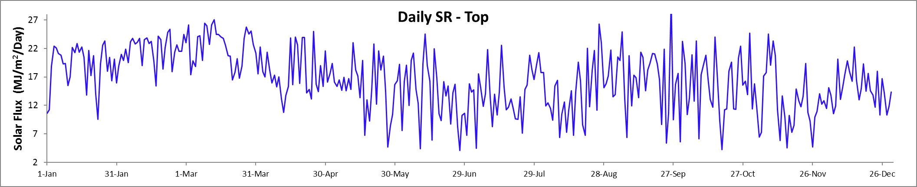
Monthly Average Total Daily Solar Radiation (MJ m⁻² day⁻¹)

Top Station
Year | Jan | Feb | Mar | Apr | May | June | July | Aug | Sep | Oct | Nov | Dec
2012 |  |  | 18.8 | 15.7 | 13.5 | 13.4 | 11.5 | 13.3 | 12.1 | 12.6 | 11.3 | 12.0
2013 | 18.3 | 17.8 | 16.3 | 16.7 | 14.1 | 12.9 | 13.1 | 13.8 | 12.3 | 12.8 | 13.2 | 13.3
2014 | 16.9 | 18.2 | 19.0 | 15.7 | 13.0 | 11.6 | 13.4 | 12.7 | 13.2 | 13.1 | 12.5 | 12.3
2015 | 16.0 | 17.2 | 18.3 | 15.9 | 13.2 | 14.9 | 14.5 | 13.3 | 13.1 | 13.4 | 11.9 | 14.4
2016 | 17.3 | 17.5 | 16.7 | 15.8 | 12.7 | 13.6 | 12.4 | 13.8 | 13.9 | 14.5 | 11.7 | 14.2
2017 | 18.4 | 20.5 | 19.3 | 16.0 | 14.1 | 13.5 | 12.4 | 13.6 | 13.8 | 13.6 | 13.0 | 14.4
2018 | 14.7 | 20.0 | 19.9 | 16.2 | 14.5 | 12.3 | 12.6 | 13.0 | 14.4 | 15.4 | 13.0 | 18.3
2019 | 20.4 | 20.2 | 21.7 | 18.5 | 14.1 | 13.8 | 14.2 | 14.0 | 14.0 | 14.3 | 13.1 | 13.8
2020 | 18.8 | 21.8 | 22.4 | 17.9 | 15.4 | 13.7 | 14.2 | 14.5 | 16.3 | 15.8 | 12.7 | 15.0
mean | 17.6 | 19.2 | 19.1 | 16.5 | 13.8 | 13.3 | 13.1 | 13.5 | 13.7 | 13.9 | 12.5 | 14.2
sd | 1.8 | 1.7 | 2.0 | 1.0 | 0.9 | 0.9 | 1.0 | 0.5 | 1.2 | 1.1 | 0.7 | 1.8
min | 14.7 | 17.2 | 16.3 | 15.7 | 12.7 | 11.6 | 11.5 | 12.7 | 12.1 | 12.6 | 11.3 | 12.0
max | 20.4 | 21.8 | 22.4 | 18.5 | 15.4 | 14.9 | 14.5 | 14.5 | 16.3 | 15.8 | 13.2 | 18.3

25 Meter Station (discontinued)
Year | Jan | Feb | Mar | Apr | May | June | July | Aug | Sep | Oct | Nov | Dec
2007 |  |  |  |  |  |  |  | 8.8 | 11.0 | 10.7 | 9.5 | 10.8
2008 | 14.4 | 13.2 | 15.0 | 11.6 | 9.0 | 7.6 | 7.7 | 9.1 | 14.6 | 13.8 | 11.9 | 14.8
2009 | 16.0 | 17.6 | 18.1 | 16.6 | 11.5 | 11.3 | 10.0 | 10.7 | 12.4 | 12.4 | 9.3 | 13.2
2010 | 16.0 | 15.3 | 15.5 | 13.1 | 12.9 | 10.6 | 10.0 | 12.4 | 12.3 | 10.7 | 11.3 | 10.8
2011 | 13.5 | 16.7 | 16.5 | 15.1 | 12.8 | 10.3 | 10.1 | 11.9 | 11.2 | 10.9 | 10.3 | 11.6
2012 | 16.3 | 17.8 | 16.8 | 13.6 | 11.0 | 10.5 | 9.5 | 11.2 | 10.5 | 11.0 | 11.4 | 12.3
2013 | 19.2 | 17.6 | 14.8 | 14.5 | 11.4 | 10.2 | 10.3 | 11.6 | 10.9 | 11.6 | 12.7 | 13.1
2014 | 16.5 | 17.2 | 17.3 | 13.1 | 10.5 | 8.1 | 11.0 | 11.0 | 12.1 | 12.3 | 12.2 | 12.3
2015 | 15.9 | 16.4 | 17.0 | 13.9 | 11.0 | 11.7 | 11.7 | 11.3 | 11.6 | 12.5 | 11.5 | 13.9
2016 | 16.1 | 15.9 | 14.2 | 12.8 | 9.6 | 11.6 | 11.2 | 11.3 | 11.8 | 12.9 | 10.1 | 12.3
2017 | 16.4 | 18.2 | 17.1 | 12.8 | 11.5 | 9.7 | 9.0 | 10.5 | 11.1 | 11.6 | 11.4 | 12.6
2018 | 12.7 | 17.0 | 16.3
mean | 16.0 | 16.6 | 16.2 | 13.7 | 11.1 | 10.2 | 10.0 | 10.9 | 11.8 | 11.9 | 11.1 | 12.5
sd | 1.5 | 1.5 | 1.3 | 1.4 | 1.2 | 1.4 | 1.2 | 1.1 | 1.1 | 1.0 | 1.1 | 1.2
min | 13.5 | 13.2 | 14.2 | 11.6 | 9.0 | 7.6 | 7.7 | 8.8 | 10.5 | 10.7 | 9.3 | 10.8
max | 19.2 | 18.2 | 18.1 | 16.6 | 12.9 | 11.7 | 11.7 | 12.4 | 14.6 | 13.8 | 12.7 | 14.8

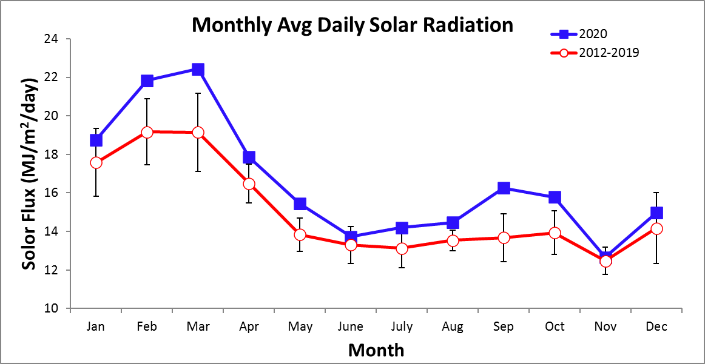

Time Series – Daily 2020

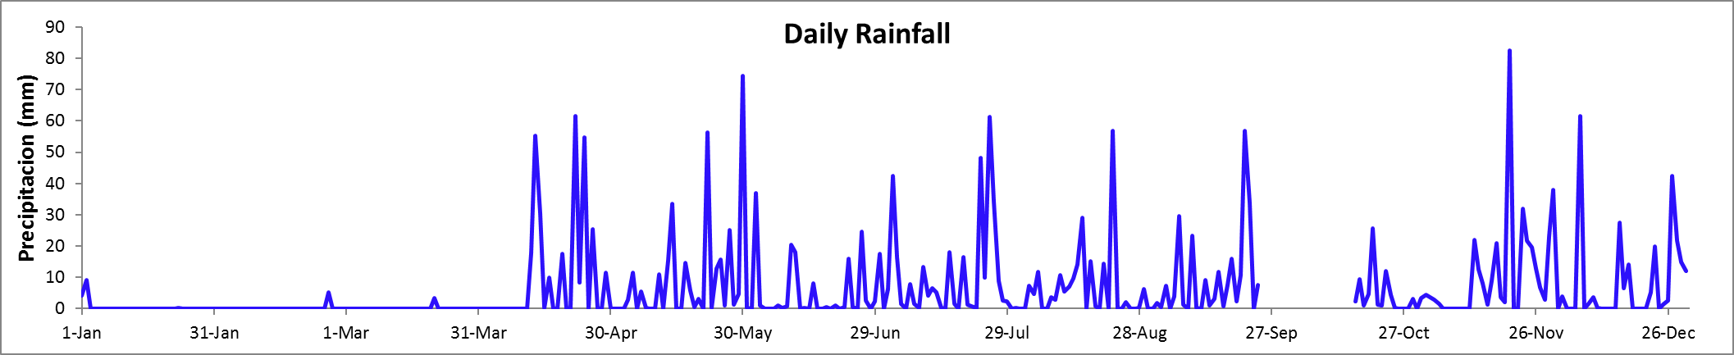

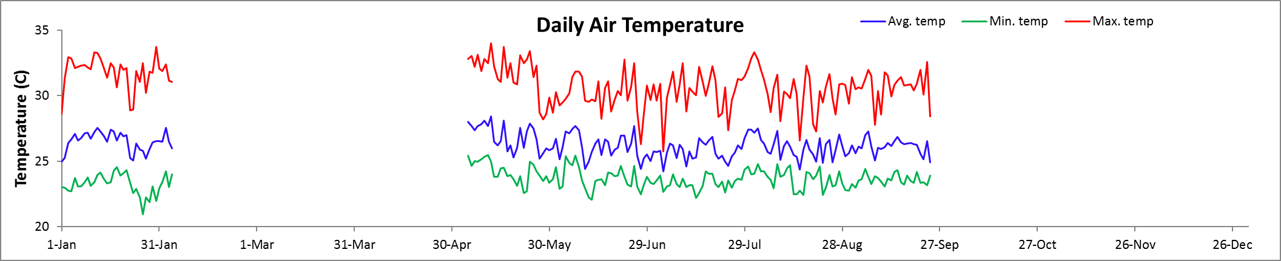

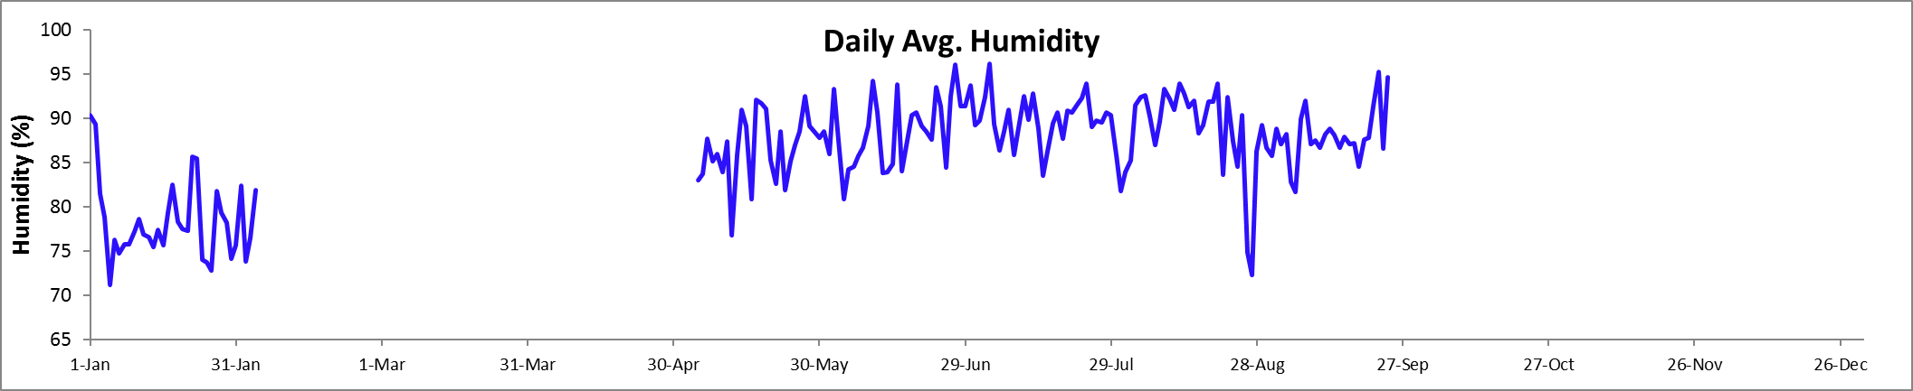

Time Series - Monthly

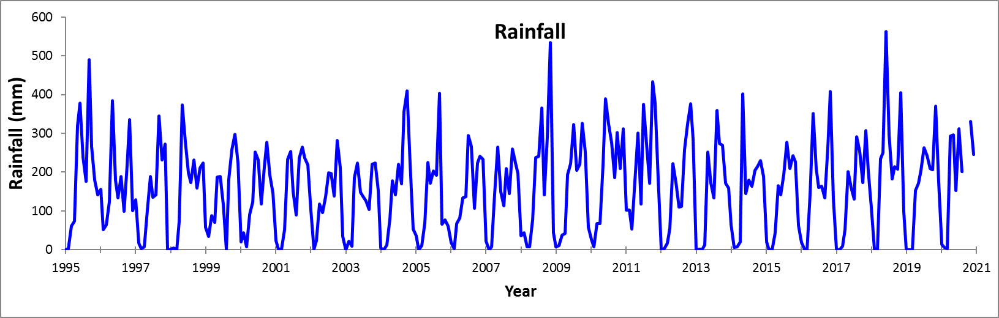

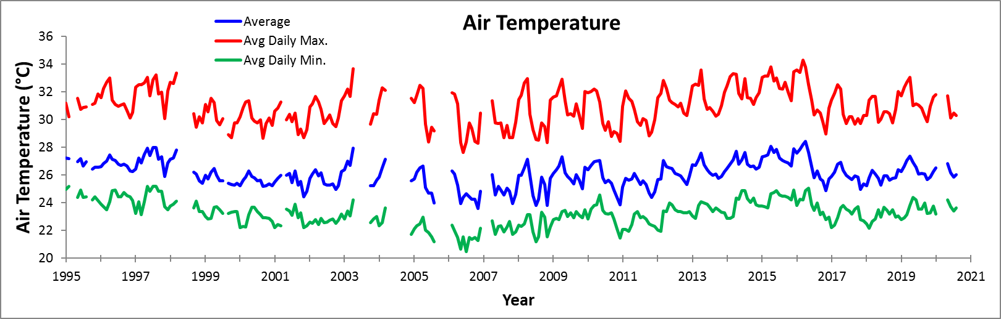

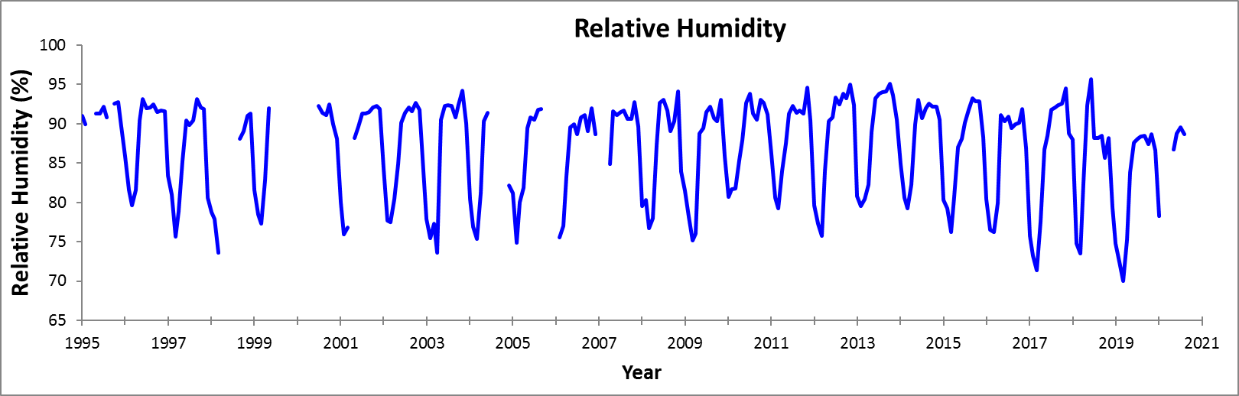
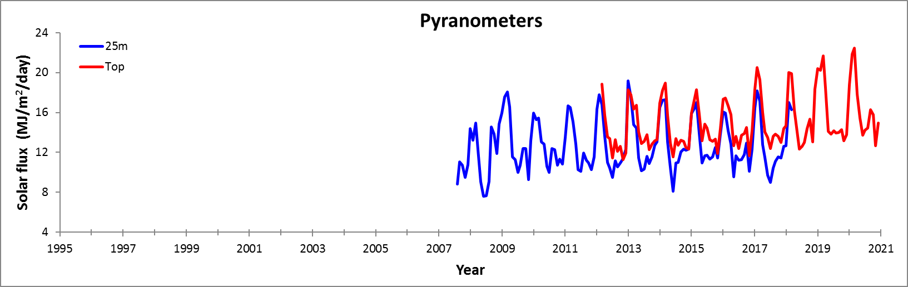

Monthly totals in green have been estimated from an average of the Balboa Heights and Albrook Airbase stations of the Panama Canal Authority

