2022 Meteorological Summary for the AVA Tower,
Barro Colorado Island

Prepared by: Steven Paton

Introduction

This is the 2nd of a series of yearly reports summarising the past year’s Smithsonian Tropical Research Institute’s Physical Monitoring Program for the BCI AVA tower. This report is not meant to be exhaustive in its coverage in that it summarizes only some of the most ‘important’ or interesting parameters available. Any comments on how future yearly summaries could be improved would be appreciated. Additional copies of this report and downloadable data from the Ava Tower and other research locations, can be obtained from: biogeodb.stri.si.edu/physical_monitoring/research/ava

Setting

The meteorology and hydrology monitoring programs on BCI are described in detail in Climate and Moisture Variability in a Tropical Forest: Long-term Records from Barro Colorado Island, Panamá. Windsor (1990). Much of the information on the next five pages has been extracted from this source.

BCI (9°10'N, 79°51'W) is a completely forested, 1567 ha island with a 53.9km perimeter, rising 137m above Lake Gatun. The island receives an average of 2660.7mm of rain per year. The meteorological year is divided into two parts: a pronounced dry season (on average from December 19 to May 2), and a wet season (May to mid-December) – as measured by the manual rain gauge in the Clearing station between 2025 and 2022. On average, 300.3 and 2265.3mm of rain falls during the dry and wet seasons respectively (based on 1972-2022 precipitation). Relative humidity, soil moisture, air pressure, solar radiation, evapotranspiration, wind speed and direction all show marked wet/dry season differences. On the other hand, temperature varies relatively little throughout the year.

This report summarises data taken from the 45m Ava Tower (see map on the following page).

The Ava tower was originally established in 2011 by the ForestGEO TEAM program. In May of 2018 the tower was hit by a tree and required replaced. A new 45m tower was installed in Feb. of 2019 and transferred to the Physical Monitoring Program. In addition to the meteorological sensors, the tower hosts an Eddyflux system (data not reported here). All data were collected using electronic sensors.

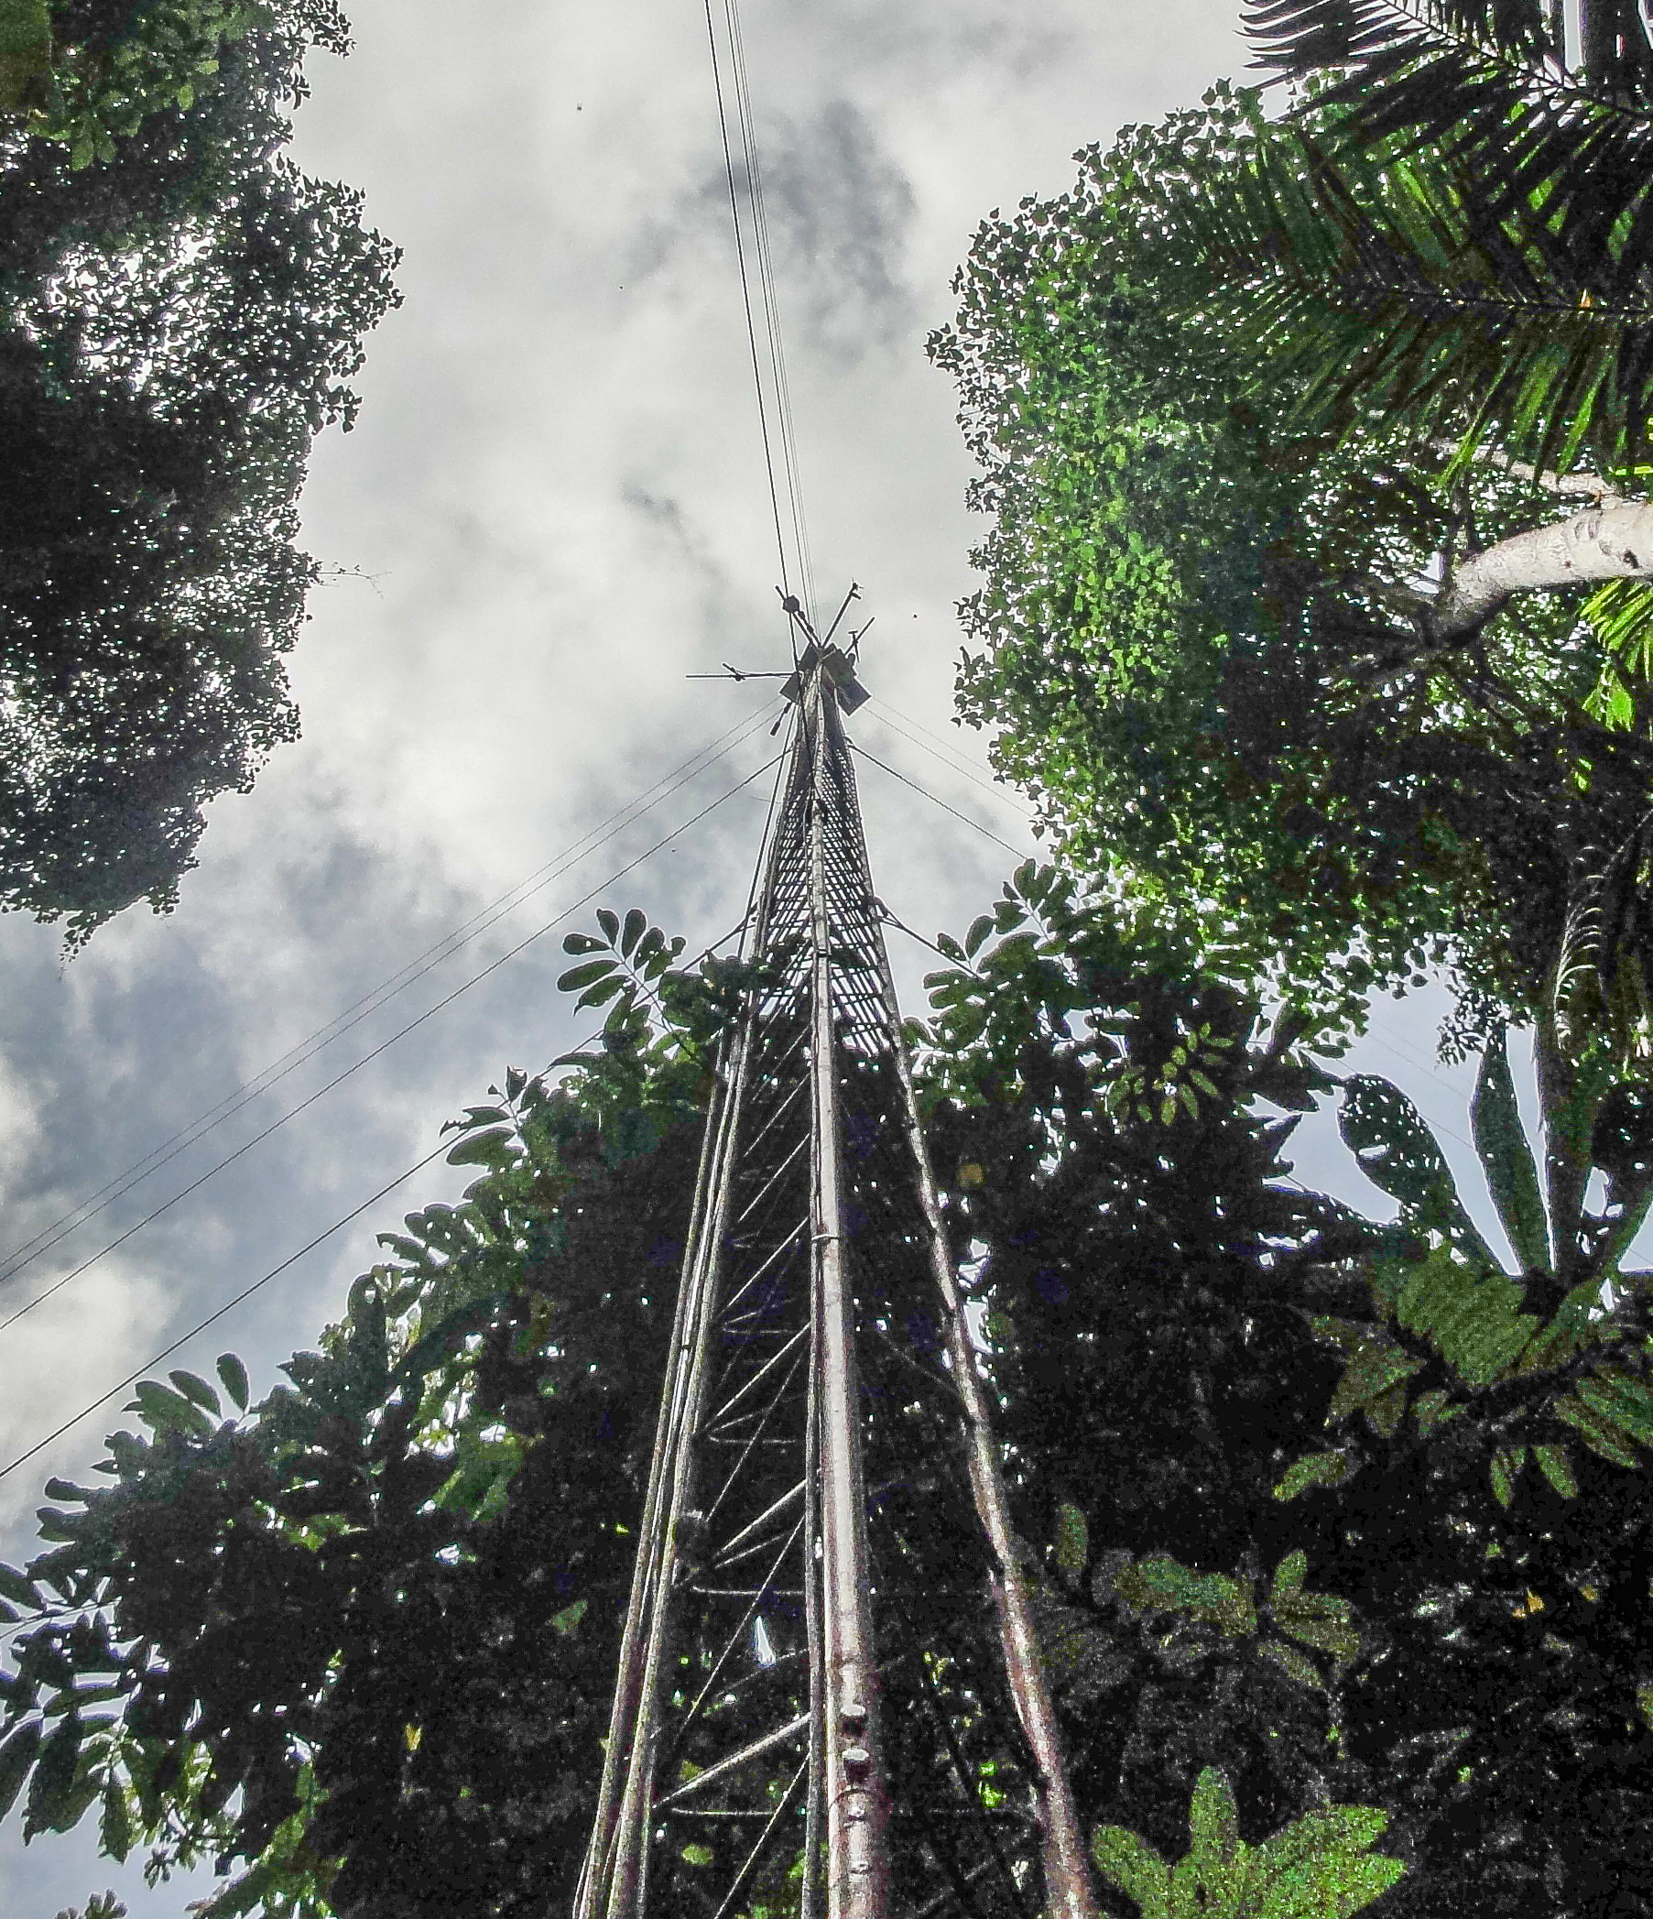

Ava versus Lutz towers. Until the installation of the Ava tower, data from the Lutz and Clearing stations were used to support research throughout BCI, including the 50ha plot. The Ava Tower station now provides that more closely describes the interior areas of the island. With almost three complete years of data at the Ava tower it is now possible meaningfully compare the conditions at the two locations. For the years 2021 & 2022:
- Temperatures at the top of the Ava tower are, on average, 0.7C lower than the top of the Lutz tower (25.2C versus 25.7C).
- Average wind at the top of Ava towers is significantly greated than at the top of the Lutz tower: 8.5 km/h versus 4.7 km/h
- Rainfall at the Ava tower is approximately 11% less than at Lutz: 216mm/month versus 245mm/month
- Solar radiation, temperature and relative humidty at the bottom, relative humidity at the top, and wind direction are not significantly different.

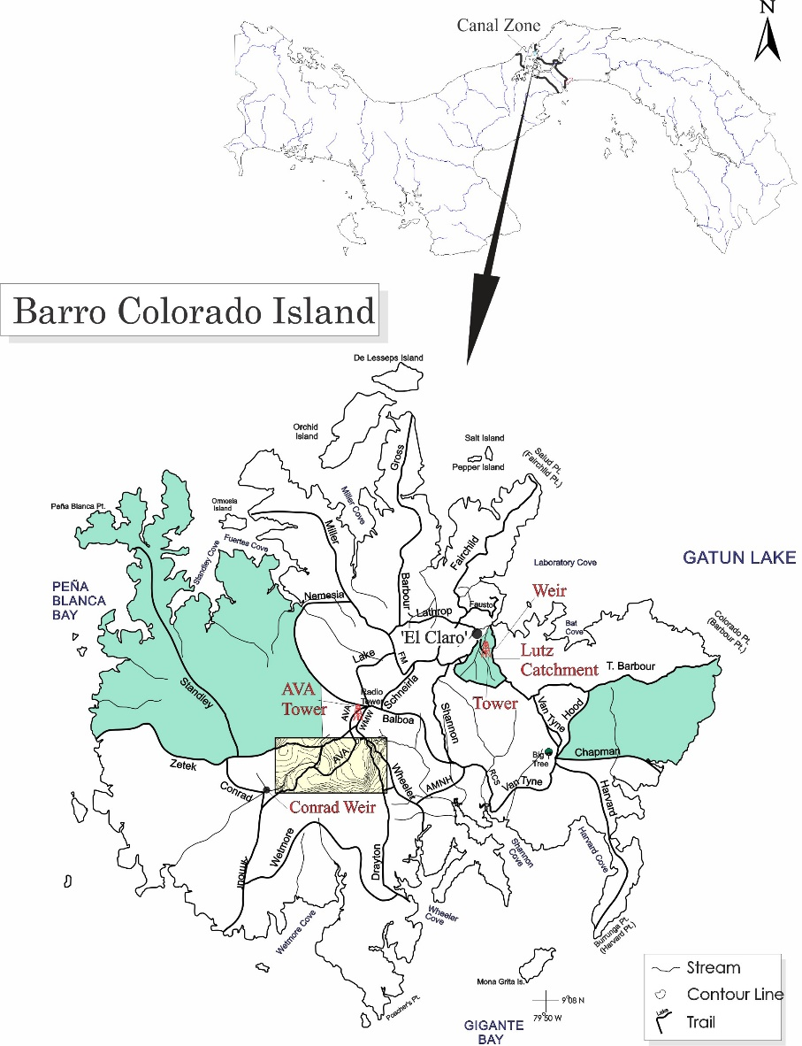

The Data

This report summarises the following data:

Ava Tower rainfall
relative humidity (top and bottom)
solar radiation (pyranometer & PAR)
temperature (top and bottom)
wind speed and direction

Rainfall

Rainfall was collected by a tipping bucket located near the top of the tower (~45m). Tipping buckets provide continuous rainfall information but tend to underestimate total rainfall by between 2% and 12% and for that reason are not used to provide data on absolute rainfall totals. Tipping buckets generate ‘events’ for every 0.254 mm of rainfall recorded. The underestimation seems to be due to the instruments’ inability to properly record intense periods of rainfall. The daily rainfall is shown on page 6.

Page 7 shows the monthly totals for this year. The graph on the same page compares this year’s monthly totals with the average monthly totals (±SD) for the period 2011 to 2022.

Page 8 shows yearly rainfall totals for all complete years. Time series graph and frequency histograms are presented for these data.

Pages 9 and 10 show an analysis of rainfall ‘events’ (storms). For convenience, and again somewhat arbitrarily, I have defined a storm as any continuous period of rain separated by at least an hour from any other rainfall. Since this analysis required the timing of rainfall events, tipping bucket data were used. As a result, the absolute size of rainfall events should be considered as only an estimate since they will tend to disproportionately underestimate the size of storms - larger storms will be more underestimated than smaller ones. Keeping this in mind, the tables and graphs on this page compare the maximum storm size and the average storm size and duration per month for the period 1972 to 2021 and for the year 2021.

Relative Humidity

Relative Humidity data were collected at the base (2m) and near the top (45m) of the Tower at 15-minute intervales by dataloggers attached to to Campbell Sci. CS215 electronic temperature/humidity sensors Average monthly relative humidities are shown in tabular and graphical form on pages 11 & 12.

Temperature
Shaded air temperature was collected at the base (2m) and near the top (45m) of the Tower at 15-minute intervales by dataloggers attached to to Campbell Sci. CS215 electronic temperature/humidity sensors. Average monthly daily maximum and minimum temperatures are shown in tabular and graphical form on pages on pages 13 & 14.

Solar Radiation
Global solar radiation was measured at the top of the tower using two Kipp&Zonen Kipp&Zonen CMP11 pyranometers attached to a datalogger. 15-minute interval total (MJ m⁻²), maximum and minimum (J m⁻² s⁻¹) were recorded. Page 15 shows the Daily Global Radiation values. Page 15 shows total monthly Global Radiation.

PAR was measured using one Kipp&Zonen CMP11 and one Kipp&Zonen CMP3. 15-minute interval total (Mol/m²/s), maximum and minimum (µMol/m²/s) were recorded. Page 17 shows the Daily PAR values. Page 18 shows total monthly PAR.

Wind Speed and Direction
15-minute interval average, maximum and minimum wind speed plus average wind direction was recorded close to the top of the tower (45m) using a Model 05103 Young Anemometer connected to a data logger.

Page 19 shows daily average and maximum wind speeds from the Young Anemometer located at 48m. The page 20 shows daily average wind direction. The angles indicated in the table and graph on this page represent the direction into which the wind was predominately blowing on a given day. Page 21 shows the monthly average and average daily-maximum wind speeds, and monthly average vectors (Young Anemometer) for the year.

Long-term Monthly Averages/Totals
Page 22 shows the long-term, monthly Averages/Totals for rainfall, runoff, relative humidity, air temperatue, evapotranspiration, solar radiation, and wind speed.

Daily Averages/Totals for 2022
Page 23 shows the daily Averages/Totals for rainfall, runoff, relative humidity, air temperatue, evapotranspiration, solar radiation, and wind speed and direction.

Daily Patterns
Pages 24 and 25 show the daily patterns for air temperatue, relative humidity, solar radiation, rainfall, and wind speed. These figures use electronic sensor data.

Comparison of Lutz and Ava tower data
Pages 26 shows comparisons of daily Lutz and Ava tower data. Pages 27 shows a comparison of daily and monthly Clearing and Ava tower precipitation data.

2022 Daily Rainfall (mm)

 | Jan. | Feb. | Mar. | Apr. | May | June | July | Aug. | Sep. | Oct. | Nov. | Dec.
1 | 0.0 | 0.0 | 23.1 | 0.0 | 14.2 | 16.5 | 14.7 | 29.2 | 0.3 | 2.3 | 0.0 | 0.0
2 | 0.0 | 0.0 | 24.4 | 1.0 | 9.4 | 5.6 | 1.3 | 52.1 | 0.3 | 1.0 | 0.0 | 4.6
3 | 5.1 | 0.0 | 1.5 | 18.0 | 0.0 | 0.3 | 5.3 | 0.3 | 0.8 | 1.3 | 19.6 | 1.3
4 | 0.3 | 0.0 | 0.3 | 38.1 | 0.0 | 0.0 | 2.5 | 0.3 | 1.0 | 0.0 | 2.0 | 5.3
5 | 0.0 | 0.0 | 0.8 | 17.0 | 54.6 | 1.0 | 37.8 | 16.0 | 6.6 | 29.5 | 1.3 | 9.9
6 | 0.0 | 4.6 | 15.5 | 0.0 | 0.3 | 1.8 | 0.0 | 21.3 | 0.8 | 11.2 | 0.0 | 0.5
7 | 0.0 | 0.0 | 2.3 | 0.0 | 1.8 | 0.3 | 29.7 | 0.3 | 3.3 | 82.5 | 3.3 | 1.8
8 | 0.0 | 0.0 | 0.0 | 0.0 | 0.0 | 0.0 | 10.7 | 0.8 | 9.1 | 5.1 | 25.7 | 0.0
9 | 0.0 | 0.5 | 6.1 | 5.8 | 0.0 | 0.0 | 10.2 | 9.1 | 0.0 | 0.5 | 3.3 | 0.0
10 | 0.3 | 12.2 | 0.3 | 0.0 | 5.3 | 1.0 | 1.8 | 3.3 | 1.3 | 0.0 | 0.3 | 0.0
11 | 0.0 | 0.0 | 0.0 | 0.3 | 4.8 | 8.1 | 0.0 | 4.1 | 3.0 | 3.6 | 0.8 | 0.0
12 | 0.0 | 0.0 | 0.0 | 1.0 | 11.2 | 0.3 | 67.1 | 14.0 | 23.4 | 4.8 | 0.3 | 0.8
13 | 20.1 | 0.0 | 0.0 | 1.8 | 12.2 | 79.0 | 7.1 | 0.5 | 0.3 | 2.3 | 59.9 | 11.9
14 | 0.0 | 0.0 | 0.0 | 0.0 | 18.8 | 2.3 | 0.3 | 1.3 | 14.2 | 0.3 | 17.0 | 3.0
15 | 0.0 | 0.0 | 0.0 | 1.8 | 3.0 | 0.3 | 7.1 | 37.3 | 0.0 | 0.0 | 12.4 | 5.1
16 | 0.0 | 0.0 | 0.8 | 0.0 | 58.2 | 21.8 | 2.0 | 0.0 | 39.1 | 0.0 | 37.1 | 0.3
17 | 0.3 | 0.0 | 0.0 | 0.8 | 25.1 | 24.6 | 3.6 | 0.0 | 8.9 | 16.5 | 13.7 | 0.3
18 | 5.8 | 0.5 | 0.0 | 0.3 | 5.3 | 0.5 | 0.8 | 4.1 | 0.3 | 8.1 | 1.3 | 0.3
19 | 0.0 | 0.0 | 0.0 | 0.0 | 1.5 | 0.3 | 10.7 | 0.3 | 0.3 | 34.5 | 3.0 | 0.0
20 | 0.5 | 3.0 | 0.0 | 0.0 | 4.6 | 0.0 | 6.6 | 3.3 | 0.5 | 0.3 | 0.3 | 0.0
21 | 0.0 | 0.0 | 0.0 | 0.0 | 0.0 | 0.3 | 1.3 | 52.1 | 0.3 | 8.4 | 53.6 | 0.0
22 | 0.0 | 0.0 | 0.0 | 0.0 | 2.5 | 1.8 | 4.3 | 11.4 | 0.0 | 18.0 | 0.3 | 0.0
23 | 0.0 | 0.0 | 0.0 | 17.0 | 17.8 | 6.4 | 3.3 | 0.0 | 0.0 | 3.8 | 49.0 | 0.0
24 | 1.0 | 3.8 | 0.0 | 0.0 | 13.0 | 0.3 | 26.2 | 9.7 | 1.5 | 6.9 | 3.0 | 0.0
25 | 2.0 | 0.0 | 0.0 | 20.1 | 8.1 | 4.6 | 15.5 | 12.4 | 5.8 | 0.5 | 0.3 | 0.0
26 | 0.0 | 0.0 | 0.0 | 19.8 | 2.5 | 4.8 | 20.6 | 0.3 | 0.8 | 2.0 | 61.0 | 0.0
27 | 0.0 | 0.0 | 74.2 | 11.7 | 1.0 | 38.4 | 2.3 | 55.1 | 0.0 | 0.0 | 29.7 | 2.0
28 | 5.8 | 0.0 | 3.8 | 5.1 | 10.2 | 51.1 | 58.4 | 7.9 | 0.0 | 0.5 | 2.5 | 11.9
29 | 1.3 |  | 0.0 | 22.6 | 0.0 | 3.0 | 33.3 | 0.3 | 0.0 | 0.0 | 49.8 | 1.3
30 | 0.8 |  | 3.8 | 18.5 | 0.3 | 2.0 | 0.8 | 0.8 | 0.0 | 0.0 | 0.3 | 0.0
31 | 2.3 |  | 0.3 |  | 0.0 |  | 0.3 | 3.3 |  | 0.0 |  | 0.0
 | 45.5 | 24.6 | 157.0 | 200.7 | 285.7 | 276.1 | 385.3 | 350.5 | 121.7 | 243.8 | 450.6 | 60.2

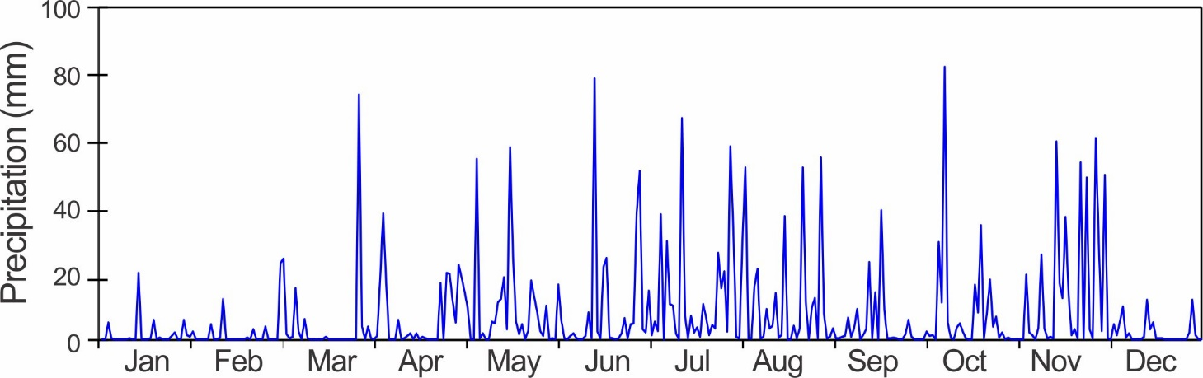
Monthly Rainfall

Rainfall (mm)
 | Average | Min | Max | S.D. | 2022 | Rank*  (n=11)
January | 46.5 | 2.0 | 261.1 | 73.4 | 45.5 | 4
February | 18.4 | 1.8 | 50.0 | 12.9 | 24.6 | 3
March | 42.1 | 1.8 | 157.0 | 45.4 | 157.0 | 1
April | 81.4 | 32.8 | 200.7 | 54.8 | 200.7 | 1
May | 239.1 | 149.1 | 447.0 | 84.4 | 285.8 | 3
June | 257.4 | 115.6 | 503.2 | 104.2 | 276.1 | 5
July | 264.7 | 101.6 | 385.6 | 91.0 | 385.3 | 2
August | 238.0 | 95.8 | 393.5 | 94.6 | 350.5 | 2
September | 206.7 | 121.7 | 313.7 | 56.4 | 121.7 | 12
October | 265.8 | 122.7 | 436.3 | 101.1 | 243.8 | 7
November | 386.2 | 126.0 | 780.5 | 199.3 | 450.6 | 4
December | 211.7 | 19.8 | 457.7 | 147.5 | 60.2 | 11
Total | 2209.5 | 1422.9 | 2981.6 | 468.9 | 2601.8 | 2
* Rank: 1 = wettest year.
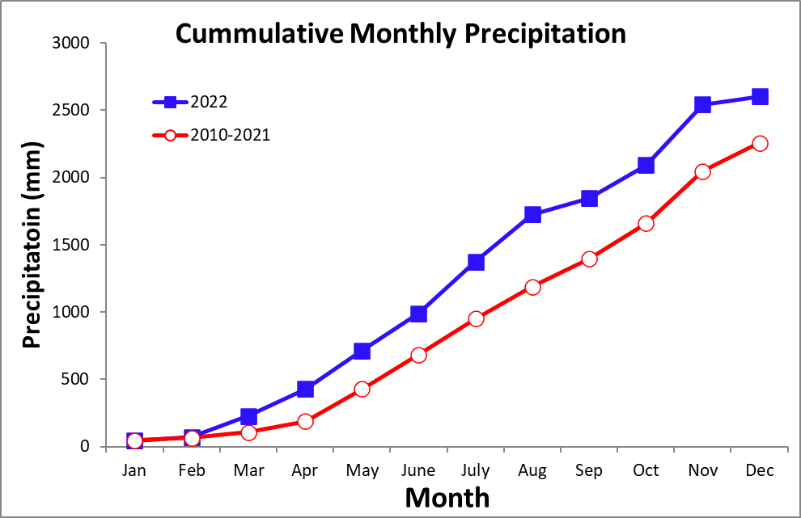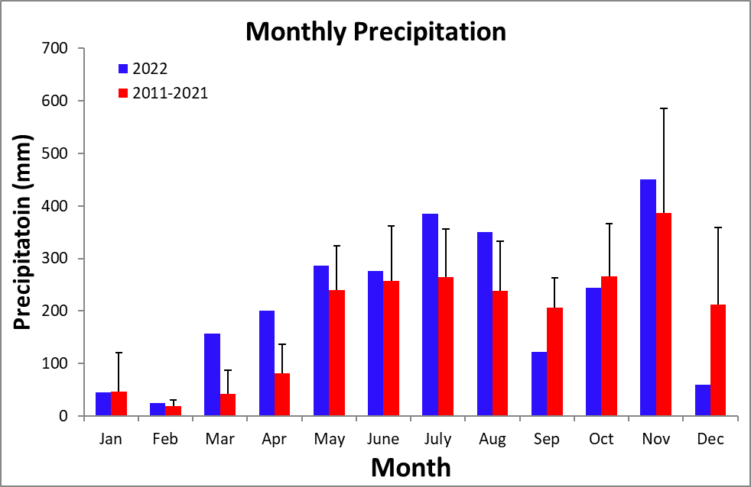
Yearly Rainfall (mm) at 'El Claro' - Rain Gauge

Year | Rain | Year | Rain | Year | Rain
2012 | 2513.6 | 2016 | 2491.0 | 2020 | 2091.4
2013 | 1584.5 | 2017 | 1977.4 | 2021 | 2554.0
2014 | 1928.9 | 2018 | 2981.6 | 2022 | 2601.8
2015 | 1422.9 | 2019 | 2157.7

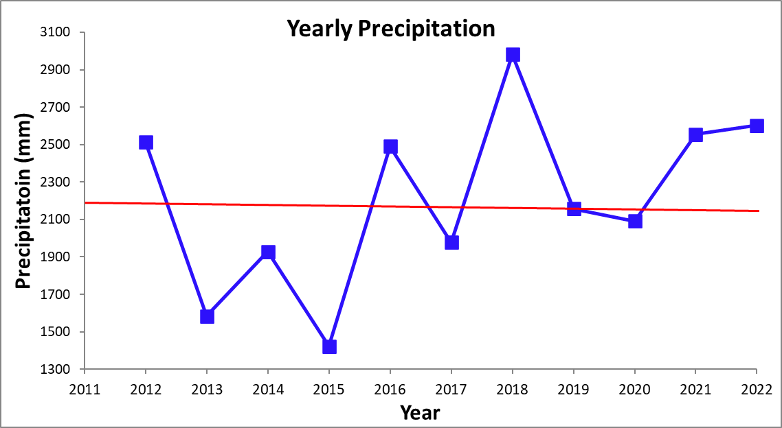
Storm Analysis

 |  | Max. Rainfall per Storm (mm) |  |  |  | Storm Duration (min.)
 | 2011-2021 |  |  | 2022 |  | 2011-2021 |  | 2022
 | Mean |  | S.D. |  |  | Mean | S.D.
January | 13.9 |  | 13.6 | 13.5 |  | 27.0 | 23.1 | 25.8
February | 9.3 |  | 10.4 | 9.1 |  | 28.0 | 19.2 | 23.9
March | 13.1 |  | 19.7 | 37.6 |  | 25.7 | 16.5 | 45.3
April | 26.7 |  | 15.5 | 35.3 |  | 40.9 | 14.3 | 52.2
May | 50.2 |  | 20.7 | 55.9 |  | 53.8 | 9.3 | 61.0
June | 36.4 |  | 16.9 | 78.5 |  | 46.2 | 17.8 | 64.5
July | 37.2 |  | 17.1 | 64.5 |  | 40.5 | 16.6 | 38.4
August | 35.0 |  | 20.9 | 54.9 |  | 42.2 | 18.7 | 56.5
September | 39.8 |  | 15.4 | 39.1 |  | 46.5 | 18.7 | 41.0
October | 48.9 |  | 31.9 | 48.8 |  | 42.0 | 17.7 | 51.4
November | 60.7 |  | 52.0 | 61.0 |  | 55.7 | 29.6 | 60.1
December | 48.4 |  | 27.8 | 11.9 |  | 39.2 | 20.2 | 18.8

 | Av. Rainfall per Storm (mm)
 | 2011-2021 |  | 2022
 | Mean | S.D.
January | 2.1 | 1.5 | 2.1
February | 2.1 | 2.0 | 1.6
March | 1.7 | 1.2 | 4.1
April | 3.8 | 1.9 | 5.0
May | 5.5 | 1.5 | 5.0
June | 4.9 | 1.9 | 6.3
July | 4.1 | 1.8 | 4.6
August | 4.1 | 2.2 | 5.6
September | 4.8 | 2.0 | 3.9
October | 5.2 | 2.4 | 4.1
November | 5.5 | 2.6 | 7.0
December | 4.2 | 2.1 | 2.0

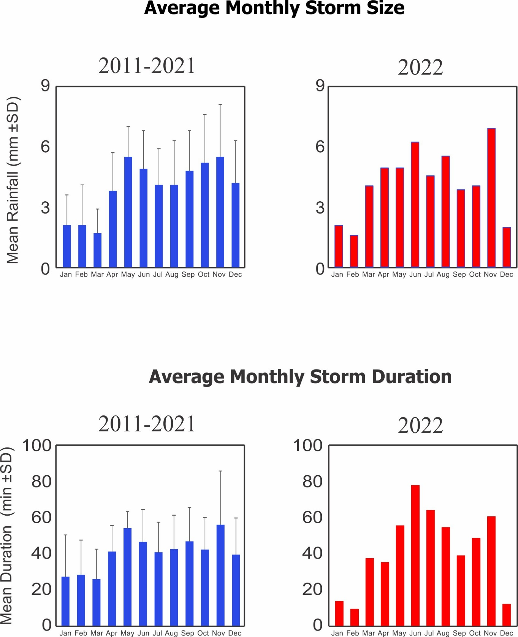
Relative Humidity (%)
45m
Year | Jan | Feb | Mar | Apr | May | June | July | Aug | Sep | Oct | Nov | Dec
2011 |  |  | 84.4 | 86.2 | 89.0 | 92.9 | 93.0 | 92.7 | 92.8 | 93.3 | 95.4 | 93.2
2012 | 84.9 | 84.5 | 85.6 | 88.4 | 92.0 | 91.9 | 93.5 | 94.0 | 93.3 | 92.9 | 95.6 | 93.3
2013 | 84.1 | 83.4 | 85.4 | 86.3 | 91.6 | 93.7 | 94.9 | 94.6 | 94.4 | 94.5 | 91.8 | 89.2
2014 | 86.4 | 84.7 | 83.9 | 86.8 | 90.4 | 93.4 | 91.9 | 91.7 | 90.7 | 91.4 | 90.9 | 90.7
2015 | 83.3 | 83.6 | 81.2 | 84.6 | 89.5 | 88.8 | 90.1 | 90.9 | 93.4 | 91.7 | 91.6 | 90.1
2016 | 83.4 | 82.7 | 83.4 | 84.2 | 90.3 | 90.9 | 93.4 | 91.6 | 91.3 | 92.0 | 94.2 | 89.8
2017 | 83.3 | 83.8 | 85.3 | 89.5 |  |  |  |  | 90.9 | 90.5 | 92.9 | 90.7
2018
2019 |  | 82.1 | 82.9 | 86.6 | 92.4 | 94.9 | 95.4 | 96.0 | 96.1 | 95.7 | 96.8 | 96.7
2020 |  |  |  |  |  |  |  |  |  |  |  | 90.9
2021 | 86.3 | 85.3 | 82.4 |  |  | 88.1 | 90.0 | 90.1 | 90.5 | 90.5 | 92.5 | 88.2
2022 | 82.7 | 80.3 | 88.4 | 91.6 | 94.7 | 94.3 | 96.5 | 95.3 | 94.5 | 94.4 | 95.8 | 89.8
mean | 96.7 | 94.7 | 92.3 | 95.5 | 98.3 | 99.1 | 99.7 | 99.4 | 99.2 | 99.5 | 99.4 | 99.1
sd | 0.7 | 1.0 | 4.5 | 2.6 | 0.7 | 0.4 | 0.3 | 0.2 | 0.2 | 0.4 | 0.4 | 0.4
min | 95.9 | 93.6 | 87.6 | 92.5 | 97.6 | 98.8 | 99.4 | 99.3 | 99.0 | 99.2 | 98.9 | 98.8
max | 97.4 | 95.4 | 96.6 | 97.3 | 99.0 | 99.6 | 99.9 | 99.6 | 99.5 | 99.9 | 99.7 | 99.6

2m
Year | Jan | Feb | Mar | Apr | May | June | July | Aug | Sep | Oct | Nov | Dec
2019 |  |  |  |  |  |  |  |  |  |  |  | 99.6
2020 | 95.9 | 93.6 | 87.6 | 92.5 | 97.6 | 99.6 | 99.9 | 99.6 | 99.5 | 99.9 | 98.9 | 98.9
2021 | 96.8 | 95.1 | 92.7 | 96.6 | 98.4 | 98.8 | 99.4 | 99.3 | 99.2 | 99.4 | 99.7 | 99.2
2022 | 97.4 | 95.4 | 96.6 | 97.3 | 99.0 | 99.0 | 99.8 | 99.3 | 99.0 | 99.2 | 99.6 | 98.8
mean | 84.3 | 83.4 | 84.3 | 87.1 | 91.2 | 92.1 | 93.2 | 93.0 | 92.8 | 92.7 | 93.7 | 91.1
sd | 1.4 | 1.5 | 2.0 | 2.4 | 1.8 | 2.4 | 2.3 | 2.1 | 1.9 | 1.8 | 2.1 | 2.4
min | 82.7 | 80.3 | 81.2 | 84.2 | 89.0 | 88.1 | 90.0 | 90.1 | 90.5 | 90.5 | 90.9 | 88.2
max | 86.4 | 85.3 | 88.4 | 91.6 | 94.7 | 94.9 | 96.5 | 96.0 | 96.1 | 95.7 | 96.8 | 96.7
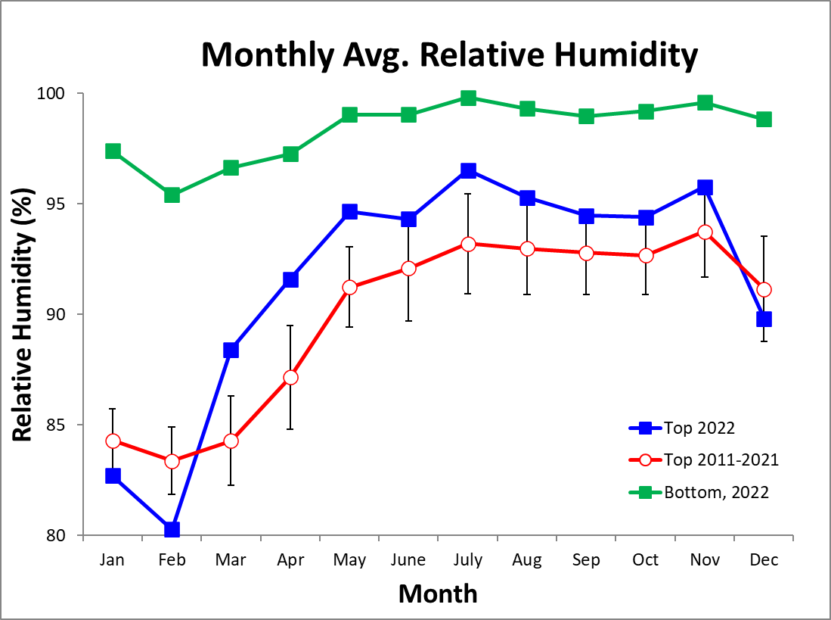
Max/Min/Avg Temperatures (°C)

 | 2m |  |  | 45m
Average | Max. | Min. | Avg | Max. | Min. | Avg
January | 24.9 | 28.1 | 23.3 | 25.3 | 27.8 | 23.7
February | 25.2 | 29.0 | 23.4 | 25.3 | 27.9 | 23.6
March | 25.5 | 29.9 | 23.3 | 25.5 | 28.2 | 23.7
April | 25.9 | 29.7 | 24.0 | 25.9 | 28.9 | 24.1
May | 25.9 | 28.9 | 24.3 | 25.7 | 28.8 | 23.9
June | 25.2 | 28.2 | 23.7 | 25.6 | 28.6 | 23.7
July | 25.4 | 27.8 | 23.9 | 25.4 | 28.1 | 23.7
August | 25.2 | 27.9 | 23.7 | 25.4 | 28.2 | 23.5
September | 25.2 | 28.1 | 23.6 | 25.4 | 28.5 | 23.5
October | 25.1 | 27.8 | 23.6 | 25.2 | 28.4 | 23.3
November | 24.4 | 27.0 | 23.1 | 24.8 | 27.6 | 23.2
December | 25.0 | 27.6 | 23.6 | 25.2 | 27.9 | 23.6
 | 2m |  |  | 45m
2022 | Max. | Min. | Avg | Max. | Min. | Avg
January | 24.5 | 27.9 | 22.8 | 24.9 | 27.9 | 22.9
February | 24.8 | 29.1 | 22.8 | 25.0 | 28.3 | 22.2
March | 25.2 | 28.9 | 23.4 | 25.5 | 28.6 | 23.7
April | 25.5 | 28.9 | 23.9 | 25.5 | 28.9 | 23.7
May | 25.6 | 28.5 | 24.1 | 25.5 | 28.7 | 23.7
June | 24.9 | 28.2 | 23.4 | 24.9 | 28.5 | 22.9
July | 25.1 | 27.5 | 23.7 | 25.1 | 28.3 | 23.3
August | 25.0 | 28.0 | 23.5 | 25.1 | 28.8 | 23.1
September | 25.1 | 28.4 | 23.5 | 25.1 | 29.1 | 23.1
October | 25.0 | 27.8 | 23.5 | 25.0 | 28.7 | 23.1
November | 24.5 | 27.0 | 23.2 | 24.5 | 28.0 | 22.7
December | 24.7 | 27.6 | 23.2 | 25.3 | 28.8 | 23.2

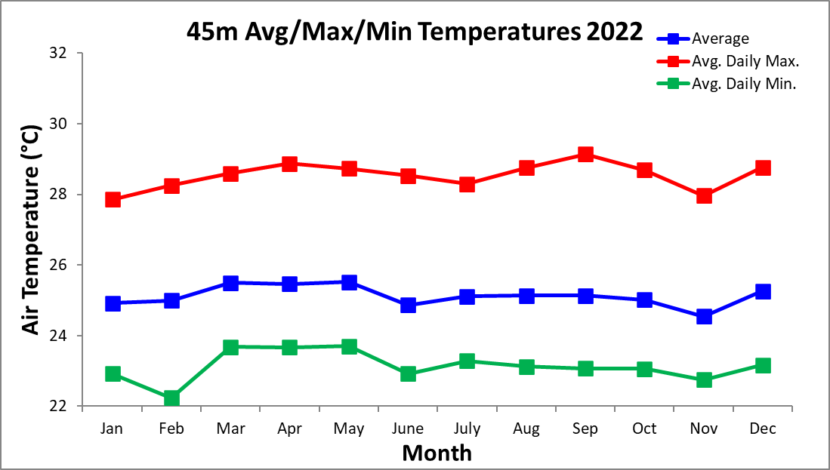

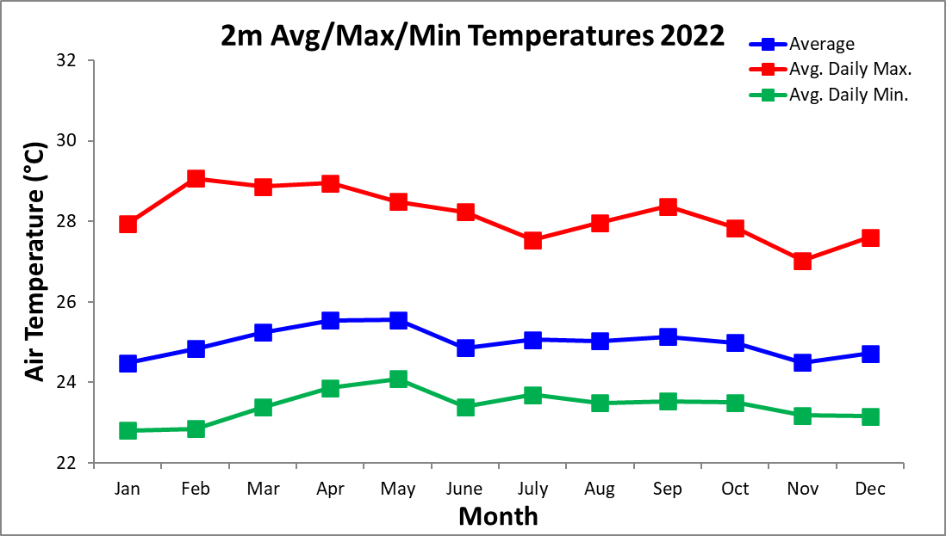

2022 Daily Total Radiation (MJ m⁻² day⁻¹)

 | Jan. | Feb. | Mar. | Apr. | May | June | July | Aug. | Sep. | Oct. | Nov. | Dec.
1 | 22.7 | 23.7 | 9.0 | 23.3 | 11.9 | 14.4 | 10.3 | 12.9 | 9.5 | 7.7 | 20.1 | 18.7
2 | 19.3 | 23.4 | 4.0 | 18.2 | 5.1 | 16.8 | 13.2 | 13.8 | 15.8 | 21.2 | 22.3 | 15.6
3 | 16.3 | 24.4 | 11.4 | 17.7 | 21.1 | 21.2 | 21.3 | 12.6 | 19.5 | 22.1 | 3.4 | 21.4
4 | 22.5 | 24.0 | 21.6 | 9.8 | 25.5 | 17.1 | 9.3 | 17.9 | 9.7 | 18.1 | 9.4 | 17.0
5 | 21.4 | 22.4 | 26.5 | 14.4 | 2.7 | 18.1 | 12.7 | 9.3 | 13.2 | 13.3 | 15.4 | 15.4
6 | 22.0 | 25.4 | 16.6 | 27.3 | 22.4 | 14.3 | 17.0 | 8.2 | 12.1 | 12.1 | 10.9 | 21.6
7 | 21.5 | 25.7 | 24.0 | 26.5 | 17.3 | 16.9 | 9.2 | 16.2 | 13.3 | 8.4 | 7.5 | 21.8
8 | 21.0 | 24.0 | 18.5 | 13.7 | 27.0 | 20.3 | 10.5 | 18.3 | 17.8 | 9.4 | 6.4 | 17.5
9 | 22.6 | 14.3 | 17.9 | 11.1 | 24.5 | 14.5 | 9.8 | 21.7 | 25.2 | 19.5 | 19.2 | 20.7
10 | 21.9 | 13.5 | 27.8 | 24.3 | 16.5 | 18.3 | 7.5 | 12.5 | 9.7 | 21.2 | 16.3 | 21.1
11 | 22.9 | 22.4 | 25.0 | 22.9 | 24.4 | 13.2 | 12.8 | 11.3 | 10.2 | 17.8 | 18.6 | 22.4
12 | 19.5 | 23.9 | 27.5 | 14.5 | 15.7 | 19.4 | 10.4 | 14.5 | 21.5 | 20.5 | 21.3 | 19.7
13 | 19.1 | 23.4 | 26.2 | 17.0 | 21.8 | 20.7 | 14.1 | 15.3 | 20.8 | 12.2 | 3.2 | 19.2
14 | 21.2 | 18.8 | 20.0 | 17.8 | 13.4 | 11.7 | 20.4 | 14.2 | 15.2 | 19.0 | 14.7 | 15.3
15 | 23.2 | 16.9 | 24.7 | 13.4 | 23.5 | 23.3 | 14.2 | 7.3 | 14.6 | 21.2 | 10.8 | 13.9
16 | 18.8 | 26.0 | 9.9 | 24.5 | 11.8 | 15.7 | 20.0 | 21.2 | 11.9 | 18.2 | 11.1 | 20.4
17 | 21.2 | 22.8 | 23.0 | 11.3 | 8.0 | 10.4 | 16.7 | 21.3 | 16.9 | 12.8 | 9.0 | 17.1
18 | 15.6 | 25.8 | 25.1 | 17.4 | 8.8 | 12.5 | 13.6 | 21.0 | 11.0 | 10.4 | 9.3 | 20.8
19 | 19.3 | 26.6 | 16.4 | 25.8 | 13.6 | 19.9 | 14.1 | 22.1 | 11.7 | 11.4 | 18.5 | 10.1
20 | 21.7 | 20.5 | 22.8 | 21.3 | 7.2 | 20.9 | 12.7 | 17.2 | 17.5 | 12.2 | 16.3 | 21.7
21 | 21.7 | 26.4 | 14.2 | 27.2 | 22.3 | 6.0 | 9.9 | 4.1 | 19.8 | 6.7 | 9.6 | 17.7
22 | 21.6 | 19.4 | 24.3 | 26.5 | 10.6 | 15.2 | 10.4 | 8.0 | 16.1 | 13.7 | 15.8 | 21.5
23 | 23.2 | 26.6 | 25.7 | 23.6 | 21.7 | 19.9 | 12.5 | 23.6 | 14.8 | 13.3 | 16.0 | 21.5
24 | 23.9 | 22.3 | 25.5 | 24.1 | 13.4 | 8.8 | 15.5 | 19.9 | 12.2 | 17.3 | 14.4 | 22.1
25 | 20.4 | 19.9 | 24.5 | 14.3 | 19.7 | 9.7 | 13.9 | 4.9 | 22.6 | 16.8 | 12.5 | 22.2
26 | 22.2 | 27.1 | 23.5 | 19.9 | 18.5 | 11.3 | 13.5 | 14.7 | 18.1 | 22.0 | 12.8 | 22.7
27 | 23.2 | 25.7 | 7.2 | 9.8 | 10.6 | 13.4 | 13.6 | 14.7 | 14.1 | 14.1 | 17.7 | 22.0
28 | 20.3 | 18.8 | 13.0 | 12.0 | 8.6 | 12.0 | 9.5 | 15.7 | 10.3 | 23.3 | 10.0 | 20.4
29 | 22.4 |  | 19.9 | 7.1 | 12.5 | 12.4 | 20.4 | 20.2 | 18.5 | 22.9 | 7.1 | 10.2
30 | 24.3 |  | 18.3 | 6.6 | 10.6 | 21.0 | 10.8 | 20.4 | 18.1 | 22.4 | 11.7 | 22.3
31 | 21.3 |  | 21.4 |  | 10.2 |  | 23.2 | 13.1 |  | 20.4 |  | 22.4

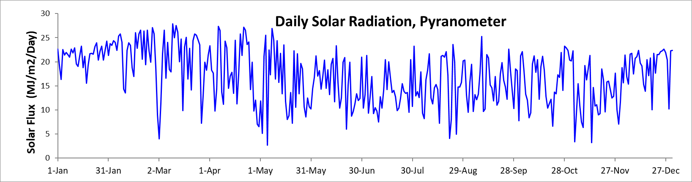
Monthly Average Total Daily Solar Radiation (Pyranometer)
 | 2011-2021 |  | 2022
 | Avg Daily Total (Mj/m²) | Avg Daily Max. (J/m²/s) | Avg Daily Total (Mj/m²) | Avg Daily Max. (J/m²/s)
January | 20.4 | 1150.1 | 21.2 | 1161.7
February | 21.7 | 1203.4 | 22.5 | 1205.8
March | 21.7 | 1260.4 | 19.9 | 1269.1
April | 20.0 | 1284.0 | 18.1 | 1290.1
May | 16.0 | 1156.5 | 15.5 | 1090.8
June | 14.8 | 1124.6 | 15.6 | 1142.81
July | 14.2 | 1131.0 | 13.6 | 1153.0
August | 14.8 | 1128.5 | 15.1 | 1144.0
September | 15.2 | 1202.4 | 15.4 | 1235.5
October | 15.0 | 1175.4 | 16.2 | 1198.3
November | 13.6 | 1107.6 | 13.0 | 1040.3
December | 16.2 | 1143.8 | 19.2 | 1149.9
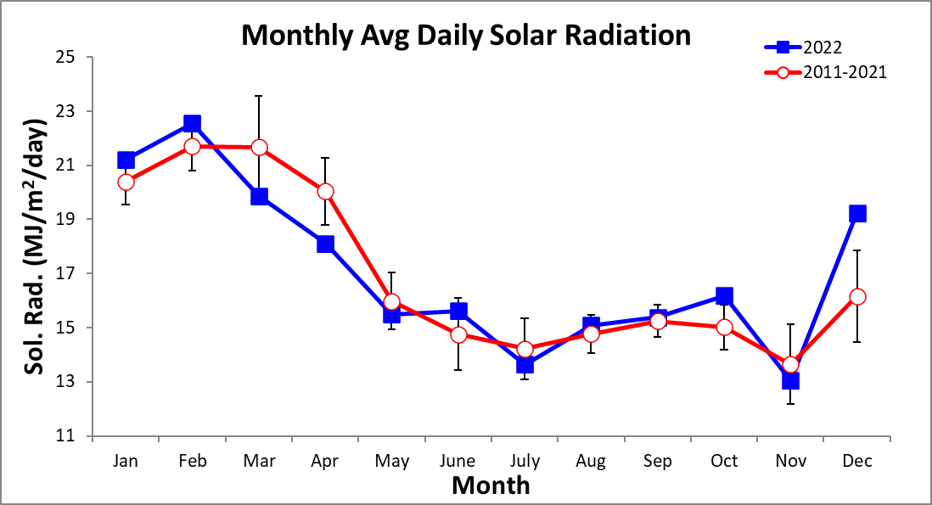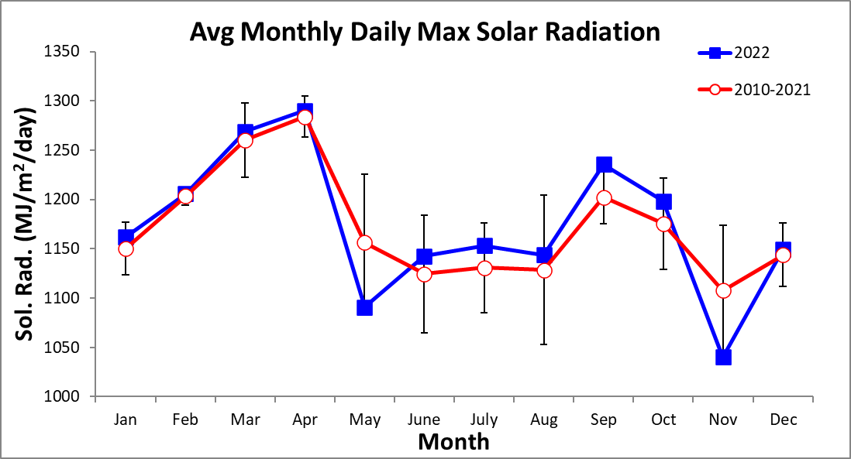
2022 Daily PAR (Mol m⁻² day⁻¹)

 | Jan. | Feb. | Mar. | Apr. | May | June | July | Aug. | Sep. | Oct. | Nov. | Dec.
1 | 49.3 | 51.5 | 19.3 | 48.1 | 24.8 | 30.0 | 21.6 | 26.5 | 19.5 | 15.9 | 39.4 | 34.9
2 | 42.2 | 50.6 | 9.1 | 37.5 | 11.4 | 34.7 | 27.3 | 28.3 | 31.8 | 42.6 | 43.1 | 29.4
3 | 35.8 | 53.1 | 24.7 | 37.2 | 44.0 | 43.5 | 44.0 | 26.0 | 39.6 | 44.6 | 7.5 | 39.8
4 | 48.9 | 51.9 | 45.1 | 20.6 | 52.3 | 35.2 | 19.5 | 36.4 | 19.9 | 36.2 | 18.6 | 31.9
5 | 43.9 | 48.0 | 55.0 | 30.4 | 6.1 | 37.6 | 26.3 | 19.5 | 26.8 | 27.0 | 30.0 | 29.1
6 | 47.5 | 55.2 | 35.2 | 55.7 | 46.7 | 29.6 | 34.8 | 17.0 | 24.6 | 24.3 | 22.0 | 40.2
7 | 46.7 | 55.8 | 50.1 | 54.1 | 35.8 | 34.9 | 19.0 | 33.4 | 27.3 | 17.2 | 15.5 | 40.2
8 | 45.6 | 52.6 | 37.9 | 28.6 | 55.7 | 41.8 | 21.4 | 37.0 | 36.7 | 19.3 | 13.1 | 32.5
9 | 48.8 | 31.4 | 37.6 | 23.8 | 50.4 | 29.8 | 20.2 | 43.7 | 51.0 | 38.7 | 36.7 | 38.5
10 | 47.2 | 29.8 | 57.5 | 49.8 | 34.1 | 38.1 | 15.7 | 25.3 | 19.9 | 42.0 | 31.2 | 39.1
11 | 49.4 | 48.8 | 51.6 | 46.8 | 50.6 | 27.3 | 26.2 | 23.2 | 20.8 | 36.1 | 35.7 | 41.6
12 | 42.7 | 51.8 | 56.8 | 29.7 | 32.8 | 40.0 | 21.5 | 29.2 | 43.6 | 41.3 | 40.6 | 37.0
13 | 41.4 | 50.4 | 54.4 | 35.0 | 45.3 | 42.8 | 28.7 | 30.9 | 41.8 | 24.5 | 6.8 | 35.6
14 | 46.2 | 41.2 | 41.9 | 36.5 | 28.1 | 24.6 | 41.5 | 29.1 | 30.8 | 37.6 | 28.7 | 28.6
15 | 50.5 | 36.8 | 51.1 | 28.0 | 49.1 | 48.2 | 29.3 | 15.3 | 29.6 | 42.4 | 21.0 | 26.6
16 | 41.0 | 55.8 | 21.7 | 49.8 | 24.6 | 32.5 | 40.3 | 42.1 | 24.0 | 36.4 | 21.6 | 38.2
17 | 46.1 | 49.1 | 47.8 | 23.6 | 17.5 | 21.7 | 34.1 | 42.7 | 34.4 | 25.9 | 18.0 | 31.9
18 | 34.1 | 55.3 | 51.7 | 35.9 | 18.9 | 25.8 | 28.1 | 41.7 | 22.6 | 21.1 | 18.6 | 38.5
19 | 41.9 | 56.5 | 33.9 | 52.5 | 28.8 | 40.8 | 29.3 | 44.0 | 23.6 | 23.1 | 35.5 | 19.4
20 | 46.8 | 44.5 | 47.1 | 43.6 | 15.3 | 43.0 | 26.1 | 34.3 | 35.3 | 24.6 | 31.4 | 40.2
21 | 47.5 | 56.2 | 29.6 | 55.4 | 46.5 | 13.0 | 20.7 | 8.6 | 40.2 | 14.0 | 19.0 | 33.1
22 | 47.3 | 40.8 | 50.1 | 54.3 | 22.2 | 31.1 | 21.7 | 16.9 | 32.7 | 27.7 | 29.6 | 39.9
23 | 50.0 | 55.1 | 53.2 | 48.8 | 44.6 | 41.1 | 25.9 | 47.2 | 29.8 | 26.9 | 30.4 | 39.8
24 | 51.8 | 46.6 | 52.5 | 50.5 | 27.9 | 18.4 | 31.7 | 39.8 | 25.0 | 34.6 | 27.5 | 40.7
25 | 44.6 | 41.3 | 50.3 | 29.8 | 40.6 | 20.5 | 28.7 | 10.7 | 45.6 | 33.2 | 24.0 | 40.7
26 | 47.8 | 55.7 | 47.9 | 42.0 | 37.7 | 23.6 | 27.9 | 29.8 | 36.8 | 43.2 | 24.4 | 41.7
27 | 50.7 | 53.2 | 16.1 | 20.8 | 22.2 | 27.7 | 28.0 | 30.2 | 28.2 | 27.7 | 33.5 | 40.4
28 | 44.6 | 39.1 | 27.2 | 25.6 | 18.0 | 24.9 | 19.7 | 31.5 | 20.9 | 45.2 | 20.1 | 37.8
29 | 48.3 |  | 41.2 | 15.1 | 25.8 | 25.7 | 41.5 | 41.0 | 37.5 | 44.8 | 14.6 | 19.5
30 | 52.2 |  | 37.9 | 14.3 | 22.1 | 43.0 | 22.1 | 40.7 | 36.7 | 43.4 | 23.0 | 41.2
31 | 45.9 |  | 44.0 |  | 21.2 |  | 46.2 | 26.6 |  | 39.7 |  | 41.2

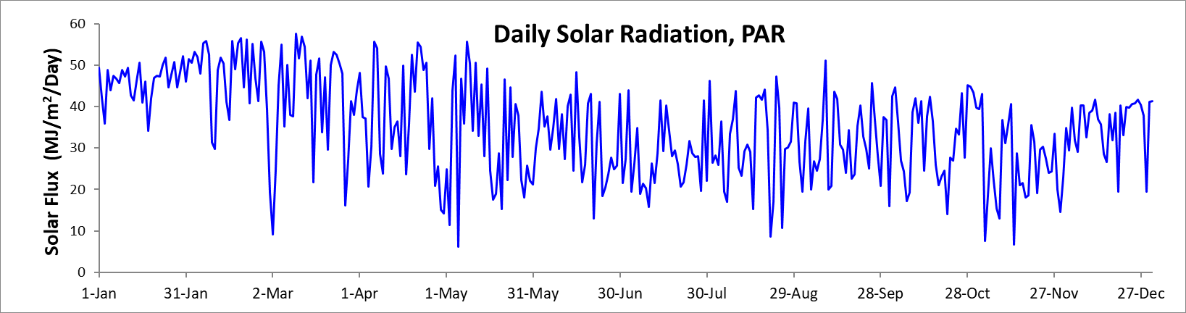

Monthly Average PAR
 | 2019-2021 |  | 2022
 | Avg Daily Total (Mj/m²) | Avg Daily Max. (J/m²/s) | Avg Daily Total (Mj/m²) | Avg Daily Max. (J/m²/s)
January | 38.8 | 2272.3 | 46.0 | 2525.7
February | 43.0 | 2381.4 | 48.5 | 2591.9
March | 44.9 | 2545.3 | 41.3 | 2658.0
April | 39.7 | 2609.7 | 37.4 | 2664.6
May | 33.0 | 2361.2 | 32.2 | 2263.4
June | 30.8 | 2353.7 | 32.4 | 2422.3
July | 29.8 | 2351.2 | 28.0 | 2392.9
August | 29.8 | 2328.8 | 30.3 | 2296.8
September | 30.8 | 2436.3 | 30.3 | 2428.6
October | 30.6 | 2343.9 | 31.4 | 2320.6
November | 27.3 | 2212.0 | 25.2 | 2041.5
December | 32.3 | 2234.9 | 35.8 | 2146.9
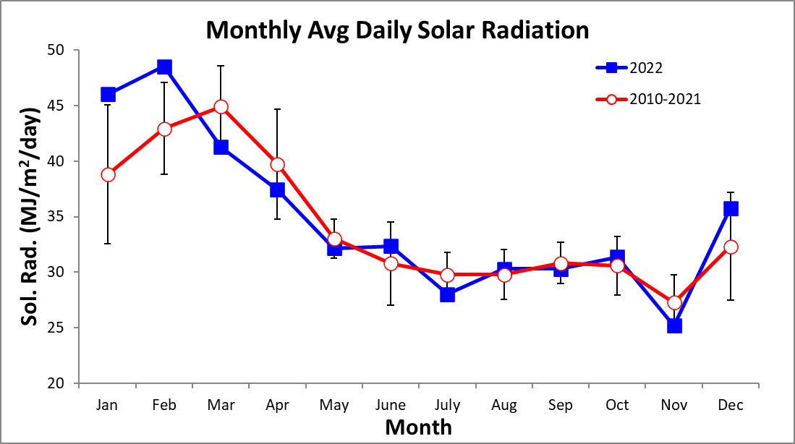
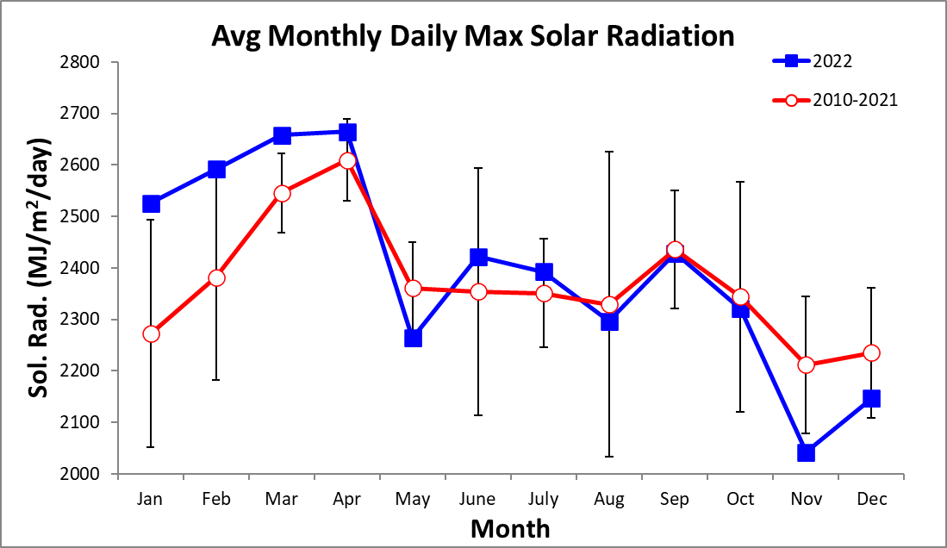

2022 Daily Average Wind Speed (km/h)
 | Jan. |  | Feb. |  |  | Mar. |  |  | Apr. |  |  | May |  |  | June |  | July |  | Aug. |  | Sep. |  | Oct. |  | Nov. |  |  | Dec.
 | Avg | Max | Avg | Max | Avg |  | Max | Avg |  | Max | Avg |  | Max | Avg |  | Max | Avg | Max | Avg | Max | Avg | Max | Avg | Max | Avg | Max | Avg |  |  | Max
1 | 10.9 | 33.5 | 10.6 | 33.9 | 14.5 |  | 39.6 | 8.3 |  | 33.6 | 8.0 |  | 25.9 | 6.2 |  | 35.3 | 8.1 | 23.3 | 6.5 | 23.8 | 8.9 | 21.8 | 9.5 | 24.6 | 6.5 | 23.7 | 7.3 |  | 26.5
2 | 9.1 | 28.2 | 11.2 | 36.1 | 12.2 |  | 34.1 | 10.6 |  | 30.9 | 5.8 |  | 18.5 | 8.6 |  | 31.8 | 8.3 | 25.7 | 5.2 | 18.9 | 6.3 | 19.3 | 8.1 | 22.8 | 8.1 | 25.3 | 7.5 |  | 28.7
3 | 8.4 | 30.4 | 10.3 | 33.2 | 9.8 |  | 30.0 | 9.8 |  | 29.6 | 8.6 |  | 24.5 | 12.4 |  | 31.5 | 8.5 | 26.6 | 5.9 | 21.9 | 6.7 | 29.4 | 7.7 | 25.7 | 7.6 | 24.6 | 9.0 |  | 30.0
4 | 11.4 | 33.5 | 11.5 | 36.3 | 11.3 |  | 38.9 | 8.4 |  | 28.9 | 9.8 |  | 29.0 | 10.8 |  | 22.7 | 7.9 | 27.4 | 6.9 | 24.5 | 6.6 | 23.4 | 8.9 | 27.8 | 8.4 | 21.5 | 8.2 |  | 35.5
5 | 11.7 | 34.8 | 12.1 | 36.0 | 12.7 |  | 37.5 | 7.3 |  | 25.2 | 7.4 |  | 23.0 | 7.7 |  | 25.2 | 6.8 | 23.6 | 7.5 | 25.1 | 6.0 | 25.8 | 7.2 | 29.4 | 7.3 | 20.0 | 8.3 |  | 25.0
6 | 10.4 | 29.1 | 10.7 | 34.6 | 11.7 |  | 30.1 | 11.1 |  | 34.2 | 9.9 |  | 25.4 | 6.0 |  | 17.5 | 7.5 | 23.0 | 5.7 | 21.1 | 6.6 | 24.5 | 7.0 | 25.6 | 9.0 | 25.4 | 8.0 |  | 28.4
7 | 10.4 | 35.0 | 11.1 | 33.4 | 11.5 |  | 36.7 | 9.6 |  | 27.8 | 7.0 |  | 24.5 | 7.9 |  | 27.0 | 8.1 | 23.5 | 5.5 | 17.3 | 5.6 | 21.9 | 9.3 | 26.0 | 7.1 | 15.8 | 9.6 |  | 32.5
8 | 9.7 | 31.9 | 11.2 | 35.5 | 11.4 |  | 35.9 | 9.1 |  | 28.4 | 6.6 |  | 26.9 | 11.0 |  | 31.9 | 7.2 | 30.4 | 8.0 | 27.0 | 6.9 | 18.5 | 9.6 | 27.7 | 6.4 | 21.5 | 8.4 |  | 23.5
9 | 11.1 | 32.0 | 13.9 | 36.0 | 9.8 |  | 26.7 | 9.5 |  | 30.0 | 9.1 |  | 29.1 | 8.2 |  | 22.8 | 7.5 | 21.3 | 8.9 | 26.4 | 10.2 | 25.3 | 15.6 | 34.3 | 9.9 | 24.0 | 7.6 |  | 26.4
10 | 11.5 | 36.7 | 11.6 | 31.2 | 10.3 |  | 34.6 | 12.9 |  | 37.2 | 6.5 |  | 26.0 | 6.9 |  | 24.6 | 7.3 | 24.2 | 7.2 | 20.3 | 5.6 | 29.8 | 9.7 | 26.4 | 9.0 | 26.3 | 8.0 |  | 28.3
11 | 10.9 | 34.0 | 10.6 | 33.6 | 11.4 |  | 33.3 | 13.1 |  | 34.4 | 6.4 |  | 23.0 | 7.1 |  | 31.2 | 6.0 | 15.7 | 5.6 | 30.1 | 7.0 | 18.5 | 6.9 | 22.3 | 8.0 | 21.4 | 8.8 |  | 26.4
12 | 9.8 | 28.6 | 12.2 | 34.2 | 11.8 |  | 31.9 | 12.6 |  | 36.3 | 5.4 |  | 17.2 | 12.3 |  | 36.6 | 5.3 | 26.6 | 6.3 | 20.4 | 6.0 | 22.2 | 7.8 | 24.6 | 6.2 | 24.1 | 8.1 |  | 24.7
13 | 9.6 | 30.5 | 11.1 | 32.9 | 12.3 |  | 36.6 | 11.2 |  | 30.1 | 7.6 |  | 27.9 | 7.1 |  | 26.0 | 5.2 | 22.8 | 5.1 | 18.3 | 7.9 | 24.5 | 8.6 | 23.1 | 5.7 | 20.1 | 9.3 |  | 33.7
14 | 10.0 | 33.8 | 8.7 | 35.6 | 11.5 |  | 30.9 | 9.5 |  | 27.6 | 6.5 |  | 21.1 | 6.7 |  | 28.1 | 6.7 | 24.8 | 4.7 | 25.1 | 7.0 | 26.7 | 11.7 | 28.7 | 6.1 | 19.0 | 9.0 |  | 27.5
15 | 10.6 | 31.2 | 10.6 | 30.5 | 13.5 |  | 37.0 | 8.9 |  | 26.7 | 7.8 |  | 32.0 | 11.4 |  | 28.1 | 6.6 | 20.4 | 7.0 | 27.0 | 5.7 | 14.5 | 8.4 | 20.3 | 5.6 | 19.7 | 8.9 |  | 26.9
16 | 10.7 | 28.6 | 13.7 | 37.9 | 9.1 |  | 26.9 | 11.4 |  | 31.3 | 8.4 |  | 28.5 | 7.9 |  | 30.5 | 10.9 | 32.9 | 8.5 | 22.9 | 7.4 | 26.6 | 4.4 | 24.6 | 6.7 | 30.1 | 8.7 |  | 26.6
17 | 12.8 | 34.8 | 11.8 | 35.6 | 11.6 |  | 34.2 | 8.8 |  | 29.5 | 7.7 |  | 28.5 | 7.0 |  | 20.2 | 8.1 | 27.4 | 9.1 | 31.3 | 7.7 | 24.0 | 7.3 | 21.9 | 8.1 | 24.0 | 7.2 |  | 24.0
18 | 14.2 | 36.1 | 12.3 | 38.4 | 11.5 |  | 33.3 | 8.7 |  | 27.3 | 7.9 |  | 20.5 | 6.6 |  | 19.3 | 6.9 | 24.7 | 10.5 | 34.7 | 8.5 | 23.2 | 7.0 | 22.5 | 6.7 | 18.2 | 8.5 |  | 26.7
19 | 13.1 | 37.8 | 13.0 | 39.1 | 12.0 |  | 35.5 | 8.7 |  | 28.1 | 6.8 |  | 16.6 | 10.9 |  | 29.1 | 6.5 | 25.7 | 9.5 | 32.0 | 11.7 | 32.5 | 6.6 | 22.4 | 6.9 | 24.3 | 9.8 |  | 27.5
20 | 12.1 | 35.7 | 13.0 | 37.5 | 13.1 |  | 40.9 | 7.7 |  | 25.1 | 10.5 |  | 28.3 | 7.5 |  | 20.0 | 6.8 | 23.1 | 8.8 | 27.5 | 9.6 | 29.6 | 5.0 | 17.5 | 7.9 | 35.8 | 10.5 |  | 34.8
21 | 11.8 | 34.5 | 13.8 | 41.7 | 12.8 |  | 33.0 | 6.9 |  | 23.3 | 7.8 |  | 19.3 | 5.9 |  | 20.7 | 5.6 | 17.6 | 6.8 | 33.6 | 7.9 | 22.6 | 4.5 | 20.0 | 8.6 | 25.7 | 9.1 |  | 26.0
22 | 11.8 | 32.7 | 13.2 | 37.8 | 10.3 |  | 31.9 | 5.6 |  | 22.8 | 6.2 |  | 18.4 | 7.6 |  | 21.9 | 4.7 | 19.0 | 6.3 | 18.9 | 9.5 | 29.1 | 5.9 | 21.9 | 9.0 | 25.5 | 8.9 |  | 27.8
23 | 12.7 | 36.7 | 14.4 | 38.7 | 10.8 |  | 30.1 | 6.8 |  | 22.9 | 6.6 |  | 26.5 | 7.4 |  | 24.5 | 5.8 | 22.4 | 6.7 | 25.2 | 6.5 | 17.8 | 6.6 | 21.8 | 7.4 | 22.5 | 11.3 |  | 33.3
24 | 11.7 | 33.8 | 12.2 | 35.7 | 12.8 |  | 37.0 | 6.2 |  | 21.6 | 7.4 |  | 25.8 | 7.2 |  | 21.1 | 7.6 | 27.1 | 5.3 | 27.3 | 6.4 | 24.4 | 6.3 | 27.7 | 5.0 | 19.5 | 11.4 |  | 41.7
25 | 10.8 | 37.2 | 11.8 | 32.3 | 13.4 |  | 35.8 | 5.4 |  | 18.4 | 6.9 |  | 18.5 | 5.9 |  | 14.3 | 5.6 | 27.2 | 5.9 | 20.5 | 9.5 | 24.7 | 6.0 | 20.6 | 4.7 | 20.5 | 11.5 |  | 36.0
26 | 11.1 | 34.5 | 13.5 | 37.5 | 14.2 |  | 38.5 | 6.6 |  | 24.4 | 6.1 |  | 19.8 | 6.1 |  | 20.7 | 6.2 | 25.3 | 5.8 | 24.0 | 9.8 | 24.7 | 6.3 | 25.4 | 4.9 | 25.2 | 9.8 |  | 27.3
27 | 11.3 | 33.6 | 13.1 | 35.7 | 12.2 |  | 33.3 | 6.2 |  | 22.8 | 6.4 |  | 22.4 | 5.8 |  | 24.2 | 6.7 | 26.5 | 5.3 | 28.4 | 7.5 | 24.4 | 5.5 | 21.8 | 5.1 | 23.4 | 8.1 |  | 31.6
28 | 11.1 | 32.8 | 14.6 | 42.6 | 10.3 |  | 37.2 | 6.5 |  | 28.5 | 6.8 |  | 37.8 | 6.1 |  | 26.2 | 6.7 | 19.6 | 4.6 | 17.3 | 5.9 | 18.7 | 6.4 | 25.2 | 5.5 | 24.6 | 8.0 |  | 31.8
29 | 11.8 | 35.6 |  |  | 11.4 |  | 30.2 | 6.5 |  | 24.0 | 4.8 |  | 16.0 | 6.8 |  | 31.4 | 7.1 | 27.2 | 9.6 | 25.1 | 7.4 | 20.3 | 6.3 | 23.5 | 7.4 | 24.5 | 7.0 |  | 21.3
30 | 13.0 | 37.5 |  |  | 9.2 |  | 30.6 | 7.9 |  | 19.8 | 6.2 |  | 22.7 | 8.1 |  | 31.1 | 7.8 | 26.0 | 6.7 | 26.6 | 9.5 | 25.2 | 5.9 | 22.7 | 5.6 | 18.6 | 9.7 |  | 29.0
31 | 11.2 | 39.1 |  |  | 10.1 |  | 28.9 |  |  |  | 7.9 |  | 20.1 |  |  |  | 9.8 | 29.0 | 5.5 | 18.3 |  |  | 7.2 | 21.4 |  |  | 8.7 |  | 27.6
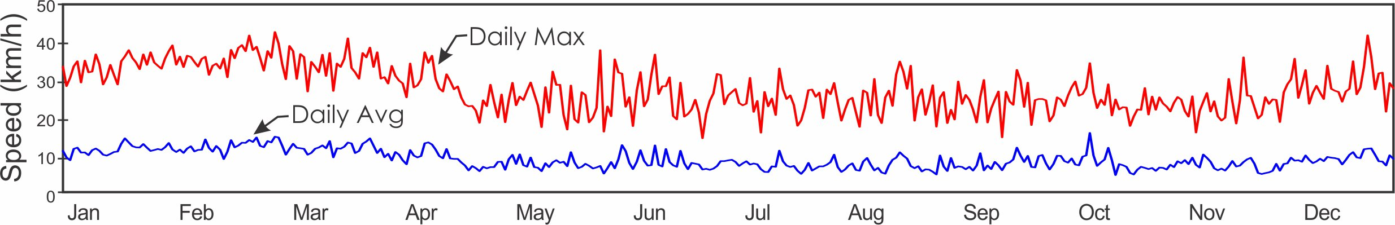
2022 Average Daily Mean Vector Wind Direction
 |  | Jan. | Feb. | Mar. | Apr. | May | June | July | Aug. | Sep. | Oct. | Nov. | Dec.
 | 1 | 314.3 | 335.6 | 321.1 | 336.0 | 283.8 | 139.1 | 174.2 | 290.0 | 115.4 | 118.8 | 42.6 | 340.4
 | 2 | 282.8 | 315.4 | 328.6 | 321.3 | 295.8 | 125.2 | 108.6 | 164.8 | 112.1 | 99.2 | 312.4 | 350.2
 | 3 | 318.0 | 322.8 | 346.7 | 295.7 | 319.4 | 126.9 | 320.8 | 271.0 | 333.0 | 312.5 | 262.8 | 353.3
 | 4 | 347.0 | 336.2 | 340.7 | 278.0 | 317.0 | 115.3 | 285.0 | 289.2 | 275.6 | 303.7 | 126.0 | 333.6
 | 5 | 337.1 | 332.2 | 329.8 | 315.8 | 210.2 | 98.1 | 267.2 | 271.0 | 223.5 | 271.8 | 143.3 | 270.1
 | 6 | 331.7 | 334.4 | 321.5 | 326.6 | 119.9 | 113.4 | 280.7 | 246.4 | 277.8 | 266.9 | 139.6 | 306.7
 | 7 | 337.1 | 334.3 | 331.5 | 317.6 | 32.4 | 122.8 | 273.1 | 290.4 | 280.4 | 258.1 | 126.9 | 351.8
 | 8 | 338.5 | 325.4 | 335.1 | 323.7 | 19.7 | 120.0 | 305.5 | 302.5 | 145.1 | 196.3 | 193.5 | 345.8
 | 9 | 340.2 | 305.7 | 320.9 | 347.1 | 306.4 | 120.5 | 272.0 | 305.4 | 112.6 | 126.0 | 120.7 | 353.0
 | 10 | 340.5 | 308.9 | 329.8 | 343.9 | 296.7 | 118.7 | 263.5 | 278.3 | 324.6 | 109.9 | 118.3 | 340.9
 | 11 | 344.3 | 330.5 | 328.6 | 331.5 | 295.2 | 125.5 | 248.1 | 226.0 | 266.2 | 262.9 | 124.1 | 331.7
 | 12 | 337.6 | 332.6 | 326.5 | 330.4 | 154.0 | 117.7 | 132.2 | 252.2 | 189.8 | 260.5 | 281.1 | 293.2
 | 13 | 315.4 | 320.8 | 333.9 | 328.5 | 274.3 | 128.2 | 278.5 | 257.6 | 114.8 | 137.1 | 250.5 | 290.1
 | 14 | 333.9 | 357.9 | 342.0 | 330.3 | 286.3 | 168.1 | 294.0 | 321.2 | 121.5 | 124.1 | 143.9 | 279.8
 | 15 | 342.3 | 351.4 | 333.8 | 326.5 | 279.7 | 117.0 | 300.2 | 256.5 | 149.2 | 104.7 | 281.8 | 281.2
 | 16 | 324.9 | 335.5 | 341.0 | 320.3 | 280.6 | 126.0 | 328.1 | 124.6 | 250.2 | 316.7 | 303.1 | 306.5
 | 17 | 332.7 | 320.0 | 321.1 | 297.0 | 287.5 | 261.7 | 300.9 | 325.0 | 114.6 | 248.4 | 254.8 | 335.3
 | 18 | 335.1 | 330.5 | 334.1 | 286.1 | 278.6 | 152.1 | 282.1 | 332.0 | 140.0 | 273.9 | 262.5 | 338.1
 | 19 | 339.3 | 340.8 | 333.3 | 302.6 | 163.7 | 117.3 | 312.6 | 325.9 | 123.6 | 228.2 | 284.3 | 334.1
 | 20 | 324.8 | 336.5 | 335.7 | 297.6 | 116.0 | 113.8 | 259.5 | 309.5 | 127.2 | 209.9 | 281.1 | 328.9
 | 21 | 329.9 | 343.7 | 334.8 | 274.1 | 72.4 | 245.4 | 208.9 | 221.0 | 109.0 | 236.2 | 273.0 | 341.9
 | 22 | 338.9 | 340.3 | 336.3 | 163.3 | 294.3 | 282.4 | 225.3 | 174.7 | 99.2 | 241.5 | 277.6 | 339.2
 | 23 | 333.2 | 341.7 | 334.4 | 127.6 | 329.3 | 292.8 | 277.4 | 136.7 | 354.4 | 272.0 | 271.0 | 331.8
 | 24 | 335.3 | 336.7 | 327.8 | 78.1 | 117.2 | 278.4 | 271.7 | 125.7 | 217.9 | 283.8 | 203.7 | 342.6
 | 25 | 328.4 | 344.7 | 329.5 | 128.0 | 79.9 | 246.3 | 287.1 | 273.8 | 122.8 | 287.5 | 243.9 | 336.4
 | 26 | 328.2 | 341.5 | 327.8 | 272.6 | 353.6 | 207.7 | 244.4 | 267.6 | 120.6 | 290.6 | 145.2 | 327.7
 | 27 | 334.3 | 331.4 | 315.9 | 264.1 | 282.3 | 243.6 | 271.7 | 262.0 | 121.6 | 314.0 | 213.3 | 312.5
 | 28 | 308.5 | 328.4 | 339.3 | 290.6 | 276.6 | 282.4 | 260.3 | 229.8 | 135.2 | 1.9 | 293.2 | 305.8
 | 29 | 325.9 |  | 342.8 | 270.6 | 291.4 | 282.9 | 289.3 | 119.5 | 138.4 | 284.3 | 274.2 | 314.5
 | 30 | 332.9 |  | 333.1 | 266.2 | 273.9 | 289.3 | 299.6 | 146.0 | 119.4 | 125.7 | 306.6 | 327.6
 | 31 | 336.8 |  | 329.3 |  | 119.7 |  | 333.2 | 14.4 |  | 138.0 |  | 309.6
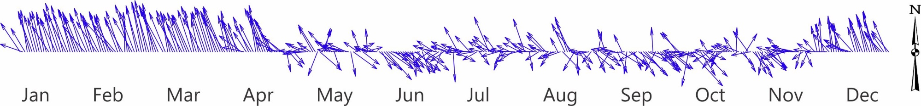

Average Monthly Wind Speed and Direction
 | 2019-2021 |  |  | 2022
 | Speed | Max | Dir. | Speed | Max | Dir.
January | 9.2 | 31.5 | 347.5 | 11.2 | 33.7 | 331.1
February | 12.2 | 35.9 | 346.2 | 12.1 | 35.8 | 332.7
March | 12.8 | 36.3 | 349.3 | 11.6 | 33.9 | 331.8
April | 10.2 | 31.2 | 342.4 | 8.7 | 27.7 | 310.7
May | 8.1 | 26.4 | 340.9 | 7.3 | 24.0 | 291.7
June | 7.6 | 26.1 | 333.1 | 7.9 | 25.8 | 149.8
July | 7.9 | 26.3 | 326.7 | 7.1 | 24.5 | 280.4
August | 7.4 | 25.2 | 329.4 | 6.8 | 24.5 | 278.1
September | 7.5 | 25.3 | 345.6 | 7.6 | 23.8 | 134.5
October | 7.3 | 24.7 | 10.5 | 7.5 | 24.2 | 247.3
November | 7.9 | 26.0 | 321.7 | 7.0 | 23.2 | 242.1
December | 7.9 | 27.8 | 334.6 | 8.9 | 28.9 | 325.9

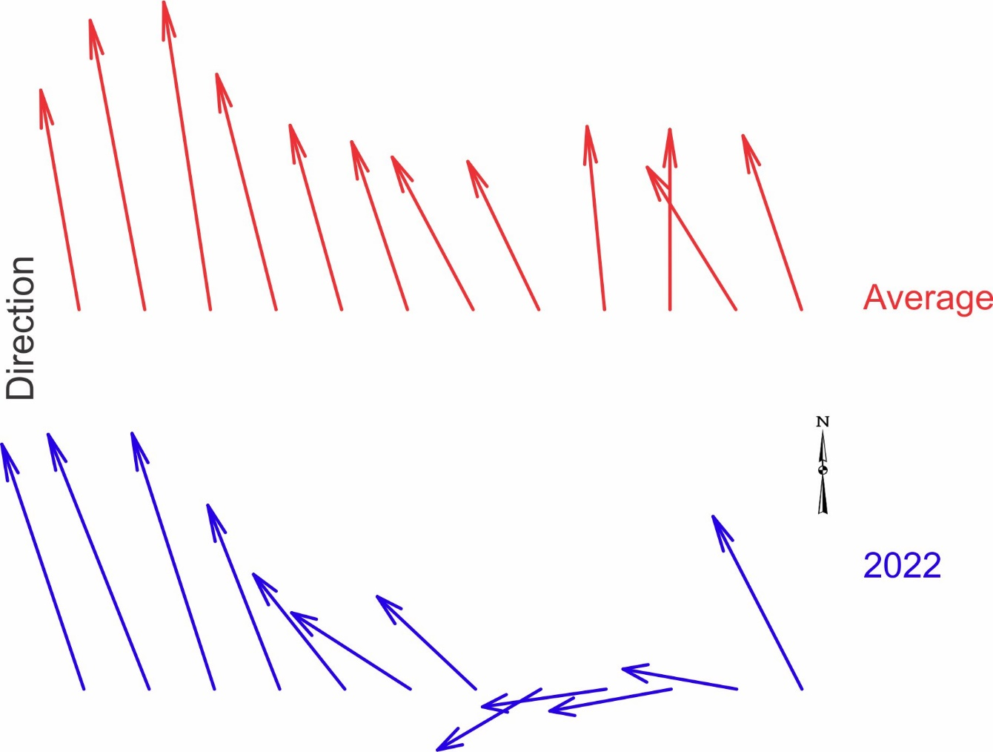

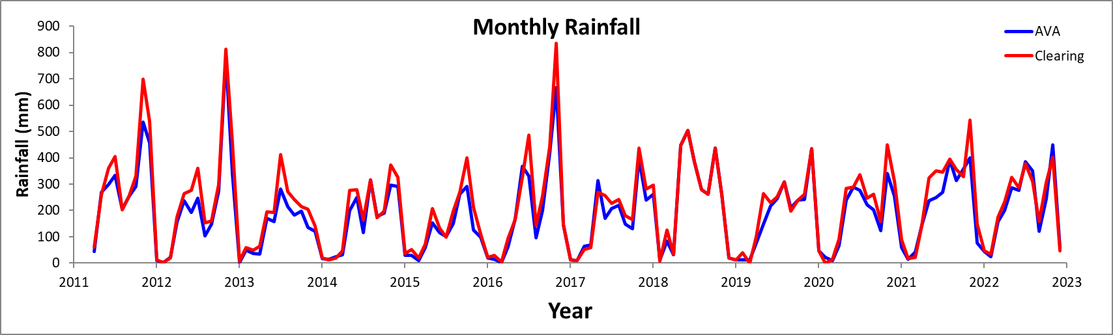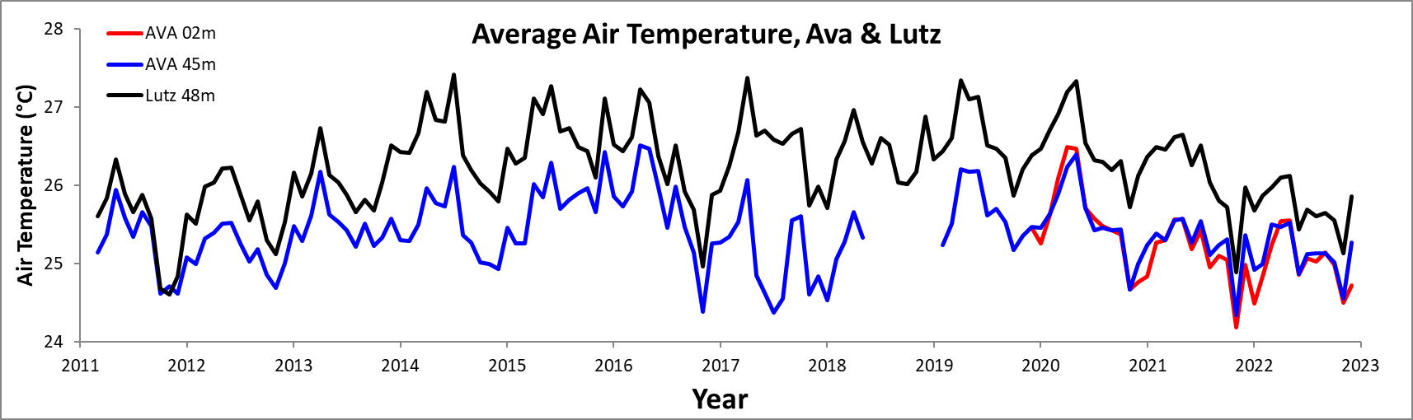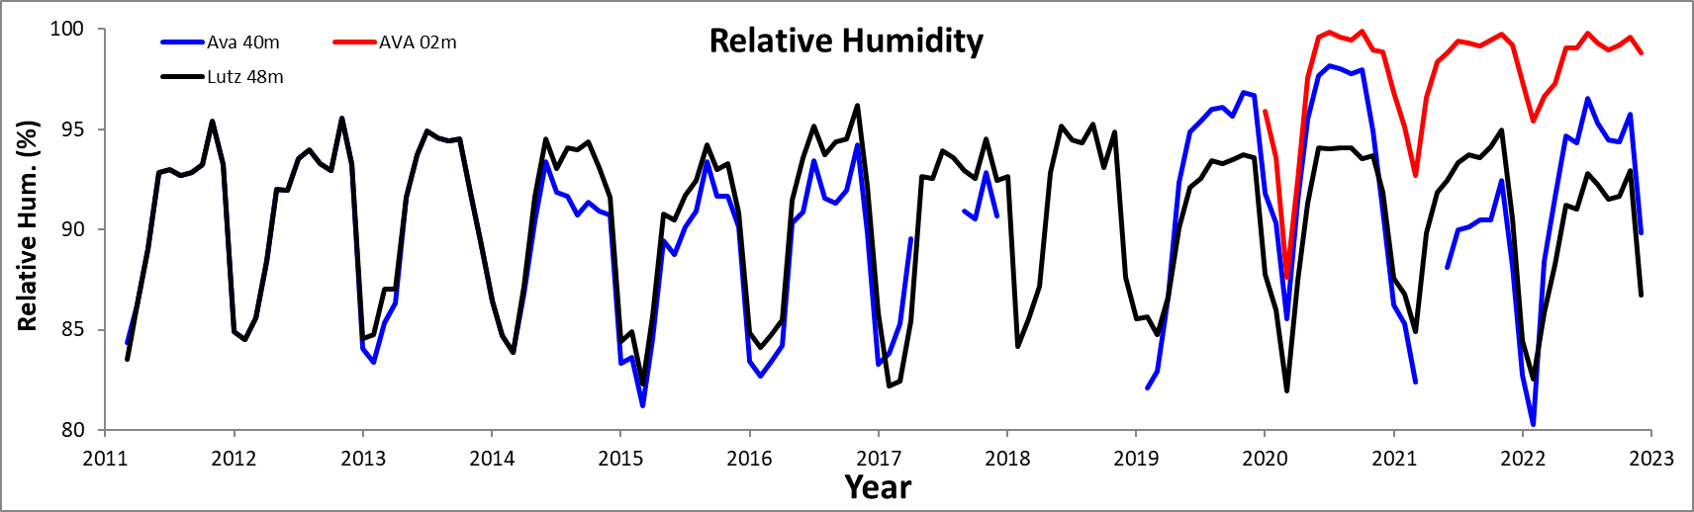
Long-term Monthly Averages/Totals
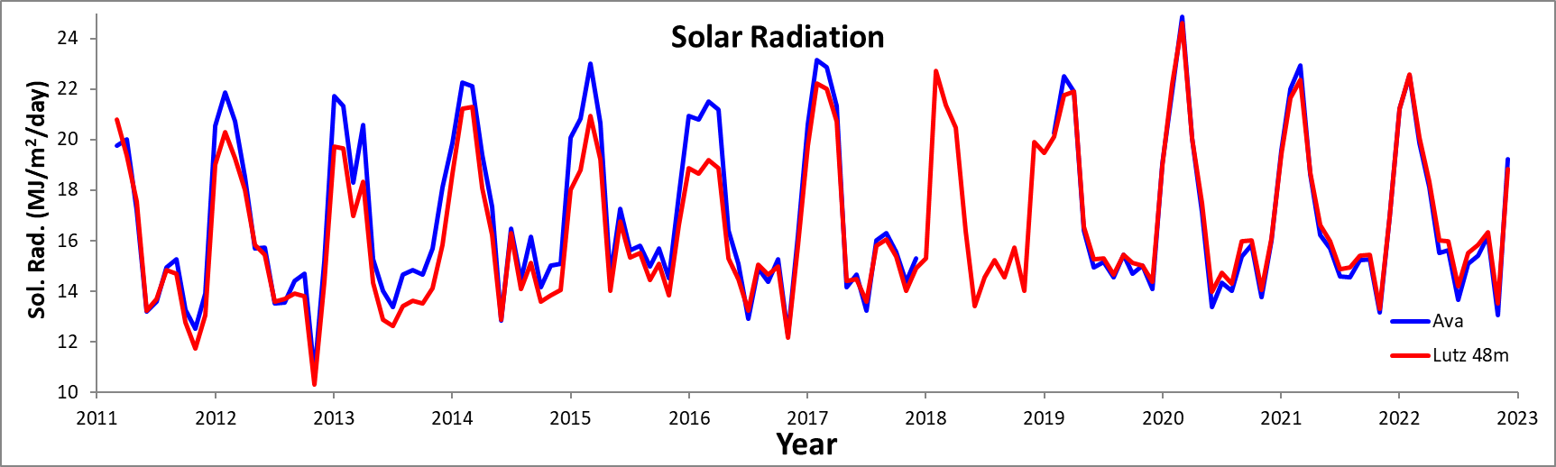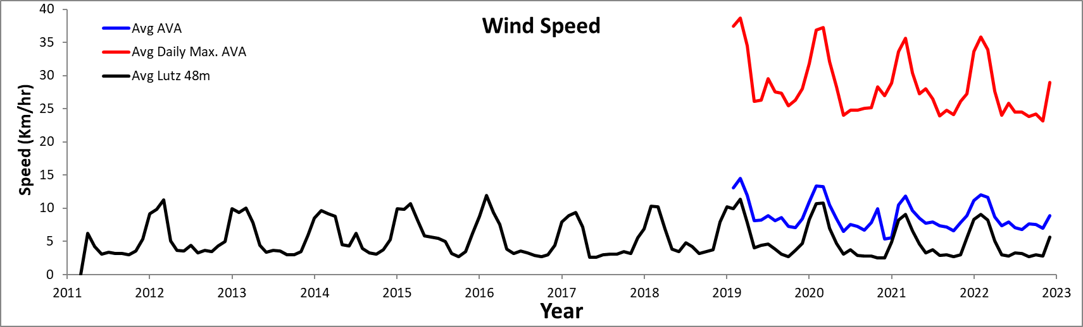

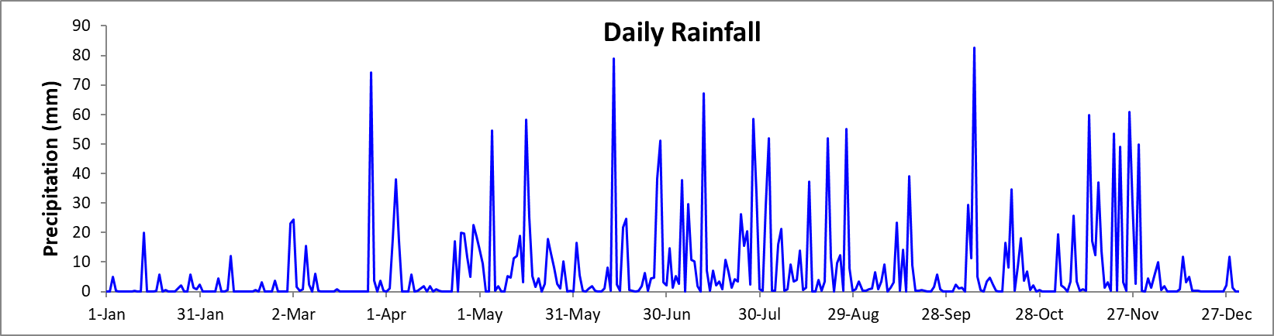
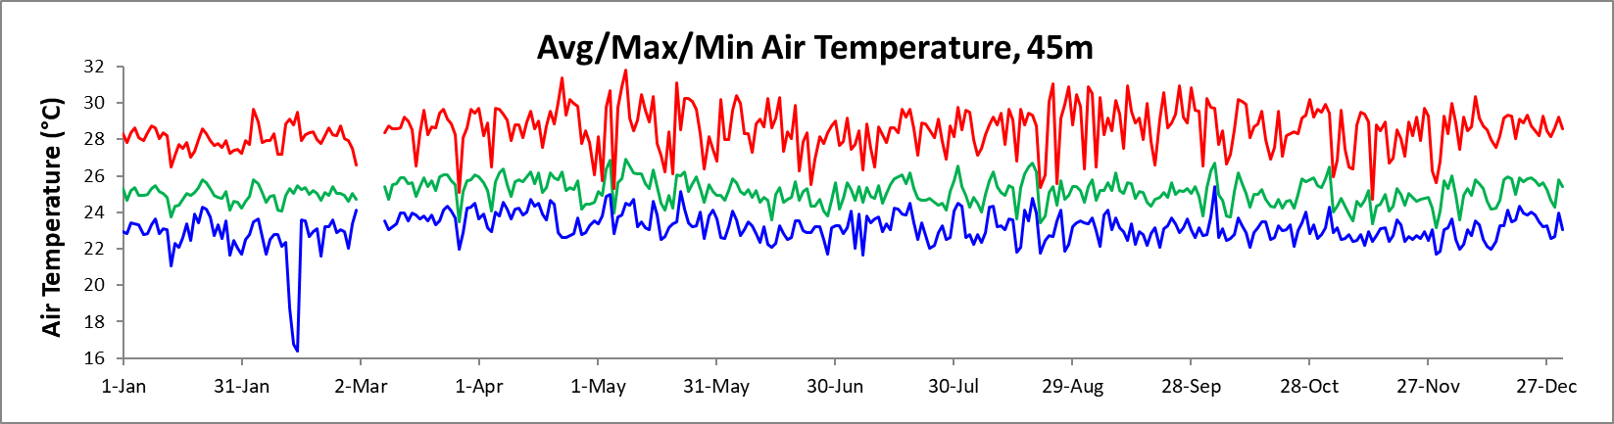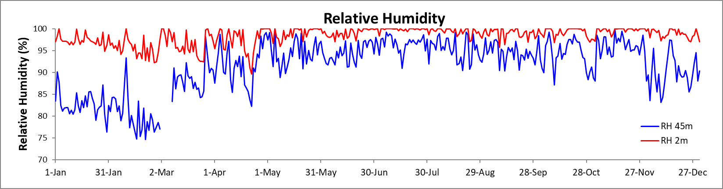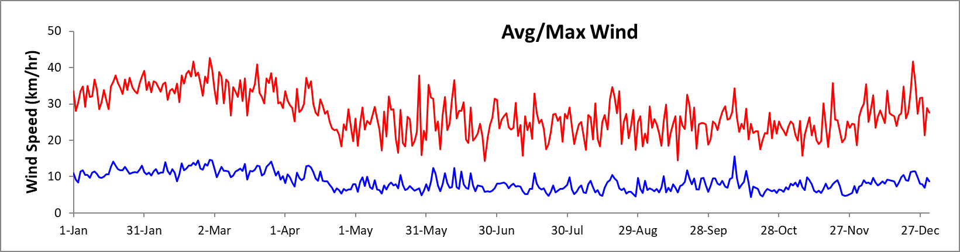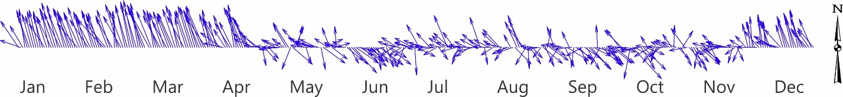
2022 Daily Averages/Totals

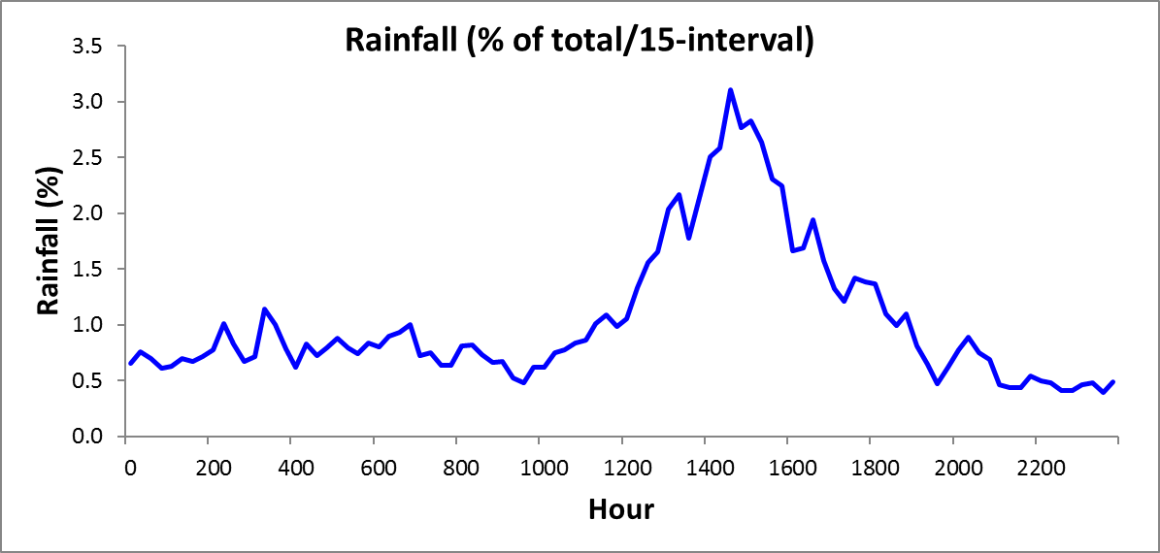

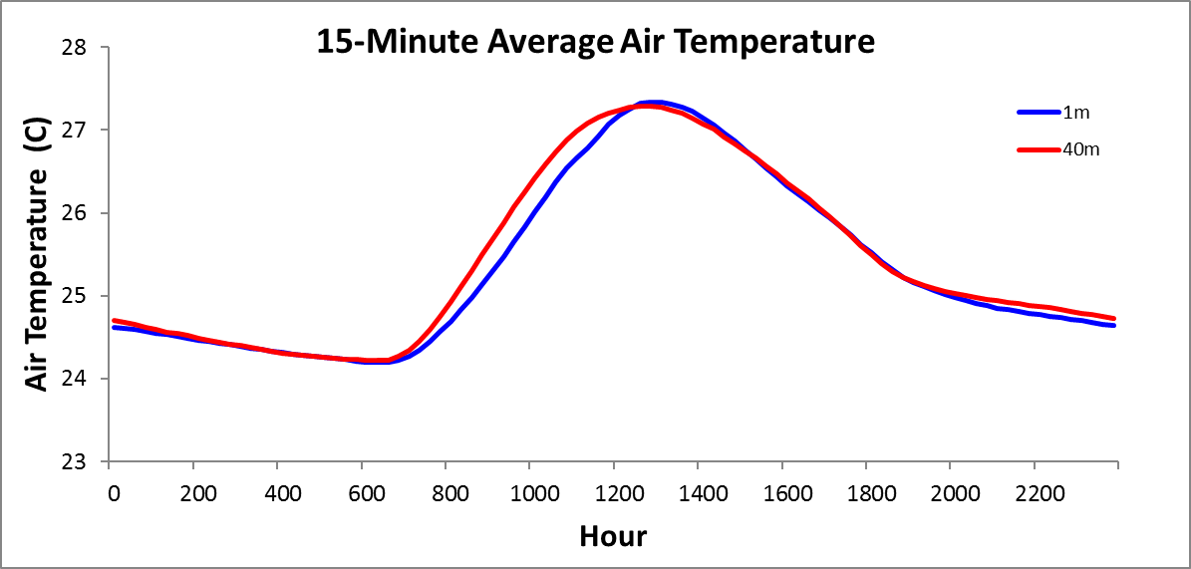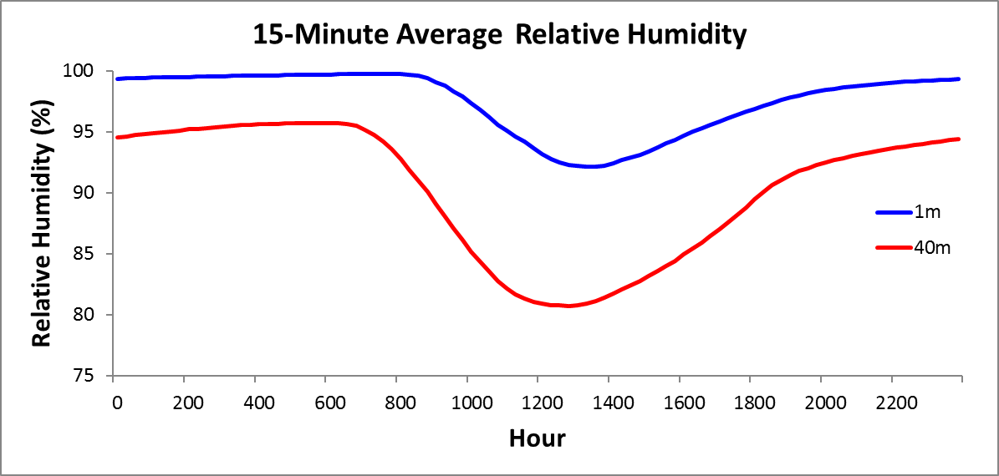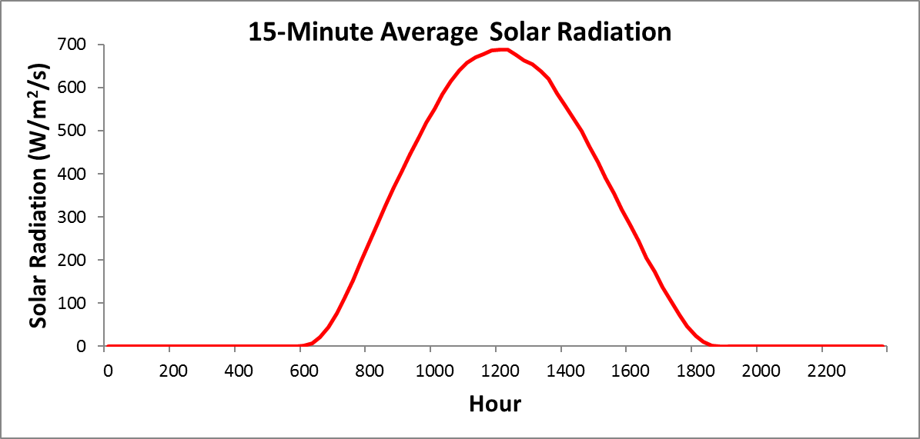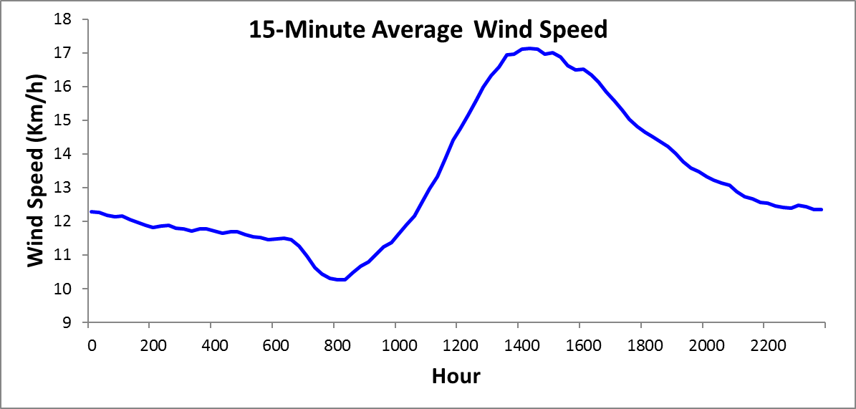
Long-term 15-min Averages
Long-term 15-min Averages

Comparison of Daily Lutz and Ava Tower Data
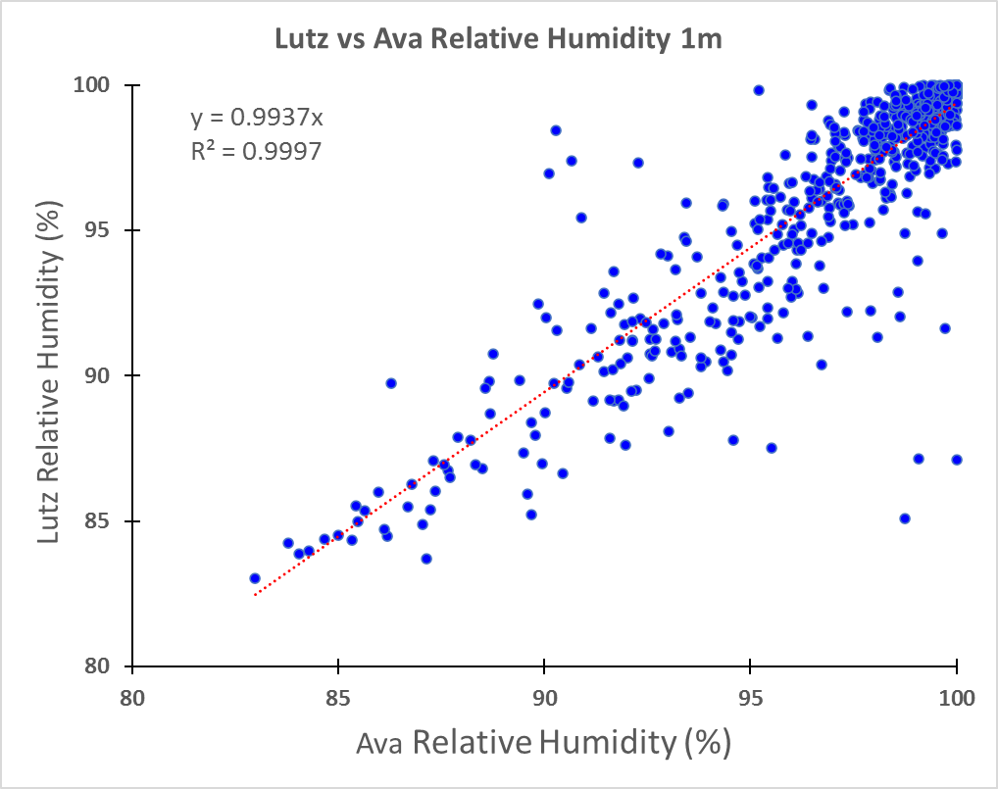 | 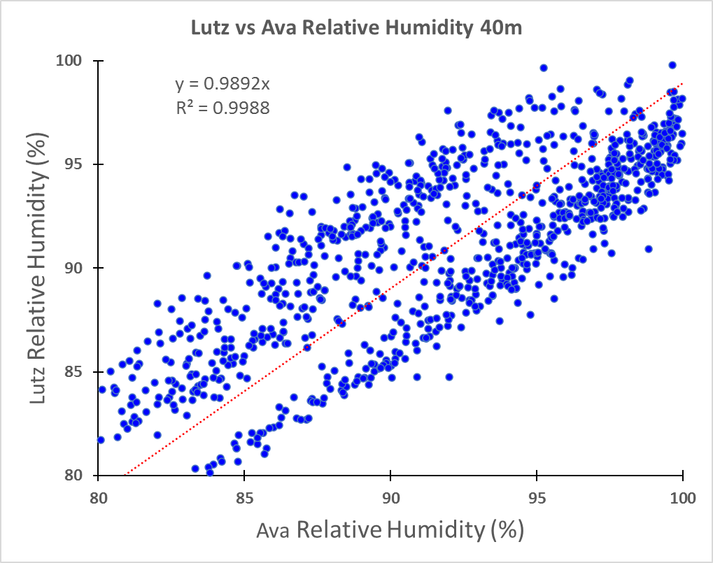
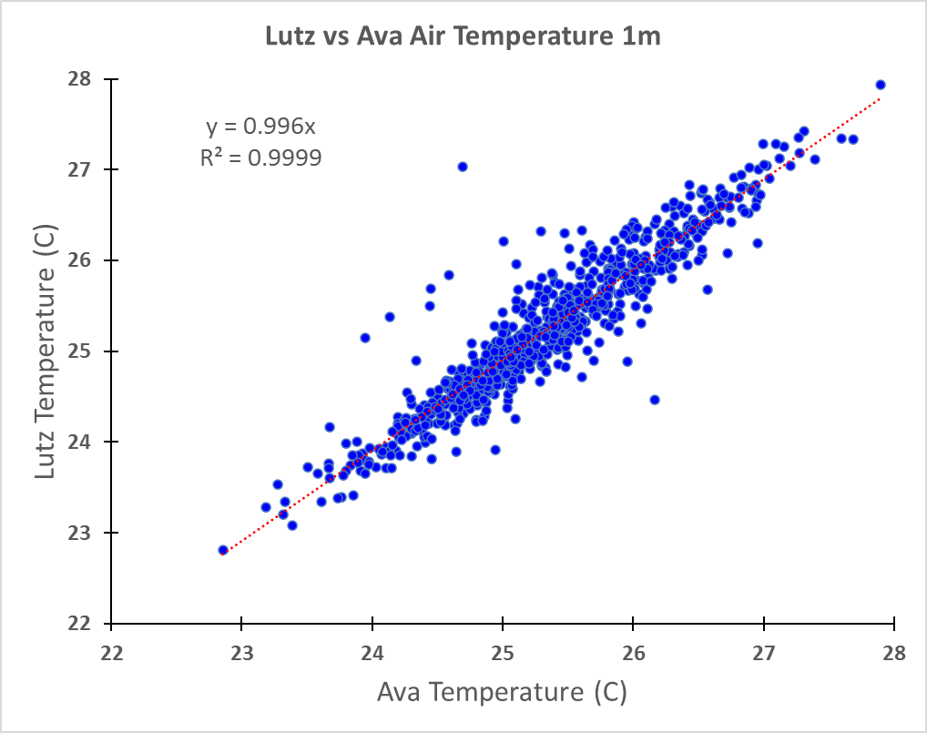 | 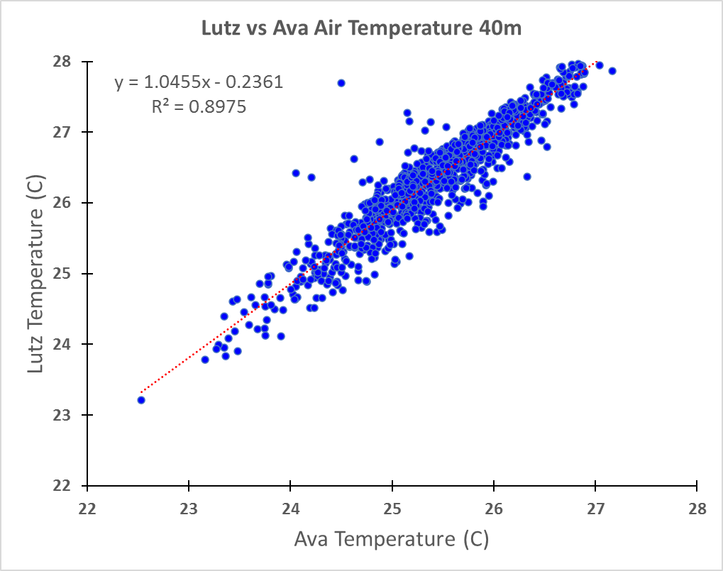
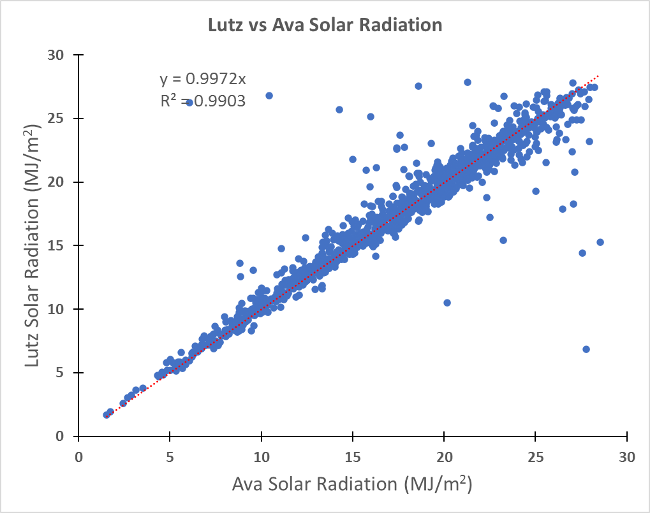 | 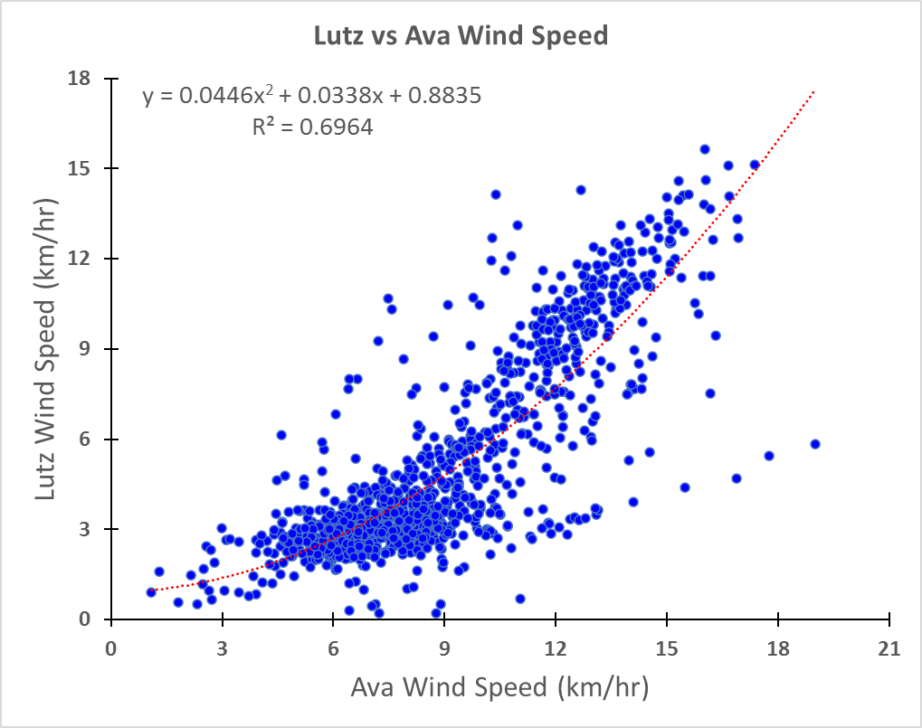

Comparison of Clearing and Ava Tower Precipitation
(Tipping bucket)

