2022 Meteorological and Hydrological
Summary for
Barro Colorado Island

Prepared by: Steven Paton

Introduction

This is the 23rd of a series of yearly reports summarising the past year’s Smithsonian Tropical Research Institute’s Physical Monitoring Program on BCI. This report is not meant to be exhaustive in its coverage in that it summarizes only some of the most ‘important’ or interesting parameters available. Any comments on how future yearly summaries could be improved would be appreciated. Additional copies of this report, reports from previous years, and downloadable data from BCI and other research locations, can be obtained from: http://biogeodb.stri.si.edu/physical_monitoring/research/barrocolorado

Setting

The meteorology and hydrology monitoring programs on BCI are described in detail in Climate and Moisture Variability in a Tropical Forest: Long-term Records from Barro Colorado Island, Panamá. Windsor (1990). Much of the information on the next five pages has been extracted from this source.

BCI (9°10'N, 79°51'W) is a completely forested, 1567 ha island with a 53.9km perimeter, rising 137m above Lake Gatun. The island receives an average of 2660.7mm of rain per year. The meteorological year is divided into two parts: a pronounced dry season (on average from December 19 to May 2), and a wet season (May to mid-December) – as measured by the manual rain gauge in the Clearing station between 2025 and 2022. On average, 300.3 and 2265.3mm of rain falls during the dry and wet seasons respectively (based on 1972-2022 precipitation). Relative humidity, soil moisture, air pressure, solar radiation, evapotranspiration, wind speed and direction all show marked wet/dry season differences. On the other hand, temperature varies relatively little throughout the year.

This report summarises data taken from three locations: a 48 m walk-up tower located within the Lutz catchment, a small clearing (‘El Claro’) located among several laboratory buildings, and the Conrad trail weir (see map on the following page).

The Lutz catchment is located on the Northeast slope of BCI immediately southwest of the laboratory clearing and dormitory area. is probably typical of many small catchment areas on the island. The catchment encompasses 9.69ha. of secondary forest that was cut during the Canal construction sometime between 1880 and 1915. The catchment has a steep grade that drains rapidly into the stream. The Lutz tower, with sensors at 10m intervals, provides a vertical meteorological transect through the forest canopy. Both the tower and the weir were constructed in 1972.

Sometime between April 27 and the 30th, 2018, a tree located approximately 40-50m SW of the tower, fell on the tension cables of the tower. The event left the tower unsafe for taking daily manual measurements. Most critically, this resulted in the suspension of the daily Evapotranspiration measurements which means that we are no longer able to estimate the hydrological balance for the catchment. This event created the largest gap ever observed in the area of the Lutz tower. Damaged to cables left the tower unsafe and, as a result, manual data on the data were not collected beginning on May 1. There is a high probability that the new gap will have affected temperature & humidity readings for all sensors from 1m to 42m. The tower was still not repaired at the writing of this report.

The Clearing station is in the northwest corner of a large clearing area with a combination of forest and open structures (tower and cages) around the perimeter. The station is located in a fenced in area measuring approximately 5 x 5m. The Clearing is a grass-covered area and is intended to mimic a forest clearing.

The Conrad weir is located on the western side of the island and drains a 42.5ha catchment in the center of the island – including most of the 50ha plot. The catchment is divided into a small, gently sloped area near to the weir, and a much larger, nearly flat area in the center of the island.

The physical aspects of both the Clearing and the Tower have changed relatively little over time. However, cycles of vegetation removal and re-growth may have had subtle effects at both locations. The recent removal and construction of buildings near to the Clearing may also have affected the local climate. Furthermore, it is evident that the canopy surrounding the Tower has risen, perhaps by as much as 5m, since the Tower was erected – with possible measurement implications, especially at the highest levels.

In May of 2002, three new, 6-foot sections were added to the top of the tower. It was necessary to remove many branches from trees next to the tower during this operation. The new maximum height of the tower is now approximately 48m. A parallel series of meterological wind speed measurements were made a both the old maximum height and the new for several years. Temperature and humidity are collected at both heights. Wind direction (it was not possible to measure at the old height) and solar radiation (assumed to be unaffected by the change in height) were moved to the 48m level and never measured in parallel.

Data were collected using two different methods: electro-mechanically (electronic sensors, data loggers, chart recorders, etc.), and manually (rain gauges, max-min thermometers, sling psychrometers, soil samples, ETGages) by a field technician - Mr. Brian Harvey. Since the Lutz tower tree strike, many of the manual measurements have been suspended. Manual relative humidity, rainfall and evapotranspiration measurements are still being made in the clearing. Soil moisture measurements continue to be made as usual.

Ava versus Lutz towers. With almost three complete years of data at the Ava tower it is now possible meaningfully compare the conditions at the two locations. For the years 2021 & 2022:
- Temperatures at the top of the Ava tower are, on average, 0.7C lower than the top of the Lutz tower (25.2C versus 25.7C).
- Average wind at the top of Ava towers is significantly greated than at the top of the Lutz tower: 8.5 km/h versus 4.7 km/h
- Rainfall at the Ava tower is approximately 11% less than at Lutz: 216mm/month versus 240mm/month
- Solar radiation, temperature and relative humidty at the bottom, relative humidity at the top, and wind direction are not significantly different.

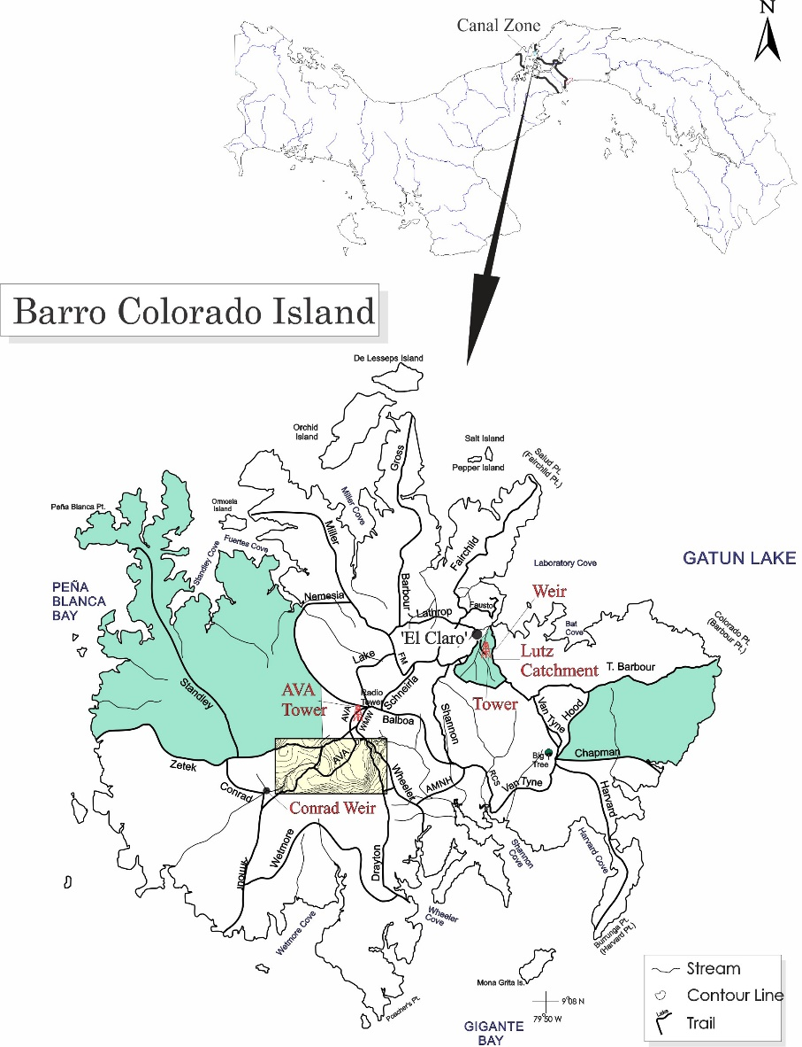

Some summaries (evapotranspiration and soil humidity) are based entirely on manual measurements. Other summaries (solar radiation, wind direction) are based entirely on electro-mechanical measurements. Finally, some summaries (rainfall and relative humidity) are based on combinations of manual and electro-mechanical measurements.

The 2020-1 Pandemic
Beginning on March 20, 2020, STRI was forced to shut down almost all field operations. This resulted in the Physical Monitoring Program suspending of all manual measurements on BCI, as well as sensor replacements and calibrations (the latter two were reestablished in Sept.). Most important of these were the evapotranspiration and soil moisture data, for which there are no electronic equivalents. There are also no temperature/humidity data for the 42m Lutz tower sensor between April 14 and Sept. 15. On Feb 1 of 2021, most monitoring activities returned to normal.

The Data

This report summarises the following data:

Lutz Tower 1m relative humidity
temperature
20m relative humidity
temperature
42m evapotranspiration
relative humidity
temperature
48m evapotranspiration
solar radiation (pyranometer)
relative humidity
temperature
wind speed and direction
Lutz catchment run-off
soil moisture
Conrad catchment run-off
‘El Claro’ air pressure
evapotranspiration
rainfall
relative humidity
temperature

Rainfall

Rainfall was collected by rain gauges in the Clearing, and by a tipping bucket in the Clearing. The rain gauges were read at approximately 9:00 am every day except weekends and holidays. Tipping buckets provide continuous rainfall information but tend to underestimate total rainfall by between 2% and 12% and for that reason are not used to provide data on absolute rainfall totals. Tipping buckets generate ‘events’ for every 0.254 mm of rainfall recorded. The underestimation seems to be due to the instruments’ inability to properly record intense periods of rainfall. To ‘fill in’ the missing rain gauge data, a computer program was written by the author that uses tipping bucket rainfall data to distribute the rain gauge data for those days when readings were not made. The program takes the total rainfall collected in the rain gauge and divides it up proportionally according to the rainfall patterns recorded by the tipping bucket. The estimated rainfall for the missing days is exactly equal to the rainfall collected by the rain gauge. The daily rainfall for the Clearing is shown on page 10.

During prolonged periods (>7 dyas) when rain gauge measurements are suspended, tipping bucket data are used to estimate the manual rainfall. A simple correlation analysis between monthly Tipping Buckent and Rain Gauge data shows that on average, the Tipping Bucket underestimates the manual gauge rainfall by 15.63%.

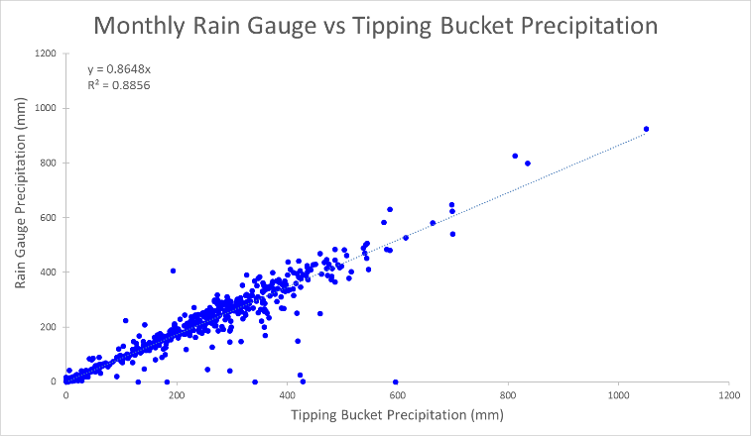

Rainfall Data prior to 1972 are provided by the Panama Canal Authority (ACP) station located approximately 360m to the NNW of the Clearing station.

Page 11 shows the monthly totals for this year. The graph on the same page compares this year’s monthly totals with the average monthly totals (±SD) for the period 1929 to 2022.

Page 12 shows yearly rainfall totals for all year since 1925. Time series graph and frequency histograms are presented for these data.

Page 13 breaks yearly rainfall approximately into wet and dry seasons. The average beginning and end dates for the seasons as defined by the Autoridad de Canal de Panamá (ACP) (Dec. 19 and May 2) are used. The two graphs on this page are frequency histograms showing the distribution of rainfalls (1929 to 2022) for the Dry and Wet Seasons. The arrow in each graph shows the rainfall for 2022 in relation to previous years. The small crossbar above each graph represents the mean (vertical bar) and the standard deviation (horizontal bar) for the period 1929 - 2022.

Page 14 shows the beginning and end dates of the Panama Canal watershed dry season as defined by the Meteorological and Hydrological Branch of the ACP. The ACP defines the existence of dry season by tracking 11 variables (see list below) and then making a subjective decision based on the performance of these variables, and their prior experience with weather patterns in the Panama Canal area. There are no publications justifying the use of this system and any questions should be directed to Johnny Cuevas of the Met. & Hyd. Branch of the ACP (jcuevas@pancanal.com). The data from Page 14 are shown graphically on Page 15. At the time of printing of this report, the 2022 wet season end date had not yet been published by the ACP.
Westerly Component of 300 HPA Wind
Gatun Lake Basin evaporation > 0.13" day⁻¹
Sea temperature at Amador < 80 °F
< 5 grams of water vapor kg⁻¹ below 12.0 ft
Temp-Dew point difference SFC-400 HPA., > 10°C
Howard Airforce Base wind speed SFC-4000 ft., > 15 knots
Intertropical Convergence Zone > 2 deg. Lat. south of Panama
Pacific coast sea breeze < 2 hours/day
Atlantic Coast surface wind average > 6.0 M.P.H.
Gatun Lake level (corrected for water usage) falling
Gatun Watershed daily rainfall average (of 26 stations) < .25"

Pages 16 and 17 show an analysis of rainfall ‘events’ (storms). For convenience, and again somewhat arbitrarily, I have defined a storm as any continuous period of rain separated by at least an hour from any other rainfall. Since this analysis required the timing of rainfall events, tipping bucket data were used. As a result, the absolute size of rainfall events should be considered as only an estimate since they will tend to disproportionately underestimate the size of storms - larger storms will be more underestimated than smaller ones. Keeping this in mind, the tables and graphs on this page compare the maximum storm size and the average storm size and duration per month for the period 1972 to 2021 and for the year 2022.

Run-off

Run-off at the Lutz catchment area was determined from the water level in a 120° V-notch weir. The height of the water was recorded by two separate instruments: continuously by a Stevens A-71 strip-chart, water level recorder and at five-minute intervals with a Sutton Radar level Recorder (replacing the ISCO Bubble Flow Meter in 2014). Data from these devices are converted (either directly or through a digitizing process) into run-off (m3) and then into rainfall equivalents.

Daily Lutz creek weir run-off totals are shown on page 18. These data are shown in terms of the equivalents of precipitation in mm. These values are calculated by taking the run-off and dividing by the total surface area of the catchment area (9.73 ha). In this way, the run-off can be more conveniently compared to the amount of rainfall.

Pages 19 shows the total monthly run-off. The first graph on page 19 compares average monthly run-off for the period 1973 to 2021 with 2022. The second graph compares monthly accumulated precipitation with 2022 and long-term monthly-accumulated run-off (in rainfall equivalents).

Run-off at the Catchment catchment area was determined from the water level in a two-stage, rectangular weir. Water level was originally measured using an ISCO Bubble Flow Meter, but recently has been measure with a pressure gauge. Pages 20 shows the total monthly run-off data for the Conrad Catchment as well as a comparison between the Lutz and Conrad weir run-off.

Soil Moisture
Soil moisture was determined gravimetrically based on samples collected weekly from Dec. and May, and bi-weekly from June to Nov. Samples are taken at two depths (0-10cm and 30-40cm) from ten sites in the Lutz catchment area. Samples of approximately 2.5 cm soil cores are made with an ‘Oakfield punch’. Page 21 shows the average soil moistures (% water by wet weight of soil) per month at each sample depth. The graph on page 22 compares monthly averages for the period 1986 to 2021 with those for 2022. The sampling locations were changed at the end of 2016 to near-by sites. This is done approximately every 4-5 years due to perturbations to the soil caused by the coring and trampling by the technician.

Relative Humidity
Relative humidity data were collected at 15-minute intervales by dataloggers attached to Campbell Sci. CS215 temperature/humidity sensors (Viasala HMP 35/45 sensors prior to 2010) at the same locations. The average monthly relative humidities are shown in tabular and graphical form on pages 23.

Temperature
Shaded air temperature data were collected at 15-minute intervales by dataloggers attached to to Campbell Sci. CS215 electronic temperature/humidity sensors (Viasala HMP 35/45 sensors prior to 2010) in the Clearing and at the 1m, 20m, 42m and 48m levels of the Lutz tower. The average monthly daily maximum and minimum temperatures are shown on pages 24 to 25.

Solar Radiation
Global solar radiation was measured at the top of the Lutz tower using one Kipp&Zonen SPLite2 and one LiCor LI200 pyranometer attached to a datalogger. 15-minute interval total (MJ m⁻²), maximum and minimum (J m⁻² s⁻¹) were recorded. Page 26 shows the Daily Global Radiation values. Page 27 shows total monthly Global Radiation.

Wind Speed and Direction
15-minute interval average, maximum and minimum wind speed plus average wind direction was recorded at the top of the Lutz tower using a Model 05103 Young Anemometer connected to a data logger.

Page 28 shows daily average and maximum wind speeds from the Young Anemometer located at 48m. The page 29 shows daily average wind direction. The angles indicated in the table and graph on this page represent the direction into which the wind was predominately blowing on a given day. Page 30 shows the monthly average and average daily-maximum wind speeds from 48m, and monthly average directions (Young Anemometer) for the year.

In addition to the electronic anemometers, manually read, totalizing anemometers were in use to measure wind passage between 1998 and 2007. This includes the period 2001-7 when totalizing anemometers were in operation at both 42m and 48m. An analysis of these data is shown on Page 31.

Estimated Evapotranspiration and Water Balance

Evapotranspiration was added to the meteorological program on BCI beginning in December of 1992 and is estimated using ceramic plate atmometers known as ETgauges. ETgauges estimate evapotranspiration by allowing water to be drawn up through a ceramic disk and out through a GorTex cover. A recent study by Fontain and Todd (Measuring Evaporation with Ceramic Bellani Plate Atmometers, 1993, Water Resources Bulletin, Vol. 29, No. 5, p. 785-795) found that such devices perform very well compared with more traditional methods of measuring evaporation.

ETgauges provide data that are very comparable with Class-A open evaporation pans. A 4-year study on BCI showed that yearly totals of the two systems vary by approximately 2%. ETgauges slightly overestimate ET during the dry season and underestimate during the rainy season – compared to the pans.

There are two ETgauges located at a height of 1.5m in the Clearing (the Lutz tower ETgauges have not been used since Apr. 2018 due to damage to the tower). The ETgauges are read at approximately the same time of day and with the same frequency as the rain gauges.

Long-term Monthly Averages/Totals
Pages 32 - 35 show the long-term, monthly Averages/Totals for rainfall, runoff, relative humidity, air temperatue, evapotranspiration, solar radiation, and wind speed.

Daily Averages/Totals for 2022
Pages 36 and 37 show the daily Averages/Totals for rainfall, runoff, relative humidity, air temperatue, evapotranspiration, solar radiation, and wind speed and direction.

Daily Patterns
Pages 38 and 39 show the daily patterns for air temperatue, relative humidity, solar radiation, rainfall and wind speed. These figures use electronic sensor data.

2022 Daily Rainfall (mm) on BCI recorded at ~930 hrs

 | Jan. | Feb. | Mar. | Apr. | May | June | July | Aug. | Sep. | Oct. | Nov. | Dec.
1 | 0.0 | 0.0 | 33.8 | 0.0 | 17.5 | 15.7 | 9.9 | 10.4 | 0.0 | 2.8 | 0.0 | 0.3
2 | 0.0 | 0.0 | 28.7 | 1.0 | 2.3 | 1.3 | 2.0 | 44.5 | 0.0 | 1.0 | 0.0 | 4.6
3 | 6.6 | 0.0 | 4.6 | 4.6 | 0.0 | 0.3 | 4.6 | 0.3 | 0.3 | 1.8 | 21.8 | 0.0
4 | 0.0 | 0.0 | 0.0 | 55.1 | 0.0 | 0.0 | 3.3 | 0.5 | 0.5 | 0.0 | 0.0 | 3.8
5 | 0.0 | 0.0 | 0.5 | 15.0 | 62.2 | 13.0 | 50.5 | 24.4 | 13.7 | 26.9 | 0.8 | 7.9
6 | 0.0 | 7.9 | 24.6 | 0.0 | 0.0 | 5.8 | 0.0 | 27.9 | 0.8 | 15.5 | 0.0 | 0.3
7 | 0.0 | 0.0 | 1.8 | 0.0 | 1.0 | 0.3 | 33.0 | 0.3 | 5.8 | 70.6 | 4.3 | 2.0
8 | 0.0 | 0.0 | 0.0 | 0.0 | 0.0 | 0.0 | 18.3 | 2.0 | 3.8 | 8.4 | 25.7 | 0.0
9 | 0.0 | 0.0 | 7.4 | 7.6 | 0.3 | 0.0 | 10.4 | 4.8 | 0.0 | 0.0 | 3.0 | 0.0
10 | 0.0 | 22.1 | 0.3 | 0.0 | 0.0 | 1.3 | 1.8 | 8.4 | 2.3 | 0.0 | 0.3 | 0.0
11 | 0.0 | 0.3 | 0.0 | 0.0 | 5.8 | 15.5 | 0.0 | 3.8 | 0.8 | 8.1 | 2.5 | 0.0
12 | 0.5 | 0.0 | 0.0 | 0.3 | 8.9 | 0.0 | 43.7 | 14.2 | 49.3 | 16.3 | 0.0 | 1.3
13 | 22.6 | 0.0 | 0.0 | 3.6 | 5.8 | 62.2 | 6.9 | 1.5 | 0.0 | 5.8 | 48.8 | 9.9
14 | 0.3 | 0.0 | 0.0 | 0.0 | 23.6 | 4.1 | 0.8 | 1.5 | 13.7 | 0.0 | 0.5 | 5.3
15 | 0.0 | 0.0 | 0.0 | 3.8 | 8.1 | 0.0 | 10.7 | 39.4 | 0.0 | 0.0 | 16.8 | 5.8
16 | 0.0 | 0.0 | 0.8 | 0.3 | 67.6 | 14.0 | 2.8 | 0.3 | 26.9 | 0.0 | 39.6 | 0.3
17 | 0.5 | 0.0 | 0.0 | 7.6 | 26.9 | 24.1 | 2.3 | 0.0 | 21.1 | 11.9 | 16.0 | 2.3
18 | 6.1 | 0.0 | 0.0 | 0.3 | 5.8 | 0.8 | 1.0 | 8.4 | 0.5 | 12.7 | 1.5 | 0.0
19 | 0.0 | 0.3 | 0.3 | 0.0 | 1.8 | 0.3 | 7.9 | 0.0 | 0.0 | 65.5 | 3.3 | 0.0
20 | 0.3 | 1.0 | 0.0 | 0.0 | 6.1 | 0.0 | 8.9 | 5.1 | 6.6 | 0.5 | 0.0 | 0.3
21 | 0.0 | 0.0 | 0.0 | 0.0 | 0.0 | 0.3 | 1.3 | 33.0 | 0.0 | 13.7 | 61.2 | 0.0
22 | 0.0 | 0.0 | 0.0 | 0.0 | 13.2 | 4.3 | 5.3 | 11.9 | 0.0 | 23.9 | 0.0 | 0.0
23 | 0.0 | 0.0 | 0.0 | 14.0 | 5.6 | 1.8 | 3.3 | 0.0 | 0.0 | 6.4 | 39.4 | 0.0
24 | 0.3 | 0.0 | 0.0 | 0.0 | 18.8 | 2.0 | 34.3 | 17.8 | 4.8 | 5.1 | 4.3 | 0.0
25 | 2.0 | 0.0 | 0.0 | 15.2 | 11.9 | 6.1 | 17.8 | 6.9 | 6.4 | 0.3 | 1.5 | 0.0
26 | 0.0 | 0.0 | 0.0 | 27.7 | 2.8 | 5.3 | 10.9 | 0.8 | 0.5 | 2.3 | 33.3 | 0.0
27 | 0.0 | 0.0 | 61.5 | 46.2 | 1.0 | 36.6 | 2.0 | 22.4 | 0.0 | 3.6 | 34.5 | 0.3
28 | 4.8 | 0.5 | 3.6 | 6.9 | 14.2 | 66.3 | 51.8 | 17.8 | 0.0 | 0.3 | 1.0 | 1.0
29 | 0.8 |  | 0.3 | 26.2 | 0.3 | 1.8 | 31.8 | 2.0 | 0.0 | 0.0 | 46.5 | 2.3
30 | 1.5 |  | 3.6 | 15.0 | 0.3 | 1.5 | 0.8 | 2.3 | 0.0 | 0.0 | 0.0 | 0.0
31 | 1.8 |  | 2.0 |  | 0.0 |  | 0.0 | 1.5 |  | 0.0 |  | 0.0
 | 48.0 | 32.0 | 173.5 | 250.2 | 311.9 | 284.5 | 378.0 | 314.0 | 157.7 | 303.3 | 406.7 | 47.5

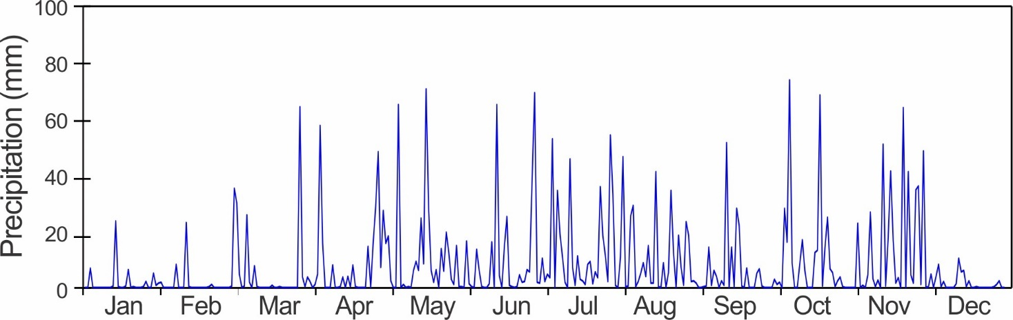
Monthly Rainfall at 'El Claro' - Rain Guage

Rainfall (mm)
 | Average | Min | Max | S.D. | 2022 | Rank*  (n=97)
January | 69.1 | 0.5 | 376.4 | 75.9 | 47.4 | 45
February | 31.5 | 0.5 | 186.4 | 31.6 | 33.6 | 36
March | 36.7 | 0.0 | 174.0 | 38.6 | 174.0 | 1
April | 94.1 | 0.0 | 463.8 | 81.7 | 231.1 | 6
May | 282.5 | 78.5 | 699.8 | 109.8 | 326.7 | 23
June | 279.4 | 66.8 | 556.8 | 90.2 | 287.3 | 43
July | 282.6 | 90.6 | 725.9 | 99.4 | 377.6 | 14
August | 310.6 | 142.7 | 677.2 | 98.4 | 310.8 | 39
September | 264.7 | 107.6 | 507.0 | 85.2 | 159.0 | 88
October | 334.3 | 115.3 | 588.7 | 101.4 | 305.2 | 59
November | 424.6 | 117.1 | 1056.1 | 188.2 | 402.1 | 50
December | 250.5 | 16.4 | 1182.9 | 192.0 | 47.0 | 86
Total | 2660.7 | 1698.9 | 4486.5 | 470.2 | 47.4 | 45
* Rank: 1 = wettest year.
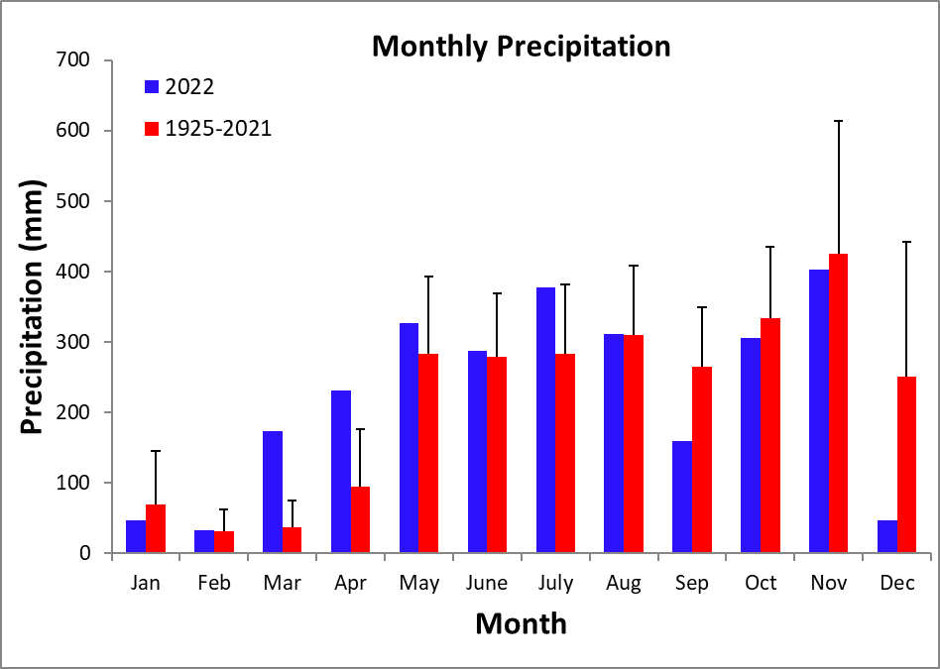
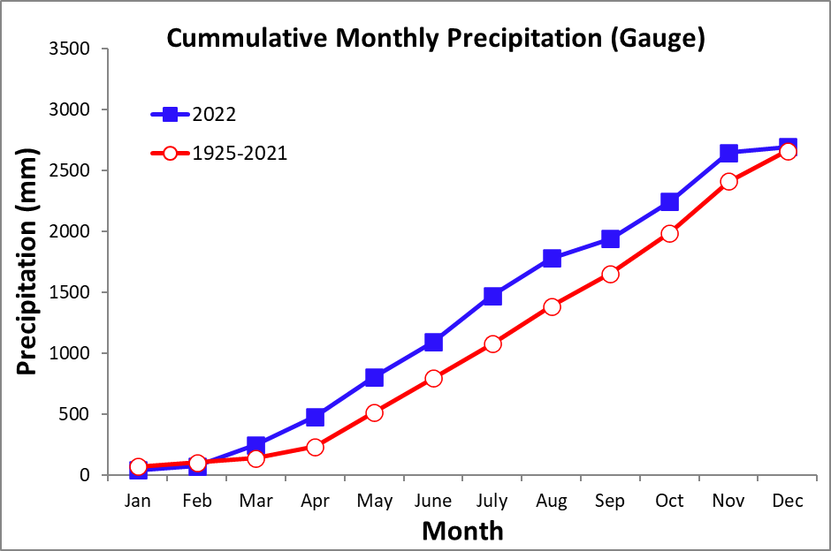
Yearly Rainfall (mm) at 'El Claro' - Rain Gauge

Year | Rain | Year | Rain | Year | Rain
1925 | 2228.5 | 1958 | 2545.1 | 1991 | 2475.2
1926 | 1940.6 | 1959 | 2319.5 | 1992 | 3071.3
1927 | 2987.4 | 1960 | 3502.3 | 1993 | 2718.9
1928 | 2878.5 | 1961 | 2545.4 | 1994 | 2289.0
1929 | 2581.8 | 1962 | 2502.8 | 1995 | 2511.2
1930 | 3109.6 | 1963 | 2767.1 | 1996 | 3236.3
1931 | 3642.7 | 1964 | 2875.2 | 1997 | 1698.9
1932 | 2384.4 | 1965 | 2357.2 | 1998 | 2688.8
1933 | 3136.8 | 1966 | 2807.7 | 1999 | 3712.1
1934 | 2969.0 | 1967 | 2181.4 | 2000 | 2420.4
1935 | 2933.0 | 1968 | 2223.4 | 2001 | 2669.3
1936 | 2195.9 | 1969 | 2192.5 | 2002 | 2338.7
1937 | 2332.2 | 1970 | 3226.7 | 2003 | 2896.7
1938 | 2816.8 | 1971 | 2373.6 | 2004 | 2760.9
1939 | 3055.4 | 1972 | 2282.4 | 2005 | 2428.0
1940 | 2838.8 | 1973 | 2506.0 | 2006 | 2800.9
1941 | 3058.9 | 1974 | 2837.3 | 2007 | 3125.3
1942 | 2221.0 | 1975 | 2847.0 | 2008 | 2085.5
1943 | 1978.2 | 1976 | 1830.5 | 2009 | 2544.1
1944 | 2105.6 | 1977 | 2599.1 | 2010 | 4135.2
1945 | 2916.3 | 1978 | 2139.7 | 2011 | 3298.4
1946 | 2908.3 | 1979 | 2730.9 | 2012 | 2998.0
1947 | 2863.8 | 1980 | 2377.5 | 2013 | 2058.4
1948 | 2228.5 | 1981 | 4486.5 | 2014 | 2203.2
1949 | 1940.6 | 1982 | 1950.7 | 2015 | 1810.1
1950 | 2987.4 | 1983 | 2669.5 | 2016 | 2950.4
1951 | 2878.5 | 1984 | 3147.7 | 2017 | 2188.1
1952 | 2481.7 | 1985 | 2213.3 | 2018 | 3054.9
1953 | 2637.5 | 1986 | 2213.4 | 2019 | 2338.8
1954 | 2781.7 | 1987 | 2945.2 | 2020 | 2599.4
1955 | 2910.4 | 1988 | 2592.6 | 2021 | 3062.1
1956 | 2732.8 | 1989 | 2152.7 | 2022 | 2701.7
1957 | 2482.1 | 1990 | 2736.2
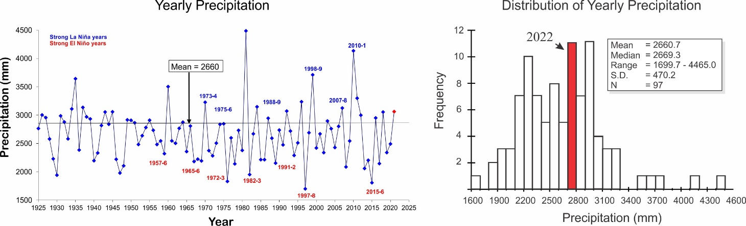
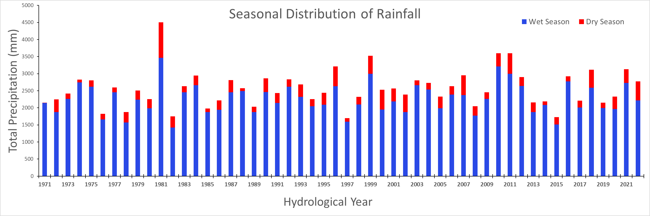

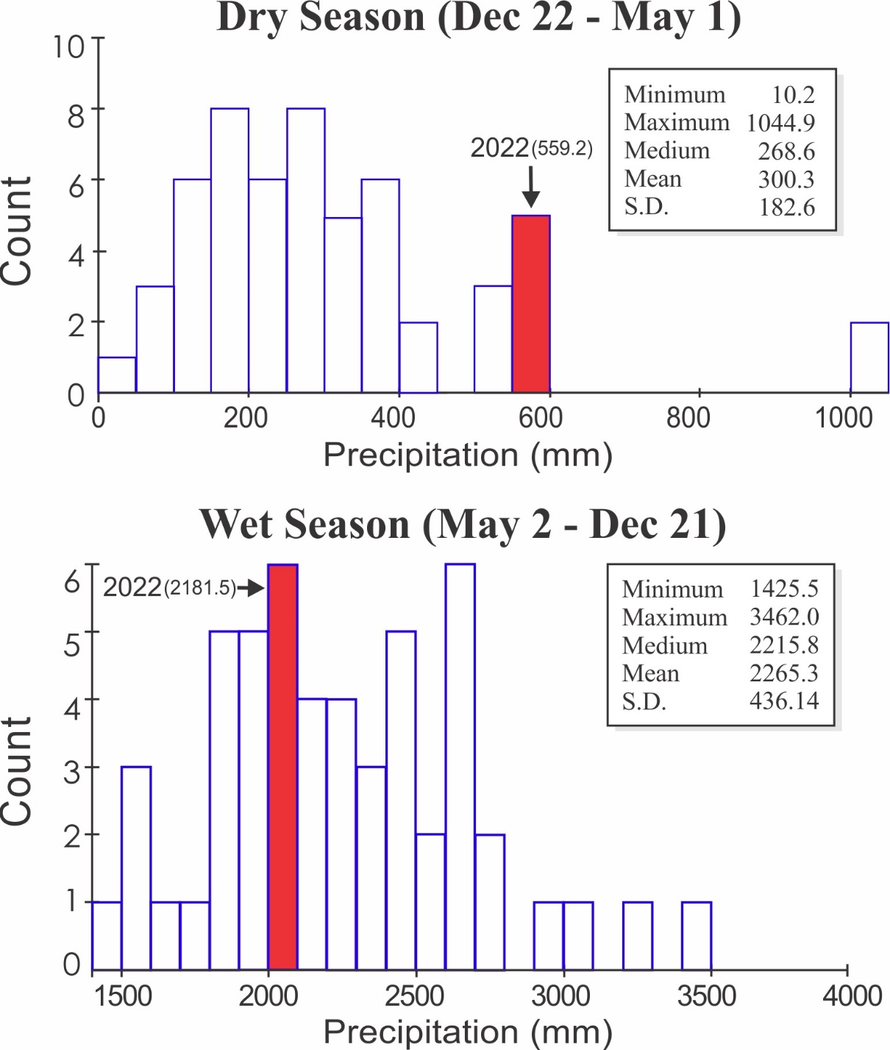
ACP Dry Season Beginning and End Dates

Year | Begin | End | Length |  |  | Year | Begin | End | Length
 |  |  | Dry  Season | Wet  Season |  |  |  |  | Dry  Season | Wet  Season
1954 | 25-Dec-53 | 05-May-54 | 131 | 236 |  | 1998 | 09-Dec-97 | 29-May-98 | 171 | 234
1955 | 27-Dec-54 | 02-May-55 | 126 | 275 |  | 1999 | 18-Jan-99 | 03-May-99 | 105 | 259
1956 | 01-Feb-56 | 02-May-56 | 91 | 231 |  | 2000 | 17-Jan-00 | 10-May-00 | 114 | 245
1957 | 19-Dec-56 | 12-May-57 | 144 | 223 |  | 2001 | 10-Jan-01 | 26-May-01 | 136 | 237
1958 | 21-Dec-57 | 30-Apr-58 | 130 | 229 |  | 2002 | 18-Jan-02 | 21-May-02 | 123 | 201
1959 | 15-Dec-58 | 15-May-59 | 151 | 234 |  | 2003 | 08-Dec-02 | 05-May-03 | 148 | 238
1960 | 04-Jan-60 | 12-Apr-60 | 99 | 247 |  | 2004 | 29-Dec-03 | 24-Apr-04 | 117 | 234
1961 | 15-Dec-60 | 11-May-61 | 147 | 231 |  | 2005 | 14-Dec-04 | 6-May-05 | 143 | 234
1962 | 28-Dec-61 | 11-May-62 | 134 | 228 |  | 2006 | 13-Jan-06 | 28-Apr-06 | 105 | 252
1963 | 25-Dec-62 | 25-Apr-63 | 121 | 213 |  | 2007 | 19-Dec-06 | 26-Apr-07 | 128 | 235
1964 | 24-Nov-63 | 22-Apr-64 | 150 | 224 |  | 2008 | 2-Jan-08 | 2-May-08 | 121 | 251
1965 | 02-Dec-64 | 08-May-65 | 157 | 231 |  | 2009 | 13-Dec-08 | 4-May-09 | 142 | 225
1966 | 25-Dec-65 | 13-Apr-66 | 109 | 257 |  | 2010 | 4-Dec-09 | 15-May-10 | 162 | 214
1967 | 26-Dec-66 | 26-Apr-67 | 121 | 231 |  | 2011 | 11-Jan-11 | 5-May-11 | 114 | 241
1968 | 13-Dec-67 | 27-Apr-68 | 136 | 229 |  | 2012 | 27-Dec-11 | 8-May-12 | 133 | 236
1969 | 12-Dec-68 | 16-Apr-69 | 125 | 248 |  | 2013 | 27-Dec-12 | 13-May-13 | 137 | 233
1970 | 20-Dec-69 | 26-Apr-70 | 127 | 239 |  | 2014 | 21-Dec-13 | 06-May-14 | 136 | 222
1971 | 21-Dec-70 | 30-Apr-71 | 130 | 213 |  | 2015 | 19-Dec-14 | 16-May-15 | 148 | 195
1972 | 29-Nov-71 | 30-Apr-72 | 153 | 239 |  | 2016 | 27-Nov-15 | 18-May-16 | 173 | 193
1973 | 25-Dec-72 | 17-May-73 | 143 | 212 |  | 2017 | 27-Nov-16 | 3-May-17 | 157 | 230
1974 | 15-Dec-73 | 02-May-74 | 138 | 226 |  | 2018 | 19-Dec-17 | 4-May-18 | 136 | 215
1975 | 14-Dec-74 | 03-May-75 | 140 | 227 |  | 2019 | 5-Dec-18 | 14-May-19 | 160 | 233
1976 | 16-Dec-75 | 20-May-76 | 156 | 185 |  | 2020 | 3-Jan-20 | 1-may-20 | 132 | 237
1977 | 21-Nov-76 | 17-May-77 | 177 | 217 |  | 2021 | 5-Jan-21 | 3-May-21 | 118 | 243
1978 | 20-Dec-77 | 13-Apr-78 | 114 | 244 |  | 2022 | 1-Jan-22 | 2-apr-22 | 91
1979 | 13-Dec-78 | 16-Apr-79 | 124 | 252
1980 | 24-Dec-79 | 05-May-80 | 133 | 244
1981 | 04-Jan-81 | 12-Apr-81 | 98 | 273
1982 | 10-Jan-82 | 09-May-82 | 119 | 189
1983 | 14-Nov-82 | 12-May-83 | 179 | 222
1984 | 20-Dec-83 | 22-May-84 | 154 | 199
1985 | 07-Dec-84 | 06-May-85 | 150 | 222
1986 | 14-Dec-85 | 20-Apr-86 | 127 | 240
1987 | 16-Dec-86 | 25-Apr-87 | 130 | 235
1988 | 16-Dec-87 | 25-May-88 | 161 | 209
1989 | 20-Dec-88 | 14-May-89 | 145 | 214
1990 | 14-Dec-89 | 04-May-90 | 141 | 223
1991 | 13-Dec-90 | 01-May-91 | 139 | 226
1992 | 13-Dec-91 | 18-May-92 | 157 | 217
1993 | 21-Dec-92 | 25-Apr-93 | 125 | 243
1994 | 24-Dec-93 | 16-May-94 | 143 | 200
1995 | 02-Dec-94 | 01-May-95 | 150 | 271
1996 | 27-Jan-96 | 07-May-96 | 101 | 255
1997 | 17-Jan-97 | 07-Jun-97 | 141 | 185
 |  |  |  |  |  | Avg | 19-Dec | 02-May | 124 | 229.4
 |  |  |  |  |  | SD | ±16 days | ±12 days | 11.6 | 19.8

Seasonality Distribution

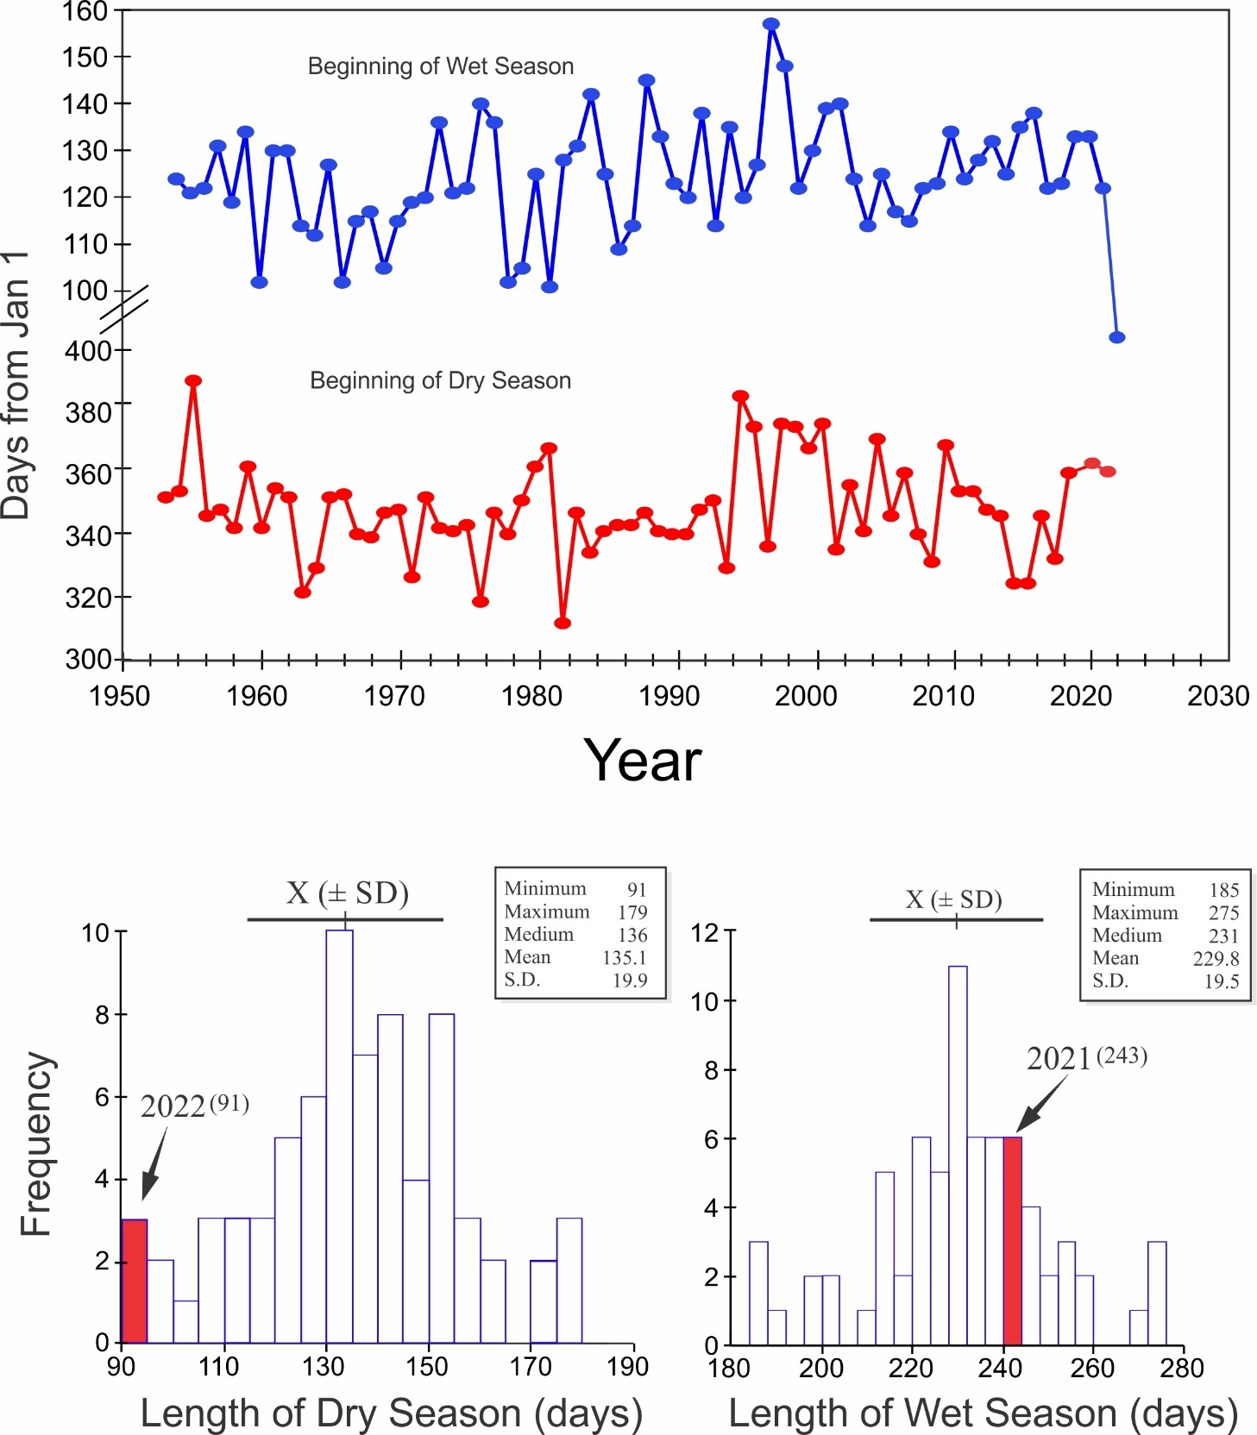
Storm Analysis

 |  | Max. Rainfall per Storm (mm) |  |  |  | Storm Duration (min.)
 | 1994-2021 |  |  | 2022 |  | 1994-2021 |  | 2022
 | Mean |  | S.D. |  |  | Mean | S.D.
January | 19.2 |  | 21.9 | 16.3 |  | 25.3 | 16.0 | 24.0
February | 10.8 |  | 11.1 | 12.2 |  | 21.7 | 13.1 | 30.3
March | 12.7 |  | 15.9 | 28.2 |  | 28.4 | 28.9 | 49.1
April | 34.4 |  | 29.6 | 53.9 |  | 38.8 | 25.8 | 46.7
May | 51.2 |  | 21.1 | 62.0 |  | 48.0 | 17.8 | 57.6
June | 54.5 |  | 24.1 | 65.0 |  | 46.1 | 14.3 | 74.1
July | 48.9 |  | 23.1 | 44.7 |  | 41.2 | 14.3 | 46.2
August | 49.6 |  | 18.8 | 44.2 |  | 42.4 | 13.1 | 62.9
September | 45.5 |  | 18.6 | 49.0 |  | 45.8 | 16.9 | 50.6
October | 50.2 |  | 23.7 | 38.6 |  | 47.7 | 14.4 | 61.5
November | 58.5 |  | 39.2 | 48.8 |  | 51.2 | 21.8 | 75.4
December | 46.7 |  | 40.5 | 9.1 |  | 38.9 | 19.1 | 18.3

 | Av. Rainfall per Storm (mm)
 | 1994-2021 |  | 2022
 | Mean | S.D.
January | 2.9 | 2.1 | 2.2
February | 2.2 | 2.0 | 3.6
March | 2.7 | 2.5 | 4.6
April | 5.0 | 3.4 | 5.6
May | 6.5 | 2.4 | 5.1
June | 6.5 | 2.5 | 6.9
July | 5.5 | 1.9 | 5.1
August | 6.3 | 2.8 | 5.2
September | 6.0 | 2.3 | 6.1
October | 6.6 | 2.5 | 6.1
November | 6.6 | 2.6 | 8.1
December | 5.1 | 2.8 | 1.9

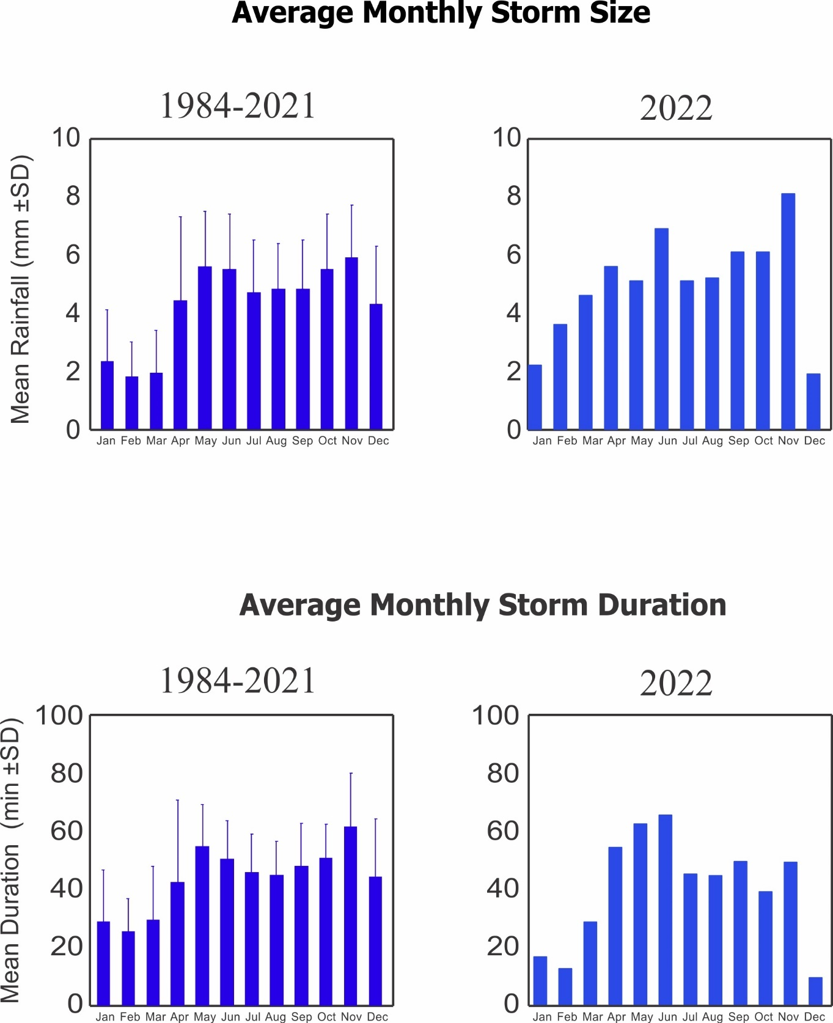
2022 Daily Lutz Weir Run-off (mm. eq.)
 | Jan. | Feb. | Mar. | Apr. | May | June | July | Aug. | Sep. | Oct. | Nov. | Dec.
1 | 2.4 | 0.3 | 0.3 | 0.2 | 2.8 | 1.9 | 2.9 | 12.6 | 2.6 | 1.0 | 1.3 | 5.3
2 | 2.1 | 0.4 | 0.6 | 0.1 | 1.1 | 1.2 | 2.4 | 15.1 | 2.3 | 0.9 | 1.2 | 1.6
3 | 1.6 | 0.2 | 0.4 | 0.1 | 0.7 | 1.0 | 2.2 | 8.8 | 2.1 | 0.8 | 2.2 | 3.1
4 | 1.5 | 0.2 | 0.3 | 2.3 | 0.5 | 1.1 | 2.3 | 5.1 | 2.0 | 0.8 | 1.4 | 2.6
5 | 1.5 | 0.2 | 0.3 | 2.0 | 7.9 | 1.2 | 12.9 | 8.0 | 2.4 | 1.9 | 1.4 | 2.4
6 | 1.2 | 0.3 | 0.7 | 0.6 | 2.1 | 1.4 | 5.3 | 12.6 | 1.9 | 2.8 | 1.6 | 2.0
7 | 1.4 | 0.2 | 0.6 | 0.3 | 1.1 | 1.6 | 10.0 | 6.9 | 1.7 | 19.2 | 1.5 | 1.9
8 | 1.2 | 0.2 | 0.4 | 0.2 | 0.9 | 1.5 | 8.3 | 4.9 | 1.7 | 6.9 | 2.9 | 1.8
9 | 1.0 | 0.2 | 0.3 | 0.4 | 0.9 | 1.5 | 6.2 | 3.8 | 1.5 | 4.2 | 1.6 | 1.6
10 | 1.0 | 0.3 | 0.3 | 0.4 | 0.9 | 1.7 | 4.5 | 3.6 | 1.3 | 2.7 | 1.4 | 1.4
11 | 0.9 | 0.4 | 0.3 | 0.4 | 1.1 | 1.9 | 3.4 | 3.1 | 1.2 | 2.6 | 1.4 | 1.3
12 | 1.0 | 0.2 | 0.1 | 0.4 | 1.4 | 1.1 | 16.0 | 4.0 | 7.5 | 3.7 | 1.5 | 1.2
13 | 1.3 | 0.2 | 0.1 | 0.4 | 0.8 | 8.0 | 7.2 | 3.0 | 2.7 | 2.3 | 9.4 | 1.3
14 | 0.7 | 0.3 | 0.1 | 0.3 | 1.3 | 4.0 | 4.5 | 2.6 | 3.6 | 2.0 | 2.8 | 1.4
15 | 0.7 | 0.3 | 0.1 | 0.1 | 1.0 | 1.9 | 4.1 | 12.1 | 2.1 | 1.8 | 2.9 | 1.2
16 | 0.8 | 0.3 | 0.1 | 0.1 | 13.4 | 1.9 | 3.3 | 5.9 | 5.7 | 1.6 | 15.6 | 1.2
17 | 0.8 | 0.3 | 0.1 | 0.2 | 15.2 | 4.8 | 2.6 | 3.7 | 7.3 | 3.1 | 7.3 | 1.0
18 | 1.1 | 0.4 | 0.1 | 0.1 | 3.9 | 2.9 | 2.2 | 3.3 | 4.0 | 3.3 | 4.9 | 0.9
19 | 1.1 | 0.1 | 0.1 | 0.1 | 2.3 | 2.1 | 2.1 | 2.5 | 2.8 | 19.8 | 3.4 | 0.9
20 | 0.9 | 0.2 | 0.1 | 0.1 | 1.8 | 1.5 | 2.1 | 2.3 | 3.0 | 5.7 | 2.8 | 0.9
21 | 0.9 | 0.2 | 0.0 | 0.1 | 1.4 | 1.3 | 2.0 | 8.0 | 2.2 | 4.5 | 18.0 | 0.8
22 | 0.9 | 0.1 | 0.0 | 0.1 | 1.8 | 1.4 | 1.9 | 5.2 | 2.0 | 10.0 | 5.7 | 0.8
23 | 0.4 | 0.1 | 0.0 | 0.1 | 1.3 | 1.6 | 1.7 | 3.7 | 1.8 | 5.7 | 20.6 | 0.7
24 | 0.4 | 0.1 | 0.0 | 0.1 | 2.4 | 1.6 | 7.1 | 5.4 | 1.8 | 4.0 | 5.9 | 0.6
25 | 0.4 | 0.1 | 0.0 | 0.3 | 2.2 | 1.8 | 7.0 | 3.7 | 1.8 | 3.1 | 5.0 | 0.6
26 | 0.3 | 0.1 | 0.1 | 0.7 | 2.1 | 1.9 | 5.1 | 3.1 | 2.0 | 2.5 | 10.7 | 0.6
27 | 0.4 | 0.1 | 0.3 | 3.7 | 1.6 | 5.0 | 3.7 | 7.5 | 1.3 | 2.1 | 14.0 | 0.6
28 | 0.4 | 0.1 | 0.5 | 0.5 | 1.9 | 28.0 | 17.8 | 6.4 | 1.2 | 1.9 | 7.5 | 0.6
29 | 0.4 |  | 0.2 | 3.7 | 1.6 | 7.5 | 55.4 | 4.6 | 1.2 | 1.8 | 15.9 | 0.7
30 | 0.4 |  | 0.2 | 2.0 | 1.3 | 3.7 | 25.3 | 3.8 | 1.0 | 1.6 | 8.6 | 0.8
31 | 0.3 |  | 0.2 |  | 1.4 |  | 18.9 | 3.0 |  | 1.5 |  | 0.8

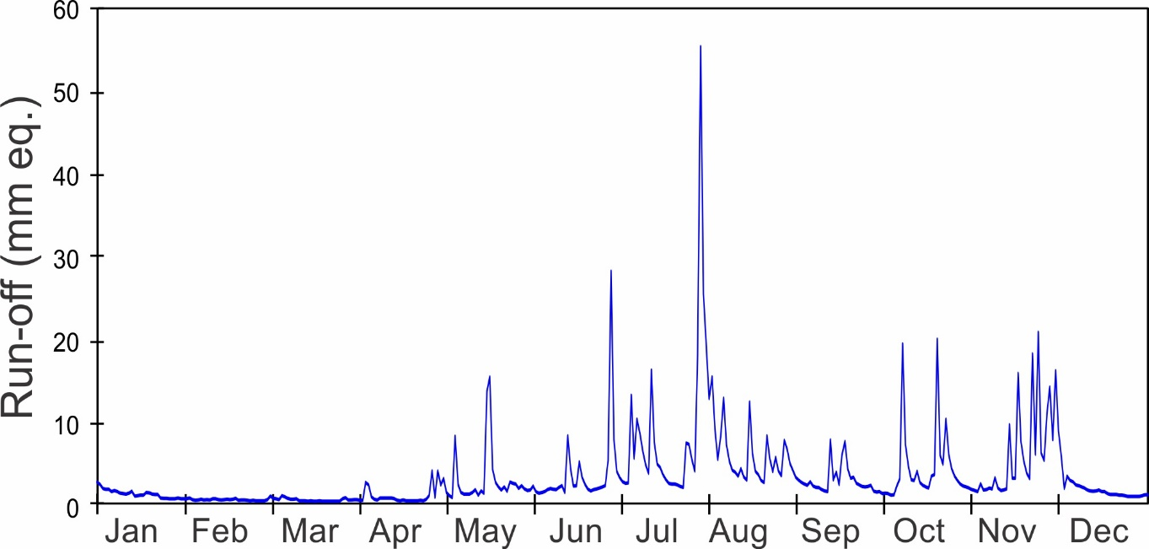
Monthly Run-off
Run-off, Lutz Weir (mm eq.)
 | Long-term Averages (1972 - 2021) |  | 2022
 | Total | S.D. | Total
January | 37.3 | 53.6 | 29.0
February | 5.6 | 8.5 | 6.1
March | 1.9 | 2.3 | 6.8
April | 4.8 | 16.5 | 20.5
May | 30.7 | 49.4 | 80.3
June | 58.4 | 66.8 | 98.1
July | 83.0 | 62.4 | 250.8
August | 120.7 | 79.1 | 178.4
September | 107.2 | 66.2 | 75.7
October | 154.8 | 82.1 | 125.8
November | 229.0 | 126.8 | 180.7
December | 148.7 | 144.0 | 42.8
Total | 981.9 |  | 1095.0
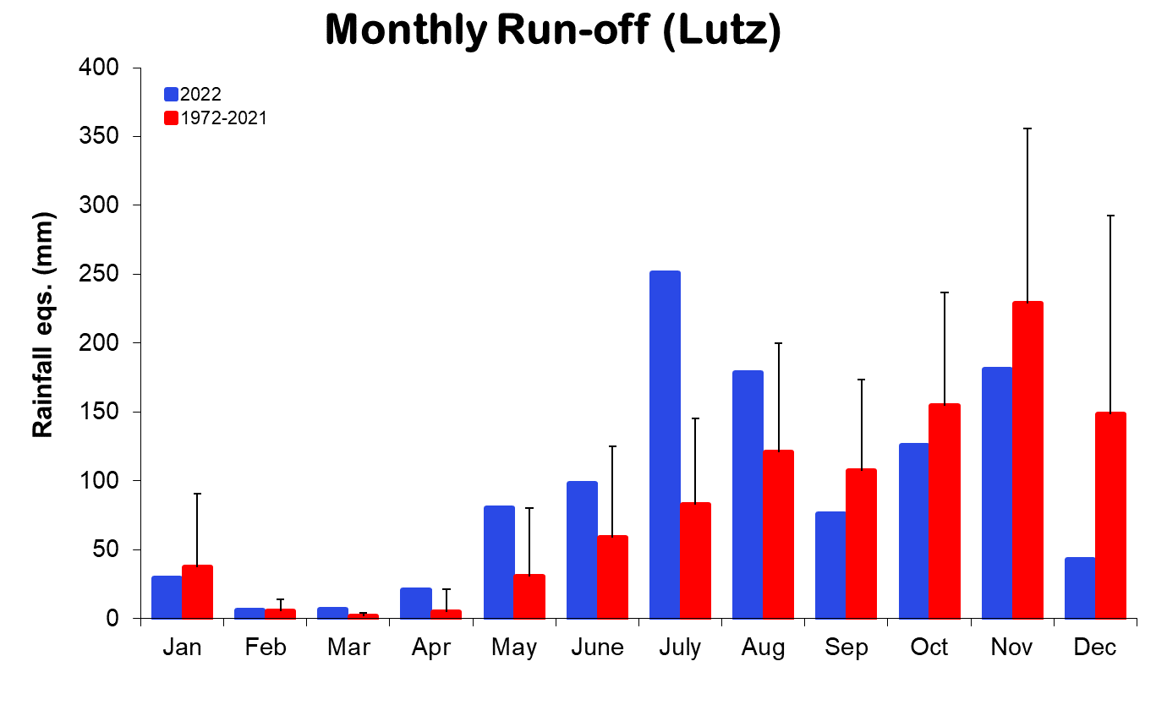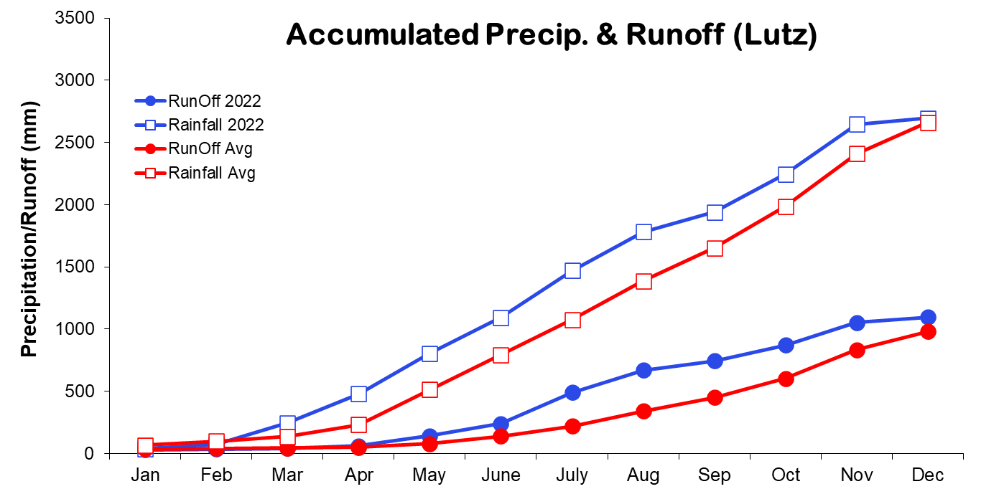
Run-off, Conrad Weir (mm eq.)

 | Long-term Averages (1972 - 2021) |  | 2022
 | Total | S.D. | Total
January | 34.1 | 33.7 | 20.1
February | 6.8 | 5.0 | 5.2
March | 3.1 | 2.5 | 6.4
April | 2.3 | 3.0 | 5.8
May | 16.5 | 31.4 | 27.8
June | 32.0 | 35.1 | 31.4
July | 48.9 | 40.8 | 40.1
August | 66.5 | 48.6 | 120.4
September | 64.9 | 40.1 | 144.9
October | 71.8 | 52.4 | 63.6
November | 139.5 | 112.5 | 61.0
December | 130.6 | 119.6 | 136.0
Total | 646.3 |  | 662.7

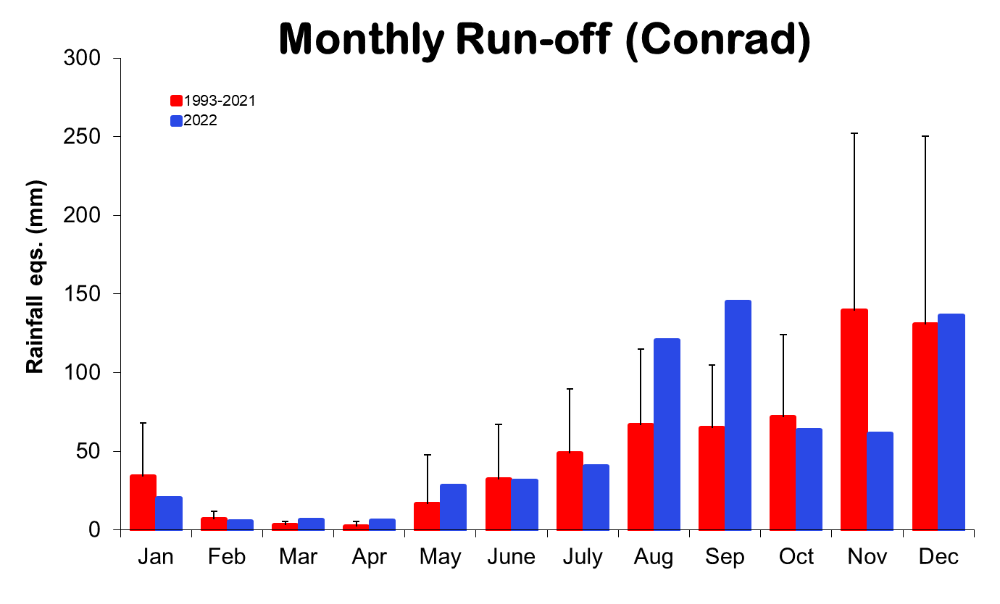

Lutz Catchment Soil Moisture

(H₂O/wet wt of soil)
 | Long-term Averages (1972-2021) |  |  |  | 2022
 | 0-10 cm |  | 30-40 cm |  | 0-10 cm | 30-40 cm
 | Mean | S.D. | Mean | S.D.
January | 36.8 | 3.2 | 33.9 | 2.5 | 40.1 | 37.6
February | 33.9 | 2.5 | 32.0 | 1.7 | 36.9 | 36.1
March | 32.1 | 2.7 | 30.7 | 2.1 | 39.4 | 37.2
April | 33.0 | 3.2 | 31.2 | 2.4 | 43.5 | 39.6
May | 37.4 | 2.5 | 34.3 | 2.0 | 44.0 | 39.2
June | 39.6 | 1.7 | 35.3 | 1.6 | 42.9 | 40.1
July | 40.8 | 1.8 | 35.8 | 1.9 | 44.8 | 40.3
August | 41.8 | 1.7 | 35.8 | 1.4 | 44.0 | 40.8
September | 42.0 | 1.4 | 36.2 | 1.6 | 43.6 | 40.9
October | 42.3 | 1.6 | 36.3 | 1.5 | 44.7 | 40.3
November | 42.8 | 1.7 | 36.1 | 1.5 | 44.8 | 37.7
December | 41.2 | 2.6 | 35.7 | 2.0 | 44.3 | 37.0

(H₂O/dry wt of soil)
 | Long-term Averages (1972-2021) |  |  |  | 2022
 | 0-10 cm |  | 30-40 cm |  | 0-10 cm | 30-40 cm
 | Mean | S.D. | Mean | S.D.
January | 59.3 | 7.8 | 52.1 | 6.2 | 67.4 | 60.5
February | 51.9 | 6.0 | 47.7 | 3.9 | 58.9 | 57.2
March | 48.2 | 6.5 | 45.1 | 4.7 | 65.8 | 60.0
April | 50.1 | 8.3 | 46.2 | 5.6 | 78.0 | 66.0
May | 60.8 | 6.5 | 52.9 | 5.0 | 79.5 | 65.4
June | 66.3 | 4.8 | 55.5 | 4.0 | 76.6 | 67.5
July | 70.0 | 5.6 | 56.7 | 4.9 | 82.4 | 68.4
August | 72.8 | 4.7 | 56.5 | 3.7 | 79.6 | 69.7
September | 73.5 | 4.0 | 57.4 | 4.1 | 78.7 | 69.8
October | 74.5 | 4.2 | 57.7 | 3.8 | 82.6 | 68.5
November | 75.7 | 5.0 | 57.3 | 3.8 | 83.1 | 61.3
December | 71.4 | 6.9 | 56.5 | 5.0 | 81.7 | 59.5

Lutz Catchment Soil Moisture
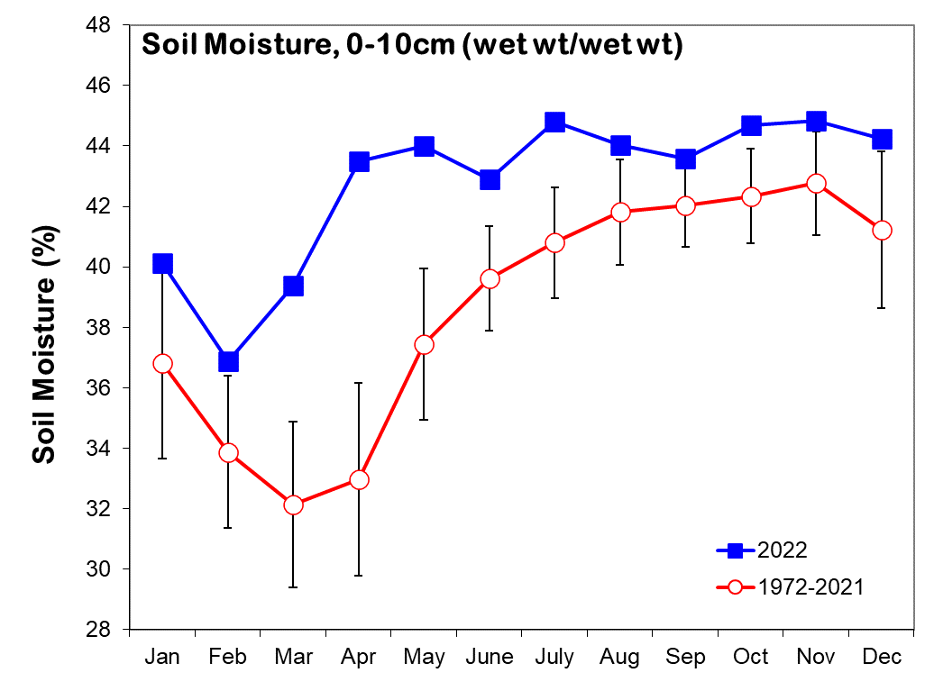
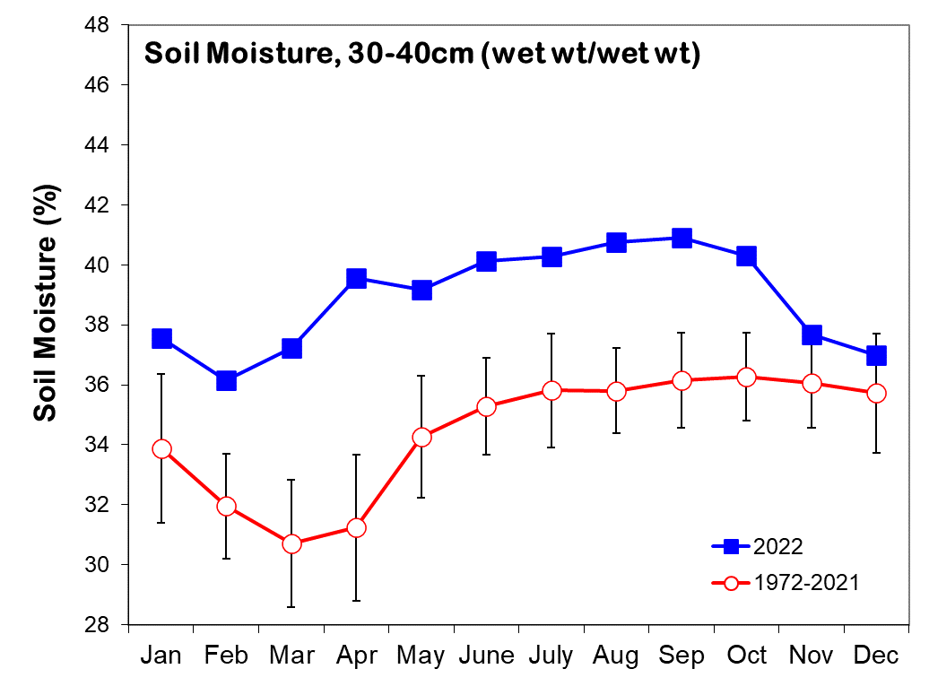

Relative Humidity (%) - Electronic Sensor
 | ‘El Claro’ |  | 1m |  | 20m |  | 42m |  | 48m
 | Avg. | 2022 | Avg. | 2022 | Avg. | 2022 | Avg. | 2022 | Avg. | 2022
January | 88.4 | 86.2 | 92.4 | 90.4 | 87.5 | 87.3 | 86.4 | 85.8 | 85.4 | 84.5
February | 85.9 | 83.5 | 89.3 | 86.8 | 85.0 | 85.3 | 84.7 | 84.4 | 83.9 | 82.6
March | 84.2 | 87.2 | 88.0 | 89.8 | 84.5 | 89.0 | 84.6 | 88.1 | 83.5 | 85.8
April | 86.7 | 90.6 | 90.1 | 92.5 | 87.0 | 92.0 | 87.2 | 90.5 | 86.3 | 88.2
May | 92.2 | 94.6 | 96.2 | 96.3 | 92.5 | 96.0 | 91.9 | 93.8 | 91.2 | 91.2
June | 94.3 | 94.4 | 97.9 | 96.4 | 94.7 | 95.9 | 93.2 | 93.6 | 92.7 | 91.0
July | 95.0 | 96.1 | 98.3 | 97.7 | 94.9 | 97.4 | 93.6 | 95.3 | 93.6 | 92.8
August | 95.2 | 95.4 | 97.9 | 97.0 | 95.1 | 95.9 | 93.6 | 94.7 | 93.6 | 92.2
September | 95.0 | 94.8 | 97.8 | 96.2 | 95.0 | 94.9 | 93.3 | 93.8 | 93.1 | 91.5
October | 95.4 | 94.8 | 98.1 | 96.8 | 95.3 | 95.3 | 93.4 | 92.9 | 93.1 | 91.7
November | 96.6 | 96.4 | 98.6 | 97.7 | 96.1 | 96.8 | 94.4 | 94.9 | 94.1 | 93.0
December | 93.6 | 90.6 | 97.0 | 94.6 | 93.1 | 91.4 | 91.2 | 88.2 | 90.2 | 86.7

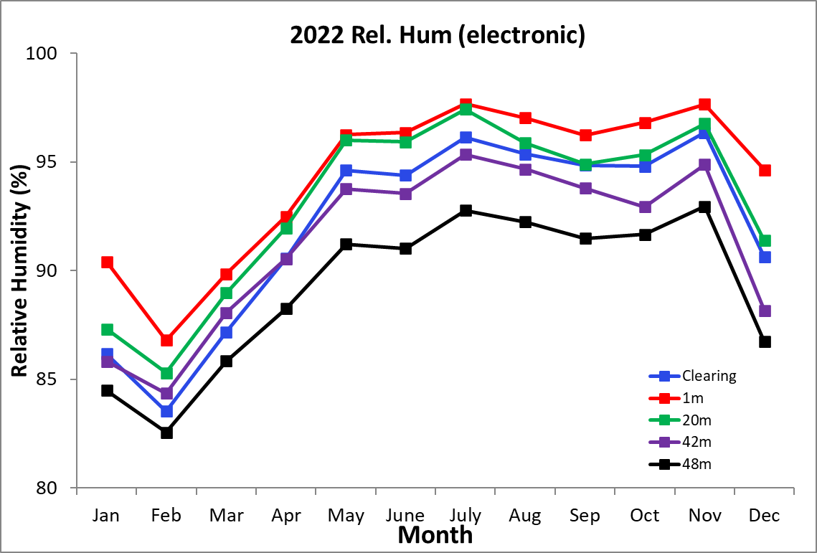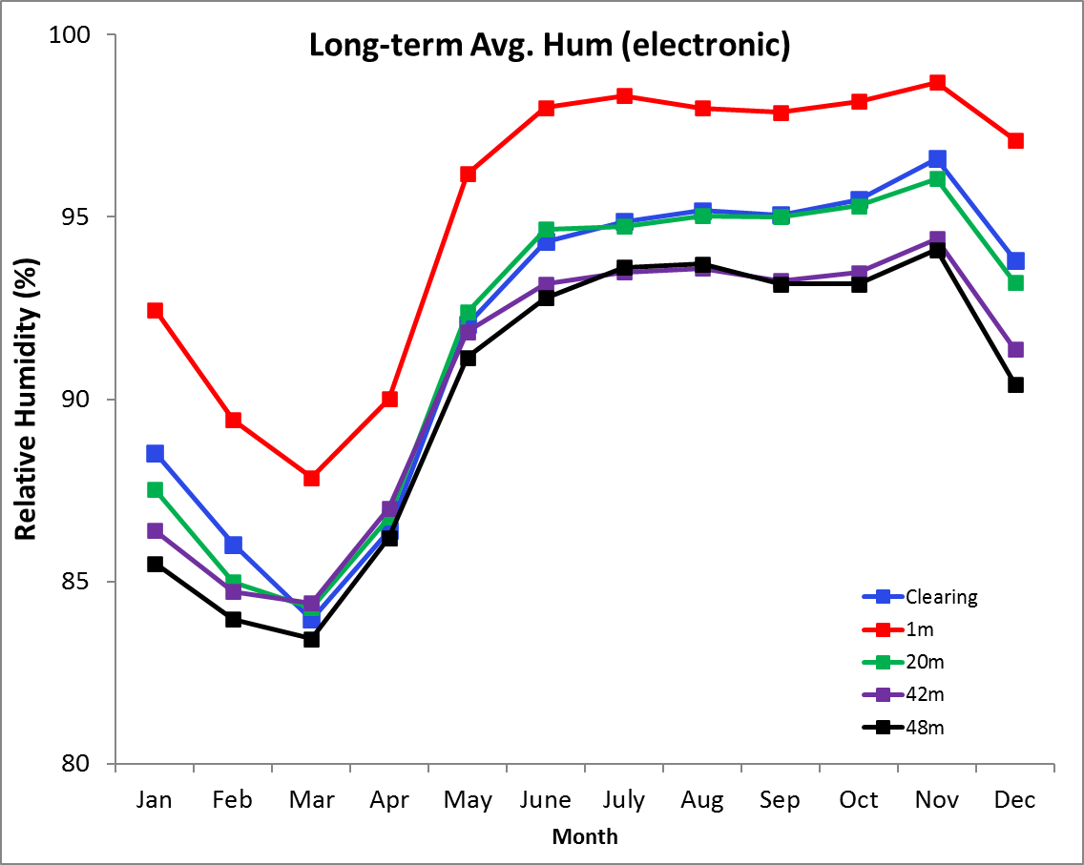
Max/Min/Avg Temperatures (°C) - Electronic

 | ‘El Claro’ |  |  | 1m |  |  | 20m |  |  | 42m |  |  | 48m
Average | Max. | Min. | Avg | Max. | Min. | Avg | Max. | Min. | Avg | Max. | Min. | Avg | Max. | Min. | Avg
January | 30.1 | 23.5 | 25.7 | 27.8 | 23.6 | 25.1 | 29.2 | 23.6 | 25.6 | 29.1 | 24.0 | 25.9 | 28.7 | 24.0 | 25.9
February | 30.6 | 23.6 | 26.0 | 28.4 | 23.6 | 25.3 | 29.2 | 23.8 | 25.8 | 29.2 | 24.1 | 25.9 | 28.8 | 24.0 | 26.0
March | 31.0 | 23.8 | 26.3 | 29.1 | 23.8 | 25.6 | 29.7 | 24.0 | 26.1 | 29.4 | 24.2 | 26.2 | 29.1 | 24.2 | 26.2
April | 31.5 | 24.2 | 26.8 | 29.6 | 24.2 | 26.1 | 30.3 | 24.3 | 26.5 | 30.2 | 24.4 | 26.5 | 29.9 | 24.3 | 26.5
May | 31.1 | 24.2 | 26.4 | 28.6 | 24.3 | 25.7 | 30.0 | 24.2 | 26.0 | 30.4 | 24.2 | 26.2 | 30.1 | 24.0 | 26.3
June | 30.7 | 23.9 | 26.1 | 28.0 | 24.0 | 25.4 | 29.5 | 23.9 | 25.6 | 30.2 | 23.9 | 26.0 | 29.9 | 23.8 | 26.1
July | 30.3 | 24.0 | 25.9 | 27.7 | 24.0 | 25.2 | 29.1 | 23.9 | 25.6 | 29.8 | 23.9 | 25.9 | 29.4 | 23.8 | 25.9
August | 30.3 | 23.8 | 25.8 | 27.9 | 24.0 | 25.2 | 29.2 | 23.7 | 25.5 | 29.9 | 23.8 | 25.9 | 29.5 | 23.6 | 25.8
September | 30.5 | 23.6 | 25.7 | 28.2 | 23.8 | 25.1 | 29.4 | 23.5 | 25.4 | 30.1 | 23.6 | 25.7 | 29.8 | 23.5 | 25.7
October | 30.2 | 23.5 | 25.4 | 27.7 | 23.7 | 24.8 | 29.3 | 23.4 | 25.2 | 29.9 | 23.5 | 25.4 | 29.6 | 23.4 | 25.5
November | 29.0 | 23.3 | 25.1 | 26.9 | 23.5 | 24.6 | 28.4 | 23.3 | 25.0 | 29.1 | 23.3 | 25.3 | 28.9 | 23.3 | 25.2
December | 29.4 | 23.5 | 25.4 | 27.2 | 23.8 | 24.9 | 28.8 | 23.5 | 25.4 | 29.1 | 23.7 | 25.6 | 28.8 | 23.8 | 25.8
 | ‘El Claro’ |  |  | 1m |  |  | 20m |  |  | 42m |  |  | 48m
2022 | Max. | Min. | Avg | Max. | Min. | Avg | Max. | Min. | Avg | Max. | Min. | Avg | Max. | Min. | Avg
January | 29.9 | 23.0 | 25.5 | 27.5 | 22.9 | 24.7 | 29.4 | 23.7 | 26.1 | 29.1 | 23.6 | 25.9 | 28.3 | 23.7 | 25.7
February | 30.8 | 23.1 | 25.9 | 28.6 | 23.1 | 25.2 | 29.8 | 24.0 | 26.4 | 29.4 | 23.8 | 26.2 | 28.6 | 23.9 | 25.9
March | 30.1 | 23.7 | 26.1 | 28.6 | 23.6 | 25.4 | 29.6 | 24.4 | 26.6 | 29.4 | 24.2 | 26.3 | 28.5 | 24.1 | 26.0
April | 30.4 | 24.1 | 26.3 | 28.6 | 23.9 | 25.5 | 30.1 | 24.6 | 26.6 | 30.3 | 24.3 | 26.5 | 29.1 | 24.2 | 26.1
May | 29.9 | 24.3 | 26.2 | 27.7 | 24.1 | 25.5 | 29.7 | 24.7 | 26.5 | 30.2 | 24.4 | 26.5 | 29.1 | 24.3 | 26.1
June | 29.8 | 23.6 | 25.5 | 27.1 | 23.5 | 24.8 | 29.7 | 24.0 | 25.8 | 30.2 | 23.7 | 25.8 | 29.0 | 23.6 | 25.4
July | 29.6 | 23.9 | 25.8 | 27.1 | 23.8 | 25.1 | 29.4 | 24.3 | 26.1 | 30.2 | 24.1 | 26.1 | 28.7 | 23.9 | 25.7
August | 29.8 | 23.8 | 25.7 | 27.7 | 23.7 | 25.0 | 29.5 | 23.9 | 25.8 | 30.3 | 23.8 | 26.0 | 29.1 | 23.7 | 25.6
September | 30.4 | 23.7 | 25.8 | 28.2 | 23.6 | 25.0 | 29.9 | 23.8 | 25.7 | 30.6 | 23.8 | 26.0 | 29.5 | 23.7 | 25.6
October | 29.7 | 23.6 | 25.6 | 27.3 | 23.5 | 24.9 | 28.8 | 23.4 | 25.3 | 29.3 | 23.5 | 25.6 | 29.1 | 23.6 | 25.5
November | 28.8 | 23.4 | 25.1 | 26.4 | 23.3 | 24.5 | 28.0 | 23.2 | 24.9 | 28.7 | 23.2 | 25.2 | 28.4 | 23.3 | 25.1
December | 30.0 | 23.2 | 25.5 | 27.1 | 23.0 | 24.6 | 29.0 | 23.1 | 25.4 | 29.4 | 23.4 | 25.9 | 29.0 | 23.6 | 25.9

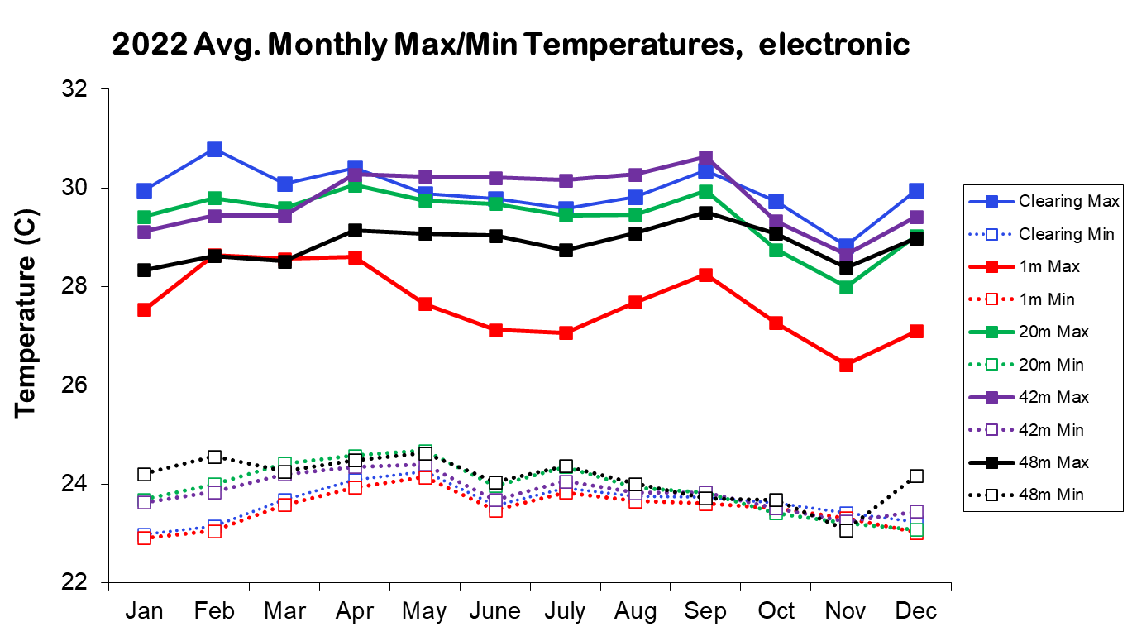
2022 Daily Total Radiation (MJ m⁻² day⁻¹)

 | Jan. | Feb. | Mar. | Apr. | May | June | July | Aug. | Sep. | Oct. | Nov. | Dec.
1 | 23.0 | 23.8 | 9.3 | 24.2 | 13.5 | 15.4 | 10.4 | 13.3 | 9.5 | 8.0 | 22.7 | 18.8
2 | 20.5 | 22.7 | 4.2 | 19.5 | 5.4 | 17.2 | 13.4 | 13.3 | 17.0 | 20.9 | 21.3 | 15.1
3 | 15.9 | 24.3 | 11.4 | 19.3 | 21.1 | 23.0 | 22.5 | 13.1 | 19.0 | 22.5 | 3.8 | 21.3
4 | 22.3 | 23.6 | 21.9 | 10.9 | 25.5 | 17.3 | 9.7 | 18.2 | 9.8 | 17.8 | 9.7 | 16.9
5 | 21.4 | 23.4 | 26.5 | 15.0 | 3.0 | 17.0 | 13.1 | 9.7 | 13.4 | 13.4 | 14.8 | 15.6
6 | 22.7 | 24.3 | 17.4 | 27.3 | 22.9 | 16.2 | 16.4 | 7.8 | 13.5 | 11.8 | 11.0 | 21.9
7 | 21.2 | 25.3 | 25.2 | 24.5 | 18.1 | 16.5 | 9.9 | 14.7 | 12.8 | 9.5 | 7.5 | 21.1
8 | 21.3 | 24.1 | 25.9 | 17.1 | 26.8 | 20.7 | 11.7 | 18.2 | 16.8 | 9.7 | 6.5 | 17.6
9 | 22.1 | 13.4 | 17.7 | 11.5 | 24.6 | 14.7 | 9.9 | 21.9 | 26.1 | 19.9 | 20.1 | 20.2
10 | 22.0 | 14.3 | 25.1 | 24.2 | 17.1 | 18.6 | 7.7 | 12.5 | 11.9 | 21.1 | 16.8 | 21.5
11 | 22.7 | 22.7 | 24.5 | 24.0 | 25.8 | 13.7 | 15.5 | 10.7 | 10.3 | 17.6 | 19.1 | 22.2
12 | 18.8 | 23.0 | 27.4 | 15.5 | 20.4 | 20.2 | 10.4 | 14.9 | 22.3 | 19.4 | 22.2 | 20.6
13 | 16.8 | 23.6 | 25.5 | 16.0 | 23.7 | 20.1 | 16.2 | 16.9 | 22.2 | 13.0 | 3.4 | 18.3
14 | 23.0 | 17.3 | 19.2 | 17.0 | 13.8 | 13.0 | 18.3 | 14.9 | 14.9 | 18.2 | 16.0 | 14.7
15 | 23.2 | 17.0 | 25.6 | 13.6 | 22.2 | 23.9 | 16.5 | 7.6 | 14.9 | 21.3 | 9.5 | 14.3
16 | 18.6 | 25.5 | 9.5 | 25.5 | 12.1 | 15.5 | 20.5 | 23.7 | 11.9 | 17.4 | 11.6 | 20.8
17 | 20.7 | 22.7 | 23.1 | 11.7 | 8.1 | 10.5 | 16.3 | 20.6 | 18.6 | 12.7 | 10.0 | 16.1
18 | 17.0 | 25.1 | 24.7 | 17.4 | 8.2 | 12.7 | 13.3 | 21.5 | 10.5 | 10.7 | 10.0 | 19.9
19 | 18.7 | 26.0 | 16.2 | 25.0 | 15.3 | 19.8 | 15.3 | 22.4 | 11.4 | 10.2 | 18.5 | 9.8
20 | 21.1 | 19.0 | 23.0 | 20.7 | 7.3 | 20.5 | 13.4 | 18.1 | 17.3 | 12.2 | 16.3 | 21.1
21 | 22.2 | 26.3 | 14.3 | 26.6 | 21.6 | 5.9 | 10.5 | 4.5 | 21.0 | 7.0 | 9.9 | 17.0
22 | 21.4 | 26.2 | 22.2 | 25.8 | 11.4 | 16.1 | 10.6 | 8.3 | 15.5 | 13.9 | 16.4 | 20.2
23 | 23.2 | 25.9 | 25.2 | 22.4 | 21.5 | 21.6 | 12.5 | 23.2 | 15.3 | 13.5 | 16.1 | 21.9
24 | 23.8 | 21.6 | 26.0 | 23.6 | 12.6 | 9.1 | 15.1 | 20.4 | 13.3 | 17.1 | 16.6 | 21.7
25 | 20.7 | 18.2 | 26.6 | 13.2 | 21.4 | 9.7 | 13.7 | 5.2 | 21.4 | 16.7 | 13.4 | 21.5
26 | 21.5 | 26.6 | 24.4 | 22.7 | 18.3 | 11.7 | 14.7 | 17.1 | 18.7 | 21.5 | 13.8 | 22.2
27 | 23.1 | 25.0 | 7.4 | 9.7 | 10.9 | 13.5 | 13.7 | 14.3 | 13.9 | 18.0 | 18.9 | 20.7
28 | 21.5 | 21.3 | 13.2 | 11.9 | 9.1 | 11.8 | 9.8 | 18.9 | 13.1 | 23.7 | 10.3 | 20.9
29 | 22.2 |  | 20.1 | 7.3 | 12.4 | 13.0 | 22.7 | 19.6 | 18.9 | 23.4 | 7.6 | 10.1
30 | 23.0 |  | 19.0 | 7.1 | 10.9 | 20.8 | 12.1 | 19.8 | 19.5 | 23.1 | 11.9 | 21.9
31 | 22.5 |  | 21.2 |  | 10.8 |  | 24.1 | 14.9 |  | 20.8 |  | 22.0

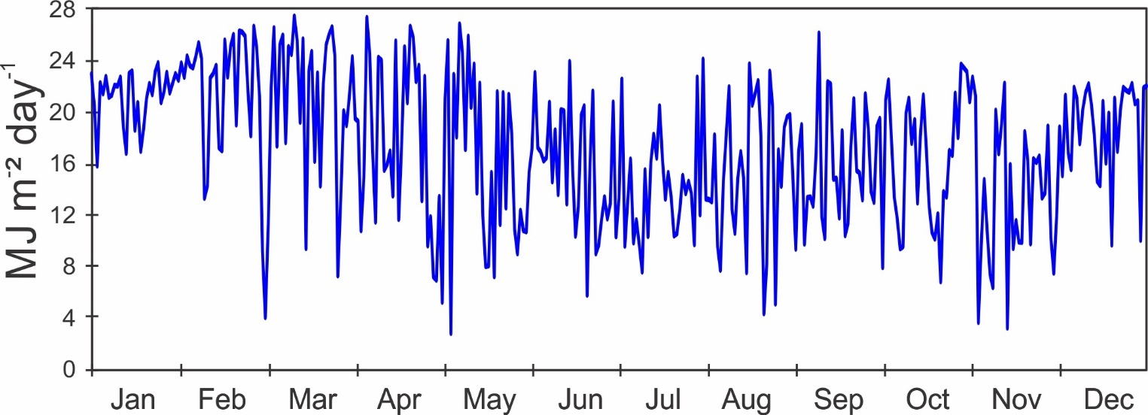
Monthly Average Total Daily Solar Radiation (Pyranometer)
 | 1984-2021 |  | 2022
 | Avg Daily Total (Mj/m²) | Avg Daily Max. (J/m²/s) | Avg Daily Total (Mj/m²) | Avg Daily Max. (J/m²/s)
January | 18.2 | 1072.7 | 21.2 | 1132.9
February | 19.9 | 1139.7 | 22.6 | 1181.5
March | 20.7 | 1173.8 | 20.1 | 1233.4
April | 19.0 | 1166.5 | 18.3 | 1266.1
May | 15.5 | 1094.1 | 16.0 | 1067.5
June | 14.0 | 1036.9 | 16.0 | 1149.6
July | 13.8 | 1025.0 | 14.2 | 1148.8
August | 14.2 | 1073.1 | 15.5 | 1147.2
September | 14.8 | 1093.8 | 15.8 | 1156.9
October | 14.1 | 1111.6 | 16.3 | 1163.7
November | 12.9 | 1048.3 | 13.5 | 1019.5
December | 14.9 | 1054.1 | 18.8 | 1086.4
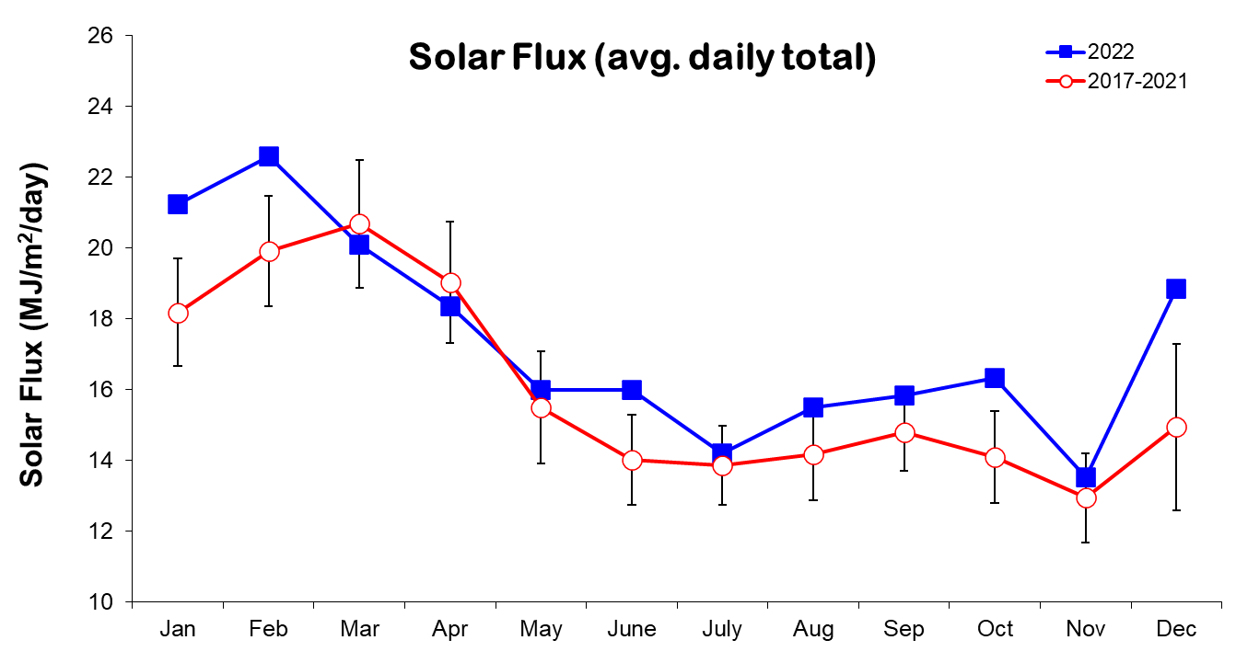
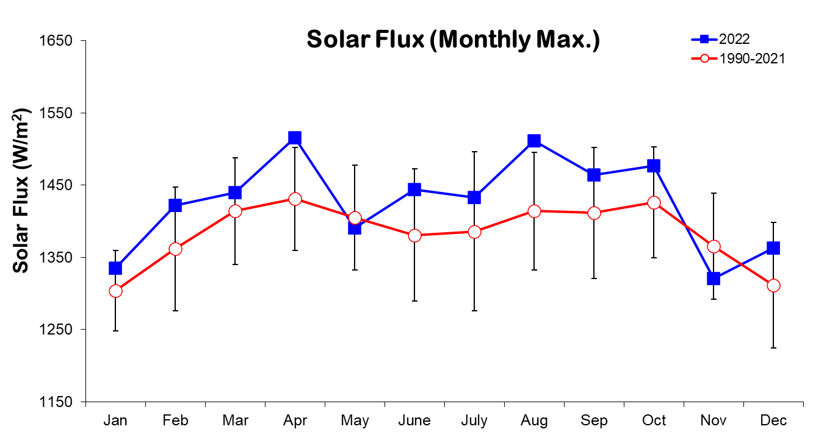

2022 Daily Average Wind Speed (km/h)
 | Jan. |  | Feb. |  |  | Mar. |  |  | Apr. |  |  | May |  |  | June |  | July |  | Aug. |  | Sep. |  | Oct. |  | Nov. |  |  | Dec.
 | Avg | Max | Avg | Max | Avg |  | Max | Avg |  | Max | Avg |  | Max | Avg |  | Max | Avg | Max | Avg | Max | Avg | Max | Avg | Max | Avg | Max | Avg |  |  | Max
1 | 7.0 | 26.2 | 7.7 | 26.0 | 7.8 |  | 39.3 | 6.3 |  | 22.5 | 3.3 |  | 19.1 | 2.1 |  | 29.9 | 3.8 | 17.5 | 2.7 | 19.3 | 2.1 | 12.4 | 2.1 | 14.1 | 3.3 | 20.6 | 4.6 |  | 23.1
2 | 4.0 | 21.3 | 5.4 | 26.1 | 8.0 |  | 34.3 | 6.2 |  | 25.8 | 1.7 |  | 11.7 | 2.8 |  | 36.9 | 2.4 | 16.0 | 2.2 | 16.9 | 2.9 | 15.2 | 2.9 | 17.3 | 2.8 | 18.8 | 4.3 |  | 30.3
3 | 4.3 | 20.5 | 6.5 | 23.9 | 7.8 |  | 21.8 | 5.4 |  | 26.9 | 4.9 |  | 19.3 | 3.8 |  | 24.9 | 3.3 | 24.8 | 3.0 | 23.5 | 3.5 | 24.5 | 3.7 | 22.8 | 2.9 | 15.3 | 6.4 |  | 28.2
4 | 9.1 | 28.3 | 9.8 | 35.8 | 8.8 |  | 31.3 | 3.3 |  | 25.4 | 5.5 |  | 22.6 | 2.4 |  | 15.3 | 2.8 | 20.1 | 3.1 | 17.2 | 2.6 | 24.5 | 3.9 | 19.3 | 2.7 | 13.2 | 5.0 |  | 24.9
5 | 9.9 | 30.3 | 10.1 | 29.7 | 9.3 |  | 26.9 | 4.4 |  | 19.2 | 3.1 |  | 20.1 | 2.6 |  | 17.1 | 2.6 | 14.9 | 2.8 | 15.6 | 2.2 | 25.0 | 3.1 | 25.0 | 2.2 | 15.6 | 3.9 |  | 15.9
6 | 7.7 | 25.4 | 7.6 | 30.5 | 6.7 |  | 29.6 | 6.6 |  | 23.0 | 2.9 |  | 15.9 | 2.3 |  | 22.9 | 3.2 | 18.3 | 1.9 | 17.4 | 1.7 | 18.2 | 2.9 | 24.9 | 2.6 | 14.2 | 4.8 |  | 23.8
7 | 7.6 | 28.3 | 7.4 | 27.1 | 8.9 |  | 30.3 | 5.3 |  | 21.1 | 2.8 |  | 23.6 | 2.6 |  | 16.2 | 4.0 | 24.7 | 2.5 | 18.0 | 1.8 | 24.3 | 3.3 | 17.3 | 2.1 | 14.6 | 5.1 |  | 30.1
8 | 7.2 | 28.1 | 6.7 | 32.0 | 8.0 |  | 27.4 | 4.7 |  | 21.0 | 3.9 |  | 23.6 | 3.1 |  | 19.3 | 3.0 | 19.2 | 3.6 | 22.7 | 2.9 | 17.3 | 3.4 | 20.5 | 2.3 | 13.9 | 5.6 |  | 25.8
9 | 9.4 | 26.2 | 5.5 | 26.3 | 5.1 |  | 18.2 | 7.7 |  | 23.6 | 4.2 |  | 24.4 | 3.1 |  | 18.3 | 2.6 | 15.1 | 4.5 | 21.6 | 2.6 | 16.9 | 3.9 | 20.7 | 3.1 | 14.5 | 4.1 |  | 21.2
10 | 9.7 | 28.8 | 5.3 | 21.8 | 5.9 |  | 27.1 | 11.1 |  | 31.2 | 2.8 |  | 23.4 | 2.1 |  | 17.9 | 2.6 | 13.9 | 2.6 | 15.8 | 2.5 | 25.8 | 2.8 | 16.2 | 2.6 | 16.3 | 5.2 |  | 22.9
11 | 8.9 | 29.6 | 8.8 | 29.5 | 6.2 |  | 27.5 | 10.6 |  | 28.6 | 3.2 |  | 19.3 | 2.8 |  | 19.0 | 2.6 | 15.1 | 2.5 | 23.7 | 1.9 | 13.0 | 3.0 | 22.8 | 2.6 | 15.6 | 6.3 |  | 23.6
12 | 7.5 | 25.5 | 9.9 | 32.7 | 6.9 |  | 23.1 | 9.6 |  | 31.7 | 2.7 |  | 13.2 | 3.3 |  | 22.3 | 2.5 | 22.7 | 2.3 | 14.5 | 3.2 | 19.0 | 3.1 | 22.3 | 2.9 | 19.6 | 4.5 |  | 20.4
13 | 5.6 | 26.4 | 6.2 | 25.1 | 9.7 |  | 28.3 | 7.9 |  | 24.3 | 2.8 |  | 20.2 | 2.9 |  | 23.1 | 3.0 | 15.8 | 2.6 | 12.3 | 2.5 | 15.3 | 2.9 | 16.8 | 2.2 | 15.4 | 5.4 |  | 23.7
14 | 7.1 | 28.9 | 5.4 | 28.2 | 9.3 |  | 26.3 | 6.9 |  | 23.5 | 2.9 |  | 15.1 | 2.5 |  | 26.1 | 2.8 | 18.4 | 2.2 | 17.9 | 3.0 | 25.1 | 3.3 | 19.9 | 2.9 | 14.8 | 4.0 |  | 21.2
15 | 7.4 | 26.6 | 9.3 | 28.9 | 10.9 |  | 31.4 | 5.9 |  | 24.3 | 3.0 |  | 22.3 | 2.9 |  | 16.8 | 3.3 | 19.2 | 3.2 | 22.3 | 3.0 | 12.7 | 2.5 | 19.8 | 2.5 | 17.3 | 3.9 |  | 21.5
16 | 6.7 | 23.8 | 11.3 | 36.1 | 6.7 |  | 23.7 | 7.3 |  | 27.2 | 3.3 |  | 20.4 | 2.4 |  | 20.4 | 7.4 | 26.0 | 2.8 | 17.5 | 3.0 | 16.8 | 2.4 | 24.3 | 2.9 | 26.0 | 4.5 |  | 22.4
17 | 9.8 | 29.6 | 7.6 | 24.5 | 5.8 |  | 25.9 | 3.8 |  | 21.7 | 2.7 |  | 19.1 | 3.0 |  | 15.5 | 3.9 | 22.5 | 4.8 | 23.4 | 3.1 | 26.0 | 3.2 | 22.3 | 3.7 | 22.3 | 4.4 |  | 23.2
18 | 11.3 | 36.6 | 9.6 | 35.3 | 9.2 |  | 25.4 | 3.0 |  | 21.7 | 2.7 |  | 14.7 | 2.7 |  | 15.2 | 2.8 | 16.3 | 7.4 | 31.1 | 2.9 | 12.7 | 3.1 | 18.3 | 2.0 | 14.4 | 6.5 |  | 25.7
19 | 11.6 | 34.6 | 12.3 | 35.4 | 9.8 |  | 27.7 | 3.4 |  | 21.5 | 2.6 |  | 15.5 | 3.1 |  | 18.6 | 2.5 | 18.3 | 6.1 | 27.4 | 2.9 | 14.8 | 2.4 | 14.9 | 3.4 | 21.0 | 8.1 |  | 25.5
20 | 8.2 | 27.6 | 10.9 | 31.4 | 11.9 |  | 33.6 | 2.6 |  | 21.9 | 2.0 |  | 13.7 | 2.0 |  | 13.8 | 3.5 | 22.7 | 5.1 | 24.3 | 3.5 | 20.5 | 2.1 | 13.9 | 2.8 | 24.9 | 8.1 |  | 28.2
21 | 9.1 | 27.6 | 12.3 | 35.5 | 10.8 |  | 30.1 | 4.0 |  | 22.3 | 3.5 |  | 18.3 | 2.3 |  | 12.0 | 2.9 | 17.8 | 2.9 | 38.9 | 2.8 | 20.7 | 2.4 | 12.5 | 4.5 | 21.0 | 7.3 |  | 24.7
22 | 10.0 | 28.8 | 12.0 | 37.3 | 8.2 |  | 27.8 | 3.8 |  | 18.4 | 3.2 |  | 16.8 | 3.3 |  | 15.2 | 2.4 | 15.8 | 2.7 | 13.7 | 2.5 | 33.9 | 2.9 | 18.0 | 3.8 | 19.2 | 5.8 |  | 21.5
23 | 10.4 | 29.3 | 13.0 | 32.2 | 8.5 |  | 27.5 | 3.7 |  | 19.2 | 3.4 |  | 22.8 | 3.1 |  | 17.5 | 2.3 | 15.3 | 2.9 | 15.5 | 2.6 | 15.0 | 2.4 | 17.0 | 2.7 | 17.2 | 8.5 |  | 26.5
24 | 9.5 | 30.3 | 10.6 | 31.8 | 9.6 |  | 29.9 | 3.6 |  | 18.7 | 2.0 |  | 20.2 | 2.5 |  | 14.6 | 3.3 | 26.9 | 2.6 | 20.0 | 2.9 | 19.2 | 3.2 | 26.4 | 2.4 | 15.6 | 10.3 |  | 32.6
25 | 7.5 | 26.6 | 9.7 | 28.6 | 10.1 |  | 30.6 | 2.1 |  | 20.4 | 3.4 |  | 15.2 | 3.0 |  | 14.2 | 2.2 | 18.6 | 1.6 | 13.2 | 3.0 | 20.8 | 2.2 | 16.6 | 2.6 | 14.6 | 9.8 |  | 29.4
26 | 7.4 | 28.5 | 12.3 | 35.0 | 9.7 |  | 29.6 | 3.2 |  | 21.1 | 2.8 |  | 18.1 | 3.0 |  | 14.0 | 2.9 | 18.4 | 2.9 | 19.2 | 2.7 | 15.7 | 2.7 | 19.4 | 2.4 | 17.1 | 6.6 |  | 24.6
27 | 8.7 | 31.5 | 9.2 | 32.0 | 5.8 |  | 27.1 | 2.9 |  | 18.1 | 2.4 |  | 18.3 | 2.4 |  | 20.8 | 2.4 | 23.4 | 2.8 | 17.8 | 2.1 | 19.0 | 2.4 | 21.3 | 2.8 | 20.3 | 4.5 |  | 24.2
28 | 6.8 | 26.5 | 10.5 | 33.9 | 7.5 |  | 29.7 | 2.9 |  | 22.5 | 2.8 |  | 22.0 | 2.3 |  | 19.9 | 2.5 | 24.2 | 2.4 | 15.5 | 3.2 | 17.3 | 3.8 | 19.0 | 1.9 | 18.6 | 3.5 |  | 20.0
29 | 7.4 | 28.0 |  |  | 10.0 |  | 27.5 | 2.4 |  | 15.6 | 1.7 |  | 12.4 | 3.1 |  | 30.8 | 4.3 | 23.4 | 3.0 | 14.8 | 2.9 | 16.8 | 3.6 | 19.2 | 2.9 | 16.0 | 3.9 |  | 16.2
30 | 9.8 | 29.7 |  |  | 6.5 |  | 26.5 | 2.7 |  | 12.8 | 2.3 |  | 17.2 | 4.0 |  | 22.2 | 3.5 | 17.0 | 3.2 | 26.9 | 2.8 | 19.3 | 3.2 | 19.8 | 2.8 | 13.9 | 6.8 |  | 25.1
31 | 9.2 | 30.8 |  |  | 6.5 |  | 22.9 |  |  |  | 2.2 |  | 11.3 |  |  |  | 6.9 | 24.8 | 2.7 | 15.5 |  |  | 3.8 | 16.5 |  |  | 3.9 |  | 23.1
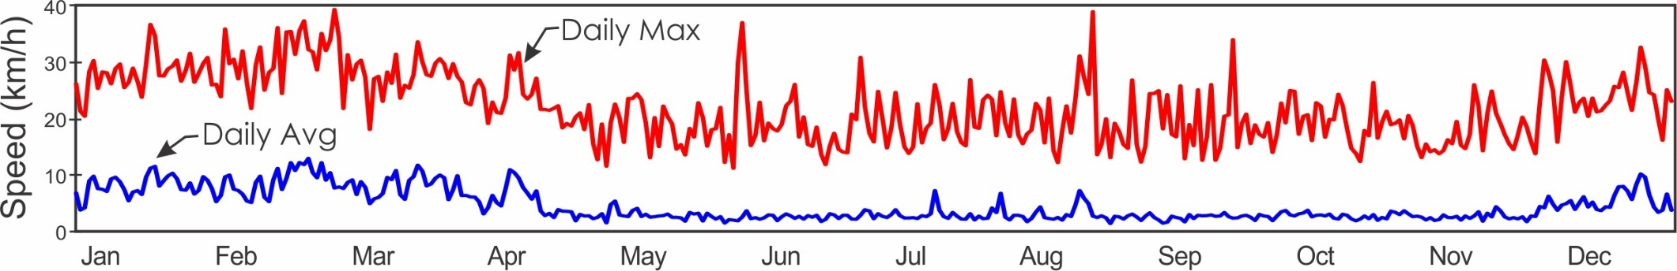
2022 Average Daily Mean Vector Wind Direction
 |  | Jan. | Feb. | Mar. | Apr. | May | June | July | Aug. | Sep. | Oct. | Nov. | Dec.
 | 1 | 329.4 | 344.6 | 340.1 | 353.7 | 281.6 | 162.5 | 177.6 | 294.0 | 137.5 | 135.6 | 45.3 | 348.7
 | 2 | 265.2 | 319.8 | 340.9 | 341.2 | 285.2 | 159.0 | 128.0 | 180.0 | 169.9 | 113.7 | 327.8 | 343.2
 | 3 | 308.1 | 340.1 | 352.3 | 304.1 | 336.8 | 148.0 | 288.2 | 249.8 | 269.4 | 327.4 | 218.2 | 356.9
 | 4 | 355.8 | 350.9 | 349.8 | 253.9 | 326.4 | 118.7 | 259.5 | 279.6 | 255.3 | 316.2 |  | 344.1
 | 5 | 347.3 | 352.3 | 351.1 | 320.7 | 190.5 | 149.0 | 248.6 | 240.7 | 187.1 | 245.8 |  | 252.7
 | 6 | 340.5 | 344.7 | 338.3 | 338.2 | 133.9 | 139.9 | 261.6 | 213.8 | 271.9 | 240.5 |  | 318.3
 | 7 | 346.2 | 346.2 | 348.6 | 332.5 | 23.3 | 141.3 | 246.3 | 287.5 | 244.7 | 221.8 |  | 353.6
 | 8 | 350.2 | 340.9 | 347.6 | 334.4 | 330.9 | 141.5 | 312.5 | 329.4 | 164.2 | 186.0 |  | 349.8
 | 9 | 353.1 | 312.0 | 332.4 | 350.3 | 309.9 | 148.1 | 253.4 | 311.9 | 124.3 | 138.5 |  | 343.6
 | 10 | 353.3 | 319.4 | 344.9 | 355.1 | 294.4 | 134.9 | 229.5 | 244.7 | 275.5 | 122.5 |  | 342.2
 | 11 | 352.3 | 344.1 | 343.3 | 349.9 | 319.9 | 150.5 | 217.7 | 192.8 | 231.7 | 221.2 |  | 345.8
 | 12 | 346.3 | 349.0 | 342.3 | 348.9 | 174.0 | 132.0 | 198.5 | 229.6 | 197.4 | 219.6 |  | 305.4
 | 13 | 329.4 | 334.0 | 351.2 | 347.8 | 256.2 | 160.4 | 237.0 | 245.8 | 138.2 | 164.7 |  | 285.3
 | 14 | 351.2 | 354.1 | 352.7 | 345.0 | 279.6 | 160.9 | 274.7 | 356.9 | 148.0 | 138.9 |  | 269.2
 | 15 | 347.0 | 355.5 | 352.6 | 335.9 | 242.0 | 128.8 | 282.8 | 224.7 | 156.7 | 119.8 | 341.3 | 273.4
 | 16 | 341.9 | 352.0 | 357.4 | 338.6 | 267.7 | 135.0 | 347.6 | 135.7 | 224.0 | 321.6 | 298.4 | 327.4
 | 17 | 350.3 | 331.6 | 336.8 | 297.4 | 274.2 | 226.8 | 307.3 | 349.6 | 164.6 | 221.3 | 228.1 | 332.9
 | 18 | 350.2 | 343.9 | 352.4 | 252.9 | 258.5 | 167.9 | 298.3 | 344.4 | 161.2 | 238.4 | 232.3 | 344.3
 | 19 | 354.5 | 355.5 | 350.9 | 306.5 | 176.1 | 135.3 | 309.2 | 337.2 | 142.0 | 205.7 | 294.2 | 352.7
 | 20 | 344.0 | 353.0 | 354.1 | 301.2 | 126.1 | 117.8 | 213.8 | 330.3 | 158.7 | 183.6 | 306.2 | 348.5
 | 21 | 348.6 | 356.1 | 353.2 | 258.3 | 72.4 | 210.7 | 182.0 | 215.7 | 153.8 | 175.9 | 248.3 | 352.2
 | 22 | 354.2 | 355.0 | 348.2 | 190.6 | 304.1 | 273.4 | 201.7 | 187.1 | 112.4 | 209.0 | 269.6 | 340.2
 | 23 | 349.4 | 356.1 | 351.2 | 180.7 | 310.0 | 291.7 | 246.5 | 170.4 | 358.6 | 246.7 | 255.9 | 349.1
 | 24 | 350.8 | 353.2 | 349.9 | 184.1 | 121.3 | 259.2 | 247.6 | 159.9 | 212.4 | 237.5 | 196.9 | 357.9
 | 25 | 348.0 | 356.2 | 349.0 | 186.1 | 147.0 | 210.0 | 284.5 | 215.6 | 148.4 | 276.5 | 221.0 | 354.9
 | 26 | 346.2 | 354.8 | 347.4 | 257.2 | 288.9 | 190.0 | 209.3 | 222.8 | 134.7 | 292.9 | 195.9 | 344.4
 | 27 | 347.4 | 349.9 | 324.1 | 230.8 | 277.9 | 216.9 | 242.2 | 211.8 | 142.3 | 319.8 | 210.6 | 345.7
 | 28 | 310.7 | 350.0 | 343.0 | 267.2 | 239.5 | 248.1 | 220.5 | 160.5 | 178.3 | 4.1 | 280.1 | 308.1
 | 29 | 343.0 |  | 354.9 | 238.6 | 261.8 | 286.9 | 295.5 | 139.8 | 166.7 | 260.5 | 247.0 | 328.0
 | 30 | 348.8 |  | 350.0 | 239.6 | 244.8 | 277.0 | 296.1 | 173.7 | 135.2 | 194.5 | 341.7 | 344.2
 | 31 | 351.7 |  | 344.7 |  | 132.3 |  | 347.1 | 210.4 |  | 186.3 |  | 327.4
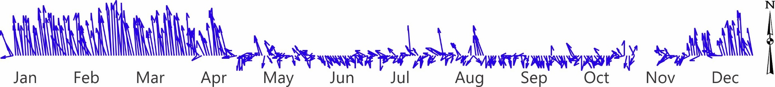

Average Monthly Wind Speed and Direction
 | Long-term Av. |  |  | 2022
 | Speed | Max | Dir. | Speed | Max | Dir.
January | 8.6 | 28.8 | 353.8 | 8.3 | 28.1 | 344.9
February | 9.6 | 30.6 | 355.8 | 9.0 | 30.4 | 346.3
March | 9.6 | 30.5 | 356.8 | 8.3 | 28.0 | 347.1
April | 7.1 | 26.4 | 349.6 | 5.1 | 22.5 | 318.3
May | 4.2 | 21.8 | 309.4 | 3.0 | 18.4 | 263.7
June | 3.6 | 20.4 | 264.0 | 2.8 | 19.7 | 163.5
July | 4.0 | 20.8 | 296.7 | 3.2 | 19.6 | 258.7
August | 3.6 | 20.4 | 275.3 | 3.1 | 19.8 | 243.4
September | 3.2 | 20.4 | 218.9 | 2.7 | 19.3 | 163.7
October | 3.1 | 19.4 | 190.6 | 3.0 | 19.3 | 201.4
November | 3.5 | 20.6 | 264.1 | 2.8 | 17.4 | 257.4
December | 5.5 | 24.1 | 330.7 | 5.7 | 24.2 | 337.3

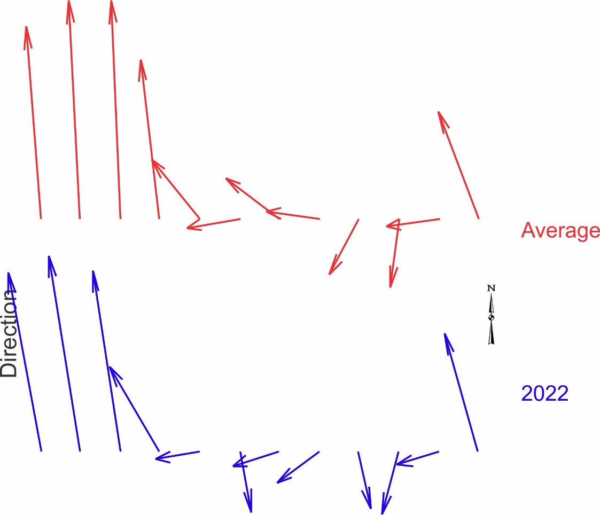
Comparison of Totalizing & Electronic Anemometers

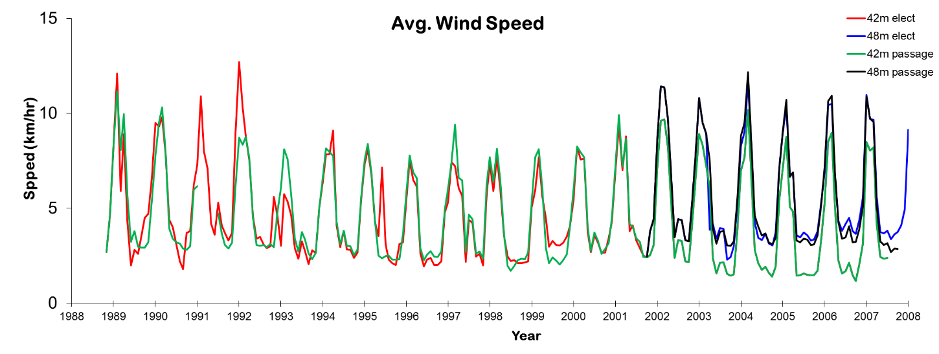
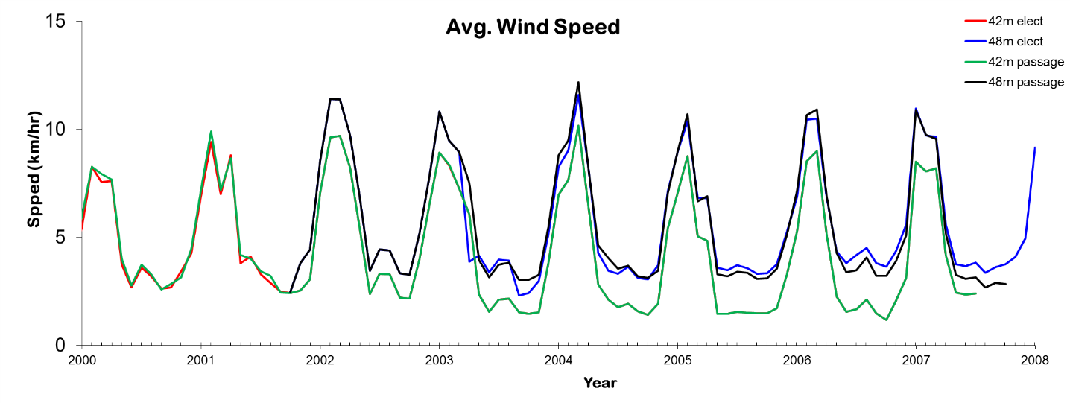
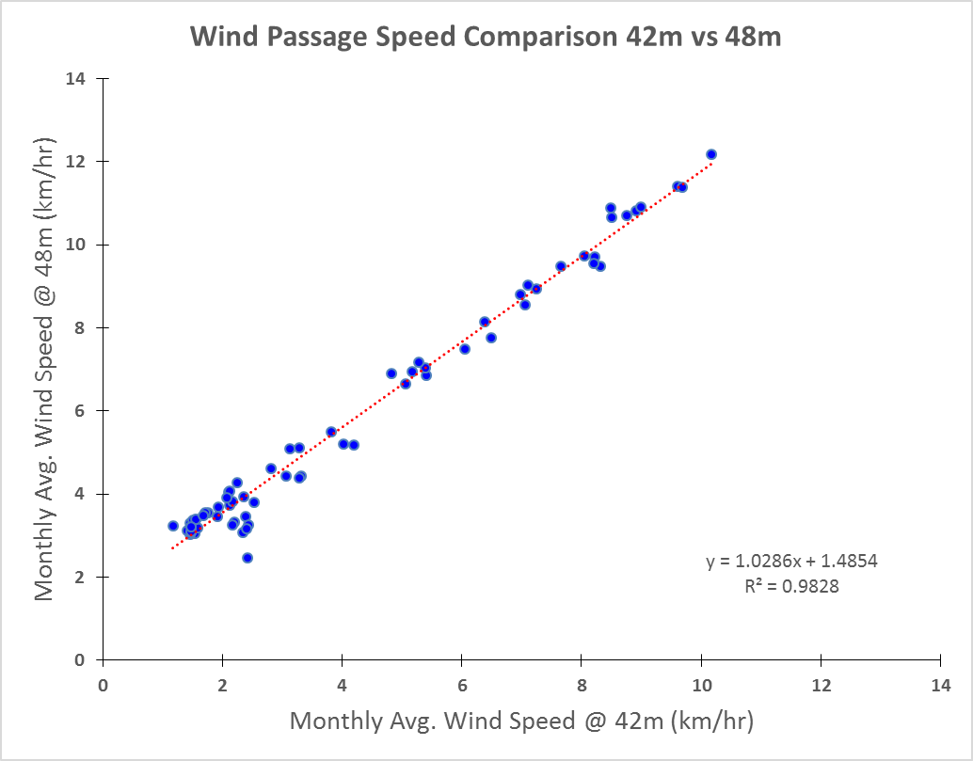
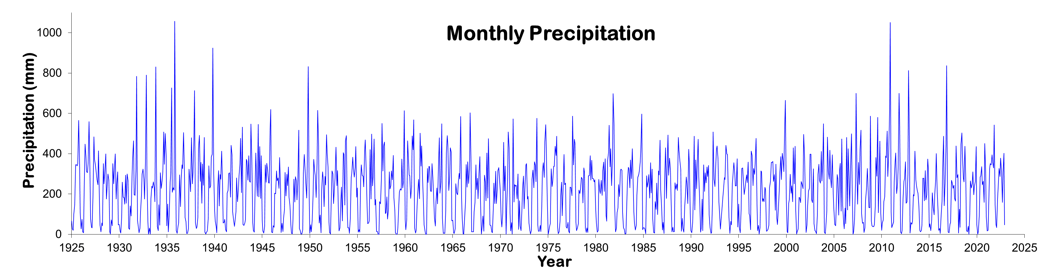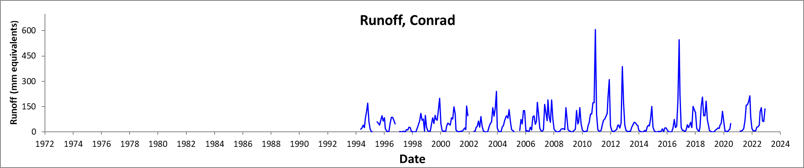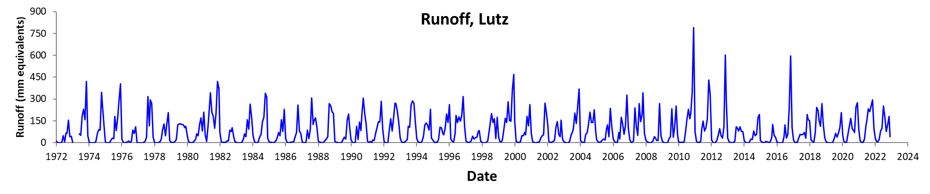
Long-term Monthly Averages/Totals
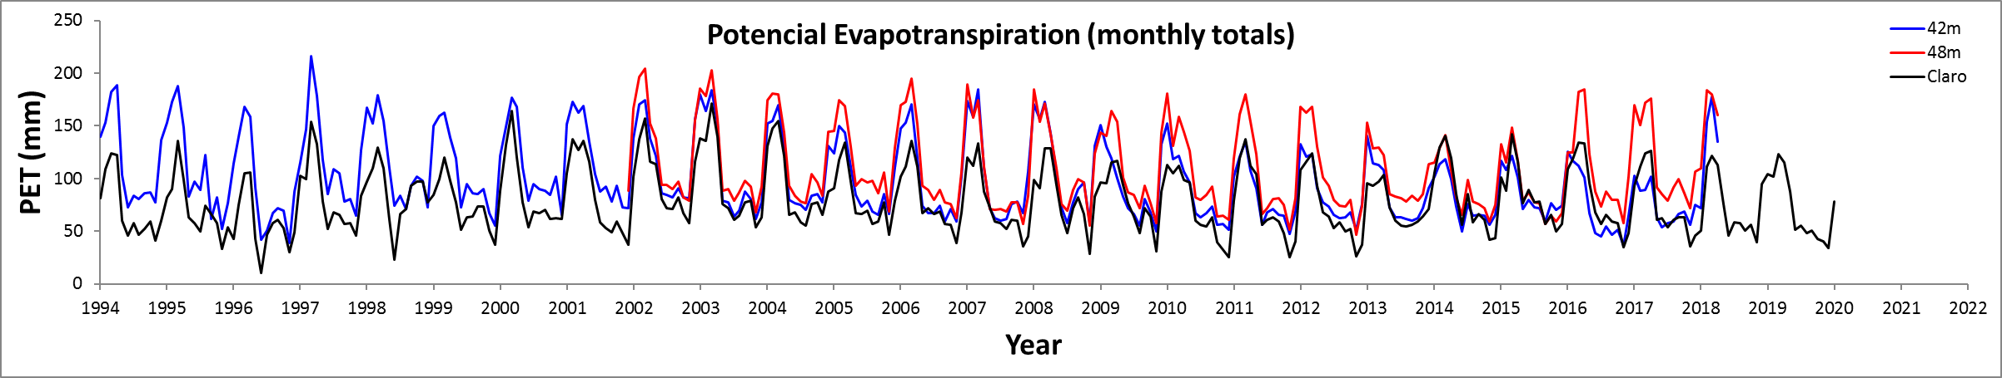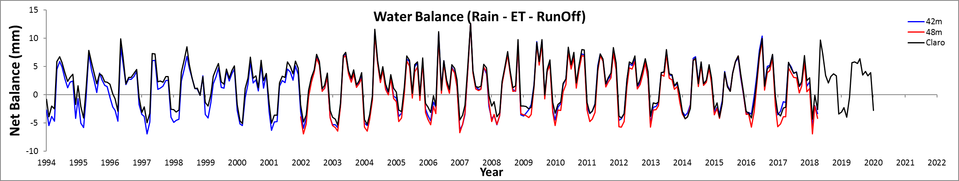
Long-term Monthly Averages/Totals

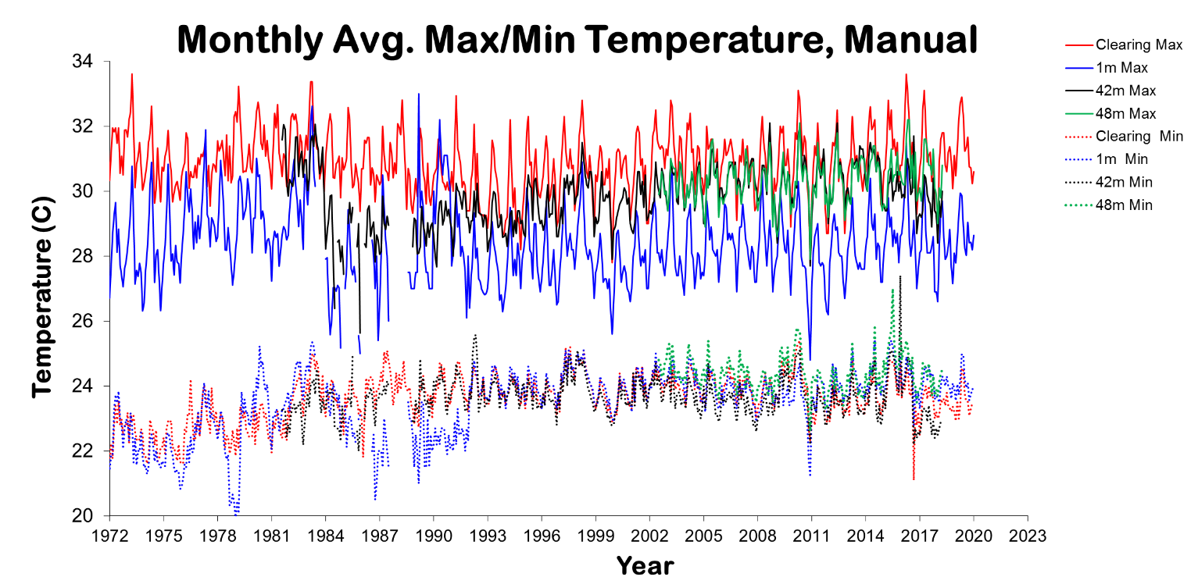
Long-term Monthly Averages/Totals
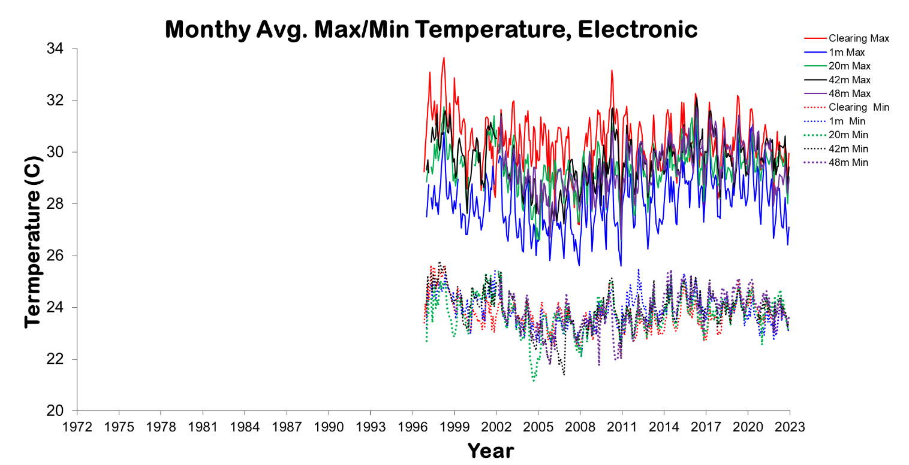
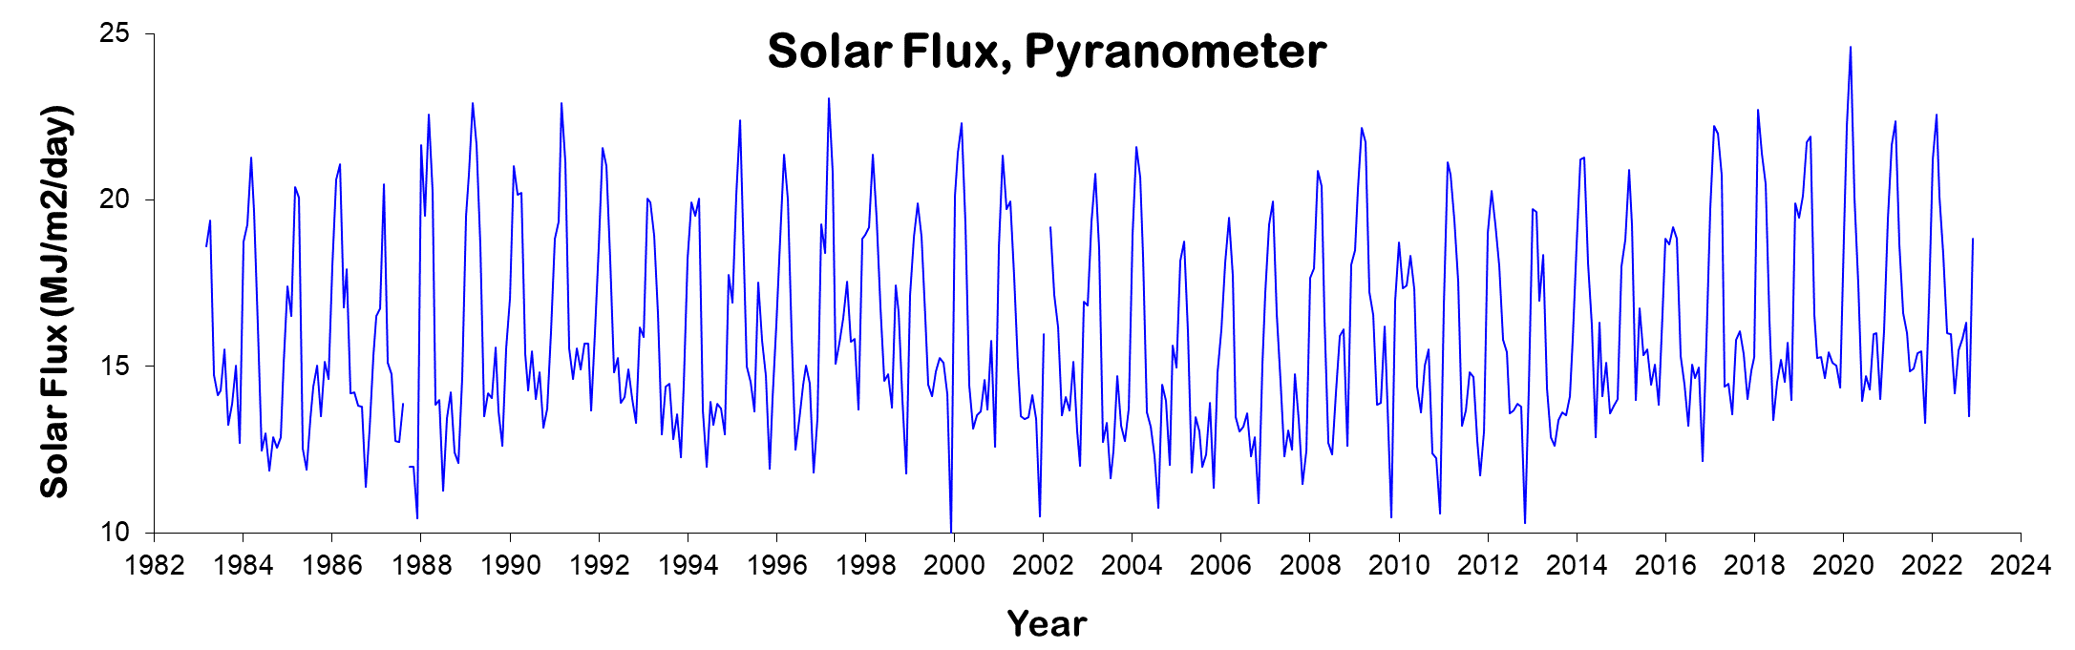
Long-term Monthly Averages/Totals
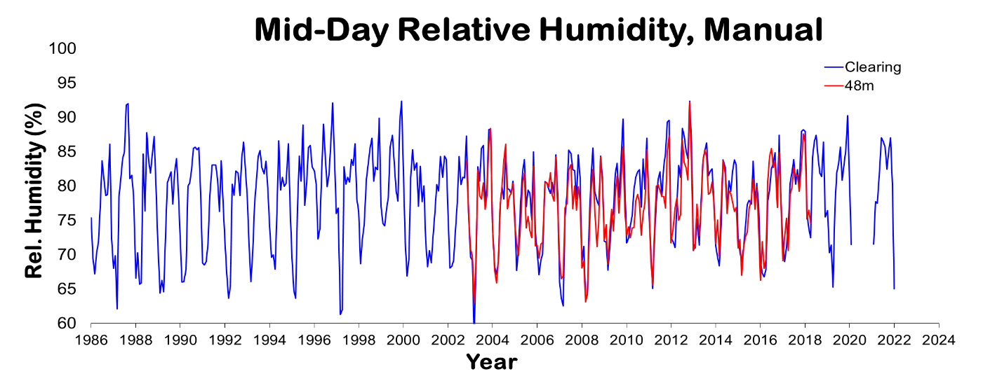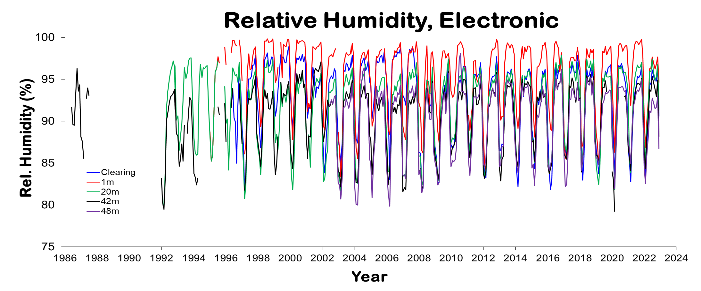
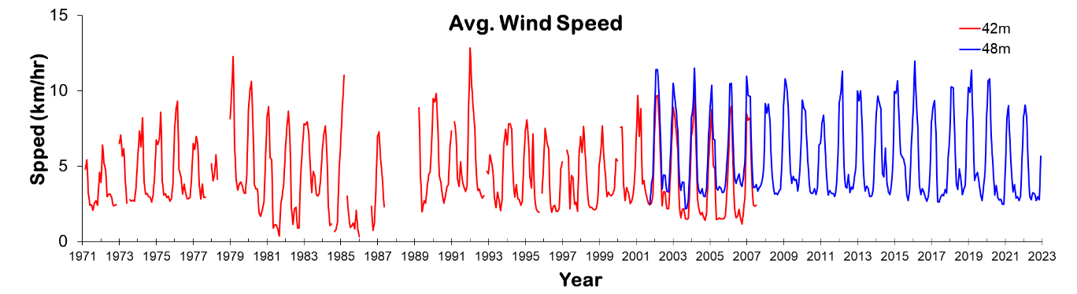
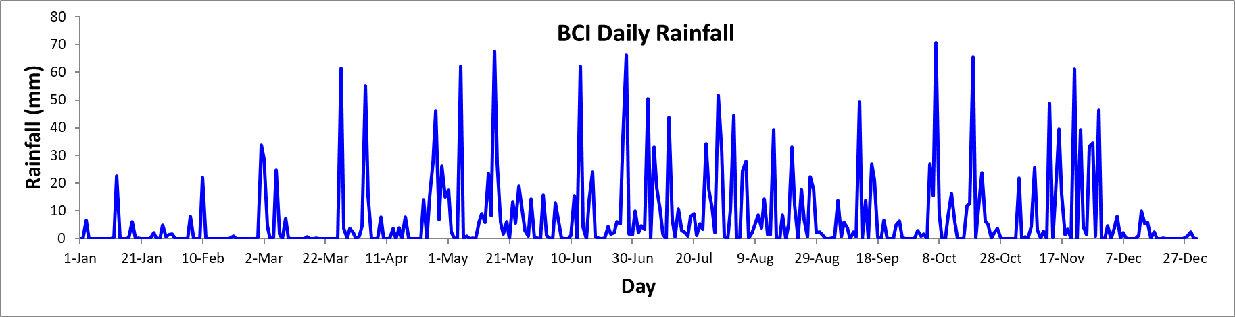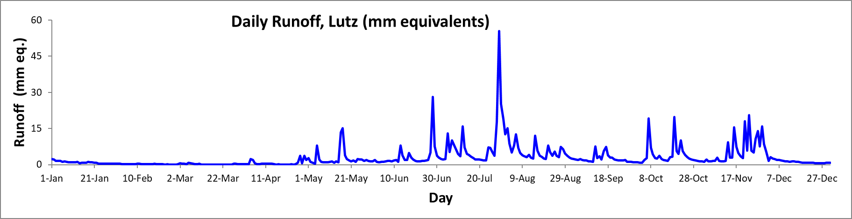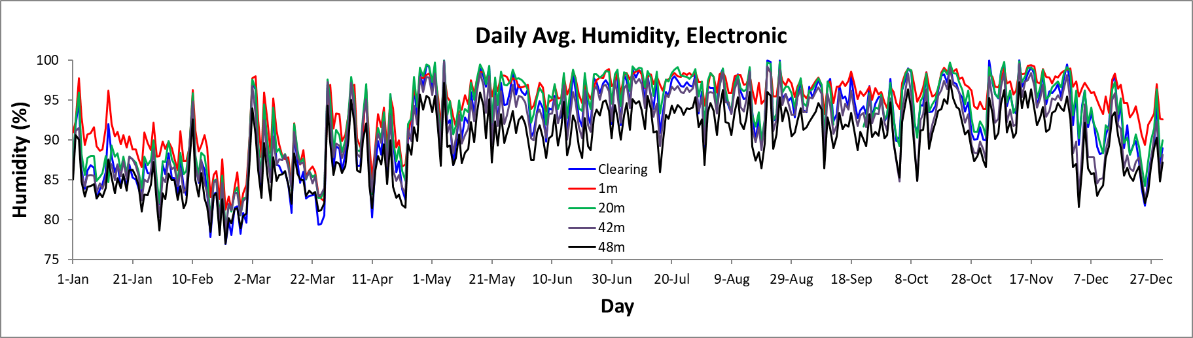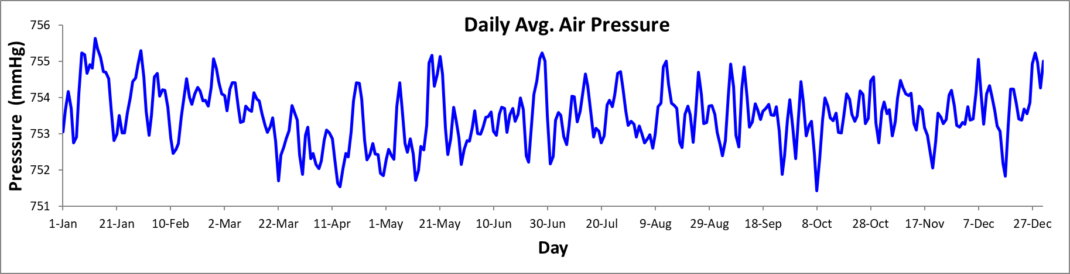
2022 Daily Averages/Totals
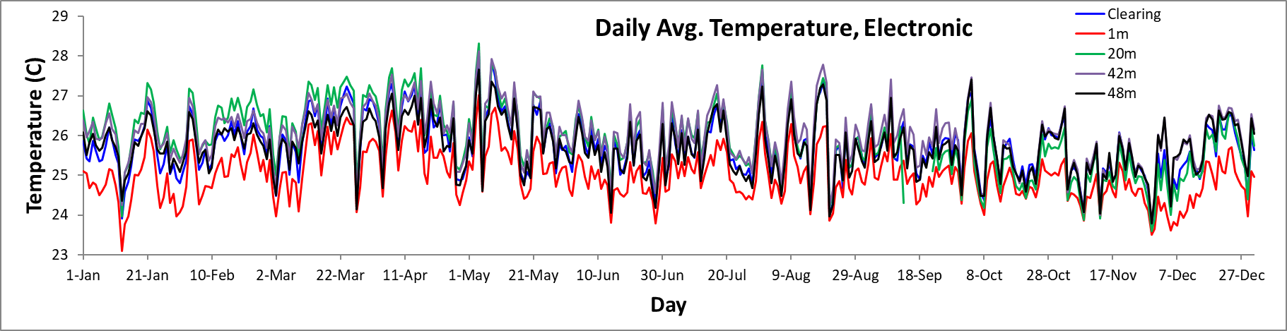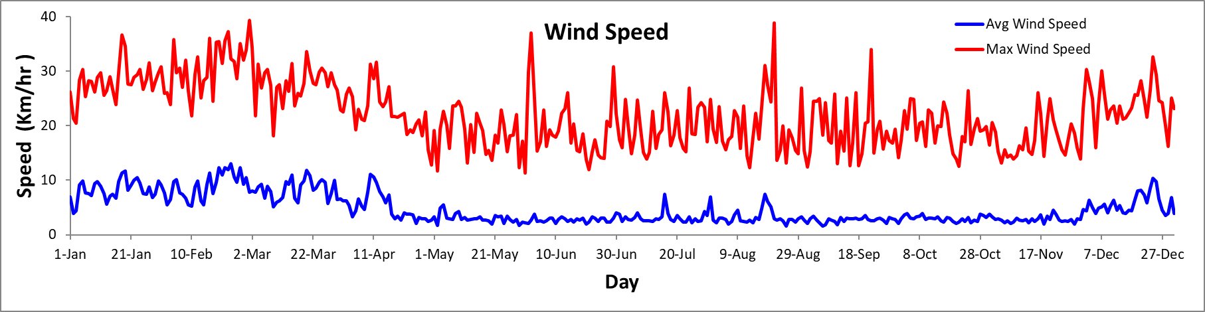
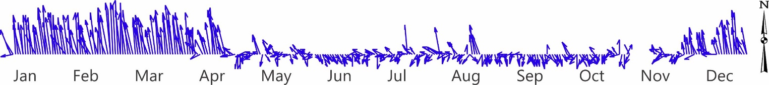
2022 Daily Averages/Totals

Long-term Hour Averages

Long-term Hour Averages

