2022 Meteorological and Oceanographic
Summary for the
Bocas del Toro Research Station

Prepared by: Steven Paton

Introduction

This is the 10th in a series of yearly reports summarising the past year’s Smithsonian Tropical Research Institute’s Physical Monitoring Program on and around the Bocas del Toro Research Station (BRS). This report is not meant to be exhaustive in its coverage in that it summarizes only some of the most ‘important’ or interesting parameters available. Any comments on how future yearly summaries could be improved would be appreciated. Additional copies of this report, reports from previous years, and downloadable data from the Bocas and other research locations, can be obtained from:
http://biogeodb.stri.si.edu/physical_monitoring/research/bocas

Setting

Established in 2002, the BRS (9.351553°, -82.256565°) is located near the western end of Isla Colon - part of the Bocas del Toro Archipelago. The archipelago is a complex region of islands, mainland bays, rivers and forested mountain slopes on the Caribbean side of the Panamanian isthmus.

The station receives an average of 3614.8mm of rain per year. The meteorological year is divided into four parts: two periods of lower rainfall (approximately from mid-December to the end of May, and the months of August to October), and two wetter periods (June-July and November-December) – see the figure on page 7. Relative humidity, solar radiation, air and sea surface temperature, wind speed (but not direction), and salinity all show seasonal patterns.

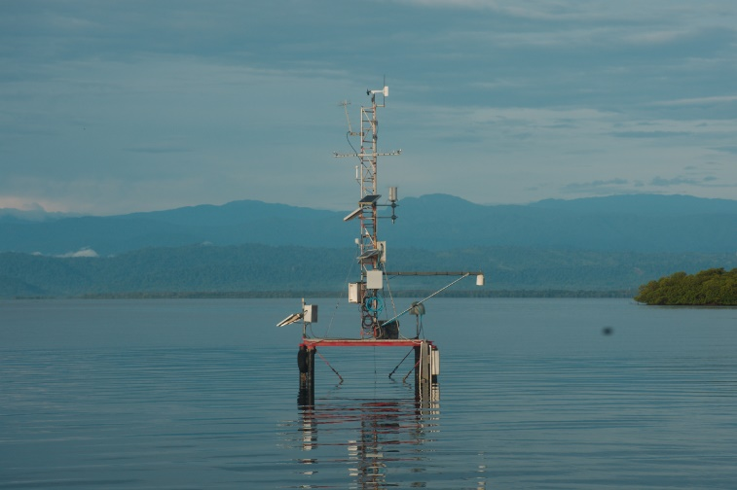
This report summarises data taken from a meteorology tower located on a platform located approximately 60m from the end of the station’s dock, as well as several Sea Surface Temperature (SST) probes located approximately 225m north west of the dock (see map on the following page), as well as the station’s aquariums. The current platform was built in 2012 to replace the original platform (see photo at right).
The platform and tower are used to measure air and water temperature, wind speed and direction, relative humidity and solar radiation.

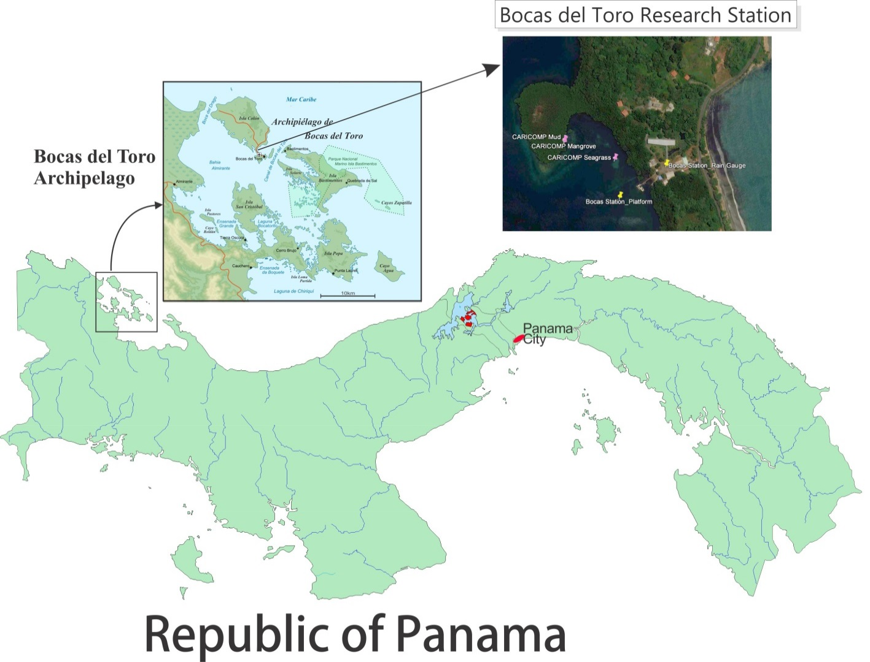

Some summaries (temperature, relative humidity, and soil humidity) are based entirely on manual measurements. Other summaries (solar radiation, wind direction) are based entirely on electro-mechanical measurements. Finally, some summaries (rainfall and wind speed) are based on combinations of manual and electro-mechanical measurements.

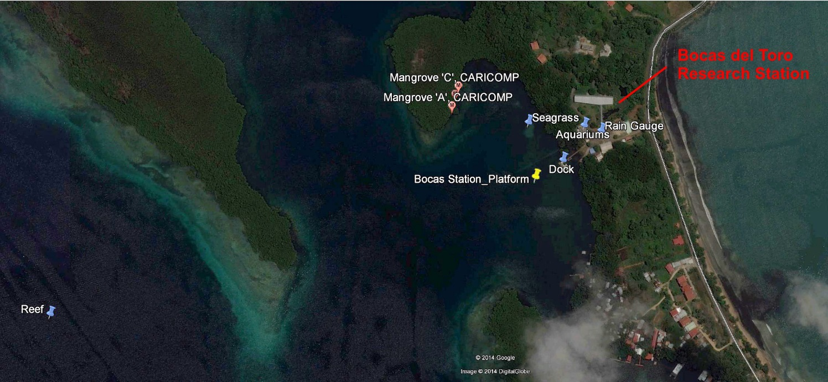
The Mangrove ‘A’, ‘B’, and ‘C’ locations refer to three mangrove census sampling sites located in the mangrove fringe 240m NW of the dock. The Seagrass location refers to the location of the former Seagrass sampling site approximately 90 NW of the dock.

The Data

Data were collected the following locations:

Name | Measurements | Dec Lat. | Dec. Long
Main Platform | Electronic air temperature, wind, solar radiation, rel. humidity, tide, water temperature | 9.350827 | -82.257943
Mangrove A | Weekly water temperature and salinity | 9.351917 | -82.259083
Mangrove B | Weekly water temperature and salinity | 9.352111 | -82.259028
Mangrove C | Weekly water temperature and salinity | 9.352250 | -82.258972
Reef | Weekly water temperature and salinity | 9.348500 | -82.266000
Seagrass | Weekly water temperature and salinity, Electronic water temp. | 9.351694 | -82.257806
Dock (muelle) | Daily water temperature, salinity & DO | 9.351039 | -82.257208
Aquariums (aquarios) | Salinity | 9.351635 | -82.256852

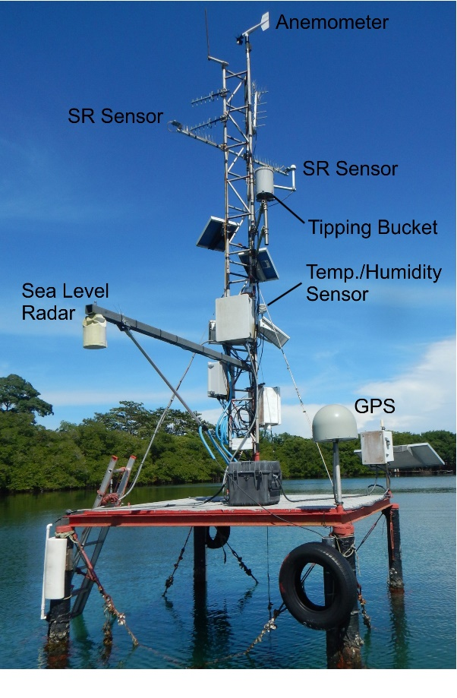
This report summarises the following data:

Platform Relative humidity
Air temperature
Water temperature
Wind speed and direction
Solar radiation
Dock Water temperature
Water Transparency
Salinity
DO
Aquarium Salinity
DO
Mangrove Water temperature
Salinity
Seagrass Water temperature
Salinity

The 2020-1 Pandemic
Beginning on March 20, 2020, STRI was forced to shut down almost all field operations. This resulted in the Physical Monitoring Program suspending of all manual measurements at and near the Bocas station, as well as sensor replacements and calibrations (the latter two were reestablished in Nov.). This includes the manual rain gauge and all ocean water quality measurements. None of the sea surface temperature sensors were recovered during 2021. Manual water quality measurements were all suspended for several months in 2021. With the exception of water transparency, measurements were reestablished at some locations by Sept.

The Data
Rainfall
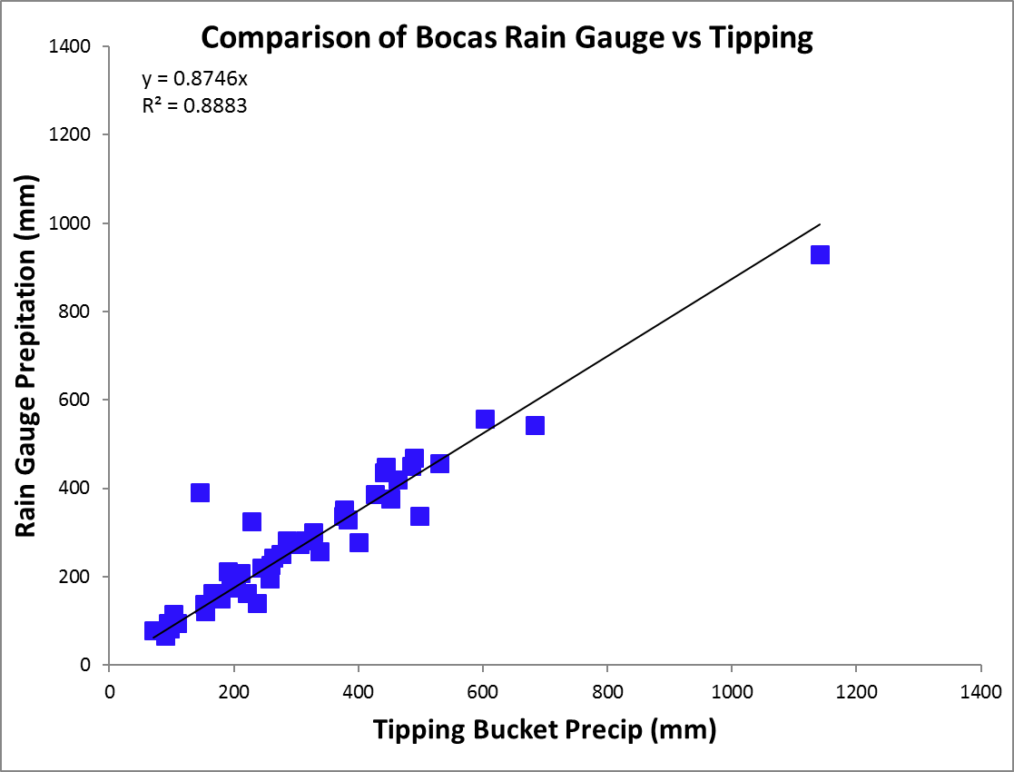
Because of the pandemic shutdown, rainfall was collected by a rain gauge near the centre of the station only until mid-Feb., Rainfall was collected throughout 2021 by a tipping bucket on the platform. The rain gauge was read at approximately 8:00am every day except some weekends and holidays. Tipping buckets generate ‘events’ for every 0.254 mm of rainfall recorded. In order to ‘fill in’ the missing rain gauge data, a computer program was written by the author that uses tipping bucket rainfall data to distribute the rain gauge data for those days when readings were not made. The program takes the total rainfall collected in the rain gauge and divides it up proportionally according to the rainfall patterns recorded by the tipping bucket. The estimated rainfall for the missing days is exactly equal to the rainfall collected by the rain gauge. The daily rainfall data for 2022 are shown on page 7.

Because manual rain gauge measurements were suspended in Feb., tipping bucket data have been used to estimate rainfall. A simple correlation analysis between monthly Tipping Buckent and Rain Gauge data shows that on average the Tipping Bucket underestimates rainfall by 14.34%. This value was used to adjust rainfall values from mid-Feb until the end of the year.

Pages 8 shows the monthly rainfall totals. The graph on page 9 compares this year’s monthly totals with the average monthly totals (±SD) for the period 2002 to 2021.

Page 10 shows yearly rainfall totals for all years since 2003. Time series graph and frequency histograms are presented for these data.

Pages 11 and 12 show an analysis of rainfall ‘events’ (storms). For convenience, and again somewhat arbitrarily, I have defined a storm as any continuous period of rain separated by at least an hour from any other rainfall. Since this analysis required the timing of rainfall events, tipping bucket data were used. As a result, the absolute size of rainfall events should be considered as estimates since they will tend to disproportionately underestimate the size of storms - larger storms will be more underestimated than smaller ones. Keeping this in mind, the tables and graphs on this page compare the maximum storm size and the average storm size and duration per month for the period 2002 to 2021 and for the year 2022.

Relative Humidity

Data were collected on the platform, approximately 3m above Mean Sea Level, at 15-minute intervals by dataloggers attached to Campbell Sci. CS215 temperature/humidity sensors (Viasala HMP 35/45 sensors prior to 2010).
The average monthly relative humidity data are shown in tabular and graphical form on page 13.

Air Temperature

Shaded air temperature data were collected on the platform, approximately 3m above Mean Sea Level, at 15-minute intervals by dataloggers attached to Campbell Sci. CS215 electronic temperature/humidity sensors (Viasala HMP 35/45 sensors prior to 2010). The monthly average temperature plus monthly maximum and minimum temperatures are shown in tabular and graphical form on pages 14 to 17.

Solar Radiation

Global solar radiation was measured at the platform tower approximately 4m above Mean Sea Level using a Li-Cor LI200SB pyranometer attached to a datalogger. 15-minute interval total (MJ m⁻²), maximum and minimum (J m⁻² s⁻¹) are collected.

Page 18 shows the Daily Global Radiation values. Page 19 shows total monthly Global Radiation.

Wind Speed and Direction

15-minute average, maximum and minimum wind speed plus average wind direction was recorded on the platform tower approximately 7m above Mean Sea Level using a Model 05103 Young Anemometer connected to a data logger.

Page 20 shows average and maximum daily wind speeds from the Young Anemometer located at the top of the platform tower. Page 21 shows daily average wind direction. The angles indicated in the table and graph on this page represent the direction into which the wind was predominately blowing on a given day. Pages 22 & 23 show the monthly average wind speed, monthy average daily maximum wind speed, and monthly average directions (Young Anemometer) for the year.

Given the location of the sensor platform with respect to surrounding topography, it is believed that these data reflect very local wind direction, and to a lesser extent wind speed, conditions

Air Pressure

Page 23 shows monthly Average air pressure.
Sea Surface Temperature (SST)

Water temperature data were collected at the platform at a depth of 1m, at 15-minute intervals by dataloggers attached to Campbell Model 107 electronic temperature sensor. Data were also collected at all other locations using Hobo U22 Water Temperature Pro V2 sensors at varying depths.

The monthly average temperature, plus monthly maximum and minimum temperatures for all locations are shown in tabular and graphical form on page 24 and 25, respectively.

Salinity
Determined from recently collected water samples (taken from a depth of 0.5m) at seven locations, using salinometer Lab-Comb model SCT (precision of 0.01 ppt), or the YSI temperature-salinity-oxygen meter model 85 (precision 0.1 ppt). Monthly averages are shown on page 26 and 27.

Water Transparency
Measured using a standard Secchi Disk at the Coral and Seagrass sites. Monthly averages are shown on page 28 and 29.

Dissolved Oxygen
Measured manually at the Dock and the Aquarium using a YSI 2030 Pro sensor. Monthly averages are shown on pages 30 to 31.

Times Series
Graphs showing the daily Air Temperature, Relative Humidity, Rainfall, Solar Radiation and Wind Speed averages for 2022 (pages 32 and 33) and monthly averages for the entire period of recorded SST, Salinity, Secchi depth and DO (pages 34 to 36).

Daily Patterns
Pages 37 and 38 show the daily patterns for air temperature, relative humidity, solar radiation, rainfall and wind speed. These figures were built using electronic sensor data from the platform.

2022 Daily Rainfall (mm)

 | Jan. | Feb. | Mar. | Apr. | May | June | July | Aug. | Sep. | Oct. | Nov. | Dec.
1 | 0.0 | 0.0 | 0.0 | 6.6 | 0.0 | 17.3 | 4.6 | 20.1 | 22.9 | 0.3 | 0.0 | 3.3
2 | 0.5 | 0.3 | 9.4 | 6.4 | 0.0 | 32.8 | 4.8 | 95.5 | 0.0 | 0.3 | 0.0 | 4.8
3 | 8.9 | 0.5 | 91.2 | 0.0 | 0.0 | 0.0 | 79.0 | 14.0 | 5.1 | 0.0 | 4.6 | 13.7
4 | 17.0 | 0.0 | 9.7 | 10.4 | 3.3 | 0.0 | 0.0 | 5.6 | 0.8 | 0.0 | 0.3 | 1.8
5 | 0.0 | 0.0 | 0.0 | 13.0 | 0.0 | 1.0 | 6.6 | 3.3 | 0.0 | 4.6 | 0.0 | 0.3
6 | 2.3 | 0.0 | 0.5 | 0.0 | 0.3 | 3.3 | 4.1 | 23.6 | 0.0 | 7.1 | 0.0 | 8.1
7 | 0.0 | 2.8 | 2.0 | 0.0 | 1.5 | 5.1 | 42.4 | 0.0 | 0.0 | 13.2 | 13.2 | 4.6
8 | 0.0 | 0.3 | 0.0 | 35.1 | 0.0 | 0.0 | 0.3 | 7.4 | 0.3 | 0.8 | 0.3 | 0.0
9 | 1.5 | 0.0 | 0.0 | 271.8 | 18.5 | 2.0 | 18.8 | 1.5 | 0.0 | 2.0 | 0.0 | 1.8
10 | 0.0 | 10.2 | 0.3 | 179.8 | 0.0 | 11.9 | 0.0 | 0.3 | 4.1 | 0.0 | 8.6 | 2.5
11 | 21.3 | 1.3 | 3.0 | 0.3 | 0.0 | 16.3 | 5.6 | 0.0 | 6.1 | 0.0 | 1.5 | 0.0
12 | 0.0 | 2.0 | 0.0 | 5.8 | 11.4 | 0.5 | 77.5 | 0.0 | 0.3 | 4.8 | 0.0 | 0.0
13 | 0.0 | 2.3 | 1.5 | 2.3 | 7.6 | 24.9 | 0.0 | 32.3 | 0.0 | 0.0 | 21.3 | 0.0
14 | 0.0 | 38.4 | 10.7 | 35.8 | 1.3 | 18.3 | 0.5 | 0.0 | 1.3 | 0.0 | 25.9 | 0.0
15 | 0.0 | 3.0 | 1.3 | 4.6 | 0.0 | 16.3 | 21.8 | 6.9 | 0.0 | 0.3 | 16.0 | 3.3
16 | 0.0 | 3.0 | 0.0 | 8.6 | 0.0 | 0.3 | 0.0 | 0.3 | 5.1 | 2.8 | 37.6 | 1.8
17 | 0.0 | 0.0 | 0.0 | 0.0 | 27.2 | 1.0 | 0.3 | 0.0 | 72.9 | 7.9 | 19.6 | 11.2
18 | 2.3 | 2.3 | 0.0 | 0.0 | 53.6 | 0.0 | 3.0 | 0.0 | 0.5 | 0.0 | 0.3 | 14.2
19 | 2.0 | 0.0 | 7.4 | 0.0 | 0.0 | 32.5 | 2.0 | 14.5 | 0.0 | 3.3 | 7.6 | 2.0
20 | 0.3 | 0.0 | 10.4 | 0.0 | 0.0 | 40.1 | 16.3 | 0.0 | 0.0 | 0.0 | 8.9 | 0.0
21 | 7.9 | 0.0 | 0.3 | 0.0 | 4.8 | 13.5 | 35.3 | 0.0 | 0.0 | 0.3 | 4.6 | 14.5
22 | 2.0 | 0.0 | 7.1 | 0.0 | 0.0 | 1.5 | 0.3 | 55.4 | 0.0 | 0.0 | 0.8 | 7.9
23 | 0.3 | 6.4 | 6.9 | 0.5 | 0.0 | 1.8 | 3.6 | 1.5 | 0.5 | 18.8 | 0.0 | 7.6
24 | 0.0 | 0.0 | 2.0 | 4.8 | 16.3 | 0.3 | 1.0 | 0.0 | 0.0 | 0.0 | 12.4 | 7.9
25 | 0.0 | 1.8 | 3.3 | 4.8 | 0.0 | 8.1 | 0.0 | 10.4 | 0.0 | 0.0 | 0.0 | 0.0
26 | 0.0 | 5.6 | 2.0 | 23.1 | 1.8 | 6.1 | 0.0 | 0.0 | 2.3 | 0.0 | 4.6 | 0.0
27 | 0.0 | 0.0 | 0.3 | 12.4 | 3.3 | 18.8 | 3.3 | 0.0 | 0.0 | 0.0 | 17.0 | 0.0
28 | 0.0 | 0.0 | 2.0 | 10.2 | 0.0 | 1.0 | 5.1 | 14.7 | 0.3 | 0.0 | 26.2 | 0.0
29 | 11.2 |  | 19.8 | 34.5 | 0.0 | 31.0 | 2.3 | 0.3 | 0.0 | 0.0 | 22.9 | 4.6
30 | 0.0 |  | 6.6 | 0.0 | 0.0 | 67.3 | 19.1 | 0.0 | 4.8 | 0.0 | 3.3 | 1.5
31 | 0.0 |  | 14.7 |  | 0.0 |  | 11.9 | 0.0 |  | 0.0 |  | 0.0
 | 77.5 | 80.0 | 212.3 | 670.8 | 150.9 | 372.9 | 369.3 | 307.3 | 127.0 | 66.3 | 257.3 | 117.3
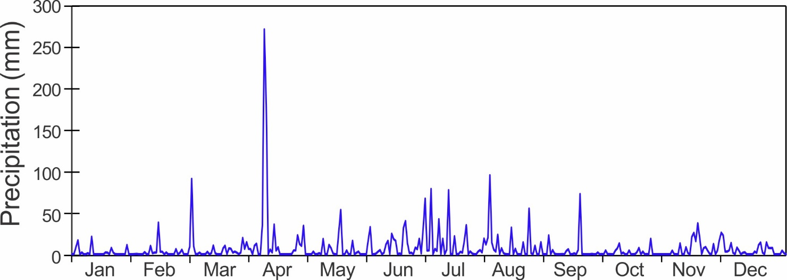
Monthly Rainfall (mm)

Year | Jan | Feb | Mar | Apr | May | June | July | Aug | Sep | Oct | Nov | Dec | Total
2002 |  |  |  |  |  | 255.6 | 734.8 | 714.4 | 200.4 | 226.5 | 760.9 | 220.7
2003 | 107.5 | 124.9 | 133.6 | 270.1 | 676.7 | 258.5 | 310.7 | 348.5 | 78.4 | 127.8 | 244.0 | 659.2 | 3339.8
2004 | 133.6 | 183.0 | 319.5 | 453.1 | 702.8 | 344.3 | 292.9 | 342.6 | 160.8 | 205.0 | 783.3 | 662.8 | 4583.6
2005 | 792.2 | 146.7 | 73.8 | 436.2 | 131.8 | 210.4 | 411.1 | 425.1 | 238.8 | 266.5 | 430.8 | 177.6 | 3741.0
2006 | 393.6 | 231.7 | 534.1 | 206.8 | 120.4 | 213.4 | 400.9 | 426.0 | 165.1 | 238.4 | 215.1 | 375.1 | 3520.6
2007 | 345.7 | 45.4 | 57.5 | 208.2 | 361.6 | 315.8 | 306.5 | 209.5 | 96.9 | 159.7 | 510.6 | 680.5 | 3297.9
2008 | 185.1 | 185.5 | 141.0 | 193.6 | 208.5 | 159.3 | 416.3 | 267.4 | 158.7 | 162.1 | 1209.2 | 264.8 | 3551.5
2009 | 306.9 | 739.3 | 425.1 | 221.5 | 504.8 | 89.3 | 434.2 | 359.7 | 167.9 | 378.6 | 526.2 | 199.4 | 4352.9
2010 | 314.2 | 175.3 | 409.8 | 268.7 | 463.2 | 233.7 | 123.5 | 267.6 | 107.0 | 140.0 | 450.2 | 586.0 | 3539.2
2011 | 267.3 | 366.0 | 203.9 | 258.1 | 369.4 | 152.1 | 301.7 | 100.4 | 218.2 | 272.7 | 185.0 | 561.8 | 3256.6
2012 | 207.2 | 171.0 | 316.6 | 185.2 | 158.2 | 214.6 | 549.6 | 114.1 | 177.6 | 176.7 | 633.8 | 335.4 | 3240.0
2013 | 69.6 | 118.7 | 168.3 | 218.2 | 183.0 | 417.3 | 620.6 | 84.3 | 93.9 | 172.8 | 341.2 | 284.7 | 2772.6
2014 | 189.5 | 76.9 | 77.0 | 263.3 | 434.7 | 362.5 | 612.8 | 303.8 | 151.5 | 241.2 | 315.1 | 483.9 | 3512.2
2015 | 480.4 | 273.5 | 225.9 | 482.9 | 820.7 | 302.4 | 572.3 | 441.2 | 261.1 | 187.0 | 282.5 | 474.6 | 4804.4
2016 | 103.3 | 337.4 | 108.4 | 196.0 | 166.1 | 327.7 | 489.1 | 314.5 | 195.4 | 236.6 | 440.9 | 462.6 | 3378.0
2017 | 258.7 | 70.9 | 375.2 | 90.0 | 244.8 | 401.7 | 285.2 | 102.8 | 152.4 | 154.3 | 263.9 | 743.5 | 3143.4
2018 | 683.8 | 400.2 | 178.2 | 485.6 | 221.3 | 451.9 | 1140.9 | 210.8 | 203.2 | 275.0 | 427.0 | 152.2 | 4830.1
2019 | 97.6 | 93.6 | 190.5 | 228.9 | 498.2 | 530.4 | 376.7 | 383.1 | 306.3 | 257.9 | 443.6 | 603.1 | 4009.9
2020 | 276.6 | 145.8 | 104.6 | 376.7 | 257.6 | 460.3 | 179.2 | 210.8 | 154.0 | 260.3 | 388.8 | 339.4 | 3092.0
2021 | 280.4 | 175.3 | 283.7 | 396.2 | 514.7 | 228.9 | 701.1 | 325.4 | 163.3 | 191.5 | 279.0 | 361.7 | 3901.1
2022 | 84.9 | 92.9 | 235.9 | 670.8 | 178.2 | 403.5 | 404.0 | 308.8 | 127.0 | 73.1 | 276.2 | 130.6 | 2985.9
Mean | 279.9 | 225.5 | 218.8 | 275.2 | 380.0 | 292.6 | 462.6 | 294.2 | 171.4 | 210.3 | 456.7 | 434.0 | 3647.9
sd | 173.1 | 179.4 | 142.1 | 107.6 | 213.1 | 111.7 | 227.3 | 152.4 | 61.5 | 61.3 | 243.0 | 186.7 | 561.3
Min | 68.4 | 45.4 | 57.5 | 90.0 | 81.4 | 89.3 | 123.5 | 84.3 | 78.4 | 127.8 | 185.0 | 152.2 | 2770.7
Max | 786.1 | 725.5 | 534.2 | 482.9 | 819.7 | 530.4 | 1058.6 | 714.4 | 306.3 | 378.8 | 1212.2 | 743.5 | 4713.3
Rank* | 19 | 17 | 8 | 1 | 17 | 3 | 12 | 11 | 16 | 21 | 17 | 21 | 18

Data in green are from the tipping bucket. All other data are from the station’s manual rain gauge
* Rank of latest year months compared to all other years. 1 = wettest

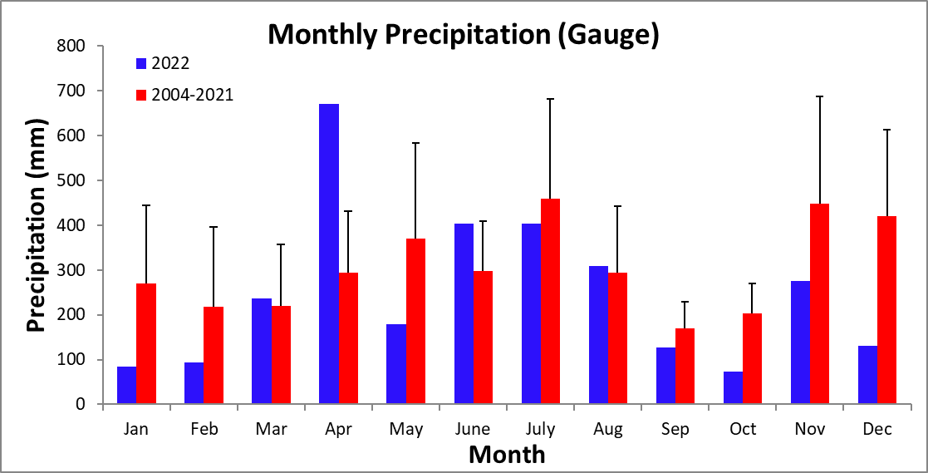
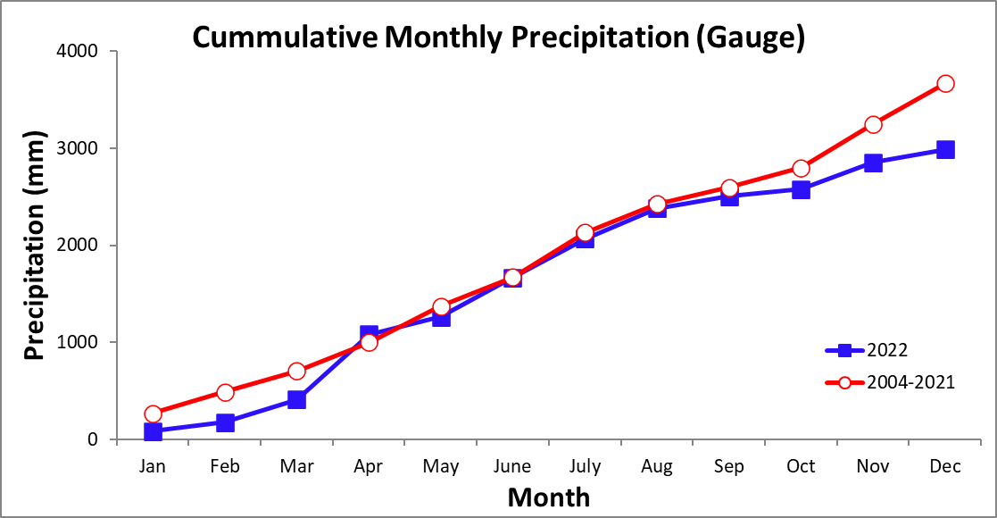
Yearly Rainfall (mm)

Year | Rain | Year | Rain | Year | Rain
2003 | 2910.0* | 2010 | 3448.4 | 2017 | 2050.1
2004 | 4358.9* | 2011 | 3158.8 | 2018 | 4811.0
2005 | 3741.0 | 2012 | 3106.8 | 2019 | 4009.9
2006 | 3473.6 | 2013 | 2750.9 | 2020 | 2814.0
2007 | 3212.5 | 2014 | 3512.2 | 2021 | 3901.1
2008 | 3518.3 | 2015 | 4622.9 | 2022 | 2985.9
2009 | 4352.9 | 2016 | 3378.0
* Data from tipping bucket. All other data from rain gauge

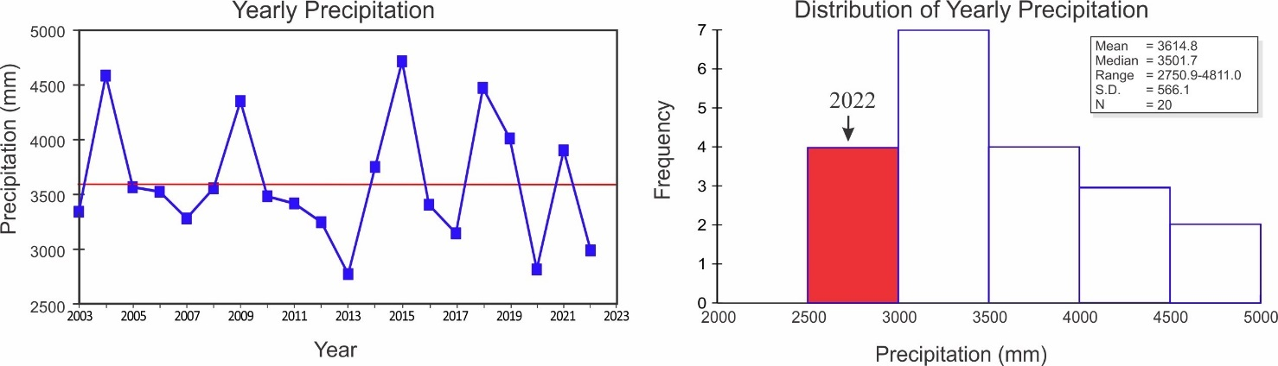

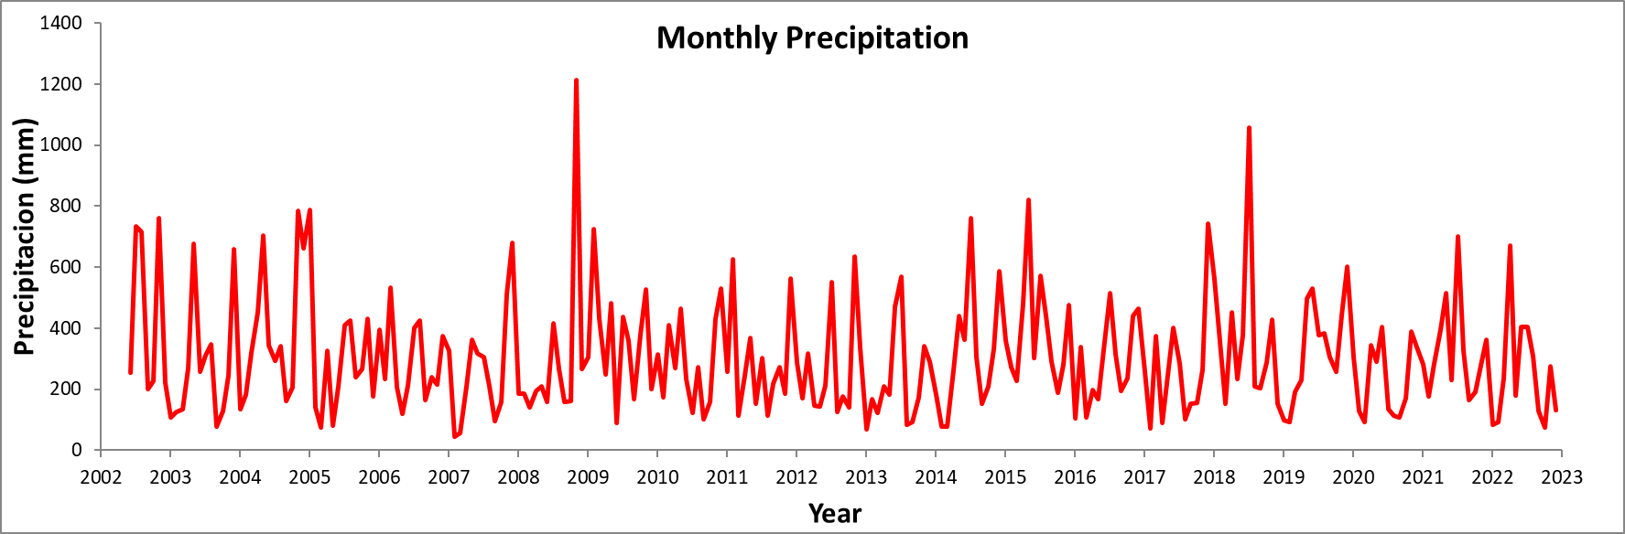

Storm Analysis

 |  | Max. Rainfall per Storm (mm) |  |  |  | Storm Duration (min.)
 | 2002-2021 |  |  | 2022 |  | 2002-2021 |  | 2022
 | Mean |  | S.D. |  |  | Mean | S.D.
January | 45.5 |  | 32.2 | 70.4 |  | 54.0 | 21.0 | 50.5
February | 37.0 |  | 35.7 | 26.4 |  | 45.8 | 22.5 | 66.1
March | 41.4 |  | 36.0 | 42.7 |  | 49.1 | 22.0 | 68.1
April | 47.6 |  | 27.3 | 81.8 |  | 54.5 | 17.5 | 74.7
May | 56.4 |  | 37.3 | 93.0 |  | 68.3 | 25.0 | 75.2
June | 62.1 |  | 29.7 | 50.8 |  | 67.7 | 22.0 | 95.6
July | 66.5 |  | 38.6 | 173.0 |  | 74.1 | 25.3 | 120.7
August | 54.0 |  | 26.6 | 43.4 |  | 61.3 | 17.7 | 126.5
September | 42.0 |  | 15.8 | 28.4 |  | 57.7 | 21.4 | 57.9
October | 42.9 |  | 17.0 | 38.3 |  | 64.9 | 26.1 | 54.2
November | 73.6 |  | 56.5 | 65.8 |  | 76.8 | 29.9 | 59.3
December | 77.0 |  | 56.3 | 65.0 |  | 65.3 | 24.2 | 80.2

 | Av. Rainfall per Storm (mm)
 | 2002-2021 |  | 2022
 | Mean | S.D.
January | 4.4 | 1.8 | 3.9
February | 4.0 | 2.4 | 5.0
March | 4.2 | 1.9 | 4.6
April | 6.1 | 2.8 | 7.5
May | 7.2 | 3.4 | 6.3
June | 6.9 | 2.2 | 7.5
July | 7.3 | 2.2 | 14.9
August | 5.9 | 2.1 | 9.6
September | 5.7 | 1.8 | 5.2
October | 5.5 | 1.9 | 6.0
November | 7.2 | 2.9 | 6.3
December | 6.3 | 2.2 | 6.3

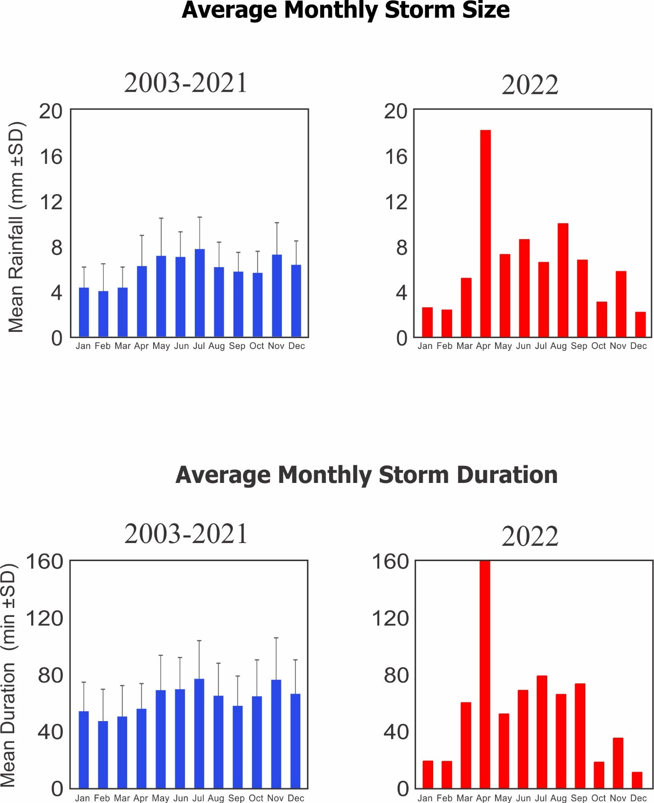
Relative Humidity (%)

Year | Jan | Feb | Mar | Apr | May | June | July | Aug | Sep | Oct | Nov | Dec
2009 |  |  |  |  |  |  |  | 83.7 | 81.6 | 83.6 | 85.5 | 83.0
2010 | 83.0 | 87.4 | 87.5 | 87.4 | 87.8 | 86.3 | 87.2 | 87.6 | 85.8 | 85.5 | 87.3 | 89.2
2011 | 88.3 | 86.0 | 84.3 | 86.1 | 87.8 | 87.1 | 88.8 | 86.9 | 86.9 | 87.3 | 88.2 | 89.4
2012 | 87.1 | 85.8 | 87.3 | 88.5 | 85.7 | 86.0 | 88.4 | 86.7 | 86.6 | 86.5 | 90.1 | 88.6
2013 | 85.6 | 85.6 | 88.1 | 88.1 | 88.0 | 89.6 | 90.6 | 88.2 | 86.8 | 88.1 | 88.3 | 86.9
2014 | 87.1 | 85.7 | 83.3 | 86.7 | 87.8 | 89.8 | 91.8 | 89.2 | 87.3 | 87.8 | 88.1 | 88.6
2015 | 88.0 | 85.9 | 84.5 | 87.0 | 89.3 | 89.3 | 89.9 | 89.9 | 88.2 | 87.2 | 87.5 | 88.4
2016 | 86.0 | 86.0 | 85.9 | 85.5 | 86.6 | 87.6 | 88.9 | 88.9 | 87.5 | 87.3 | 88.2 | 87.5
2017 | 82.9 | 80.8 | 82.0 | 82.9 | 84.2 | 85.3 | 86.7 | 84.4 | 83.8 | 84.6 | 83.7 | 85.4
2018 | 87.1 |  |  |  |  |  |  | 87.7 | 85.6 | 86.9 | 87.9 | 83.9
2019 | 83.2 | 82.8 | 85.4 | 85.9 | 88.8 | 87.9 | 88.2 | 88.8 | 87.9 | 86.4 | 88.6 | 89.0
2020 | 88.1 | 85.4 | 82.3 | 88.2 | 88.9 | 88.5 | 88.2 | 87.8 | 86.2 | 86.3 | 87.7
2021 | 81.7 | 79.9 | 80.1 | 83.1 | 84.6 | 83.2 | 85.2 | 83.4 | 82.5 | 84.0 | 85.9 | 84.9
2022 | 80.6 | 79.5 | 81.4 | 84.8 | 84.7 | 85.1 | 85.9 | 84.5 | 83.7 | 83.3 | 84.8 | 83.1
mean | 86.0 | 85.1 | 85.1 | 86.6 | 87.5 | 87.7 | 88.9 | 87.5 | 86.2 | 86.4 | 87.6 | 87.3
sd | 2.1 | 1.9 | 2.2 | 1.7 | 1.6 | 1.6 | 1.6 | 1.5 | 1.2 | 1.0 | 1.5 | 2.1
min | 82.9 | 80.8 | 82.0 | 82.9 | 84.2 | 85.3 | 86.7 | 83.8 | 81.6 | 83.6 | 83.7 | 83.0
max | 88.3 | 87.4 | 88.1 | 88.5 | 89.3 | 89.8 | 91.8 | 89.9 | 88.2 | 88.1 | 90.1 | 89.4

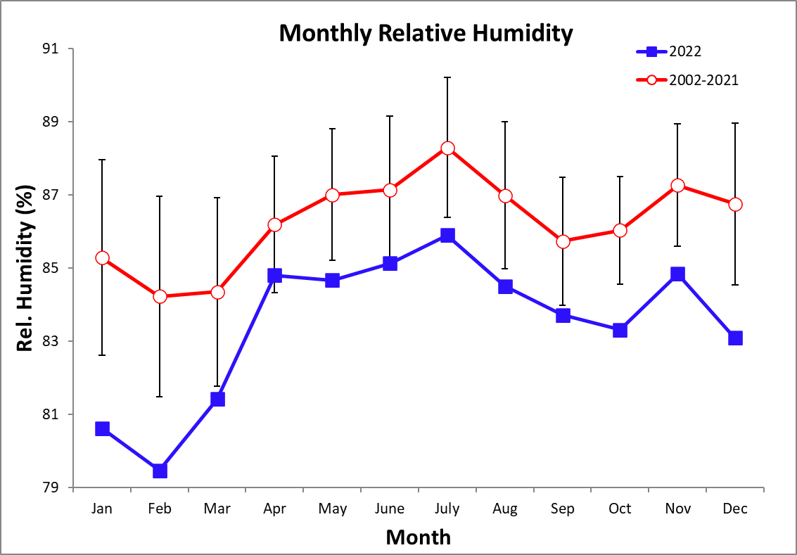
Monthly Average of Daily Average/Maximum/Minimum Temperatures (°C)

Monthly Average Temperature
Year | Jan | Feb | Mar | Apr | May | June | July | Aug | Sep | Oct | Nov | Dec
2002 |  |  |  |  |  | 26.9 | 26.3 | 26.2 | 27.6 | 26.9 | 26.4
2003 | 25.7 | 26.2 | 27.1 | 27.3 | 27.1 | 27.2 | 26.7 | 26.6 | 27.6 | 27.6 | 26.9 | 25.4
2004 | 25.6 | 25.8 | 25.8 | 26.5 | 26.4 | 26.8 | 26.4 | 26.5 | 27.4 | 27.4 | 25.6 | 25.1
2005 | 24.4 | 25.0 | 27.3 | 26.3 |  | 28.2 | 27.5 | 27.0 | 27.1 | 27.5 | 25.9 | 25.9
2006 | 25.5 | 25.3 | 25.2 | 26.3 | 27.1 | 27.3 | 26.9 | 27.0 | 27.1 | 27.3 | 26.3 | 26.1
2007 | 25.3 | 26.1 | 26.5 | 27.0 | 27.2 | 27.3 | 26.8 | 27.1 | 27.1 | 27.2 | 25.9 | 25.3
2008 | 25.1 | 25.3 | 25.6 | 26.2 | 26.8 | 26.9 | 26.3 | 26.9 | 27.5 | 27.1 | 25.6 | 25.1
2009 | 25.0 | 24.5 | 24.9 | 26.2 | 26.7 | 27.2 | 26.5 | 26.7 | 27.5 | 26.9 | 26.1 | 26.2
2010 | 25.6 | 26.0 | 26.0 | 26.9 | 27.2 | 27.2 | 27.0 | 26.9 | 27.1 | 26.5 | 25.2 | 23.7
2011 | 24.6 | 25.1 | 25.2 | 25.7 | 26.8 | 27.2 | 26.5 | 27.0 | 26.9 | 26.4 | 25.6 | 24.7
2012 | 24.5 | 25.1 | 24.8 |  | 27.6 | 27.5 | 26.4 | 27.2 | 27.0 | 27.0 | 25.6 | 25.8
2013 | 25.9 | 25.7 | 25.8 | 26.7 | 26.8 | 26.8 | 26.5 | 27.0 | 27.6 | 27.2 | 26.6 | 26.0
2014 | 25.5 | 25.6 | 25.9 | 26.1 | 26.5 | 26.5 | 26.1 | 26.3 | 26.8 | 26.7 | 26.3 | 25.5
2015 | 25.2 | 25.6 | 25.7 | 26.5 | 26.6 | 27.2 | 26.4 | 26.8 | 27.1 | 27.6 | 27.1 | 26.9
2016 | 26.1 | 25.7 | 26.6 | 27.3 | 27.8 | 27.4 | 26.4 | 26.9 | 27.1 | 27.3 | 26.4 | 25.8
2017 | 25.5 | 26.0 | 25.7 | 27.1 | 27.6 | 27.3 | 26.4 | 27.1 | 27.5 | 27.3 | 26.5 | 25.1
2018 | 24.4 | 24.7 | 25.6 | 25.9 | 27.0 | 27.3 | 26.9 | 26.5 | 27.2 | 26.9 | 26.5 | 26.2
2019 | 25.9 | 26.1 | 25.7 | 26.7 | 27.3 | 27.6 | 26.9 | 27.1 | 27.3 | 27.3 | 26.5 | 26.2
2020 | 25.9 | 26.2 | 26.5 | 27.0 | 27.6 | 27.3 | 27.2 | 27.4 | 27.6 | 27.6 | 27.3 | 25.8
2021 | 25.6 | 26.0 | 25.6 | 26.4 | 26.8 | 27.0 | 26.7 | 26.9 | 27.2 | 27.4 | 26.1 | 25.7
2022 | 25.6 | 25.3 | 25.8 | 26.1 | 27.1 | 26.4 | 26.5 | 26.9 | 27.3 | 27.0 | 26.4 | 25.4
mean | 25.3 | 25.6 | 25.9 | 26.5 | 27.1 | 27.2 | 26.6 | 26.9 | 27.3 | 27.1 | 26.2 | 25.6
sd | 0.5 | 0.5 | 0.7 | 0.5 | 0.4 | 0.4 | 0.3 | 0.3 | 0.2 | 0.3 | 0.5 | 0.7
min | 24.4 | 24.5 | 24.8 | 25.7 | 26.4 | 26.4 | 26.1 | 26.2 | 26.8 | 26.4 | 25.2 | 23.7
max | 26.1 | 26.2 | 27.3 | 27.3 | 27.8 | 28.2 | 27.5 | 27.4 | 27.6 | 27.6 | 27.3 | 26.9
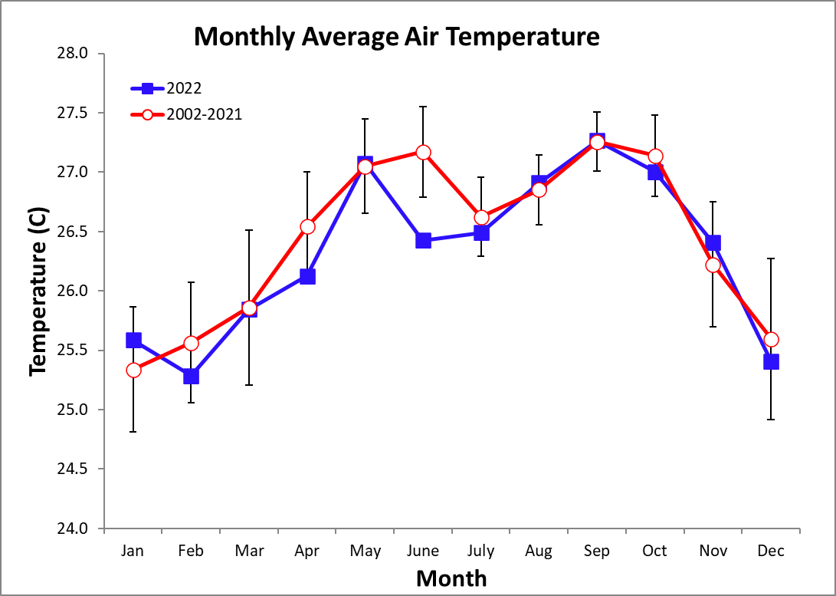
Monthly Average of Daily Maximum Temperature
Year | Jan | Feb | Mar | Apr | May | June | July | Aug | Sep | Oct | Nov | Dec
2010 |  |  |  |  | 29.9 | 29.9 | 29.4 | 29.5 | 29.9 | 29.0 | 27.8 | 26.1
2011 | 27.6 | 28.4 | 28.0 | 28.5 | 29.3 | 29.7 | 29.0 | 29.6 | 29.6 | 28.8 | 28.1 | 27.4
2012 | 27.6 | 28.3 | 27.6 |  | 30.4 | 30.2 | 29.1 | 29.9 | 29.7 | 29.7 | 27.9 | 28.5
2013 | 29.0 | 28.6 | 28.6 | 29.4 | 29.4 | 29.3 | 28.9 | 29.6 | 30.3 | 29.8 | 29.5 | 29.0
2014 | 28.3 | 28.5 | 28.7 | 28.7 | 29.2 | 29.0 | 28.5 | 29.1 | 29.5 | 29.2 | 28.9 | 28.3
2015 | 28.5 | 29.6 | 29.7 | 30.4 | 29.8 | 30.4 | 29.8 | 30.2 | 30.6 | 31.4 | 30.9 | 31.3
2016 | 30.2 | 29.5 | 29.7 | 31.0 | 31.1 | 30.6 | 30.0 | 29.8 | 31.0 | 30.8 | 30.0 | 29.8
2017 | 29.2 | 29.5 | 29.4 | 30.2 | 30.9 | 30.5 | 29.4 | 30.2 | 30.9 | 30.8 | 29.7 | 29.0
2018 | 27.9 | 28.7 | 28.9 | 29.1 | 30.5 | 30.5 | 30.9 | 29.7 | 30.7 | 30.4 | 30.3 | 30.4
2019 | 29.9 | 29.7 | 29.0 | 29.6 | 30.5 | 30.8 | 30.0 | 30.1 | 30.3 | 30.9 | 29.9 | 29.6
2020 | 29.3 | 29.6 | 30.6 | 30.0 | 30.7 | 30.5 | 30.5 | 30.9 | 31.1 | 31.2 | 30.5 | 29.4
2021 | 29.3 | 29.6 | 29.1 | 29.5 | 29.7 | 30.0 | 29.6 | 29.9 | 30.1 | 30.2 | 28.7 | 28.6
2022 | 28.5 | 28.2 | 28.6 | 28.7 | 29.4 | 28.9 | 29.0 | 29.5 | 29.7 | 29.4 | 28.9 | 28.2
mean | 28.8 | 29.0 | 29.0 | 29.6 | 30.1 | 30.0 | 29.5 | 29.8 | 30.3 | 30.1 | 29.3 | 28.9
sd | 0.9 | 0.6 | 0.8 | 0.8 | 0.6 | 0.6 | 0.7 | 0.4 | 0.6 | 0.9 | 1.0 | 1.3
min | 27.6 | 28.2 | 27.6 | 28.5 | 29.2 | 28.9 | 28.5 | 29.1 | 29.5 | 28.8 | 27.8 | 26.1
max | 30.2 | 29.7 | 30.6 | 31.0 | 31.1 | 30.8 | 30.9 | 30.9 | 31.1 | 31.4 | 30.9 | 31.3

Monthly Average of Daily Minimum Temperature
Year | Jan | Feb | Mar | Apr | May | June | July | Aug | Sep | Oct | Nov | Dec
2010 |  |  |  |  | 24.9 | 24.9 | 24.9 | 24.7 | 24.9 | 24.3 | 23.2 | 21.8
2011 | 22.5 | 22.6 | 22.6 | 23.3 | 24.7 | 24.9 | 24.4 | 24.9 | 24.6 | 24.2 | 23.7 | 22.8
2012 | 22.2 | 22.8 | 22.6 |  | 25.3 | 25.2 | 24.1 | 24.8 | 24.7 | 24.7 | 23.8 | 23.8
2013 | 23.5 | 23.4 | 23.6 | 24.6 | 24.7 | 24.6 | 24.3 | 25.0 | 25.4 | 25.1 | 24.2 | 23.6
2014 | 23.4 | 23.1 | 23.4 | 24.0 | 24.3 | 24.5 | 24.4 | 24.1 | 24.4 | 24.5 | 24.3 | 23.4
2015 | 23.1 | 23.1 | 23.2 | 24.2 | 24.4 | 25.1 | 24.3 | 24.6 | 24.7 | 25.4 | 24.8 | 24.6
2016 | 23.8 | 23.3 | 24.4 | 24.8 | 25.5 | 25.2 | 23.9 | 24.7 | 24.7 | 25.1 | 24.2 | 23.6
2017 | 23.1 | 23.6 | 23.2 | 24.9 | 25.2 | 25.0 | 24.4 | 24.8 | 25.1 | 25.0 | 24.0 | 22.7
2018 | 22.4 | 22.2 | 23.2 | 23.4 | 24.6 | 24.9 | 24.5 | 24.1 | 24.7 | 24.6 | 24.2 | 23.5
2019 | 23.4 | 23.7 | 23.3 | 24.6 | 25.2 | 25.3 | 24.5 | 25.0 | 24.9 | 24.7 | 24.3 | 24.1
2020 | 23.8 | 23.9 | 23.7 | 24.9 | 25.2 | 25.0 | 24.8 | 25.1 | 25.0 | 25.2 | 25.1 | 22.8
2021 | 29.3 | 29.6 | 29.1 | 29.5 | 29.7 | 30.0 | 29.6 | 29.9 | 30.1 | 30.2 | 28.7 | 28.6
2022 | 23.3 | 23.0 | 23.5 | 24.1 | 25.2 | 24.3 | 24.6 | 24.8 | 25.0 | 25.0 | 24.4 | 23.3
mean | 23.1 | 23.2 | 23.3 | 24.2 | 24.9 | 24.9 | 24.4 | 24.7 | 24.8 | 24.8 | 24.2 | 23.4
sd | 0.5 | 0.5 | 0.5 | 0.6 | 0.4 | 0.3 | 0.3 | 0.3 | 0.2 | 0.4 | 0.5 | 0.7
min | 22.2 | 22.2 | 22.6 | 23.3 | 24.2 | 24.3 | 23.9 | 24.1 | 24.4 | 24.2 | 23.2 | 21.8
max | 23.8 | 23.9 | 24.4 | 24.9 | 25.5 | 25.3 | 24.9 | 25.1 | 25.4 | 25.4 | 25.1 | 24.6

Monthly Air Temperature (°C)

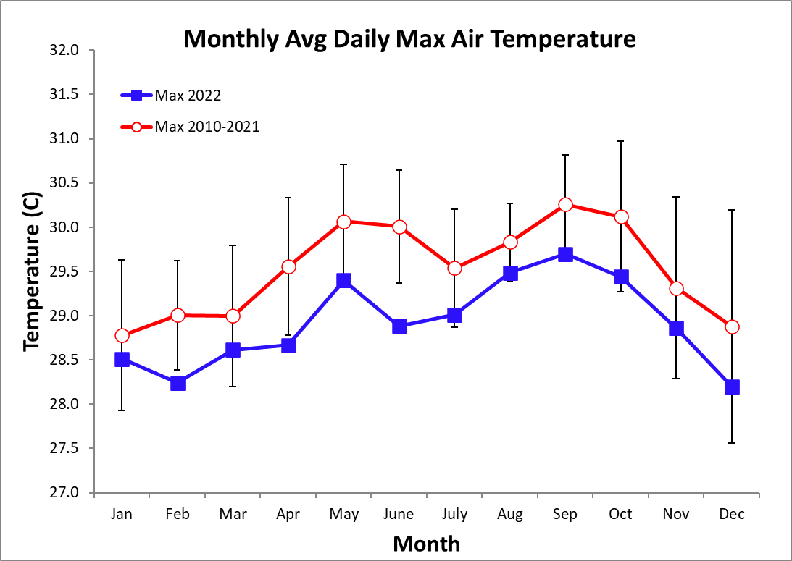

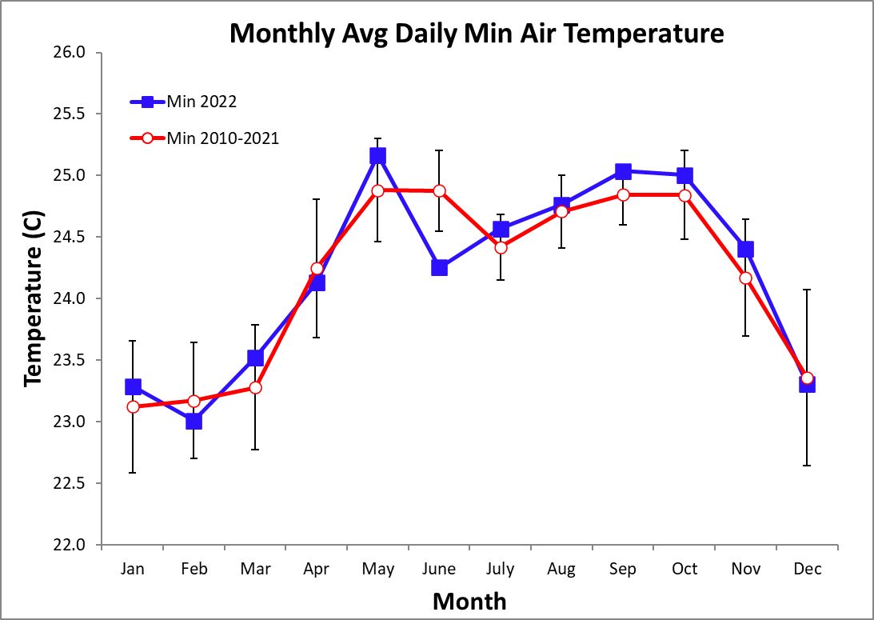
2022 Daily Total Radiation (MJ m⁻² day⁻¹)

 | Jan. | Feb. | Mar. | Apr. | May | June | July | Aug. | Sep. | Oct. | Nov. | Dec.
1 | 19.8 | 25.2 | 14.6 | 14.6 | 25.7 | 15.3 | 11.6 | 19.1 | 20.8 | 19.1 | 20.1 | 10.6
2 | 13.7 | 15.8 | 10.7 | 22.3 | 13.0 | 14.7 | 25.9 | 17.5 | 18.1 | 11.5 | 25.4 | 8.7
3 | 11.9 | 5.3 | 5.4 | 23.5 | 24.4 | 26.2 | 15.4 | 15.8 | 4.1 | 26.0 | 2.9 | 8.6
4 | 12.9 | 7.3 | 15.9 | 16.3 | 2.9 | 27.2 | 8.4 | 15.8 | 10.9 | 22.8 | 15.1 | 12.9
5 | 21.6 | 24.0 | 26.4 | 5.2 | 14.8 | 18.7 | 5.8 | 19.9 | 14.9 | 15.2 | 6.9 | 20.1
6 | 16.0 | 22.0 | 27.4 | 24.9 | 15.1 | 24.9 | 12.6 | 8.0 | 22.5 | 12.7 | 9.9 | 14.1
7 | 14.2 | 21.3 | 27.3 | 25.1 | 19.3 | 12.9 | 10.5 | 18.1 | 25.6 | 3.3 | 8.0 | 23.2
8 | 16.6 | 21.5 | 23.5 | 9.8 | 27.0 | 26.0 | 19.4 | 19.9 | 24.9 | 9.1 | 19.2 | 21.2
9 | 12.9 | 20.5 | 27.6 | 1.1 | 21.6 | 6.3 | 8.6 | 19.2 | 25.4 | 17.8 | 21.2 | 8.2
10 | 20.9 | 16.7 | 20.2 | 10.5 | 20.0 | 22.0 | 8.7 | 17.8 | 16.2 | 16.3 | 21.4 | 8.7
11 | 14.2 | 16.6 | 25.7 | 22.5 | 26.7 | 12.9 | 22.2 | 15.6 | 4.1 | 17.5 | 20.4 | 9.7
12 | 22.5 | 22.6 | 25.9 | 13.5 | 20.3 | 21.3 | 15.6 | 12.2 | 16.0 | 19.7 | 11.7 | 18.4
13 | 17.3 | 15.0 | 16.5 | 14.9 | 23.5 | 10.0 | 16.7 | 18.9 | 18.1 | 12.9 | 4.3 | 13.7
14 | 23.2 | 7.3 | 24.9 | 10.8 | 22.1 | 16.9 | 22.8 | 27.5 | 9.6 | 21.0 | 4.1 | 17.8
15 | 23.4 | 16.8 | 23.4 | 13.0 | 17.8 | 19.5 | 15.1 | 9.4 | 23.4 | 23.7 | 13.8 | 4.3
16 | 22.2 | 21.0 | 19.8 | 10.2 | 21.0 | 18.5 | 22.9 | 26.3 | 24.5 | 18.3 | 6.4 | 9.0
17 | 19.7 | 20.6 | 25.9 | 16.7 | 7.6 | 7.7 | 18.6 | 19.6 | 17.3 | 6.6 | 9.1 | 14.7
18 | 9.3 | 8.0 | 20.7 | 15.3 | 7.9 | 15.8 | 17.7 | 23.2 | 10.6 | 23.4 | 14.8 | 13.4
19 | 8.3 | 22.4 | 13.8 | 18.7 | 24.6 | 20.0 | 8.4 | 16.4 | 17.0 | 2.9 | 16.1 | 7.7
20 | 18.3 | 23.7 | 12.4 | 23.0 | 13.6 | 22.7 | 15.1 | 22.4 | 13.5 | 6.9 | 18.1 | 8.0
21 | 12.8 | 20.7 | 15.3 | 27.1 | 16.7 | 6.7 | 5.8 | 15.5 | 26.7 | 15.3 | 3.1 | 13.4
22 | 15.8 | 19.3 | 21.0 | 22.8 | 25.6 | 15.9 | 20.7 | 11.7 | 23.1 | 14.0 | 9.7 | 6.6
23 | 18.3 | 11.3 | 13.7 | 20.7 | 21.7 | 18.8 | 5.9 | 11.9 | 20.6 | 8.2 | 20.5 | 16.6
24 | 23.7 | 24.9 | 13.1 | 22.2 | 10.2 | 7.2 | 25.6 | 26.5 | 18.7 | 20.1 | 11.9 | 18.6
25 | 23.5 | 12.9 | 13.2 | 15.6 | 15.3 | 16.3 | 22.5 | 19.5 | 22.2 | 24.3 | 19.4 | 18.0
26 | 22.1 | 16.7 | 17.6 | 13.2 | 15.5 | 6.9 | 16.1 | 22.2 | 20.3 | 23.0 | 22.2 | 15.3
27 | 21.6 | 23.6 | 19.2 | 16.0 | 6.4 | 10.0 | 19.8 | 24.4 | 12.3 | 17.1 | 20.9 | 19.0
28 | 20.4 | 16.0 | 7.4 | 12.5 | 12.4 | 18.0 | 9.8 | 25.7 | 21.2 | 19.6 | 8.0 | 16.7
29 | 10.9 |  | 14.6 | 7.1 | 21.8 | 23.0 | 18.1 | 13.7 | 24.8 | 24.9 | 5.5 | 10.9
30 | 22.5 |  | 19.4 | 12.8 | 13.5 | 4.4 | 17.5 | 24.0 | 24.0 | 22.7 | 8.0 | 10.8
31 | 15.1 |  | 23.8 |  | 22.3 |  | 23.6 | 24.0 |  | 22.6 |  | 21.9
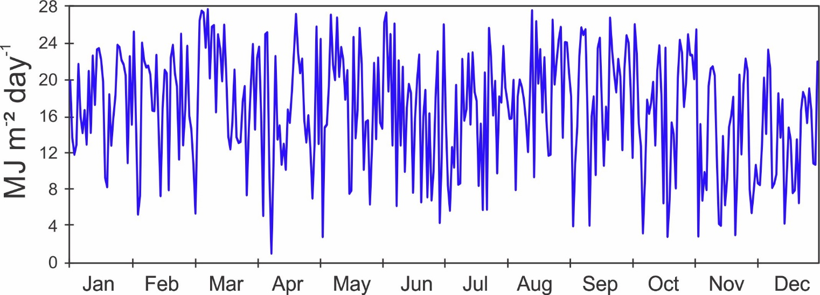

Monthly Average Total Daily Solar Radiation (MJ m⁻² day⁻¹)
Year | Jan | Feb | Mar | Apr | May | June | July | Aug | Sep | Oct | Nov | Dec
2002 |  |  |  |  |  |  |  | 15.2 | 17.2 | 13.9 | 11.6 | 12.3
2003 | 14.4 | 17.8 | 18.1 | 18.8 | 14.4 | 15.4 | 13.8 | 13.7 | 17.2 | 15.9 | 14.0 | 12.8
2004 | 16.3 | 15.6 | 16.3 | 16.0 | 13.0 | 14.5 | 13.7 | 13.0 | 18.3 | 16.1 | 11.8 | 13.3
2005 | 11.1 | 15.6 | 19.9 | 12.9 |  | 17.9 | 15.8 | 14.2 | 13.6 | 17.1 | 12.2 | 14.2
2006 | 12.1 | 14.9 | 12.4 | 15.6 | 14.6 | 14.8 | 13.1 | 13.1 | 14.6 | 15.0 | 11.8 | 13.2
2007 | 11.4 | 18.0 | 17.4 | 16.2 | 16.3 | 13.9 | 13.3 | 16.0 | 17.1 | 16.5 | 12.3 | 13.4
2008 | 15.2 | 16.7 | 17.2 | 16.4 | 16.6 | 14.4 | 15.1 | 17.8 | 16.5 | 14.8 | 12.1 | 13.8
2009 | 13.0 | 12.2 | 15.1 | 17.6 | 15.5 | 15.3 | 12.1 | 13.1 | 16.6 | 13.8 | 11.5 | 13.5
2010 | 14.8 | 12.9 | 15.4 | 15.5 | 15.8 | 15.5 | 14.6 | 15.8 | 17.2 | 14.4 | 12.7 | 10.2
2011 | 14.0 | 16.9 | 16.7 | 17.1 | 17.0 | 16.1 | 13.6 | 16.6 | 15.9 | 13.7 | 12.9 | 11.5
2012 | 13.8 | 16.8 | 12.3 | 13.1 | 15.9 | 15.5 | 11.2 | 16.5 | 15.5 | 15.4 | 10.0 | 13.4
2013 | 13.9 | 14.7 | 15.1 | 14.8 | 13.3 | 11.7 | 12.2 | 15.3 | 18.0 | 15.7 | 15.3 | 14.8
2014 | 14.6 | 16.6 | 17.4 | 14.6 | 15.2 | 11.9 | 11.0 | 14.2 | 16.3 | 14.4 | 11.9 | 12.1
2015 | 13.1 | 16.0 | 17.7 | 15.4 | 13.3 | 13.3 | 12.7 | 13.3 | 14.6 | 16.0 | 14.4 | 13.6
2016 | 16.0 | 15.0 | 17.0 | 17.6 | 15.2 | 14.7 | 12.2 | 13.1 | 14.7 | 16.0 | 13.4 | 13.0
2017 | 15.7 | 17.5 | 17.0 | 17.5 | 16.1 | 14.9 | 12.8 | 16.4 | 18.1 | 15.5 | 15.9 | 12.7
2018 | 13.3 | 15.6 | 18.0 | 16.3 | 17.6 | 14.0 | 11.1 | 13.6 | 17.6 | 16.0 | 14.1 | 15.9
2019 | 16.2 | 17.7 | 15.5 | 16.0 | 14.9 | 15.2 | 14.3 | 15.4 | 15.9 | 17.4 | 13.9 | 12.4
2020 | 14.2 | 16.8 | 21.0 | 15.2 | 15.8 | 14.5 | 16.3 | 16.0 | 18.9 | 18.3 | 15.7 | 15.1
2021 | 14.8 | 17.6 | 17.6 | 16.6 | 15.1 | 16.7 | 13.6 | 16.7 | 16.9 | 18.2 | 13.4 | 14.5
2022 | 17.6 | 17.8 | 18.8 | 16.1 | 17.8 | 16.3 | 15.3 | 18.4 | 18.2 | 16.7 | 13.2 | 13.6
mean | 14.3 | 16.1 | 16.8 | 16.0 | 15.4 | 14.8 | 13.4 | 15.1 | 16.6 | 15.8 | 13.1 | 13.3
sd | 1.7 | 1.6 | 2.1 | 1.5 | 1.4 | 1.5 | 1.5 | 1.7 | 1.4 | 1.3 | 1.5 | 1.3
min | 11.1 | 12.2 | 12.3 | 12.9 | 13.0 | 11.7 | 11.0 | 13.0 | 13.6 | 13.7 | 10.0 | 10.2
max | 17.6 | 18.0 | 21.0 | 18.8 | 17.8 | 17.9 | 16.3 | 18.4 | 18.9 | 18.3 | 15.9 | 15.9
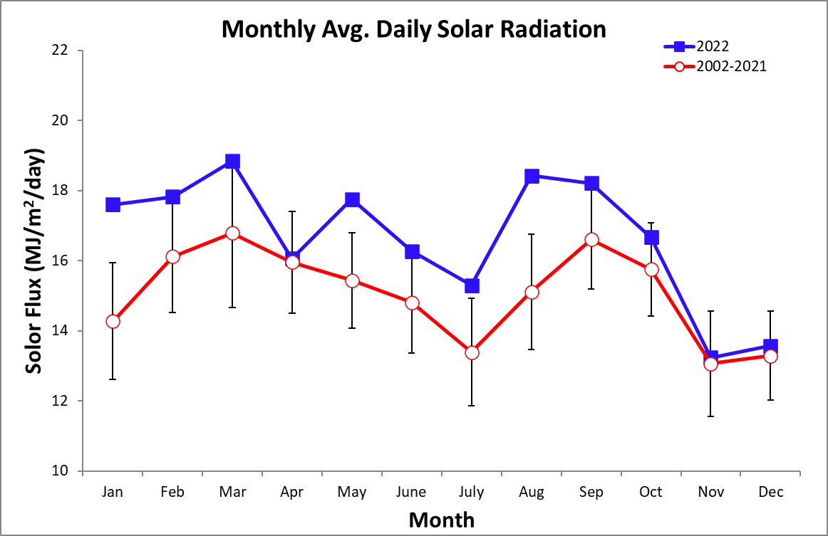

2022 Daily Average Wind Speed (km/h)
 | Jan. |  | Feb. |  |  | Mar. |  |  | Apr. |  |  | May |  |  | June |  | July |  | Aug. |  | Sep. |  | Oct. |  | Nov. |  |  | Dec.
 | Avg | Max | Avg | Max | Avg |  | Max | Avg |  | Max | Avg |  | Max | Avg |  | Max | Avg | Max | Avg | Max | Avg | Max | Avg | Max | Avg | Max | Avg |  |  | Max
1 | 4.4 | 17.4 | 5.5 | 20.5 | 6.5 |  | 19.3 | 6.8 |  | 23.0 | 7.4 |  | 22.0 | 6.5 |  | 40.0 | 11.7 | 33.8 | 8.7 | 21.3 | 5.1 | 28.1 | 8.3 | 26.7 | 6.0 | 19.2 | 7.8 |  | 24.3
2 | 4.7 | 14.6 | 5.2 | 17.6 | 11.5 |  | 34.1 | 6.1 |  | 20.3 | 5.3 |  | 18.2 | 7.3 |  | 27.3 | 6.4 | 25.5 | 7.1 | 22.2 | 6.1 | 18.9 | 5.5 | 20.6 | 5.6 | 19.1 | 10.5 |  | 27.0
3 | 7.5 | 18.1 | 6.7 | 19.4 | 13.4 |  | 31.9 | 6.4 |  | 22.2 | 5.3 |  | 18.7 | 5.8 |  | 19.0 | 10.7 | 26.5 | 11.3 | 35.4 | 5.4 | 21.5 | 6.1 | 23.8 | 7.3 | 24.6 | 10.5 |  | 20.9
4 | 7.1 | 24.3 | 8.9 | 22.2 | 10.0 |  | 27.2 | 4.8 |  | 19.2 | 4.6 |  | 16.8 | 5.3 |  | 17.6 | 6.8 | 18.2 | 10.6 | 22.6 | 5.4 | 21.0 | 8.7 | 22.7 | 6.9 | 23.6 | 8.6 |  | 23.2
5 | 5.7 | 18.4 | 7.7 | 24.8 | 6.8 |  | 20.3 | 7.4 |  | 23.0 | 5.7 |  | 20.1 | 5.4 |  | 17.6 | 3.4 | 13.4 | 10.5 | 25.2 | 7.8 | 28.1 | 7.9 | 25.3 | 6.9 | 20.8 | 7.8 |  | 26.5
6 | 5.9 | 19.7 | 7.2 | 21.3 | 6.2 |  | 21.5 | 5.3 |  | 18.1 | 4.4 |  | 13.7 | 4.6 |  | 17.1 | 7.3 | 33.3 | 9.6 | 21.9 | 4.6 | 15.2 | 7.6 | 18.8 | 5.8 | 17.5 | 6.6 |  | 28.1
7 | 7.3 | 23.6 | 7.4 | 24.5 | 5.6 |  | 19.3 | 4.8 |  | 17.7 | 4.2 |  | 16.2 | 5.4 |  | 23.7 | 9.9 | 31.9 | 6.1 | 17.8 | 4.9 | 17.9 | 13.0 | 34.9 | 8.3 | 23.3 | 8.5 |  | 26.0
8 | 6.7 | 21.6 | 7.3 | 23.3 | 5.6 |  | 20.4 | 6.5 |  | 18.1 | 5.4 |  | 17.7 | 6.0 |  | 17.4 | 7.4 | 19.4 | 8.5 | 26.6 | 5.7 | 21.7 | 11.1 | 33.1 | 5.2 | 22.3 | 8.0 |  | 23.4
9 | 7.8 | 19.2 | 5.7 | 15.7 | 5.4 |  | 17.9 | 13.0 |  | 34.6 | 4.5 |  | 17.3 | 5.5 |  | 16.7 | 10.6 | 31.4 | 7.0 | 21.1 | 6.0 | 19.1 | 7.3 | 23.2 | 6.3 | 25.1 | 8.1 |  | 24.4
10 | 7.1 | 22.4 | 9.7 | 24.9 | 6.2 |  | 23.1 | 11.1 |  | 30.5 | 4.7 |  | 18.2 | 5.0 |  | 18.7 | 5.1 | 18.0 | 7.0 | 18.7 | 5.5 | 14.0 | 5.3 | 17.4 | 5.2 | 21.2 | 8.9 |  | 20.5
11 | 9.4 | 26.2 | 8.0 | 25.6 | 5.2 |  | 17.7 | 6.9 |  | 19.8 | 5.8 |  | 19.2 | 6.8 |  | 20.5 | 4.9 | 18.8 | 7.4 | 19.5 | 6.5 | 36.6 | 6.4 | 18.4 | 4.6 | 17.8 | 4.7 |  | 16.1
12 | 5.8 | 18.0 | 7.0 | 22.1 | 5.8 |  | 17.7 | 7.7 |  | 23.6 | 10.3 |  | 26.7 | 7.4 |  | 20.3 | 7.9 | 30.0 | 6.6 | 22.8 | 5.0 | 15.1 | 7.3 | 23.9 | 4.5 | 15.8 | 5.4 |  | 23.0
13 | 7.7 | 19.9 | 10.5 | 29.8 | 8.0 |  | 29.4 | 10.7 |  | 29.4 | 15.1 |  | 30.3 | 8.1 |  | 31.8 | 5.5 | 18.6 | 6.8 | 27.2 | 6.9 | 32.3 | 6.1 | 17.6 | 7.9 | 25.7 | 5.7 |  | 16.2
14 | 6.0 | 21.6 | 16.8 | 34.0 | 8.8 |  | 25.6 | 10.7 |  | 25.7 | 6.9 |  | 24.5 | 10.2 |  | 34.7 | 6.5 | 27.1 | 5.6 | 20.9 | 6.2 | 18.4 | 6.8 | 20.4 | 8.1 | 22.3 | 4.5 |  | 17.3
15 | 5.7 | 16.8 | 12.1 | 28.4 | 8.4 |  | 21.1 | 9.8 |  | 26.7 | 7.6 |  | 21.0 | 6.1 |  | 22.4 | 10.0 | 24.1 | 6.3 | 19.9 | 5.5 | 18.8 | 5.1 | 17.9 | 10.2 | 25.8 | 8.3 |  | 22.9
16 | 4.8 | 18.3 | 9.4 | 23.9 | 7.2 |  | 26.1 | 6.4 |  | 24.8 | 8.2 |  | 24.0 | 10.5 |  | 24.8 | 6.9 | 18.9 | 5.6 | 18.8 | 6.1 | 25.9 | 6.3 | 22.2 | 11.2 | 25.9 | 12.3 |  | 29.7
17 | 8.2 | 23.0 | 7.0 | 20.8 | 5.4 |  | 18.5 | 6.2 |  | 16.7 | 10.4 |  | 25.0 | 4.6 |  | 25.5 | 7.6 | 24.0 | 5.8 | 17.6 | 8.9 | 27.9 | 6.5 | 21.0 | 9.3 | 26.3 | 11.6 |  | 26.8
18 | 10.8 | 26.5 | 10.8 | 25.9 | 5.2 |  | 16.3 | 4.7 |  | 18.9 | 6.9 |  | 27.8 | 4.4 |  | 16.2 | 8.6 | 26.9 | 8.8 | 24.4 | 5.1 | 28.3 | 5.3 | 20.6 | 6.8 | 18.8 | 10.2 |  | 31.1
19 | 8.8 | 23.8 | 7.4 | 27.6 | 7.7 |  | 30.0 | 5.1 |  | 20.1 | 5.1 |  | 16.7 | 6.4 |  | 21.8 | 5.9 | 20.8 | 7.5 | 24.3 | 4.7 | 14.3 | 4.7 | 15.2 | 10.6 | 30.5 | 7.8 |  | 27.2
20 | 7.0 | 18.9 | 6.3 | 23.6 | 8.1 |  | 27.0 | 7.1 |  | 21.1 | 5.1 |  | 19.5 | 6.1 |  | 17.4 | 6.9 | 26.5 | 6.3 | 19.6 | 5.7 | 16.2 | 4.3 | 13.8 | 12.9 | 29.7 | 8.4 |  | 24.1
21 | 6.5 | 21.1 | 5.6 | 19.8 | 5.3 |  | 21.6 | 4.9 |  | 20.1 | 6.2 |  | 23.5 | 6.4 |  | 21.0 | 8.1 | 21.1 | 7.0 | 24.1 | 5.2 | 18.8 | 5.9 | 26.2 | 7.1 | 26.0 | 9.0 |  | 24.2
22 | 7.8 | 24.8 | 7.3 | 22.5 | 6.2 |  | 18.9 | 8.9 |  | 29.9 | 6.0 |  | 18.9 | 7.4 |  | 18.1 | 5.4 | 24.0 | 5.5 | 23.0 | 5.5 | 19.9 | 5.4 | 26.1 | 6.4 | 27.2 | 10.1 |  | 24.6
23 | 6.3 | 23.7 | 12.0 | 29.6 | 5.5 |  | 14.8 | 8.1 |  | 21.0 | 5.7 |  | 17.0 | 8.5 |  | 26.4 | 6.5 | 18.8 | 6.2 | 21.0 | 4.8 | 18.5 | 4.4 | 24.0 | 6.9 | 24.6 | 9.4 |  | 20.7
24 | 6.0 | 21.4 | 6.0 | 22.4 | 8.8 |  | 23.2 | 8.6 |  | 28.3 | 5.2 |  | 18.2 | 9.9 |  | 24.8 | 8.4 | 23.3 | 5.8 | 18.8 | 5.0 | 17.4 | 6.1 | 19.9 | 5.9 | 17.0 | 9.5 |  | 28.3
25 | 5.8 | 19.8 | 7.3 | 25.6 | 9.7 |  | 26.0 | 5.9 |  | 29.5 | 4.3 |  | 15.3 | 6.6 |  | 19.1 | 5.9 | 19.9 | 5.3 | 19.2 | 4.3 | 17.8 | 5.2 | 16.8 | 5.9 | 18.6 | 8.5 |  | 21.4
26 | 5.5 | 18.4 | 10.2 | 35.2 | 8.2 |  | 25.1 | 7.9 |  | 21.4 | 6.0 |  | 14.8 | 9.2 |  | 32.0 | 7.0 | 23.6 | 4.5 | 16.2 | 6.9 | 24.9 | 4.8 | 15.6 | 5.8 | 21.0 | 8.6 |  | 31.4
27 | 7.1 | 27.2 | 6.9 | 24.0 | 5.9 |  | 21.6 | 11.1 |  | 32.7 | 4.8 |  | 16.2 | 9.3 |  | 28.1 | 5.2 | 18.7 | 8.0 | 24.7 | 5.5 | 20.1 | 4.9 | 18.1 | 6.3 | 29.4 | 6.4 |  | 27.2
28 | 6.6 | 20.4 | 6.5 | 23.4 | 9.5 |  | 25.1 | 9.1 |  | 25.4 | 4.8 |  | 23.9 | 5.5 |  | 23.4 | 5.1 | 20.7 | 6.0 | 35.3 | 6.0 | 20.2 | 6.2 | 20.7 | 6.7 | 23.7 | 7.1 |  | 24.9
29 | 8.9 | 37.0 |  |  | 7.7 |  | 21.4 | 9.3 |  | 20.9 | 4.1 |  | 17.2 | 9.5 |  | 25.2 | 4.9 | 15.0 | 5.8 | 18.9 | 5.8 | 18.6 | 7.8 | 20.2 | 5.9 | 19.4 | 8.7 |  | 24.5
30 | 5.3 | 18.7 |  |  | 6.8 |  | 25.4 | 9.9 |  | 30.8 | 5.8 |  | 20.4 | 8.6 |  | 30.4 | 7.3 | 20.5 | 5.0 | 16.9 | 6.4 | 44.0 | 5.1 | 18.0 | 6.8 | 22.9 | 7.7 |  | 25.3
31 | 5.8 | 20.3 |  |  | 6.0 |  | 19.3 |  |  |  | 6.3 |  | 22.1 |  |  |  | 8.2 | 22.1 | 4.7 | 17.5 |  |  | 6.6 | 30.1 |  |  | 5.2 |  | 19.2
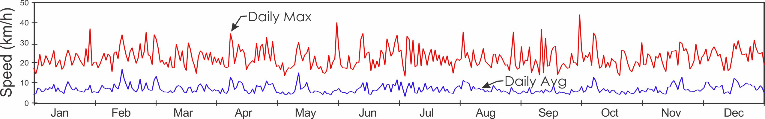
2022 Average Daily Wind Direction (°)
 |  | Jan. | Feb. | Mar. | Apr. | May | June | July | Aug. | Sep. | Oct. | Nov. | Dec.
 | 1 | 339.2 | 354.7 | 308.5 | 331.3 | 321.7 | 310.9 | 303.0 | 319.0 | 340.0 | 310.8 | 330.7 | 308.9
 | 2 | 327.0 | 336.8 | 320.1 | 342.9 | 328.6 | 317.6 | 81.0 | 321.1 | 324.5 | 341.1 | 349.7 | 309.3
 | 3 | 318.9 | 323.4 | 299.0 | 345.6 | 329.1 | 87.3 | 317.2 | 301.9 | 337.2 | 323.4 | 309.9 | 281.4
 | 4 | 332.9 | 303.8 | 325.5 | 329.9 | 330.2 | 17.4 | 319.8 | 312.0 | 332.1 | 317.9 | 314.5 | 298.3
 | 5 | 335.8 | 337.0 | 326.6 | 318.1 | 331.6 | 329.1 | 338.0 | 319.7 | 327.5 | 310.7 | 314.4 | 299.1
 | 6 | 311.3 | 334.8 | 329.2 | 357.7 | 327.9 | 25.4 | 325.5 | 316.8 | 340.7 | 316.2 | 1.3 | 312.6
 | 7 | 308.3 | 311.1 | 335.1 | 349.4 | 354.4 | 332.0 | 315.2 | 336.6 | 343.5 | 303.5 | 299.9 | 302.5
 | 8 | 325.4 | 326.0 | 347.6 | 293.0 | 24.4 | 355.7 | 321.9 | 319.6 | 340.8 | 279.5 | 320.1 | 325.6
 | 9 | 296.7 | 329.8 | 350.6 | 305.5 | 5.9 | 332.2 | 303.7 | 321.5 | 354.6 | 303.8 | 333.4 | 296.5
 | 10 | 317.5 | 322.8 | 325.2 | 285.1 | 357.7 | 335.8 | 319.2 | 327.3 | 307.1 | 328.1 | 338.1 | 301.9
 | 11 | 319.7 | 317.7 | 357.6 | 330.3 | 348.7 | 321.5 | 325.9 | 316.3 | 305.4 | 326.2 | 342.6 | 339.7
 | 12 | 332.1 | 331.0 | 336.8 | 318.5 | 315.2 | 306.4 | 317.6 | 330.5 | 317.9 | 322.2 | 333.8 | 338.4
 | 13 | 315.3 | 313.5 | 327.3 | 288.8 | 310.0 | 320.5 | 309.4 | 314.4 | 349.1 | 313.4 | 319.2 | 2.8
 | 14 | 321.0 | 303.0 | 337.7 | 309.9 | 328.2 | 288.6 | 327.9 | 355.9 | 314.6 | 330.1 | 288.4 | 343.6
 | 15 | 3.0 | 301.8 | 321.6 | 322.9 | 325.5 | 324.6 | 304.1 | 317.4 | 339.6 | 357.8 | 314.0 | 321.7
 | 16 | 5.6 | 325.2 | 331.2 | 299.8 | 321.8 | 316.1 | 337.3 | 353.3 | 320.6 | 336.2 | 291.4 | 313.3
 | 17 | 330.0 | 318.9 | 350.4 | 321.6 | 310.5 | 309.8 | 324.8 | 335.1 | 310.9 | 304.9 | 279.0 | 310.1
 | 18 | 314.4 | 298.2 | 349.5 | 286.1 | 210.9 | 340.4 | 317.5 | 339.2 | 301.7 | 344.7 | 302.3 | 299.7
 | 19 | 307.6 | 330.4 | 315.8 | 345.9 | 0.0 | 49.4 | 323.9 | 315.6 | 330.9 | 335.1 | 302.8 | 299.5
 | 20 | 316.8 | 327.6 | 313.2 | 308.4 | 350.8 | 359.1 | 315.9 | 338.8 | 329.6 | 330.7 | 313.2 | 309.8
 | 21 | 325.7 | 334.4 | 339.0 | 351.0 | 329.5 | 319.5 | 311.7 | 325.3 | 4.8 | 328.9 | 311.6 | 304.1
 | 22 | 329.3 | 329.8 | 28.2 | 316.2 | 332.2 | 321.5 | 318.1 | 339.7 | 355.5 | 327.0 | 307.7 | 304.8
 | 23 | 335.2 | 295.9 | 293.6 | 326.6 | 7.8 | 319.7 | 317.7 | 299.6 | 0.0 | 276.2 | 315.4 | 295.4
 | 24 | 335.5 | 335.6 | 295.0 | 327.6 | 335.2 | 312.0 | 323.6 | 308.5 | 344.1 | 331.2 | 317.3 | 319.8
 | 25 | 342.0 | 312.7 | 299.2 | 340.7 | 341.3 | 319.1 | 352.6 | 345.4 | 342.8 | 339.5 | 321.9 | 332.5
 | 26 | 353.8 | 318.9 | 332.1 | 307.3 | 342.6 | 316.4 | 312.0 | 346.3 | 316.9 | 330.4 | 324.7 | 321.6
 | 27 | 328.1 | 331.0 | 339.8 | 318.3 | 327.8 | 309.5 | 336.6 | 320.9 | 18.3 | 335.8 | 329.7 | 319.8
 | 28 | 327.9 | 328.0 | 315.8 | 315.8 | 357.7 | 333.4 | 339.2 | 354.6 | 317.5 | 328.4 | 316.9 | 323.0
 | 29 | 329.1 |  | 322.5 | 311.7 | 354.3 | 313.1 | 325.0 | 338.3 | 327.1 | 330.3 | 309.2 | 306.5
 | 30 | 347.3 |  | 335.3 | 314.4 | 332.3 | 312.5 | 330.6 | 73.1 | 331.0 | 341.1 | 324.9 | 323.6
 | 31 | 337.0 |  | 344.1 |  | 330.6 |  | 334.2 | 3.9 |  | 323.3 |  | 329.5

Average Monthly Wind Speed (km/h) and Direction (°)

 | Long-term Av. |  |  | 2022
 | Speed | Sp max | Dir. | Speed | Sp max | Dir.
January | 8.4 | 23.8 | 324.5 | 6.8 | 21.5 | 327.6
February | 7.8 | 23.4 | 329.0 | 8.2 | 24.2 | 321.7
March | 7.5 | 23.1 | 331.2 | 7.3 | 22.8 | 327.5
April | 6.7 | 21.9 | 335.8 | 7.7 | 23.8 | 320.9
May | 6.6 | 22.3 | 332.9 | 6.2 | 20.0 | 334.7
June | 6.7 | 22.9 | 330.9 | 6.9 | 23.3 | 327.2
July | 7.5 | 24.2 | 322.9 | 7.2 | 23.0 | 322.3
August | 6.7 | 23.1 | 328.8 | 7.0 | 22.0 | 328.6
September | 6.0 | 22.7 | 334.7 | 5.7 | 22.0 | 333.4
October | 6.5 | 22.8 | 331.2 | 6.5 | 21.7 | 325.0
November | 8.9 | 25.9 | 321.2 | 7.1 | 22.8 | 316.7
December | 8.9 | 25.1 | 319.4 | 8.2 | 24.2 | 313.3

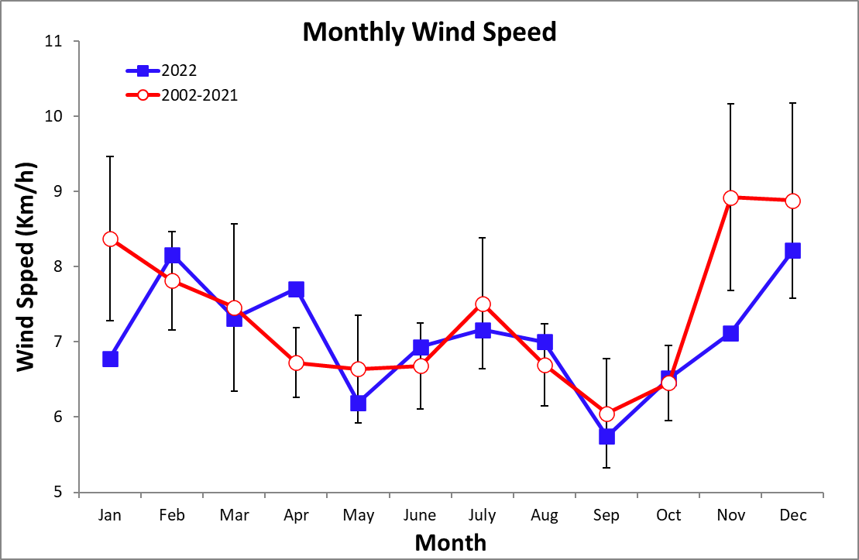

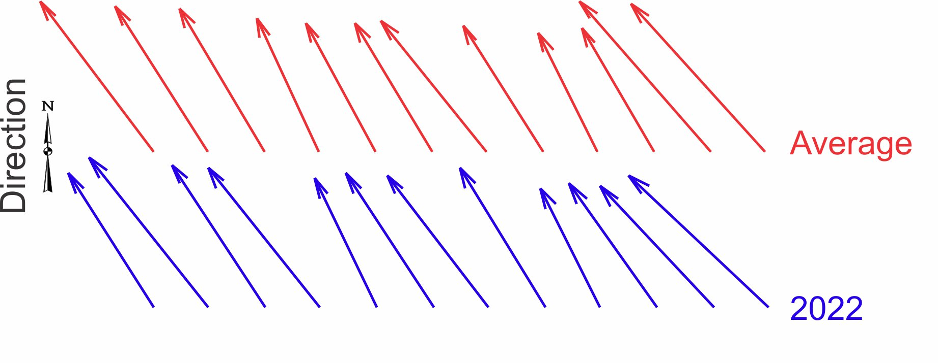

Air Pressure (mmHg)

Year | Jan | Feb | Mar | Apr | May | June | July | Aug | Sep | Oct | Nov | Dec
2016 |  |  | 759.7 | 758.7 | 758.4 | 758.8 | 759.2 | 758.3 | 758.7 | 757.5 | 757.8 | 759.2
2017 | 760.4 | 760.2 | 760.4 | 758.6 | 758.3 | 758.2 | 759.1 | 758.7 | 758.1 | 757.4 | 758.0 | 759.4
2018 | 759.5 | 760.8 | 759.6 | 759.6 | 758.5 | 758.7 | 759.0 | 758.9 | 757.7 | 758.0 | 758.4 | 759.6
2019 | 760.4 | 759.9 | 760.2 | 759.3 | 757.8 | 759.0 | 759.6 | 759.4 | 759.5 | 759.1 | 759.7 | 760.1
2020 | No data available
2021 | 761.9 | 762.0 | 762.5 | 761.3 | 761.5 | 761.4 | 761.5 | 761.3 | 761.3 | 760.8 | 761.6 | 761.8
2022 | 760.2 | 760.0 | 759.4 | 758.1 | 758.1 | 758.2 | 758.5 | 758.3 | 757.9 | 758.1 | 758.2 | 759.2
mean | 760.4 | 760.6 | 760.3 | 759.3 | 758.8 | 759.1 | 759.5 | 759.2 | 758.9 | 758.5 | 758.9 | 759.9
sd | 0.9 | 0.9 | 1.1 | 1.1 | 1.4 | 1.2 | 1.0 | 1.1 | 1.4 | 1.3 | 1.4 | 1.0
min | 759.5 | 759.9 | 759.4 | 758.1 | 757.8 | 758.2 | 758.5 | 758.3 | 757.7 | 757.4 | 757.8 | 759.2
max | 761.9 | 762.0 | 762.5 | 761.3 | 761.5 | 761.4 | 761.5 | 761.3 | 761.3 | 760.8 | 761.6 | 761.8

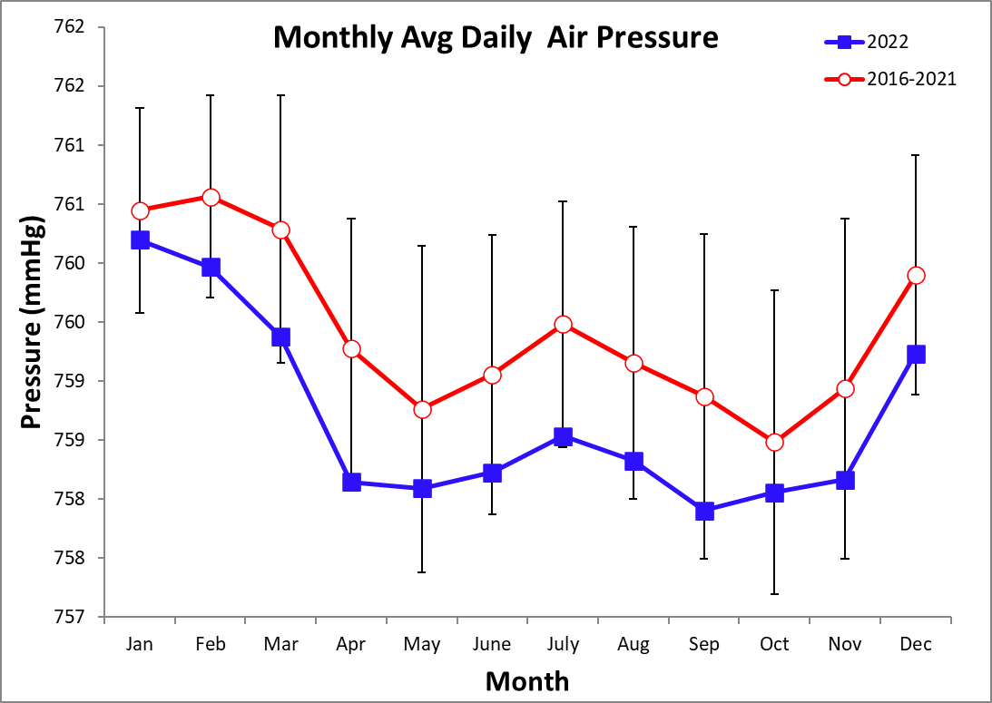

Average Sea Surface Temperature (°C)

Long-term Average Monthly Temperatures (1999-2021)

 | Dock | Platform | Sea  grass | Isla  Colon 3m | Cayo Agua 3m | Isla  Roldan  3m
January | 27.4 |  | 27.5 |  | 27.6 | 27.0
February | 27.7 |  | 27.8 |  | 27.8 | 27.2
March | 28.2 |  | 28.2 |  | 28.2 | 27.6
April | 29.1 |  | 28.9 |  | 28.9 | 28.4
May | 29.3 |  | 29.6 |  | 29.5 | 29.0
June | 29.5 |  | 29.7 |  | 29.6 | 29.2
July | 28.6 |  | 28.9 |  | 28.8 | 28.4
August | 29.0 |  | 29.2 |  | 29.1 | 28.6
September | 29.8 |  | 29.8 |  | 29.7 | 29.1
October | 29.8 |  | 29.8 |  | 29.8 | 29.2
November | 28.5 |  | 28.8 |  | 28.7 | 28.0
December | 27.5 |  | 27.8 |  | 27.8 | 27.3

Average Monthly Temperatures (2022)

 | Dock | Platform | Sea  grass | Isla  Colon 3m | Cayo Agua 3m | Isla  Roldan  3m
January | 27.5 | 28.2 | 28.3 | 28.3 | 28.5 | 28.7
February | 27.4 | 28.0 | 28.1 | 28.0 | 28.3 | 28.4
March | 27.7 | 28.4 | 28.6 | 28.4 | 28.5 | 29.1
April | 28.2 | 28.8 | 29.0 | 28.9 | 28.9 | 30.1
May | 29.2 | 29.6 | 29.8 | 29.5 | 29.6 | 30.7
June | 28.5 | 29.4 | 29.7 | 29.5 | 29.9 | 30.4
July | 28.1 | 28.9
August | 29.1 | 29.5
September | 29.7 | 30.0
October | 29.4 | 29.6
November | 28.6 | 29.3
December | 27.8 | 28.2

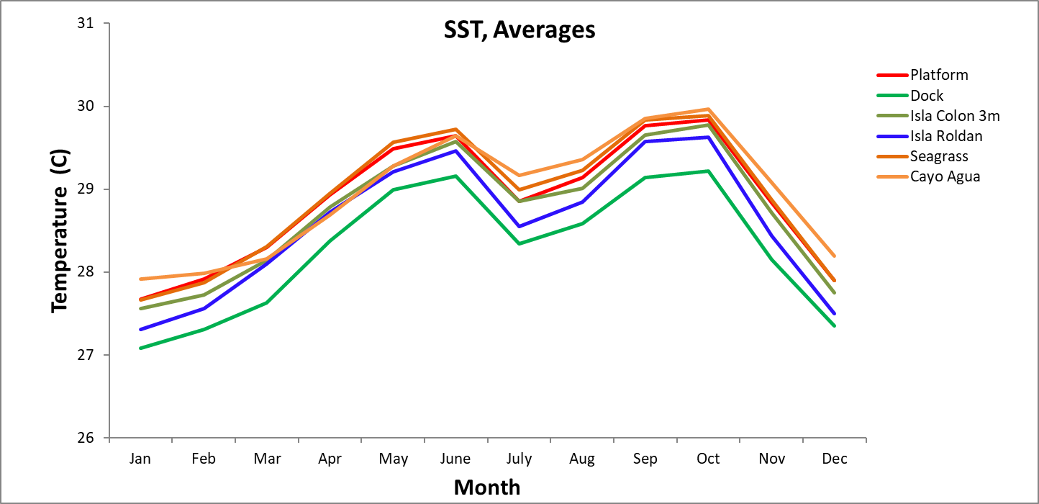

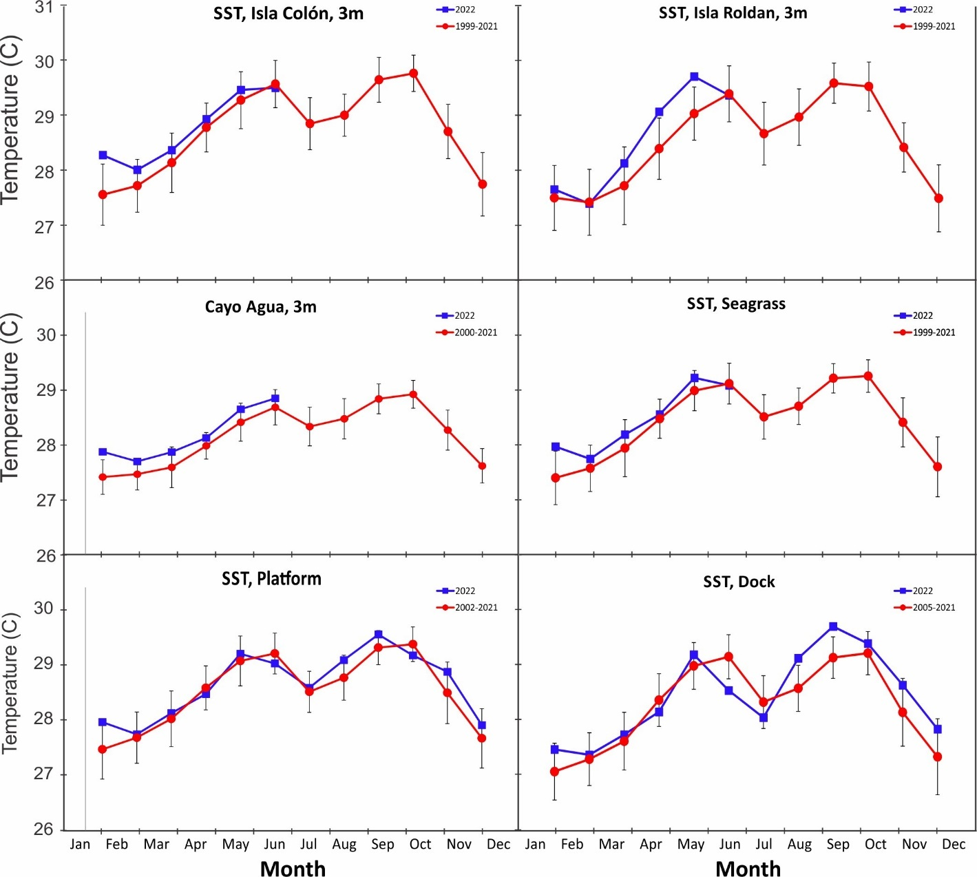
Average Salinity (ppt)

Long-term Average Monthly Salinity (1999-2021)

 | Mangrove |  |  | Aquarium | Coral | Dock | Seagrass
 | ‘A’ | ‘B’ | ‘C’
January | 32.4 | 32.4 | 32.4 | 31.6 | 32.0 | 32.0 | 31.6
February | 33.3 | 33.6 | 33.6 | 32.9 | 33.7 | 33.2 | 32.9
March | 33.8 | 33.8 | 33.9 | 33.4 | 33.6 | 33.7 | 33.4
April | 33.0 | 33.0 | 33.1 | 33.8 | 33.7 | 33.7 | 33.8
May | 33.4 | 33.5 | 33.4 | 33.4 | 33.3 | 33.5 | 33.4
June | 33.1 | 33.2 | 33.2 | 33.3 | 32.9 | 33.3 | 33.3
July | 32.0 | 32.0 | 32.0 | 31.8 | 31.9 | 31.7 | 31.8
August | 31.5 | 31.6 | 31.6 | 31.4 | 31.4 | 31.4 | 31.4
September | 32.7 | 32.8 | 32.8 | 33.2 | 33.0 | 32.9 | 33.2
October | 33.5 | 33.6 | 33.6 | 33.2 | 33.5 | 33.2 | 33.2
November | 32.4 | 32.5 | 32.5 | 31.8 | 32.1 | 32.0 | 31.8
December | 31.3 | 31.5 | 31.5 | 30.6 | 30.9 | 31.1 | 30.6

Average Monthly Salinity (2022)

 | Mangrove |  |  | Aquarium | Coral | Dock | Seagrass
 | ‘A’ | ‘B’ | ‘C’
January | 33.2 | 33.3 | 33.3 |  |  | 33.5
February | 35.2 | 35.2 | 35.2 |  |  | 35.5
March | 34.9 | 34.6 | 34.9 |  |  | 34.5
April | 30.0 | 29.9 | 29.8 |  |  | 32.6
May | 35.0 | 35.0 | 34.9 |  |  | 34.6
June | 35.2 | 35.3 | 35.3 |  |  | 33.6
July | 31.6 | 31.2 | 31.0 |  |  | 30.5
August | 31.5 | 31.4 | 31.4 |  |  | 30.9
September | 32.9 | 32.9 | 32.9 |  |  | 31.6
October | 32.6 | 32.7 | 32.7 |  |  | 32.6
November | 31.7 | 31.7 | 31.8 |  |  | 31.6
December | 33.2 | 33.2 | 33.2 |  |  | 32.9

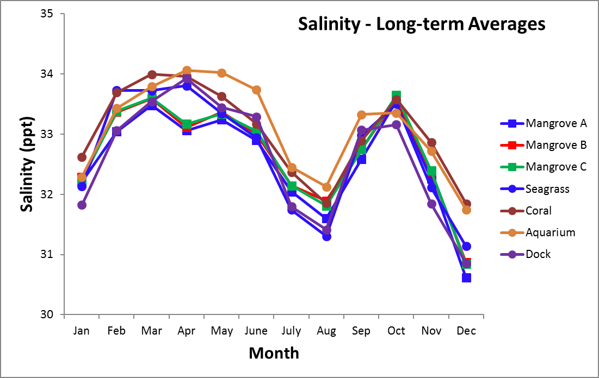

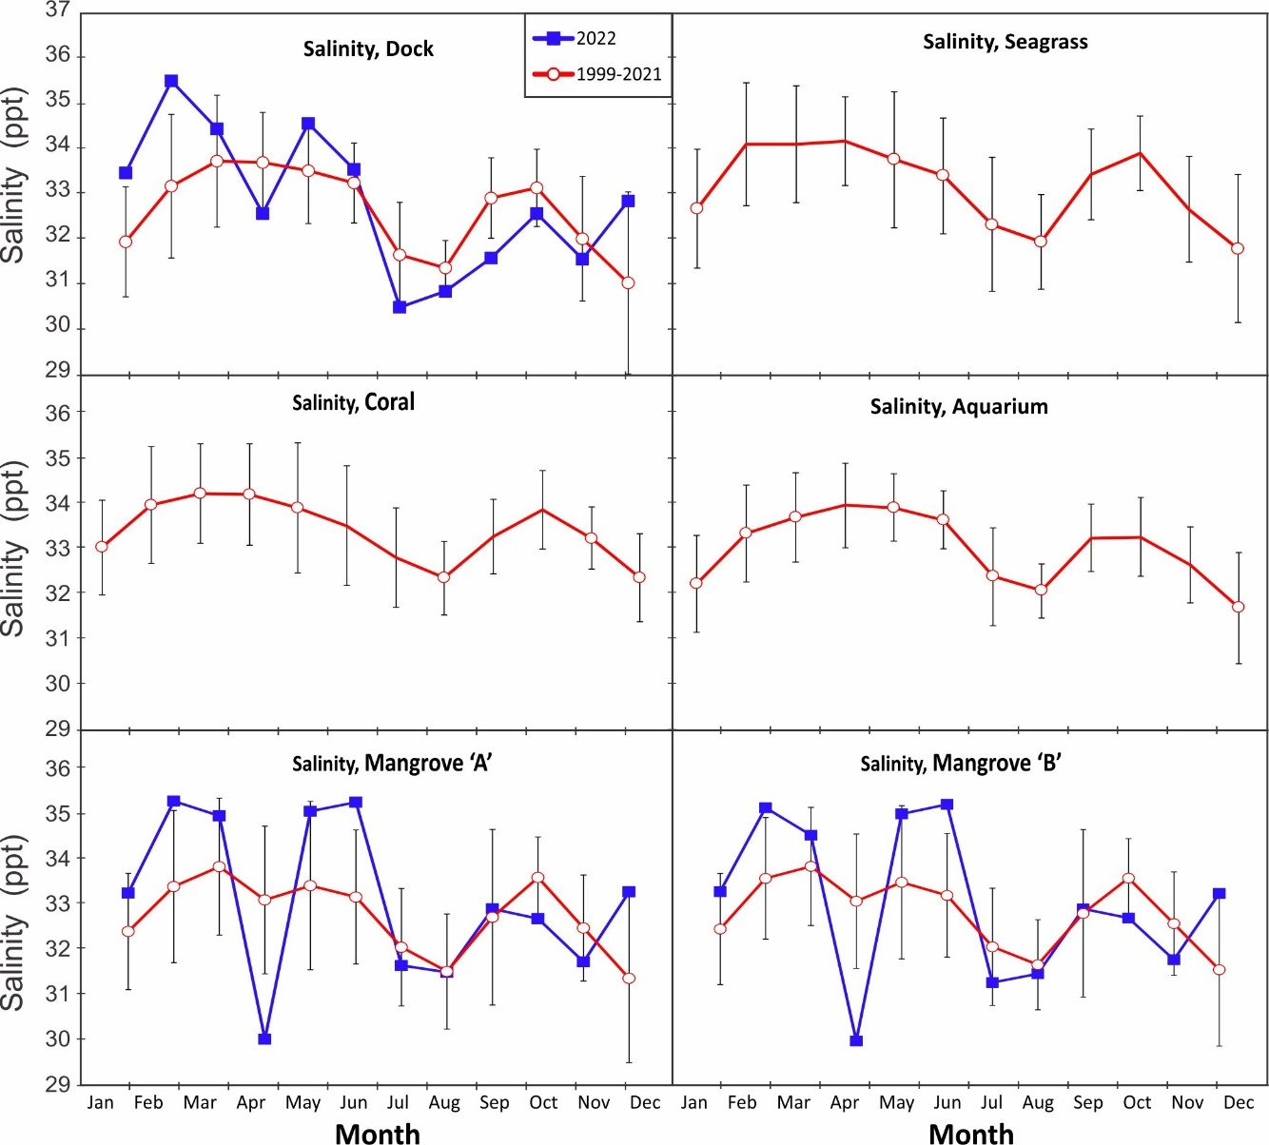

Average Water Transparancy (Secchi depth)
Coral
Year | Jan | Feb | Mar | Apr | May | June | July | Aug | Sep | Oct | Nov | Dec
2001 |  |  |  |  |  |  |  |  | 9.5 | 6.8 | 8.2 | 7.7
2002 | 5.8 | 7.1 | 8.9 | 9.4 | 6.4 | 8.3 | 6.3 | 5.6 | 9.4 | 11.2 | 8.5 | 6.6
2003 | 9.9 | 11.3 | 10.4 | 8.8 | 6.7 | 6.9 | 7.4 | 6.3 | 7.5 | 9.9 | 8.5 | 9.6
2004 | 7.9 | 11.4 | 8.6 | 5.2 | 7.9 | 7.1 | 6.3 | 4.5 | 9.9 | 11.5 | 7.4 | 9.1
2005 | 9.8 | 10.1 | 10.8 | 8.4 | 7.3 | 8.3 | 8.3 | 6.1 | 10.0 | 7.1 | 6.9 | 4.5
2006 | 8.5 | 9.1 | 7.2 | 10.0 | 6.1 | 7.3 | 6.2 | 6.7 | 13.1 | 12.0 | 5.2 | 5.0
2007 | 4.9 | 6.3 | 11.3 | 11.0 | 9.6 | 12.8 | 9.0 | 5.4 | 9.4 | 8.0 | 6.7 | 11.5
2008 | 5.3 | 10.8 | 6.0 | 10.4 | 9.4 | 8.0 | 7.8 | 10.5 | 9.8 | 6.8 | 7.2 | 9.9
2009 | 4.3 | 11.5 | 16.5 | 8.4 | 10.7 | 7.3 | 7.0 | 7.4 | 13.3 | 6.2 | 2.9 | 7.3
2010 | 6.0 | 9.8 | 9.2 | 9.7 | 9.0 | 7.8 | 5.5 | 7.3 | 7.0 | 7.5 | 6.3 | 5.5
2011 | 7.5 | 4.2 | 9.8 | 11.8 | 8.4 | 10.1 | 7.9 | 5.6 | 8.8 | 7.6 | 5.6 | 6.5
2012 | 7.3 | 8.0 | 7.1 | 14.5 | 10.3 | 6.3 | 9.5 | 6.1 | 6.8 | 9.5 | 5.5 | 0.8
2013 | 8.1 | 8.0 | 11.4 | 8.4 | 8.7 | 8.4 | 7.8 | 8.3 | 7.5 | 7.8 | 7.0 | 5.3
2014 | 8.0 | 5.5 | 6.7 | 8.3 | 8.8 | 4.3 | 6.0 | 5.4 | 9.5 | 8.6 | 7.5 | 10.3
2015 | 8.5 | 8.5 | 8.0 | 7.8 | 4.5 | 6.6 | 4.0 | 6.4 | 9.2 | 7.3 | 5.3 | 6.3
2016 | 5.5 | 4.9 | 8.0 | 6.8 | 4.7 | 5.9 | 4.3 | 5.5 | 5.0 | 6.0 | 4.5 | 5.5
2017 | 4.8 | 4.5 | 6.9 | 4.3 | 6.5
2018 |  |  | 6.6 | 5.3 | 4.8 | 5.6 | 3.4 | 6.1 | 5.5 | 5.2 | 4.8 | 3.7
2019 | 4.9 | 9.5 | 7.5 | 6.1 | 7.7 | 5.9 | 7.1 | 8.3 | 8.3 | 6.5 | 4.8 | 4.1
2020 | 4.3 | Discontinued
mean | 6.6 | 7.9 | 8.6 | 8.2 | 7.6 | 7.1 | 6.3 | 6.4 | 8.4 | 7.4 | 5.9 | 6.5
sd | 1.7 | 2.5 | 2.6 | 2.7 | 2.0 | 2.1 | 2.1 | 1.6 | 2.6 | 2.2 | 1.4 | 2.8
min | 4.3 | 4.2 | 6.0 | 4.3 | 4.5 | 4.3 | 2.3 | 3.5 | 4.6 | 4.1 | 2.9 | 0.8
max | 9.8 | 11.5 | 16.5 | 14.5 | 10.7 | 12.8 | 9.5 | 10.5 | 13.3 | 12.0 | 7.7 | 11.5
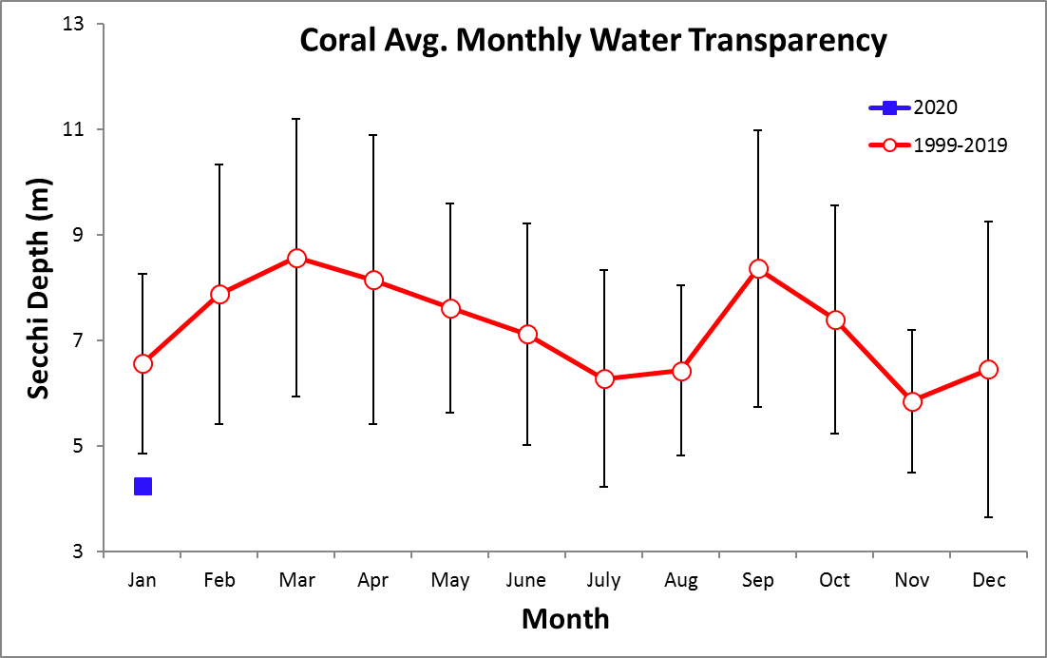
Seagrass
Year | Jan | Feb | Mar | Apr | May | June | July | Aug | Sep | Oct | Nov | Dec
2000 |  |  |  |  |  |  | 9.9 | 9.6 | 14.4 | 13.2 | 10.6 | 9.5
2001 | 12.8 | 14.3 | 11.9 | 12.5 | 12.6 | 10.8 | 8.0 | 9.8 | 9.5 | 12.9 | 9.7 | 12.1
2002 | 11.6 | 14.9 | 12.9 | 7.5 | 10.5 | 13.6 | 8.0 | 7.0 | 12.4 | 11.7 | 8.8 | 9.5
2003 | 11.8 | 13.5 | 14.4 | 11.6 | 9.9 | 11.0 | 9.8 | 11.4 | 13.4 | 12.0 | 10.9 | 8.0
2004 | 10.7 | 12.0 | 13.3 | 11.0 | 7.1 | 8.4 | 10.0 | 10.7 | 14.6 | 16.5 | 10.4 | 6.7
2005 | 8.3 | 8.0 | 15.7 | 12.6 | 15.6 | 13.4 | 10.5 | 8.8 | 15.3 | 11.5 | 10.6 | 11.1
2006 | 12.2 | 12.5 | 12.4 | 10.9 | 14.4 | 15.5 | 12.5 | 11.7 | 15.4 | 11.8 | 11.9 | 10.0
2007 | 11.6 | 16.8 | 17.7 | 13.9 | 16.0 | 13.3 | 13.3 | 13.9 | 15.2 | 11.0 | 8.3 | 11.5
2008 | 11.6 | 14.8 | 12.0 | 13.7 | 14.6 | 12.5 | 9.0 | 10.3 | 10.6 | 9.1 | 10.8 | 11.0
2009 | 11.9 | 6.3 | 14.3 | 14.0 | 14.1 | 14.1 | 9.6 | 10.3 | 11.9 | 9.8 | 8.9 | 10.0
2010 | 8.3 | 13.6 | 12.1 | 15.8 | 15.3 | 12.0 | 13.0 | 9.8 | 10.3 | 10.0 | 8.2 | 7.5
2011 | 12.6 | 11.5 | 13.8 | 14.8 | 14.2 | 14.5 | 11.3 | 14.3 | 13.1 | 13.4 | 11.0 | 10.0
2012 | 17.3 | 9.8 | 12.8 | 14.5 | 16.3 | 11.0 | 11.5 | 11.5 | 10.8 | 12.5 | 6.8 | 9.5
2013 | 10.5 | 16.0 | 12.0 | 15.3 | 9.0 | 12.0 | 6.3 | 9.0 | 15.0 | 12.2 | 9.5 | 12.5
2014 | 11.0 | 9.3 | 12.3 | 13.7 | 10.5 | 10.0 | 7.7 | 9.0 | 10.5 | 10.1 | 11.3 | 12.0
2015 | 9.5 | 11.0 | 11.3 | 8.7 | 11.0
2016 |  |  | 11.1 | 10.3 | 12.0 | 13.3 | 11.8 | 9.1 | 10.5 | 9.7 | 9.8 | 9.7
2017 | 7.6 | 16.2 | 8.3 | 11.1 | 10.3 | 9.5 | 10.5 | 9.8 | 10.3 | 11.0 | 7.5 | 8.3
2018 | 9.3 | 10.8 | 10.3 | 11.0 | 13.5 | 7.4 | 4.6 | 7.7 | 11.5 | 7.7 | 5.0 | 5.5
2019 | 11.8 | 10.3 | 12.5 | 9.8 | 9.0 | 9.5 | 8.1 | 9.1 | 8.8 | 9.2 | 6.5 | 9.3
2020 | 10.5 | Discontinued
mean | 11.0 | 12.2 | 12.7 | 12.2 | 12.4 | 11.8 | 9.9 | 10.2 | 12.3 | 11.1 | 9.2 | 9.5
sd | 2.2 | 3.0 | 2.1 | 2.4 | 2.8 | 2.3 | 2.4 | 1.9 | 2.1 | 2.0 | 1.9 | 1.9
min | 7.6 | 6.3 | 8.3 | 7.5 | 7.1 | 7.4 | 4.6 | 7.0 | 8.8 | 7.7 | 5.0 | 5.5
max | 17.3 | 16.8 | 17.7 | 15.8 | 16.3 | 15.5 | 13.3 | 14.3 | 15.4 | 16.5 | 11.9 | 12.5

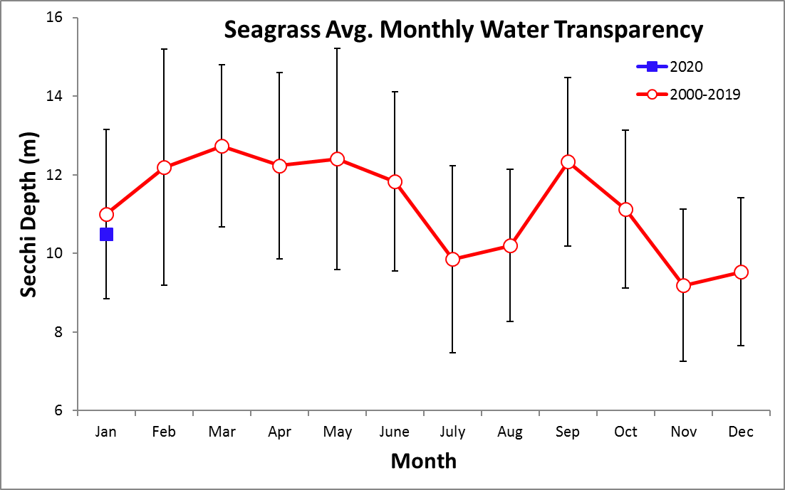

Average Disolved Oxygen (mg/l)

Long-term Average Monthly Temperatures (1999-2021)

 | Aquarium | Dock | Coral | Sea  grass | Mangrove
 |  |  |  |  | ‘A’ | ‘B’ | ‘C’
January | 5.8 | 5.1 | 6.1 | 5.8 | 5.8 | 5.7 | 5.7
February | 5.6 | 4.9 | 6.2 | 5.9 | 5.8 | 5.7 | 5.7
March | 5.6 | 4.8 | 6.2 | 5.7 | 5.7 | 5.5 | 5.6
April | 5.4 | 4.5 | 6.3 | 6.0 | 5.9 | 5.7 | 5.8
May | 5.3 | 4.5 | 6.1 | 5.3 | 5.4 | 5.2 | 5.3
June | 5.3 | 4.4 | 6.1 | 5.4 | 5.4 | 5.1 | 5.1
July | 5.5 | 4.7 | 6.1 | 5.7 | 5.6 | 5.4 | 5.3
August | 5.4 | 4.5 | 6.1 | 5.7 | 5.5 | 5.2 | 5.3
September | 5.4 | 4.5 | 6.0 | 5.7 | 5.6 | 5.4 | 5.3
October | 5.4 | 4.7 | 6.2 | 5.6 | 5.6 | 5.2 | 5.3
November | 5.6 | 4.8 | 6.0 | 5.6 | 5.6 | 5.4 | 5.4
December | 5.6 | 5.0 | 6.2 | 5.8 | 5.7 | 5.5 | 5.6

Average Monthly Temperatures (2022)

 | Aquarium | Dock | Coral | Sea  grass | Mangrove
 |  |  |  |  | ‘A’ | ‘B’ | ‘C’
January |  | 4.8 | 6.0 | 5.6 | 5.2 | 5.1 | 5.2
February |  | 5.5 | 6.0 | 5.8 | 5.4 | 5.4 | 5.3
March |  | 5.4 | 6.3 | 5.0 | 5.5 | 4.9 | 5.2
April |  | 5.3 | 6.8 | 6.2 | 6.3 | 6.0 | 6.2
May |  | 4.9 | 6.1 | 5.0 | 5.4 | 4.9 | 4.9
June |  | 5.3 | 6.1 | 4.1 | 4.5 | 3.8 | 4.0
July |  | 5.5 | 5.9 | 6.2 | 6.0 | 5.4 | 5.7
August |  | 4.9 | 5.8 | 5.6 | 5.1 | 4.5 | 4.6
September |  | 6.0 | 6.0 | 5.3 | 5.8 | 5.4 | 5.5
October |  | 6.0 | 6.0 | 5.3 | 5.8 | 5.4 | 5.5
November |  | 4.5 | 6.0 | 5.4 | 5.5 | 5.3 | 5.3
December |  | 4.9 | 6.0 | 5.6 | 5.4 | 5.2 | 5.3

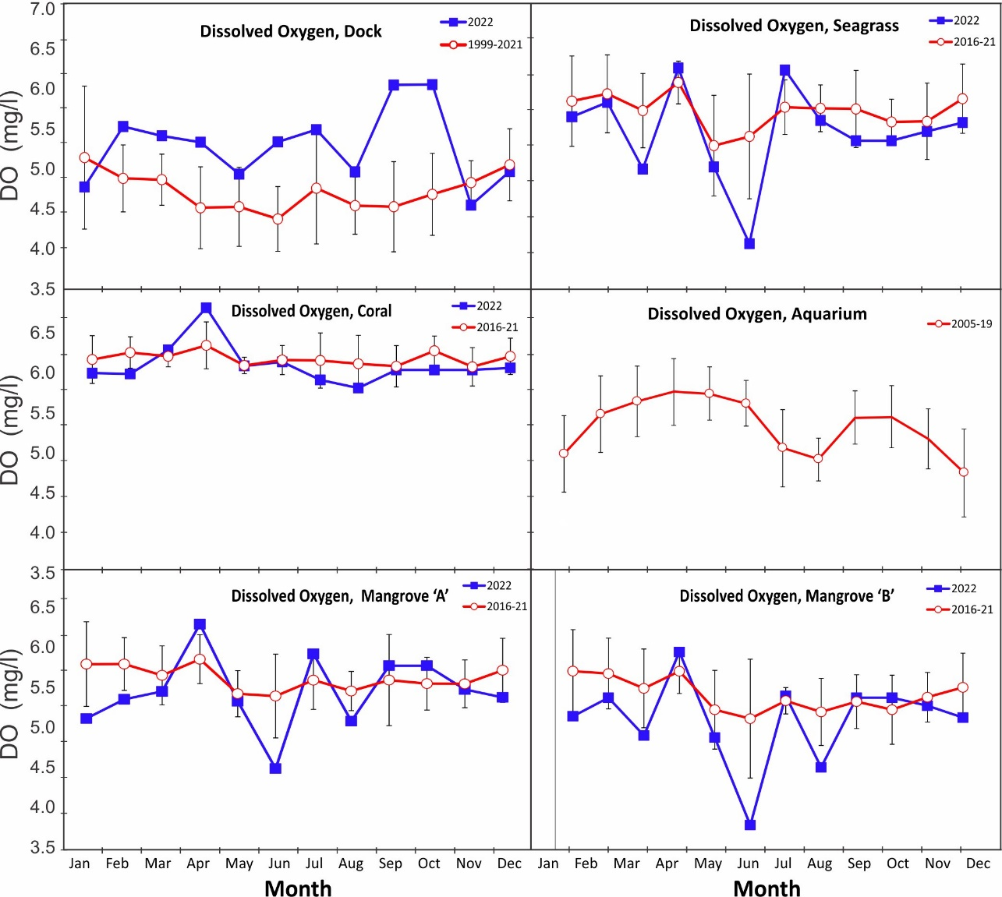

Time Series – Daily, 2022

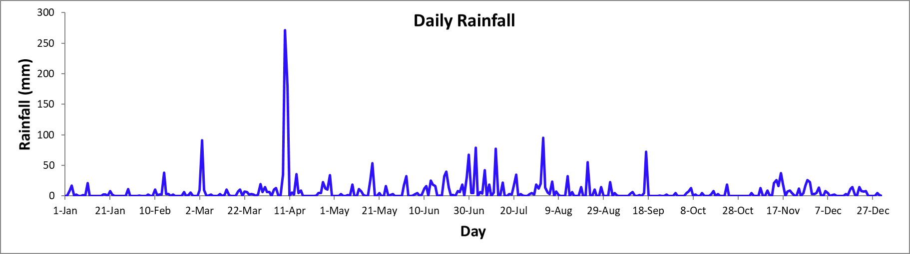

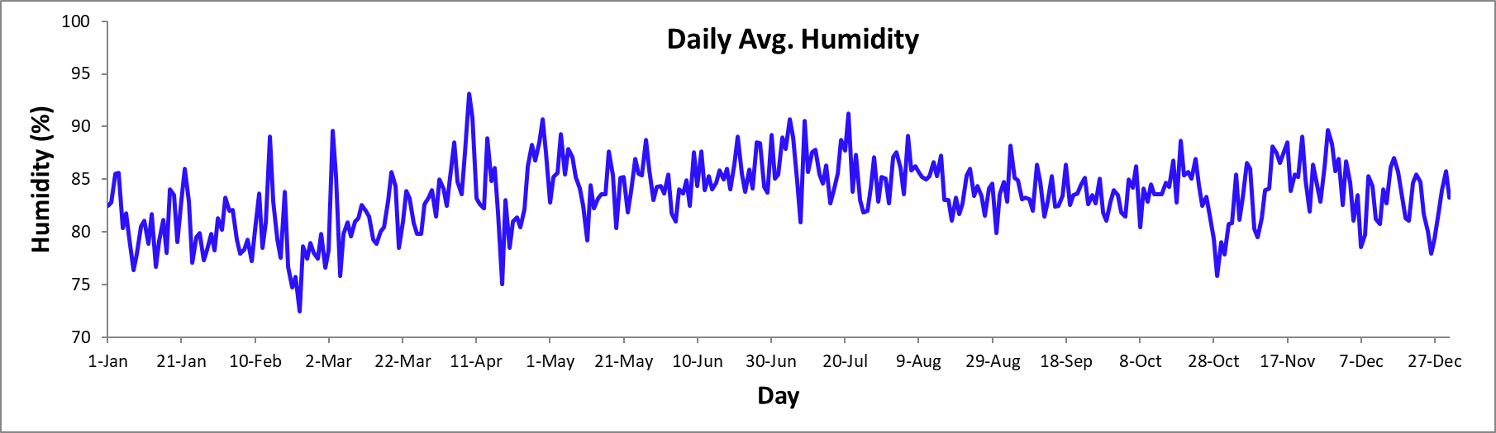

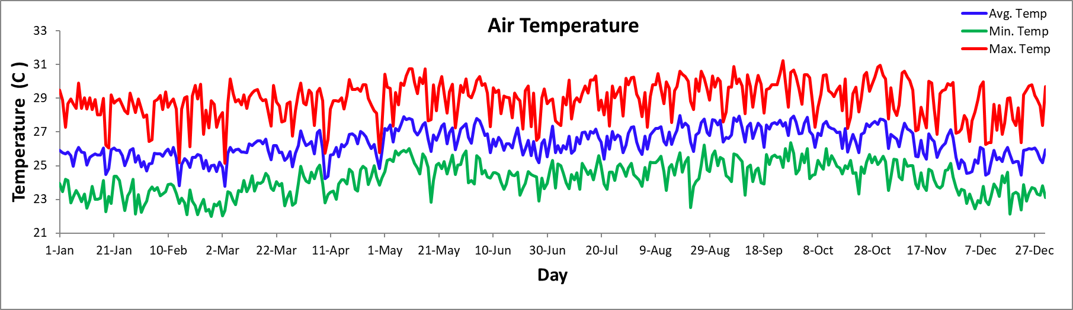

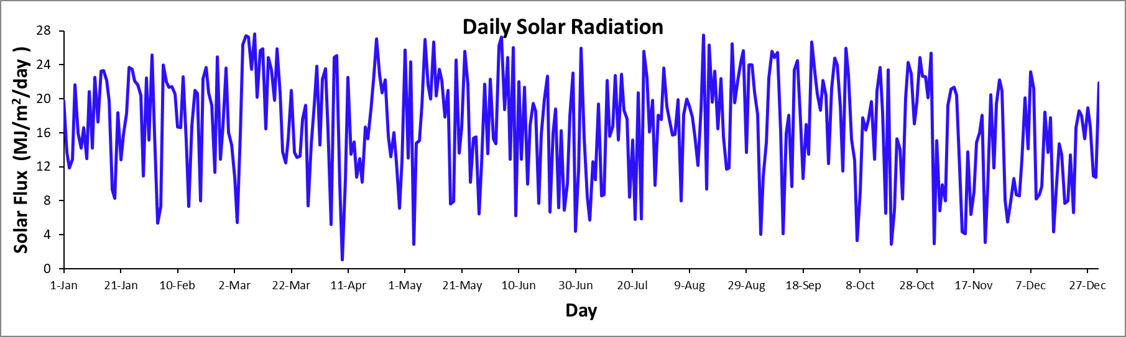

Time Series – Daily, 2022

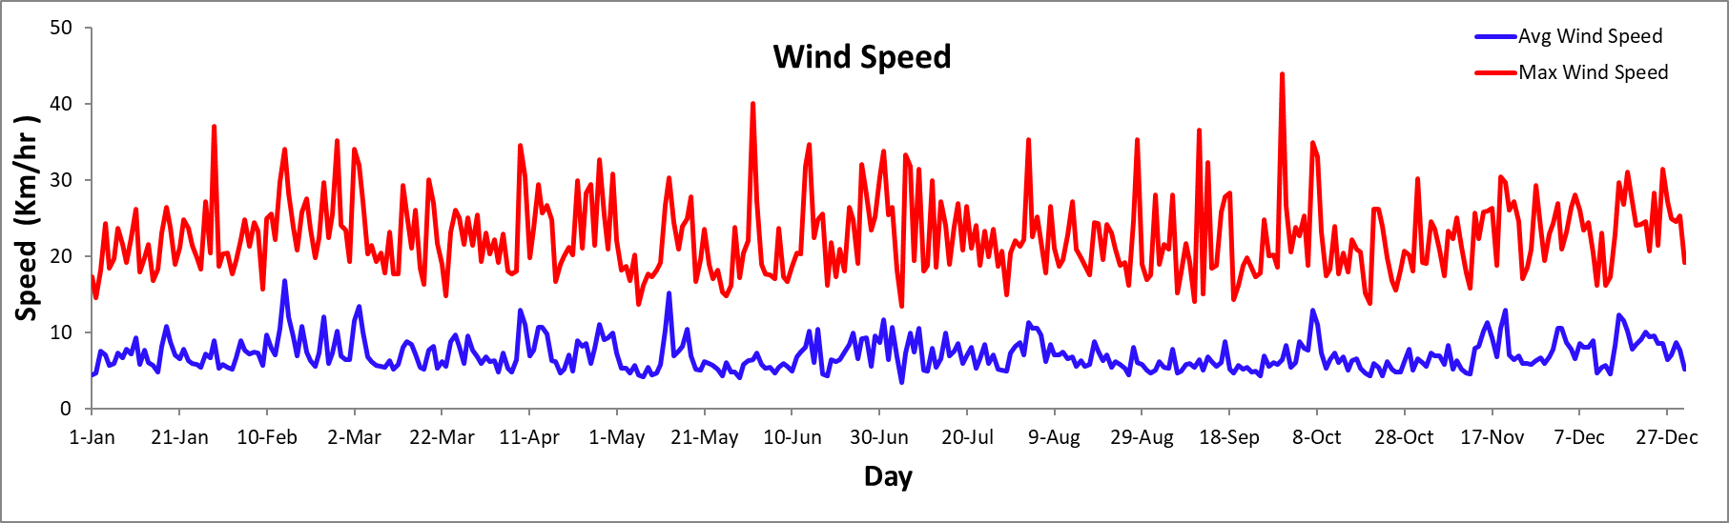

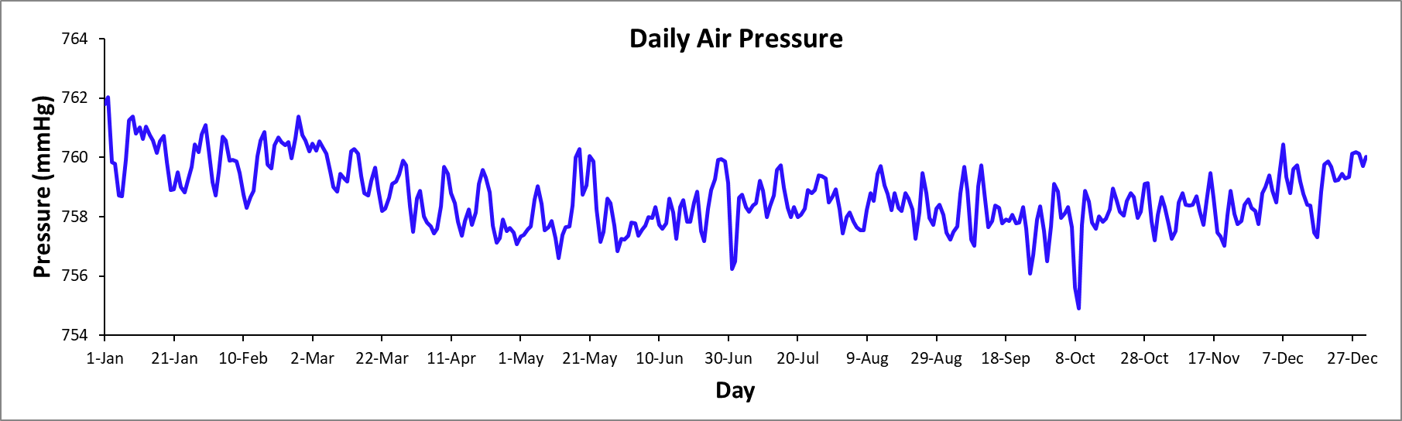

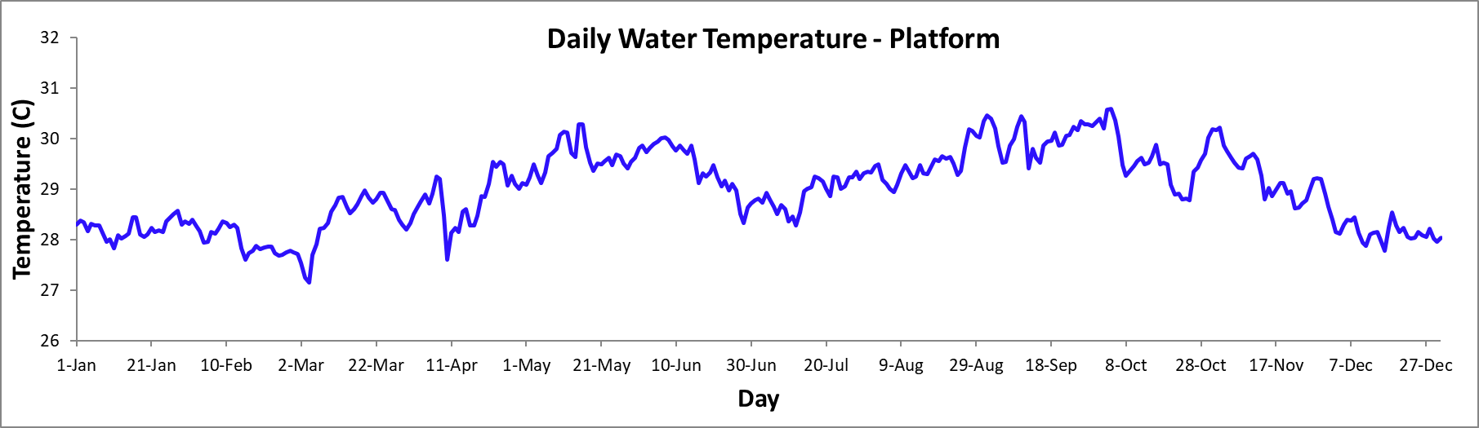

Time Series – Monthly

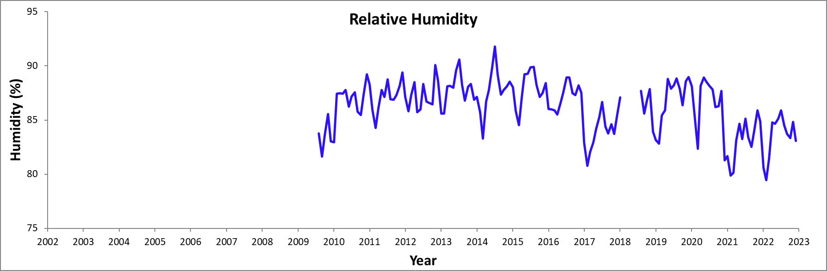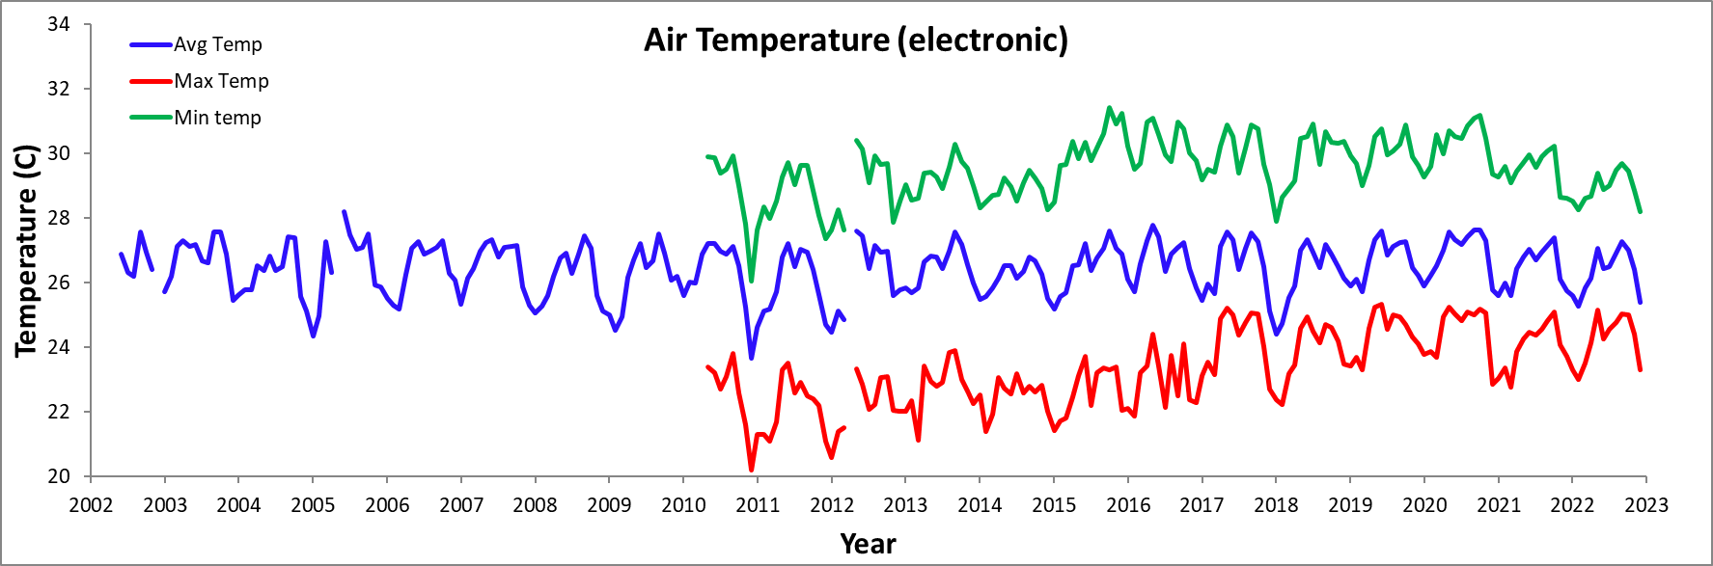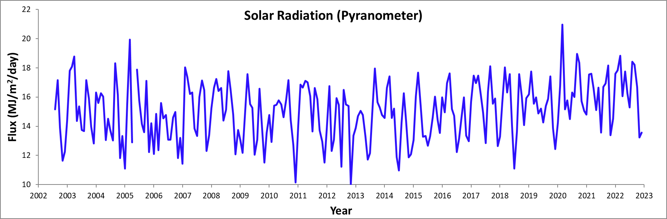

Time Series – Monthly

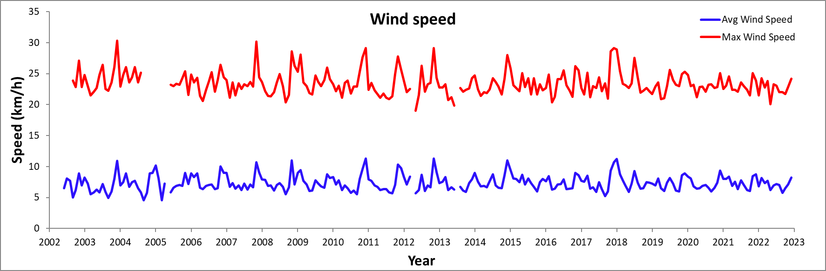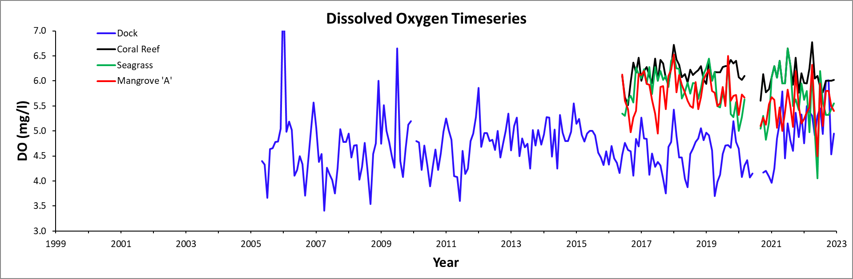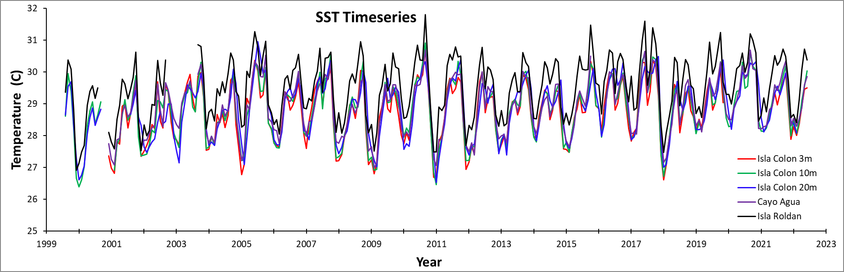

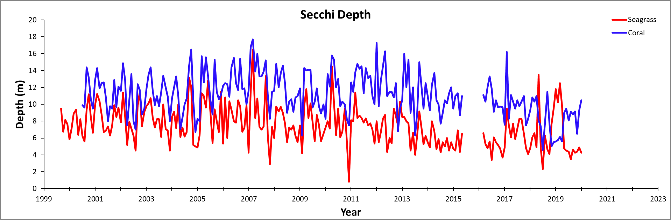
Time Series – Monthly

