2022 Meteorological Summary for
the San Lorenzo/Fort Sherman
Canopy Crane

Prepared by: Steven Paton

Introduction

This is the 10th in a series of yearly reports summarising the past year’s Smithsonian Tropical Research Institute’s Physical Monitoring Program on the Fort Sherman/San Lorenzo (FTS) Canopy Access Crane. This report is not meant to be exhaustive in its coverage in that it summarizes only some of the most ‘important’ or interesting parameters available. Any comments on how future yearly summaries could be improved would be appreciated. Additional copies of this report, reports from previous years, and downloadable data from the FTS and other research locations, can be obtained from:
http://biogeodb.stri.si.edu/physical_monitoring/research/sherman

Setting

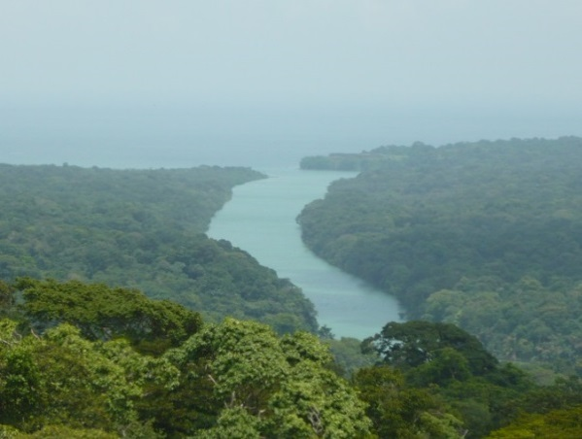
Established in 1997, the FTS canopy crane (9.281031°, -79.974518°) is located approximately 11 km Southwest from the city of Colon, in the middle the Parque Natural San Lorenzo (formerly known as Fort Sherman) and is surrounded by 300-year-old, low-land tropical rainforest. The crane is 52m tall with a radius of 54m and can reach approximately 240 species of trees and lianas. The crane stands in a 6-hectare plot where all 22,400 trees with a bole size of 1 cm in dbh or greater have been identified, measured and mapped. Structurally, the forest can be characterized as including 3,338 stems per hectare (greater than 1cm dbh) and a total basal area of almost 32m² per hectare with the tallest trees being 45m tall.

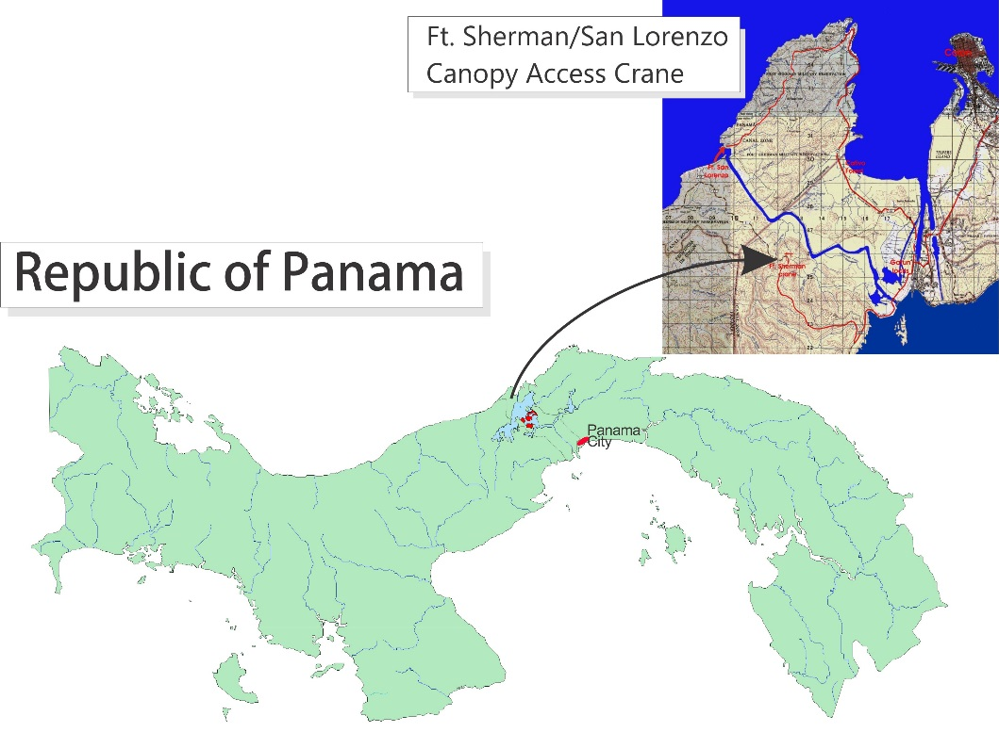
The station receives an average of 3294.8mm of rain per year. The meteorological year is divided into two parts: a pronounced dry season (approximately from mid-December to the end of April), and a wet season (May to mid-December). On average, only 655mm of rain falls during the dry season. Relative humidity, soil moisture, air pressure, solar radiation, evapotranspiration, wind speed and direction all show marked wet/dry season differences. On the other hand, temperature varies relatively little throughout the year.

All data are collected using electronic sensors. All sensors are located at the top of the crane, with the exception of the anemometer which is located to the side of vertical shaft approximately 3m below the boom.

This report summarises the following data:

Relative humidity
Air temperature
Rainfall
Wind speed and direction
Solar radiation
Rainfall
Rainfall was collected by a rain gauge located on the counterweight of the crane boom. Tipping buckets generate ‘events’ for every 0.254 mm of rainfall recorded. There are several large gaps in the data for the years 2003, 2005-7, and 2010. Missing data have been estimated from the Panama Canal Authority’s “Gatun West” rain gauge station. This station is located 5.3 km SE of the FTS crane (see image on previous page). The correlation r² between the two station’s monthly rainfall is 0.926

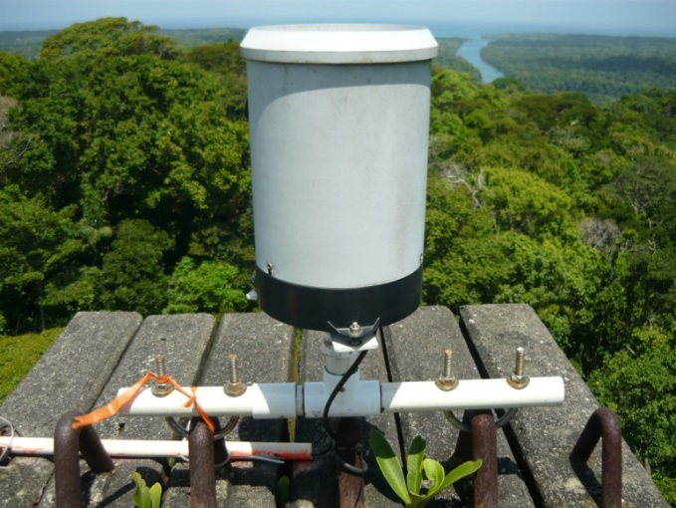
The daily rainfall data for 2022 are shown on page 5.

Page 6 shows the monthly totals for 2022. The graph on the same page compares this year’s monthly totals with the average monthly totals (±SD) for the period 1997 to 2022.

Page 7 shows yearly rainfall totals for all year since 1997. Time series graph and frequency histograms are presented for these data.

Pages 8 and 9 show an analysis of rainfall ‘events’ (storms). For convenience, and again somewhat arbitrarily, I have defined a storm as any continuous period of rain separated by at least an hour from any other rainfall. Since this analysis required the timing of rainfall events, tipping bucket data were used. As a result, the absolute size of rainfall events should be considered as only an estimate since they will tend to disproportionately underestimate the size of storms - larger storms will be more underestimated than smaller ones. Keeping this in mind, the tables and graphs on this page compare the maximum storm size and the average storm size and duration per month for the period 1997 to 2021 and for the year 2022.

Relative Humidity
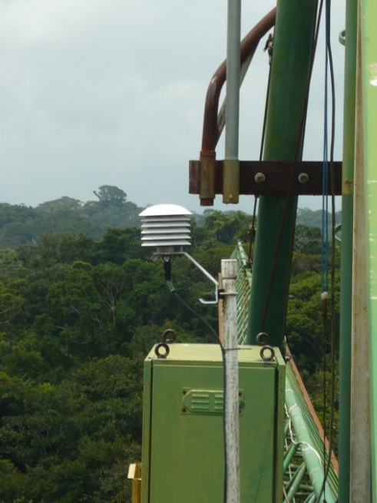
Data were also collected on top of the crane boom, at 15- minute intervals by dataloggers attached to Campbell Sci. CS215 temperature/humidity sensors (Viasala HMP 35/45 sensors prior to 2010).

The average monthly relative humidity data are shown in tabular and graphical form on pages 10 & 11.

Air Temperature

Shaded air temperature data were also collected on top of the crane boom at 15-minute intervals by dataloggers attached to Campbell Sci. CS215 electronic temperature/humidity sensors (Viasala HMP 35/45 sensors prior to 2010). The monthly average, maximum and minimum temperatures are shown in tabular and graphical form on page 12 to 15, respectively.

Solar Radiation

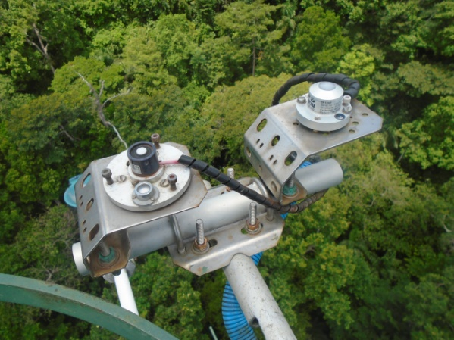
Until July 13, 2016, global solar radiation was measured on top of the crane boom using two Li-Cor LI200SB pyranometers attached to a datalogger. On that date one of the sensors was replaced with a Kipp&Zonen SPLite2 pyranometer. 15-minute inter-val total (MJm⁻²), maximum and minimum (J m⁻² s⁻¹) are collected.

Page 16 shows the Daily Global Radiation values. Page 17 shows total monthly Global Radiation. Page 18 shows total monthly Photosynthetically Active Radiation (PAR) collected on the crane from 1997 to 2007.

Wind Speed and Direction

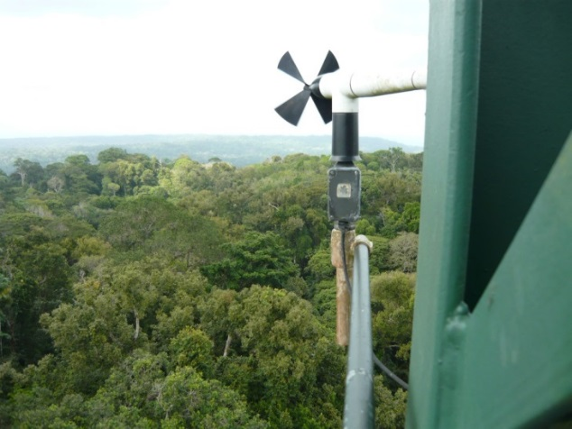
15-minute interval average, maximum and minimum wind speed plus average wind direction was recorded by a Model 05103 Young Anemometer approximately three meters below the crane boom and two meters from the central column on the north side (exposed to the predominately northernly winds).

Page 19 shows average and maximum daily wind speeds. Page 20 shows daily average wind direction. The angles indicated in the table and graph on this page represent the direction into which the wind was predominately blowing on a given day. Pages 21 to 24 show the monthly average wind speed, average daily maximum wind speed and average wind directions for the year.

Times Series

Graphs showing daily and monthly averages for the entire period of record for Humidity, Air Temperature, Rainfall, Wind Speed and Solar Radiation can be found on pages 25 to 27.

Daily Patterns
Pages 28 and 29 show the daily patterns for Humidity, Air Temperature, Rainfall, Wind Speed and Solar Radiation.

Rainfall data from the ACP

The Panama Canal Authority (ACP) maintains a network of meteorogical stations throughout the Panama Canal. Rainfall data from the station known as Gatun West (9.263337° N, -9.929035°W) has been used to supplement the rainfall data collected at the FTS station.
2022 Daily Rainfall (mm)

 | Jan. | Feb. | Mar. | Apr. | May | June | July | Aug. | Sep. | Oct. | Nov. | Dec.
1 | 0.3 | 0.0 | 8.4 | 0.0 | 6.9 | 1.5 | 12.2 | 4.8 | 0.0 | 8.6 | 0.0 | 0.8
2 | 0.0 | 1.3 | 49.5 | 3.3 | 0.3 | 3.0 | 0.8 | 27.4 | 3.3 | 25.1 | 0.0 | 11.7
3 | 2.8 | 0.3 | 2.0 | 42.9 | 0.3 | 0.0 | 17.3 | 25.2 | 23.4 | 0.8 | 76.5 | 0.0
4 | 0.0 | 0.0 | 24.1 | 20.1 | 0.3 | 0.0 | 6.6 | 2.3 | 50.3 | 0.0 | 1.8 | 17.5
5 | 0.0 | 1.8 | 0.3 | 1.8 | 49.3 | 27.7 | 32.0 | 33.0 | 40.1 | 35.1 | 2.3 | 27.7
6 | 0.0 | 23.9 | 6.6 | 0.0 | 6.9 | 10.9 | 6.4 | 32.0 | 7.4 | 25.2 | 0.3 | 1.5
7 | 0.0 | 0.0 | 0.0 | 0.0 | 0.3 | 0.0 | 31.5 | 0.0 | 0.5 | 179.3 | 1.0 | 2.5
8 | 0.0 | 0.0 | 0.3 | 27.9 | 0.3 | 0.0 | 5.8 | 0.8 | 3.8 | 13.2 | 28.2 | 10.4
9 | 0.0 | 10.7 | 0.0 | 37.8 | 1.3 | 0.0 | 10.7 | 22.9 | 0.0 | 0.0 | 0.0 | 0.3
10 | 0.0 | 56.1 | 0.0 | 0.3 | 0.0 | 41.1 | 23.1 | 12.4 | 11.4 | 0.8 | 9.9 | 0.0
11 | 0.8 | 0.3 | 1.0 | 1.5 | 7.4 | 14.5 | 22.1 | 27.9 | 5.6 | 0.5 | 3.6 | 0.3
12 | 5.1 | 0.0 | 0.0 | 1.5 | 7.4 | 0.0 | 13.5 | 1.8 | 4.8 | 3.8 | 0.0 | 17.8
13 | 6.1 | 3.3 | 0.0 | 21.6 | 21.1 | 46.0 | 25.4 | 0.0 | 6.6 | 2.0 | 39.4 | 21.1
14 | 2.0 | 1.3 | 1.8 | 0.0 | 64.5 | 30.2 | 0.0 | 2.0 | 2.5 | 0.0 | 6.9 | 16.8
15 | 0.0 | 0.0 | 0.5 | 8.4 | 0.5 | 0.0 | 0.5 | 64.0 | 0.0 | 0.0 | 23.6 | 10.4
16 | 0.0 | 0.3 | 2.3 | 0.0 | 31.8 | 10.7 | 0.0 | 0.0 | 9.1 | 0.0 | 6.6 | 0.0
17 | 0.0 | 8.4 | 1.8 | 2.5 | 121.2 | 1.3 | 8.4 | 0.0 | 1.0 | 16.8 | 19.3 | 0.0
18 | 0.0 | 2.5 | 0.0 | 0.8 | 28.4 | 8.1 | 0.5 | 1.3 | 0.5 | 18.3 | 9.1 | 0.0
19 | 0.3 | 0.0 | 4.3 | 0.0 | 0.0 | 0.0 | 1.8 | 0.0 | 0.0 | 3.0 | 0.3 | 2.5
20 | 0.0 | 0.8 | 0.0 | 0.0 | 0.8 | 0.0 | 24.1 | 21.6 | 14.7 | 50.5 | 0.3 | 0.0
21 | 0.0 | 0.3 | 1.3 | 0.0 | 0.0 | 10.2 | 35.8 | 60.5 | 0.0 | 6.1 | 76.7 | 0.3
22 | 0.0 | 0.0 | 0.0 | 0.0 | 1.0 | 23.6 | 30.7 | 18.0 | 4.1 | 7.1 | 5.8 | 0.0
23 | 6.1 | 0.0 | 0.0 | 26.2 | 0.3 | 3.0 | 38.4 | 12.7 | 0.0 | 0.5 | 4.6 | 0.0
24 | 0.0 | 0.5 | 0.0 | 0.3 | 10.7 | 28.4 | 21.8 | 0.8 | 9.4 | 12.4 | 1.3 | 0.0
25 | 1.8 | 0.0 | 0.0 | 5.3 | 3.3 | 5.1 | 11.2 | 18.0 | 1.5 | 12.4 | 7.6 | 0.3
26 | 0.3 | 0.0 | 0.0 | 6.9 | 3.0 | 29.5 | 5.1 | 1.3 | 11.4 | 13.5 | 5.6 | 2.0
27 | 0.0 | 0.0 | 14.2 | 24.6 | 2.5 | 25.7 | 7.1 | 7.6 | 0.0 | 8.4 | 2.3 | 0.0
28 | 8.4 | 0.0 | 23.6 | 8.9 | 32.0 | 18.3 | 14.2 | 58.2 | 1.5 | 0.3 | 5.1 | 24.6
29 | 0.3 |  | 0.0 | 6.9 | 0.0 | 3.0 | 7.6 | 0.0 | 8.1 | 0.0 | 18.3 | 0.3
30 | 1.3 |  | 0.8 | 34.8 | 0.3 | 6.6 | 10.2 | 0.0 | 1.0 | 0.0 | 0.0 | 0.3
31 | 8.4 |  | 0.0 |  | 0.0 |  | 0.0 | 1.5 |  | 0.0 |  | 0.0
 | 43.7 | 111.5 | 142.8 | 284.2 | 401.6 | 348.5 | 424.7 | 458.0 | 222.3 | 443.7 | 356.1 | 168.9
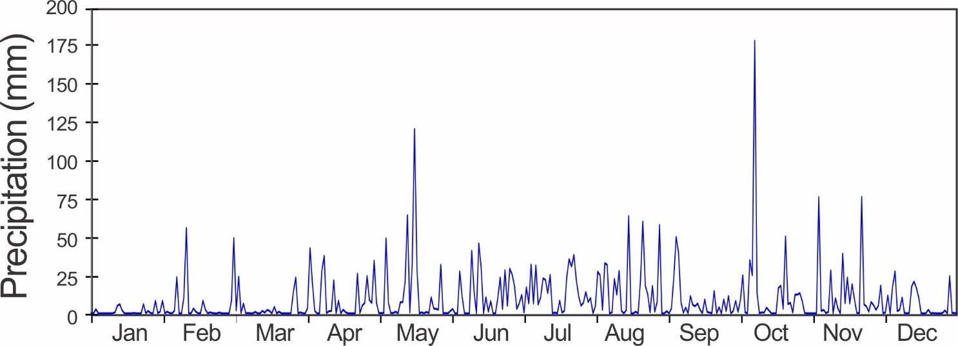
Monthly Rainfall (mm)

Year | Jan | Feb | Mar | Apr | May | June | July | Aug | Sep | Oct | Nov | Dec | Total
1997 | 63.0 | 20.0 | 5.7 | 22.9 | 194.5 | 168.2 | 206.1 | 335.8 | 265.9 | 187.2 | 216.5 | 33.5 | 1719.4
1998 | 29.1 | 36.8 | 39.2 | 502.5 | 302.2 | 250.4 | 514.1 | 360.6 | 102.7 | 260.4 | 268.4 | 533.6 | 3200.0
1999 | 88.2 | 61.1 | 119.7 | 128.6 | 273.9 | 291.0 | 391.0 | 396.2 | 258.1 | 204.8 | 511.4 | 699.4 | 3423.6
2000 | 89.7 | 54.2 | 6.8 | 118.5 | 435.1 | 595.9 | 159.6 | 248.1 | 150.5 | 575.1 | 253.3 | 658.0 | 3344.8
2001 | 92.6 | 2.8 | 168.0 | 52.0 | 181.4 | 137.3 | 283.3 | 403.7 | 446.3 | 376.7 | 581.6 | 388.6 | 3114.2
2002 | 188.0 | 20.3 | 73.7 | 233.7 | 172.7 | 140.9 | 288.2 | 546.5 | 306.4 | 389.1 | 622.0 | 101.0 | 3082.5
2003 | 40.5 | 12.7 | 2.5 | 198.1 | 251.8 | 249.9 | 330.8 | 524.3 | 393.8 | 252.3 | 656.6 | 583.0 | 3496.3
2004 | 39.6 | 74.1 | 38.8 | 154.8 | 640.2 | 307.5 | 357.1 | 494.8 | 146.1 | 374.0 | 375.9 | 373.4 | 3376.3
2005 | 121.9 | 33.0 | 53.3 | 287.0 | 320.0 | 157.5 | 243.8 | 467.4 | 396.2 | 177.8 | 612.1 | 215.9 | 3086.1
2006 | 50.8 | 45.7 | 109.2 | 88.9 | 264.2 | 81.3 | 629.8 | 146.2 | 307.6 | 265.6 | 485.1 | 360.7 | 2835.1
2007 | 10.2 | 20.3 | 55.9 | 144.0 | 323.0 | 227.0 | 202.5 | 287.0 | 318.3 | 699.6 | 970.9 | 264.4 | 3523.1
2008 | 33.0 | 63.2 | 42.3 | 99.4 | 548.7 | 309.7 | 415.6 | 333.1 | 156.3 | 309.7 | 845.7 | 133.5 | 3290.2
2009 | 71.0 | 47.0 | 48.1 | 163.0 | 205.5 | 272.6 | 278.3 | 370.9 | 268.3 | 294.9 | 742.0 | 80.2 | 2841.8
2010 | 31.9 | 16.0 | 48.0 | 76.0 | 110.0 | 333.0 | 166.0 | 353.0 | 210.2 | 709.6 | 615.4 | 1075.0 | 3744.1
2011 | 205.4 | 114.2 | 68.4 | 154.1 | 326.9 | 436.3 | 490.2 | 281.5 | 221.0 | 298.4 | 973.4 | 627.5 | 4197.3
2012 | 21.8 | 21.8 | 131.9 | 227.6 | 339.6 | 284.2 | 355.5 | 209.5 | 368.3 | 370.5 | 1506.3 | 542.2 | 4379.3
2013 | 10.7 | 49.4 | 41.5 | 99.7 | 586.7 | 341.9 | 408.9 | 420.1 | 211.9 | 290.1 | 206.3 | 302.6 | 2969.9
2014 | 53.0 | 28.7 | 45.4 | 141.6 | 431.1 | 457.1 | 150.9 | 414.0 | 182.9 | 428.5 | 520.1 | 312.8 | 3166.0
2015 | 59.4 | 35.5 | 16.7 | 61.6 | 386.0 | 283.2 | 411.1 | 337.6 | 464.8 | 268.5 | 229.4 | 156.0 | 2315.5
2016 | 58.9 | 53.2 | 10.4 | 68.3 | 254.6 | 283.2 | 411.0 | 142.8 | 431.0 | 269.0 | 1158.0 | 436.4 | 3576.6
2017 | 35.7 | 10.4 | 14.7 | 32.0 | 511.0 | 329.0 | 474.9 | 295.1 | 255.8 | 253.0 | 539.5 | 737.1 | 3488.1
2018 | 634.5 | 7.4 | 41.4 | 137.2 | 368.1 | 547.6 | 378.5 | 332.7 | 554.5 | 337.8 | 625.8 | 96.8 | 4062.2
2019 | 39.9 | 18.3 | 57.7 | 206.3 | 249.4 | 210.1 | 365.0 | 368.0 | 351.0 | 174.8 | 474.0 | 730.0 | 3244.4
2020 | 72.9 | 44.5 | 13.7 | 126.0 | 304.8 | 353.6 | 309.4 | 457.0 | 271.5 | 235.7 | 499.4 | 293.4 | 2981.7
2021 | 62.7 | 73.4 | 54.9 | 231.1 | 262.9 | 356.4 | 355.6 | 421.1 | 558.3 | 340.4 | 794.3 | 289.3 | 3800.4
2022 | 43.7 | 111.5 | 142.8 | 284.2 | 401.6 | 348.5 | 424.7 | 458.0 | 222.3 | 443.7 | 356.1 | 168.9 | 3405.9
mean | 86.5 | 41.4 | 55.8 | 155.3 | 332.5 | 298.8 | 343.6 | 361.7 | 300.8 | 338.0 | 601.5 | 392.0 | 3334.0
sd | 121.2 | 29.1 | 44.5 | 101.3 | 131.8 | 122.7 | 118.7 | 104.0 | 122.8 | 140.9 | 307.9 | 257.3 | 520.3
min | 10.2 | 2.8 | 2.5 | 22.9 | 110.0 | 81.3 | 150.9 | 142.8 | 102.7 | 174.8 | 206.3 | 33.5 | 1719.4
max | 634.5 | 114.2 | 168.0 | 502.5 | 640.2 | 595.9 | 629.8 | 546.5 | 558.3 | 709.6 | 1506.3 | 1075.0 | 4379.3
Rank* | 16 | 2 | 2 | 3 | 7 | 7 | 5 | 5 | 18 | 4 | 21 | 20 | 11
* Rank of most year, 1 = wettest

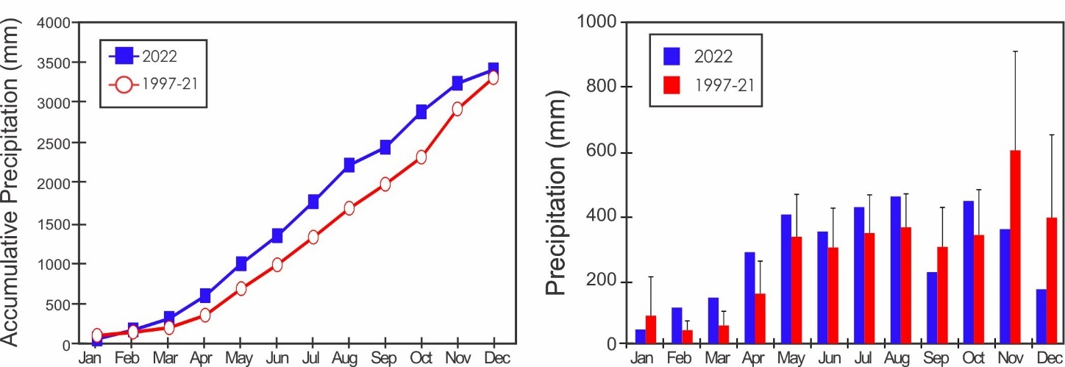
Yearly Rainfall (mm)

Year | Rain | Year | Rain | Year | Rain
1997 | 1719.4 | 2006 | 2891.3 | 2015 | 2315.5
1998 | 3200.0 | 2007 | 3342.8 | 2016 | 3579.4
1999 | 3416.0 | 2008 | 3288.2 | 2017 | 3488.1
2000 | 3342.2 | 2009 | 2841.8 | 2018 | 4062.2
2001 | 2759.1 | 2010 | 3476.5 | 2019 | 3244.4
2002 | 3089.8 | 2011 | 4197.3 | 2020 | 2981.7
2003 | 3497.8 | 2012 | 4379.3 | 2021 | 3800.4
2004 | 3203.8 | 2013 | 2969.9 | 2022 | 3405.9
2005 | 3476.9 | 2014 | 3166.0

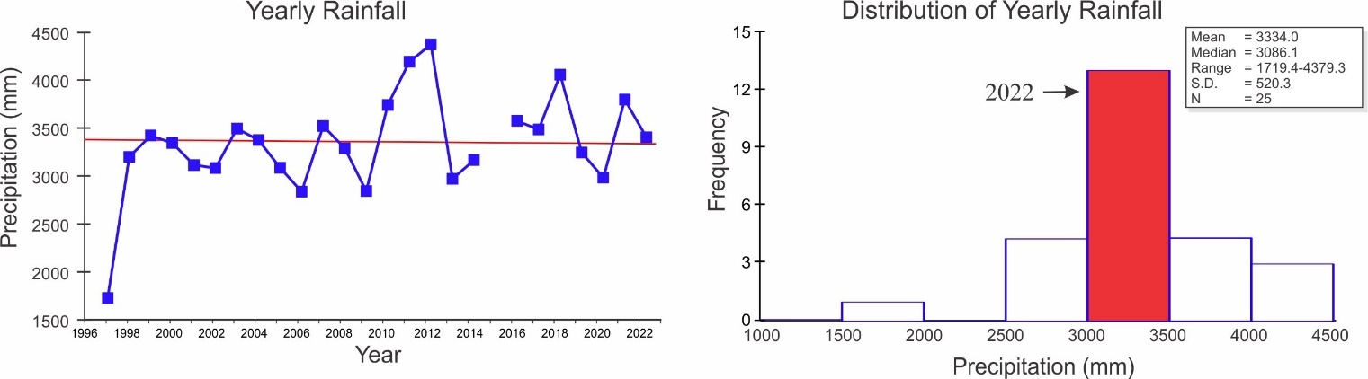

Storm Analysis

 |  | Max. Rainfall per Storm (mm) |  |  |  | Storm Duration (min.)
 | 1997-2021 |  |  | 2022 |  | 1997-2021 |  | 2022
 | Mean |  | S.D. |  |  | Mean | S.D.
January | 19.1 |  | 20.5 | 8.4 |  | 37.9 | 13.2 | 38.8
February | 13.1 |  | 15.6 | 33.5 |  | 30.8 | 10.4 | 52.9
March | 18.4 |  | 21.2 | 38.9 |  | 35.3 | 12.9 | 51.0
April | 46.6 |  | 32.5 | 34.0 |  | 54.6 | 19.6 | 62.1
May | 77.3 |  | 49.5 | 64.5 |  | 64.0 | 15.4 | 79.4
June | 61.2 |  | 33.2 | 46.7 |  | 57.6 | 17.8 | 94.2
July | 62.7 |  | 37.1 | 35.6 |  | 56.5 | 16.6 | 68.8
August | 62.6 |  | 32.3 | 57.9 |  | 61.8 | 14.7 | 77.7
September | 56.9 |  | 22.6 | 40.1 |  | 61.9 | 7.6 | 63.8
October | 72.1 |  | 71.1 | 148.3 |  | 72.0 | 21.6 | 74.8
November | 103.0 |  | 66.2 | 69.9 |  | 79.0 | 24.8 | 67.9
December | 78.9 |  | 63.3 | 20.1 |  | 60.7 | 18.4 | 38.7

 | Av. Rainfall per Storm (mm)
 | 1997-2021 |  | 2022
 | Mean | S.D.
January | 2.8 | 2.1 | 1.9
February | 2.1 | 1.3 | 4.3
March | 2.8 | 2.3 | 3.3
April | 5.8 | 3.4 | 5.5
May | 7.6 | 2.4 | 7.7
June | 6.4 | 2.2 | 8.3
July | 5.9 | 2.7 | 5.6
August | 6.7 | 2.1 | 8.3
September | 7.0 | 2.2 | 6.5
October | 8.6 | 6.3 | 8.2
November | 8.4 | 3.0 | 5.8
December | 6.8 | 3.5 | 3.1

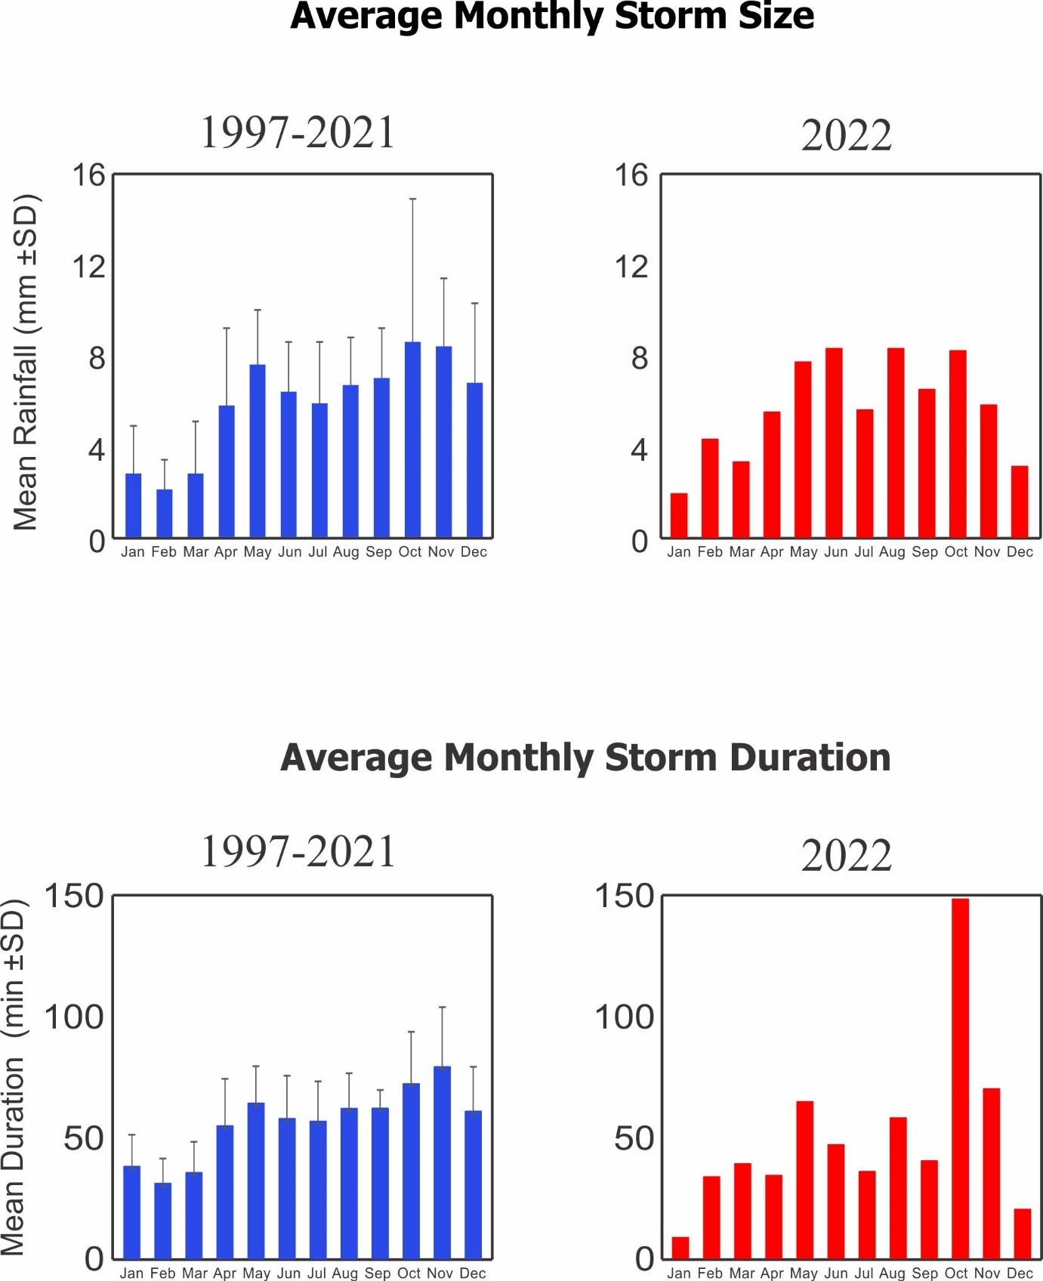
Relative Humidity (%)

Year | Jan | Feb | Mar | Apr | May | June | July | Aug | Sep | Oct | Nov | Dec
1997 |  |  |  |  |  | 91.6 | 94.1 | 95.4 | 95.7 | 95.1 | 97.0 | 92.9
1998 | 92.1 | 90.9 | 89.5 | 92.0 | 96.5 | 97.5 | 98.3 | 98.0 | 95.2 | 95.7 | 97.3 | 98.6
1999 | 94.5 | 93.0 | 94.1 | 92.1 | 91.6 | 94.4 | 94.6 | 94.9 | 93.2 | 93.1 | 94.5 | 95.7
2000 | 89.3 | 87.3 | 85.8 | 89.4 | 93.8 | 94.7 | 94.2 | 95.2 | 92.6 | 95.5 | 93.4 | 94.0
2001 | 89.7 | 88.4 | 90.5 | 92.1 | 94.0 | 94.5 | 96.7 | 97.1 | 95.7 | 95.4 | 97.1 | 97.7
2002 | 95.3 | 91.5 | 93.1 | 94.0 | 96.1 | 96.7 | 98.2 | 98.5 | 96.8 | 97.8 | 98.6 | 93.4
2003 | 86.0 | 86.3 | 90.2 |  |  |  |  |  |  |  | 95.4 | 93.7
2004 | 86.1 | 84.9 | 85.8 | 89.3 | 93.7 | 94.1 | 94.8 | 95.6 | 91.3 | 91.5 | 93.1 | 88.9
2005 | 90.2 | 85.9 | 88.9 | 90.3 | 94.5 | 90.0 | 89.2 | 92.5 | 92.8 | 90.1 | 94.2 | 88.5
2006 | 88.7 | 86.1 | 87.2 | 89.4 | 93.0 | 92.8 | 94.5 | 93.3 | 93.8 | 92.9 | 94.0 | 93.7
2007 | 87.6 | 86.8 | 87.0 | 90.3 | 94.5 | 94.2 | 95.1 | 91.8 | 90.1 | 90.3 | 93.9 | 90.9
2008 | 83.9 | 84.9 | 83.2 | 84.5 | 88.7 | 92.0 | 92.6 | 90.7 | 88.8 | 88.8 | 94.6 | 88.6
2009 | 87.5 | 86.9 | 85.8 | 86.7 | 91.8 | 90.6 | 93.6 | 94.1 | 91.7 | 91.7 | 95.3 | 90.7
2010 | 87.2 | 88.9 | 89.4 | 88.4 | 89.3 | 91.5 | 92.1 | 92.7 | 91.2 | 94.5 | 93.9 | 94.6
2011 | 93.4 | 89.5 | 87.1 | 89.6 | 91.9 | 94.0 | 94.1 | 91.9 | 89.6 | 90.7 | 96.3 | 94.9
2012 | 87.1 | 86.9 | 89.3 | 91.2 | 93.5 | 92.6 | 96.1 | 94.6 | 94.3 | 94.0 | 98.2 | 96.2
2013 | 88.5 | 88.0 | 91.0 | 90.8 | 92.9 | 94.8 | 96.2 | 95.1 | 93.7 | 93.8 | 92.9 | 91.4
2014 | 90.7 | 90.1 | 88.8 | 92.9 | 95.1 | 97.5 | 97.1 | 96.8 | 95.3 | 95.5 | 96.5 | 96.5
2015 | 91.1 | 91.4 | 89.6 | 92.8 | 96.5 | 95.8 | 97.3 | 97.5 | 97.3 | 93.6 | 93.0 | 93.7
2016 | 87.1 | 87.5 | 88.7 | 89.2 | 93.0 | 93.1 | 91.1 | 91.1 | 90.5 | 90.2 | 93.4 | 90.0
2017 | 83.9 | 82.8 | 83.6 | 86.8 | 91.5 | 90.4 | 95.1 | 93.6 | 91.5 | 92.1 | 95.3 | 94.5
2018 | 95.6 | 86.9 | 88.4 | 90.0 | 92.3 | 95.6 | 96.0 | 95.7 | 94.6 | 92.5 | 94.7 | 87.7
2019 | 86.0 | 87.3 | 87.1 | 89.1 | 92.6 | 92.9 | 94.2 | 93.5 | 93.2 | 91.6 | 92.3 | 93.5
2020 | 87.5 | 86.1 |  |  |  |  |  |  |  | 88.9 | 90.8
2021 | 84.0 | 84.3 | 82.1 | 88.3 | 91.7 | 91.0 | 92.5 | 91.8 | 91.5 | 92.5 | 95.2 | 92.5
2022 | 87.1 | 86.1 | 89.8 | 91.6 | 93.6 | 92.7 | 94.4 | 92.2 | 90.8 | 90.9 | 92.1 | 87.2
mean | 88.1 | 86.9 | 87.2 | 89.4 | 92.7 | 93.1 | 94.2 | 93.7 | 92.4 | 92.0 | 94.3 | 92.2
sd | 3.1 | 2.1 | 2.5 | 2.1 | 1.9 | 2.1 | 2.2 | 2.0 | 2.2 | 1.9 | 1.7 | 2.8
min | 83.9 | 82.8 | 82.1 | 84.5 | 88.7 | 90.0 | 89.2 | 90.7 | 88.8 | 88.8 | 90.8 | 87.7
max | 95.6 | 91.4 | 91.0 | 92.9 | 96.5 | 97.5 | 97.3 | 97.5 | 97.3 | 95.5 | 98.2 | 96.5

Notes: Change in Sensor type in Dec of 2003 resulted in a significant drop in recorded Humidity
Analysis only includes 2004 to the present
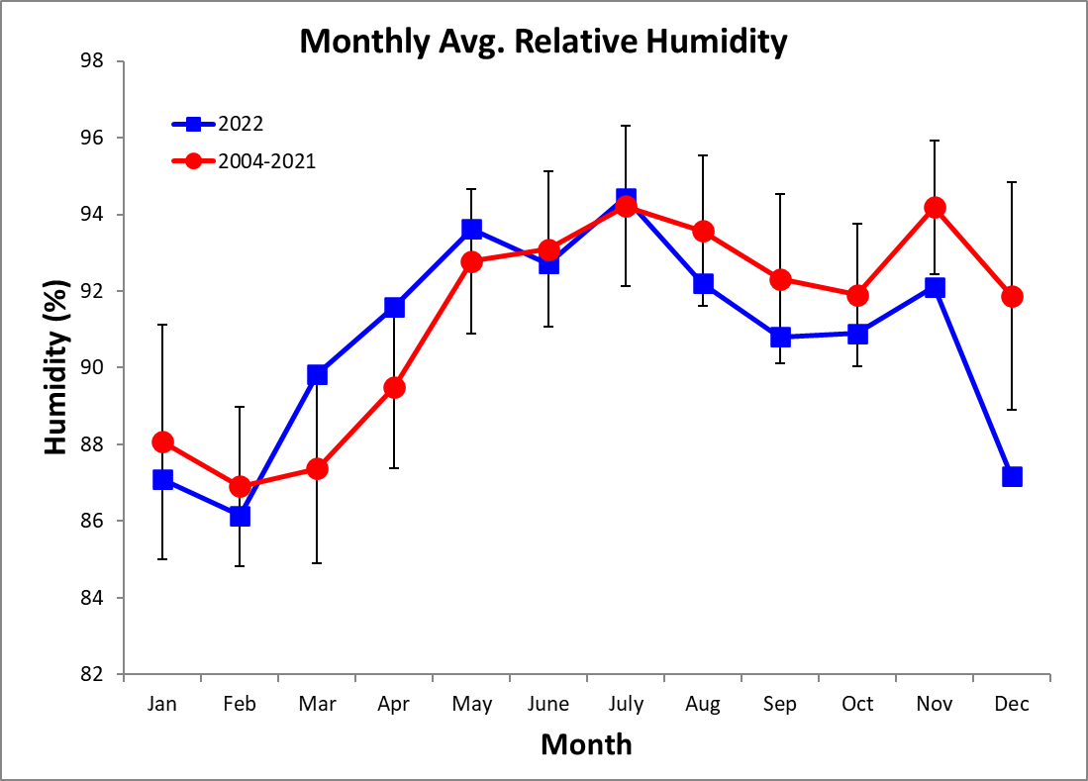
Monthly Average of Daily Maximum & Minimum Temperatures (°C)
Monthly Average Temperature
Year | Jan | Feb | Mar | Apr | May | June | July | Aug | Sep | Oct | Nov | Dec
1997 |  |  |  | 27.8 | 27.2 | 25.6 | 25.9 | 25.8 | 25.4 | 25.7 | 25.1 | 25.5
1998 | 25.4 | 25.5 | 25.8 | 26.1 | 26.2 | 25.8 | 25.2 | 25.3 | 25.7 | 25.4 | 25.0 | 24.4
1999 | 25.0 | 24.4 | 24.7 | 25.1 | 25.3 | 24.8 | 24.8 | 24.6 | 24.7 | 24.6 | 24.2 | 24.6
2000 | 25.2 | 25.2 | 25.3 | 25.8 | 26.2 | 26.2 | 26.1 | 26.4 | 26.3 | 26.0 | 26.3 | 25.8
2001 | 25.7 | 25.6 | 25.5 | 26.3 | 26.7 | 27.0 | 26.4 | 27.0 | 26.4 | 26.8 | 26.0 | 26.6
2002 | 26.8 | 26.1 | 26.1 | 26.5 | 27.2 | 27.0 | 26.8 | 26.8 | 26.7 | 26.3 | 26.4 | 26.7
2003 | 26.2 | 26.2 | 26.4 | 26.6 | 26.7 | 26.3 | 26.4 | 26.5 | 26.7 | 26.4 | 25.3 | 24.8
2004 | 25.0 | 25.2 | 25.3 | 25.3 | 25.2 | 25.2 | 24.5 | 24.6 | 24.9 | 25.0 | 24.4 | 24.9
2005 | 24.5 | 24.3 | 25.2 | 25.5 | 25.3 | 25.9 | 25.9 | 24.9 | 24.6 | 24.7 | 23.7 | 24.7
2006 | 24.8 | 24.5 | 24.6 | 24.5 | 24.3 | 24.6 | 24.2 | 24.6 | 24.4 | 24.2 | 23.3 | 23.9
2007 | 24.8 | 24.5 | 24.7 | 24.5 | 23.6 | 23.8 | 23.0 | 25.2 | 25.5 | 25.0 | 24.6 | 24.7
2008 | 25.0 | 24.8 | 25.0 | 25.5 | 25.4 | 25.4 | 24.9 | 25.1 | 25.6 | 25.3 | 24.1 | 24.9
2009 | 24.7 | 24.5 | 24.5 | 25.2 | 25.4 | 25.6 | 25.4 | 25.1 | 25.7 | 25.2 | 24.7 | 25.4
2010 | 25.2 | 25.4 | 25.6 | 26.2 | 26.4 | 25.6 | 25.3 | 25.2 | 25.1 | 24.5 | 23.8 | 23.2
2011 | 24.2 | 24.7 | 24.6 | 24.9 | 25.5 | 25.3 | 25.1 | 25.4 | 25.5 | 24.7 | 24.3 | 24.5
2012 | 25.1 | 24.8 | 25.2 | 25.6 | 26.0 | 26.2 | 25.6 | 25.6 | 25.7 | 25.2 | 24.7 | 25.1
2013 | 25.5 | 25.3 | 25.6 | 26.2 | 25.9 | 25.8 | 25.7 | 25.4 | 25.9 | 25.3 | 25.4 | 25.5
2014 | 25.1 | 24.9 | 25.2 | 25.6 | 25.6 | 25.6 | 26.0 | 25.3 | 25.4 | 25.2 | 24.9 | 24.9
2015 | 25.4 | 25.0 | 24.9 | 25.6 | 25.6 | 26.1 | 25.3 | 25.4 | 25.5 | 25.9 | 25.6 | 26.1
2016 | 25.7 | 25.6 | 25.7 | 26.3 | 26.5 | 26.1 | 25.2 | 25.8 | 25.5 | 25.4 | 24.4 | 25.1
2017 | 25.0 | 25.0 | 25.1 | 25.2 | 24.3 | 24.4 | 24.6 | 25.9 | 26.2 | 26.1 | 24.9 | 25.0
2018 | 24.5 | 25.0 | 25.3 | 25.7 | 25.8 | 25.5 | 25.5 | 25.4 | 25.2 | 25.1 | 25.1 | 25.7
2019 | 25.1 | 25.0 | 25.1 | 25.9 | 26.1 | 26.3 | 25.5 | 25.7 | 25.6 | 25.5 | 25.4 | 25.4
2020 | 25.4 | 25.4 | 25.6 | 26.0 | 26.3 | 25.8 | 25.5 | 25.5 | 25.7 | 25.5 | 24.9 | 25.1
2021 | 25.1 | 25.0 | 25.1 | 25.4 | 25.4 | 25.3 | 25.5 | 25.1 | 25.3 | 25.5 | 24.3 | 25.3
2022 | 24.9 | 25.0 | 25.1 | 25.3 | 25.5 | 24.9 | 25.1 | 25.2 | 25.3 | 25.2 | 24.7 | 25.2
mean | 25.2 | 25.1 | 25.2 | 25.7 | 25.8 | 25.6 | 25.4 | 25.5 | 25.6 | 25.4 | 24.9 | 25.1
sd | 0.6 | 0.5 | 0.5 | 0.7 | 0.9 | 0.8 | 0.8 | 0.7 | 0.6 | 0.6 | 0.8 | 0.8
min | 24.2 | 24.3 | 24.5 | 24.5 | 23.6 | 23.8 | 23.0 | 24.6 | 24.4 | 24.2 | 23.3 | 23.2
max | 26.8 | 26.2 | 26.4 | 27.8 | 27.2 | 27.0 | 26.8 | 27.0 | 26.7 | 26.8 | 26.4 | 26.7
Monthly Average of Daily Maximum Temperature
Year | Jan | Feb | Mar | Apr | May | June | July | Aug | Sep | Oct | Nov | Dec
1997 |  |  |  | 31.9 | 31.7 | 28.8 | 28.4 | 28.4 | 28.0 | 28.6 | 27.8 | 27.4
1998 | 27.3 | 27.7 | 27.9 | 28.3 | 28.7 | 28.3 | 27.6 | 28.0 | 29.1 | 28.5 | 27.5 | 26.6
1999 | 26.9 | 26.3 | 26.6 | 27.2 | 27.9 | 27.5 | 27.5 | 27.9 | 28.2 | 27.7 | 26.7 | 26.8
2000 | 27.2 | 27.1 | 27.3 | 27.9 | 28.7 | 28.6 | 28.4 | 29.0 | 29.4 | 28.5 | 28.7 | 27.8
2001 | 27.6 | 27.3 | 27.5 | 28.0 | 29.3 | 29.2 | 28.7 | 29.4 | 29.3 | 29.7 | 28.4 | 28.6
2002 | 28.7 | 27.9 | 27.9 | 28.5 | 29.8 | 29.7 | 29.2 | 29.2 | 29.9 | 29.2 | 28.6 | 28.6
2003 | 28.0 | 28.2 | 29.1 | 29.1 | 29.0 | 29.3 | 28.5 | 28.9 | 30.0 | 29.6 | 27.8 | 26.9
2004 | 27.3 | 27.0 | 27.6 | 27.9 | 27.8 | 26.9 | 26.8 | 28.5 | 28.3 | 26.9 | 26.9
2005 | 26.2 | 26.3 | 27.5 | 27.5 | 28.4 | 29.6 | 28.7 | 27.9 | 28.0 | 29.0 | 26.5 | 27.0
2006 | 27.0 | 26.5 | 26.6 | 27.0 | 27.5 | 27.9 | 27.6 | 27.6 | 27.5 | 27.7 | 26.6 | 26.7
2007 | 26.7 | 26.8 | 27.0 | 27.4 | 27.2 | 27.3 | 26.6 | 28.5 | 29.0 | 28.9 | 27.5 | 27.0
2008 | 26.8 | 27.0 | 27.4 | 28.1 | 28.4 | 28.0 | 27.6 | 28.4 | 29.2 | 28.7 | 26.6 | 27.1
2009 | 26.6 | 26.4 | 26.6 | 27.4 | 28.0 | 28.7 | 27.7 | 27.4 | 28.4 | 28.4 | 27.1 | 27.6
2010 | 27.3 | 27.6 | 27.9 | 28.9 | 29.6 | 28.8 | 28.4 | 28.9 | 29.0 | 27.3 | 26.5 | 25.2
2011 | 26.4 | 26.9 | 26.7 | 27.2 | 28.5 | 28.3 | 28.0 | 28.0 | 28.8 | 28.1 | 26.7 | 26.6
2012 | 27.0 | 26.8 | 27.2 | 28.3 | 29.0 | 29.1 | 27.8 | 28.5 | 28.2 | 28.3 | 26.8 | 27.2
2013 | 27.4 | 27.4 | 27.7 | 28.6 | 28.8 | 28.6 | 28.2 | 28.1 | 29.1 | 28.1 | 28.2 | 27.7
2014 | 27.0 | 27.0 | 27.5 | 28.0 | 28.2 | 27.9 | 28.2 | 27.8 | 28.2 | 28.4 | 27.4 | 27.1
2015 | 27.1 | 27.1 | 27.0 | 28.0 | 27.6 | 28.7 | 27.3 | 27.8 | 28.2 | 29.0 | 28.5 | 28.0
2016 | 27.7 | 27.5 | 28.0 | 29.1 | 29.7 | 29.7 | 27.7 | 28.3 | 28.2 | 28.7 | 26.9 | 27.2
2017 | 27.0 | 27.3 | 27.3 | 28.2 | 28.1 | 28.0 | 27.5 | 28.8 | 29.5 | 29.1 | 27.6 | 27.0
2018 | 26.4 | 26.8 | 27.4 | 28.3 | 29.0 | 28.0 | 28.0 | 28.2 | 28.3 | 28.6 | 27.7 | 27.9
2019 | 27.1 | 27.2 | 27.2 | 28.5 | 29.2 | 29.0 | 28.2 | 28.5 | 28.4 | 28.5 | 27.7 | 27.4
2020 | 27.2 | 27.2 | 27.7 | 28.3 | 29.0 | 28.5 | 28.0 | 28.2 | 28.8 | 28.9 | 28.1 | 27.1
2021 | 27.0 | 27.0 | 27.2 | 27.8 | 27.7 | 28.1 | 27.8 | 28.1 | 28.1 | 28.0 | 26.6 | 27.0
2022 | 26.6 | 26.8 | 26.8 | 27.4 | 27.8 | 27.7 | 27.3 | 27.7 | 28.3 | 27.7 | 27.1 | 27.0
mean | 27.1 | 27.1 | 27.4 | 28.2 | 28.7 | 28.5 | 27.9 | 28.3 | 28.7 | 28.5 | 27.4 | 27.2
sd | 0.6 | 0.5 | 0.6 | 1.0 | 1.0 | 0.8 | 0.6 | 0.5 | 0.6 | 0.7 | 0.7 | 0.7
min | 26.2 | 26.3 | 26.6 | 27.0 | 27.2 | 26.9 | 26.6 | 27.4 | 27.5 | 26.9 | 26.5 | 25.2
max | 28.7 | 28.2 | 29.1 | 31.9 | 31.7 | 29.7 | 29.2 | 29.4 | 30.0 | 29.7 | 28.7 | 28.6
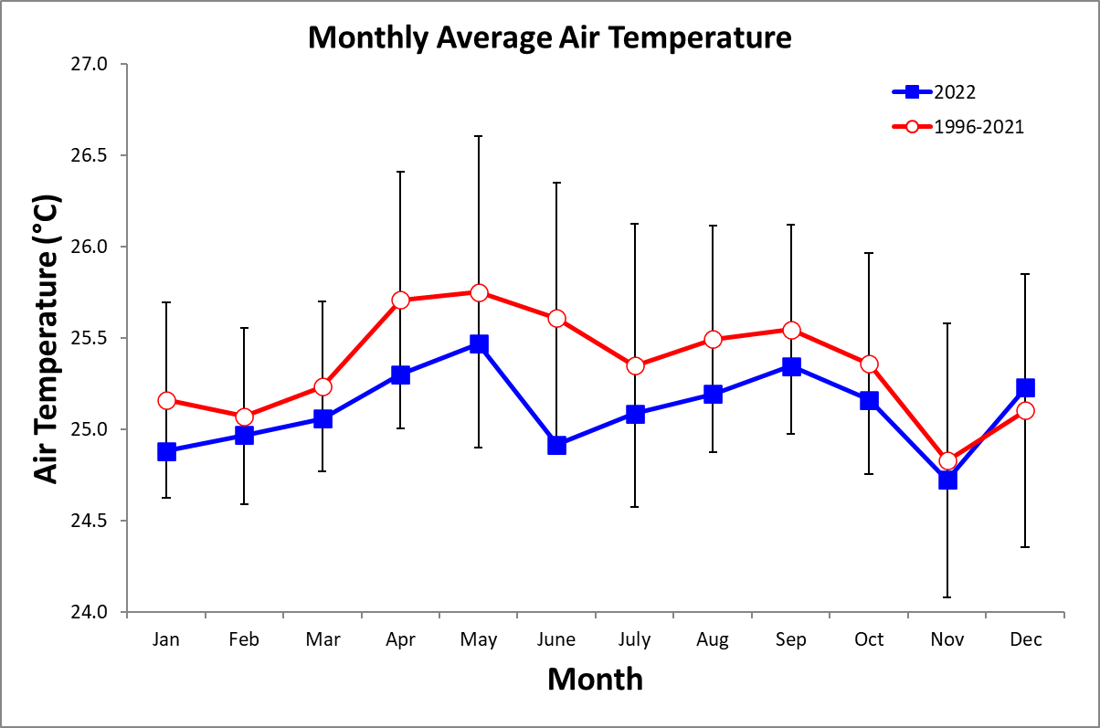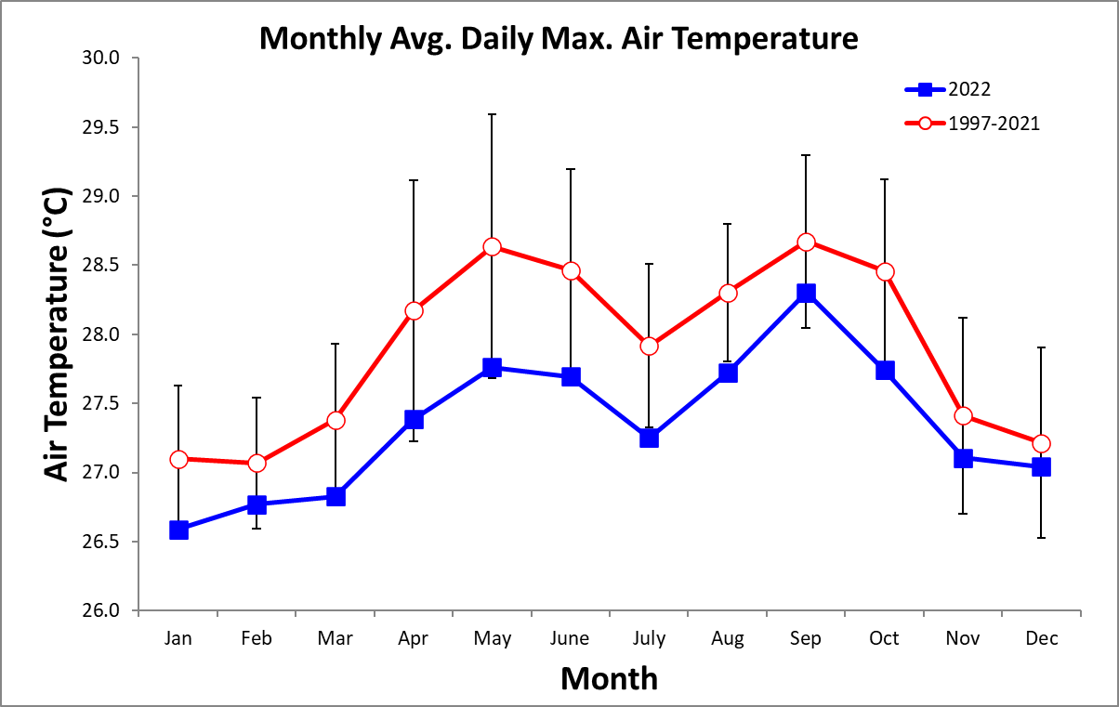
Monthly Average of Daily Minimum Temperature
Year | Jan | Feb | Mar | Apr | May | June | July | Aug | Sep | Oct | Nov | Dec
1997 |  |  |  | 24.7 | 24.7 | 23.6 | 24.1 | 24.0 | 23.5 | 23.7 | 23.3 | 23.6
1998 | 23.8 | 24.2 | 24.4 | 24.7 | 24.4 | 24.1 | 23.3 | 23.5 | 23.6 | 23.3 | 23.2 | 22.8
1999 | 23.5 | 23.0 | 23.3 | 23.7 | 23.5 | 22.8 | 22.5 | 22.2 | 22.5 | 22.8 | 22.2 | 23.1
2000 | 23.8 | 23.8 | 24.0 | 24.4 | 24.4 | 24.5 | 24.6 | 24.7 | 24.4 | 24.2 | 24.5 | 24.2
2001 | 24.2 | 24.6 | 24.3 | 25.1 | 25.1 | 25.5 | 24.8 | 25.0 | 24.2 | 24.9 | 24.3 | 25.0
2002 | 25.4 | 24.8 | 24.9 | 24.9 | 25.6 | 25.3 | 25.1 | 25.1 | 24.7 | 24.4 | 24.6 | 25.1
2003 | 24.9 | 24.9 | 24.9 | 24.9 | 25.0 | 24.3 | 24.8 | 24.6 | 24.7 | 24.6 | 23.5 | 23.2
2004 | 23.5 | 23.8 | 23.9 | 23.8 | 23.5 | 23.2 | 22.9 | 22.7 | 22.9 | 22.8 | 22.7 | 23.2
2005 | 23.1 | 22.7 | 23.7 | 24.0 | 23.3 | 23.6 | 23.5 | 22.8 | 22.4 | 22.3 | 21.8 | 22.7
2006 | 23.0 | 22.9 | 23.2 | 22.7 | 22.2 | 22.5 | 21.8 | 22.4 | 22.1 | 21.8 | 20.9 | 21.6
2007 | 23.3 | 22.9 | 22.9 | 22.4 | 21.1 | 21.1 | 20.2 | 23.2 | 23.2 | 22.9 | 22.9 | 23.0
2008 | 23.6 | 23.3 | 23.5 | 23.9 | 23.5 | 23.7 | 23.0 | 22.9 | 23.4 | 23.3 | 22.5 | 23.1
2009 | 23.3 | 23.1 | 23.1 | 23.6 | 23.7 | 23.5 | 23.6 | 23.4 | 23.7 | 23.1 | 23.1 | 24.0
2010 | 23.7 | 24.2 | 24.1 | 24.5 | 24.6 | 23.3 | 23.3 | 23.1 | 23.0 | 22.6 | 21.9 | 21.5
2011 | 22.8 | 23.2 | 23.1 | 23.4 | 23.5 | 23.1 | 23.1 | 23.4 | 23.6 | 22.9 | 22.6 | 23.1
2012 | 23.8 | 23.5 | 23.9 | 23.9 | 24.1 | 24.1 | 23.8 | 23.7 | 23.7 | 23.3 | 23.1 | 23.5
2013 | 24.5 | 23.7 | 24.2 | 24.8 | 24.1 | 23.7 | 23.8 | 23.4 | 23.7 | 23.2 | 23.4 | 23.7
2014 | 23.8 | 23.6 | 23.8 | 24.2 | 23.9 | 23.7 | 24.4 | 23.4 | 23.4 | 23.1 | 22.9 | 23.3
2015 | 24.1 | 23.5 | 23.5 | 24.3 | 24.0 | 24.5 | 23.9 | 23.7 | 23.6 | 23.6 | 23.8 | 25.0
2016 | 24.4 | 24.2 | 24.5 | 24.7 | 24.3 | 23.6 | 23.4 | 23.9 | 23.5 | 23.4 | 22.7 | 23.4
2017 | 23.4 | 23.5 | 23.6 | 23.3 | 21.8 | 22.0 | 22.6 | 23.9 | 24.0 | 23.9 | 23.2 | 23.5
2018 | 23.0 | 23.9 | 24.0 | 24.1 | 23.8 | 23.5 | 23.6 | 23.5 | 23.1 | 23.0 | 23.4 | 24.1
2019 | 23.7 | 23.8 | 23.7 | 24.1 | 24.2 | 24.3 | 23.8 | 23.6 | 23.7 | 23.4 | 23.5 | 23.5
2020 | 24.0 | 24.1 | 24.2 | 24.5 | 24.6 | 23.9 | 23.6 | 23.5 | 23.6 | 23.6 | 23.1 | 23.5
2021 | 23.6 | 23.6 | 23.5 | 23.7 | 23.9 | 23.4 | 23.7 | 23.3 | 23.3 | 23.5 | 22.6 | 23.9
2022 | 23.5 | 23.5 | 23.7 | 23.8 | 23.8 | 23.2 | 23.5 | 23.4 | 23.5 | 23.4 | 23.1 | 23.6
mean | 23.8 | 23.7 | 23.8 | 24.1 | 23.8 | 23.6 | 23.4 | 23.6 | 23.5 | 23.3 | 23.0 | 23.4
sd | 0.7 | 0.6 | 0.6 | 0.7 | 1.1 | 1.0 | 1.1 | 0.8 | 0.7 | 0.8 | 0.9 | 0.9
min | 22.8 | 22.7 | 22.9 | 22.4 | 21.1 | 21.1 | 20.2 | 22.2 | 22.1 | 21.8 | 20.9 | 21.5
max | 25.4 | 24.9 | 24.9 | 25.1 | 25.6 | 25.5 | 25.1 | 25.1 | 24.7 | 24.9 | 24.6 | 25.1
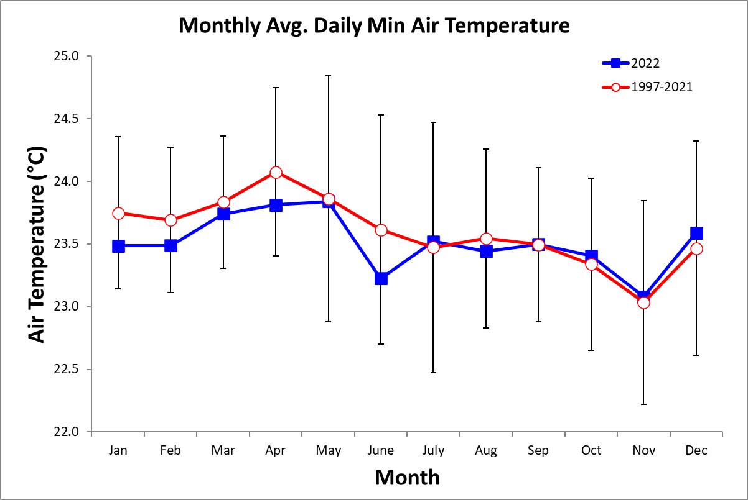
2022 Daily Total Radiation (MJ m⁻² day⁻¹)

 | Jan. | Feb. | Mar. | Apr. | May | June | July | Aug. | Sep. | Oct. | Nov. | Dec.
1 | 19.1 | 19.6 | 10.2 | 18.8 | 18.7 | 23.0 | 10.0 | 12.0 | 4.8 | 3.8 | 23.7 | 19.8
2 | 20.1 | 19.8 | 13.7 | 17.1 | 9.3 | 12.8 | 13.9 | 17.5 | 25.6 | 24.3 | 17.8 | 18.6
3 | 16.8 | 21.3 | 10.7 | 17.2 | 21.4 | 16.6 | 21.0 | 11.6 | 23.0 | 20.8 | 4.3 | 21.5
4 | 18.3 | 21.5 | 18.4 | 15.6 | 22.2 | 16.0 | 8.7 | 19.5 | 10.4 | 16.1 | 12.5 | 18.9
5 | 15.2 | 22.8 | 23.7 | 21.9 | 2.5 | 17.7 | 11.3 | 7.5 | 22.3 | 11.0 | 16.5 | 18.6
6 | 16.3 | 19.8 | 19.5 | 25.1 | 17.7 | 19.4 | 14.2 | 10.0 | 18.9 | 22.1 | 14.0 | 18.8
7 | 17.0 | 20.7 | 18.2 | 25.9 | 24.3 | 13.9 | 16.7 | 13.8 | 17.0 | 13.2 | 7.4 | 21.4
8 | 19.0 | 23.2 | 21.3 | 17.5 | 27.1 | 14.8 | 15.1 | 23.6 | 21.7 | 11.3 | 7.0 | 20.0
9 | 20.5 | 14.7 | 21.2 | 15.0 | 17.7 | 14.1 | 11.5 | 18.4 | 25.5 | 25.2 | 15.4 | 19.2
10 | 18.5 | 14.8 | 24.7 | 16.2 | 11.6 | 21.5 | 9.3 | 13.8 | 15.9 | 21.7 | 17.9 | 16.0
11 | 21.0 | 18.0 | 22.1 | 17.9 | 19.2 | 13.8 | 12.0 | 17.7 | 13.7 | 21.8 | 21.1 | 18.7
12 | 13.5 | 18.6 | 25.9 | 15.4 | 24.1 | 20.4 | 10.9 | 14.7 | 21.6 | 16.5 | 19.6 | 14.1
13 | 17.7 | 23.4 | 22.5 | 18.8 | 22.8 | 15.0 | 15.6 | 17.7 | 21.0 | 14.5 | 4.4 | 13.7
14 | 18.3 | 20.6 | 19.7 | 18.1 | 13.0 | 14.9 | 20.3 | 21.7 | 14.4 | 22.5 | 15.0 | 18.7
15 | 19.0 | 12.2 | 19.1 | 18.2 | 15.7 | 20.6 | 21.0 | 4.7 | 15.8 | 19.6 | 15.9 | 12.3
16 | 16.0 | 23.6 | 17.2 | 20.8 | 17.0 | 22.7 | 16.2 | 22.3 | 13.4 | 19.6 | 18.9 | 20.8
17 | 20.1 | 19.4 | 23.1 | 11.6 | 9.9 | 9.0 | 16.0 | 26.1 | 18.2 | 12.1 | 16.7 | 14.6
18 | 19.0 | 22.8 | 21.1 | 19.6 | 8.9 | 9.8 | 18.5 | 20.3 | 7.6 | 13.8 | 9.3 | 19.8
19 | 15.7 | 23.4 | 19.2 | 22.0 | 9.9 | 12.4 | 20.6 | 17.9 | 5.2 | 18.0 | 18.0 | 14.4
20 | 21.7 | 19.8 | 18.5 | 19.5 | 5.7 | 20.4 | 13.9 | 12.8 | 20.7 | 24.3 | 19.8 | 16.1
21 | 19.1 | 23.7 | 17.9 | 27.1 | 23.0 | 4.2 | 6.9 | 4.6 | 22.1 | 9.8 | 8.5 | 16.4
22 | 20.3 | 23.6 | 24.5 | 27.2 | 9.2 | 18.7 | 17.1 | 10.5 | 10.9 | 16.3 | 14.9 | 18.1
23 | 19.3 | 23.9 | 25.1 | 19.1 | 18.3 | 19.6 | 14.7 | 27.7 | 17.1 | 16.7 | 20.1 | 19.3
24 | 21.1 | 20.4 | 21.4 | 22.1 | 20.0 | 7.1 | 18.1 | 23.2 | 18.9 | 13.2 | 21.3 | 18.7
25 | 20.5 | 17.9 | 26.3 | 23.4 | 24.6 | 8.9 | 15.2 | 5.3 | 17.3 | 13.5 | 22.2 | 18.7
26 | 20.9 | 23.1 | 22.4 | 21.7 | 18.9 | 13.8 | 21.8 | 22.1 | 14.3 | 17.3 | 20.9 | 18.3
27 | 16.2 | 22.2 | 16.0 | 12.1 | 8.9 | 17.1 | 17.9 | 19.0 | 15.3 | 21.0 | 20.7 | 20.8
28 | 17.9 | 12.4 | 12.6 | 11.6 | 16.2 | 23.8 | 12.0 | 24.4 | 19.9 | 24.2 | 5.7 | 21.3
29 | 23.3 |  | 16.7 | 12.2 | 17.7 | 24.0 | 20.5 | 18.1 | 22.0 | 24.3 | 7.8 | 17.9
30 | 22.6 |  | 20.7 | 15.5 | 12.3 | 16.4 | 15.4 | 23.5 | 20.5 | 24.0 | 11.0 | 21.3
31 | 18.3 |  | 24.8 |  | 10.1 |  | 21.5 | 21.1 |  | 23.2 |  | 17.2

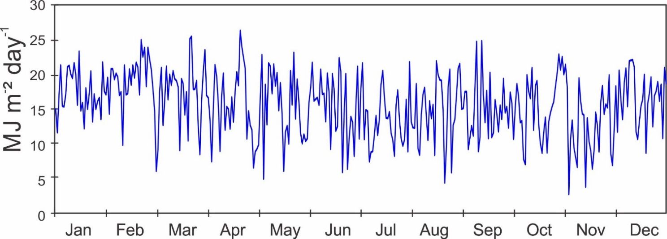

Monthly Average Total Daily Solar Radiation (MJ m⁻² day⁻¹)

Year | Jan | Feb | Mar | Apr | May | June | July | Aug | Sep | Oct | Nov | Dec
2002 |  |  |  |  |  |  |  |  | 15.3 | 12.7 | 10.7 | 13.9
2003 | 13.6 | 14.6 | 17.2 | 16.1 | 11.6 | 12.4 | 10.4 | 11.6 | 13.9 | 13.6 | 10.7 | 10.3
2004 | 14.7 | 16.4
2005
2006
2007 |  |  |  |  |  |  | 14.8 | 13.2 | 14.2 | 14.5 | 10.8 | 13.0
2008 | 16.8 | 16.3 | 18.7 | 18.5 | 15.4 | 11.0 | 10.9 | 12.7 | 14.0 | 13.3 | 9.8 | 15.1
2009 | 14.3 | 15.4 | 18.1 | 17.3 | 14.2 | 15.0 | 12.3 | 12.3 | 13.7 | 12.8 | 9.7 | 14.0
2010 | 13.3 | 13.0 | 13.9 | 16.6 | 16.3 | 14.2 | 14.4 | 14.5 | 15.1 | 12.0 | 11.6 | 8.5
2011 | 13.4 | 17.5 | 18.3 | 17.1 | 16.4 | 13.8 | 13.5 | 14.5 | 14.9 | 13.3 | 10.1 | 11.0
2012 | 17.1 | 16.7 | 15.6 | 15.9 | 15.3 | 14.3 | 11.7 | 12.9 | 13.1 | 12.9 | 8.8 | 12.0
2013 | 16.2 | 17.0 | 14.4 | 16.4 | 13.4 | 12.6 | 12.0 | 13.4 | 14.4 | 13.5 | 13.7 | 14.6
2014 | 14.6 | 15.8 | 17.3 | 14.5 | 14.2 | 11.3 | 12.9 | 12.7 | 14.0 | 13.1 | 13.3 | 12.7
2015 | 16.4 | 15.7 | 17.3 | 16.5 | 12.1 | 15.6 | 12.7 | 13.2 | 13.3 | 14.9 | 12.8 | 13.3
2016 | 15.5 | 16.3 | 17.3 | 18.1 | 15.5 | 15.1 | 12.1 | 13.9 | 13.2 | 15.2 | 11.3 | 15.0
2017 | 18.1 | 19.3 | 19.6 | 17.9 | 13.7 | 14.7 | 12.5 | 14.8 | 15.8 | 15.1 | 12.4 | 13.9
2018 | 13.0 | 20.3 | 17.6 | 17.4 | 15.6 | 11.9 | 13.6 | 13.7 | 14.1 | 14.6 | 11.6 | 15.9
2019 | 14.6 | 15.7 | 17.0 | 18.1 | 15.0 | 14.6 | 13.4 | 13.6 | 15.0 | 15.4 | 13.6 | 12.3
2020 | 16.0 | 16.9 | 20.0 | 17.6 | 15.9 | 12.8 | 14.5 | 13.7 | 14.9 | 15.1 | 14.4 | 14.5
2021 | 17.7 | 17.3 | 20.9 | 16.1 | 14.5 | 15.4 | 13.4 | 14.5 | 14.7 | 15.2 | 13.1 | 15.6
2022 | 17.3 | 19.6 | 16.9 | 15.7 | 15.0 | 15.7 | 13.5 | 14.6 | 14.9 | 15.0 | 12.1 | 16.8
mean | 15.4 | 16.7 | 17.5 | 16.9 | 14.6 | 13.8 | 12.8 | 13.5 | 14.4 | 14.0 | 11.7 | 13.5
sd | 1.6 | 1.8 | 1.9 | 1.1 | 1.4 | 1.6 | 1.2 | 0.9 | 0.8 | 1.1 | 1.6 | 2.1
min | 13.0 | 13.0 | 13.9 | 14.5 | 11.6 | 11.0 | 10.4 | 11.6 | 13.1 | 12.0 | 8.8 | 8.5
max | 18.1 | 20.3 | 20.9 | 18.5 | 16.4 | 15.7 | 14.8 | 14.8 | 15.8 | 15.4 | 14.4 | 16.8

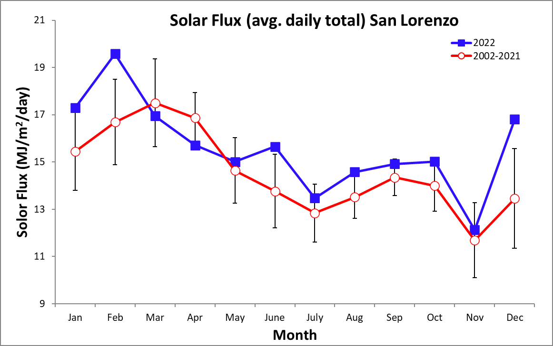
Monthly Average Daily PAR (Mol m⁻² day⁻¹)

Year | Jan | Feb | Mar | Apr | May | June | July | Aug | Sep | Oct | Nov | Dec
1997 |  |  |  |  |  |  |  |  | 27.5 | 33.6 | 31.4 | 34.5
1998 | 36.4 | 37.4 | 40.0 | 37.1 | 27.7 | 26.5 | 25.3 | 23.5 | 29.1 | 27.3 | 23.2 | 21.0
1999 | 36.9 | 35.0 | 35.6 | 24.2 | 21.8 | 22.0 | 34.9 | 42.0 | 43.3 | 41.4 | 36.2 | 25.2
2000 | 42.1 | 37.6 | 42.4 | 38.7 | 31.3 | 28.3 | 27.8 | 26.7 | 28.4 | 24.5 | 29.0 | 20.6
2001 | 31.4 | 32.8 | 35.9 | 39.6 | 40.7 | 35.1 | 31.7 | 32.2 | 32.9 | 35.1 | 29.1 | 23.6
2002 | 32.1 | 36.7 | 36.2 | 37.6 | 37.2 | 27.9 | 24.0 | 21.5 | 37.7 | 28.9 | 24.6 | 31.7
2003 | 32.0 | 33.6 | 38.2 | 36.6 | 27.5 | 28.9 | 24.2 | 26.2 | 31.2 | 30.6 | 24.4 | 22.8
2004 | 32.9 | 36.8 | 34.9 | 34.0 | 29.2 | 26.6 | 25.3 | 22.8 | 30.5 | 28.2 | 23.6 | 25.3
2005 | 30.3 | 33.7 | 33.1 | 27.9 | 23.9 | 28.4 | 31.4 | 26.6 | 27.4 | 33.4 | 23.9 | 31.3
2006 | 31.7 | 30.1 | 33.8 | 37.2 | 29.5 | 28.9 | 25.1 | 26.5 | 22.2 | 24.8 | 20.1 | 24.9
2007 | 28.5 | 28.9 | 31.4 | 29.0 | 26.2
mean | 33.4 | 34.3 | 36.2 | 34.2 | 29.5 | 28.1 | 27.7 | 27.5 | 31.0 | 30.8 | 26.5 | 26.1
sd | 4.0 | 3.0 | 3.3 | 5.3 | 5.8 | 3.4 | 4.0 | 6.2 | 5.9 | 5.2 | 4.8 | 4.8
min | 28.5 | 28.9 | 31.4 | 24.2 | 21.8 | 22.0 | 24.0 | 21.5 | 22.2 | 24.5 | 20.1 | 20.6
max | 42.1 | 37.6 | 42.4 | 39.6 | 40.7 | 35.1 | 34.9 | 42.0 | 43.3 | 41.4 | 36.2 | 34.5

2022 Daily Average Wind Speed (km/h)
 | Jan. |  | Feb. |  |  | Mar. |  |  | Apr. |  |  | May |  |  | June |  | July |  | Aug. |  | Sep. |  | Oct. |  | Nov. |  |  | Dec.
 | Avg | Max | Avg | Max | Avg |  | Max | Avg |  | Max | Avg |  | Max | Avg |  | Max | Avg | Max | Avg | Max | Avg | Max | Avg | Max | Avg | Max | Avg |  |  | Max
1 | 7.8 | 21.1 | 8.2 | 21.9 | 9.1 |  | 26.7 | 7.4 |  | 21.8 | 5.6 |  | 22.9 | 3.2 |  | 19.0 | 4.4 | 20.4 | 5.7 | 20.5 | 3.6 | 19.7 | 2.4 | 16.6 | 3.9 | 15.3 | 8.0 |  | 27.3
2 | 6.5 | 26.0 | 7.1 | 26.2 | 9.4 |  | 26.3 | 6.9 |  | 24.4 | 5.0 |  | 15.7 | 3.2 |  | 23.6 | 4.3 | 22.9 | 2.8 | 15.4 | 3.3 | 15.7 | 3.7 | 17.4 | 5.2 | 18.9 | 9.0 |  | 31.3
3 | 8.4 | 28.2 | 8.6 | 25.4 | 12.0 |  | 28.2 | 6.8 |  | 24.2 | 5.3 |  | 15.5 | 3.3 |  | 25.5 | 5.3 | 21.8 | 4.8 | 15.5 | 4.4 | 24.2 | 4.6 | 19.7 | 6.7 | 26.3 | 9.7 |  | 28.9
4 | 12.3 | 30.4 | 9.9 | 27.0 | 11.5 |  | 28.6 | 5.9 |  | 20.1 | 6.6 |  | 18.0 | 4.2 |  | 19.1 | 6.8 | 26.6 | 6.3 | 18.1 | 5.5 | 24.9 | 5.6 | 21.0 | 2.0 | 14.1 | 7.8 |  | 24.3
5 | 11.0 | 27.6 | 9.7 | 23.9 | 9.0 |  | 22.5 | 6.4 |  | 18.7 | 4.5 |  | 21.7 | 3.8 |  | 18.6 | 6.7 | 20.8 | 6.5 | 22.1 | 3.9 | 38.8 | 6.1 | 21.8 | 3.1 | 24.2 | 6.1 |  | 25.3
6 | 8.6 | 22.5 | 9.0 | 24.5 | 7.7 |  | 23.5 | 7.0 |  | 20.6 | 3.4 |  | 17.4 | 2.8 |  | 12.9 | 5.5 | 18.3 | 4.9 | 17.8 | 5.6 | 22.1 | 5.3 | 23.3 | 2.0 | 16.7 | 7.4 |  | 24.3
7 | 9.1 | 24.3 | 8.3 | 22.9 | 9.1 |  | 26.3 | 6.0 |  | 18.3 | 3.9 |  | 15.7 | 3.8 |  | 18.2 | 6.3 | 21.2 | 4.3 | 14.6 | 5.9 | 19.5 | 7.2 | 27.3 | 2.1 | 14.3 | 9.1 |  | 29.3
8 | 10.6 | 28.9 | 7.5 | 20.7 | 8.4 |  | 23.1 | 6.1 |  | 21.9 | 5.5 |  | 18.7 | 3.8 |  | 24.9 | 6.3 | 25.7 | 5.9 | 17.3 | 4.4 | 19.6 | 5.5 | 29.8 | 4.3 | 19.7 | 9.3 |  | 28.6
9 | 11.7 | 28.0 | 7.2 | 27.7 | 7.1 |  | 19.6 | 10.5 |  | 26.5 | 5.2 |  | 22.4 | 3.3 |  | 16.1 | 6.5 | 19.0 | 6.5 | 19.9 | 3.9 | 21.5 | 3.8 | 30.2 | 2.3 | 16.7 | 8.0 |  | 25.2
10 | 11.5 | 28.4 | 6.9 | 21.4 | 7.7 |  | 22.2 | 12.2 |  | 27.7 | 5.2 |  | 23.7 | 2.7 |  | 16.9 | 6.9 | 23.2 | 6.4 | 18.8 | 4.4 | 15.9 | 3.6 | 21.1 | 2.3 | 19.4 | 8.7 |  | 25.2
11 | 11.2 | 31.6 | 9.7 | 27.4 | 7.6 |  | 20.9 | 10.7 |  | 24.7 | 5.1 |  | 23.3 | 3.0 |  | 21.3 | 4.7 | 14.1 | 4.1 | 19.4 | 6.1 | 22.4 | 4.7 | 20.7 | 2.8 | 15.7 | 9.2 |  | 25.5
12 | 9.7 | 26.4 | 9.9 | 24.7 | 7.5 |  | 20.4 | 10.2 |  | 25.8 | 3.4 |  | 15.0 | 4.2 |  | 26.5 | 3.7 | 19.7 | 5.1 | 19.3 | 3.9 | 28.9 | 5.5 | 19.9 | 3.7 | 17.8 | 6.9 |  | 20.9
13 | 6.5 | 19.8 | 7.1 | 19.5 | 9.2 |  | 25.1 | 9.4 |  | 23.7 | 7.2 |  | 27.5 | 4.1 |  | 21.0 | 4.7 | 17.6 | 4.1 | 17.5 | 2.7 | 19.5 | 2.4 | 16.1 | 4.7 | 19.1 | 6.9 |  | 18.8
14 | 7.7 | 21.5 | 11.7 | 31.9 | 12.2 |  | 31.9 | 8.1 |  | 21.2 | 4.3 |  | 19.8 | 4.0 |  | 24.1 | 5.1 | 21.1 | 3.3 | 17.3 | 3.1 | 16.6 | 3.7 | 22.7 | 3.7 | 17.5 | 5.8 |  | 20.9
15 | 8.6 | 21.9 | 14.2 | 31.8 | 10.3 |  | 24.3 | 7.6 |  | 21.7 | 6.0 |  | 24.2 | 4.7 |  | 22.1 | 7.0 | 24.3 | 4.9 | 16.0 | 3.1 | 13.6 | 3.8 | 19.9 | 3.8 | 14.4 | 6.9 |  | 26.1
16 | 7.2 | 18.6 | 11.6 | 31.2 | 8.9 |  | 21.2 | 7.6 |  | 21.7 | 6.6 |  | 24.0 | 3.1 |  | 22.5 | 8.2 | 21.4 | 4.3 | 27.6 | 5.7 | 24.1 | 3.3 | 15.3 | 5.1 | 24.7 | 7.1 |  | 22.2
17 | 9.5 | 23.8 | 8.6 | 21.7 | 6.4 |  | 18.3 | 6.5 |  | 18.9 | 6.2 |  | 23.3 | 6.2 |  | 24.5 | 6.6 | 22.2 | 5.8 | 20.0 | 2.9 | 16.6 | 5.3 | 19.8 | 6.6 | 27.6 | 9.8 |  | 24.9
18 | 11.4 | 26.3 | 10.2 | 25.9 | 8.6 |  | 24.7 | 6.4 |  | 24.6 | 6.5 |  | 21.9 | 2.7 |  | 13.7 | 5.4 | 24.0 | 9.3 | 30.4 | 3.3 | 16.9 | 6.2 | 20.6 | 5.7 | 18.3 | 10.9 |  | 29.3
19 | 11.8 | 29.1 | 12.0 | 28.4 | 10.4 |  | 25.5 | 5.6 |  | 21.0 | 3.1 |  | 16.2 | 4.0 |  | 20.7 | 5.7 | 19.4 | 8.2 | 22.9 | 2.9 | 24.5 | 6.1 | 25.4 | 5.4 | 19.3 | 9.6 |  | 24.1
20 | 8.6 | 22.5 | 11.9 | 30.8 | 10.9 |  | 25.3 | 5.5 |  | 21.5 | 4.0 |  | 19.7 | 3.9 |  | 17.8 | 6.9 | 24.3 | 6.2 | 17.9 | 2.9 | 19.6 | 3.9 | 19.1 | 6.0 | 24.2 | 9.8 |  | 27.0
21 | 9.0 | 21.4 | 12.9 | 30.8 | 10.1 |  | 24.9 | 5.4 |  | 18.8 | 4.8 |  | 15.7 | 5.1 |  | 16.8 | 3.9 | 17.8 | 5.0 | 25.3 | 2.5 | 13.3 | 3.5 | 19.1 | 6.8 | 27.0 | 11.1 |  | 34.4
22 | 10.4 | 27.6 | 12.4 | 29.9 | 12.3 |  | 29.6 | 3.4 |  | 16.7 | 5.9 |  | 18.8 | 5.6 |  | 24.8 | 3.8 | 13.9 | 4.3 | 17.7 | 4.5 | 25.9 | 5.9 | 17.7 | 7.1 | 20.9 | 10.7 |  | 25.4
23 | 10.2 | 26.3 | 13.0 | 30.2 | 9.8 |  | 25.9 | 3.9 |  | 27.5 | 6.2 |  | 17.1 | 5.5 |  | 26.1 | 5.9 | 24.0 | 3.4 | 20.7 | 4.3 | 15.5 | 5.6 | 17.5 | 6.5 | 23.5 | 9.2 |  | 23.1
24 | 9.4 | 23.6 | 11.3 | 30.0 | 9.6 |  | 28.5 | 3.3 |  | 15.0 | 2.8 |  | 14.5 | 5.2 |  | 21.0 | 6.3 | 28.5 | 2.7 | 14.3 | 4.2 | 19.2 | 4.9 | 17.5 | 4.2 | 20.9 | 11.5 |  | 26.2
25 | 7.8 | 25.6 | 12.1 | 31.1 | 10.0 |  | 24.6 | 3.1 |  | 12.7 | 3.4 |  | 14.3 | 4.8 |  | 15.6 | 6.2 | 22.6 | 5.7 | 18.6 | 2.4 | 16.3 | 5.4 | 18.0 | 3.6 | 16.7 | 10.9 |  | 27.5
26 | 7.3 | 20.6 | 11.9 | 30.0 | 9.6 |  | 28.6 | 4.2 |  | 17.2 | 3.6 |  | 13.9 | 4.9 |  | 20.0 | 5.1 | 20.5 | 5.0 | 18.1 | 4.2 | 20.7 | 4.6 | 19.5 | 2.9 | 14.2 | 9.0 |  | 25.9
27 | 9.8 | 26.7 | 9.4 | 23.7 | 7.6 |  | 22.9 | 5.0 |  | 20.5 | 5.1 |  | 18.8 | 4.5 |  | 18.2 | 5.3 | 15.0 | 4.8 | 23.0 | 3.7 | 18.5 | 4.3 | 16.7 | 3.9 | 17.6 | 6.6 |  | 21.2
28 | 6.5 | 21.8 | 10.6 | 27.5 | 10.7 |  | 26.6 | 4.0 |  | 18.8 | 6.6 |  | 24.0 | 4.2 |  | 15.4 | 6.4 | 23.0 | 4.2 | 25.7 | 2.5 | 18.0 | 4.4 | 17.6 | 5.0 | 17.4 | 5.6 |  | 22.0
29 | 8.5 | 22.5 |  |  | 11.9 |  | 26.2 | 4.3 |  | 20.5 | 4.6 |  | 12.5 | 5.8 |  | 21.1 | 4.8 | 21.8 | 4.5 | 26.9 | 2.4 | 16.7 | 4.4 | 15.9 | 6.5 | 22.1 | 6.3 |  | 18.8
30 | 9.7 | 25.2 |  |  | 9.6 |  | 26.5 | 6.0 |  | 20.5 | 4.5 |  | 16.8 | 6.8 |  | 22.1 | 6.0 | 19.8 | 3.4 | 16.1 | 3.5 | 23.0 | 3.0 | 18.6 | 4.5 | 18.7 | 8.7 |  | 26.7
31 | 9.0 | 25.3 |  |  | 8.3 |  | 24.3 |  |  |  | 2.4 |  | 13.4 |  |  |  | 9.3 | 29.5 | 2.8 | 18.1 |  |  | 3.0 | 21.1 |  |  | 6.1 |  | 19.6
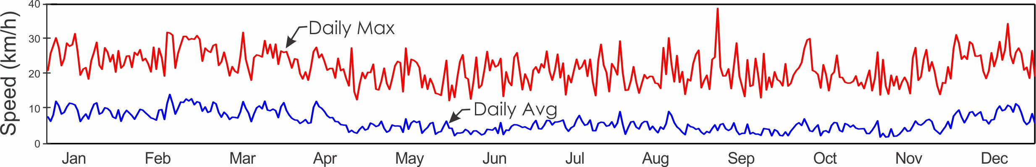
2022 Average Daily Wind Direction (°)
 |  | Jan. | Feb. | Mar. | Apr. | May | June | July | Aug. | Sep. | Oct. | Nov. | Dec.
 | 1 | 319.3 | 353.3 | 310.2 | 5.6 | 245.9 | 132.8 | 171.1 | 249.6 | 88.9 | 92.9 | 334.6 | 10.3
 | 2 | 242.4 | 316.1 | 339.2 | 314.2 | 250.2 | 109.6 | 90.1 | 164.2 | 99.3 | 151.2 | 298.8 | 20.2
 | 3 | 348.1 | 337.0 | 7.6 | 299.9 | 300.4 | 98.8 | 255.3 | 230.8 | 306.5 | 283.5 | 233.3 | 21.2
 | 4 | 6.9 | 355.4 | 1.2 | 232.0 | 325.7 | 94.1 | 246.6 | 244.3 | 230.7 | 280.6 | 113.0 | 12.1
 | 5 | 2.0 | 334.6 | 336.4 | 8.9 | 184.7 | 78.1 | 229.7 | 237.4 | 206.3 | 238.5 | 151.9 | 248.6
 | 6 | 350.1 | 353.3 | 324.8 | 338.0 | 94.3 | 91.5 | 249.7 | 214.7 | 230.4 | 235.0 | 129.0 | 352.2
 | 7 | 358.9 | 342.8 | 337.1 | 309.0 | 23.0 | 101.9 | 259.7 | 251.5 | 231.8 | 222.4 | 120.4 | 14.3
 | 8 | 356.2 | 322.2 | 349.2 | 310.6 | 5.1 | 93.9 | 268.3 | 273.3 | 170.1 | 179.5 | 197.5 | 10.2
 | 9 | 359.0 | 277.5 | 334.9 | 8.1 | 269.8 | 95.9 | 232.0 | 294.1 | 84.1 | 104.1 | 99.6 | 22.5
 | 10 | 355.9 | 301.9 | 350.6 | 1.1 | 260.3 | 92.4 | 230.6 | 242.3 | 44.4 | 70.2 | 102.3 | 14.9
 | 11 | 2.7 | 355.0 | 343.0 | 340.8 | 241.0 | 130.5 | 242.2 | 215.0 | 220.5 | 233.8 | 106.0 | 350.5
 | 12 | 358.2 | 345.2 | 327.8 | 345.3 | 230.6 | 98.1 | 181.1 | 212.7 | 196.8 | 234.3 | 242.5 | 307.4
 | 13 | 299.1 | 317.7 | 351.6 | 342.8 | 231.0 | 137.3 | 226.9 | 223.7 | 85.2 | 143.0 | 213.8 | 263.7
 | 14 | 333.6 | 14.1 | 2.8 | 1.8 | 260.4 | 159.4 | 252.2 | 257.7 | 111.1 | 98.9 | 190.8 | 253.3
 | 15 | 2.5 | 9.7 | 345.7 | 353.1 | 241.1 | 84.8 | 345.3 | 220.7 | 145.6 | 84.2 | 246.8 | 256.2
 | 16 | 336.9 | 346.6 | 346.6 | 313.5 | 249.8 | 106.4 | 337.8 | 81.5 | 223.2 | 265.4 | 296.0 | 339.3
 | 17 | 337.5 | 332.7 | 311.5 | 269.4 | 241.5 | 230.4 | 316.2 | 337.3 | 85.0 | 219.6 | 248.0 | 10.1
 | 18 | 336.5 | 358.0 | 355.3 | 238.4 | 238.3 | 151.3 | 237.2 | 352.3 | 129.7 | 227.6 | 230.5 | 5.0
 | 19 | 354.3 | 355.6 | 353.0 | 269.5 | 153.2 | 85.8 | 345.3 | 351.4 | 103.1 | 213.4 | 252.3 | 357.5
 | 20 | 321.8 | 348.4 | 350.1 | 261.8 | 93.4 | 80.1 | 282.4 | 302.7 | 119.5 | 184.1 | 242.9 | 354.9
 | 21 | 343.8 | 3.4 | 351.7 | 239.8 | 38.1 | 210.2 | 222.7 | 219.5 | 78.4 | 219.5 | 247.7 | 8.9
 | 22 | 356.1 | 0.2 | 6.6 | 194.0 | 317.7 | 254.7 | 209.0 | 240.3 | 81.5 | 222.6 | 267.5 | 6.6
 | 23 | 344.4 | 1.0 | 352.4 | 173.1 | 327.3 | 250.5 | 235.3 | 106.3 | 1.6 | 242.7 | 242.8 | 346.4
 | 24 | 340.5 | 350.3 | 335.8 | 359.1 | 108.9 | 244.6 | 247.6 | 67.0 | 227.2 | 246.5 | 213.4 | 1.5
 | 25 | 331.7 | 4.4 | 337.0 | 171.3 | 61.0 | 233.9 | 264.7 | 218.3 | 102.5 | 233.4 | 228.6 | 356.8
 | 26 | 330.7 | 356.7 | 319.7 | 236.7 | 347.0 | 208.9 | 223.8 | 232.0 | 101.7 | 261.4 | 193.9 | 351.1
 | 27 | 348.9 | 333.6 | 302.9 | 214.9 | 245.7 | 215.1 | 228.5 | 228.3 | 110.7 | 301.1 | 221.4 | 318.8
 | 28 | 295.6 | 326.1 | 5.7 | 301.0 | 233.2 | 225.7 | 232.6 | 216.3 | 118.0 | 11.3 | 256.8 | 285.6
 | 29 | 317.7 |  | 4.7 | 225.2 | 237.4 | 246.3 | 267.2 | 83.9 | 110.3 | 292.0 | 250.8 | 338.0
 | 30 | 336.5 |  | 356.3 | 218.5 | 228.7 | 313.0 | 307.5 | 109.3 | 97.1 | 261.1 | 250.2 | 349.3
 | 31 | 345.2 |  | 350.4 |  | 96.4 |  | 355.9 | 71.7 |  | 186.6 |  | 286.0
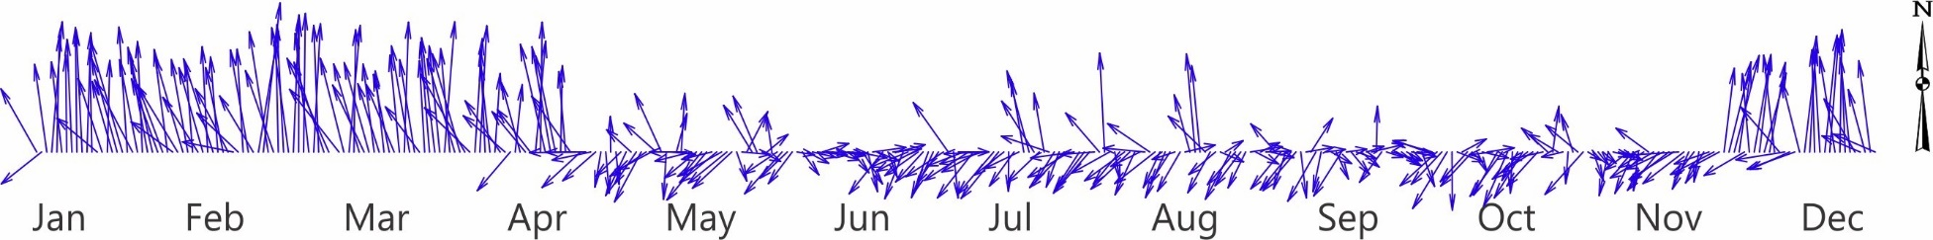

Average Monthly Wind Speed (km/h) and Direction (°)

Monthly Average Wind Speed
Year | Jan | Feb | Mar | Apr | May | June | July | Aug | Sep | Oct | Nov | Dec
1997 |  |  |  | 5.3 | 8.3 | 5.6 | 7.5 | 7.6 | 6.0 | 5.6 | 5.6 | 8.5
1998 | 9.8 | 8.8 | 10.5 | 9.4 |  | 5.0 | 6.5 | 5.5 | 4.9 | 5.4 | 6.1 | 7.6
1999 | 10.0 | 11.0 | 10.8 | 9.1 | 6.0 | 3.8 | 6.3 | 5.2 | 4.2 | 4.9 |  | 7.9
2000 | 8.5 | 10.8 |  |  | 5.5 | 5.9 | 6.8 | 6.7 | 4.5 | 6.2 | 6.7 | 8.3
2001 | 9.8 | 11.5 | 8.4 | 10.4 | 6.0 | 6.9 | 6.2 | 6.4 | 5.1 | 4.9 | 6.4 | 7.5
2002 | 9.5 | 11.0 | 11.0 | 10.3 | 7.7 | 4.8 | 6.6 | 6.9 | 4.9 |  |  | 10.0
2003 | 10.3 | 9.7 | 7.3 | 7.8 | 5.4 | 5.1 | 6.3 | 5.9 | 4.7 |  | 6.3 | 8.0
2004 | 10.2 | 10.2 | 12.2 | 8.9 | 6.4 | 6.1 | 6.2 | 6.4 | 4.7 | 4.8 | 6.9 | 9.3
2005 | 11.5 | 11.1 | 7.7 |  | 3.0 | 3.1 | 5.0 | 5.6 | 5.7 | 4.1 | 6.6 | 7.7
2006 | 9.8 | 10.7 | 10.8 | 7.3 | 5.7 | 4.9 | 5.5 | 5.8 | 5.6 | 5.1 | 6.7 | 7.8
2007 | 11.8 | 9.5 | 10.0 | 7.0 | 5.4 | 5.3 | 6.2 | 4.6 | 5.4 | 4.9 | 7.1 | 7.8
2008 | 10.6 | 9.4 | 9.6 | 9.1 | 6.0 | 5.4 | 5.6 | 5.0 | 4.2 | 4.5 | 6.2 | 8.4
2009 | 10.1 | 11.7 | 10.8 | 9.2 | 6.1 | 5.1 | 7.0 | 6.7 | 6.2 | 4.8 | 6.3 | 8.3
2010 | 9.2 | 8.7 | 8.6 | 7.3 | 5.0 | 3.9 | 3.7 | 3.7 | 2.9 | 5.1 | 6.1 | 8.6
2011 | 8.5 | 9.4 | 9.2 | 7.3 | 5.5 | 4.3 | 4.5 |  | 4.0 | 3.5 | 6.6 | 7.4
2012 | 10.5 | 9.9 | 10.9 | 6.3 | 4.7 | 5.1 | 7.2 | 4.8 | 5.7 | 4.7 | 7.2 | 8.0
2013 | 10.3 | 9.6 | 9.9 | 8.2 | 6.0 | 5.3 | 6.5 | 5.9 | 4.2 | 4.6 | 5.4 | 8.2
2014 | 8.9 | 9.5 | 9.0 | 8.7 | 6.4 | 6.4 | 7.4 | 6.1 | 4.8 | 4.3 | 6.8 | 7.2
2015 | 9.0 | 8.3 | 10.4 | 8.6 | 7.3 | 6.5 | 7.3 | 7.0 | 5.9 | 4.8 | 5.2 | 7.9
2016 | 8.8 | 11.1 | 9.0 | 7.8 | 5.8 | 4.9 | 6.6 | 5.5 | 5.2 | 3.7 | 5.4 | 9.1
2017 | 9.6 | 9.2 | 10.3 | 7.4 | 4.0 | 4.5 | 6.1 | 5.1 | 3.8 | 4.3 | 6.1 | 8.8
2018 | 9.1 | 11.9 | 10.1 | 7.7 | 4.6 | 5.8 | 7.5 | 6.6 | 5.1 | 4.3 | 5.6 | 7.5
2019 | 9.9 | 9.5 | 10.7 | 8.2 | 4.7 | 6.2 | 6.6 | 5.8 | 5.3 | 4.0 | 6.3 | 7.5
2020 | 9.5 | 10.6 | 10.8 | 7.8 | 5.7 | 4.6 | 5.8 | 4.8 | 4.1 | 4.2 | 4.6 | 7.9
2021 | 9.5 | 9.1 | 10.2 | 7.7 | 6.6 | 5.0 | 5.7 | 5.0 | 4.9 | 4.5 | 6.3 | 8.3
2022 | 9.3 | 10.1 | 9.4 | 6.5 | 4.9 | 4.2 | 5.8 | 5.0 | 3.9 | 4.6 | 4.4 | 8.4
mean | 9.8 | 10.1 | 9.9 | 8.2 | 5.7 | 5.2 | 6.3 | 5.9 | 4.9 | 4.7 | 6.3 | 8.1
sd | 0.9 | 1.0 | 1.2 | 1.2 | 1.2 | 0.9 | 1.0 | 0.9 | 0.8 | 0.6 | 0.6 | 0.7
min | 8.5 | 8.3 | 7.3 | 5.3 | 3.0 | 3.1 | 3.7 | 3.7 | 2.9 | 3.5 | 5.2 | 7.2
max | 11.8 | 11.9 | 12.2 | 10.4 | 8.3 | 6.9 | 7.5 | 7.6 | 6.2 | 6.2 | 7.2 | 10.0

Monthly Average Daily Maximum Wind Speed
Year | Jan | Feb | Mar | Apr | May | June | July | Aug | Sep | Oct | Nov | Dec
1997 |  |  |  | 27.6 | 33.4 | 27.2 | 28.9 | 30.6 | 28.3 | 26.4 | 27.6 | 29.0
1998 | 26.0 | 19.1 | 21.7 | 20.5 |  | 14.6 | 17.2 | 15.1 | 16.6 | 16.1 | 17.7 | 18.3
1999 | 21.8 | 22.2 | 22.1 | 25.2 | 19.9 | 17.2 | 24.3 | 22.7 | 22.4 | 25.2 |  | 29.1
2000 | 27.6 | 30.6 |  |  | 22.8 | 23.0 | 24.9 | 24.8 | 21.9 | 25.2 | 24.4 | 28.5
2001 | 28.7 | 31.2 | 25.7 | 29.4 | 24.4 | 25.2 | 24.0 | 25.1 | 23.8 | 23.2 | 26.1 | 27.1
2002 | 28.1 | 31.4 | 30.6 | 30.3 | 26.9 | 22.0 | 24.3 | 25.8 | 22.3 |  |  | 28.6
2003 | 32.4 | 28.2 | 26.8 | 26.1 | 22.4 | 25.1 | 24.8 | 24.4 | 22.7 |  | 25.2 | 27.5
2004 | 28.9 | 29.4 | 32.7 | 26.3 | 23.4 | 25.8 | 26.1 | 26.2 | 24.7 | 22.7 | 25.9 | 28.9
2005 | 33.3 | 30.9 | 24.0 |  | 21.3 | 22.6 | 22.9 | 24.1 | 25.3 | 24.4 | 26.2 | 25.9
2006 | 28.2 | 30.3 | 30.2 | 24.7 | 24.1 | 22.5 | 23.9 | 24.0 | 24.6 | 23.8 | 26.7 | 25.8
2007 | 32.1 | 27.1 | 28.0 | 24.6 | 23.4 | 26.0 | 23.3 | 20.8 | 21.1 | 22.4 | 25.3 | 25.1
2008 | 29.4 | 26.3 | 24.9 | 23.0 | 21.8 | 20.1 | 21.9 | 20.8 | 21.3 | 21.2 | 24.4 | 25.3
2009 | 27.0 | 30.5 | 27.9 | 24.9 | 20.3 | 21.6 | 23.1 | 22.2 | 21.8 | 20.6 | 22.3 | 24.3
2010 | 25.8 | 24.7 | 24.7 | 22.6 | 22.0 | 20.5 | 19.9 | 20.5 | 20.6 | 22.8 | 23.4 | 26.7
2011 | 25.2 | 25.8 | 25.5 | 23.0 | 19.9 | 21.2 | 21.3 |  | 20.0 | 20.1 | 23.9 | 24.0
2012 | 27.6 | 26.9 | 28.0 | 22.4 | 20.4 | 20.7 | 23.3 | 20.5 | 20.9 | 21.5 | 24.6 | 24.4
2013 | 27.0 | 25.8 | 26.3 | 23.0 | 22.4 | 20.9 | 22.3 | 22.7 | 18.9 | 20.4 | 20.8 | 24.7
2014 | 24.7 | 25.4 | 25.1 | 23.6 | 21.2 | 21.4 | 23.4 | 21.9 | 21.6 | 20.4 | 23.3 | 25.0
2015 | 26.6 | 24.0 | 27.1 | 24.3 | 22.2 | 21.3 | 22.4 | 22.0 | 21.3 | 19.9 | 19.8 | 22.6
2016 | 24.4 | 28.3 | 24.7 | 24.0 | 22.3 | 20.2 | 22.0 | 20.7 | 21.1 | 19.9 | 25.0 | 25.9
2017 | 26.0 | 24.9 | 26.5 | 22.3 | 19.7 | 20.1 | 21.9 | 21.0 | 19.4 | 21.2 | 23.1 | 27.3
2018 | 26.9 | 29.9 | 26.6 | 22.7 | 20.1 | 20.8 | 23.7 | 22.2 | 20.9 | 20.6 | 20.8 | 24.2
2019 | 25.4 | 25.0 | 26.8 | 23.7 | 18.8 | 21.3 | 22.6 | 21.1 | 22.3 | 20.2 | 22.1 | 24.5
2020 | 24.9 | 27.0 | 27.1 | 22.4 | 20.1 | 19.2 | 21.0 | 20.7 | 19.7 | 20.4 | 21.9 | 24.5
2021 | 25.5 | 23.9 | 26.7 | 21.9 | 22.1 | 20.4 | 21.8 | 21.6 | 21.4 | 18.9 | 21.8 | 24.4
2022
mean | 27.3 | 27.2 | 26.5 | 24.4 | 22.3 | 21.7 | 23.1 | 22.6 | 21.8 | 21.7 | 23.7 | 25.7
sd | 2.7 | 3.2 | 2.6 | 2.4 | 3.0 | 2.8 | 2.2 | 2.9 | 2.4 | 2.3 | 2.5 | 2.4
min | 21.8 | 19.1 | 21.7 | 20.5 | 18.8 | 14.6 | 17.2 | 15.1 | 16.6 | 16.1 | 17.7 | 18.3
max | 33.3 | 31.4 | 32.7 | 0.3 | 33.4 | 27.2 | 28.9 | 30.6 | 28.3 | 26.4 | 27.6 | 29.1
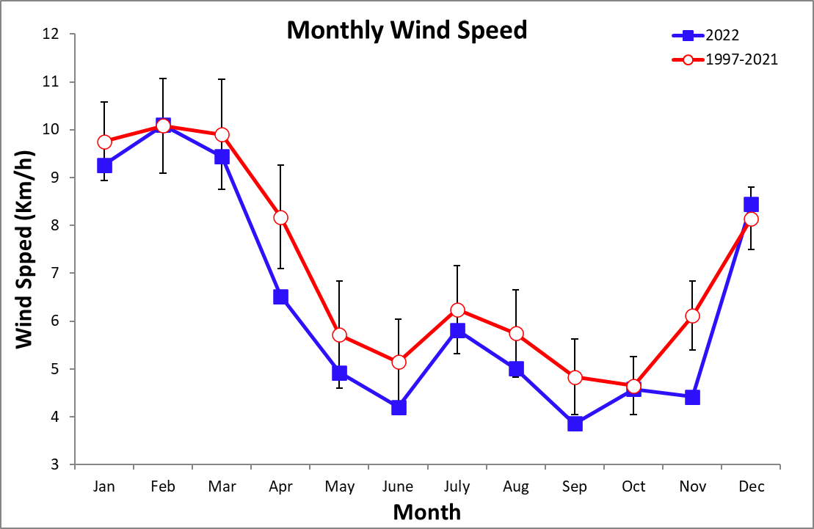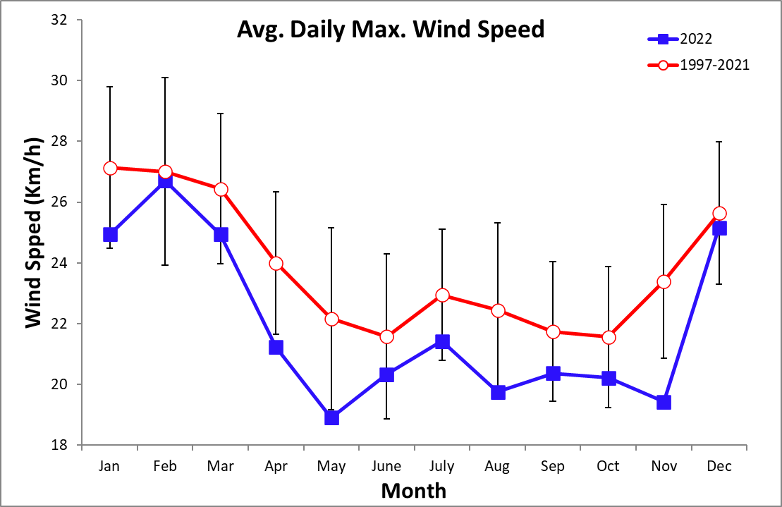
Monthly Average Wind Direction
Year | Jan | Feb | Mar | Apr | May | June | July | Aug | Sep | Oct | Nov | Dec
1997 |  |  |  | 147.0 | 188.7 | 207.8 | 276.3 | 251.7 | 200.2 | 242.1 | 159.3 | 272.2
1998 | 278.8 | 286.8 | 293.6 | 349.9 |  | 297.7 | 275.1 | 260.5 | 160.1 | 181.2 | 258.9 | 283.1
1999 | 356.6 | 308.9 | 285.2 | 295.0 | 228.6 | 166.4 | 203.3 | 169.2 | 98.7 | 98.6 | 169.8 | 252.6
2000 | 304.9 | 308.1 |  | 292.3 | 272.7 | 227.2 | 263.0 | 240.9 | 109.5 | 216.0 | 237.3 | 275.6
2001 | 306.7 | 314.5 | 293.2 | 314.2 | 255.3 | 302.9 | 231.4 | 234.6 | 167.6 | 180.4 | 203.6 | 242.9
2002 | 305.7 | 313.4 | 310.9 | 314.9 | 342.6 | 1.9 | 249.5 | 243.7 | 181.7
2003
2004
2005
2006
2007 |  | 270.1 | 269.4 | 272.1 | 187.6 | 224.4 | 215.2 | 202.0 | 228.7 | 106.0 | 259.5 | 332.2
2008 | 340.8 | 325.4 | 329.6 | 325.0 | 353.7 | 264.0 | 237.6 | 204.4 | 118.2 | 115.9 | 237.2 | 337.3
2009 | 338.7 | 345.1 | 6.0 | 1.3 | 327.8 | 319.5 | 301.7 | 293.5 | 296.3 | 217.3 | 281.1 | 339.0
2010 | 348.7 | 352.6 | 342.0 | 8.7 | 77.3 | 217.6 | 183.6 | 188.2 | 137.7 | 264.9 | 275.5 | 340.2
2011 | 359.4 | 21.4 | 12.8 | 341.5 | 3.3 | 217.7 | 237.7 |  | 184.6 | 161.1 | 244.5 | 315.5
2012 | 1.8 | 352.3 | 352.7 | 306.6 | 265.6 | 250.5 | 282.4 | 238.7 | 252.5 | 212.9 | 285.7 | 304.7
2013 | 356.6 | 350.6 | 347.3 | 339.9 | 300.8 | 238.9 | 258.0 | 240.3 | 166.9 | 233.3 | 292.1 | 350.6
2014 | 337.5 | 338.0 | 337.3 | 337.1 | 315.9 | 283.8 | 321.2 | 269.6 | 241.5 | 158.5 | 255.2 | 308.9
2015 | 357.5 | 337.1 | 347.9 | 345.3 | 326.5 | 339.4 | 297.1 | 292.2 | 256.5 | 217.8 | 246.4 | 325.4
2016 | 340.1 | 346.1 | 344.6 | 344.1 | 273.9 | 258.0 | 267.2 | 266.8 | 236.6 | 155.4 | 218.3 | 353.8
2017 | 354.0 | 349.5 | 349.4 | 337.9 | 213.5 | 209.8 | 258.1 | 252.6 | 158.7 | 199.0 | 230.6 | 318.8
2018 | 317.0 | 358.4 | 338.7 | 335.0 | 319.4 | 255.3 | 291.3 | 274.0 | 250.3 | 181.8 | 277.7 | 338.2
2019 | 336.7 | 338.2 | 344.2 | 337.7 | 313.4 | 319.0 | 281.4 | 279.7 | 207.6 | 145.4 | 272.1 | 308.1
2020 | 351.9 | 348.5 | 352.8 | 349.0 | 325.6 | 234.5 | 268.3 | 227.2 | 185.7 | 142.9 | 156.8 | 314.3
2021 | 353.3 | 339.5 | 355.9 | 345.4 | 315.1 | 266.5 | 313.5 | 213.6 | 223.9 | 226.0 | 238.1 | 343.4
2022 | 341.7 | 344.7 | 344.4 | 305.4 | 252.9 | 134.1 | 252.7 | 243.5 | 127.9 | 218.6 | 218.0 | 349.6
mean | 338.7 | 335.0 | 334.9 | 332.6 | 297.8 | 260.5 | 267.2 | 250.4 | 196.8 | 184.0 | 243.4 | 318.4

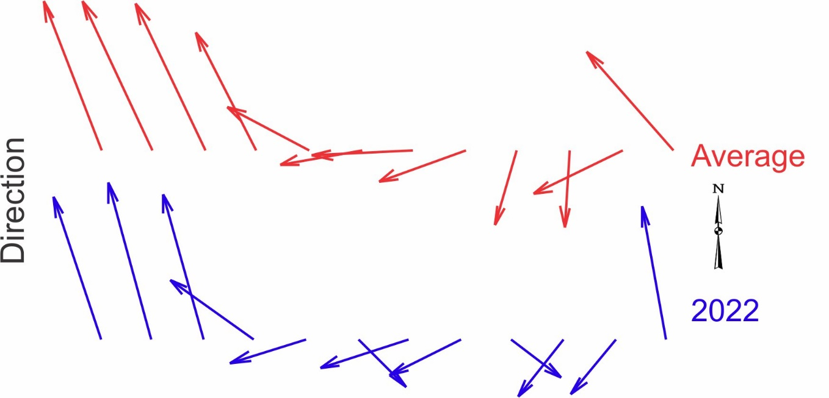

Time Series – Daily 2022

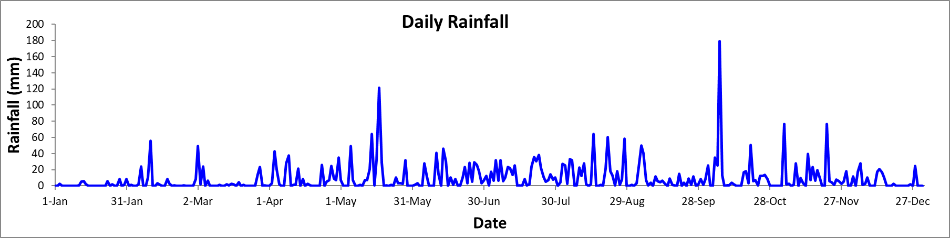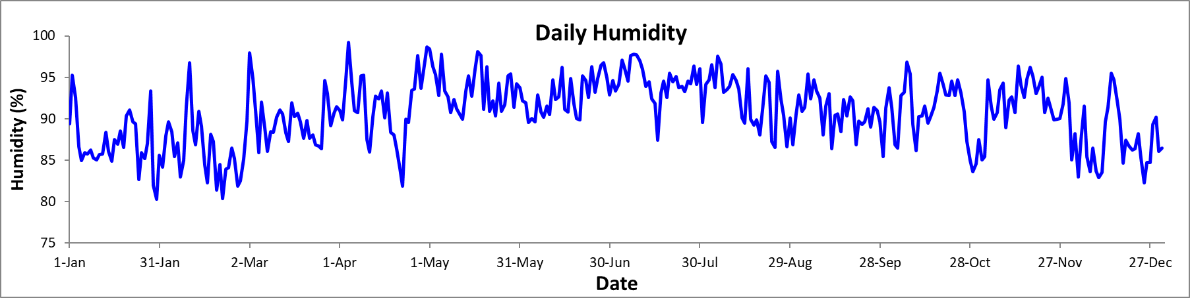

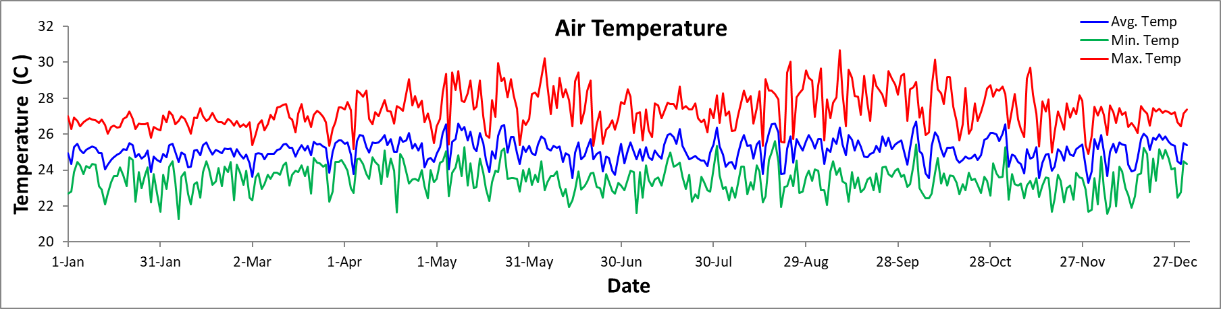

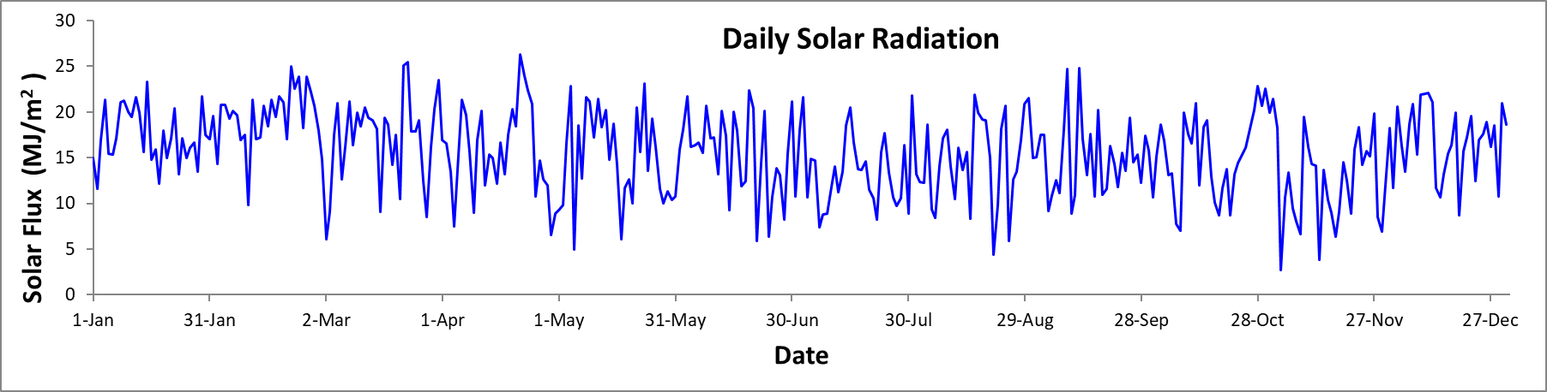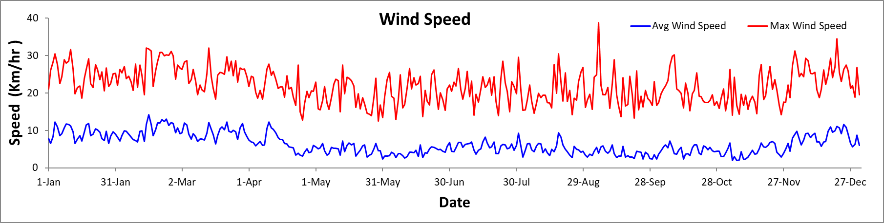
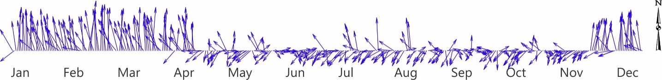
Time Series – Monthly

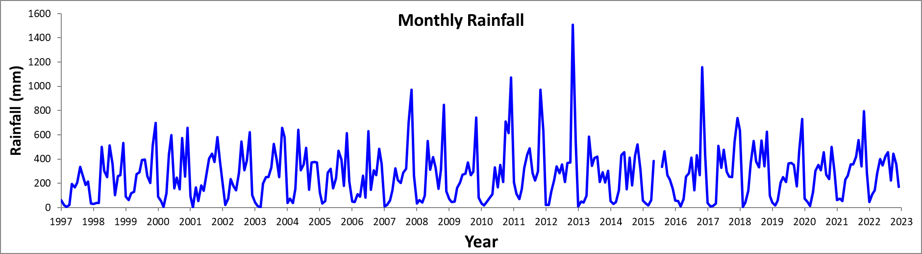

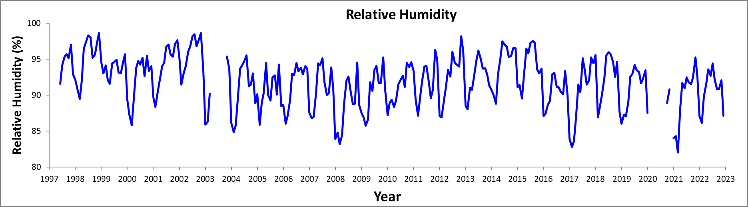

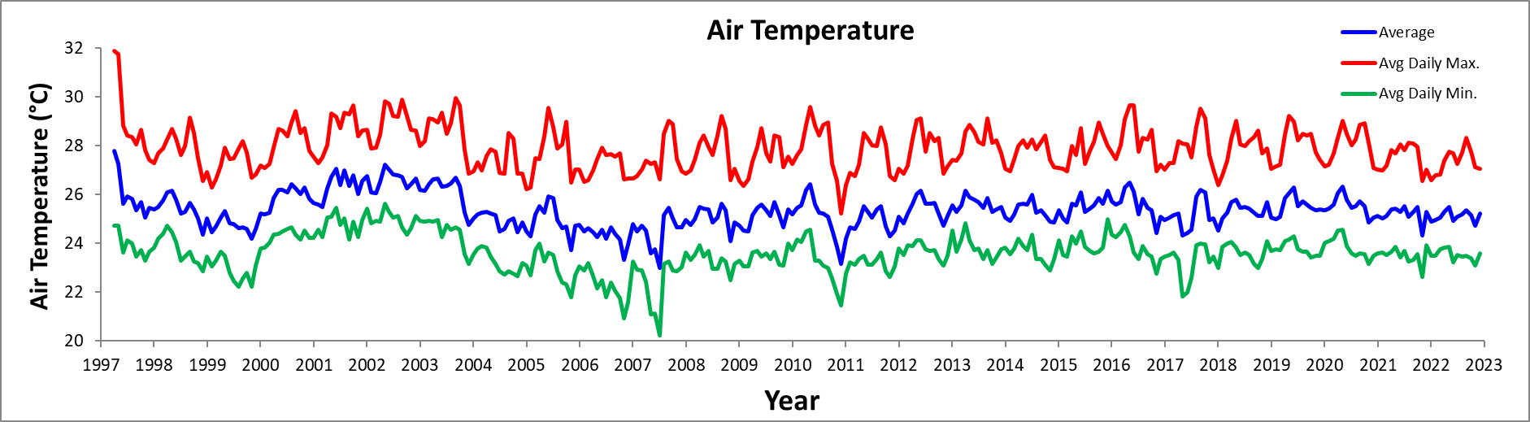

Time Series – Monthly

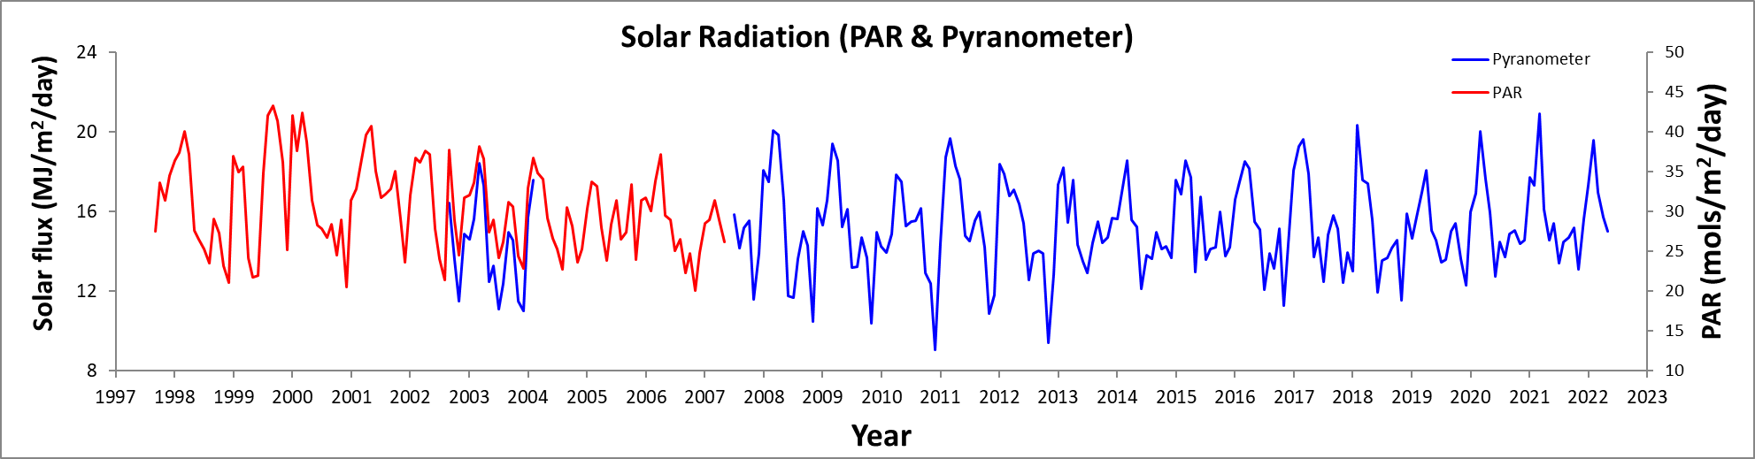

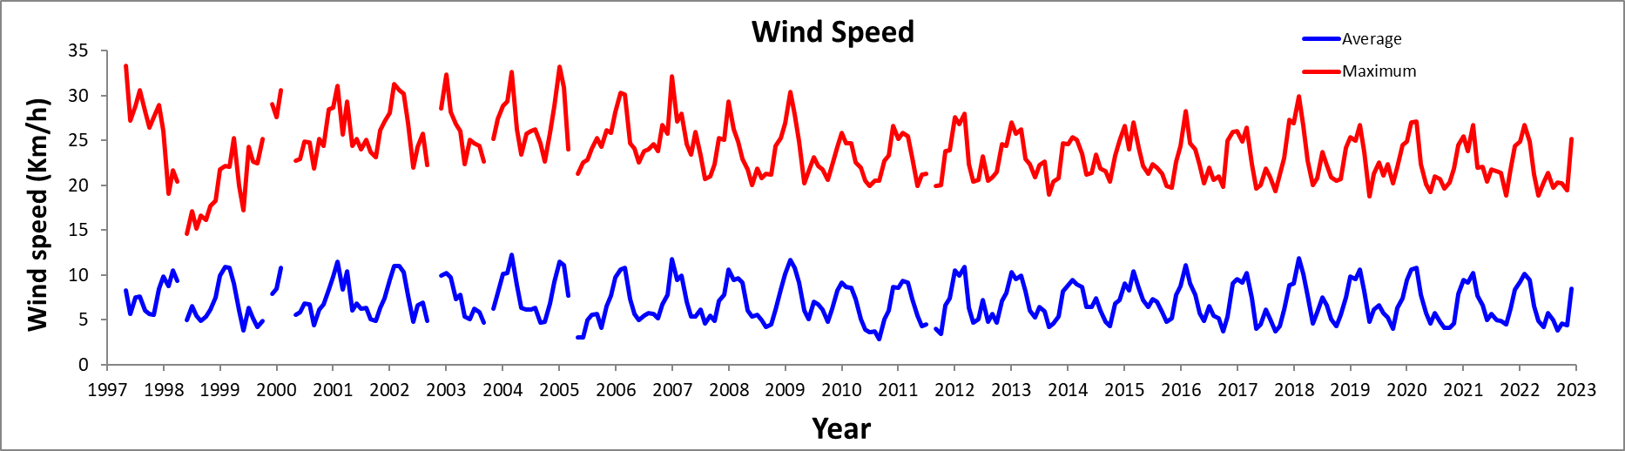

Monthly totals in green have been estimated from the Gatun West station of the Panama Canal Authority

